P. chaitanya
1N19IS108

Checking the hadoop version.
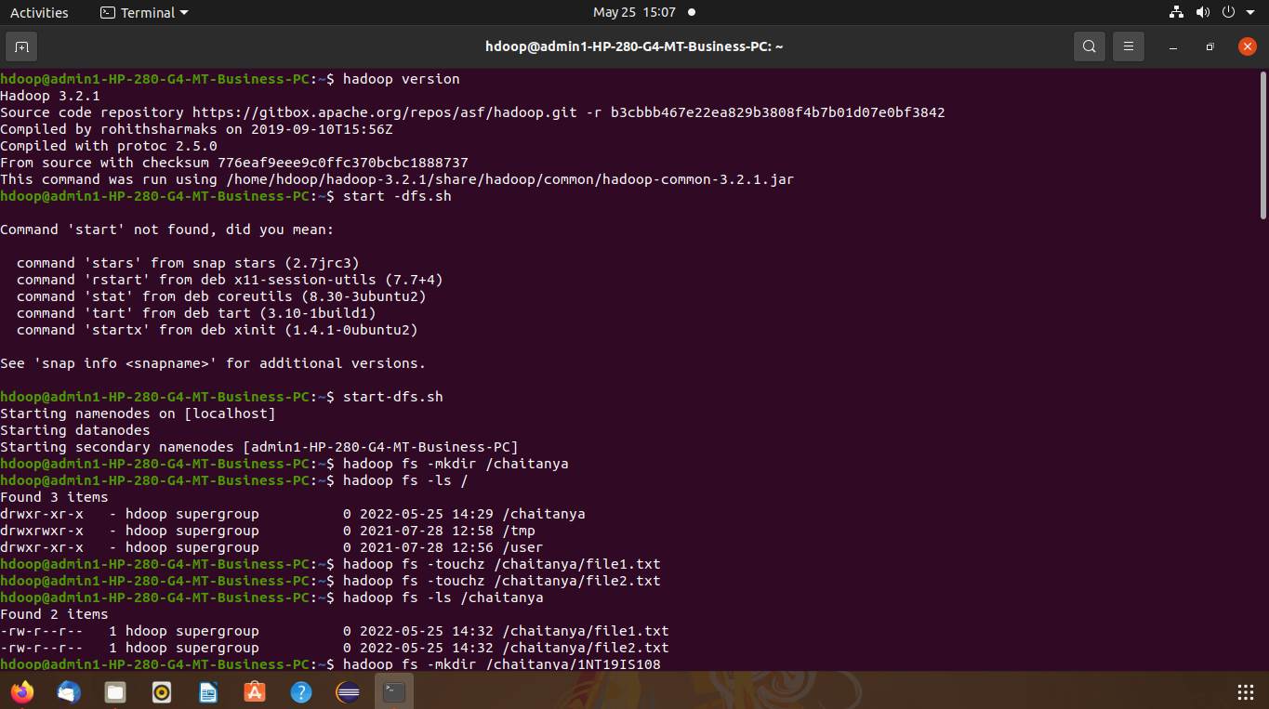

start -dfs.sh
1.Create a directory named by your name.
hadoop fs -mkdir /chaitanya
hadoop fs -ls /

2. Add two empty files into it.
hadoop fs -touchz /chaitanya/file1.txt
hadoop fs -touchz /chaitanya/file2.txt

3. List all the files in the directory that you have created.
hadoop fs -ls /chaitanya

4.Create one more directory by your USN and put that inside the directory of your name. hadoop fs -mkdir /chaitanya/1NT19IS108
hadoop fs -ls /chaitanya
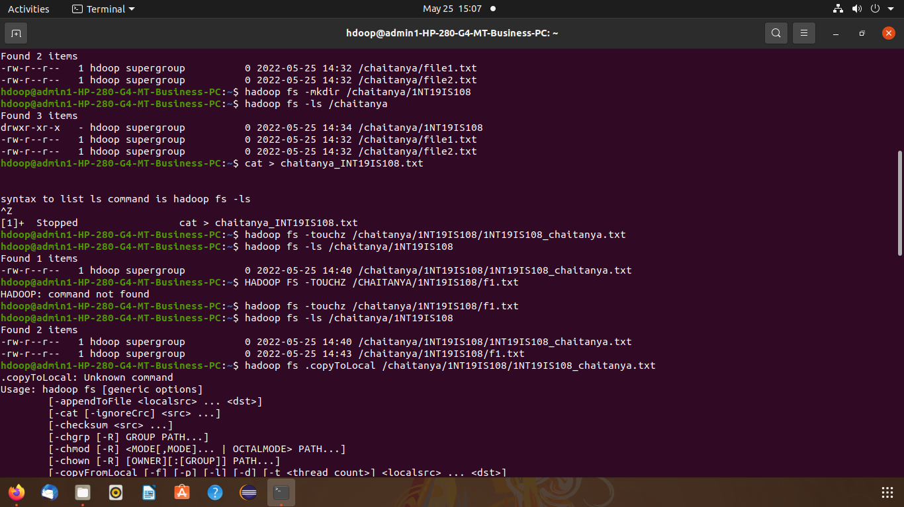

5. Create a file in your local system by the name_usn.txt and add the contents as “Syntax to list ls command is hadoop fs-ls”
cat > harshini_1NT19IS108.txt
Syntax to list ls command is
hadoop fs -ls

Put the file usn_name.txt in your hdfs directory called usn Put an empty file of hdfs into the local file system.
hadoop fs -touchz /chaitanya/1NT19IS108/1NT19IS108_chaitanya.txt
hadoop fs -touchz /chaitanya/1NT19IS108/f1.txt
hadoop fs -ls /chaitanya/1NT19IS108
hadoop fs -copyToLocal /chaitanya/1NT19IS108/1NT19IS108_chaitanya.txt
ls

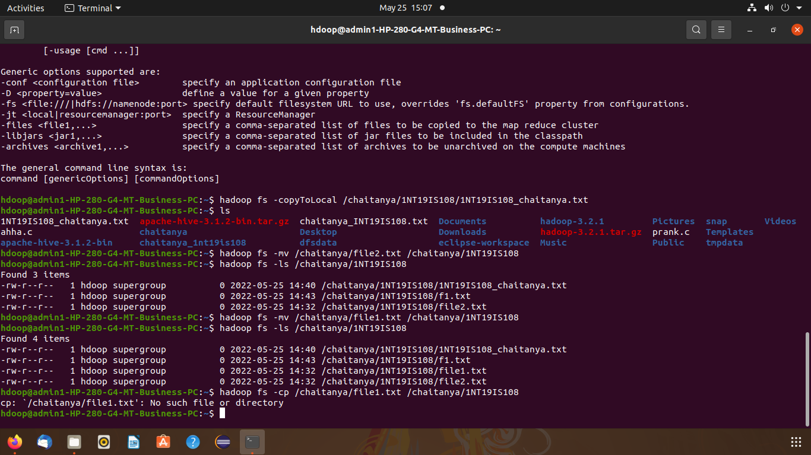
Use mv command to move files from local file system and hdfs file system
hadoop fs -mv /chaitanya/file2.txt /chaitanya/1NT19IS108
hadoop fs -ls /chaitanya/1NT19IS108

Experiment of cp command
hadoop fs -cp /chaitanya/file1.txt /chaitanya/1NT19IS108
hadoop fs -ls /chaitanya/1NT19IS108
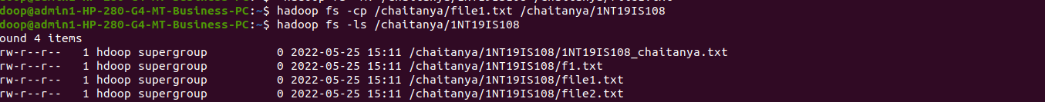

Display the total size of all files in name directory
hadoop fs -du /chaitanya
hadoop fs -du -s /chaitanya

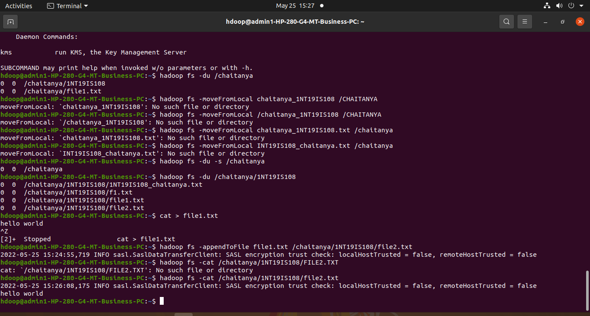

Display each file size in USN directory Use stat command on name and usn directories.

Illustrate the use of append command
cat > empty1.txt Hello World
hadoop fs -appendToFile file1.txt /chaitanya/1NT19IS108/file2.txt
hadoop fs -cat /chaitanya/1NT19IS108/file2.txt

