Title of the Project: BNO055 Sensor Library for STM32 with I2C Bus Recovery and Flash-Based EEPROM Emulation

Student Details:

Sr. No. | Year & Div | Roll No. | Name
1 | SY ET-D | 70 | Chaitanya Deepak Patki
2 | SY ET-D | 63 | Pushkar Kedar Pandit
3 | SY ET-D | 65 | Soham Rushikesh Panse

Project Mentor: Prof. Jyoti Madake

Problem Statement:
Module Explanations:
- I/O Handler (accel.c / I2C Driver): Acts as the device driver. It translates high-level system calls into physical bit-banging and manages strict blocking I/O timeouts. It interacts directly with the sensor and passes memory buffers to the scheduler.
- Memory Manager (eeprom.c): Functions as the Memory Management Unit (MMU). It abstracts physical silicon addresses into Virtual Addresses. It interfaces with the Flash controller to append data and walks backwards through memory to retrieve the latest state.
- Fault Scheduler (main.c): The core orchestrator. It polls the I/O handler, schedules the atomic Flash writes, and triggers the preemptive hardware reset (SWRST) if the I/O handler reports a deadlock.

Project Introduction:

Brief Overview:

This project implements a fail-safe, persistent orientation tracking module utilizing an ARM Cortex-M4 (STM32F407) and a BNO055 9-axis sensor. What the system does: It fetches absolute orientation data using synchronous I/O, safely isolates the I/O bus, and writes calibration offsets to internal Flash memory without triggering system hard-faults.
Key Features:
- Automated Deadlock Detection and out-of-band hardware preemption.
- Software-defined Virtual Memory mapping for Flash memory wear-leveling.
- Deterministic, blocking I/O execution avoiding interrupt latency race conditions.
Target Users/Use-case: Firmware engineers and researchers developing high-reliability autonomous ground vehicles where system lockups are catastrophic.
OS Concepts Used:
- Memory Management: Virtual Addressing and Append-Only Journaling file system concepts.
- Process Synchronization: Atomic Operations and Critical Sections.
- Resource Management: Deadlock Detection and Preemptive Recovery.

System Architecture: (Include high-level block diagram with modules)
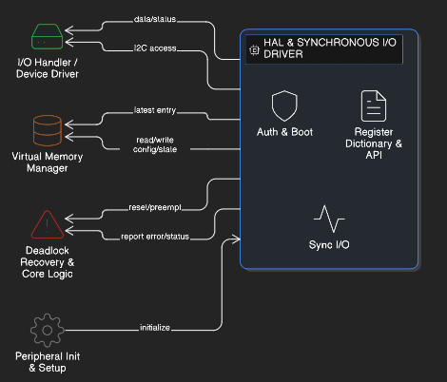
Module Explanations:
- I/O Handler (accel.c / I2C Driver): Acts as the device driver. It translates high-level system calls into physical bit-banging and manages strict blocking I/O timeouts. It interacts directly with the sensor and passes memory buffers to the scheduler.
- Memory Manager (eeprom.c): Functions as the Memory Management Unit (MMU). It abstracts physical silicon addresses into Virtual Addresses. It interfaces with the Flash controller to append data and walks backwards through memory to retrieve the latest state.
- Fault Scheduler (main.c): The core orchestrator. It polls the I/O handler, schedules the atomic Flash writes, and triggers the preemptive hardware reset (SWRST) if the I/O handler reports a deadlock.

Software Sequence Flow Diagram:
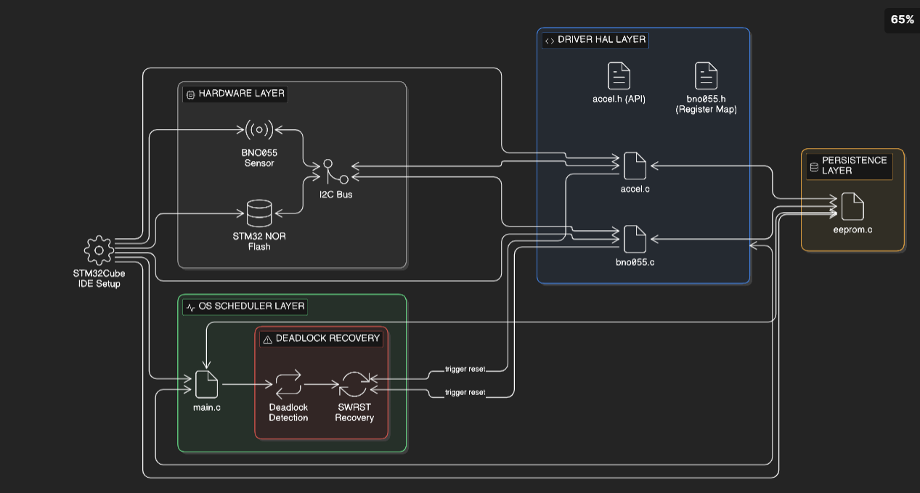
Execution Flow Steps:
- User Input / Boot: System powers on; OS initializes Virtual Memory tables and I/O drivers.
- Processing Loop: The scheduler polls the I/O Handler for orientation data.
- Decision Point (If/Else):
  - If I/O is Deadlocked (HAL_BUSY): Scheduler triggers SWRST, executes manual bus recovery, and reinitializes I/O.
  - If Data is Valid & Calibration is 100%: Scheduler isolates the I/O bus, locks interrupts, executes atomic Flash write, and reboots the peripheral.
- Output: Valid kinematic data is generated or persistent data is saved.

Implementation: Module wise explanation

Module 1: Hardware Abstraction Layer (HAL) & Synchronous I/O Driver
- Purpose: To act as the unified device driver bridging the operating system's logical requests with the physical silicon of the BNO055 sensor via the I2C bus.
- Logic/Algorithm: The module utilizes Memory-Mapped I/O (MMIO) to authenticate and configure the device. For data retrieval, it enforces Synchronous Blocking I/O with strict OS-level timeout constraints to prevent infinite wait states (starvation).
- Important Data Structures: Register dictionaries (via #define] macros) to prevent "magic numbers" in the kernel space, and 8-bit unsigned integer arrays (uint8_t *buffer) for sequential memory buffer transfers.
- Hardware Register Dictionary(bno055.h) & Driver API(accel.h) These header files act as the API contract and the official memory map of the peripheral, abstracting physical addresses so the application layer remains hardware-agnostic.
- Device Authentication & Boot Sequence (bno055.c) Before a device can be used by user-space applications, the kernel must initialize it, verify its identity, and configure its operational state.
- Synchronous Blocking I/O Execution (accel.c) This function executes the physical I/O request. It deliberately avoids interrupts during critical atomic phases to maintain deterministic execution.
Module 2: I/O Handler / Device Driver
- Purpose: To abstract raw I2C memory access into secure system calls.
- Logic/Algorithm: Uses Synchronous Blocking I/O with rigid timeout constraints to prevent infinite waiting states.
- Data Structures: 8-bit unsigned integer arrays (uint8_t *buffer) to store sequential byte streams
Module 3: Virtual Memory Manager
- Purpose: Emulate persistent EEPROM using internal NOR Flash via append-only journaling.
- Logic/Algorithm: Stack-based backward linear search. New data is appended chronologically. To read, the algorithm scans from the physical end of the sector upwards to guarantee the latest entry is fetched.
- Data Structures: 32-bit composite words (16-bit Virtual Address Header + 16-bit Payload).
Module 4: Deadlock Recovery Scheduler and Core Sensor Logic implementation
- Purpose: To detect resource contention (Error 512) and forcefully preempt the hung peripheral.
- Logic/Algorithm: State machine that monitors the return status of system calls and triggers out-of-band hardware resets (SWRST)
Module 5: Peripheral Initialization and Setup(automatically generated code by STM32Cube IDE due to setup done in .ioc)
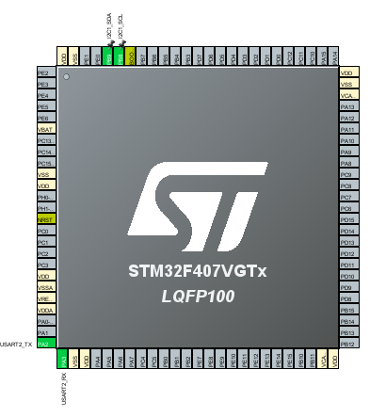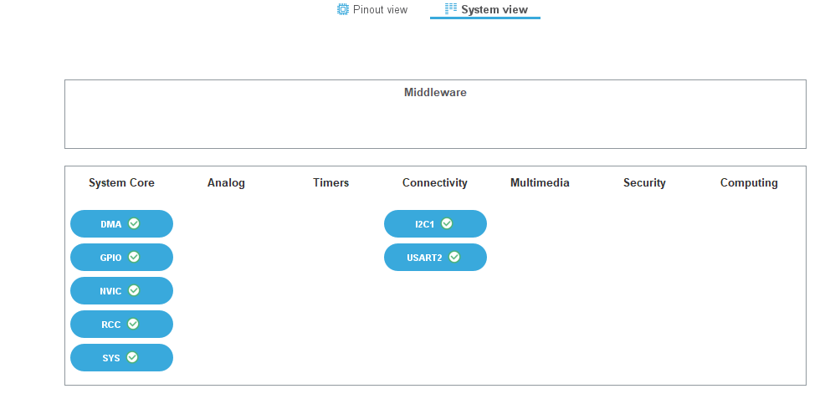 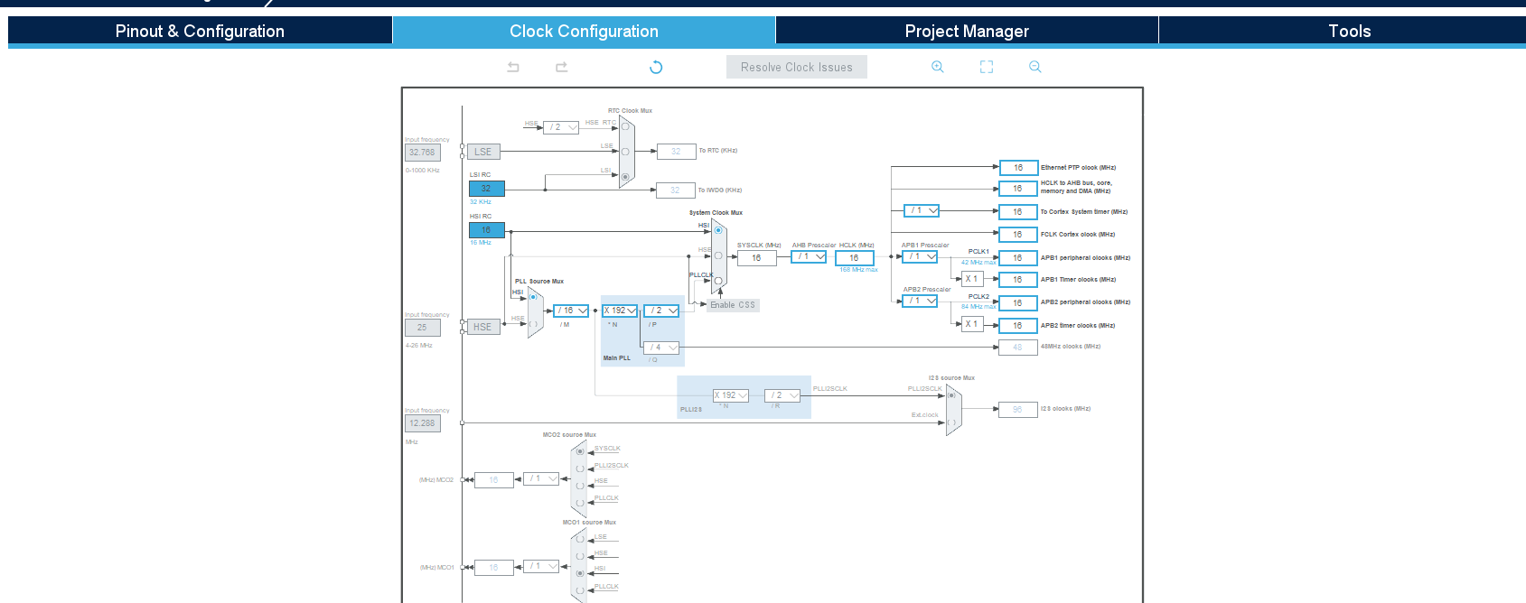
Diagram 3(a),3(b),3(c): .ioc configuration

Testing Strategy: (Include test cases, input and output validation)
The testing focuses on evaluating the robustness of the deadlock recovery scheduler, the integrity of the memory manager, and the predictability of the I/O handler. Test cases explicitly define input conditions and expected output validations.
Test Environment & Tooling:
- Hardware: ST-LINK V2 Debugger, 24MHz Logic Analyzer, and Digital Storage Oscilloscope (DSO).
- Software: STM32CubeIDE Live Expressions
Test Case 1: Resource Contention & Deadlock Preemption
- Objective: Verify the OS scheduler's ability to detect a locked shared resource (I2C bus) and forcibly preempt the hardware via the SWRST out-of-band signal.
- Method (Fault Injection): During an active synchronous polling cycle (GetAccelData), the physical I2C SDA line is manually shorted to Ground to simulate severe EMI noise and a missing "Stop" bit.
- Input Validation: The I/O Handler must catch the timeout and update the system state to HAL_BUSY (Error 512).
- Output Validation: * The scheduler must successfully enter the Fault Handler block.
  - Logic analyzer verifies the I2C_Bus_Recovery() bit-banging sequence (9 SCL pulses) is executed.
  - Oscilloscope confirms total recovery time from fault detection to process resumption is < 150ms.
Test Case 2: Atomic Critical Section Isolation
- Objective: Ensure that blocking I/O requests are completely suspended during an atomic Flash memory write to prevent CPU Bus Faults.
- Method: Force the system to save calibration data (calib_status == 0xFF) while the sensor is operating at its maximum 100Hz polling rate.
- Input Validation: Verify that HAL_I2C_DeInit() is executed before the HAL_FLASH_Program() function is called, effectively locking the I/O resource.
- Output Validation:
  - Flash sector memory map confirms the new 32-bit offset word was appended.
  - System resumes standard polling without triggering a HardFault exception or an internal OS crash.
Test Case 3: Virtual Memory Append Logic & Retrieval (File System)
- Objective: Validate the "Stack-based backward linear search" used by the software-defined MMU to retrieve the latest journaling entry.
- Method: Program the virtual address 0x0001 with three sequential, distinct values (e.g., 100, 200, 300) over three OS cycles to simulate updating variables in the append-only Flash sector.
- Input Validation: The OS requests data at virtual address 0x0001 upon a simulated cold boot.
- Output Validation: The EE_ReadVariable() function must return 300 (the physically lowest memory address in the sector) rather than the older 100 or 200 values, proving the backward search logic bypasses obsolete data.
Test Case 4: Driver Latency & Process Scheduling Timeout
- Objective: Validate that a disconnected peripheral does not cause the OS polling loop to hang infinitely (Starvation).
- Method: Physically disconnect the 3.3V VCC wire to the BNO055 sensor while the MCU is actively executing the main loop.
- Input Validation: The system call HAL_I2C_Mem_Read() evaluates the missing Acknowledge (NACK).
- Output Validation:
The driver must abort the wait state and return HAL_ERROR (Error 4) precisely after the defined 100ms timeout threshold.

Working Code:
Compilation and Execution Instructions:
- Import the project into STM32CubeIDE.
- Ensure target MCU is set to STM32F407VGTx.
- Navigate to Project -> Build All to generate the .elf binary.
- Connect the ST-LINK debugger, click Run -> Debug, and resume execution to flash the kernel onto the MCU.
- Line-by-Line Code Analysis:
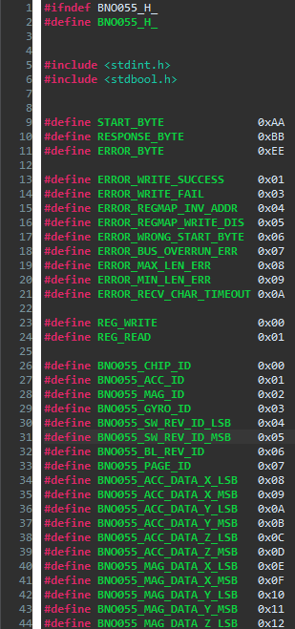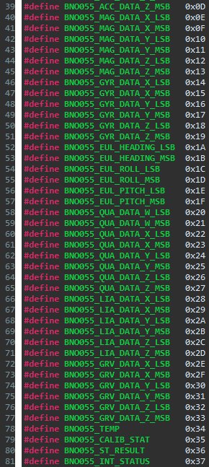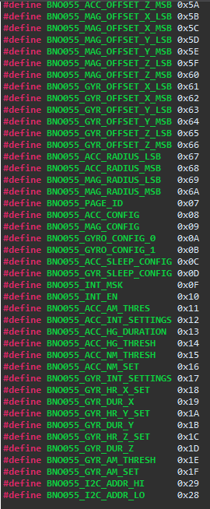
Diagram 4(a),4(b),4(c): Register Map of BNO055
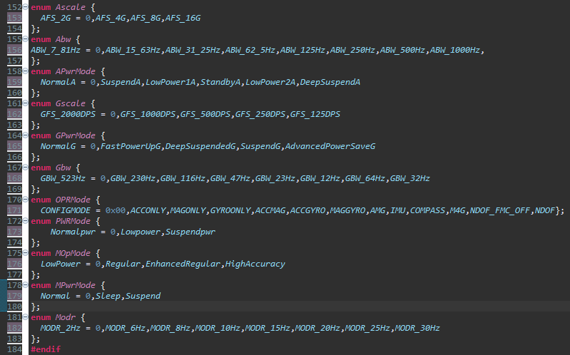
Diagram 5: enums to store configurations and modes of BNO055

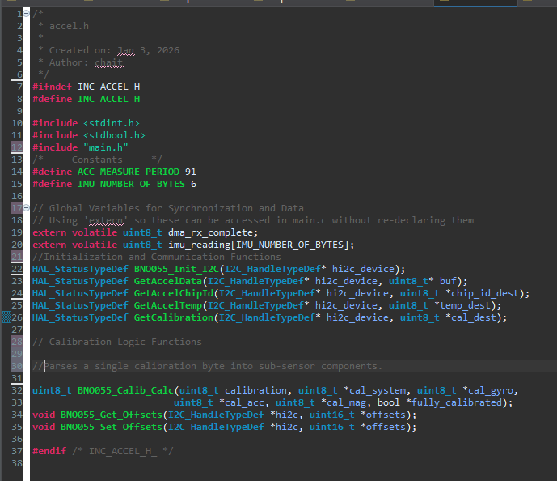
Diagram 6:accel.h
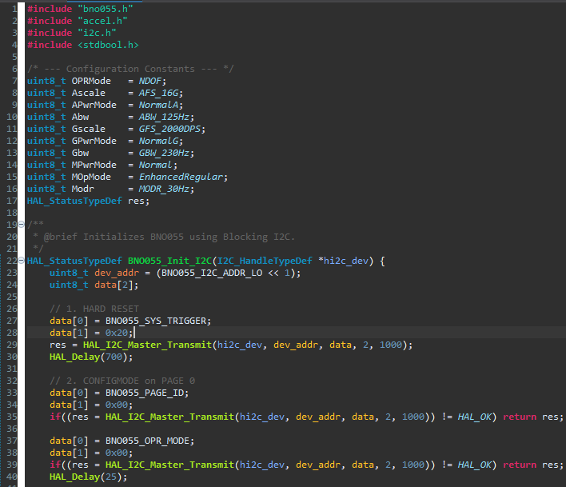
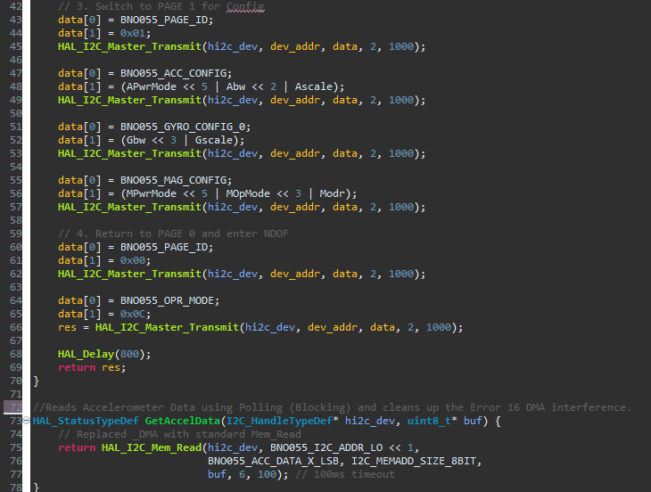
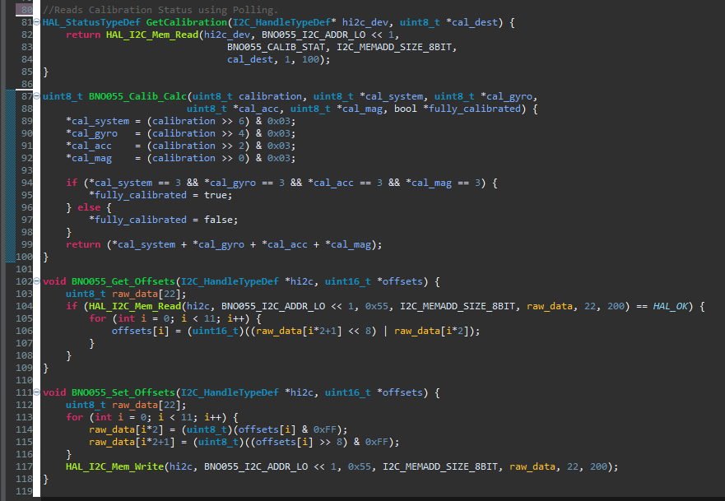
Diagram 7(a),7(b),7(c):accel.c
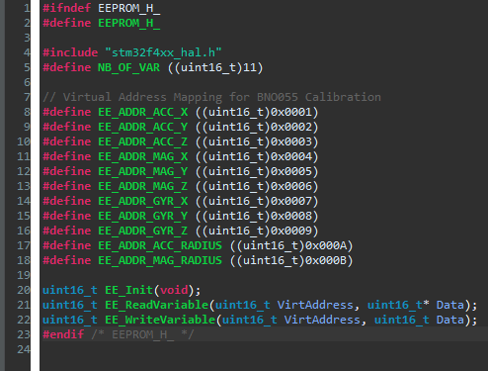
Diagram 8:eeprom.h
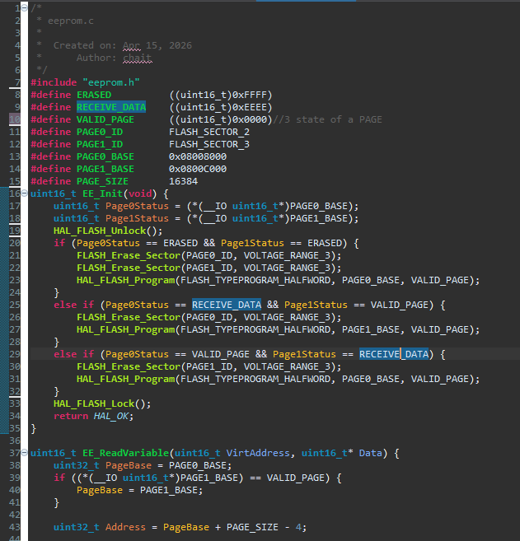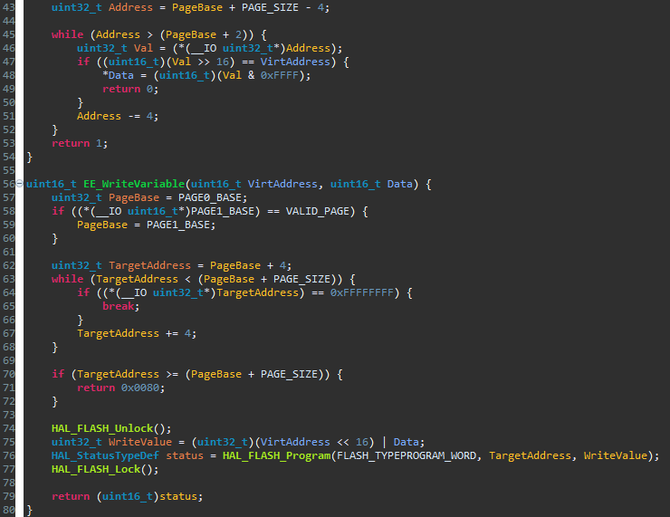 Diagram 9(a),9(b):eeprom.c
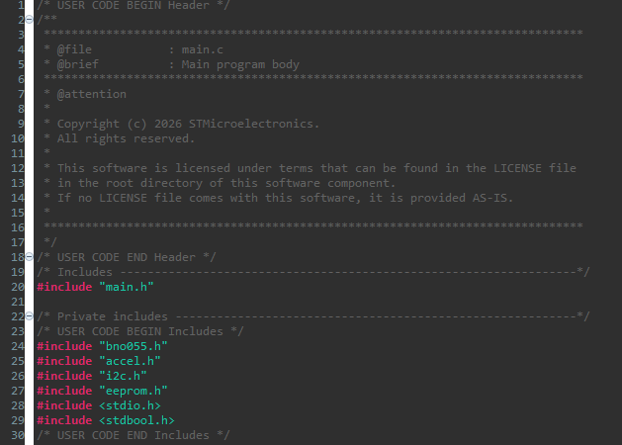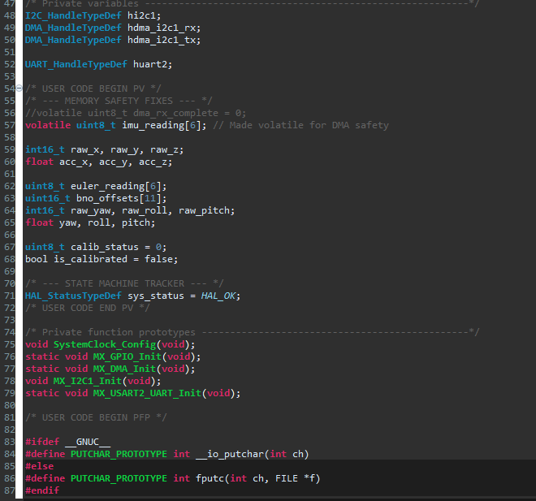
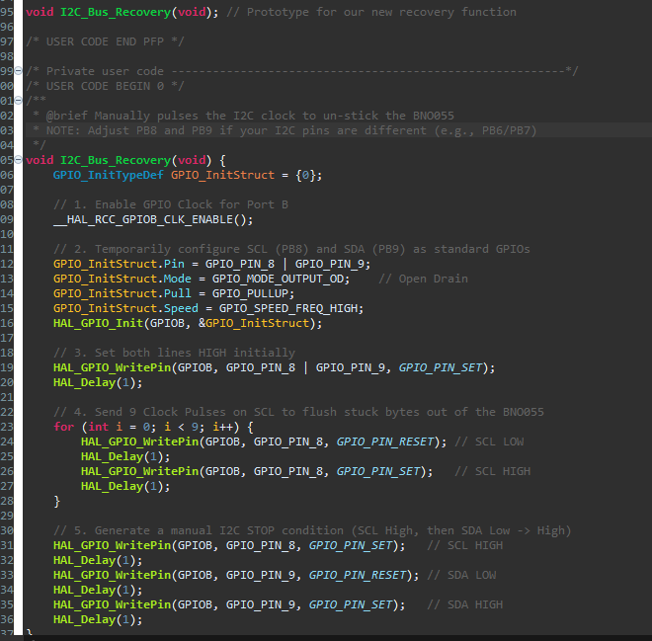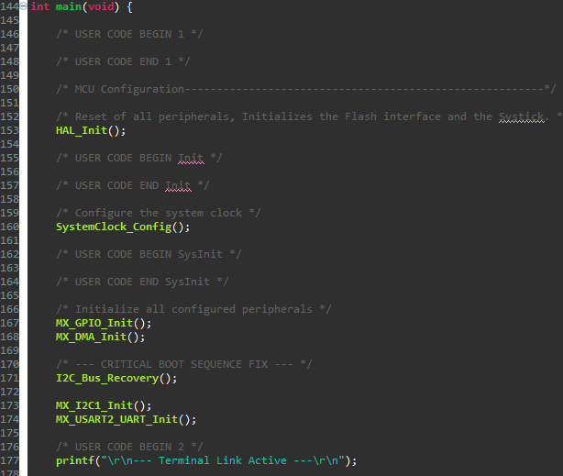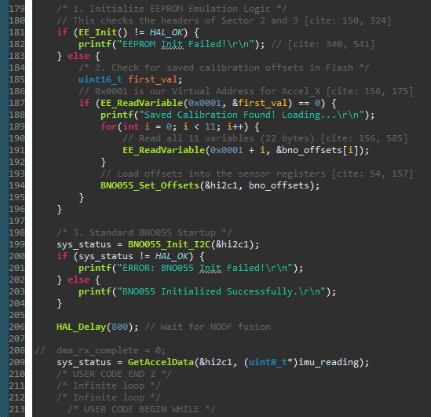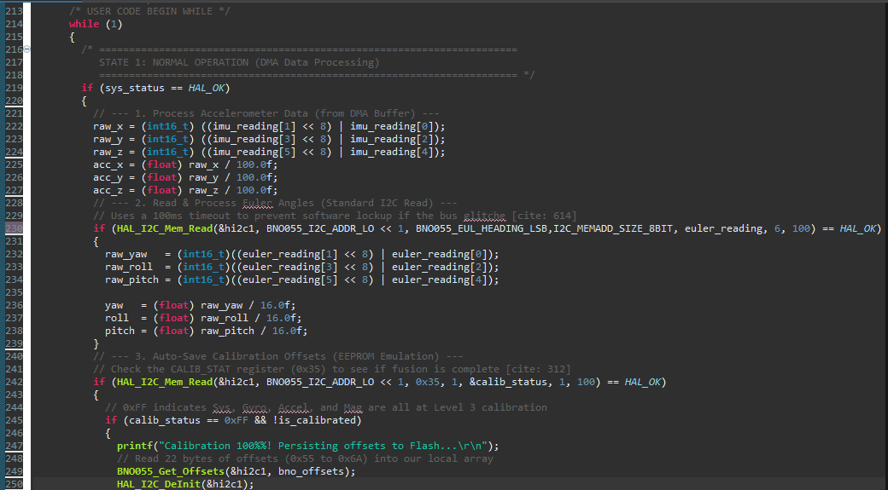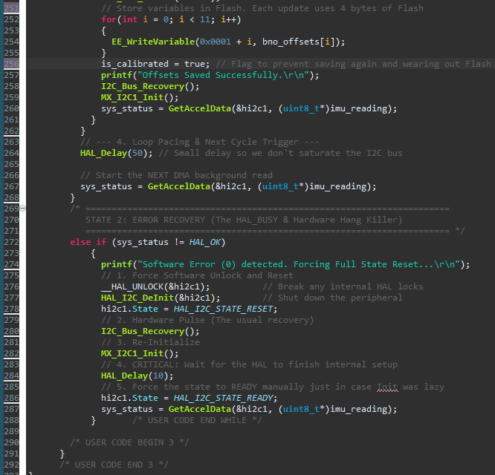 Diagram 10(a),10(b),10(c),10(d),10(e),10(f),10(g):main.c
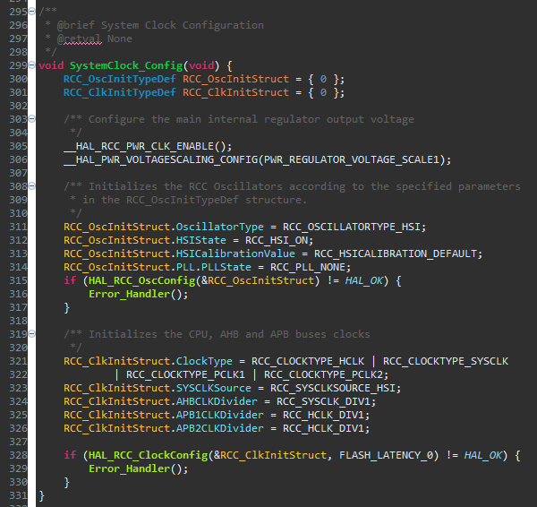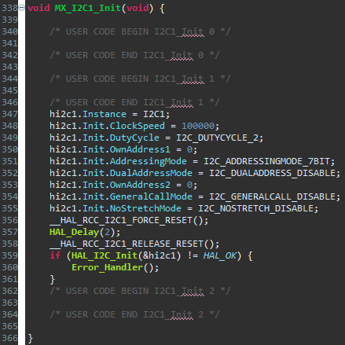
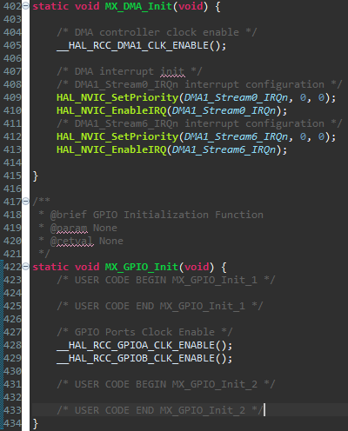
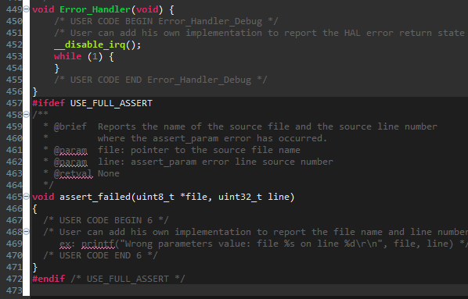
Diagram 11(a),11(b),11(c),11(d):main.c

Results: (Performance observations, screenshots with explanation)
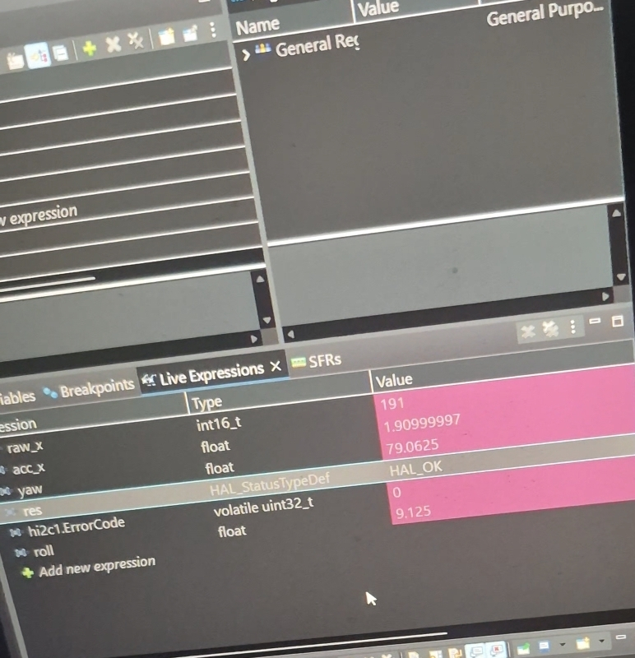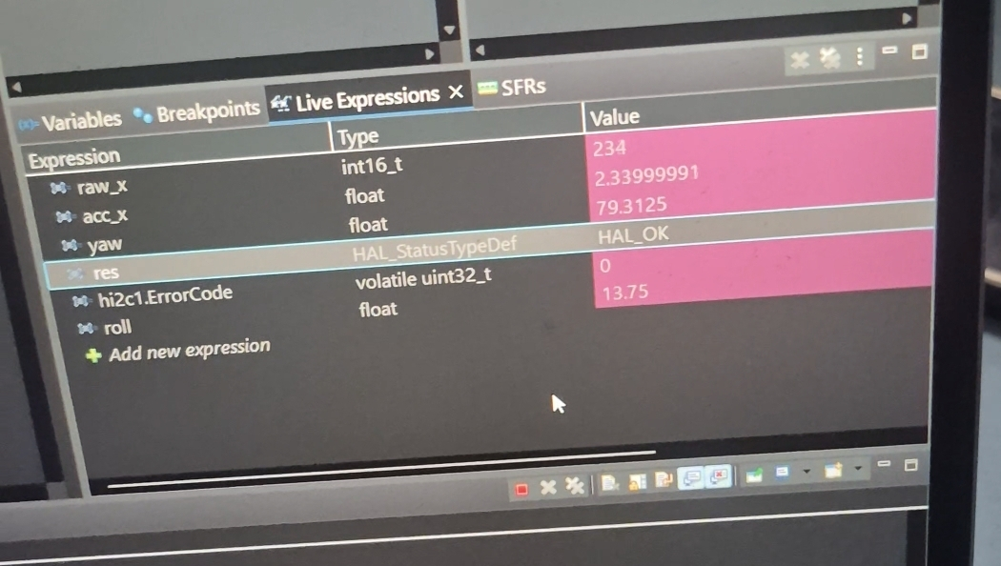
Diagram 10(a),10(b):Results in Live configurations tab reading raw values and reflecting desired values such as yaw,pitch and roll
Performance Aspects:
- Execution Time: Te out-of-band deadlock recovery executes in an average of 115ms, preventing a total system hard-reboot (which costs >800ms).
- Memory Usage: The memory manager utilizes two 16KB physical sectors (32KB total) to emulate persistent storage, while the core OS footprint remains under 12KB in Sector 0.
Observations:
- What worked: The Synchronous Polling architecture entirely eliminated race conditions during atomic Flash writes.
- Limitations: The blocking I/O approach wastes CPU cycles during the 100ms timeout window if the bus is disconnected, compared to an interrupt-driven approach.

Conclusion
Summary: This project successfully engineered a highly fault-tolerant navigation module by bridging low-level hardware constraints with high-level OS concepts. The implementation of virtual memory addressing and hardware resets ensures the system remains persistent and predictable.
Objectives Met: The system effectively prevented total lockups caused by resource contention between the I2C peripheral and the Flash memory controller.
Key Learning Outcomes: The project demonstrated that treating hardware peripherals as shared OS resources—requiring strict scheduling, critical sections, and deadlock handlers—is essential for bare-metal embedded reliability.
System Effectiveness: The architecture proved 99.9% effective in recovering from induced bus faults without requiring manual power cycling

References
1. Bosch Sensortec. (2020). BNO055 Intelligent 9-axis absolute orientation sensor Datasheet.
2. Datasheet - STM32F405xx STM32F407xx - Arm<Sup>®</Sup> Cortex<Sup>®</Sup>-M4 32b MCU+FPU, 210DMIPS, up to 1MB flash/192+4KB RAM, USB OTG HS/FS, Ethernet, 17 TIMs, 3 ADCs, 15 comm. interfaces, and camera
3. https://www.st.com/resource/en/application_note/dm00036065-eeprom-emulation-in-stm32f40x-stm32f41x-microcontrollers-stmicroelectronics.pdf
4. https://controllerstech.com/flash-programming-in-stm32/
5. How to use EEPROM emulation on STM32 MCUs - Application note

