**OMIS 652: BUSINESS APPLICATIONS DATABASE MANAGEMENT SYSTEM**

**Project Title: ONLINE BUS TICKET RESERVATION**



**Group:** **I**

**Team Members:**

YASASWANI GANDI (Z1852719)

CHAITANYA SWAROOP POKURI (Z183880)

HEMNATH TUMMALA (Z1850110)

MANEESHA AVVARU (Z1835461)

**DESCRIPTION**

Online Bus booking system provides the facility to the passengers to book the tickets for buses that operate between cities Chicago, Rockford, Naperville etc. A passenger can book tickets by logging in with their username and password after which the booking information with such as Booking_Id,Bus number,Date of journey,Source and Destination,number of passengers travelling are displayed. Each booking has a payment mode which can be either a Credit or Debit card.

Each Bus has a unique bus number, rating, number of seats along with the driver details included.A bus can operate in multiple scheduled times having Departure and Arrival time information and each schedule for the bus is associated with specific route details such as Route_Id and fare. Every Route has different stops in each city. Every Stop is represented with Stop_Id, stop name in the cities Rosemont, Jackson, Naperville and Dekalb.

This system also provides the facility for passengers to talk to customer representative regarding any queries or complaints. Each representative has a unique Rep_Id working each under different departments such as Booking, Payment, Front desk, Cancellations and Feedback & Complaints.

**ENTITIES AND ATTRIBUTES**

|  |  |
| --- | --- |
| **ENTITIES** | **ATTRIBUTES** |
| 1) Login | Login_id  Username  Password |
| 2) Login_Passenger | Pass_id  Login_id |
| 3) Passenger | Pass_id  Name  Gender  Phone |
| 4) Rep_Passenger | Rep_Id  Pass_Id |
| 5) Representative | Rep_Id  Name  Gender  Dept_Num |
| 6) Department | Dept_Num  Dept_Name |
| 7) BookingInfo | Booking_Id  Pass_Id  Bus_no  Quantity  Source  Destination  DateOfJourney |
| 8) Payment | Pay_Id  Booking_Id  Price  Type |
| 9) Bus_Info | Bus_no  Schedule_Id  Bus_Rating  Seats  Driver_Id |
| 10)Driver | Driver_Id  Name  Contact  Rating |
| 11)Schedule | Schedule_Id  Route_Id  Departure  Arrival |
| 12)Route | Route_Id  Fare |
| 13)Route_stop | Route_Id  Stop_Id |
| 14)Stop | Stop_Id  Name  City |

**ER DIAGRAM**

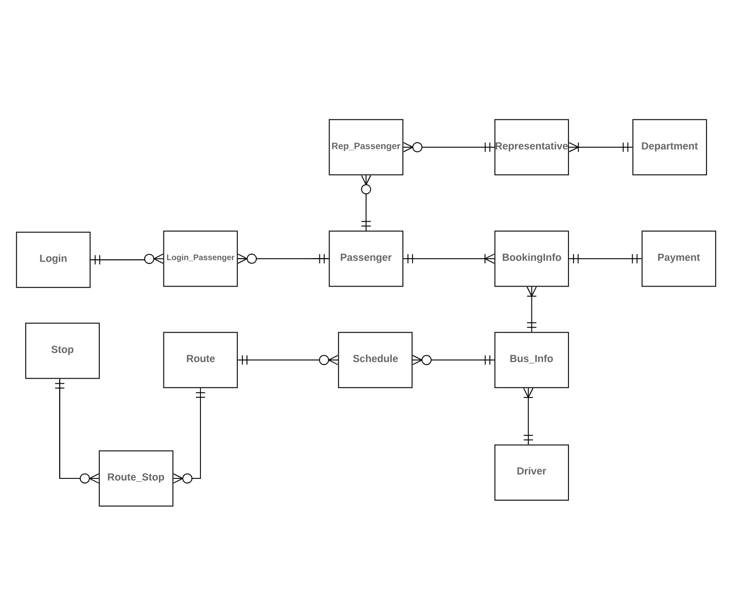

**ASSUMPTIONS**

* Each User Credentials belong to one and only one passenger.
* A Passenger can have many login credentials.
* A Representative belong to one Department and a department can have many representatives.
* A passenger can book tickets any number of times.
* Each BookingId has a unique payment information.
* A Booking Info contains the details of one bus.
* A Bus has a driver and a driver can ride one or many buses.
* A Bus can have many schedules and a schedule belong to one bus.
* A Route_stop can contain information of one route and a route can be included in zero or many Route_stop.

**DATABASE DIAGRAM**

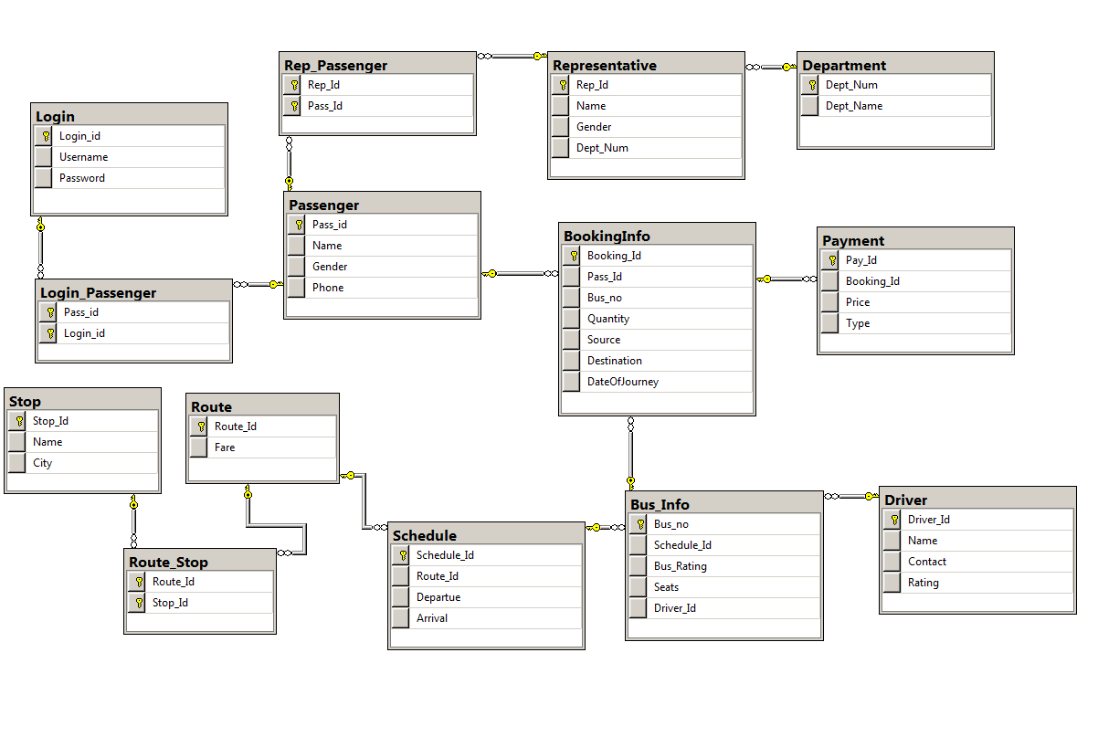

**QUERIES**

**1.**

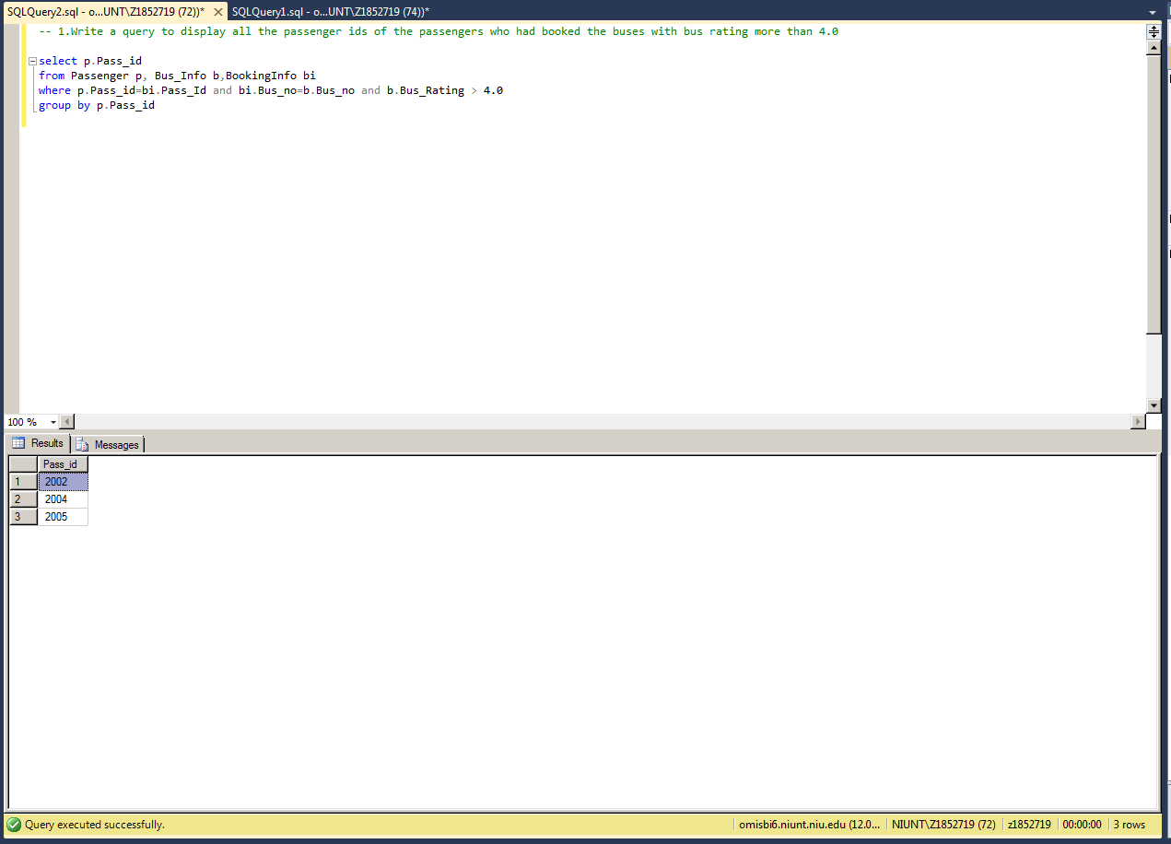

**2.**

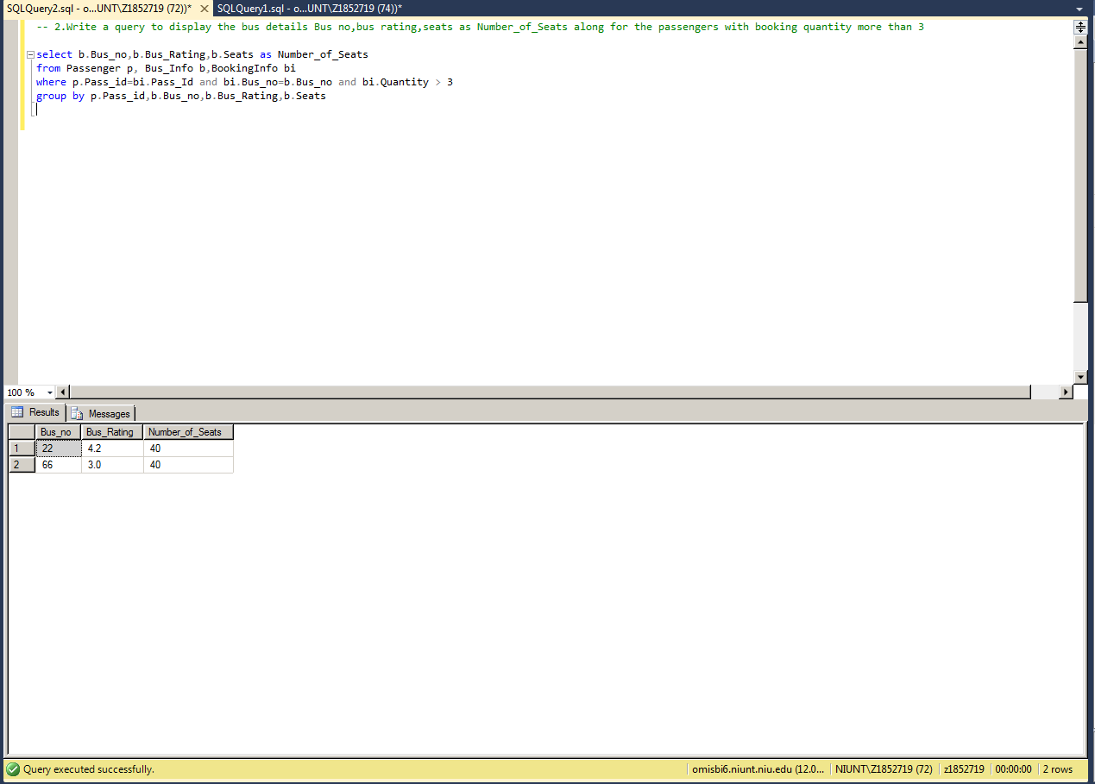

**3.**

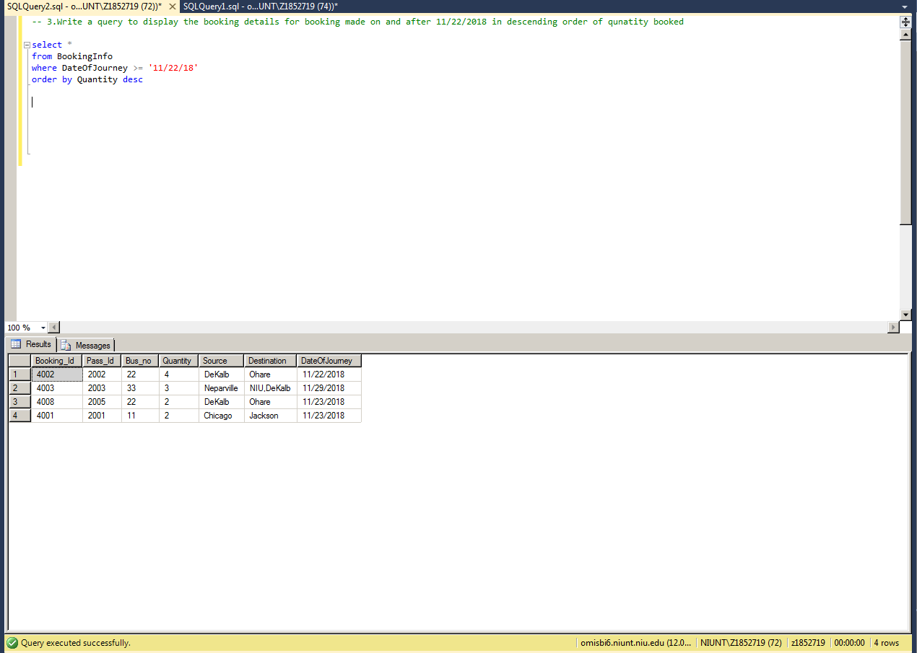

**4.**

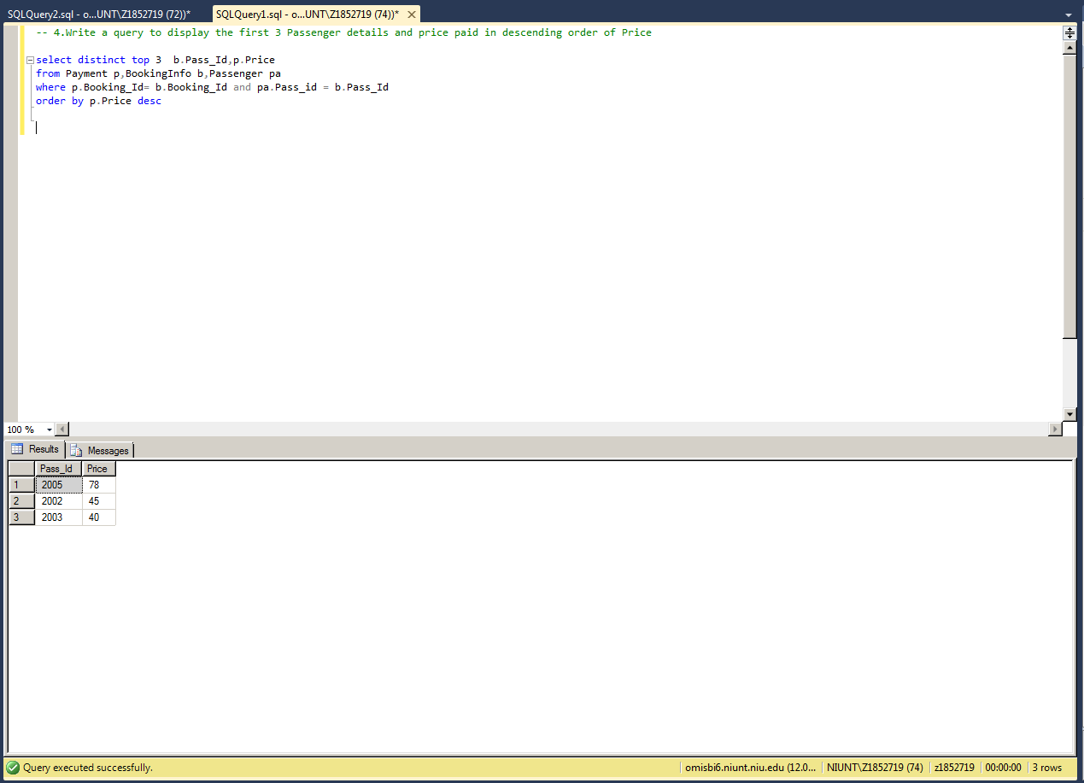

**5.**

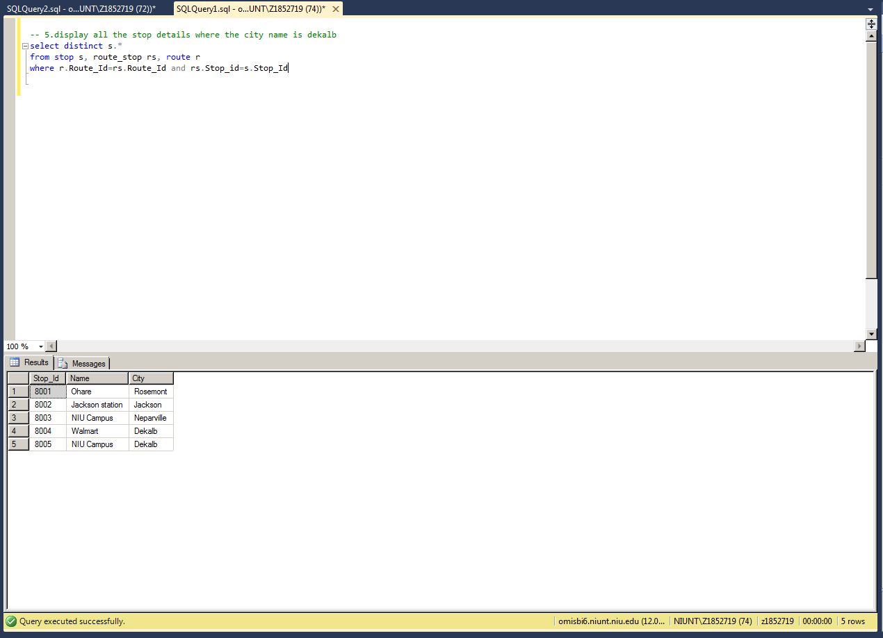

**6.**

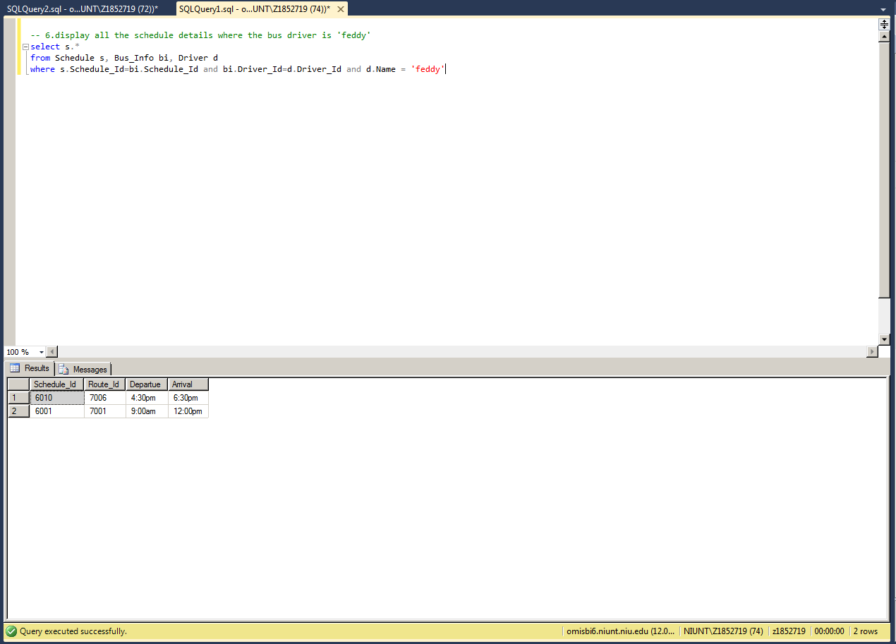

**7.**

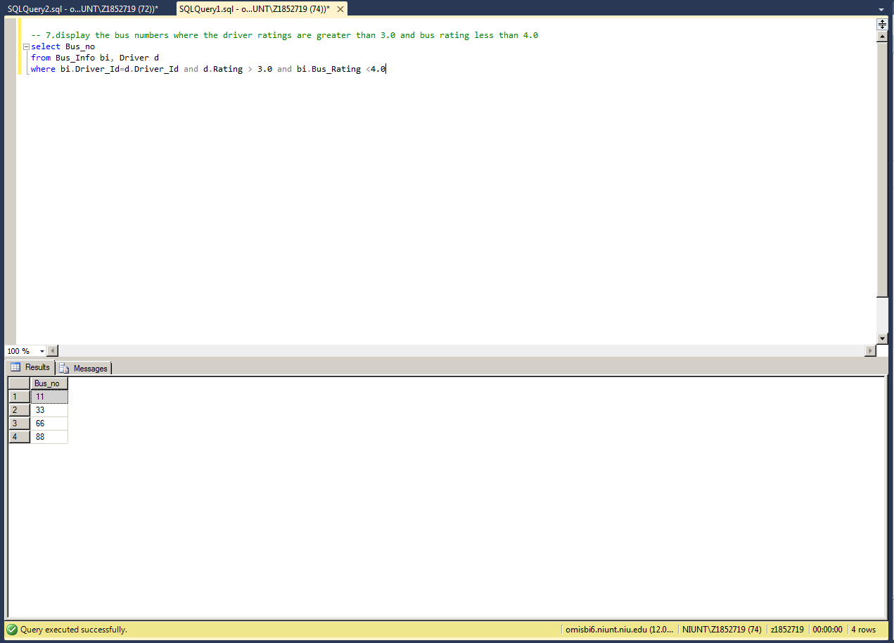

**8.**

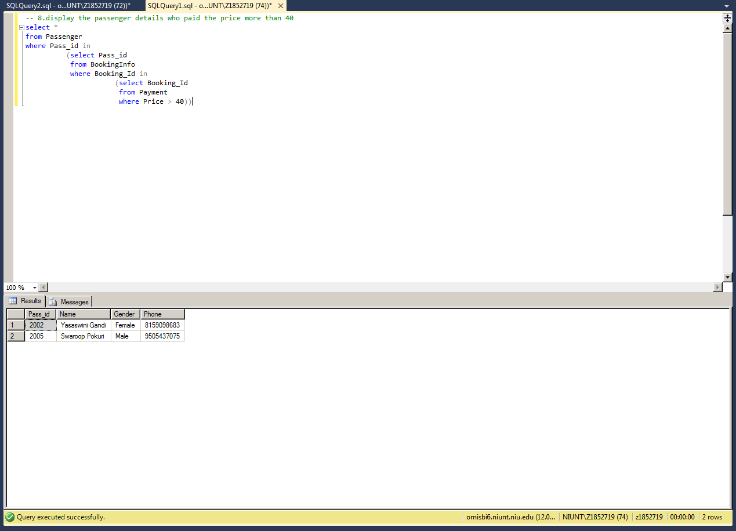

**9.**

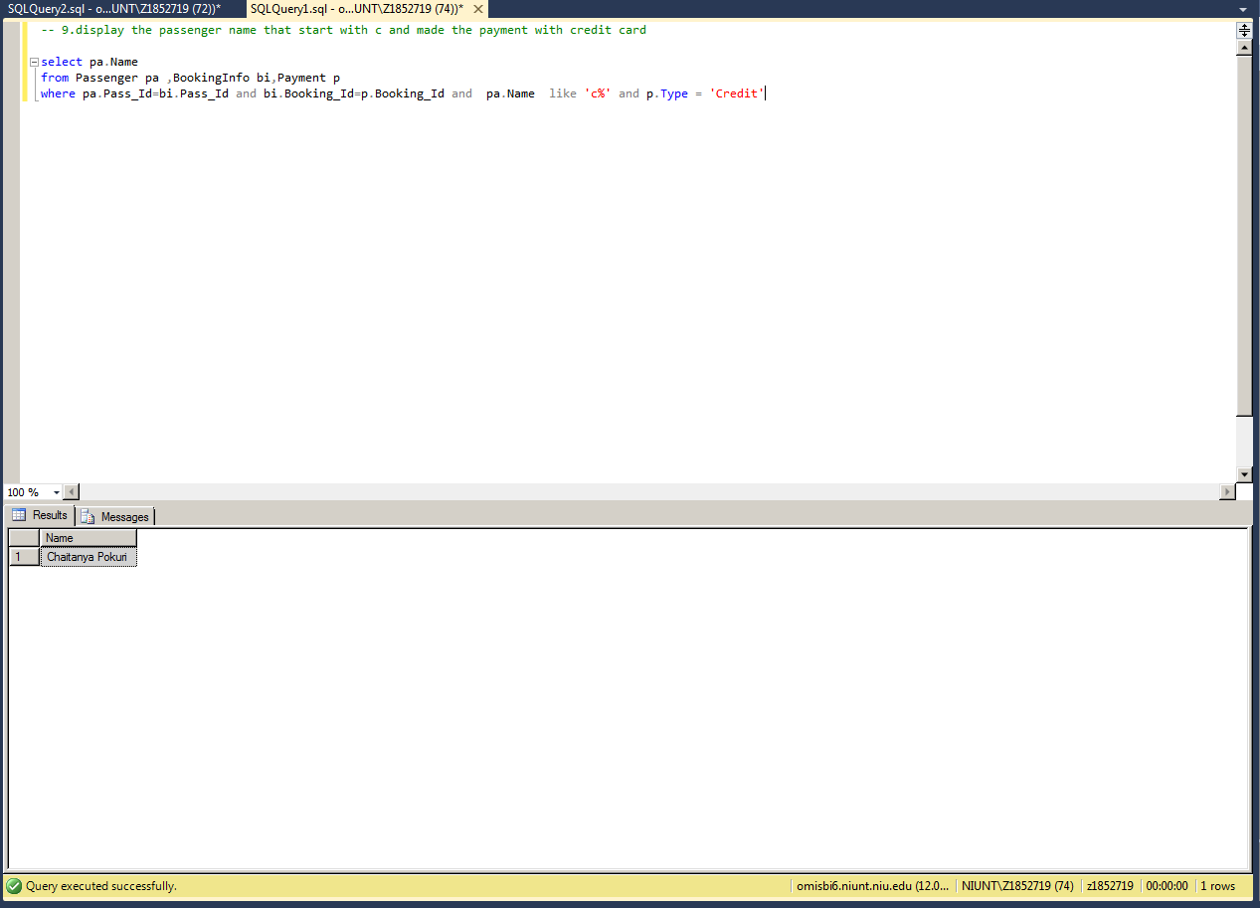

**10.**

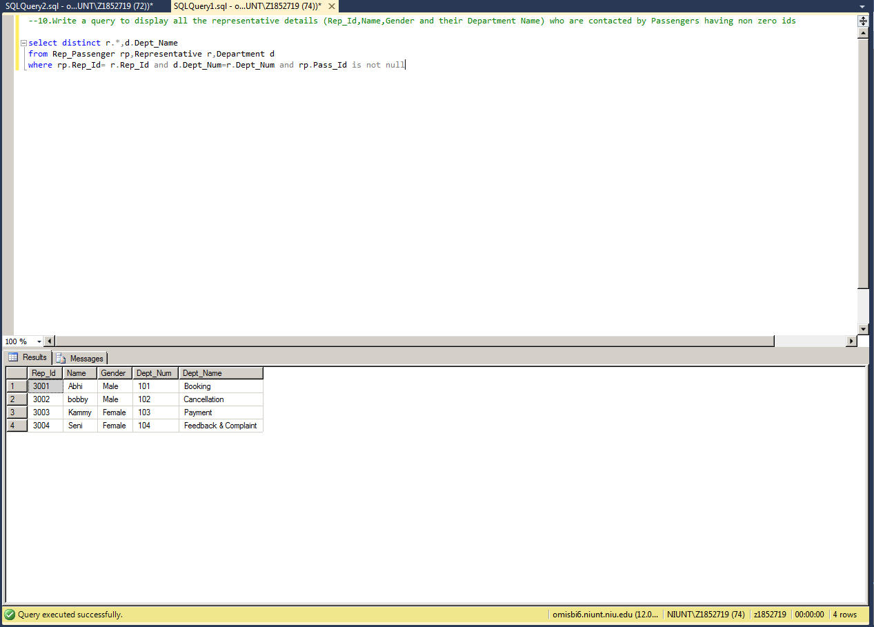

**11.**

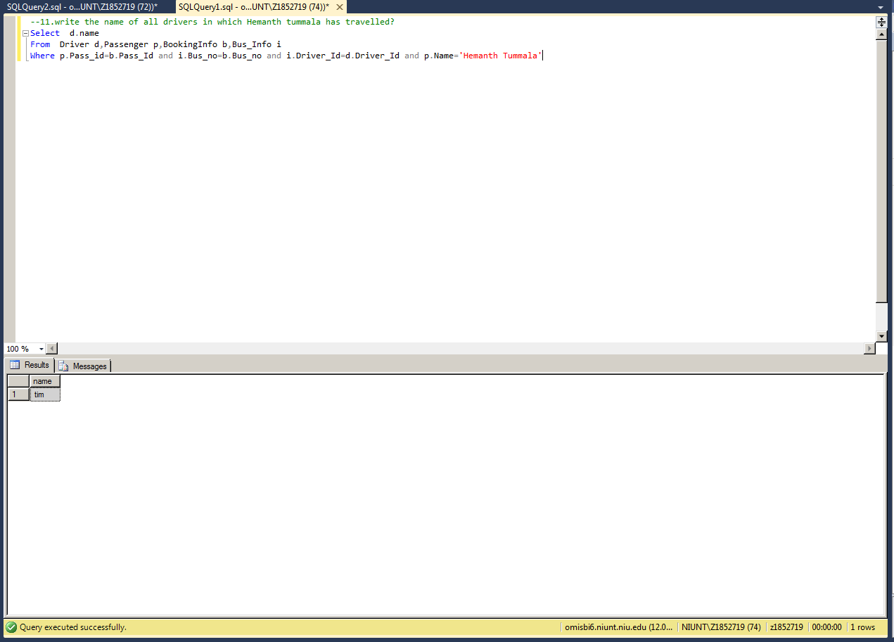

**12.**

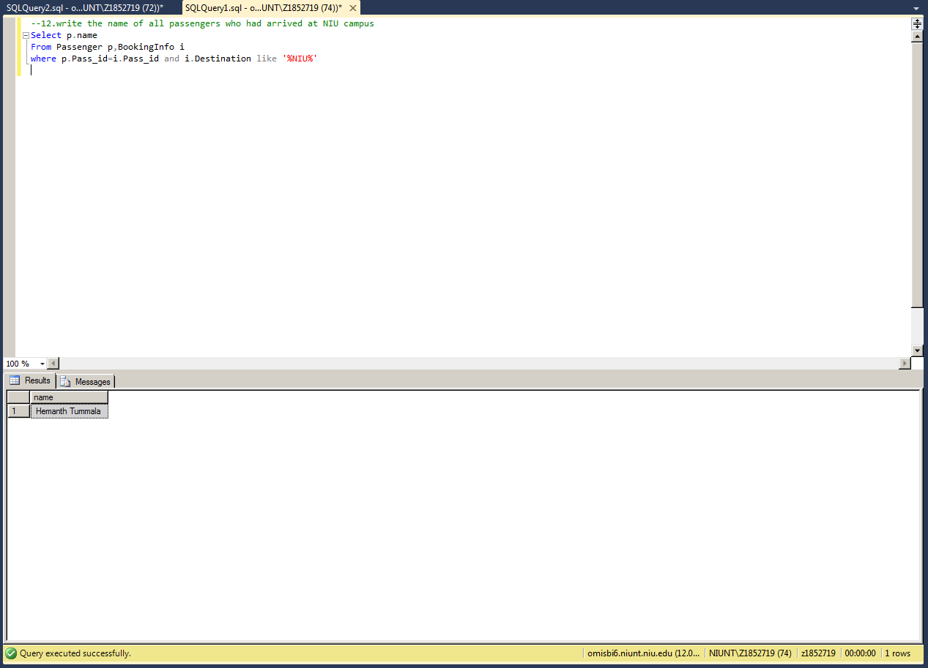

**13.**

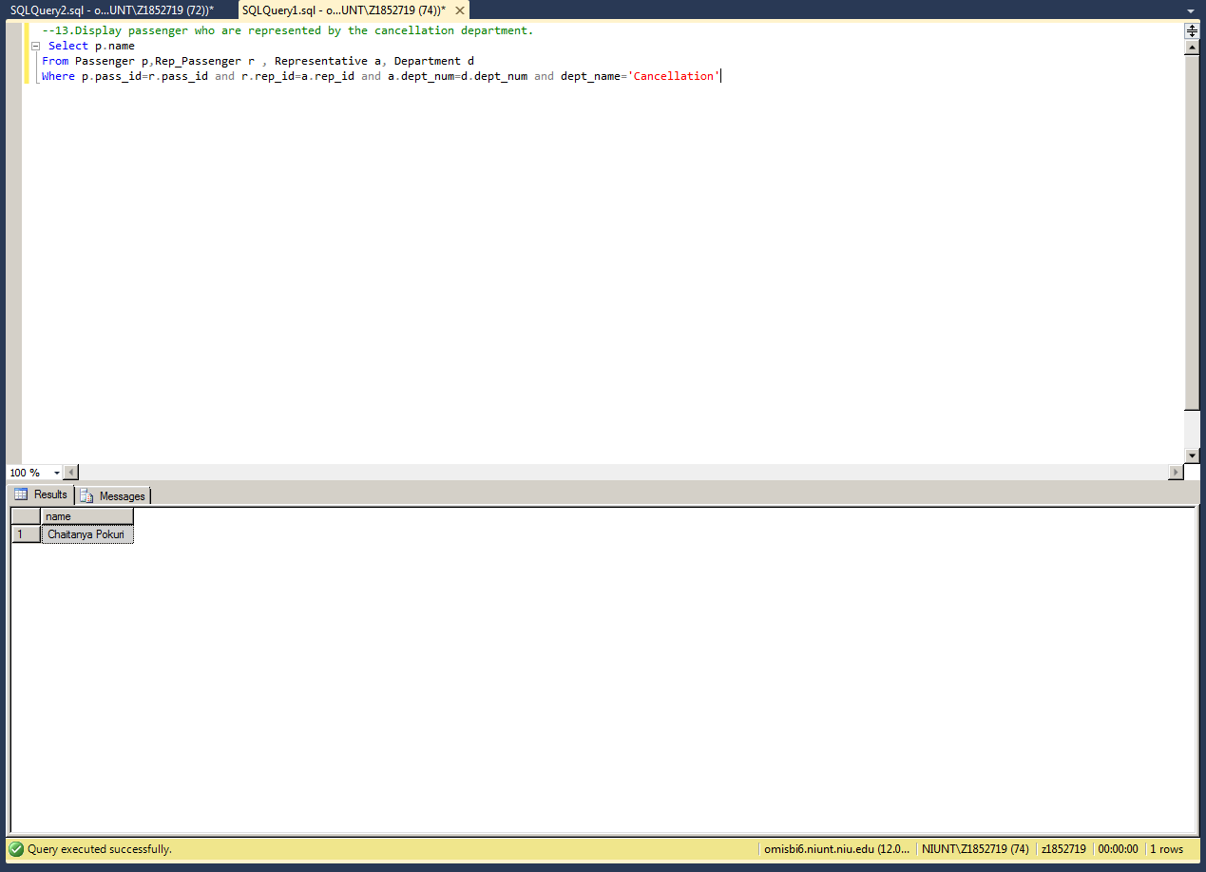

**14.**

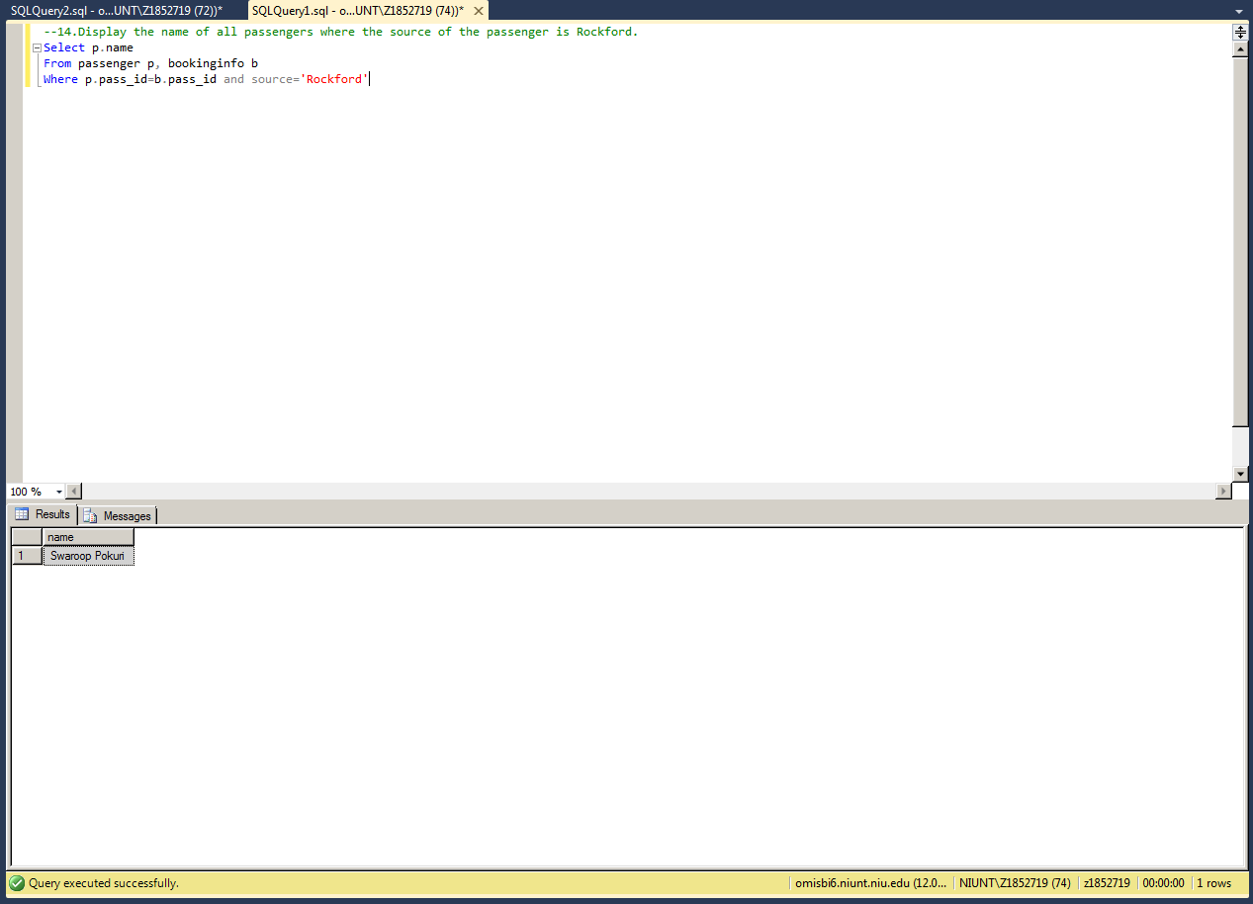

**15.**

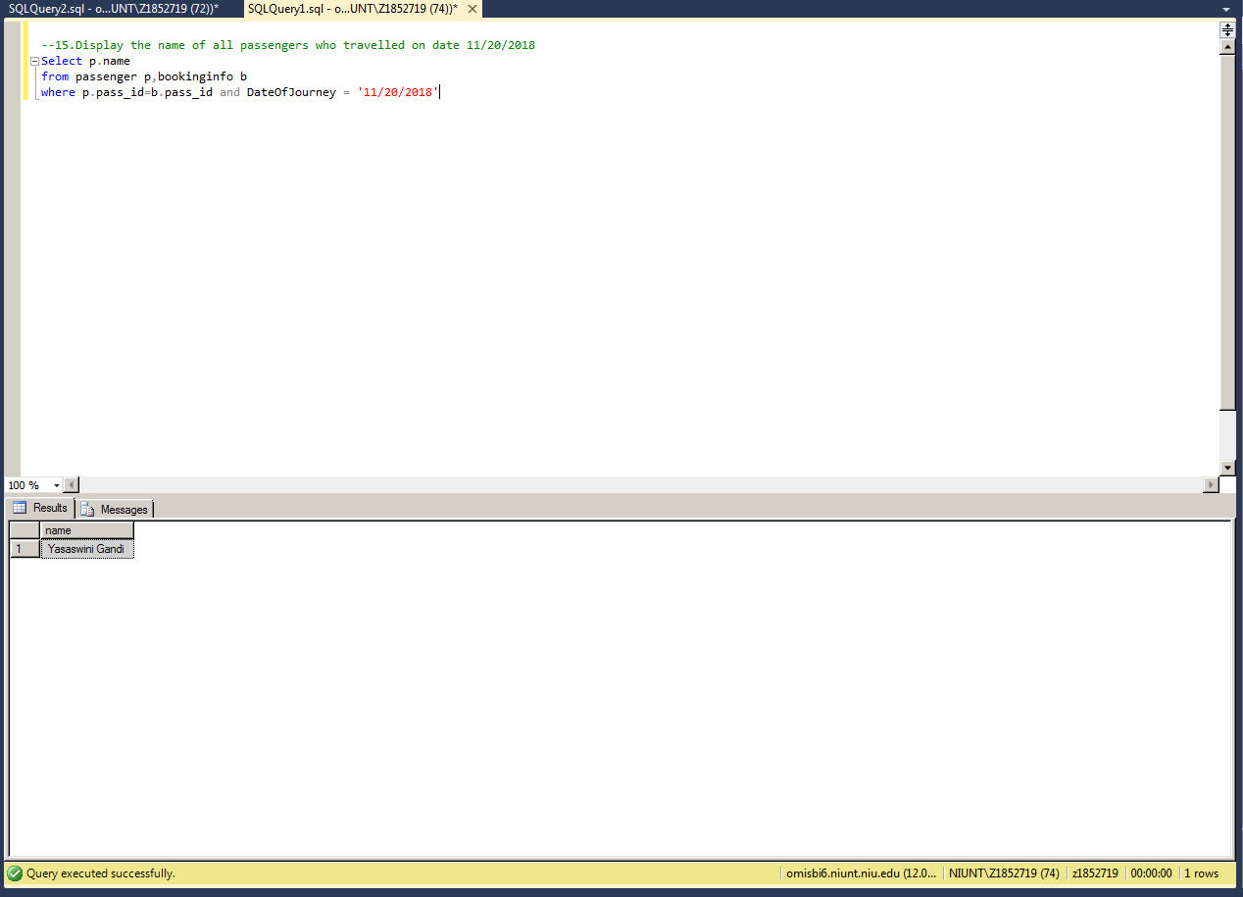

**16.**

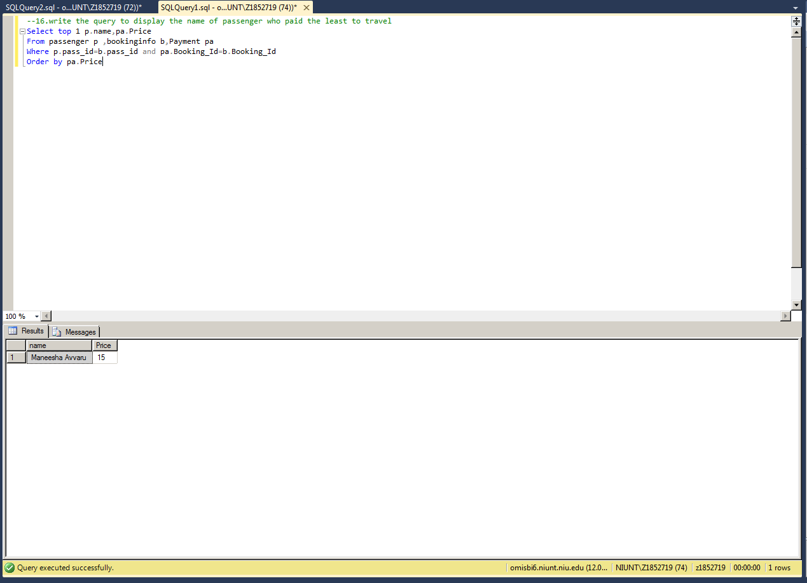

**17.**

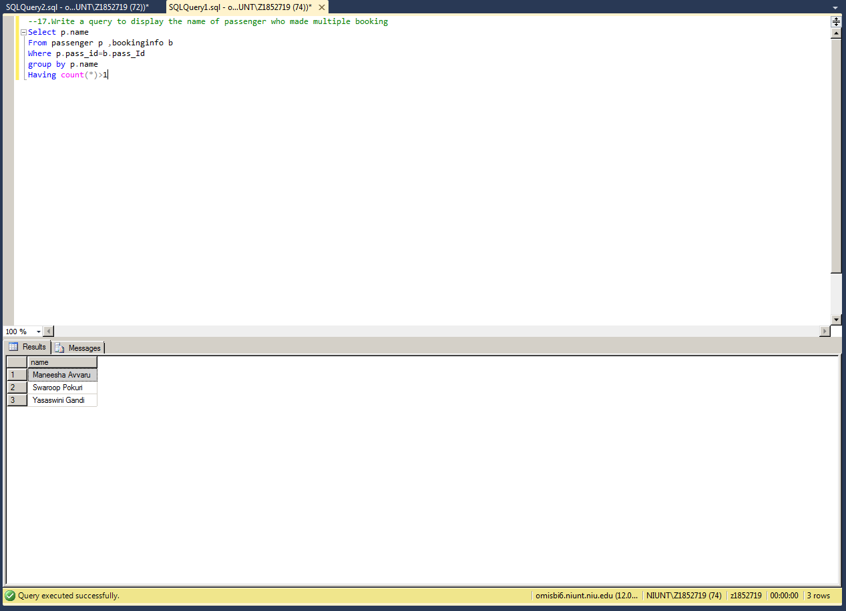

**18.**

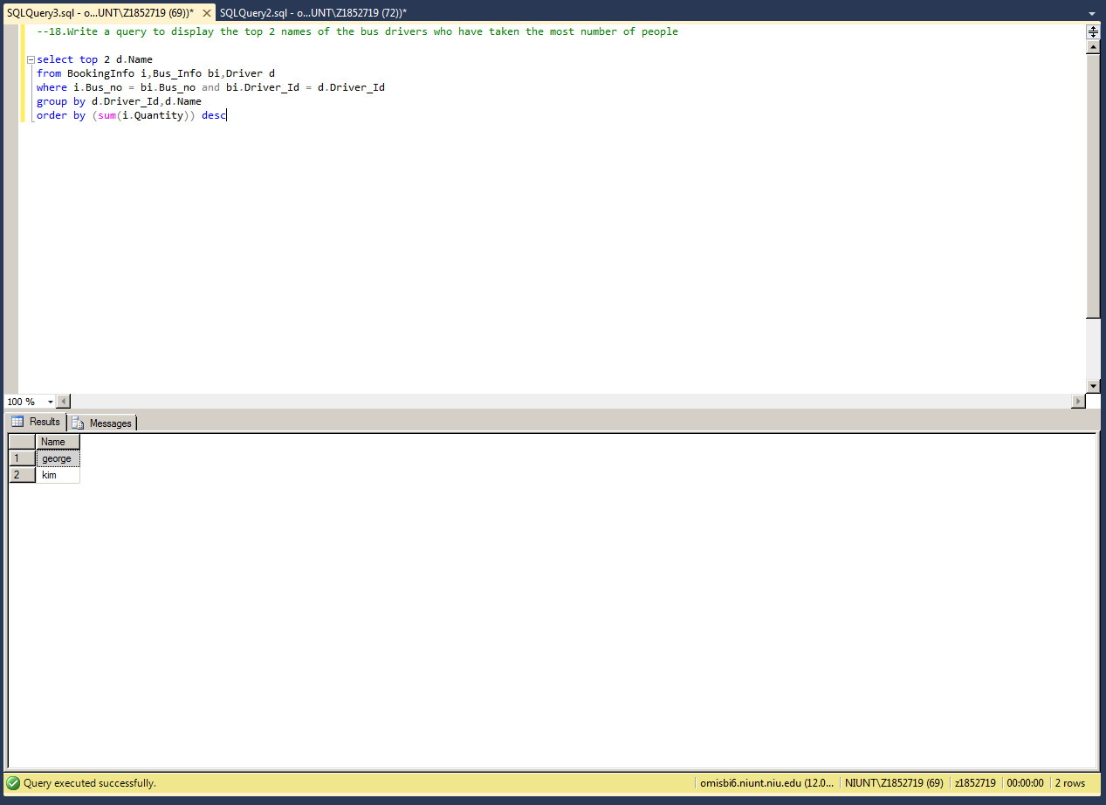

**19.**

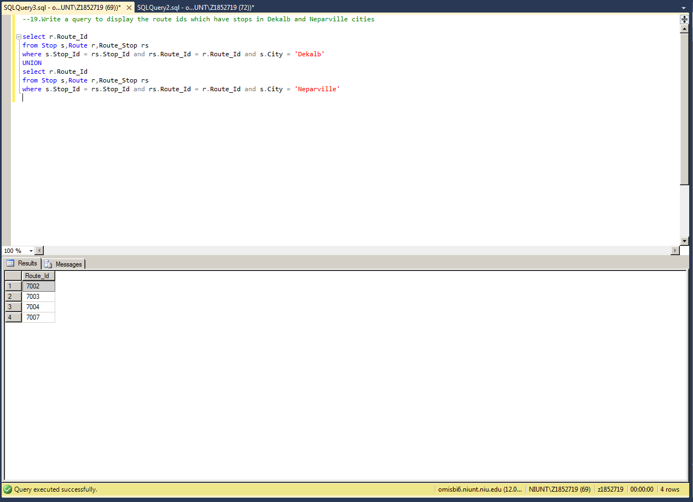

**20.**

