**PROJECT REPORT**

**ON**

**Student Employment Portal**

**version 2.0**



**By**

**Group 2**

**Project Team Members**

Yasaswani Gandi (Z1852719)

Chaitanya Swaroop Pokuri (Z1853880)

Venkata VijayBhaskar Bommakanti (Z1869592)

Chizoba Ohalete (Z1856424)

 Submitted in partial fulfillment of the course

**OMIS 651 – Business Systems Analysis and Design** 

**Professor: Dr. Onkar Malgonde**

Department of Operations Management and Information Systems

Northern Illinois University

  December 2019

**Table of Contents**

**Page**

* Summary ……………………………………………………………………………………………….. 1
* Introduction to current system and challenges ………………………………………. 1
* Proposed solution ………………………………………………………………………………….. 2
* Software development approach …………………………………………………………… 4
* Requirements ………………………………………………………………………………………… 4
* Use cases ……………………………………………………………………………………………….. 5
* System acquisition strategy ……………………………………………………………………. 10
* UML diagrams ………………………………………………………………………………………… 11
* UI designs ………………………………………………………………………………………………. 14
* Test plan ………………………………………………………………………………………………… 19
* Test cases ………………………………………………………………………………………………. 20
* Transition strategy …………………………………………………………………………………. 22

**SUMMARY**

Northern Illinois University (NIU) is a public research university in the state of Illinois, founded in 1895. The university provides quality education to over 25,000 students, both local and international, through its various colleges. The school also provides students with job opportunities to improve their earnings, which can be used to supplement their finances. The vacancies are posted on the NIU Student employment portal, a website where students will find a variety of opportunities ranging from faculty positions and administrative and professional jobs for on-campus employment and extra help positions, and through which students can apply for their desired jobs.

Jobs are posted by any department affiliated with NIU and with their specific experience and skill requirements to further aid in a student’s decision on which job(s) to apply for. A review of the portal revealed some drawbacks that will not intelligently guide a student’s job search and/or application. This project aims at improving the observed drawbacks, thus making a student’s search for jobs a satisfying experience.

**INTRODUCTION TO CURRENT SYSTEM AND CHALLENGES**

The student employment portal can be accessed through this link: <https://jobs.niu.edu/ServiceAreas/StudentEmployment/JobSearch.cfm>. The layout is clean and free from clutter and has a simple interface, which makes it easy for any student to navigate and interact with the website with minimal effort. The site’s contents easily allow users to be aware of the information that can be obtained if they click on any resource tab or link, while the overall aesthetics reflect the black/red colors of Northern Illinois University without being overwhelming.

Based on the information obtained at the requirements gathering stage, the underlying challenges with the website laid with the lack of features needed to enhance the overall quality and efficiency of students’ interaction with respect to job search, update of information and application while the employers had a common issue with multiple application and inability to remove the job posts from the website. The following are the most common challenges assessed from the interviews and observation:

1. Currently, on clicking the “Apply” button for a job position, the function will directly submit the student’s application without asking for any confirmation, thereby not giving the student the opportunity to make any necessary changes needed before submitting.
2. The job portal allows multiple applications for the same job. This allows for inefficiency in the system as it leaves employers receiving multiple applications for a particular job position from the same student.
3. The portal has no option to upload a Resume. This does not give the applicant the opportunity to present detailed background information that could in turn aid the employer in making an informed decision, especially with jobs that require some form of technical experience or special skill set.
4. Currently, the configuration of the scheduling section makes it a tedious process for students to provide their availability in the portal.
5. Currently, the landing page of the job site shows all the jobs posted in no pre-defined order. A student applicant is thus forced to scroll through each of the jobs shown before arriving at the preferred job. This is a time-consuming process.
6. Some jobs remain on the portal months after the deadline for submission and due dates for work assumption is passed, in some cases, over 12 months. This comes with its set of problems, as employers will still be beset with the unwelcome distraction of receiving job applications for positions that have long be filled.

**PROPOSED SOLUTIONS**

After a review of the challenges, the recommendations below are proposed for the upgrade of the website. The overall goal is to aid in time management of students when searching for and/or applying for jobs, eliminate the redundancy of multiple job applications received by employers, ensure a quality database of information for jobs for future analysis, and provide a more satisfying browsing experience by students in the use of the job site. The proposed solutions are as follows:

1. Upon clicking the “Apply” button, rather than directly submitting the application, the student will be directed to a new webpage that will allow the student’s skills to be filled for every job position available in the website.
2. To address the issue of multiplicity of applications for a single job position, the website will be constructed such that the student will be notified via a pop-up message that the job has already been applied for whenever the student is trying to reapply for the same position, and asks if the student would like to update the current application. Updating the current application will not lead to an additional application but will be an amendment to the already existing application.
3. A new tab labelled, “Documents” will be introduced, where a student could go to upload and save his/her résumé and any important document relevant to the job applications.
4. Instead of the current configuration for scheduling availability, which is quite tedious, this proposal seeks to redesign the scheduling section such that all the days of the week are shown at a single glance and the student will have the ease of selecting the available time from the dropdown menu for each day. In a situation where a student will require more than one available time band for a single day, the option to add multiple time slots will be provided. Once this is done, a single click on the submit button will create the availability.
5. To reduce the lengthy time spent on scrolling through all the posted jobs, the site will be upgraded to allow for filtering by the student based on “Position Type” with additional filtering option of “Sort by”. This allows the student to quickly narrow down the search criteria thus improving the student’s time management.

There will be no changes made to the overall aesthetics of the job portal. This will remain the same in line with NIU’s website policy of ensuring that all websites affiliated with NIU have the same theme and color scheme.

**SOFTWARE DEVELOPMENT APPROACH**

Agile methodology is best suited software development approach for this project instead of plan-driven approach. The approach to agile development is quite different from that of the waterfall. It is free, flexible and necessary to adjust expectations. Agile methodology encourages external input along the way, influencing the final outcome, allows adjustment during the development cycle, using a cooperative, team-driven strategy.

Since the features are small and team size is small, using agile the developed features can be tested simultaneously and are made available. If there are any breaks, they can be fixed in the next sprint release and by this way we can avoid the major risk of system failure.

**REQUIREMENTS GATHERING**

Before embarking on the project, the project team needed to determine the requirements for the proposed upgrade to the job portal. The information obtained formed the basis for the analysis of the requirements for the job portal, the areas for process improvement, process reengineering and the project scope.

The project team employed a dual system of interviews and observations to obtain the requirements. Each of the project team member was assigned the responsibility of interviewing 10 members of the users of the portal, comprising of eight students and two employers. This made a total of 40 people interviewed comprising of 32 students and eight employers as conducted by the 4-member project team.

In addition to the interviews, the team also conducted observations with at least one of the interviewed students and joint observation among the team members in the use of the site. The challenges presented were diverse, such as, the need for more colourful aesthetics, allowance to update details, obsolete job posts et al. The project team narrowed down the challenges to the top six most mentioned challenges among the respondents and this was the basis for the proposed upgrade to the website.

**USE CASES**

**Use Case 1: Applying for the Job**

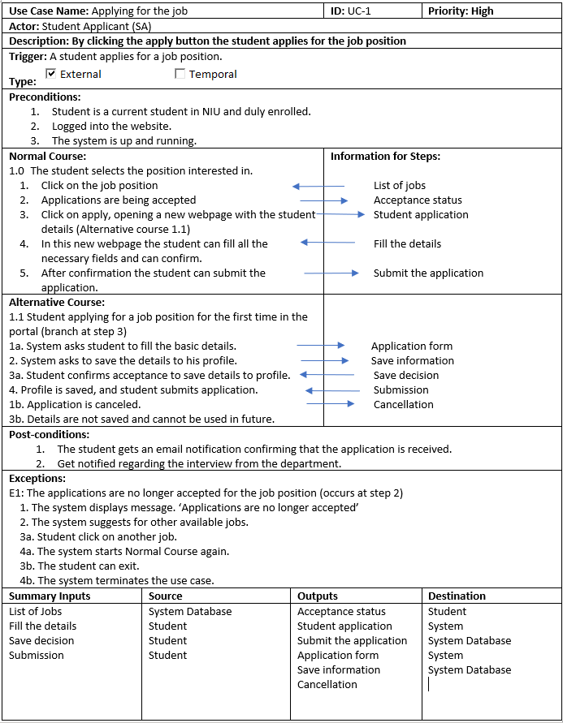

**Use Case 2: Re-apply for a Job Position**

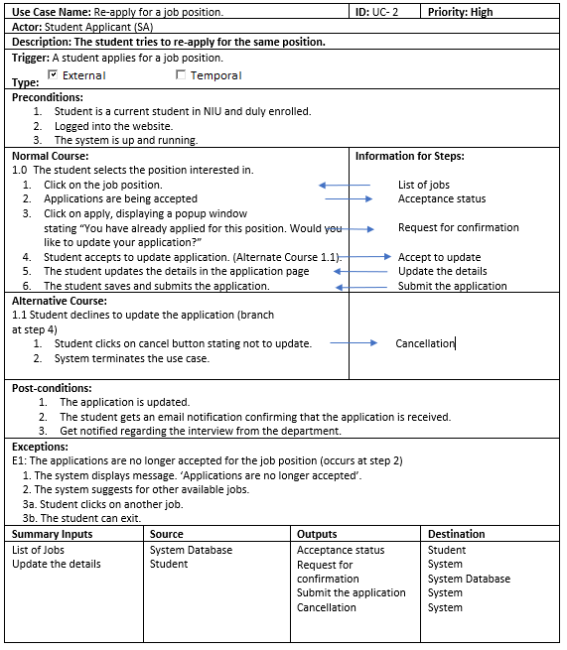

**Use Case 3: Upload in “My Documents”**

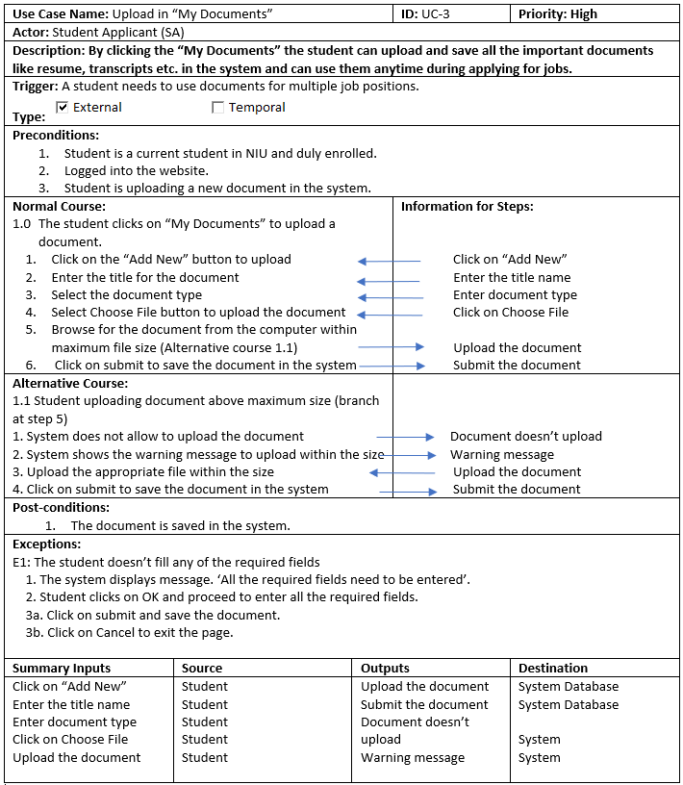

**Use Case 4: Scheduling Availability**

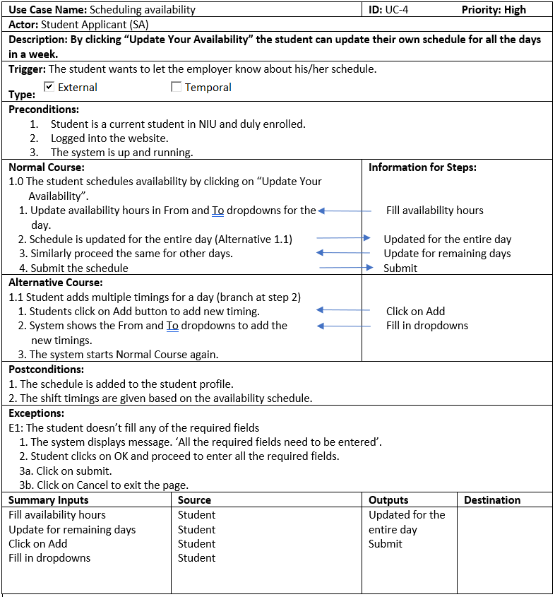

**Use Case 5: Search Using Filter**

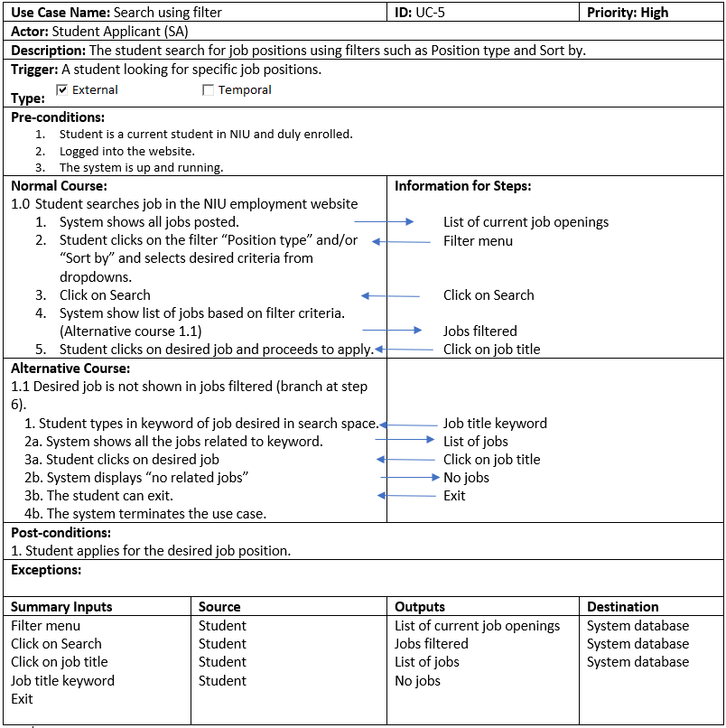

**SYSTEM ACQUISITION STRATEGY**

In deciding the system acquisition strategy to adopt for this project, several factors were considered bordering on the scope of the project, schedule and cost. This project does not require building a website from the scratch and the upgrades required are not highly specialized. It is not a time sensitive project and there is a need to work within the IT budget hence reducing costs to the bare minimum is necessary. Given all these considerations, the appropriate strategy decided on is for in-house custom development, which is the best fit to fulfil all the requirements of the project management. This strategy is implemented along the whole project life cycle. The objectives for selecting this strategy are as follows:

**Business Strategy**

Since the NIU student portal is an existing system and our scope is to implement some of the features to improve the efficiency of students’ interaction with the website, consulting the NIU IT Team is a better idea than hiring an external vendor or installing an external software to build the system. Furthermore, adopting this approach will aid in developing the technical experience of the in-house team.

**Data privacy**

Given that the business requirement is unique and is bound to NIU, it is the responsibility of NIU to secure the personal data of the students and ensure no leakages. In-house custom Development approach is the best fit here.

**Faster Communication**

As NIU IT Team have already built the NIU student employment portal, it would be easy to communicate the requirements to the team and to obtain feedback quickly.

**Cost and time management**

It will be more cost-effective to upgrade the system in-house rather than purchasing an external software, since the website requires upgrades in specific areas rather than a total overhaul of the job site. Additionally, the NIU IT Team having built the system from the scratch will have better understanding of the codes needed to upgrade the system. Bugs will be faster to fix and changes. This saves costs in buying a pre-packaged software and installing it to the system, which will come with its attendant challenges. This also gives the flexibility the development team needs to use these costs in training the employees on the newer technologies needed to build the website.

**USE CASE DIAGRAM**

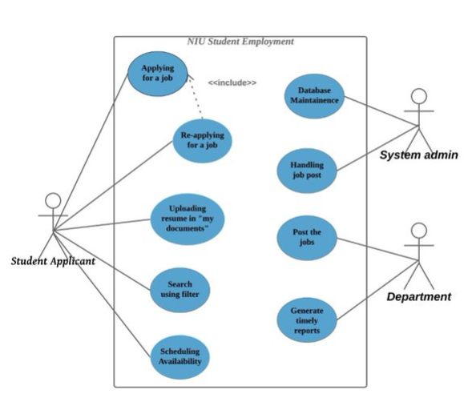

**CLASS DIAGRAM**

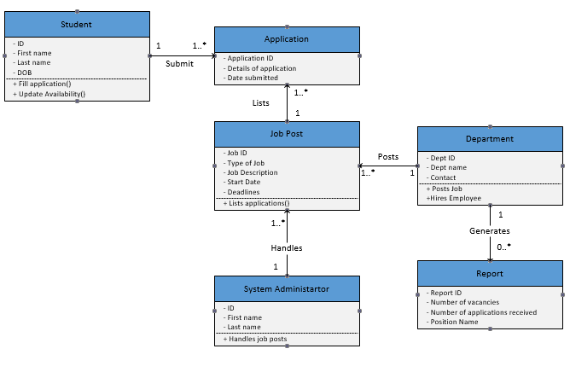

**SEQUENCE DIAGRAM – SEARCH USING FILTER USE CASE**

**A screenshot of a social media post

Description generated with very high confidence**

**STATE MACHINE DIAGRAM – STUDENT CLASS**

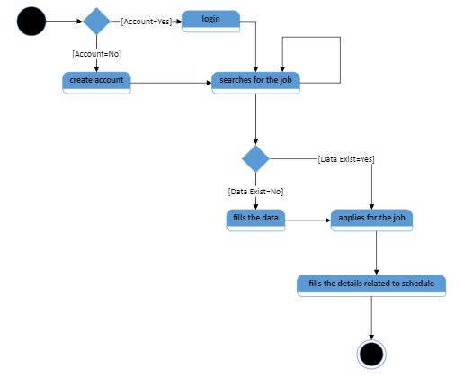

**STATE MACHINE DIAGRAM – JOB POST**

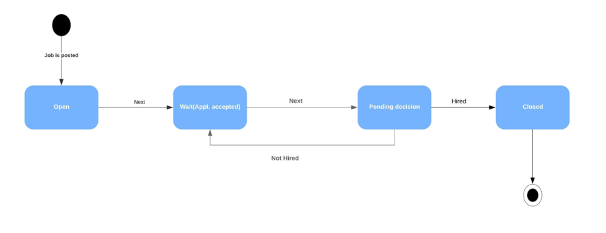

**USER INTERFACE DESIGNS**

**User Interface for Use Case 1: Applying for the Job**

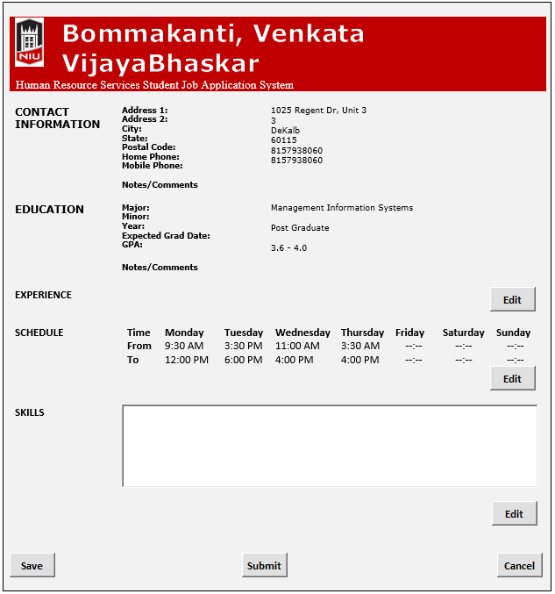

**User Interface for Use Case 2: Re-apply for a Job Position**

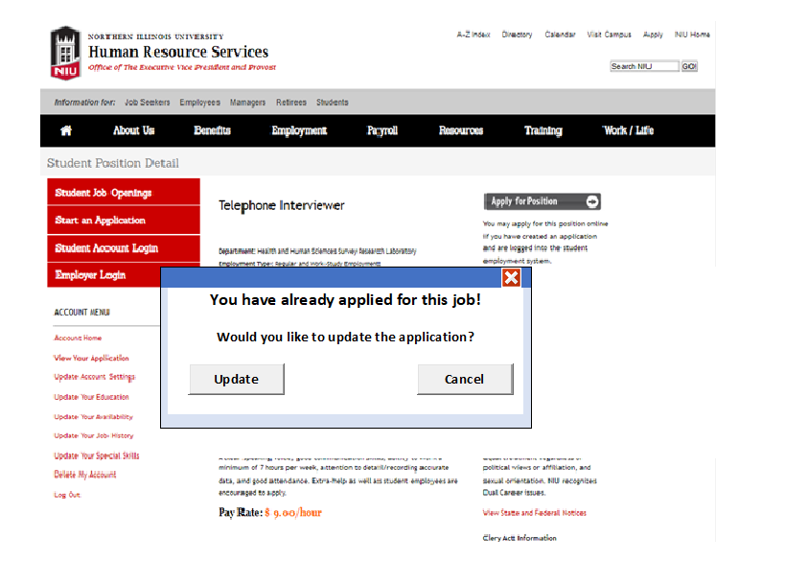

**User Interfaces for Use Case 3: Upload in “My Documents”**

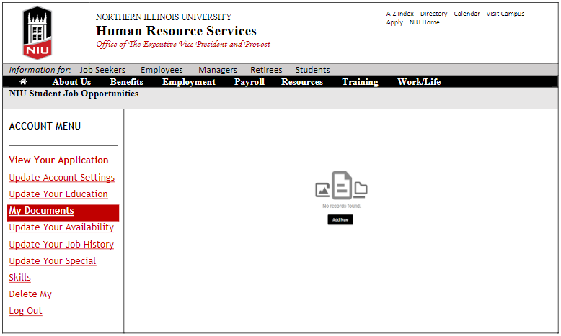

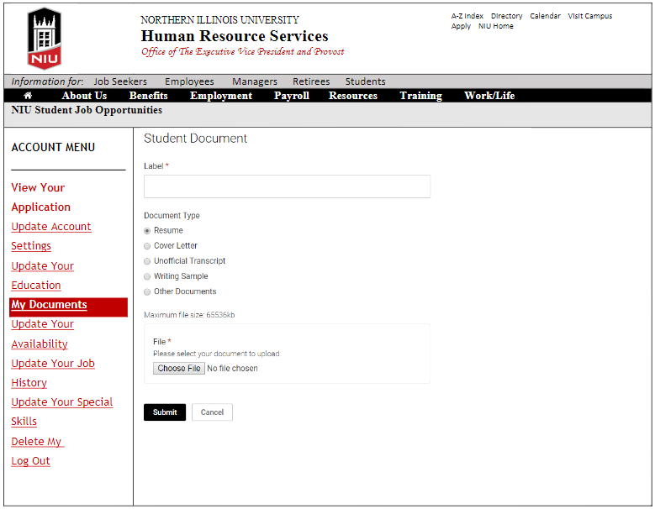

**User Interface for Use Case 4: Scheduling Availability**

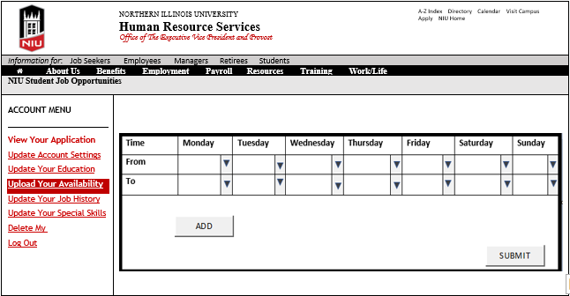

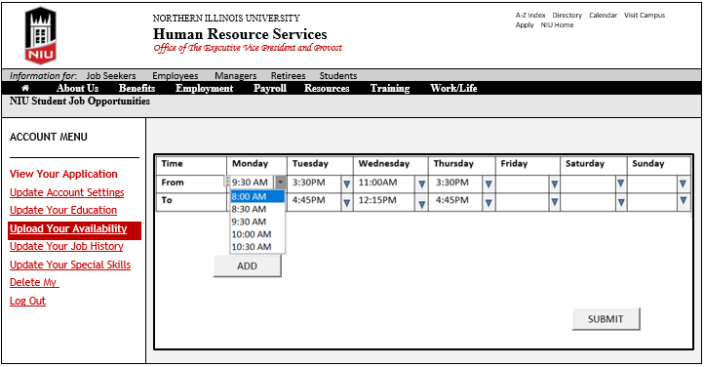

**User Interface for Use Case 5: Search Using Filter**

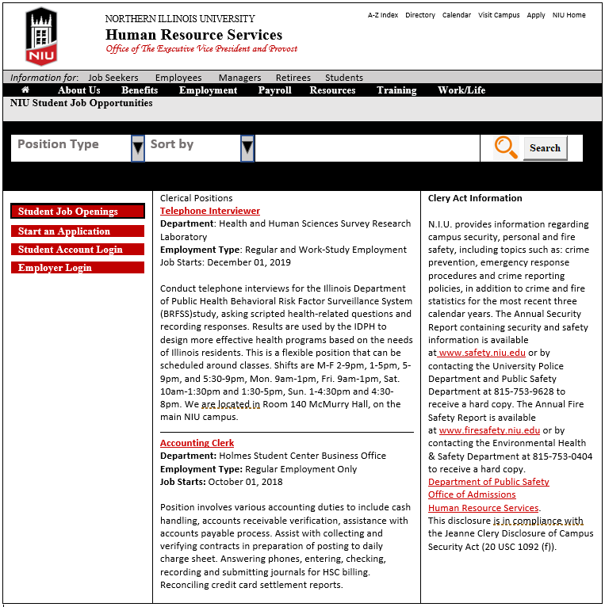

**TEST PLAN**

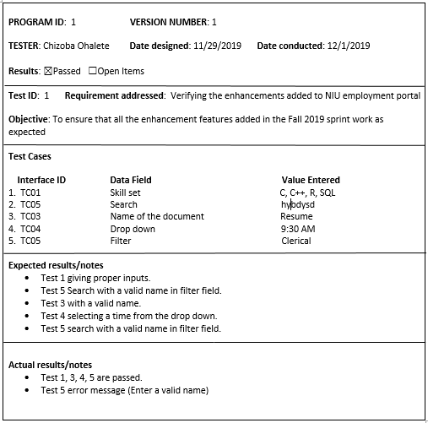

**TEST CASE 1**

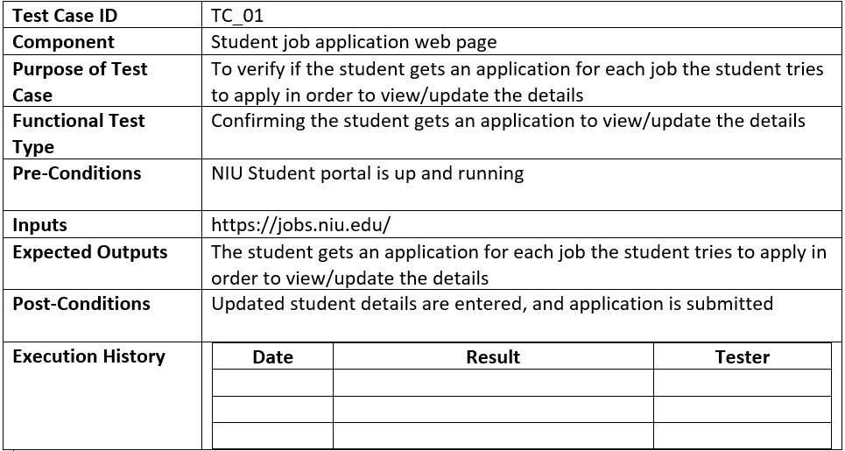

**TEST CASE 2**

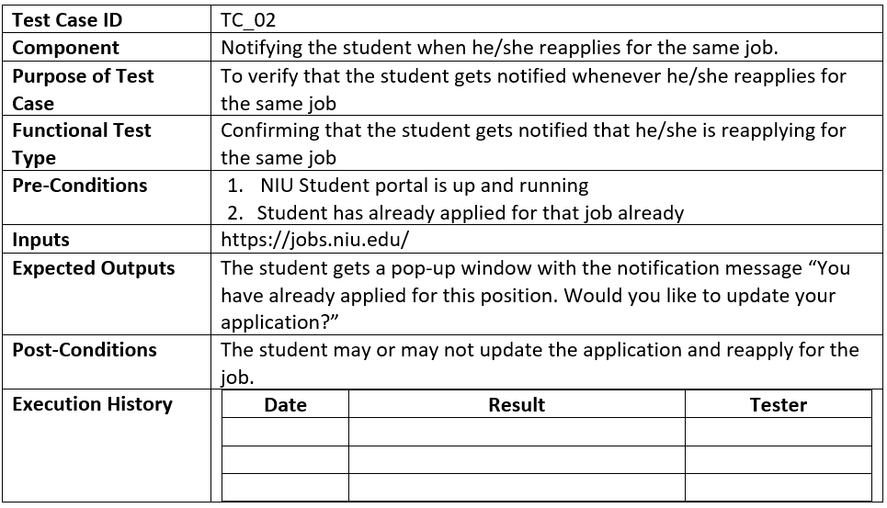

**TEST CASE 3**

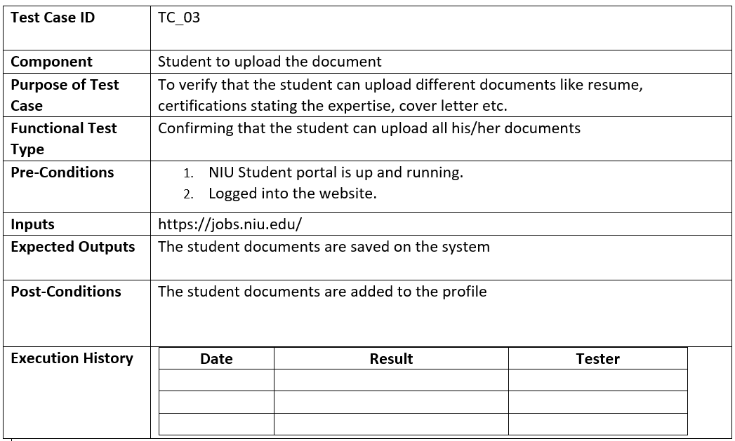

**TEST CASE 4**

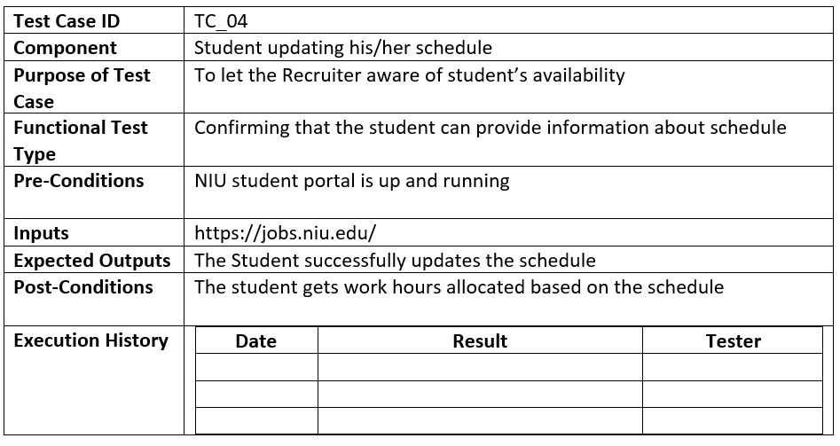

**TEST CASE 5**

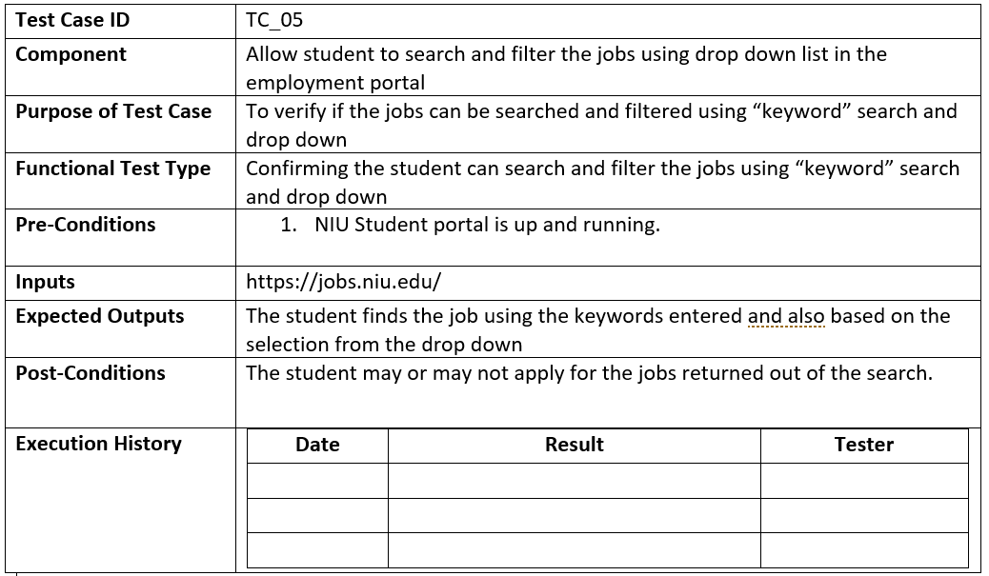

**TRANSITION STRATEGY**

1. We chose direct method as we don’t want the old system to be existed.
2. In addition to this, our changes do not cost much and will be changed in a short period of time.
3. We chose modular approach as we wanted to add each feature at a time.
4. And changes are made in a small scale environment ie only NIU website so we chose modular approach.