**Python**

**How to launch python?**

‘python’

**How to get python help?**

python -h

**How to get python version?**

python -V

**How to initialize variable?**

i = 0 or i = “Hello” or f = 1.0

**How to get data type of a variable?**

type(variable_name) gives its data type.

Eg: type(i)

<type 'int'>

**In python how to execute block of code?**

In regular programming languages we use { } brackets to place a block of code but in python we use indentation to achevie the same.

Eg:

i = 10

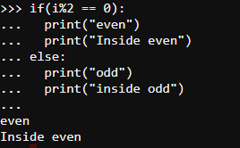

**Ternary operator in Python?**

Syntax: <expression1> if <condition> else <expression2>

Eg: print("even") if(I % 2 == 0) else print("odd")

**How to print between lower bound and upper bound using “for loop”?**

Eg:

lb = 0

ub = 100

for i in range(lb, ub+1): print(i)

**How to print even numbers?**

Eg:

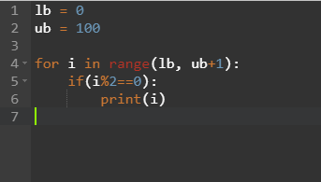

**How to print sum of even numbers?**

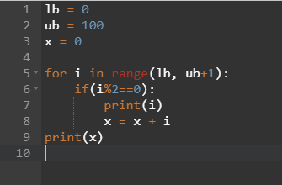

**How to get list of functions available for ‘string’?**

Command: **help(str)** will list all functions you can use to perform operations on strings

**How to get help for a particular function?**

Command: **help(str.lower)** will return syntax and usage of that function

Examples:

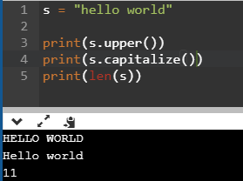

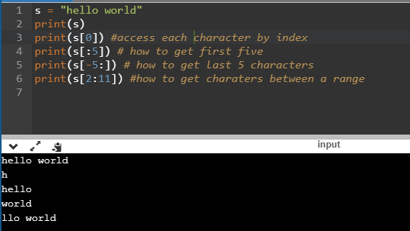

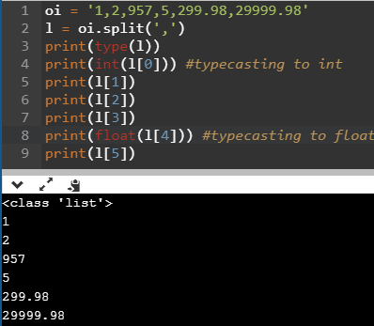

**User Defined Functions:**

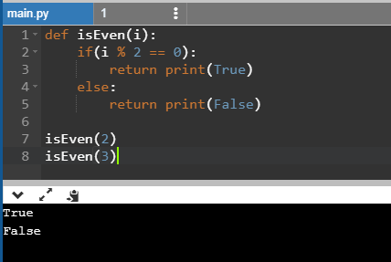

Function to print even numbers within a range of numbers:

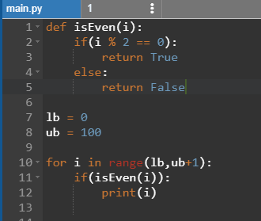

Function to add numbers given within a range:

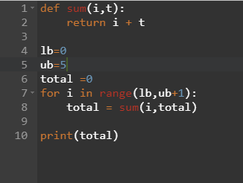

**Points to Remember:**

* All variables need to be initialized.
* All for loops or if conditions should end with colon (“ : “)
* In python you can represent string in single quote or double quote.