Create /Delete

Azure

Resource Group

Storage Accounts

V1

Create a Resource Group Azure CLI

PS C:\WINDOWS\system32>
PS C:\WINDOWS\system32> az group create --name RG_Test_Prod --location centralindia
{
"id": "/subscriptions/594ca230-6fcf-4aa3-81ac-5e4d3ec2027c/resourceGroups/RG_Test_Prod",
"location": "centralindia",
"managedBy": null,
"name": "RG_Test_Prod",
"properties": {
"provisioningState": "Succeeded"
},
"tags": null,
"type": "Microsoft.Resources/resourceGroups"
}
PS C:\WINDOWS\system32>
PS C:\WINDOWS\system32> az group list --output table
Name Location Status
------------ ------------ ---------
RG_Test_Prod centralindia Succeeded
PS C:\WINDOWS\system32>

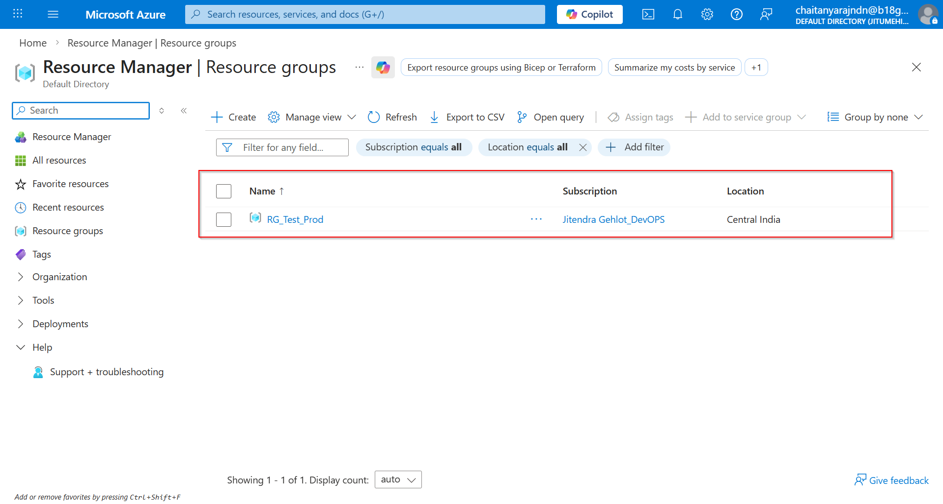

Delete Resource Group on AZURE CLI

PS C:\WINDOWS\system32>
PS C:\WINDOWS\system32> az group delete --name RG_Test_Prod --yes
PS C:\WINDOWS\system32>
PS C:\WINDOWS\system32> az group list --output table

PS C:\WINDOWS\system32>
PS C:\WINDOWS\system32>

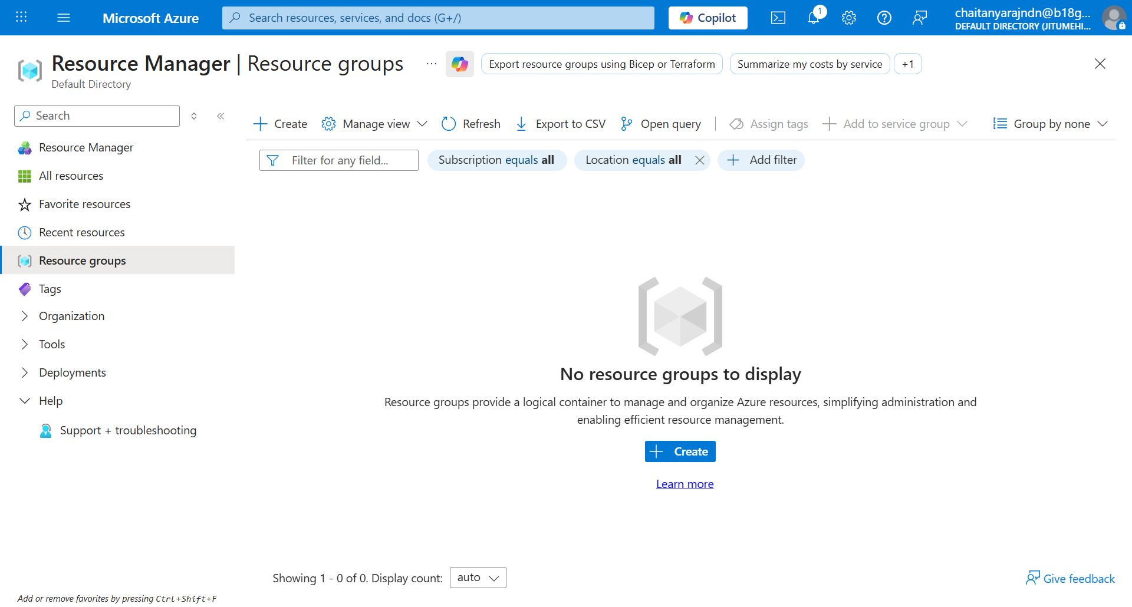

Create Resource Group on Azure Portal



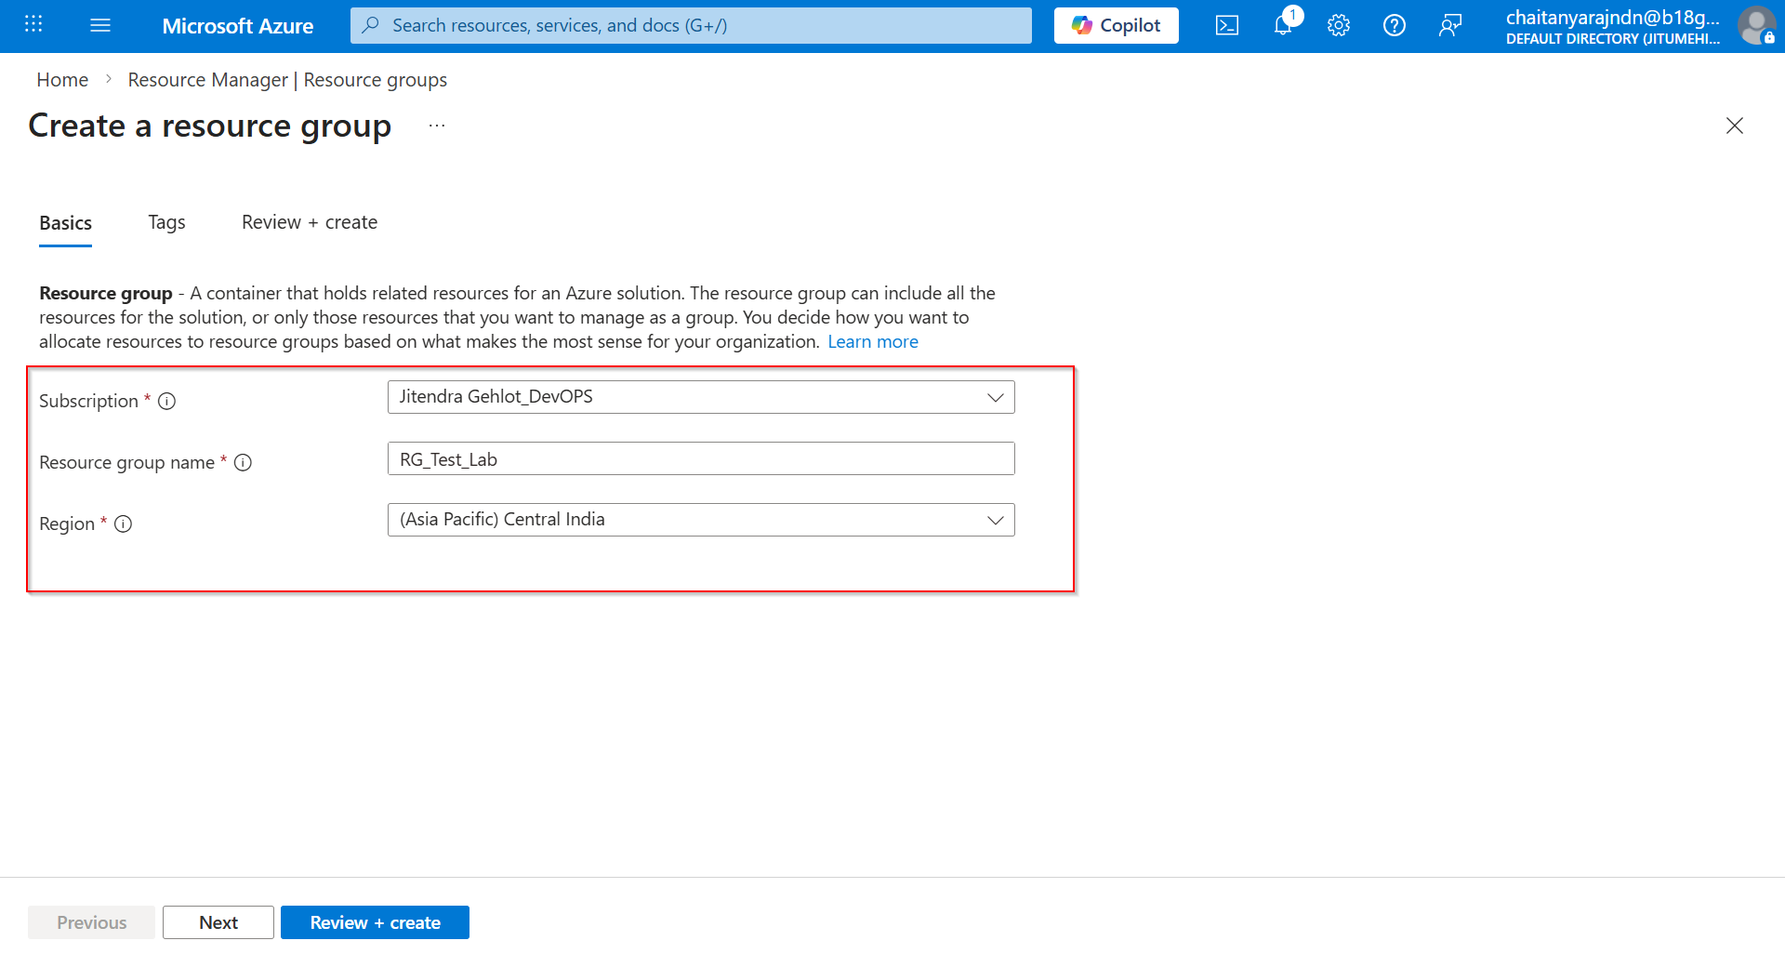

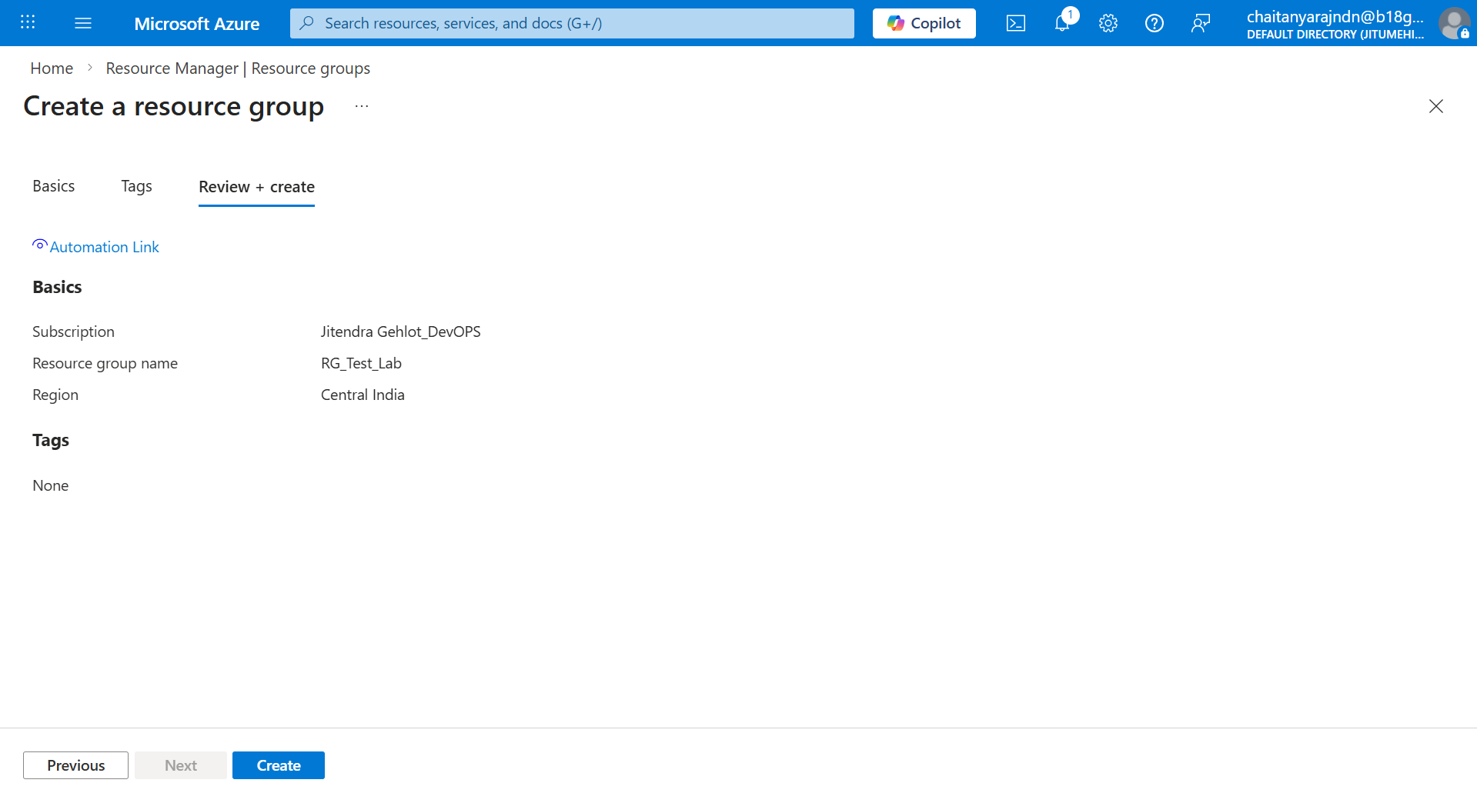

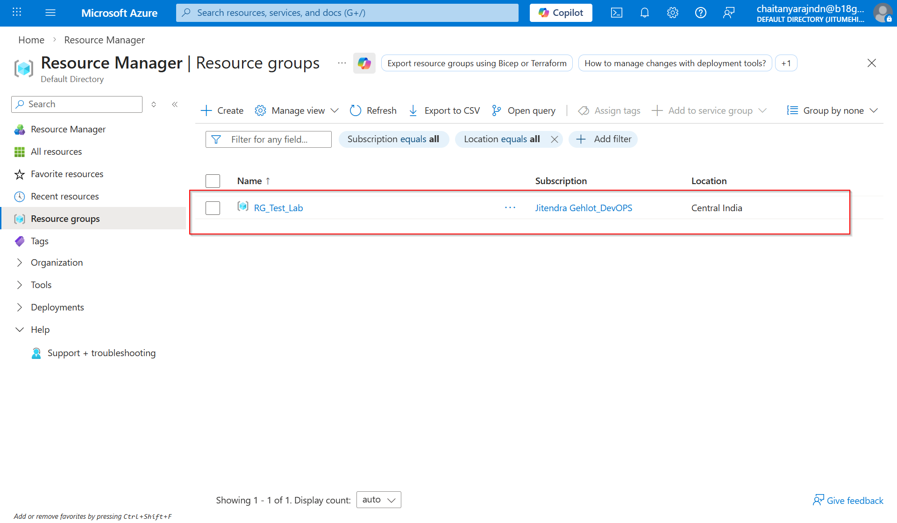

Verify on AZ CLI:

PS C:\WINDOWS\system32>
PS C:\WINDOWS\system32> az group list --output table
Name Location Status
----------- ------------ ---------
RG_Test_Lab centralindia Succeeded
PS C:\WINDOWS\system32>
PS C:\WINDOWS\system32>

Delete Resource Group on Azure Portal

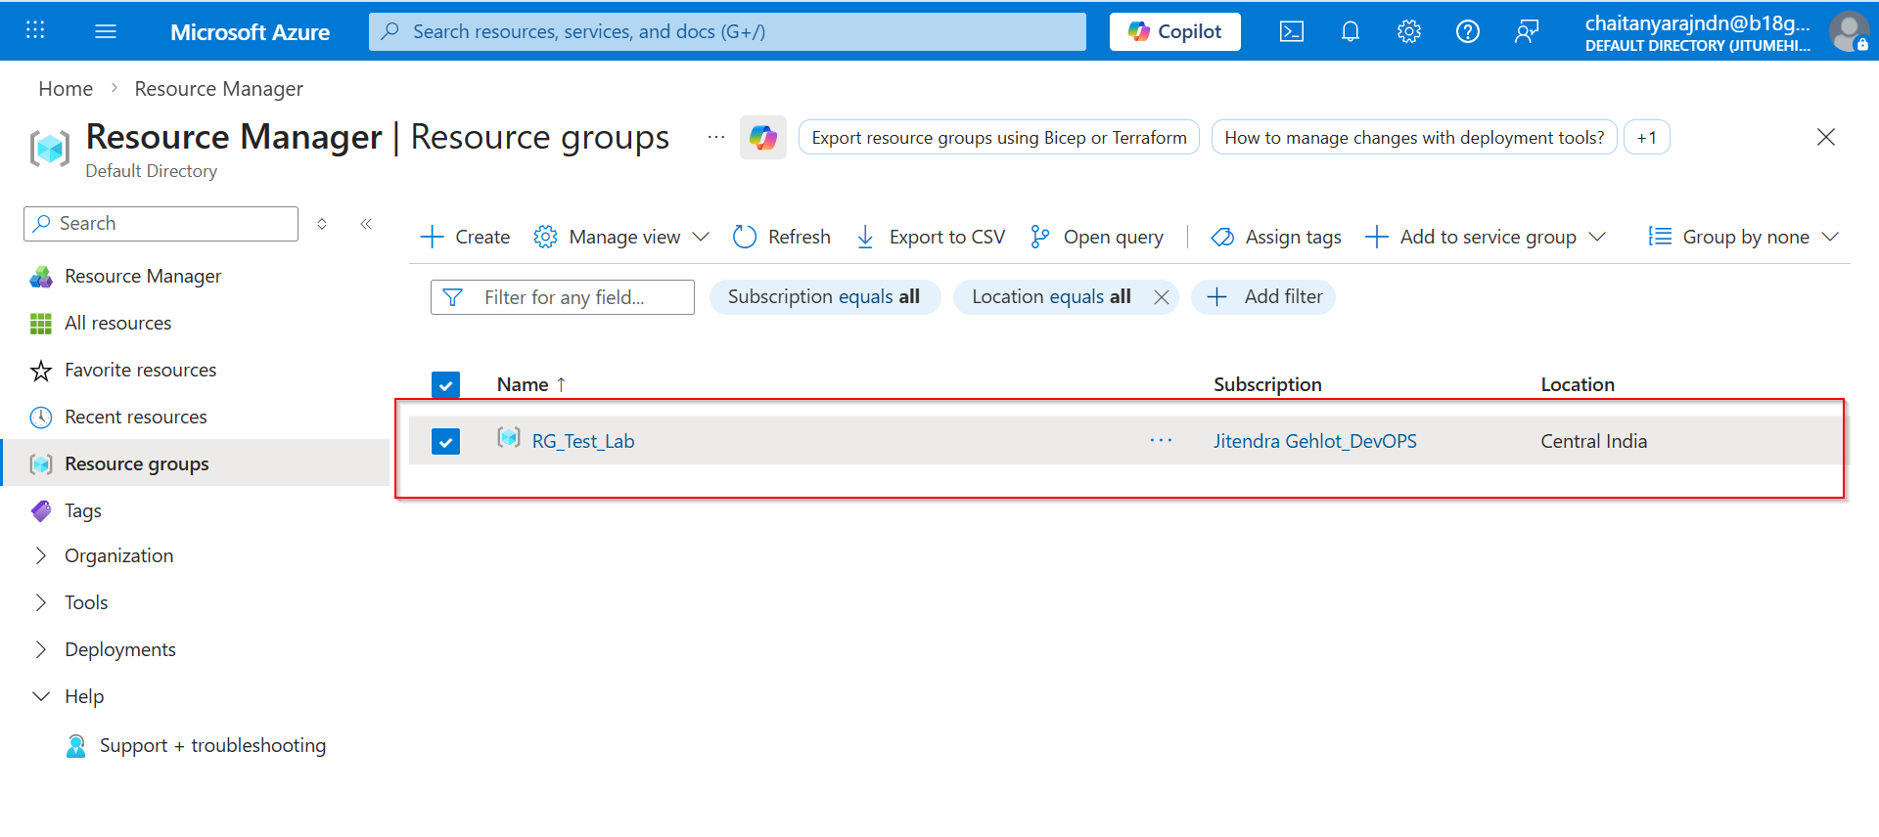

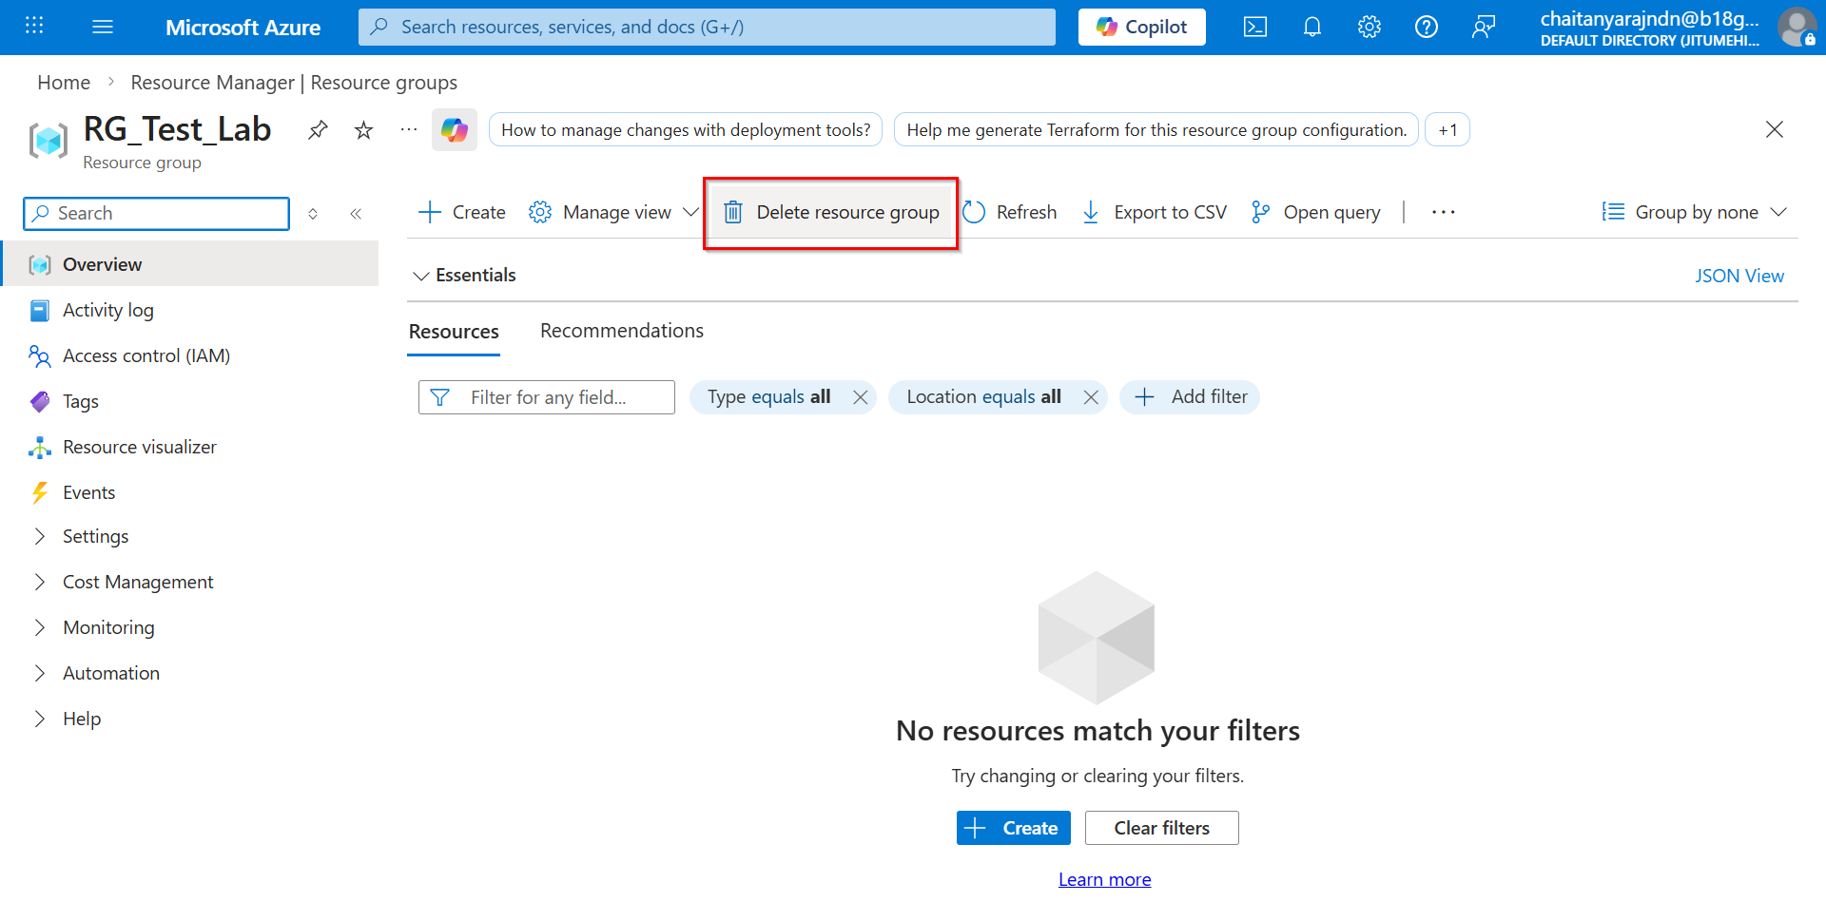

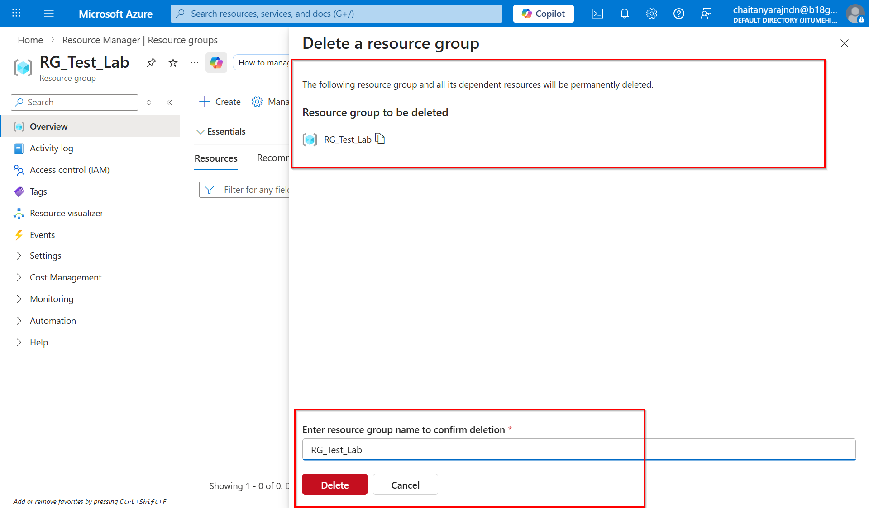

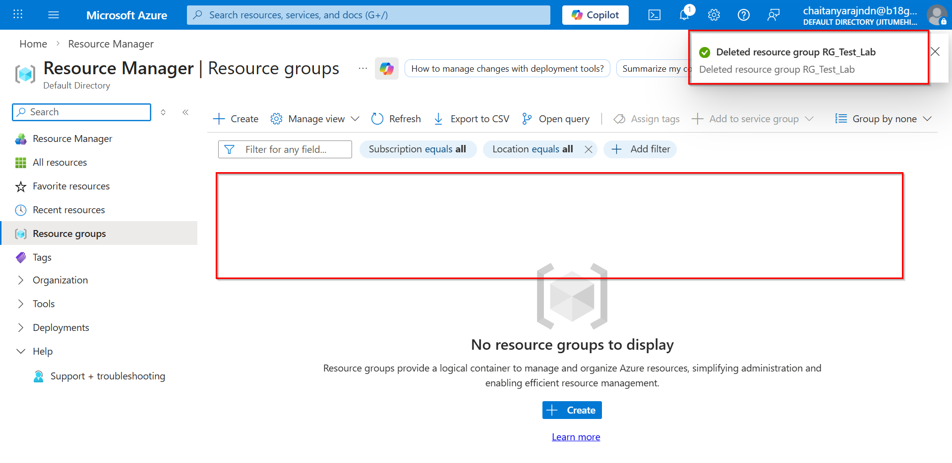

Check on AZ CLI:
==============
PS C:\WINDOWS\system32>
PS C:\WINDOWS\system32>
PS C:\WINDOWS\system32> az group list --output table
PS C:\WINDOWS\system32>

Create Storage Account on Azure CLI

Note: User must have already had Subscription Resource Group in order to create Storage Account. See screenshot below.

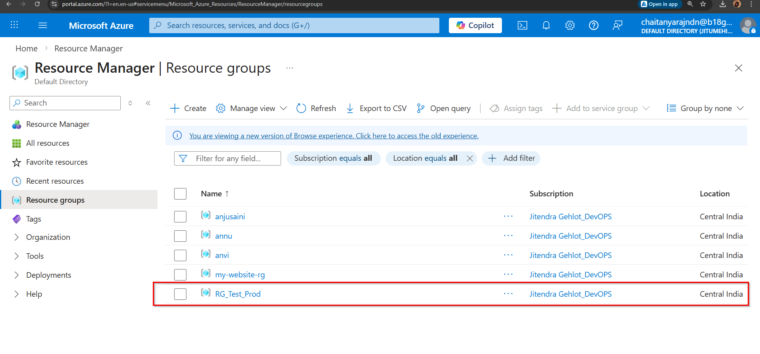

Delete Storage Account on Azure CLI

Create Storage Account on Azure Portal

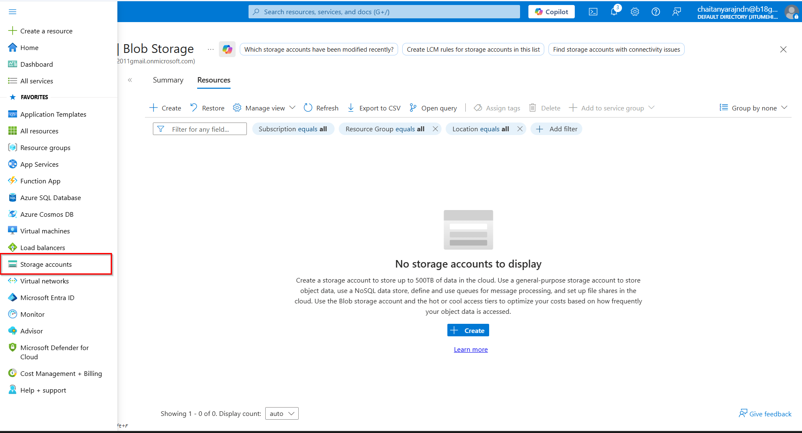

Delete Storage Account on Azure Portal

