CREATE / DELETE

AZURE RESOURCE GROUP & STORGAE ACCOUNTS

VIA GUI & CLI

V2

Table of Contents
2 Create a Resource Group Azure CLI 3
3 Delete Resource Group on AZURE CLI 4
4 Create Resource Group on Azure Portal 5
5 Delete Resource Group on Azure Portal 8
6 Create Storage Account on Azure CLI 10
7 Delete Storage Account on Azure CLI 11
8 Create Storage Account on Azure Portal 11
9 Delete Storage Account on Azure Portal 12

Create a Resource Group Azure CLI

PS C:\WINDOWS\system32>
PS C:\WINDOWS\system32> az group create --name RG_Test_Prod --location centralindia
{
"id": "/subscriptions/594ca230-6fcf-4aa3-81ac-5e4d3ec2027c/resourceGroups/RG_Test_Prod",
"location": "centralindia",
"managedBy": null,
"name": "RG_Test_Prod",
"properties": {
"provisioningState": "Succeeded"
},
"tags": null,
"type": "Microsoft.Resources/resourceGroups"
}
PS C:\WINDOWS\system32>
PS C:\WINDOWS\system32> az group list --output table
Name Location Status
------------ ------------ ---------
RG_Test_Prod centralindia Succeeded
PS C:\WINDOWS\system32>

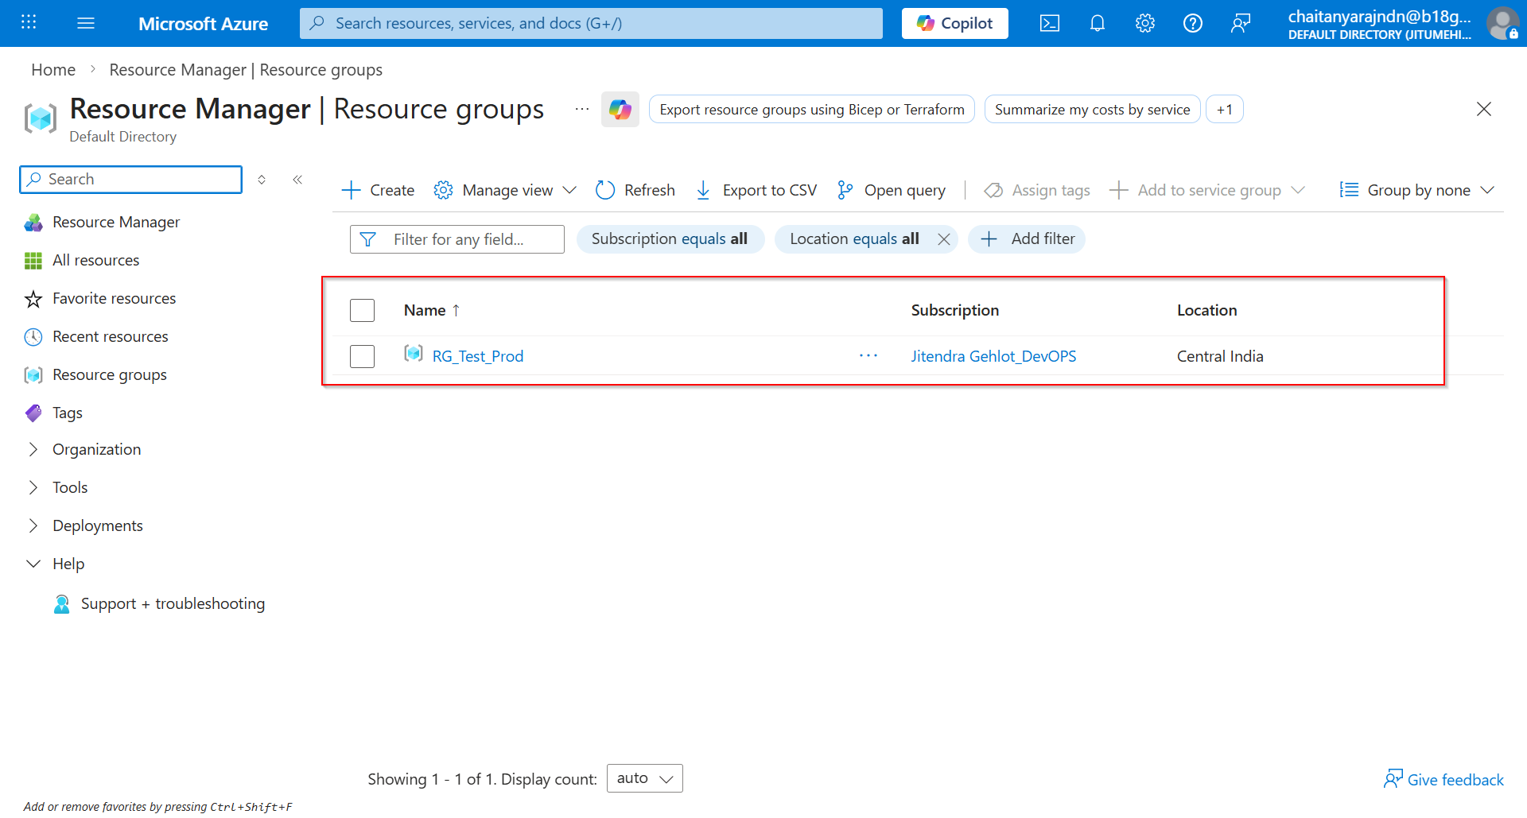

Delete Resource Group on AZURE CLI

PS C:\WINDOWS\system32>
PS C:\WINDOWS\system32> az group delete --name RG_Test_Prod --yes
PS C:\WINDOWS\system32>
PS C:\WINDOWS\system32> az group list --output table

PS C:\WINDOWS\system32>
PS C:\WINDOWS\system32>

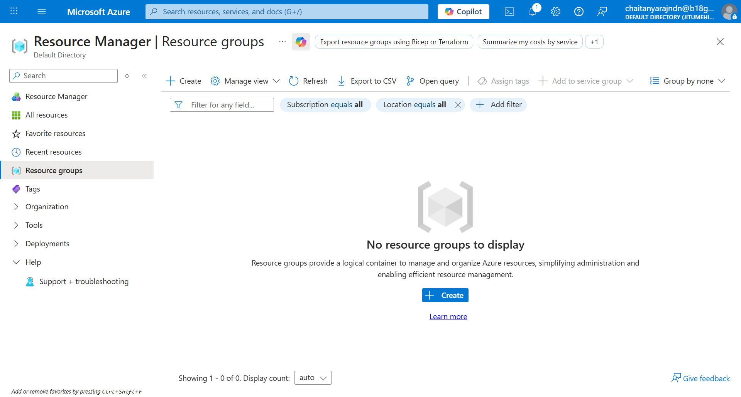

Create Resource Group on Azure Portal



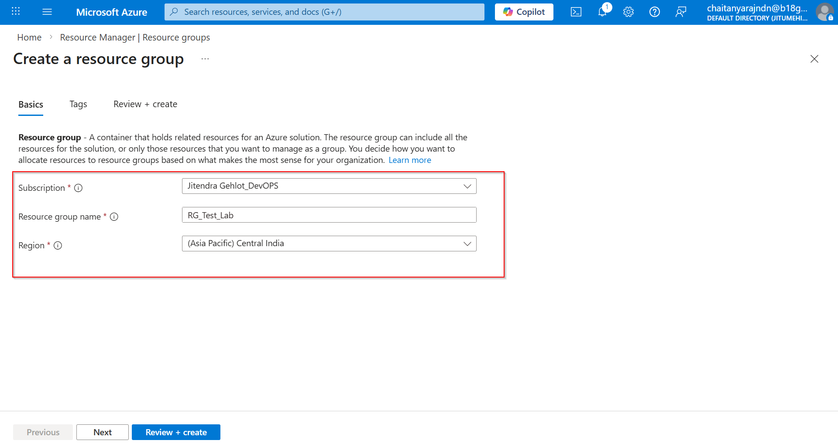

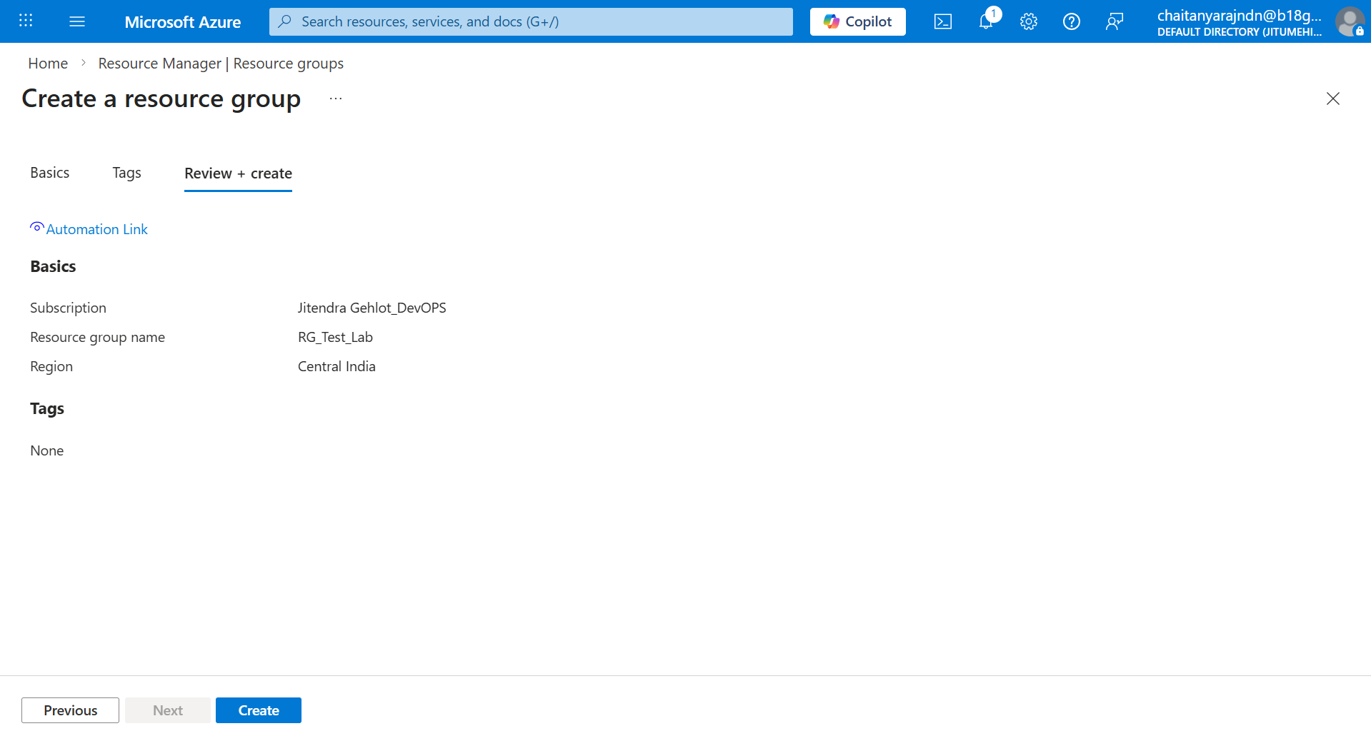

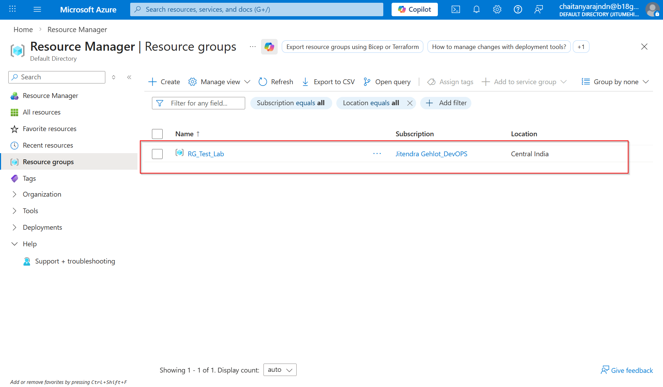

Verify on AZ CLI:

PS C:\WINDOWS\system32>
PS C:\WINDOWS\system32> az group list --output table
Name Location Status
----------- ------------ ---------
RG_Test_Lab centralindia Succeeded
PS C:\WINDOWS\system32>
PS C:\WINDOWS\system32>

Delete Resource Group on Azure Portal

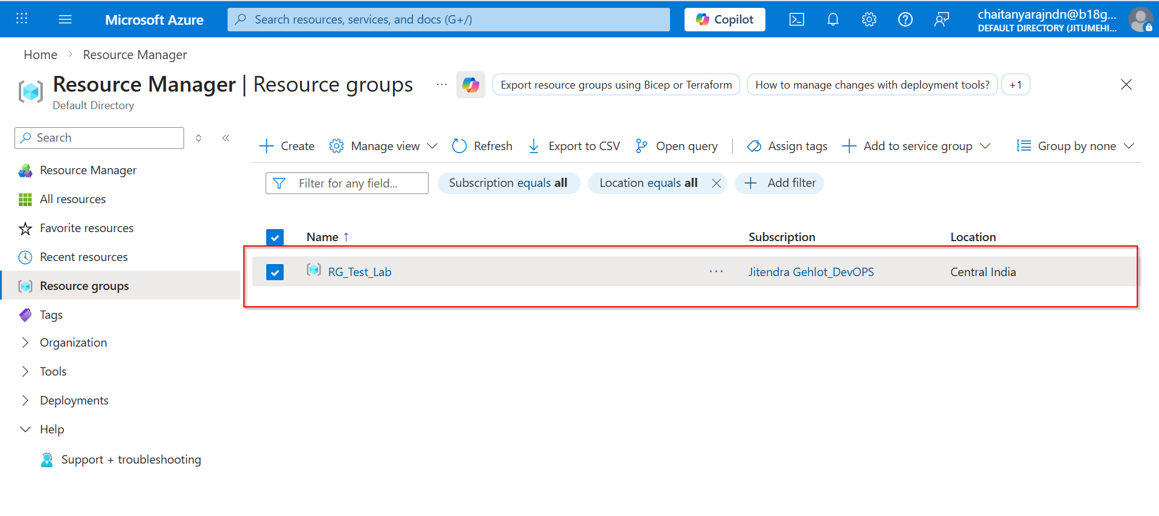

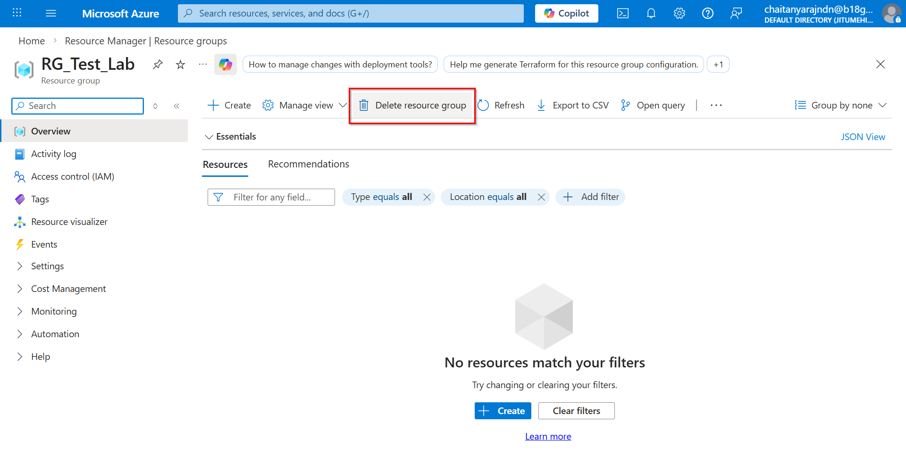

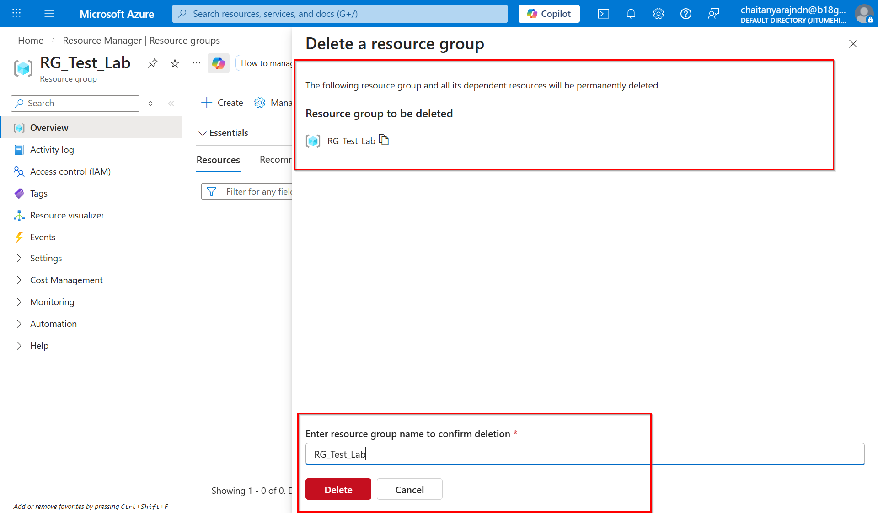

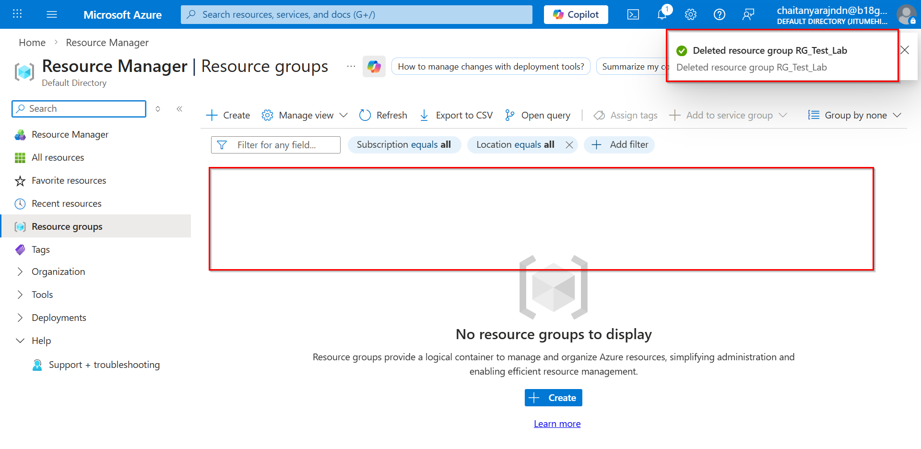

Check on AZ CLI:
==============
PS C:\WINDOWS\system32>
PS C:\WINDOWS\system32>
PS C:\WINDOWS\system32> az group list --output table
PS C:\WINDOWS\system32>

Create Storage Account on Azure CLI

Note: User must have already had Subscription Resource Group in order to create Storage Account. See screenshot below.

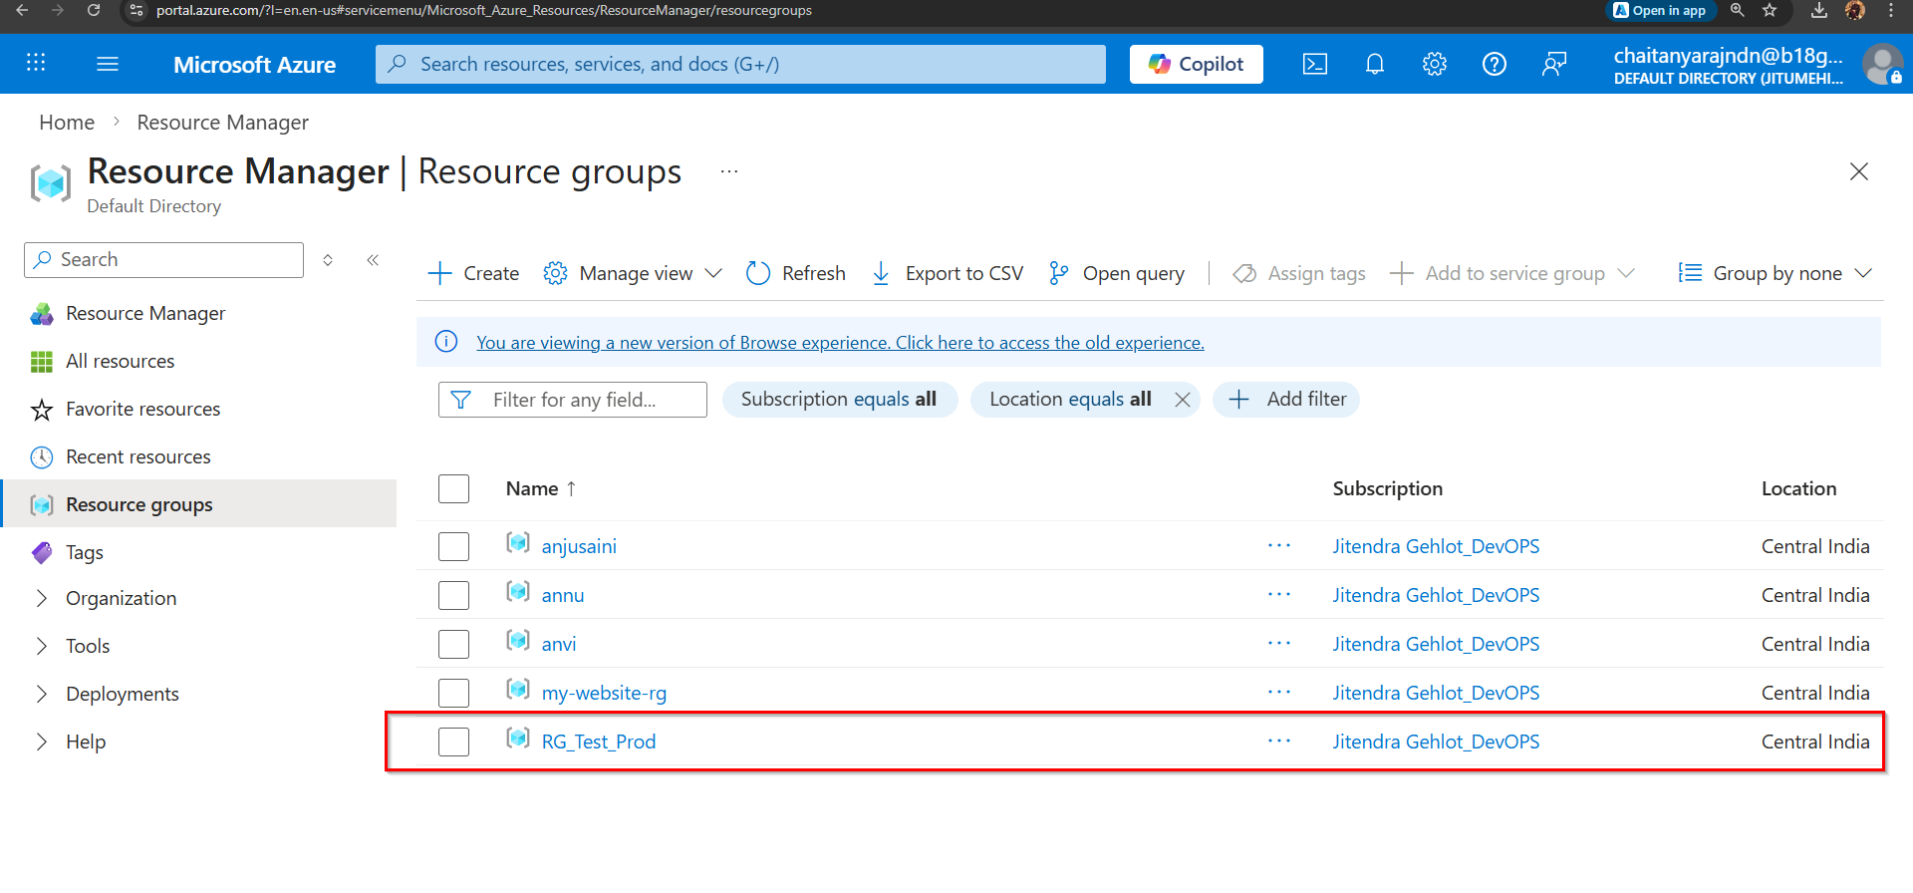

root@Chaitanya-Raj:~#
root@Chaitanya-Raj:~#
root@Chaitanya-Raj:~#
root@Chaitanya-Raj:~#
root@Chaitanya-Raj:~#
root@Chaitanya-Raj:~#
root@Chaitanya-Raj:~# az group show --name RG_Test_Prod
{
"id": "/subscriptions/594ca230-6fcf-4aa3-81ac-5e4d3ec2027c/resourceGroups/RG_Test_Prod",
"location": "centralindia",
"managedBy": null,
"name": "RG_Test_Prod",
"properties": {
"provisioningState": "Succeeded"
},
"tags": null,
"type": "Microsoft.Resources/resourceGroups"
}
root@Chaitanya-Raj:~#
root@Chaitanya-Raj:~#
root@Chaitanya-Raj:~# az storage account create --name Test_DB --resource-group RG_Test_Prod --location centralindia --sku Standard_LRS --kind StorageV2 --min-tls-version TLS1_2
The --min-tls-version argument values TLS1_0 and TLS1_1 have been retired on 2026/02/03 and will be removed on 2026/03/03.
(AccountNameInvalid) Test_DB is not a valid storage account name. Storage account name must be between 3 and 24 characters in length and use numbers and lower-case letters only.
Code: AccountNameInvalid
Message: Test_DB is not a valid storage account name. Storage account name must be between 3 and 24 characters in length and use numbers and lower-case letters only.
root@Chaitanya-Raj:~#
root@Chaitanya-Raj:~#
root@Chaitanya-Raj:~#
root@Chaitanya-Raj:~#
root@Chaitanya-Raj:~# az storage account create --name testdb2026 --resource-group RG_Test_Prod --location centralindia --sku Standard_LRS --kind StorageV2 --min-tls-version TLS1_2
The --min-tls-version argument values TLS1_0 and TLS1_1 have been retired on 2026/02/03 and will be removed on 2026/03/03.
{
"accessTier": "Hot",
"accountMigrationInProgress": null,
"allowBlobPublicAccess": false,
"allowCrossTenantReplication": false,
"allowSharedKeyAccess": null,
"allowedCopyScope": null,
"azureFilesIdentityBasedAuthentication": null,
"blobRestoreStatus": null,
"creationTime": "2026-03-21T11:13:05.075996+00:00",
"customDomain": null,
"defaultToOAuthAuthentication": null,
"dnsEndpointType": null,
"dualStackEndpointPreference": null,
"enableExtendedGroups": null,
"enableHttpsTrafficOnly": true,
"enableNfsV3": null,
"encryption": {
"encryptionIdentity": null,
"keySource": "Microsoft.Storage",
"keyVaultProperties": null,
"requireInfrastructureEncryption": null,
"services": {
"blob": {
"enabled": true,
"keyType": "Account",
"lastEnabledTime": "2026-03-21T11:13:05.177838+00:00"
},
"file": {
"enabled": true,
"keyType": "Account",
"lastEnabledTime": "2026-03-21T11:13:05.177838+00:00"
},
"queue": null,
"table": null
}
},
"extendedLocation": null,
"failoverInProgress": null,
"geoPriorityReplicationStatus": null,
"geoReplicationStats": null,
"id": "/subscriptions/594ca230-6fcf-4aa3-81ac-5e4d3ec2027c/resourceGroups/RG_Test_Prod/providers/Microsoft.Storage/storageAccounts/testdb2026",
"identity": null,
"immutableStorageWithVersioning": null,
"isHnsEnabled": null,
"isLocalUserEnabled": null,
"isSftpEnabled": null,
"isSkuConversionBlocked": null,
"keyCreationTime": {
"key1": "2026-03-21T11:13:05.167221+00:00",
"key2": "2026-03-21T11:13:05.167221+00:00"
},
"keyPolicy": null,
"kind": "StorageV2",
"largeFileSharesState": null,
"lastGeoFailoverTime": null,
"location": "centralindia",
"minimumTlsVersion": "TLS1_2",
"name": "testdb2026",
"networkRuleSet": {
"bypass": "AzureServices",
"defaultAction": "Allow",
"ipRules": [],
"ipv6Rules": [],
"resourceAccessRules": null,
"virtualNetworkRules": []
},
"placement": null,
"primaryEndpoints": {
"blob": "https://testdb2026.blob.core.windows.net/",
"dfs": "https://testdb2026.dfs.core.windows.net/",
"file": "https://testdb2026.file.core.windows.net/",
"internetEndpoints": null,
"ipv6Endpoints": null,
"microsoftEndpoints": null,
"queue": "https://testdb2026.queue.core.windows.net/",
"table": "https://testdb2026.table.core.windows.net/",
"web": "https://testdb2026.z29.web.core.windows.net/"
},
"primaryLocation": "centralindia",
"privateEndpointConnections": [],
"provisioningState": "Succeeded",
"publicNetworkAccess": null,
"resourceGroup": "RG_Test_Prod",
"routingPreference": null,
"sasPolicy": null,
"secondaryEndpoints": null,
"secondaryLocation": null,
"sku": {
"name": "Standard_LRS",
"tier": "Standard"
},
"statusOfPrimary": "available",
"statusOfSecondary": null,
"storageAccountSkuConversionStatus": null,
"tags": {},
"type": "Microsoft.Storage/storageAccounts",
"zones": null
}
root@Chaitanya-Raj:~#
root@Chaitanya-Raj:~#
root@Chaitanya-Raj:~#
root@Chaitanya-Raj:~#
root@Chaitanya-Raj:~#
root@Chaitanya-Raj:~#
root@Chaitanya-Raj:~#
root@Chaitanya-Raj:~#
root@Chaitanya-Raj:~#
root@Chaitanya-Raj:~#
root@Chaitanya-Raj:~#
root@Chaitanya-Raj:~#
root@Chaitanya-Raj:~#
root@Chaitanya-Raj:~# az storage account list -o table
AccessTier AllowBlobPublicAccess AllowCrossTenantReplication AllowSharedKeyAccess CreationTime DefaultToOAuthAuthentication DnsEndpointType EnableHttpsTrafficOnly Kind Location MinimumTlsVersion Name PrimaryLocation ProvisioningState PublicNetworkAccess ResourceGroup SecondaryLocation StatusOfPrimary StatusOfSecondary
------------ ----------------------- ----------------------------- ---------------------- -------------------------------- ------------------------------ ----------------- ------------------------ --------- ------------ ------------------- ------------- ----------------- ------------------- --------------------- --------------- ------------------- ----------------- -------------------
Hot False False True 2026-03-20T16:35:48.147555+00:00 False Standard True StorageV2 centralindia TLS1_2 anjusaini2329 centralindia Succeeded Enabled anjusaini southindia available available
Hot False False 2026-03-20T16:56:04.505251+00:00 True StorageV2 centralindia TLS1_0 annu centralindia Succeeded anjusaini available
Hot False False True 2026-03-20T16:59:51.737835+00:00 False Standard True StorageV2 centralindia TLS1_2 annuanvi centralindia Succeeded Enabled anjusaini southindia available available
Hot False False 2026-03-21T09:45:17.822835+00:00 True StorageV2 centralindia TLS1_0 anviannu centralindia Succeeded anjusaini available
Hot False False True 2026-03-20T16:36:53.758360+00:00 False Standard True StorageV2 centralindia TLS1_2 jeetu1 centralindia Succeeded Enabled anjusaini southindia available available
Hot False False 2026-03-21T11:13:05.075996+00:00 True StorageV2 centralindia TLS1_2 testdb2026 centralindia Succeeded RG_Test_Prod available
root@Chaitanya-Raj:~#
root@Chaitanya-Raj:~#
root@Chaitanya-Raj:~#
root@Chaitanya-Raj:~#
root@Chaitanya-Raj:~# az storage account show --name testdb2026
{
"accessTier": "Hot",
"accountMigrationInProgress": null,
"allowBlobPublicAccess": false,
"allowCrossTenantReplication": false,
"allowSharedKeyAccess": null,
"allowedCopyScope": null,
"azureFilesIdentityBasedAuthentication": null,
"blobRestoreStatus": null,
"creationTime": "2026-03-21T11:13:05.075996+00:00",
"customDomain": null,
"defaultToOAuthAuthentication": null,
"dnsEndpointType": null,
"dualStackEndpointPreference": null,
"enableExtendedGroups": null,
"enableHttpsTrafficOnly": true,
"enableNfsV3": null,
"encryption": {
"encryptionIdentity": null,
"keySource": "Microsoft.Storage",
"keyVaultProperties": null,
"requireInfrastructureEncryption": null,
"services": {
"blob": {
"enabled": true,
"keyType": "Account",
"lastEnabledTime": "2026-03-21T11:13:05.177838+00:00"
},
"file": {
"enabled": true,
"keyType": "Account",
"lastEnabledTime": "2026-03-21T11:13:05.177838+00:00"
},
"queue": null,
"table": null
}
},
"extendedLocation": null,
"failoverInProgress": null,
"geoPriorityReplicationStatus": null,
"geoReplicationStats": null,
"id": "/subscriptions/594ca230-6fcf-4aa3-81ac-5e4d3ec2027c/resourceGroups/RG_Test_Prod/providers/Microsoft.Storage/storageAccounts/testdb2026",
"identity": null,
"immutableStorageWithVersioning": null,
"isHnsEnabled": null,
"isLocalUserEnabled": null,
"isSftpEnabled": null,
"isSkuConversionBlocked": null,
"keyCreationTime": {
"key1": "2026-03-21T11:13:05.167221+00:00",
"key2": "2026-03-21T11:13:05.167221+00:00"
},
"keyPolicy": null,
"kind": "StorageV2",
"largeFileSharesState": null,
"lastGeoFailoverTime": null,
"location": "centralindia",
"minimumTlsVersion": "TLS1_2",
"name": "testdb2026",
"networkRuleSet": {
"bypass": "AzureServices",
"defaultAction": "Allow",
"ipRules": [],
"ipv6Rules": [],
"resourceAccessRules": null,
"virtualNetworkRules": []
},
"placement": null,
"primaryEndpoints": {
"blob": "https://testdb2026.blob.core.windows.net/",
"dfs": "https://testdb2026.dfs.core.windows.net/",
"file": "https://testdb2026.file.core.windows.net/",
"internetEndpoints": null,
"ipv6Endpoints": null,
"microsoftEndpoints": null,
"queue": "https://testdb2026.queue.core.windows.net/",
"table": "https://testdb2026.table.core.windows.net/",
"web": "https://testdb2026.z29.web.core.windows.net/"
},
"primaryLocation": "centralindia",
"privateEndpointConnections": [],
"provisioningState": "Succeeded",
"publicNetworkAccess": null,
"resourceGroup": "RG_Test_Prod",
"routingPreference": null,
"sasPolicy": null,
"secondaryEndpoints": null,
"secondaryLocation": null,
"sku": {
"name": "Standard_LRS",
"tier": "Standard"
},
"statusOfPrimary": "available",
"statusOfSecondary": null,
"storageAccountSkuConversionStatus": null,
"tags": {},
"type": "Microsoft.Storage/storageAccounts",
"zones": null
}
root@Chaitanya-Raj:~#

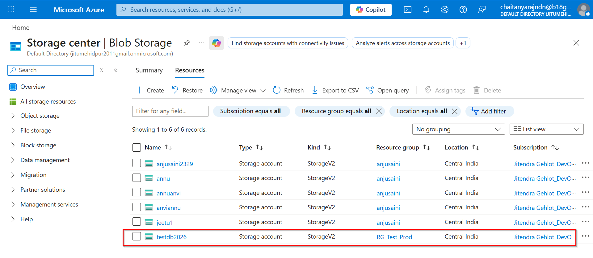

Delete Storage Account on Azure CLI

root@Chaitanya-Raj:~#
root@Chaitanya-Raj:~#
root@Chaitanya-Raj:~#
root@Chaitanya-Raj:~#
root@Chaitanya-Raj:~# az storage account delete --name testdb2026
Are you sure you want to perform this operation? (y/n): y
root@Chaitanya-Raj:~#
root@Chaitanya-Raj:~#
root@Chaitanya-Raj:~# az storage account show --name testdb2026
Storage account 'testdb2026' not found.
root@Chaitanya-Raj:~#
root@Chaitanya-Raj:~#
root@Chaitanya-Raj:~# az storage account list -o table
AccessTier AllowBlobPublicAccess AllowCrossTenantReplication AllowSharedKeyAccess CreationTime DefaultToOAuthAuthentication DnsEndpointType EnableHttpsTrafficOnly Kind Location MinimumTlsVersion Name PrimaryLocation ProvisioningState PublicNetworkAccess ResourceGroup SecondaryLocation StatusOfPrimary StatusOfSecondary
------------ ----------------------- ----------------------------- ---------------------- -------------------------------- ------------------------------ ----------------- ------------------------ --------- ------------ ------------------- ------------- ----------------- ------------------- --------------------- --------------- ------------------- ----------------- -------------------
Hot False False True 2026-03-20T16:35:48.147555+00:00 False Standard True StorageV2 centralindia TLS1_2 anjusaini2329 centralindia Succeeded Enabled anjusaini southindia available available
Hot False False 2026-03-20T16:56:04.505251+00:00 True StorageV2 centralindia TLS1_0 annu centralindia Succeeded anjusaini available
Hot False False True 2026-03-20T16:59:51.737835+00:00 False Standard True StorageV2 centralindia TLS1_2 annuanvi centralindia Succeeded Enabled anjusaini southindia available available
Hot False False 2026-03-21T09:45:17.822835+00:00 True StorageV2 centralindia TLS1_0 anviannu centralindia Succeeded anjusaini available
Hot False False True 2026-03-20T16:36:53.758360+00:00 False Standard True StorageV2 centralindia TLS1_2 jeetu1 centralindia Succeeded Enabled anjusaini southindia available available
root@Chaitanya-Raj:~#

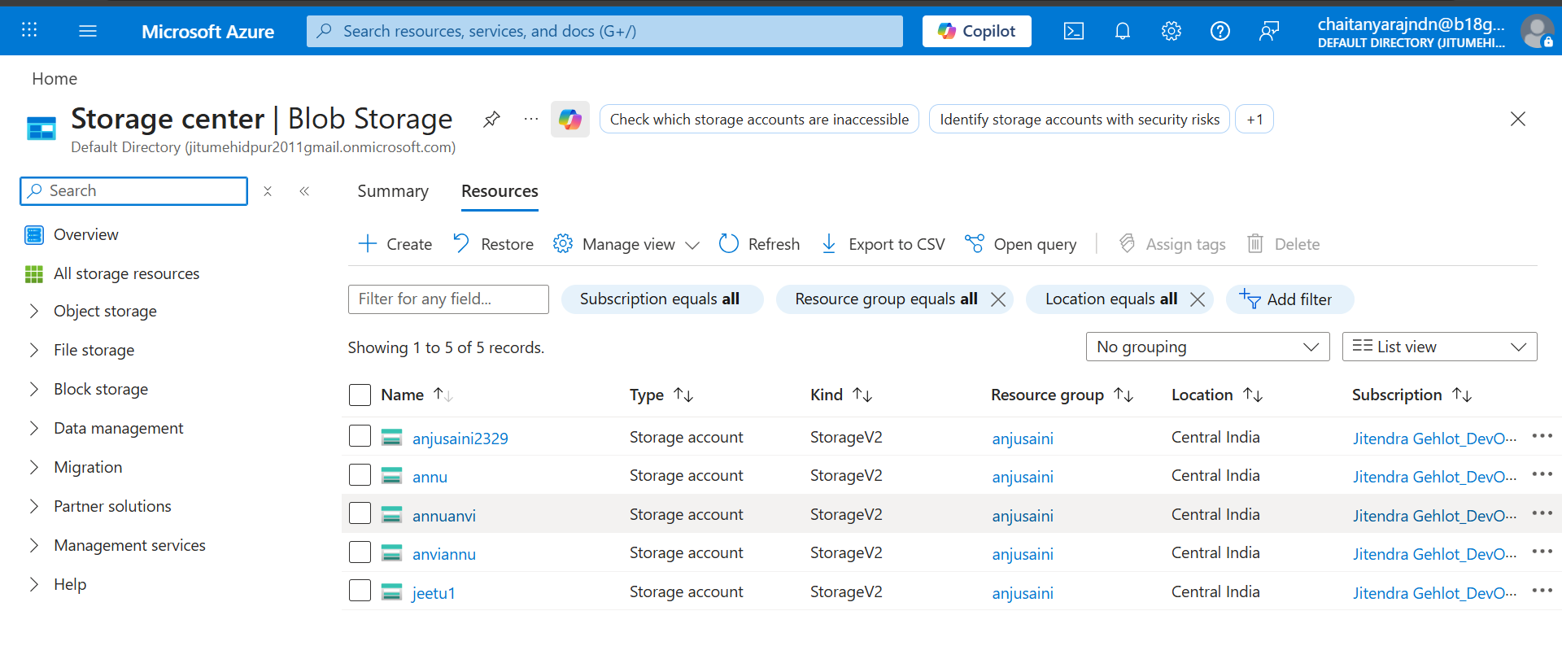

Create Storage Account on Azure Portal

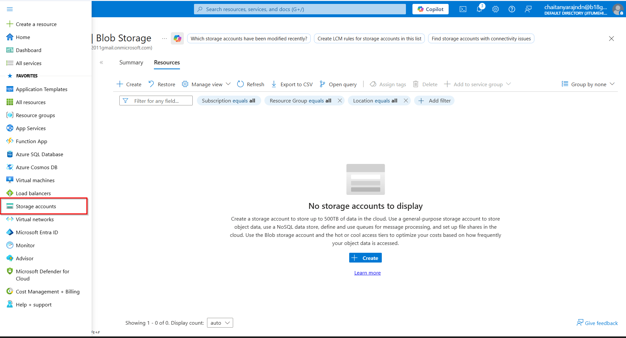

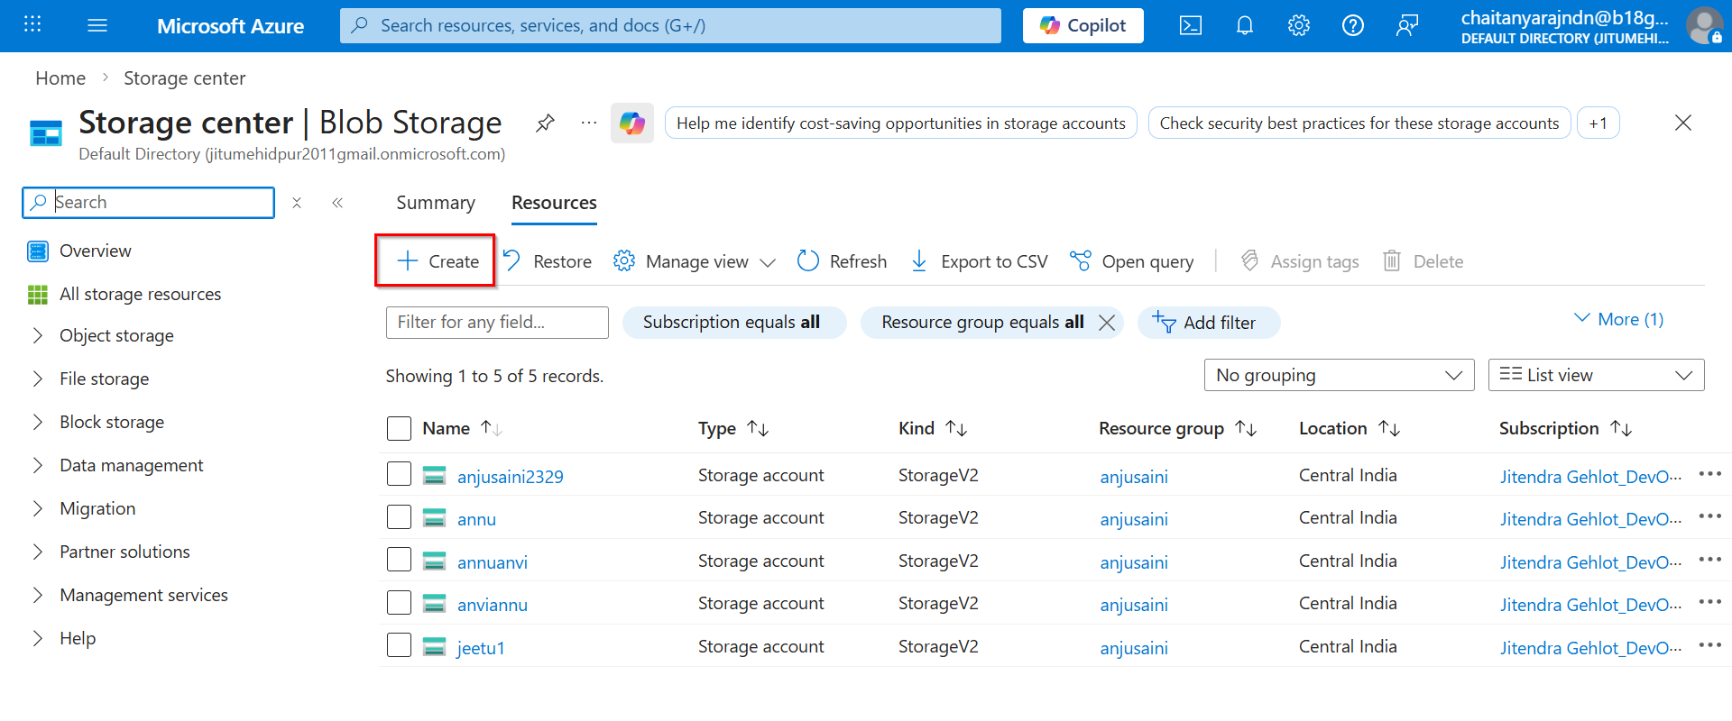

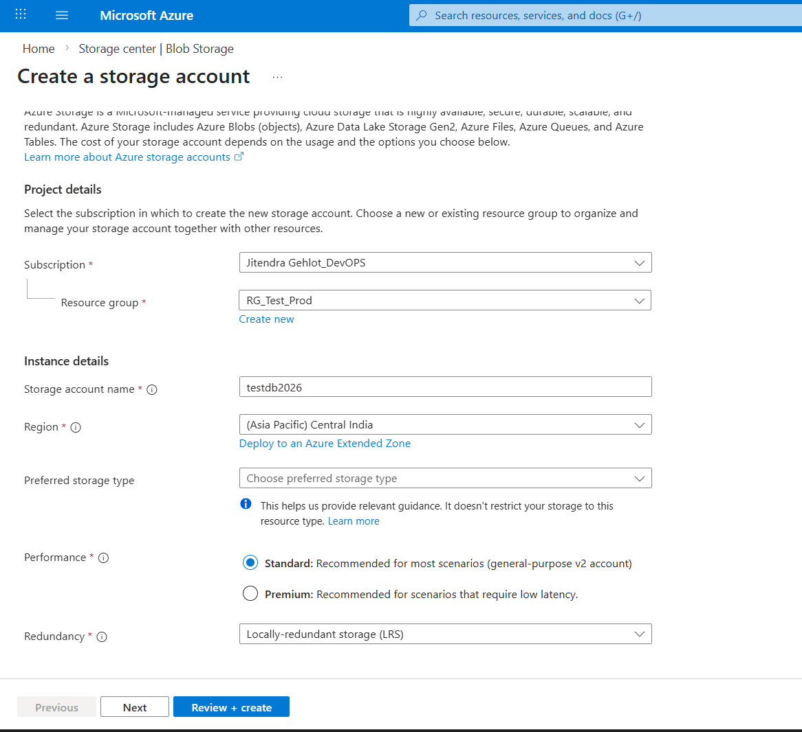

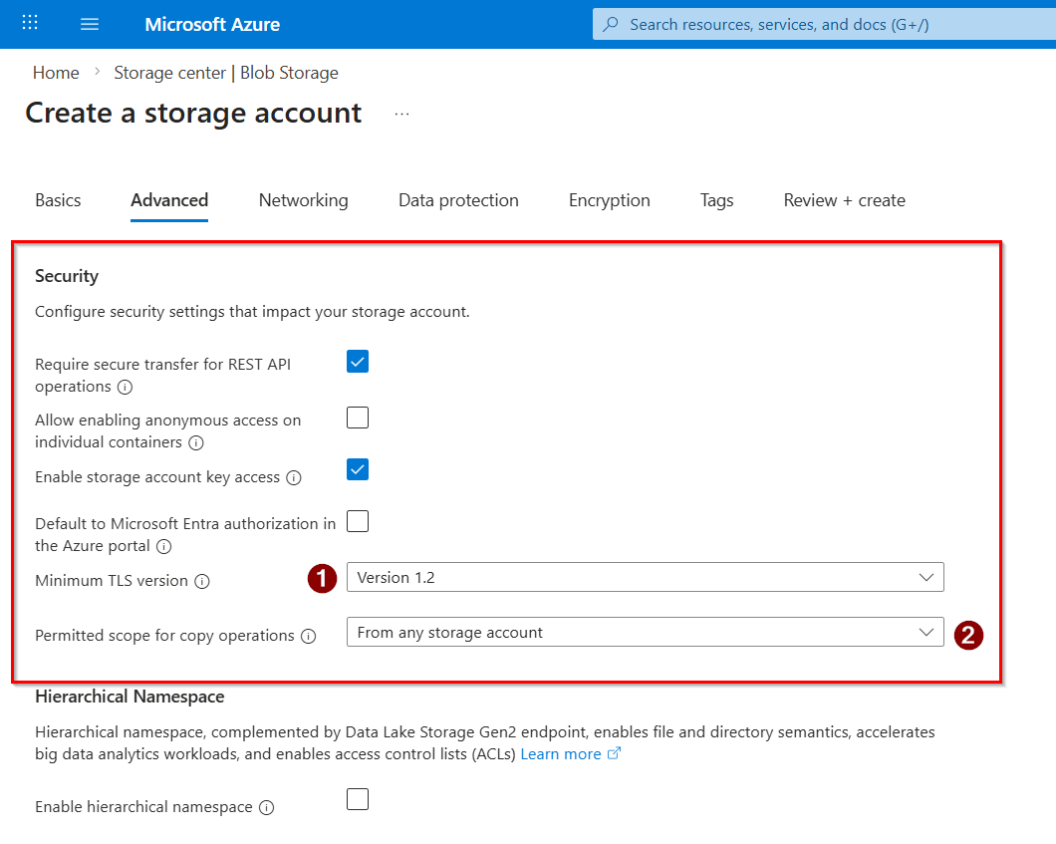

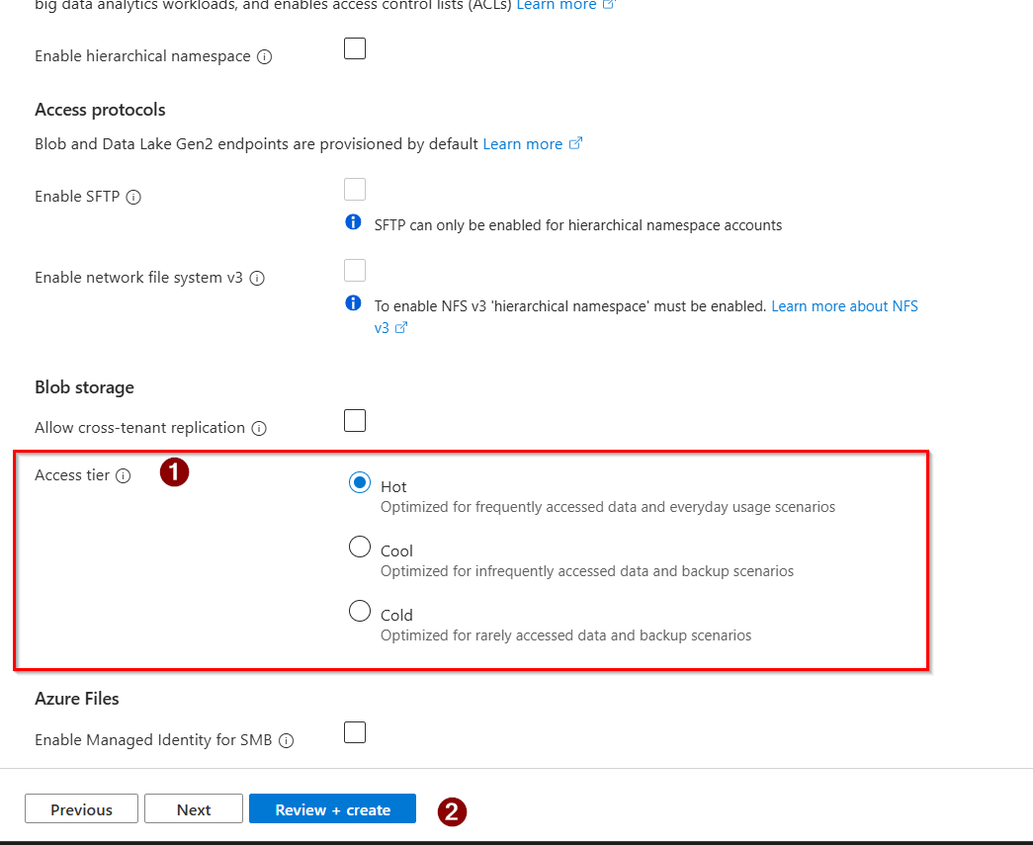

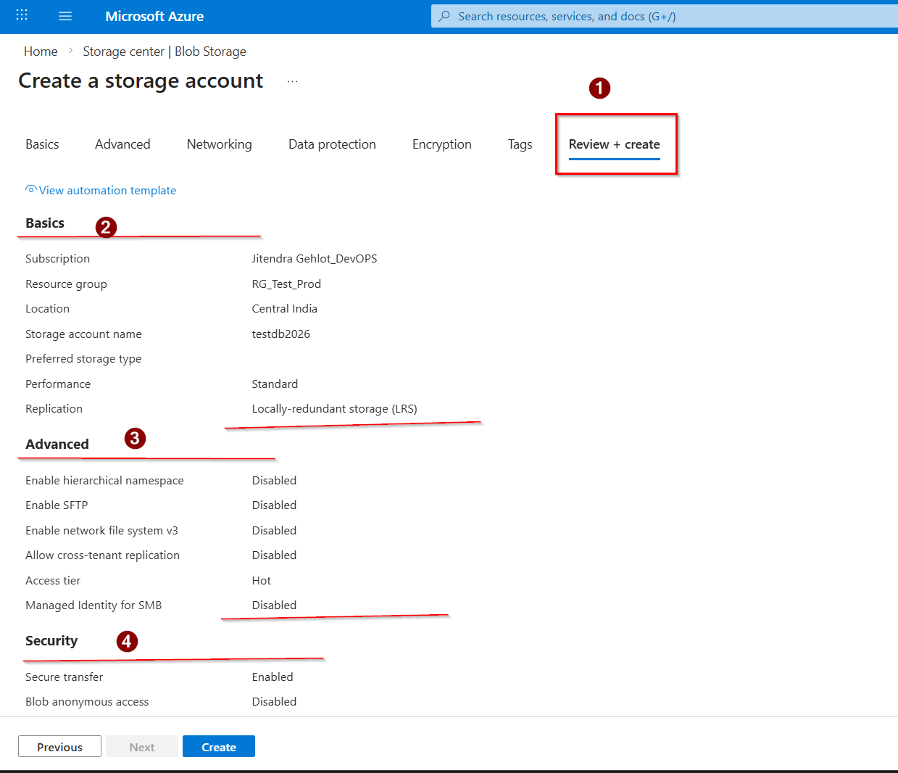

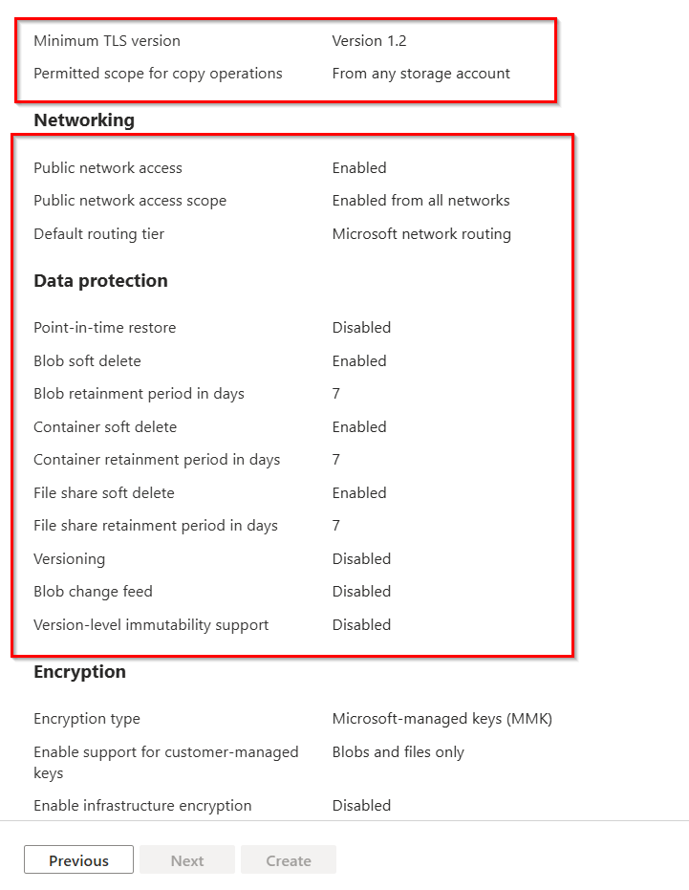



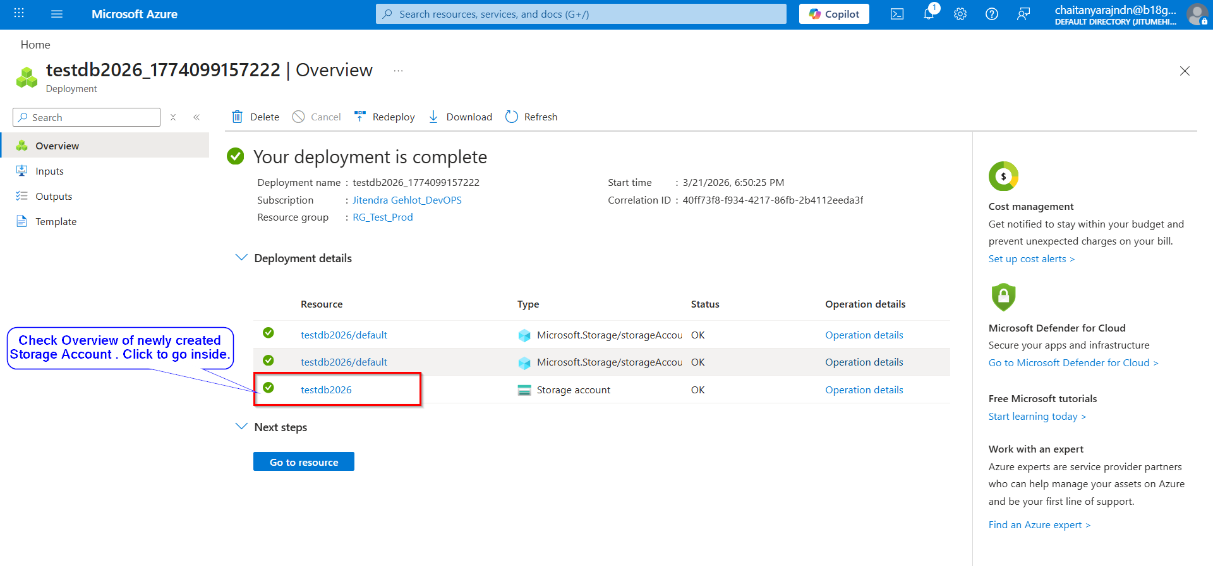

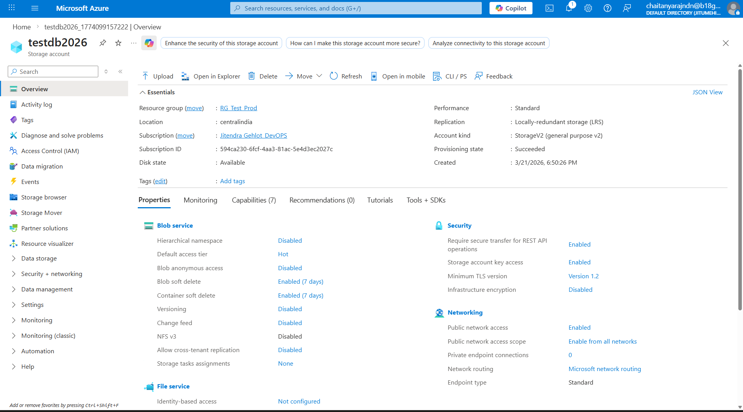

ON Azure CLI:

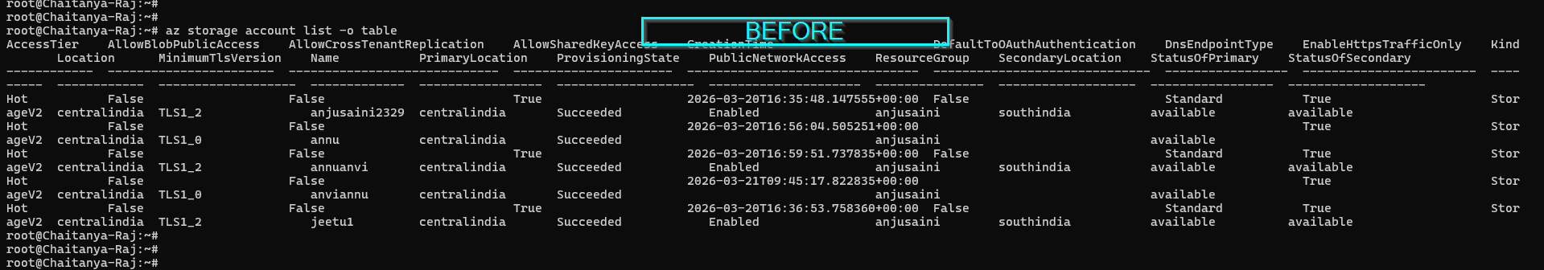

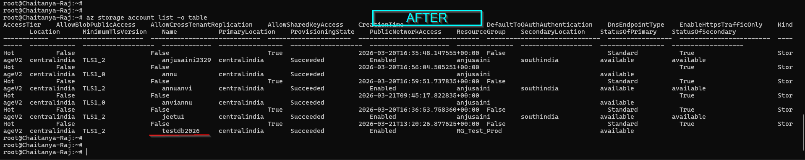

root@Chaitanya-Raj:~# az storage account list -o table
AccessTier AllowBlobPublicAccess AllowCrossTenantReplication AllowSharedKeyAccess CreationTime DefaultToOAuthAuthentication DnsEndpointType EnableHttpsTrafficOnly Kind Location MinimumTlsVersion Name PrimaryLocation ProvisioningState PublicNetworkAccess ResourceGroup SecondaryLocation StatusOfPrimary StatusOfSecondary
------------ ----------------------- ----------------------------- ---------------------- -------------------------------- ------------------------------ ----------------- ------------------------ --------- ------------ ------------------- ------------- ----------------- ------------------- --------------------- --------------- ------------------- ----------------- -------------------
Hot False False True 2026-03-20T16:35:48.147555+00:00 False Standard True StorageV2 centralindia TLS1_2 anjusaini2329 centralindia Succeeded Enabled anjusaini southindia available available
Hot False False 2026-03-20T16:56:04.505251+00:00 True StorageV2 centralindia TLS1_0 annu centralindia Succeeded anjusaini available
Hot False False True 2026-03-20T16:59:51.737835+00:00 False Standard True StorageV2 centralindia TLS1_2 annuanvi centralindia Succeeded Enabled anjusaini southindia available available
Hot False False 2026-03-21T09:45:17.822835+00:00 True StorageV2 centralindia TLS1_0 anviannu centralindia Succeeded anjusaini available
Hot False False True 2026-03-20T16:36:53.758360+00:00 False Standard True StorageV2 centralindia TLS1_2 jeetu1 centralindia Succeeded Enabled anjusaini southindia available available
root@Chaitanya-Raj:~#
root@Chaitanya-Raj:~#
root@Chaitanya-Raj:~#
root@Chaitanya-Raj:~#
root@Chaitanya-Raj:~#
root@Chaitanya-Raj:~# az storage account list -o table
AccessTier AllowBlobPublicAccess AllowCrossTenantReplication AllowSharedKeyAccess CreationTime DefaultToOAuthAuthentication DnsEndpointType EnableHttpsTrafficOnly Kind Location MinimumTlsVersion Name PrimaryLocation ProvisioningState PublicNetworkAccess ResourceGroup SecondaryLocation StatusOfPrimary StatusOfSecondary
------------ ----------------------- ----------------------------- ---------------------- -------------------------------- ------------------------------ ----------------- ------------------------ --------- ------------ ------------------- ------------- ----------------- ------------------- --------------------- --------------- ------------------- ----------------- -------------------
Hot False False True 2026-03-20T16:35:48.147555+00:00 False Standard True StorageV2 centralindia TLS1_2 anjusaini2329 centralindia Succeeded Enabled anjusaini southindia available available
Hot False False 2026-03-20T16:56:04.505251+00:00 True StorageV2 centralindia TLS1_0 annu centralindia Succeeded anjusaini available
Hot False False True 2026-03-20T16:59:51.737835+00:00 False Standard True StorageV2 centralindia TLS1_2 annuanvi centralindia Succeeded Enabled anjusaini southindia available available
Hot False False 2026-03-21T09:45:17.822835+00:00 True StorageV2 centralindia TLS1_0 anviannu centralindia Succeeded anjusaini available
Hot False False True 2026-03-20T16:36:53.758360+00:00 False Standard True StorageV2 centralindia TLS1_2 jeetu1 centralindia Succeeded Enabled anjusaini southindia available available
Hot False False True 2026-03-21T13:20:26.877625+00:00 False Standard True StorageV2 centralindia TLS1_2 testdb2026 centralindia Succeeded Enabled RG_Test_Prod available
root@Chaitanya-Raj:~#
root@Chaitanya-Raj:~#
root@Chaitanya-Raj:~#

Delete Storage Account on Azure Portal

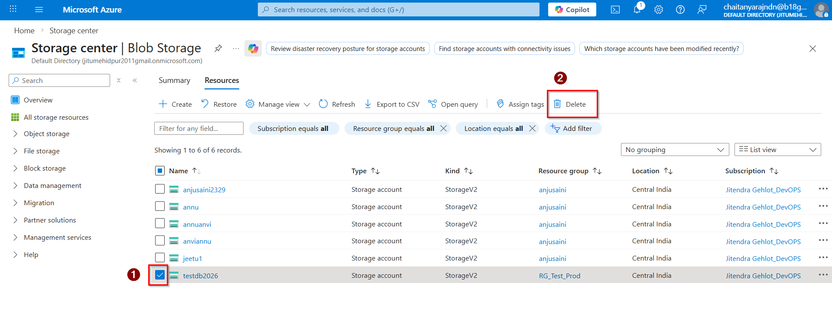

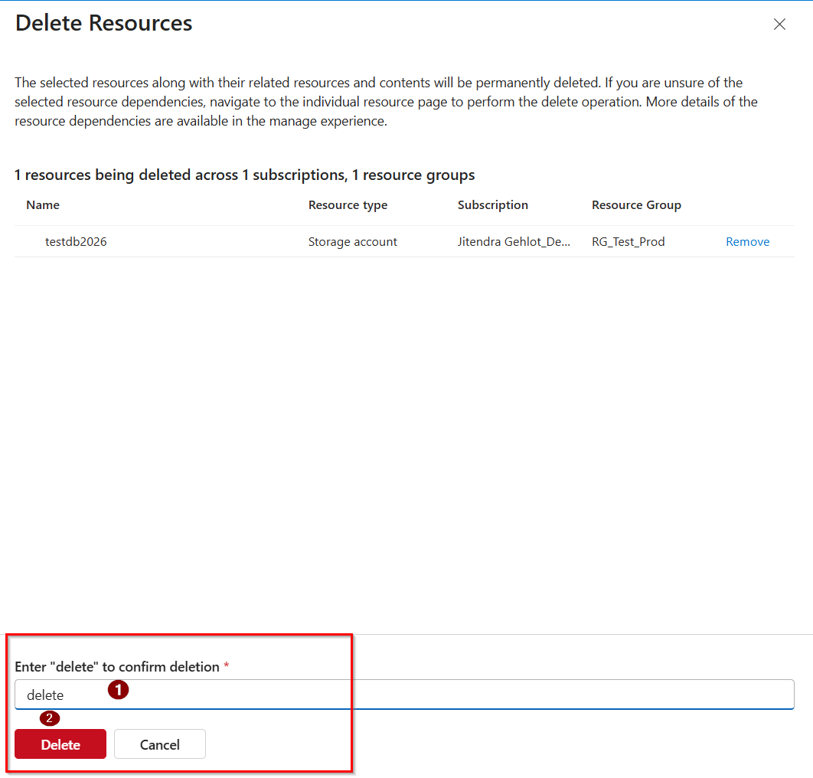

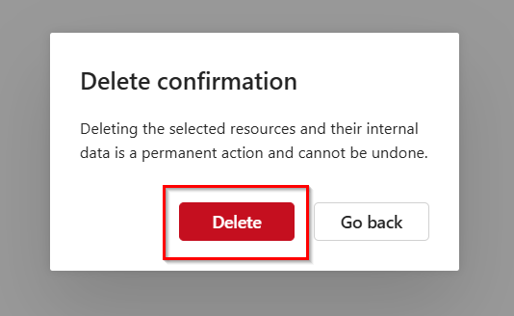

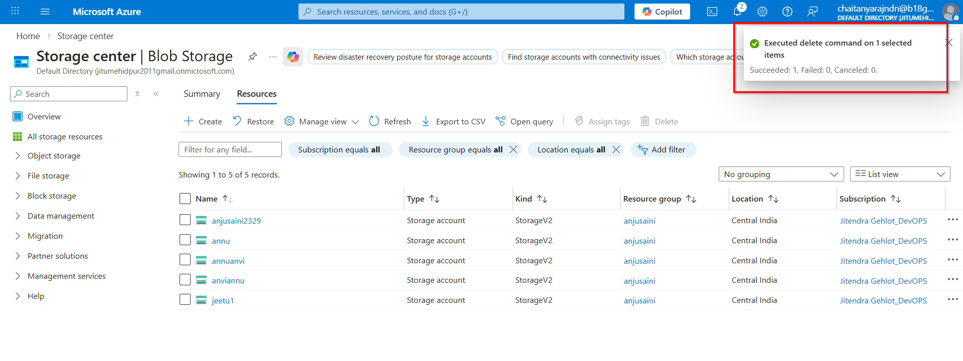

root@Chaitanya-Raj:~#
root@Chaitanya-Raj:~#
root@Chaitanya-Raj:~# az storage account list -o table
AccessTier AllowBlobPublicAccess AllowCrossTenantReplication AllowSharedKeyAccess CreationTime DefaultToOAuthAuthentication DnsEndpointType EnableHttpsTrafficOnly Kind Location MinimumTlsVersion Name PrimaryLocation ProvisioningState PublicNetworkAccess ResourceGroup SecondaryLocation StatusOfPrimary StatusOfSecondary
------------ ----------------------- ----------------------------- ---------------------- -------------------------------- ------------------------------ ----------------- ------------------------ --------- ------------ ------------------- ------------- ----------------- ------------------- --------------------- --------------- ------------------- ----------------- -------------------
Hot False False True 2026-03-20T16:35:48.147555+00:00 False Standard True StorageV2 centralindia TLS1_2 anjusaini2329 centralindia Succeeded Enabled anjusaini southindia available available
Hot False False 2026-03-20T16:56:04.505251+00:00 True StorageV2 centralindia TLS1_0 annu centralindia Succeeded anjusaini available
Hot False False True 2026-03-20T16:59:51.737835+00:00 False Standard True StorageV2 centralindia TLS1_2 annuanvi centralindia Succeeded Enabled anjusaini southindia available available
Hot False False 2026-03-21T09:45:17.822835+00:00 True StorageV2 centralindia TLS1_0 anviannu centralindia Succeeded anjusaini available
Hot False False True 2026-03-20T16:36:53.758360+00:00 False Standard True StorageV2 centralindia TLS1_2 jeetu1 centralindia Succeeded Enabled anjusaini southindia available available
Hot False False True 2026-03-21T13:20:26.877625+00:00 False Standard True StorageV2 centralindia TLS1_2 testdb2026 centralindia Succeeded Enabled RG_Test_Prod available
root@Chaitanya-Raj:~#
root@Chaitanya-Raj:~#
root@Chaitanya-Raj:~#
root@Chaitanya-Raj:~#
root@Chaitanya-Raj:~#
root@Chaitanya-Raj:~#
root@Chaitanya-Raj:~#
root@Chaitanya-Raj:~#
root@Chaitanya-Raj:~#
root@Chaitanya-Raj:~#
root@Chaitanya-Raj:~#
root@Chaitanya-Raj:~# az storage account list -o table
AccessTier AllowBlobPublicAccess AllowCrossTenantReplication AllowSharedKeyAccess CreationTime DefaultToOAuthAuthentication DnsEndpointType EnableHttpsTrafficOnly Kind Location MinimumTlsVersion Name PrimaryLocation ProvisioningState PublicNetworkAccess ResourceGroup SecondaryLocation StatusOfPrimary StatusOfSecondary
------------ ----------------------- ----------------------------- ---------------------- -------------------------------- ------------------------------ ----------------- ------------------------ --------- ------------ ------------------- ------------- ----------------- ------------------- --------------------- --------------- ------------------- ----------------- -------------------
Hot False False True 2026-03-20T16:35:48.147555+00:00 False Standard True StorageV2 centralindia TLS1_2 anjusaini2329 centralindia Succeeded Enabled anjusaini southindia available available
Hot False False 2026-03-20T16:56:04.505251+00:00 True StorageV2 centralindia TLS1_0 annu centralindia Succeeded anjusaini available
Hot False False True 2026-03-20T16:59:51.737835+00:00 False Standard True StorageV2 centralindia TLS1_2 annuanvi centralindia Succeeded Enabled anjusaini southindia available available
Hot False False 2026-03-21T09:45:17.822835+00:00 True StorageV2 centralindia TLS1_0 anviannu centralindia Succeeded anjusaini available
Hot False False True 2026-03-20T16:36:53.758360+00:00 False Standard True StorageV2 centralindia TLS1_2 jeetu1 centralindia Succeeded Enabled anjusaini southindia available available
root@Chaitanya-Raj:~#
root@Chaitanya-Raj:~#
root@Chaitanya-Raj:~#
root@Chaitanya-Raj:~#

