DOCKER

By Chaitanya Raj Nandan
Contents
1 Before Containers 3
1.1 What is A Container? 3
1.2 Containers Vs Virtual Machines 3
2 Introduction 5
2.1 Why Use Docker 5
2.2 Docker Terminologies 5
3 Dockerfiles 6
4 Basic Docker Command 7
4.1 Docker Build 7
4.2 Docker Run 7
4.3 Docker Pull 7
4.4 Docker Push 7
4.5 Docker PS 7
4.6 Docker Images 7
4.7 Docker Stop 7
4.8 Docker RMI (Remove Image) 7
4.9 Docker RM (Remove Container) 7
4.10 Docker Exec 7
5 Building a Python web app 8

Before Containers
Let us dial back the clock. Back when computers were a novelty, and companies wanted to run their applications, they would have had to buy a server for doing so. However, this came with a caveat: you could only run one application per server. If you wanted to run multiple applications, you would have to buy as many servers. As costs would skyrocket, this was a problem, for both the company and the environment on a larger scale
IBM fixed this issue by introducing the concept of virtual machines into the game. With them, we could run multiple applications on the same server. You may have heard of / done dual booting on your PC; like installing windows on your Mac device or Ubuntu on Windows. These are virtual machines. However, they had a problem as well. They needed their own operating system, which tended to take up a lot of memory and storage on your hard disk. This made them slow and not so efficient.
In came containers.

What is A Container?
Imagine you are moving to US from India. Would it make sense to send your belongings one by one, or would you rather put them all in one giant box and ship the box directly? Obviously the latter, right?
That big box is, in simple terms, a container.
Let’s say you built a website that works well on your system but your friend runs into some problems with it when they try using it on their computer. To avoid such hassles, you can use a container, which would ship the entire website along with its dependencies, such as the web database, front end, back end, source code, etc. This would ensure that the website runs smoothly.
In computing terms, containerization is an efficient method for running, deploying and scaling applications.

Containers Vs Virtual Machines

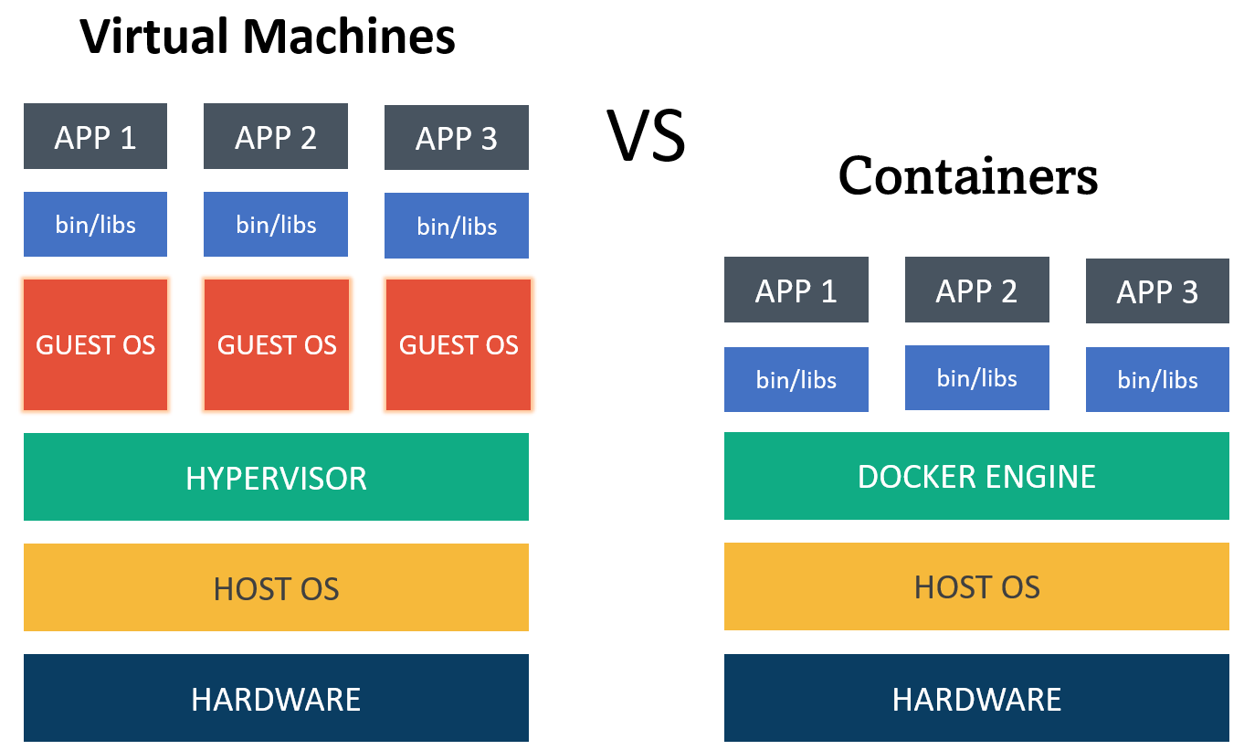
Any application which runs on a virtual machine will require a guest OS to run, which would require a hypervisor. A hypervisor manages the virtual machines and is used to create multiple machines on the host operating system. As you can see from the picture, every OS would require a dedicated amount of space in the hardware, which is virtually divided.
In the case of containers, you need have only one operating system, and on top of that, you have a container engine, on which you run applications. They use the idea of isolating your application from the main operating system.
To sum it up succinctly, virtual machines use multiple operating systems to run multiple applications whereas containers use only the host operating system to run applications via the container engine.
In reality, however, containers run on top of virtual machines. This is because virtual machines allow faster access to hardware resources and hypervisors provide better security compared to containers.
Aspect | Containers | Virtual Machines
OS | Share host’s Kernel | Has its own Kernel
Resource Usage | Lightweight, efficient | Heavier, more resource usage
Startup Time | Quick start | Slower start
Isolation | Process-level separation | Full OS isolation
Portability | Highly portable | Compatibility concerns
Resource Overhead | Minimal overhead | Higher overhead
Isolation Level | Lighter isolation | Stronger isolation

Advantages of Containerization

- Increased Portability

- Easier Scalability

- Easy and Fast Deployments

- Better Productivity

- Improved Security

- Consistent test environment for development and QA.

- Cross-platform packages called images.

- Isolation and encapsulation of application dependencies.

- Ability to scale efficiently, easily, and in real time.

- Enhances efficiency via easy reuse of images.

Introduction

Docker is a platform for developing, shipping, and running applications in containers. Containers are lightweight, portable, and self-sufficient units that can run applications and their dependencies in isolated environments. Docker provides a consistent and reproducible environment across different machines, making it easier to manage and deploy applications.

Why Use Docker

Helps transport code faster.

Makes scaling, deploying, and identifying issues in the application easier.

Saves up space as you do not need to install the whole application locally.

Docker Terminologies
Docker Engine: The core of Docker is the Docker Engine, which is responsible for building, running, and managing containers. It consists of a server (daemon) and a REST API that allows you to interact with the daemon.
- Server – which runs the daemon
- Rest API – deals with the interaction of applications with their server
- Client – which is nothing but the command line interface (CLI)

Docker Images: Images are lightweight, standalone, and executable packages that include everything needed to run a piece of software, including the code, runtime, libraries, and system tools. Images are used to create containers.

Docker Containers: Containers are instances of Docker images that run in isolated environments. They encapsulate an application and its dependencies, ensuring consistency across different environments. Containers are portable and can run on any system that supports Docker.
Docker Runtime: It allows us to start and stop containers. There are two types:
- Low-level runtime (runc)
- High-level runtime (containerd)

Docker Client: It is what we use to interact with Docker. You can think of it like the user interface for Docker. Whenever you type in a command, the client sends these to the daemon.

Docker CLI: It allows users to issue commands to the Docker Daemon. Docker uses a client – server architecture.

Docker Daemon: It is the heart of the Docker architecture, which does the crucial work of building, running, and distributing the containers. It also manages the Docker images and the containers.
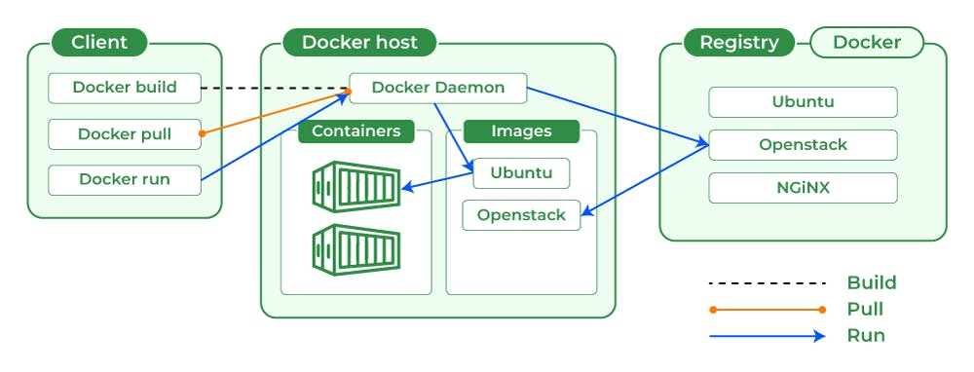

Dockerfiles
A Dockerfile is a script that contains a set of instructions for building a Docker image. Docker images are lightweight, standalone, and executable packages that include everything needed to run a piece of software, including the code, runtime, libraries, and system tools. Dockerfiles are used to automate the process of creating Docker images.
Here's a basic example of a Dockerfile:
# Use an official base image
FROM ubuntu:20.04

# Set the working directory
WORKDIR /app

# Copy application code into the container
COPY . .

# Install dependencies RUN apt-get update && \ apt-get install -y python3 && \ apt-get clean

# Expose a port
EXPOSE 8080

# Define the command to run the application
CMD ["python3", "app.py"]

Now, let's break down each part of this Dockerfile:
- FROM: Specifies the base image. In this case, it's Ubuntu 20.04.
- WORKDIR: Sets the working directory inside the container. Subsequent instructions will be executed from this directory.
- COPY: Copies files from the host machine to the container. Here, it copies the content of the current directory (the "." represents the current directory) into the "/app" directory inside the container.
- RUN: Executes commands during the image build process. In this example, it updates the package list, installs Python3, and cleans up the package cache.
- EXPOSE: Informs Docker that the container will listen on the specified network ports at runtime. It doesn't actually publish the ports, but it is a helpful documentation for other developers.
- CMD: Provides the default command to run when the container starts. It specifies the command to run our application (in this case, a Python script). Now, let's move on to a multi-stage Dockerfile example. Multi-stage builds allow you to use multiple FROM statements in a single Dockerfile, resulting in a smaller and more efficient final image.

Basic Docker Commands
Now, let us look at some common Docker commands and their usage:

Docker Build
Command: docker build -t image_name:tag .
Usage: Builds a Docker image from a Dockerfile in the current directory.

Docker Run
Command: docker run [options] image_name:tag
Usage: Creates and runs a container based on a specified image.

Docker Pull
Command: docker pull image_name:tag
Usage: Downloads a Docker image from a registry.

Docker Push
Command: docker push image_name:tag
Usage: Uploads a Docker image to a registry.

Docker PS
Command: docker ps [options]
Usage: Lists the currently running containers.

Docker Images
Command: docker images [options]
Usage: Lists all available Docker images on the local machine.

Docker Stop
Command: docker stop container_id
Usage: Stops a running container.

Docker RMI (Remove Image)
Command: docker rmi image_name:tag
Usage: Removes a Docker image from the local machine.

Docker RM (Remove Container)
Command: docker rm container_id
Usage: Removes a stopped container.

Docker Exec
Command: docker exec [options] container_id command
Usage: Executes a command inside a running container.

Building a Python web app

