Method of Procedure

for

MICROSOFT AZURE RESOURCE GROUP

Create Using Terraform and Azure CLI

V1 Draft
Contents
1 Purpose and Scope 3
2 Log in Microsoft Azure 4
3 Resource Group Creation 5
3.1 Manual Resource Group Creation 5
3.2 Automation Resource Group Creation 5
3.2.1 Imperative Automation 5
3.2.2 Declarative Automation 5
3.3 Visual Flow Diagram Appendix 5
3.4 Difference Table 6
3.5 Where Terraform Fits 6
4 Imperative Automation in Azure 7
4.1 Install Azure CLI 7
4.2 Logging into Azure CLI 7
4.3 Common Azure CLI Commands (Imperative) 9
4.4 Key Characteristics of Imperative Automation 10
4.5 Azure CLI Script Example 10
4.5.1 Step 1: Log in to Azure CLI 10
4.5.2 Step 2: Create a Resource Group 10
4.5.3 Step 3: Create a Storage Account 10
4.5.4 Step 4: Delete the Resource Group (Cleanup) 11
4.5.5 Full Script (Imperative Automation) 11
4.5.6 Key Takeaways 11
4.6 ✅ In short: 12
5 Declarative Automation (Terraform) 13
5.1 Step 1: Create a Terraform configuration file (main.tf) 13
5.2 Step 2: Run Terraform commands 13
6 Side-by-Side Comparison 14
7 Rollback 15
7.1 Uninstall Azure CLI 15
7.1.1 Step 1: Remove the CLI package 15
7.1.2 Step 2: Remove repository Info (Optional) 15
7.1.3 Step 3: Remove Microsoft Signing Key (Optional) 15
7.1.4 Step 4: Clean up unused packages 15
7.1.5 Step 5: Remove Azure CLI data (optional) 15
7.2 Summary 15
8 Appendix 16
A1 Install Azure CLI 16
A1.1 Option 1: Install with One Command (Quick Method) 16
A1.2 Option 2: Step-by-Step Installation (Manual Method) 16
A1.3 Summary 17
A2 Update Azure CLI 18
A2.1 Option 1: Update using az upgrade (Recommended) 18
A2.2 Option 2: Update using apt-get upgrade (Linux) 18
A2.3 Option 3: Update CLI only 18

Purpose and Scope
This Method of Procedure (MOP) document outlines the complete lifecycle of Microsoft Azure Resource Group creation and management. It covers both manual methods using the Azure Portal and automation approaches using Azure CLI and Infrastructure-as-Code (IaC) tools. The scope includes a detailed comparison of Imperative vs Declarative automation, highlighting their differences, advantages, and limitations. It also explains where Terraform fits into declarative automation for scalable, repeatable deployments. Additionally, the document provides step-by-step guidance on installing, updating, and uninstalling the Azure CLI, logging in, and executing commands for resource creation and cleanup.

Log in Microsoft Azure
To log in to Microsoft Azure:
- Go to the official Azure Portal: https://portal.azure.com
- Click Sign in.
- Enter your Microsoft account email (or organizational account).
- Provide your password.
- If enabled, complete Multi-Factor Authentication (MFA).
- Once logged in, you’ll see the Azure dashboard where you can manage resources.
Reference: Microsoft Azure Portal official site.

Resource Group Creation

Manual Resource Group Creation
- Done through Azure Portal (GUI).
- Steps: Login → Navigate to Resource Groups → Click Create → Fill details (Name, Region, Tags) → Submit.
- Pros: Simple, beginner-friendly, no coding required.
- Cons: Error-prone, slow for large-scale deployments, not repeatable.

Automation Resource Group Creation
Automation means using scripts or Infrastructure-as-Code (IaC) tools.

Imperative Automation
- You tell the system how to do it step by step.
- Example: Using Azure CLI or PowerShell.
az group create --name MyRG --location eastus
- Pros: Easy to learn, direct control.
- Cons: Harder to scale, less reusable, procedural.

Declarative Automation
- You declare what you want, and the tool figures out how to achieve it.
- Example: Using ARM Templates, Bicep, or Terraform ➜ You define desired state in JSON/HCL, and the tool ensures Azure matches it.
- Pros: Scalable, repeatable, idempotent (same config → same result).
- Cons: Learning curve, requires IaC tools.

Visual Flow Diagram Appendix
The following diagram illustrates the three approaches to Azure Resource Group creation: Manual, Imperative, and Declarative.

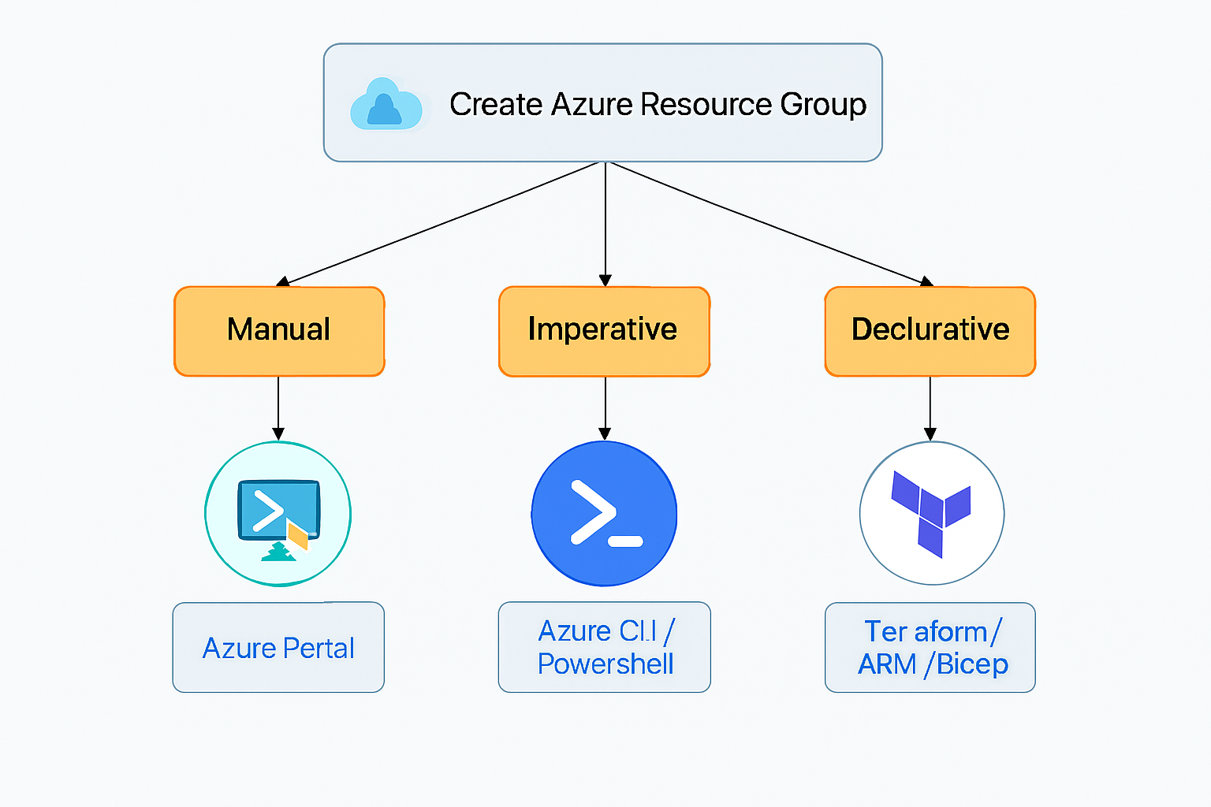

Difference Table
Aspect | Manual (Portal) | Automation (Imperative) | Automation (Declarative)
Approach | Click-based GUI | Step-by-step commands | Desired state definition
Repeatability | Low | Medium | High
Scalability | Poor | Moderate | Excellent
Error-prone | High | Medium | Low
Tools | Azure Portal | Azure CLI, PowerShell | ARM, Bicep, Terraform

Where Terraform Fits
- Terraform is a Declarative IaC tool.
- Uses HCL (HashiCorp Configuration Language) to define infrastructure.
Example:
resource "azurerm_resource_group" "example" {
name = "MyRG"
location = "East US"
}
- Terraform ensures the resource group exists in the desired state.
- Benefits:
- Cross-cloud support (Azure, AWS, GCP).
- Idempotent (safe to reapply).
- Version-controlled (works well with Git).

Imperative Automation in Azure
Here’s a step‑by‑step procedure for Imperative Automation using Azure CLI, covering the login process and explaining the essential commands along with their functions.

Install Azure CLI
You need the Azure CLI installed before you can log in.
👉 Official installation guide: Install Azure CLI (Microsoft Learn) (learn.microsoft.com in Bing)

IMPORTANT!!! Follow Appendix A1 Install Azure CLI for more Detailed Procedure.

Logging into Azure CLI
- Open terminal/command prompt
  - Windows: PowerShell or Command Prompt
  - macOS/Linux: Terminal
- Login command
az login
  - Opens a browser window for authentication.
  - Enter your Microsoft/Azure credentials.
  - If successful, CLI stores your session locally.

OR//

az login --use-device-code
The Azure CLI will immediately print out two things in your terminal:
- A URL (something like https://microsoft.com/devicelogin)
- A short alphanumeric code (for example: ABCD-EFGH)
Here’s how it works step by step:
- Copy the URL from your terminal and open it in any browser (this can be on the same machine or even another device like your phone).
- The browser will show a Microsoft sign-in page asking for the code.
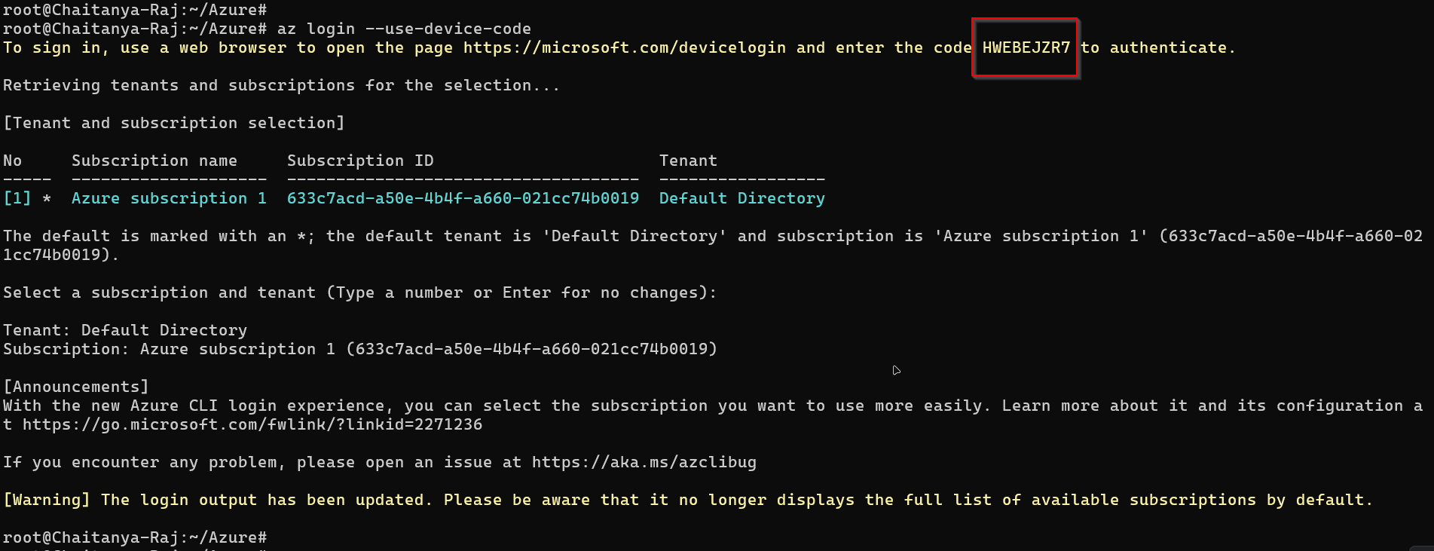
- Paste the code that was shown above in image and check in your terminal.
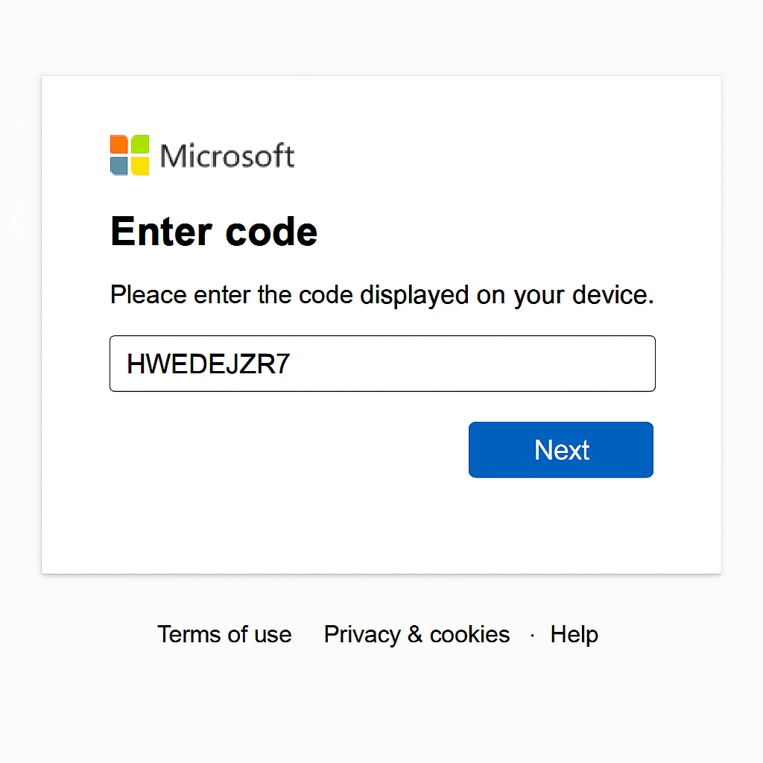

- After entering the code, you’ll be prompted to sign in with your Azure account credentials.
- Once you finish signing in, the CLI session on your terminal will automatically be authenticated.

So, you don’t need to “get” the code from anywhere else — the CLI itself generates and displays it for you when you run the command.

Would you like me to show you an example of what the output looks like when you run az login --use-device-code, so you know exactly what to expect in your terminal?

- Verify subscription
az account show
  - Displays the current subscription details.
  - Useful if you have multiple subscriptions.

root@Chaitanya-Raj:~/Azure# az account show
{
"environmentName": "AzureCloud",
"homeTenantId": "753f6bb3-2161-49b9-9591-ae1a80b3f24a",
"id": "633c7acd-a50e-4b4f-a660-021cc74b0019",
"isDefault": true,
"managedByTenants": [],
"name": "Azure subscription 1",
"state": "Enabled",
"tenantDefaultDomain": "chaitanyarajndngmail.onmicrosoft.com",
"tenantDisplayName": "Default Directory",
"tenantId": "753f6bb3-2161-49b9-9591-ae1a80b3f24a",
"user": {
"name": "chaitanyarajndn@gmail.com",
"type": "user"
}
}
root@Chaitanya-Raj:~/Azure#

- After that, you’re fully authenticated and ready to run Azure CLI commands like:
az group list
az vm list
az account show
- Switch subscription (if needed)
az account set --subscription "SUBSCRIPTION_NAME"

Common Azure CLI Commands (Imperative)

Command | Meaning
az group create --name MyRG --location eastus | Creates a new resource group named MyRG in East US region.
az group list | Lists all resource groups in your subscription.
az group show --name MyRG | Shows details of the resource group MyRG.
az group delete --name MyRG --yes --no-wait | Deletes the resource group MyRG (with confirmation bypass).
az account list | Lists all subscriptions linked to your account.
az account set --subscription "SUBSCRIPTION_NAME" | Switches to a specific subscription.

Key Characteristics of Imperative Automation
- Direct control: You specify each action.
- Procedural: Commands run in sequence.
- Good for small tasks: Quick creation/deletion of resources.
- Not scalable: Harder to manage large environments compared to declarative IaC.

Azure CLI Script Example
Let’s walk through a step-by-step Azure CLI script example that demonstrates Imperative Automation end-to-end. This will cover logging in, creating a resource group, deploying a storage account, and finally deleting everything.

KEY TO REMEMBER
===========================================
DEPENDENCY & HIERARCHY NOTES
===========================================

**Subscription** → Top-level container. All resources must belong to a subscription.
**Resource Group** → Logical container inside a subscription. Required before creating storage accounts, VMs, or networking.
**Storage Account** → Must be inside a resource group. Used to store blobs, files, queues, tables.
**Virtual Machines (VMs)** → Must be inside a resource group. Typically require networking (VNet, subnet, public IP).
**Networking Resources** → Must be inside a resource group. Provide connectivity for VMs and other services.
**Regions** → Every resource must be assigned to a region. Resource group and resources must be in supported regions.

===========================================
KEY REQUIREMENTS TO REMEMBER
===========================================

- You cannot create a resource group without a subscription.
- You cannot create a storage account, VM, or network without a resource group.
- Storage account names must be globally unique and lowercase.
- VMs require networking resources for connectivity.
- Always check available regions before creating resources.
- Deleting a resource group deletes all resources inside it.

This cheat sheet now shows commands + hierarchy + requirements in one place.
Would you like me to also add a visual diagram (like a hierarchy tree) showing how subscription → resource group → resources are linked, so you can quickly grasp the structure?

Step 1: Log in to Azure CLI
az login

OR

az login --use-device-code

- Opens a browser window for authentication.
- Enter your Microsoft/Azure credentials.
- CLI stores your session locally.
👉 Verify your subscription: az account show

Test connection to AZURE CLI

To check if your internet/firewall allows outbound HTTPS (port 443), you can test connectivity in a few simple ways:

PS C:\WINDOWS\system32> Test-NetConnection -ComputerName www.azure.com -Port 443

ComputerName : www.azure.com
RemoteAddress : 2603:1020:201:10::10f
RemotePort : 443
InterfaceAlias : Wi-Fi
SourceAddress : 2409:40d2:1161:d2d8:7c47:7a11:4398:d248
TcpTestSucceeded : True

PS C:\WINDOWS\system32>
PS C:\WINDOWS\system32>

List Regions via Azure CLI
You can fetch all available regions directly from Azure CLI:

az account list-locations -o table

This will display a table of all regions, their display names, and short codes

Step 2: Create a Resource Group
az group create --name <MyResourceGroup> --location eastus

- --name → Name of the resource group.
- --location → Region where resources will be deployed (e.g., East US).

👉 Check it exists:
az group list --output table

OR//

az group show --name <MyResourceGroup>

Step 3: Create a Storage Account
⚠️ Also NOTE: Storage account names must be lowercase, 3–24 characters, globally unique. Your account creation will fail because of uppercase letters and underscore.

az storage account create \
--name test_account141 \
--resource-group RG_Test_Prod \
--location centralindia \
--sku Standard_LRS \
--kind StorageV2

OR// (Prefer below)

az storage account create --name test_account141 --resource-group RG_Test_Prod --location centralindia --sku Standard_LRS --kind StorageV2

- --name → Globally unique storage account name.
- --resource-group → Resource group where it will live.
- --location → Same region as the resource group.
- --sku → Performance tier (Standard_LRS = locally redundant storage).
- --kind → Storage type (StorageV2 = latest general-purpose).

👉 Verify:
az storage account list --resource-group <MyResourceGroup> --output table

az storage account show --name Test_Account --resource-group RG_Test_Prod

Delete the Resource Group (Cleanup)
az group delete --name <MyResourceGroup> --yes --no-wait

- Deletes the resource group and all resources inside it.
- --yes → Skips confirmation prompt.
- --no-wait → Returns immediately without waiting for deletion to finish.

To delete the resource group you created, you can use the following Azure CLI command:
az group delete --name <MyResourceGroup>

By default, this command will prompt you for confirmation before proceeding. If you want to skip the confirmation step, you can add:
az group delete --name <MyResourceGroup> --yes

And if you want the command to run in the background without waiting for completion:
az group delete --name <MyResourceGroup> --yes --no-wait

⚠️ IMPORTANT!!! Deleting a resource group will also delete all resources inside it (VMs, storage accounts, databases, etc.). Make sure you don’t need them before running the command.
Would you like me to also show you how to list all resource groups first, so you can double-check before deleting?

Delete Storage Account

Here’s a clean workflow for managing a Storage Account in Azure using the CLI:

- 1️⃣ Create a Storage Account
az storage account create \
--name mystorageacct123 \
--resource-group RG_Test_Prod \
--location centralindia \
--sku Standard_LRS \
--kind StorageV2
- --name → globally unique name (lowercase, 3–24 chars).
- --resource-group → must exist already.
- --sku → replication type (e.g., Standard_LRS, Standard_GRS).
- --kind → StorageV2 is the recommended type.

Verify Creation
This returns JSON with details like location, SKU, and provisioning state.

- 3️⃣ Check All Storage Accounts
az storage account list -o table
This lists all storage accounts in your subscription in a neat table format.

- 4️⃣ Delete the Storage Account
az storage account delete --name mystorageacct123 --resource-group RG_Test_Prod
- Add --yes to skip confirmation.
- Add --no-wait if you don’t want to wait for completion.
⚠️ Warning: Deleting a storage account permanently removes all blobs, files, queues, and tables inside it.

👉 Would you like me to also show you how to create a container inside the storage account (for blobs), so you can start storing files right away?

Full Script (Imperative Automation)
Here’s the complete workflow in one script:
# Log in
az login

# Show current subscription
az account show

# Create resource group
az group create --name <MyResourceGroup> --location eastus

# Create storage account
az storage account create \
--name mystorageacct123 \
--resource-group <MyResourceGroup> \
--location eastus \
--sku Standard_LRS \
--kind StorageV2

# Verify storage account
az storage account list --resource-group <MyResourceGroup> --output table

# Delete resource group (cleanup)
az group delete --name <MyResourceGroup> --yes --no-wait

Common Azure CLI checks (commands and examples)
Show a specific resource group (detailed JSON):
az group show --name <MyResourceGroup>

This returns the resource group object (location, id, properties).

List all resource groups (summary):
az group list --output table

Use --output json or --output yaml for machine-readable output.

Check if a resource group exists (exit code / boolean):
az group exists --name <MyResourceGroup>

Returns true or false. Useful in scripts.

List resources inside a resource group:
az resource list --resource-group <MyResourceGroup> --output table

Shows all resources (type, name, location) in that group.

Quick examples and useful flags

Human-friendly output: add --output table or -o table.

Filter fields: use --query with JMESPath, e.g.:

az group show --name <MyResourceGroup> --query "{name:name,location:location,provisioningState:properties.provisioningState}"

Get only the location:
az group show --name <MyResourceGroup> --query "location" -o tsv

PowerShell and Portal alternatives

Azure PowerShell:
Get-AzResourceGroup -Name <MyResourceGroup>

Azure Portal: open Resource groups blade, search <MyResourceGroup> to view properties and contained resources. These alternatives are documented in Azure CLI / PowerShell references.

What the az group show output contains (key fields):

Id — full resource ID.
name — resource group name.
location — Azure region (e.g., eastus).
properties.provisioningState — provisioning status (Succeeded/Updating/Failed).
tags — any user tags.

These fields help confirm the group’s region and health.

Troubleshooting & tips
Not logged in: Run az login first.
Subscription context: If you have multiple subscriptions, set the right one:

az account set --subscription "SUBSCRIPTION_NAME_OR_ID"

Permission errors: ensure your account has Reader or higher on the subscription/resource group.
Script-friendly checks: use az group exists in CI/CD to avoid errors when creating/deleting groups.

Key Takeaways
- Imperative automation = step-by-step commands.
- Great for quick tasks and learning.
- Not as scalable as Declarative IaC (Terraform, ARM, Bicep).

✅ In short:
- Imperative Automation = Azure CLI / PowerShell scripts
- Declarative Automation = Terraform, ARM Templates, Bicep

Declarative Automation (Terraform)
Declarative = define the desired state. You tell Azure what you want, and Terraform figures out how to make it happen.

Step 1: Create a Terraform configuration file (main.tf)
# Define the Azure provider
provider "azurerm" {
features {}
}

# Step 2: Create a resource group
resource "azurerm_resource_group" "example" {
name = "MyResourceGroup"
location = "East US"
}

# Step 3: Create a storage account
resource "azurerm_storage_account" "example" {
name = "mystorageacct123"
resource_group_name = azurerm_resource_group.example.name
location = azurerm_resource_group.example.location
account_tier = "Standard"
account_replication_type = "LRS"
}

Step 2: Run Terraform commands
# Initialize Terraform (downloads provider plugins)
terraform init

# See what Terraform will do
terraform plan

# Apply the configuration (creates resources)
terraform apply

# Destroy resources (cleanup)
terraform destroy
👉 Here, you declare the desired state in a file. Terraform ensures Azure matches it.
- Pros: Scalable, repeatable, version-controlled, idempotent (safe to reapply).
- Cons: Slight learning curve, requires Terraform setup.

Side-by-Side Comparison

Aspect | Imperative (Azure CLI) | Declarative (Terraform)
Approach | Step-by-step commands | Desired state definition
Execution | Immediate, procedural | Planned, then applied
Repeatability | Low | High
Scalability | Moderate | Excellent
Best for | Quick tasks, learning | Production IaC, teams

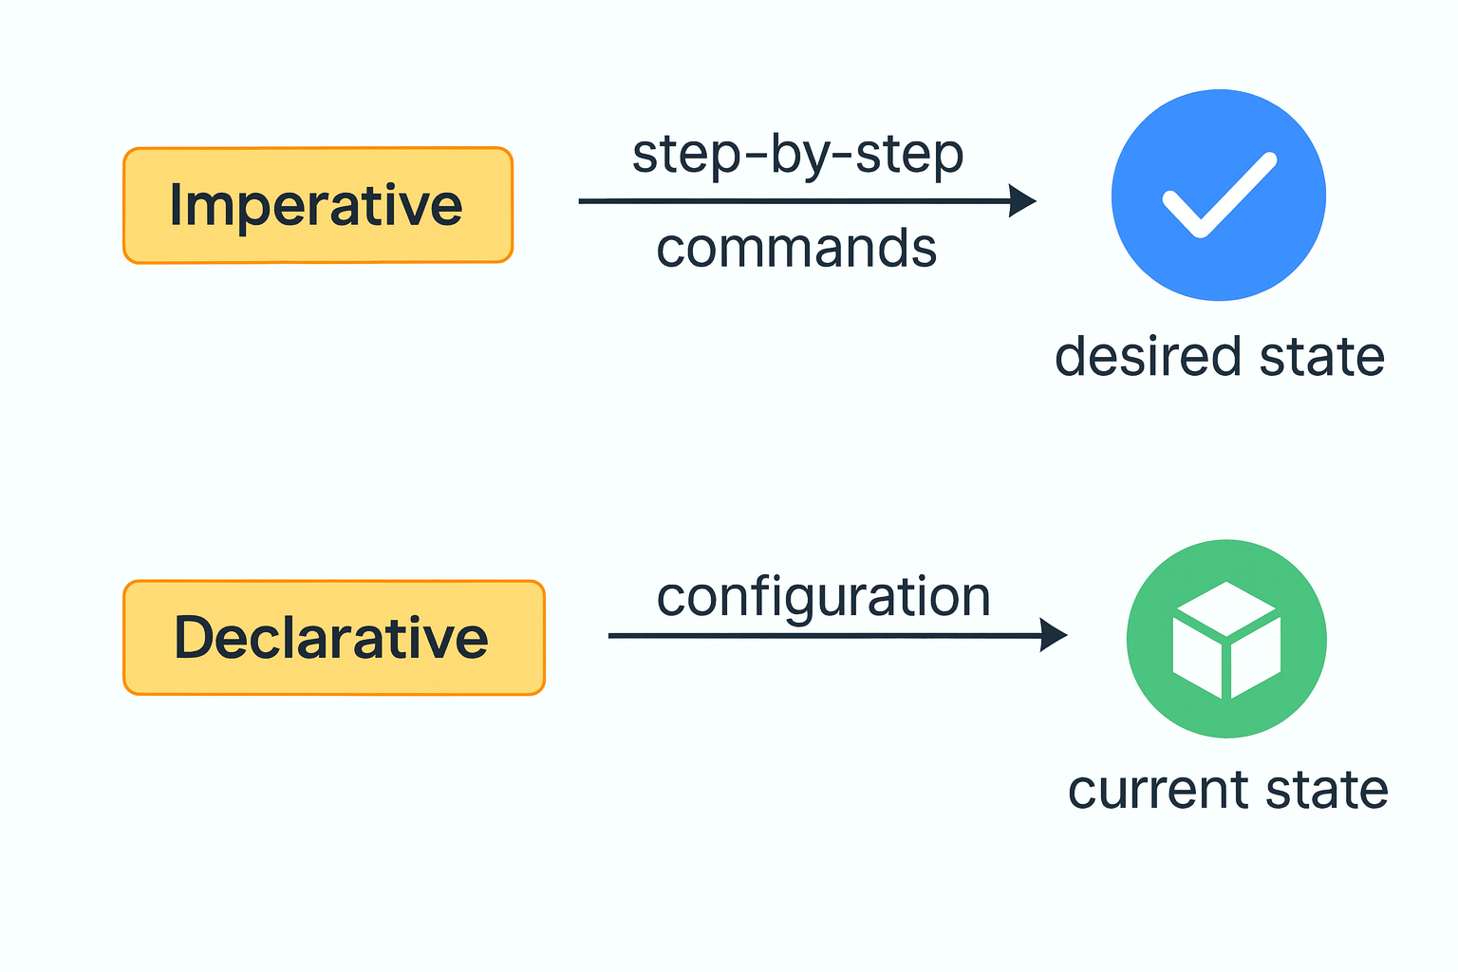

✅ Key takeaway for a fresher:
- Imperative (CLI) → You tell Azure exactly what to do step by step.
- Declarative (Terraform) → You describe what you want, and Terraform makes sure Azure matches it.

Rollback

Uninstall Azure CLI
If you decide to remove Azure CLI:

Step 1: Remove the CLI package
sudo apt-get remove -y azure-cli

Step 2: Remove repository Info (Optional)
sudo rm /etc/apt/sources.list.d/azure-cli.sources

Step 3: Remove Microsoft Signing Key (Optional)
sudo rm /etc/apt/keyrings/microsoft.gpg

Step 4: Clean up unused packages
sudo apt autoremove

Step 5: Remove Azure CLI data (optional)
rm -rf ~/.azure

- Deletes cached login info, configs, and CLI data.
- Do this only if you don’t plan to reinstall.

Summary
- Install: Either one-command script or step-by-step manual setup.
- Update: Use az upgrade (preferred) or apt-get methods.
- Uninstall: Remove package, repo, key, and data if needed.

Appendix
- Install Azure CLI
let’s break down the Azure CLI installation process you shared into simple steps. There are two options: a one-command quick install, and a step-by-step manual install.
- Option 1: Install with One Command (Quick Method)
This is the fastest way. It downloads and runs the installation script in one go.
curl -sL https://aka.ms/InstallAzureCLIDeb | sudo bash

IMPORTANT!!! You do not need to run it inside /root or create a separate Azure directory.

- curl -sL → Downloads the script quietly (-s) and follows redirects (-L).
- https://aka.ms/InstallAzureCLIDeb → Official Microsoft link to the install script.
- “ | sudo bash ” → Pipes the script directly into bash to execute with admin rights.
👉 This method is quick, but you may want to inspect the script before running it for security awareness.

cd /root

mkdir Azure

chmod 777 Azure

cd /root/Azure

ls -lrth

curl -sL https://aka.ms/InstallAzureCLIDeb -o install_AzureCLI.sh

less install_AzureCLI.sh

sudo bash install_AzureCLI.sh
- Option 2: Step-by-Step Installation (Manual Method)
This gives you more control and visibility over each step.
- Step 1: Update package lists
sudo apt-get update

- Refreshes your system’s package index so you get the latest versions.

- Step 2: Install required packages
sudo apt-get install apt-transport-https ca-certificates curl gnupg lsb-release
- Installs tools needed for secure downloads and repository management.

- Step 3: Download and install Microsoft signing key
sudo mkdir -p /etc/apt/keyrings
curl -sLS https://packages.microsoft.com/keys/microsoft.asc | \
gpg --dearmor | sudo tee /etc/apt/keyrings/microsoft.gpg > /dev/null
sudo chmod go+r /etc/apt/keyrings/microsoft.gpg

- Creates a directory for keys.
- Downloads Microsoft’s official signing key.
- Converts it into a format apt can use (gpg --dearmor).
- Ensures proper permissions so apt can read it.

- Step 4: Add Azure CLI repository
AZ_DIST=$(lsb_release -cs)
echo "Types: deb
URIs: https://packages.microsoft.com/repos/azure-cli/
Suites: ${AZ_DIST}
Components: main
Architectures: $(dpkg --print-architecture)
Signed-by: /etc/apt/keyrings/microsoft.gpg" | sudo tee /etc/apt/sources.list.d/azure-cli.sources

- Detects your Linux distribution codename (lsb_release -cs).
- Adds the Azure CLI repository to apt sources.
- Ensures packages are signed with Microsoft’s key.

- Step 5: Update repository info and install Azure CLI

sudo apt-get update

sudo apt-get install azure-cli

- Updates apt again to include the new Azure CLI repo.
- Installs the Azure CLI package.

- Summary
- Option 1 (One Command) → Quick, easy, but less transparent.
- Option 2 (Step-by-Step) → More secure, lets you see each step, better for troubleshooting.
👉 After installation, you can verify by running:
az version
This shows the installed Azure CLI version.

- Update Azure CLI
- Option 1: Update using az upgrade (Recommended)
az upgrade

- Works for Azure CLI version 2.11.0 and later.
- Updates the CLI itself and all installed extensions.
- Interactive — may ask for confirmation.
👉 For more options, see the az upgrade command reference (learn.microsoft.com in Bing).

- Option 2: Update using apt-get upgrade (Linux)
sudo apt-get update && sudo apt-get upgrade

- Updates all packages on your system, including Azure CLI.
- Good if you want to keep your system fully updated.

- Option 3: Update CLI only
sudo apt-get update && sudo apt-get install --only-upgrade -y azure-cli

- Updates only the Azure CLI package.
- Useful if you don’t want to upgrade other system packages.

