Here’s your wide-angle Draw.io-style diagram showing how LRS, ZRS, GRS, and GZRS are structured and linked:
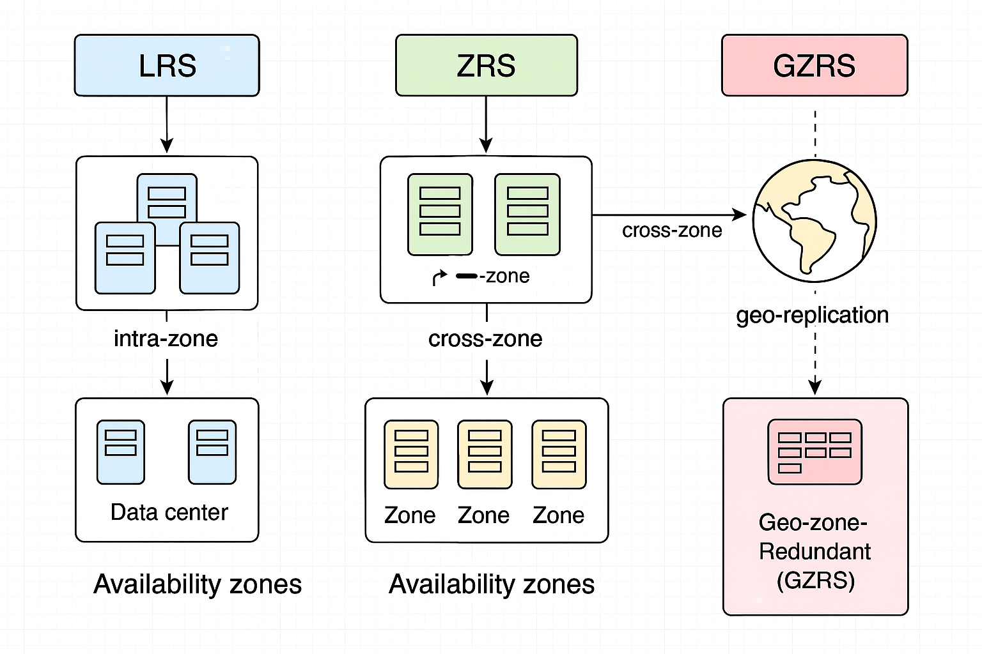
- Diagram Highlights
- LRS (Locally Redundant Storage):
Three individual datacenters, each with internal replication. These are the building blocks — each one replicates data within itself.
- ZRS (Zone Redundant Storage):
Groups of three LRS datacenters form three Availability Zones. Data is replicated across these zones within the same region.
- GRS (Geo-Redundant Storage):
A Primary Region (with ZRS structure) replicates data to a Secondary Region using geo-replication. This protects against regional disasters.
- GZRS (Geo-Zone Redundant Storage):
Combines ZRS (zone-level replication) and GRS (geo-level replication). The diagram shows this with a highlighted box around the primary ZRS and the geo arrow to the secondary region.
This layout gives you a clear, layered view of how each redundancy model builds on the previous one — from local to zone to geo — and how they interconnect. Let me know if you’d like a version with editable Draw.io XML or a bundled export. 

