📄 AZURE HIERARCHY - PHASE 2 (IDENTITY + ACCESS) 📄

MOP Version 1

Table of Contents
1 STEP 01: MICROSOFT ENTRA ID ➜ OVERVIEW 4
1.1 STEP 02: USERS 6
1.2 STEP 03: CREATE NEW USER (devuser) 8
1.2.1 STEP 04: USER PROPERTIES (Next: Properties) 10
1.2.2 STEP 05: USER ROLE ASSIGNMENTS 12
1.2.3 Creating qauser and produser also 17
1.3 STEP 04: GROUPS 20
1.3.1 CREATE GROUP 22
1.3.2 Create DEV-TEAM GROUP 24
1.3.3 Create QA-Team & Prod-Team 28
1.3.4 Group Membership - (Add users in new Group first) 30
1.3.5 AZURE PHASE 2 PROGRESS 37
1.4 RBAC = Role Based Access Control / IAM – Identity and Access Management 39
1.4.1 Resource level IAM - Small Scope Access 39
1.4.2 SUBSCRIPTION LEVEL (INHERITED) - Large Scope Access 44
1.5 TILL NOW: 54
1.6 NOTES 55

STEP 01: MICROSOFT ENTRA ID ➜ OVERVIEW

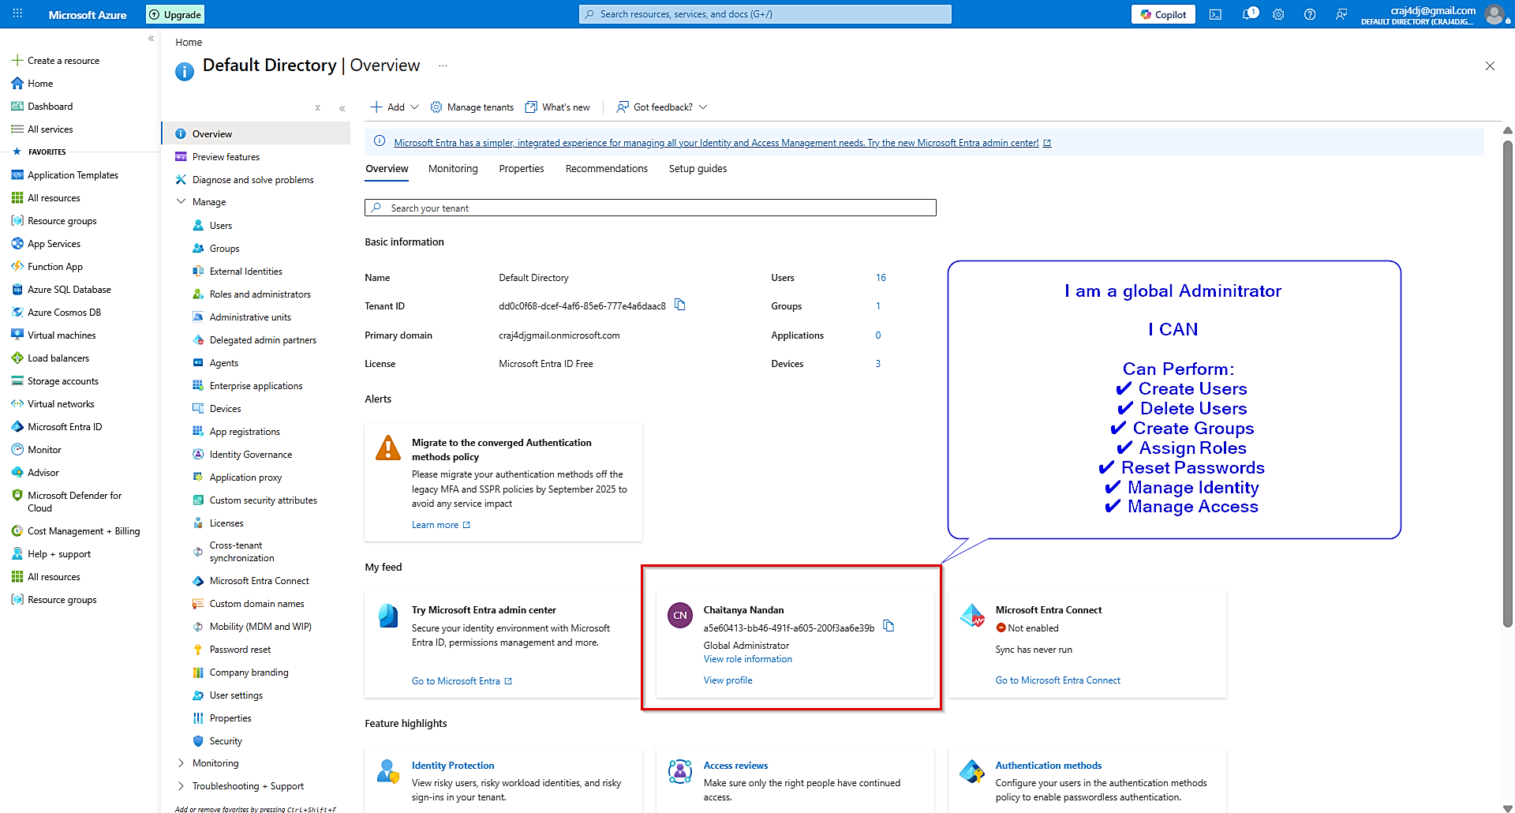

====================================================
AZURE HIERARCHY - PHASE 2 (IDENTITY + ACCESS)
STEP-01 : MICROSOFT ENTRA ID > OVERVIEW
====================================================

IMPORTANT THINGS IN THIS SCREEN

1. TENANT
Name : Default Directory

- Tenant is the highest identity boundary in Azure.
- All Users, Groups, Roles and Applications belong to a Tenant.
- Think of Tenant as a Company.

Example:
ABC Telecom
├─ Users
├─ Groups
├─ Roles
└─ Applications

2. PRIMARY DOMAIN
craj4djgmail.onmicrosoft.com

- Default Azure domain for this Tenant.
- New users can be created using this domain.

Example:
devuser@craj4djgmail.onmicrosoft.com
qauser@craj4djgmail.onmicrosoft.com

3. GLOBAL ADMINISTRATOR ⭐ MOST IMPORTANT

- Highest privilege role in Microsoft Entra ID.
- Equivalent to Linux root user.
- Has full control over the Tenant.

Can Perform:
✔ Create Users
✔ Delete Users
✔ Create Groups
✔ Assign Roles
✔ Reset Passwords
✔ Manage Identity
✔ Manage Access

Memory Trick:

Linux = root
Windows = Administrator
Azure = Global Administrator

WHY IMPORTANT?

Before learning Users, Groups, IAM and RBAC,
we must know who has permission to perform these actions.

In this lab:
You are Global Administrator.

Therefore you can perform all Phase-2 practicals.

CURRENT POSITION IN HIERARCHY

Tenant
↓
Users ← Next Step
↓
Groups
↓
Roles
↓
IAM
↓
Subscription Access

STEP 02: USERS

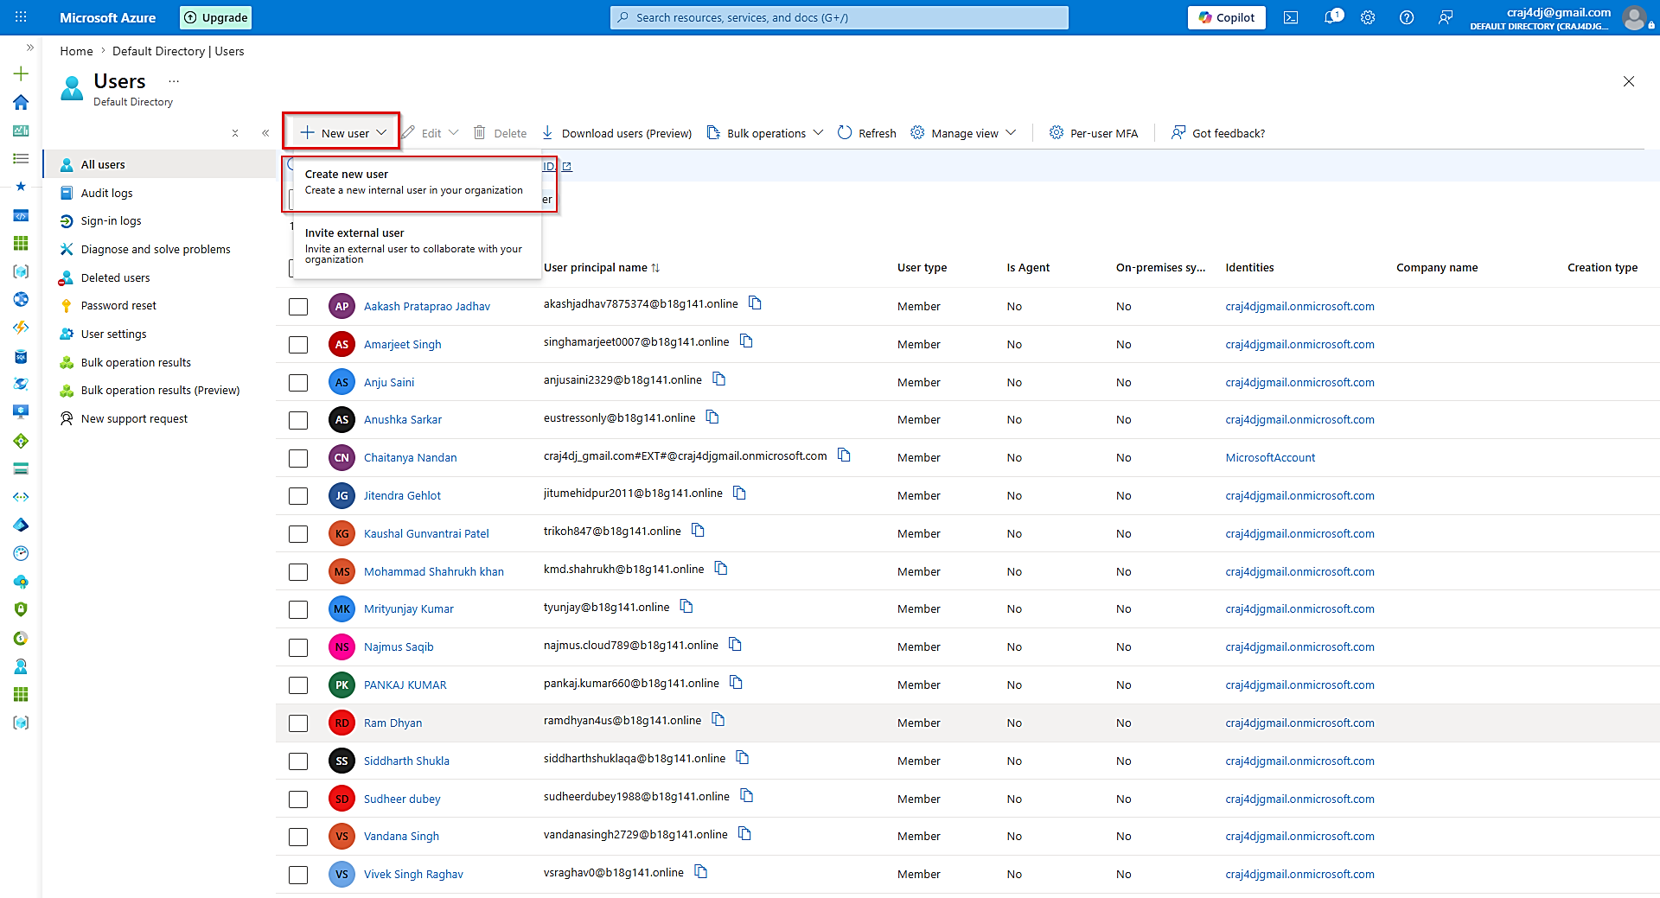

====================================================
AZURE PHASE-2
STEP-02: USERS
====================================================

USERS PAGE PURPOSE

Stores all identities inside a Tenant.

IMPORTANT ITEMS

1. New User
- Creates new identities.

2. User Principal Name (UPN)
- Azure username.
- Used during login.

Example:
devuser@company.com

3. User Type

Member
- Internal user.
- Employee.

Guest
- External user.
- Vendor/Partner.

4. Current User

Chaitanya Nandan

Type:
Member

Role:
Global Administrator

5. Total Users

16 Users Found

NOTE

Do not modify existing users.

We will create our own users for lab.

====================================================
MEMORY TRICK
====================================================

Tenant = Company

User = Employee

UPN = Login ID

Member = Internal Employee

Guest = External Person

STEP 03: CREATE NEW USER (devuser)

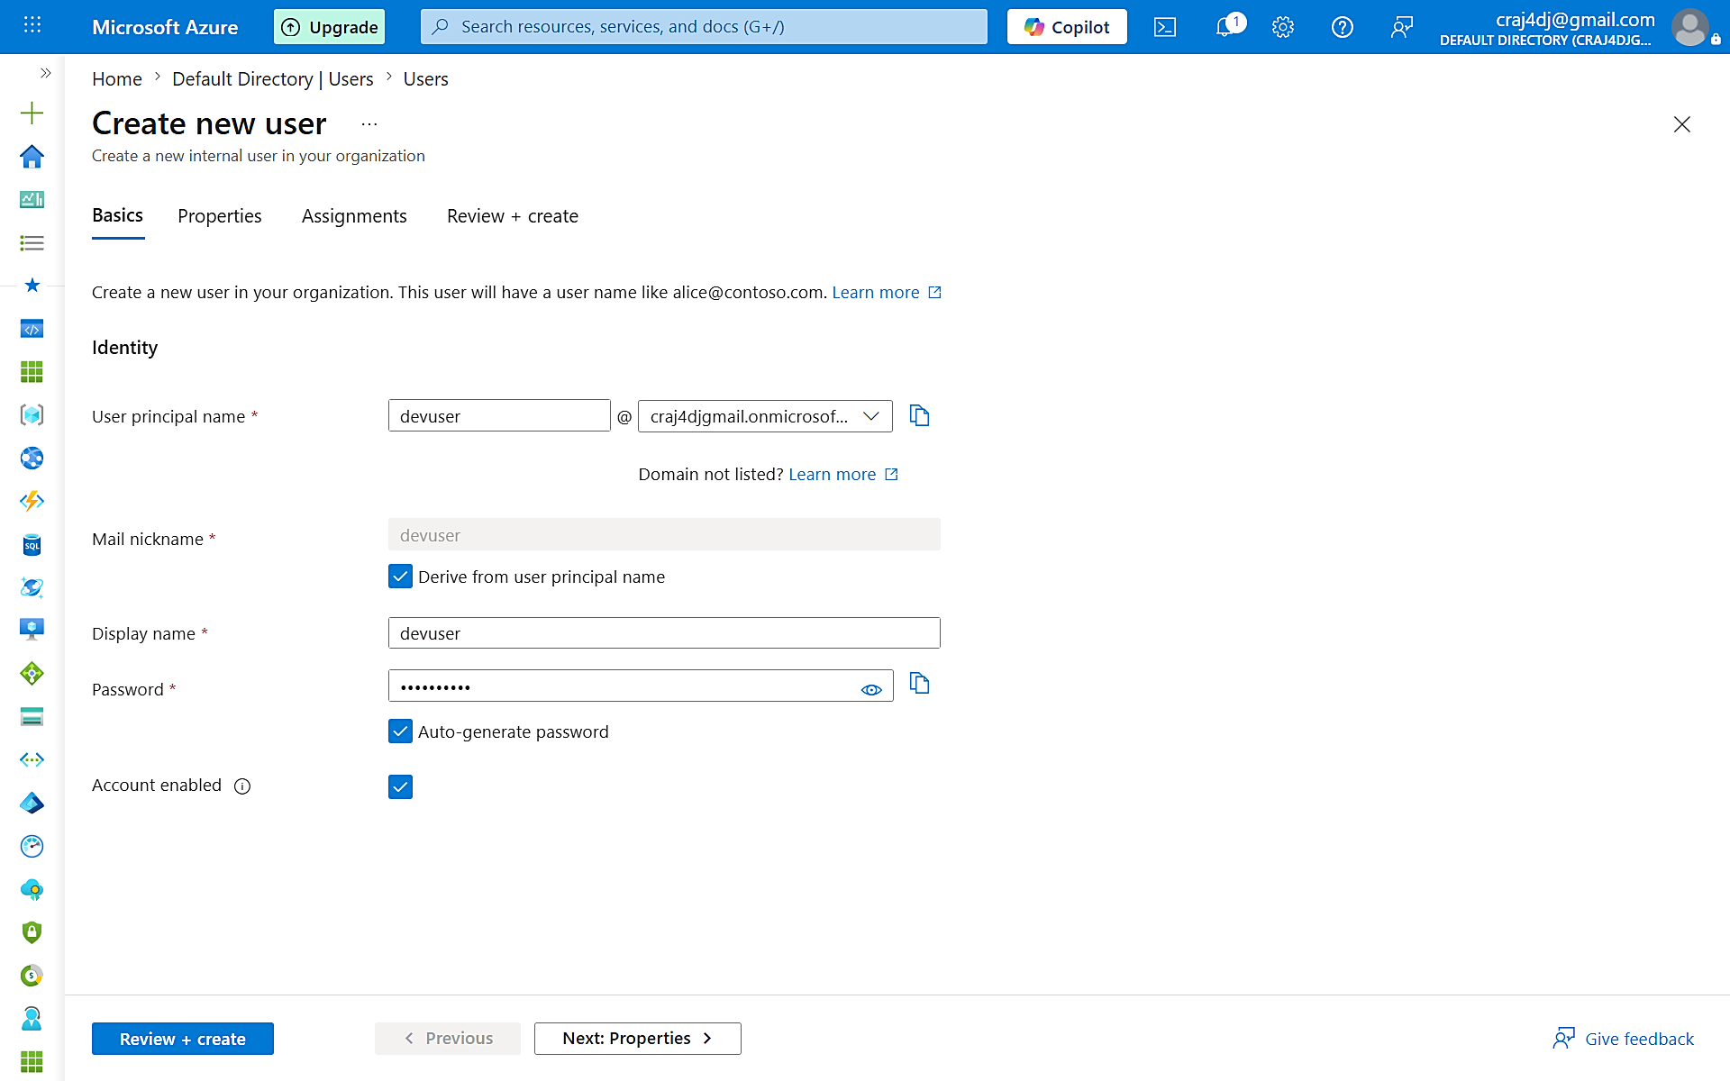

====================================================
AZURE PHASE-2
STEP-03: CREATE DEV USER
====================================================

USER PRINCIPAL NAME

devuser

Azure Login ID:

devuser@craj4djgmail.onmicrosoft.com

DISPLAY NAME

Current:
devuser

Recommended:
Dev User

Reason:
Display Name should be human readable.

Example:

UPN = devuser
Display Name = Dev User

PASSWORD

Auto Generated

ACCOUNT STATUS

Enabled

Meaning:

User can login to Azure.

====================================================
IDENTITY CREATED

Tenant
↓
devuser

Next:
Properties
↓
Assignments
↓
Create

====================================================
IDENTITY FLOW
====================================================

Tenant
↓
User
↓
Group
↓
Role
↓
IAM
↓
Azure Resource

====================================================
MOST IMPORTANT CONCEPT
====================================================

No Identity
=
No Access

Therefore User creation is the first practical step
of Identity & Access Management.

STEP 04: USER PROPERTIES (Next: Properties)

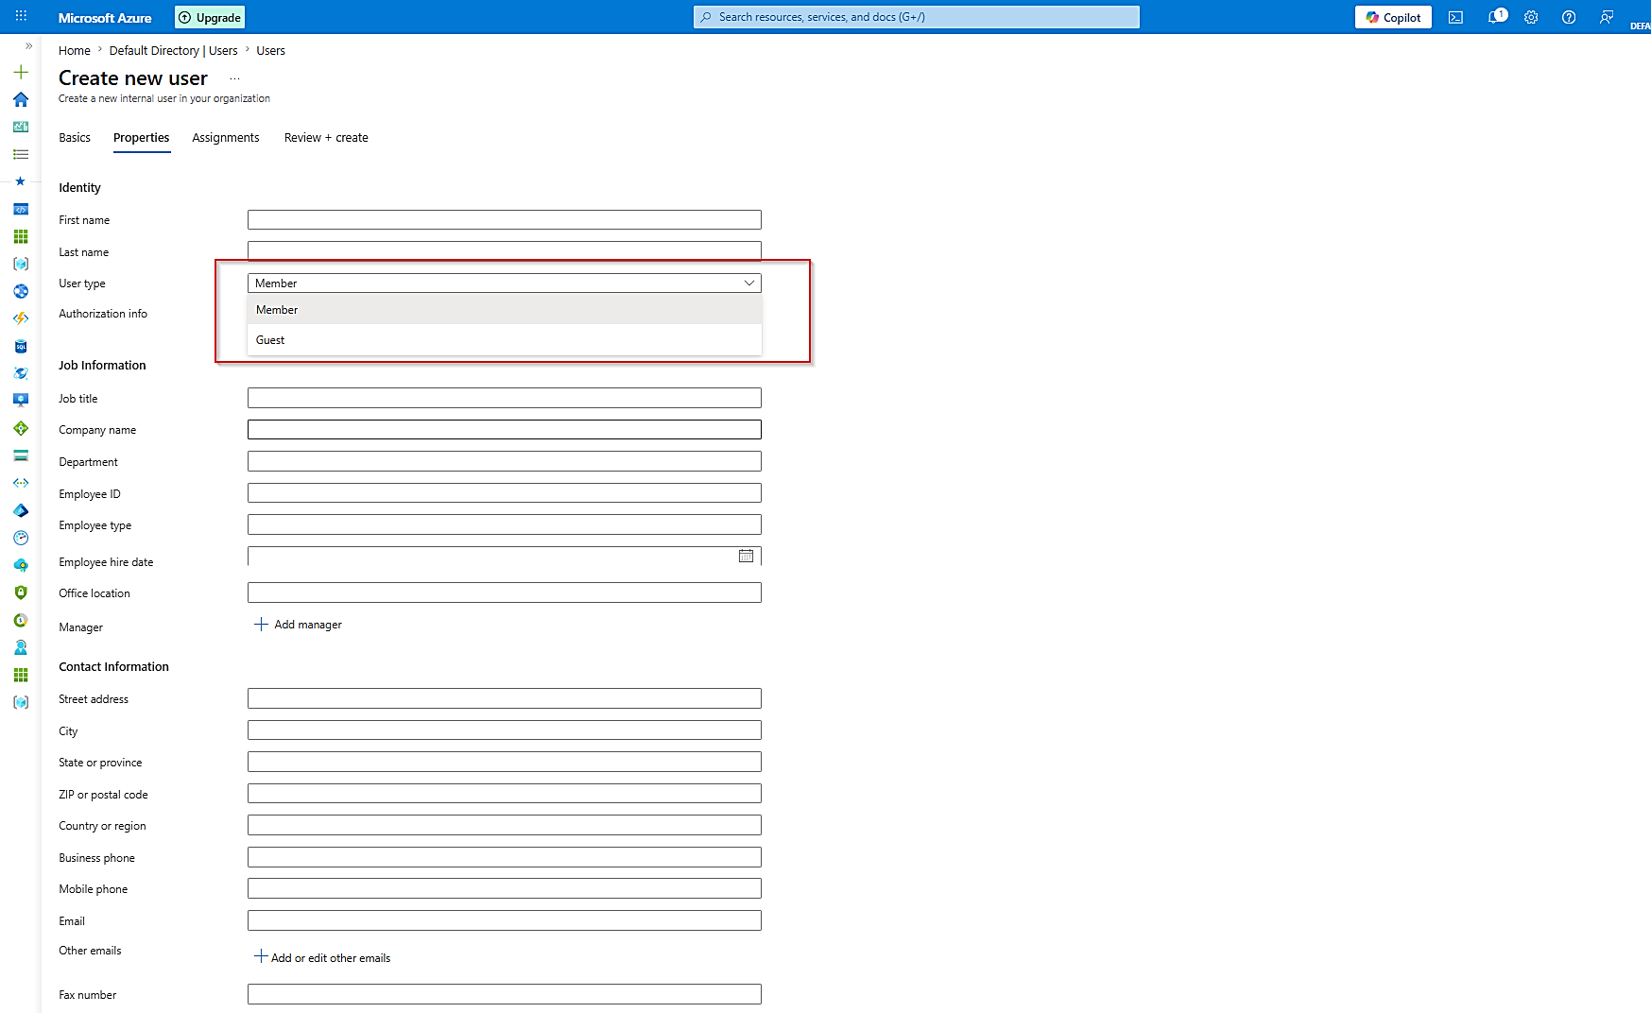

====================================================
AZURE PHASE-2
STEP-04 : USER PROPERTIES
====================================================

PURPOSE

Additional information about User.

Identity already created in Basics tab.

Properties tab stores metadata.

====================================================
MOST IMPORTANT FIELD
====================================================

User Type

Current Value:
Member

Meaning:
Internal organization user.

Examples:

Dev User
QA User
Azure Admin
Network Engineer

All are Members.

====================================================
GUEST USER
====================================================

Guest = External User

Examples:

Vendor
Consultant
Partner Company
Customer

Guest users are invited from outside.

====================================================
MEMBER vs GUEST
====================================================

Member
--------
Internal Employee
Managed by Organization
Full Identity

Guest
-------
External Person
Limited Access
Usually Temporary

====================================================
JOB INFORMATION
====================================================

Job Title
Department
Manager
Office Location

Purpose:

Organization Information

Not required for our lab.

====================================================
CONTACT INFORMATION
====================================================

Address
Phone
Email

Purpose:

User Directory Information

Not required for our lab.

====================================================
FOR OUR LAB
====================================================

Keep:

User Type = Member

Leave all other fields empty.

Reason:

We are creating an internal employee account.

====================================================
ENTERPRISE EXAMPLE
====================================================

Tenant
│
├── Dev User (Member)
├── QA User (Member)
├── Prod User (Member)
│
└── Vendor User (Guest)

====================================================
IMPORTANT CONCEPT
====================================================

Member = Internal Employee

Guest = External User

STEP 05: USER ROLE ASSIGNMENTS

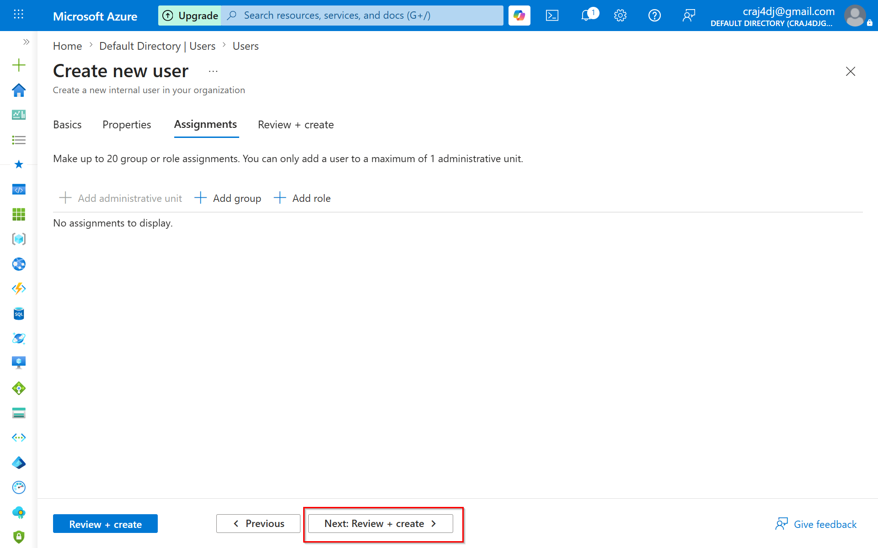

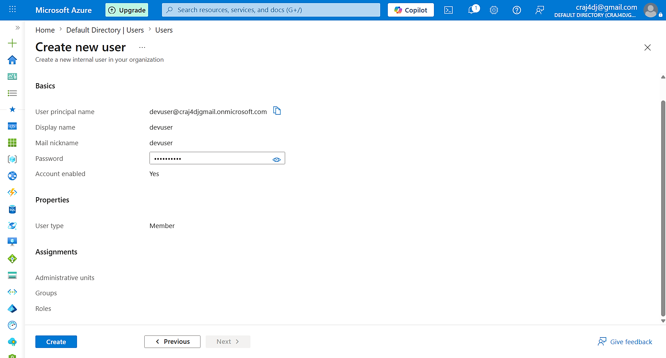

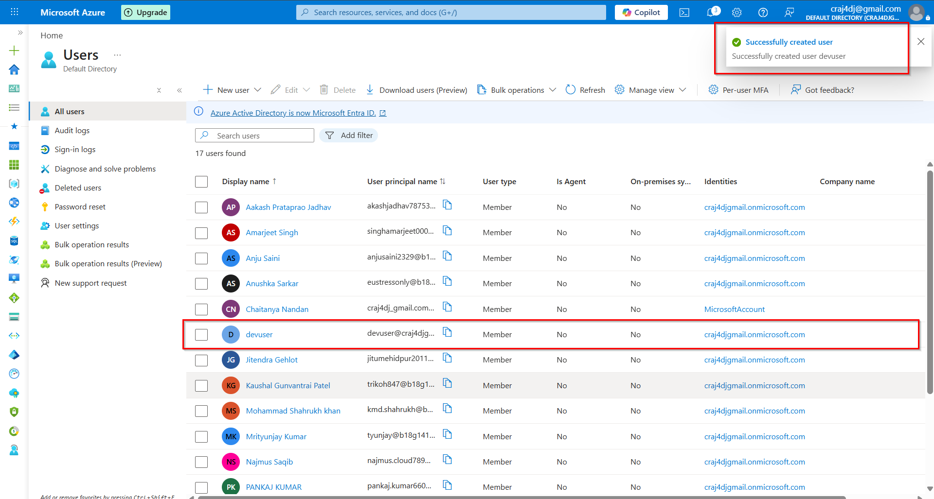

ROLE ASSIGNMENT IMPORTANT NOTE!!!
We have not assigned any roles yet. we will assign later in group.

• A User does not get permissions automatically after creation.
• Permissions are granted through Roles (Reader, Contributor, Owner, etc.).
• In real environments, Roles are usually assigned to Groups, not directly to Users.
• This makes access management easier when many users join or leave the organization.
• Therefore, before learning Role Assignments, we should understand Groups as well.

Small Lab:
User -> Role

Real Enterprise:
User -> Group -> Role -> IAM

====================================================
AZURE PHASE-2
STEP-05 : ASSIGNMENTS
====================================================

MOST IMPORTANT AZURE CONCEPT

User ≠ Permission

Creating a User does NOT give any access.

Example:

Created:
devuser

Can login?
YES

Can manage Azure Resources?
NO

Can create VM?
NO

Can create Resource Group?
NO

Can modify Azure Resources?
NO

Reason:

No Role Assigned

====================================================
ACCESS FORMULA
====================================================

User
+
Role
+
Scope
=
Access

Example:

devuser
+
Contributor
+
Resource Group
=
Can manage resources inside that RG

====================================================
THIS SCREEN OPTIONS
====================================================

1. Add Group

Adds user into an existing group.

Example:

Dev-Team
QA-Team
Prod-Team

2. Add Role

Assign Azure AD Role.

Examples:

Global Administrator
User Administrator
Groups Administrator

3. Add Administrative Unit

Used in large enterprises.

Not required for our lab.

====================================================
IMPORTANT
====================================================

We will NOT assign any role now.

Reason:

First create identity.

Then learn Groups.

Then learn Roles.

Then learn IAM.

Following Azure hierarchy.

====================================================
AZURE HIERARCHY
====================================================

Tenant
↓
User
↓
Group
↓
Role
↓
IAM
↓
Resource Group
↓
Resources

====================================================
MEMORY TRICK
====================================================

User = Person

Role = Permission

Without Role
=
No Power

Creating qauser and produser also

QA USER
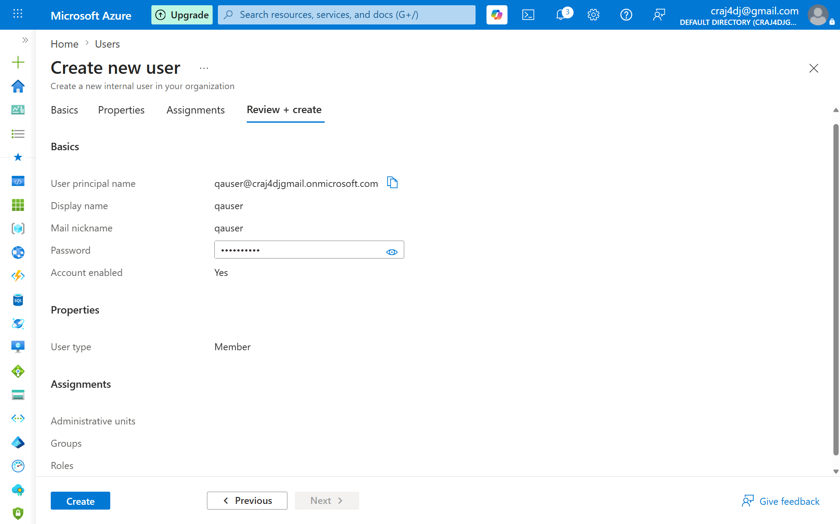

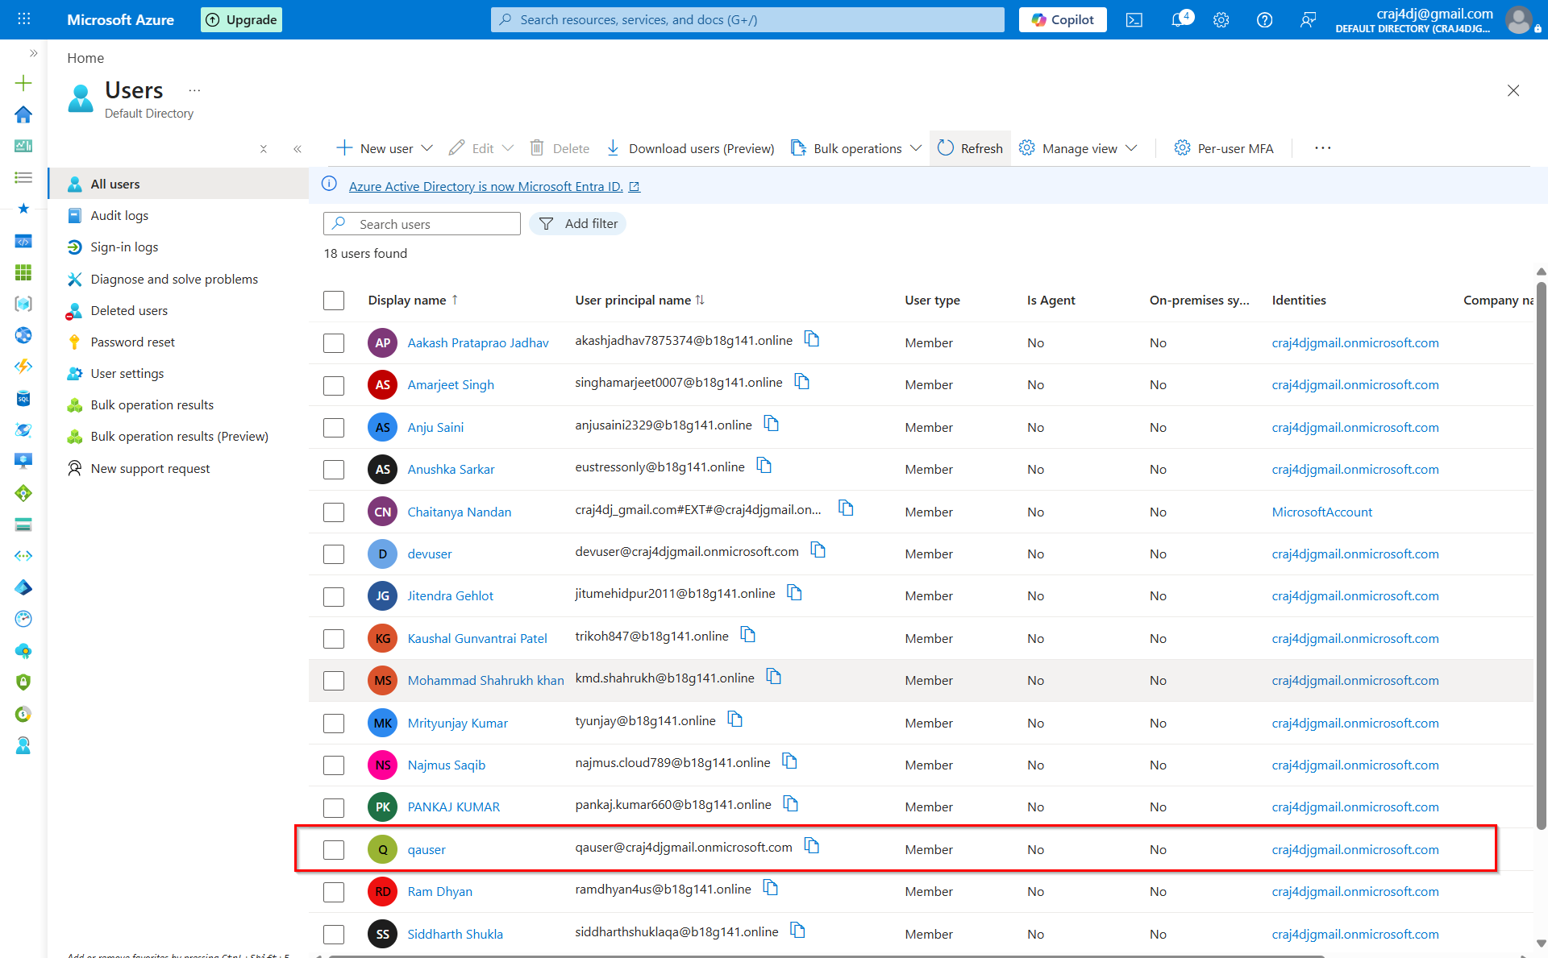

PROD-USER:
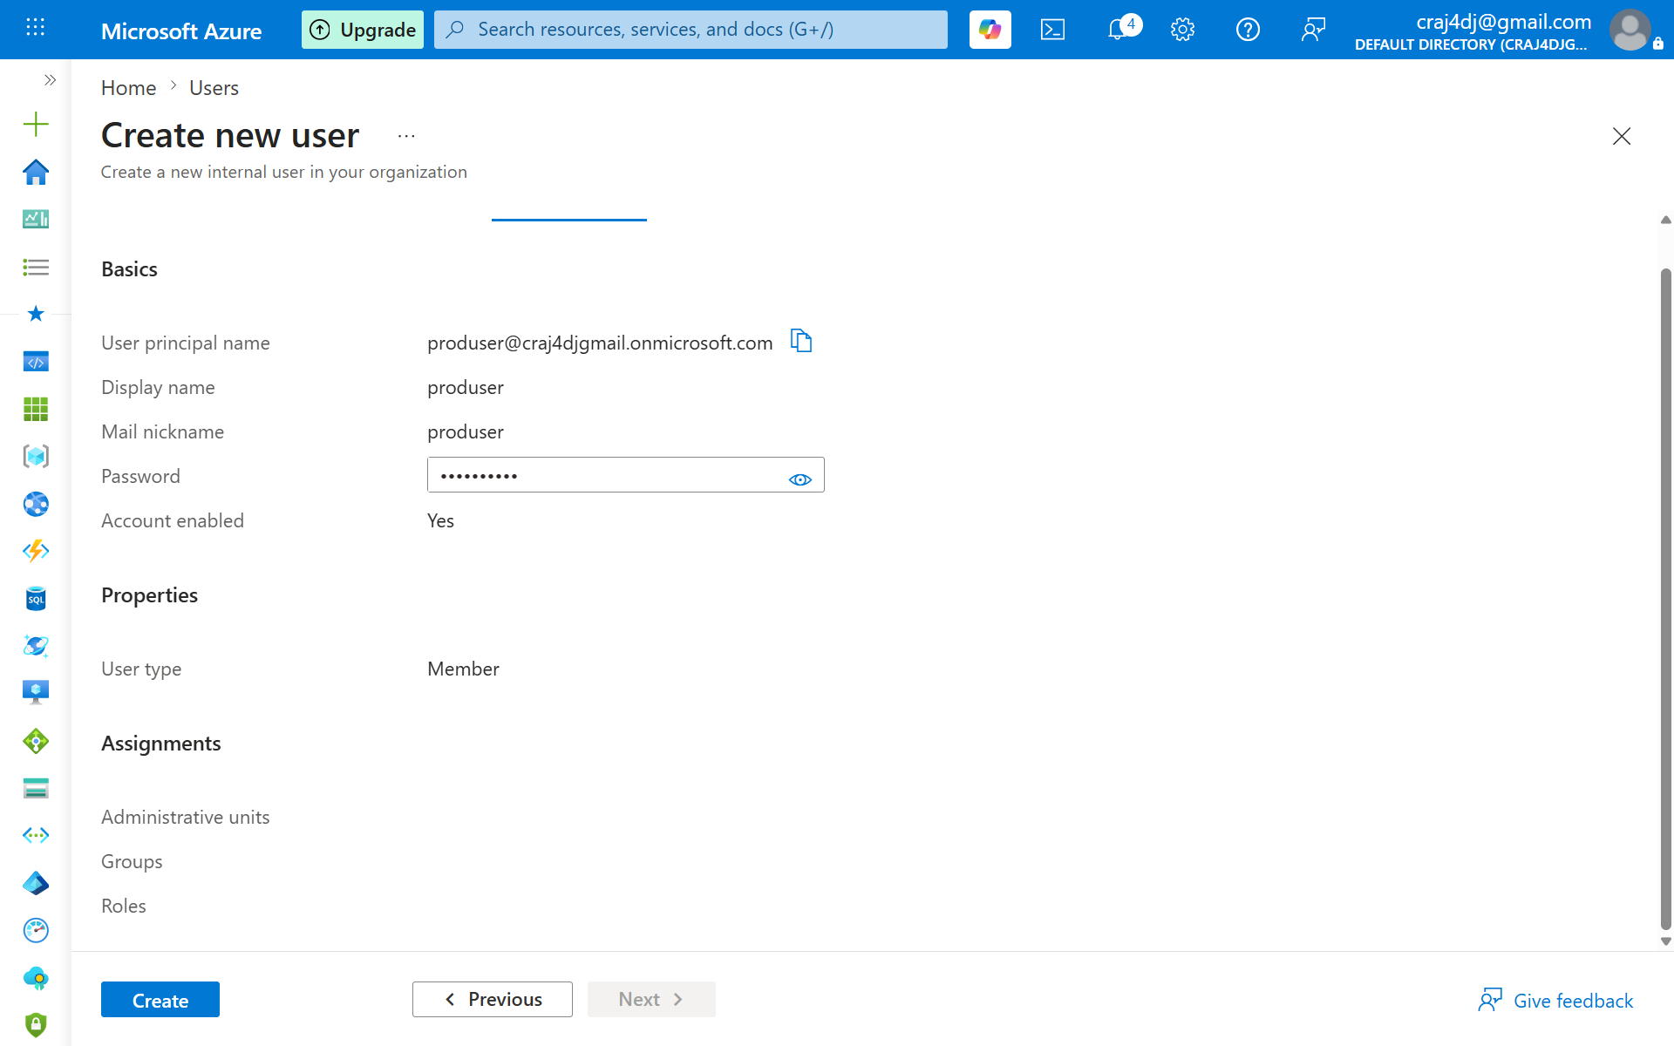

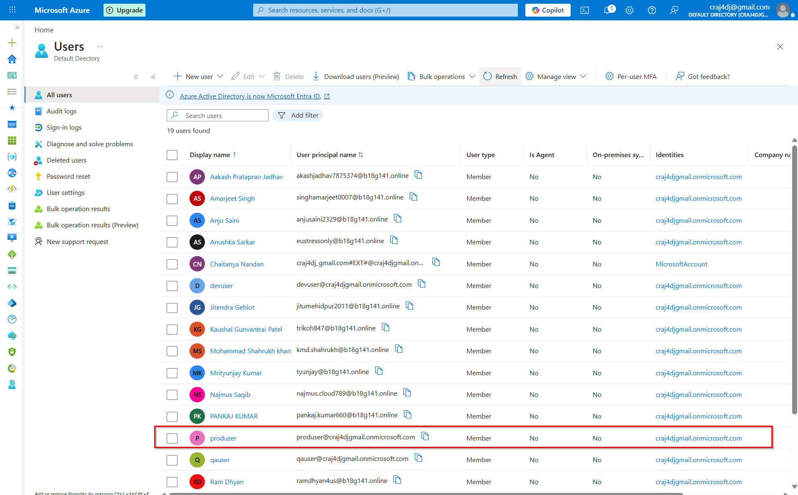

====================================================
AZURE PHASE-2
STEP 06: LAB USERS CREATED
====================================================

Created Users

1. devuser
2. qauser
3. produser

User Type:
Member

Role:
None

Group:
None

IMPORTANT

Users have identities only.

No permissions assigned yet.

Current Hierarchy

Tenant
│
├── Global Administrator
├── devuser
├── qauser
└── produser

NEXT STEP

Groups

Reason:

In real enterprises, permissions are usually assigned
to Groups instead of individual Users.

Small Lab:
User -> Role

Real Enterprise:
User -> Group -> Role -> IAM
====================================================

STEP 04: GROUPS

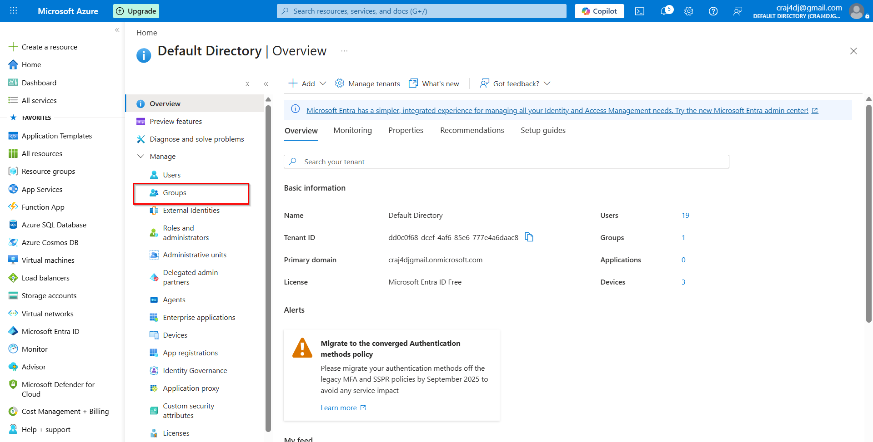

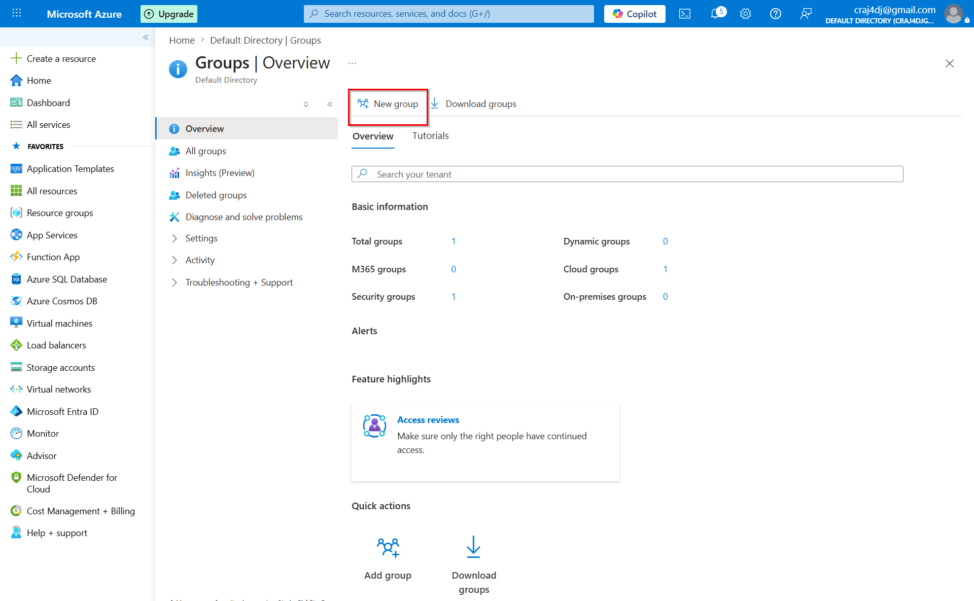

====================================================
AZURE PHASE-2
STEP 1: GROUPS
====================================================

WHAT IS A GROUP?

A Group is a collection of Users.

Example:

Dev-Team
├── devuser
├── developer01
├── developer02

Instead of assigning permissions to each user,
permissions can be assigned to the Group.

WHY USE GROUPS?

Without Groups:

devuser -> Contributor
developer01 -> Contributor
developer02 -> Contributor

With Groups:

Dev-Team -> Contributor

All members inherit the same access.

BENEFITS

✔ Easier management
✔ Scalable
✔ Enterprise standard
✔ Centralized access control

CURRENT STATUS

Tenant
│
├── devuser
├── qauser
└── produser

NEXT

Create Groups:

Dev-Team
QA-Team
Prod-Team

Small Lab:
User -> Role

Real Enterprise:
User -> Group -> Role -> IAM
====================================================

CREATE GROUP

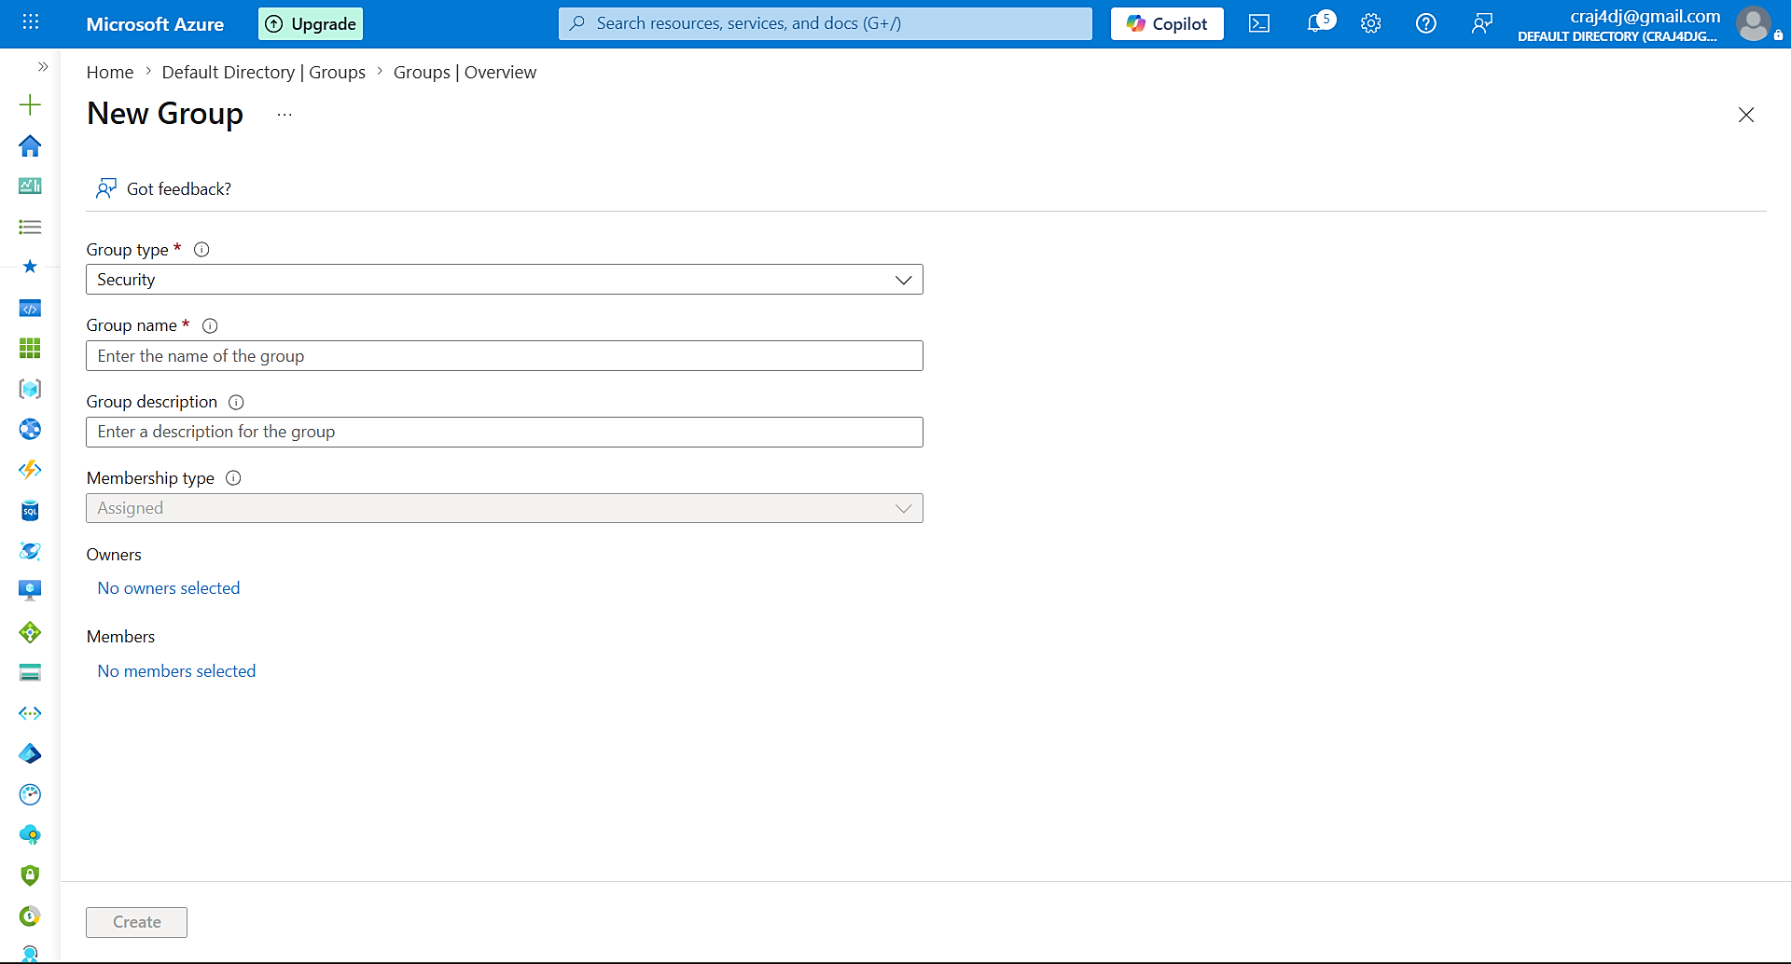

====================================================
AZURE PHASE-2
CREATE GROUP
====================================================

WHAT IS A GROUP?

A Group is a collection of Users.

Example:

Dev-Team
├── devuser
├── developer01
└── developer02

====================================================
MOST IMPORTANT FIELDS
====================================================

1. Group Type

Current:
Security

Purpose:
Used for RBAC, IAM and Access Management.

This is the most commonly used group type.

2. Group Name

Example:

Dev-Team
QA-Team
Prod-Team

====================================================
LESS IMPORTANT FOR NOW
====================================================

Group Description
Membership Type
Owners

Can be configured later.

====================================================
MEMBERSHIP TYPE
====================================================

Assigned

Meaning:
Users are added manually.

Example:

Add devuser
Add qauser
Add produser

====================================================
OUR LAB DESIGN
====================================================

Dev-Team
└── devuser

QA-Team
└── qauser

Prod-Team
└── produser

====================================================
IMPORTANT
====================================================

Groups do not provide permissions.

Permissions will be assigned later through Roles and IAM.

Access Flow:

User
↓
Group
↓
Role
↓
IAM
↓
Azure Resources
====================================================

Create DEV-TEAM GROUP

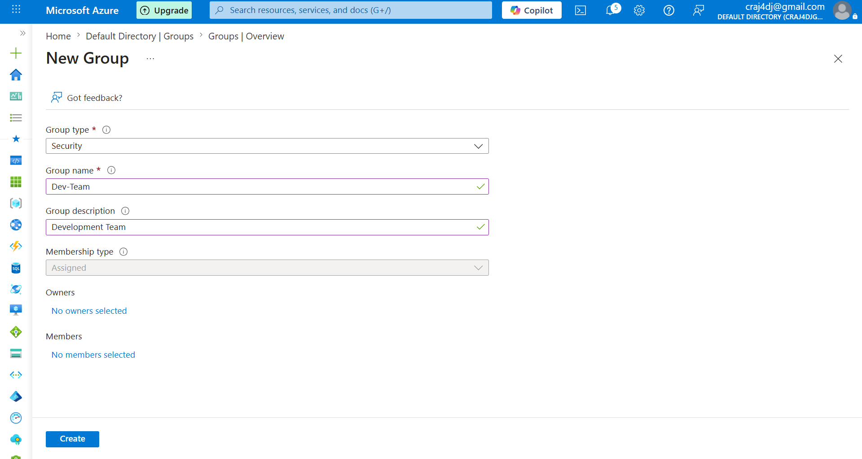

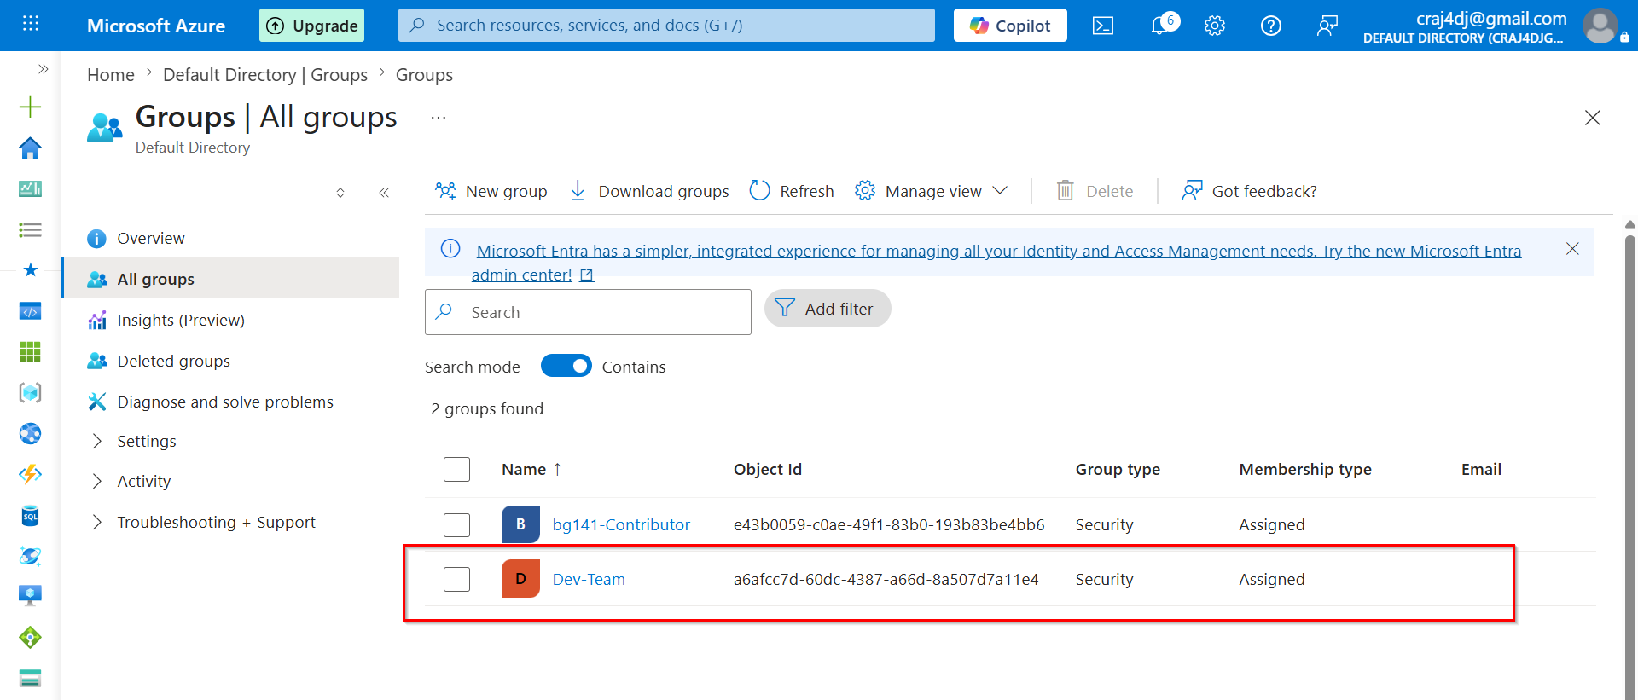

====================================================
AZURE PHASE-2
Create DEV-TEAM GROUP
====================================================

Group Name:
Dev-Team

Group Type:
Security

Membership Type:
Assigned

Description:
Development Team

IMPORTANT

Security Group is used for:

✔ RBAC
✔ IAM
✔ Access Management

Membership Type = Assigned

Meaning:

Users are added manually.

Example:

Dev-Team
└── devuser

====================================================
OWNER vs MEMBER
====================================================

Owner
-----
Manages the Group.

Can add/remove members.

Member
------
Belongs to the Group.

Receives permissions assigned to the Group.

Example:

Owner:
Global Administrator

Member:
devuser

====================================================
IMPORTANT!!!

Group does NOT provide permissions.

Permissions will be assigned later using:

Group
↓
Role
↓
IAM
====================================================

====================================================
AZURE PHASE-2
IMPORTANT!!!
GROUP MEMBER ADDITION APPROACHES
====================================================

APPROACH A (RECOMMENDED - ENTERPRISE STYLE)

Create Group First
↓
Open Group
↓
Add Members Later

Example:

Dev-Team
QA-Team
Prod-Team

After Group Creation:

Dev-Team -> Add devuser
QA-Team -> Add qauser
Prod-Team -> Add produser

Benefits:

✔ Real Enterprise Workflow
✔ Better Learning Sequence
✔ Easy Group Management
✔ Matches Azure Hierarchy

Hierarchy:

User
↓
Group
↓
Role
↓
IAM

====================================================
APPROACH B (QUICK METHOD)
====================================================

Create Group
↓
Add Member Immediately
↓
Create Group

Example:

Dev-Team -> devuser
QA-Team -> qauser
Prod-Team -> produser

Benefits:

✔ Faster Setup
✔ Fewer Steps

Limitations:

✖ Learning Flow Becomes Compressed
✖ Does Not Clearly Separate Group Creation
from Member Management

====================================================

OUR LAB CHOICE

✔ Approach A (Enterprise Style)

Reason:
We want to understand each Azure hierarchy
component separately before moving to the next one.

Users
↓
Groups
↓
Members
↓
Roles
↓
IAM
====================================================

Create QA-Team & Prod-Team

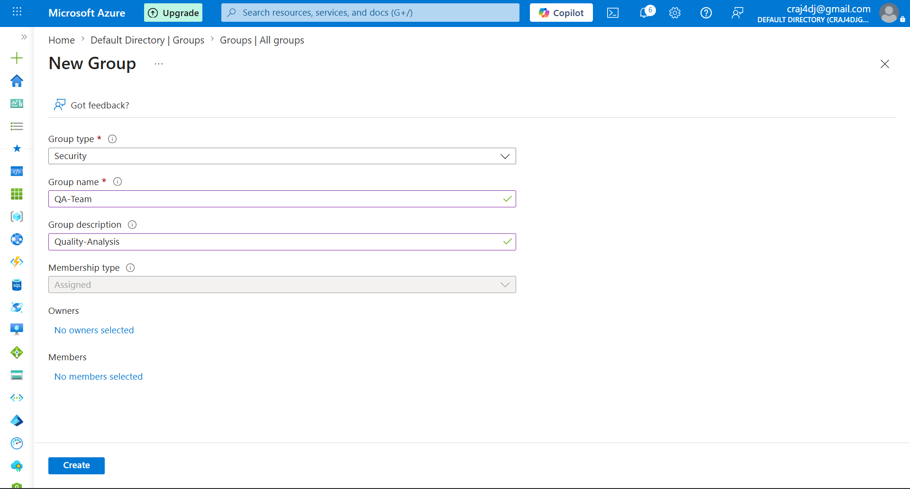

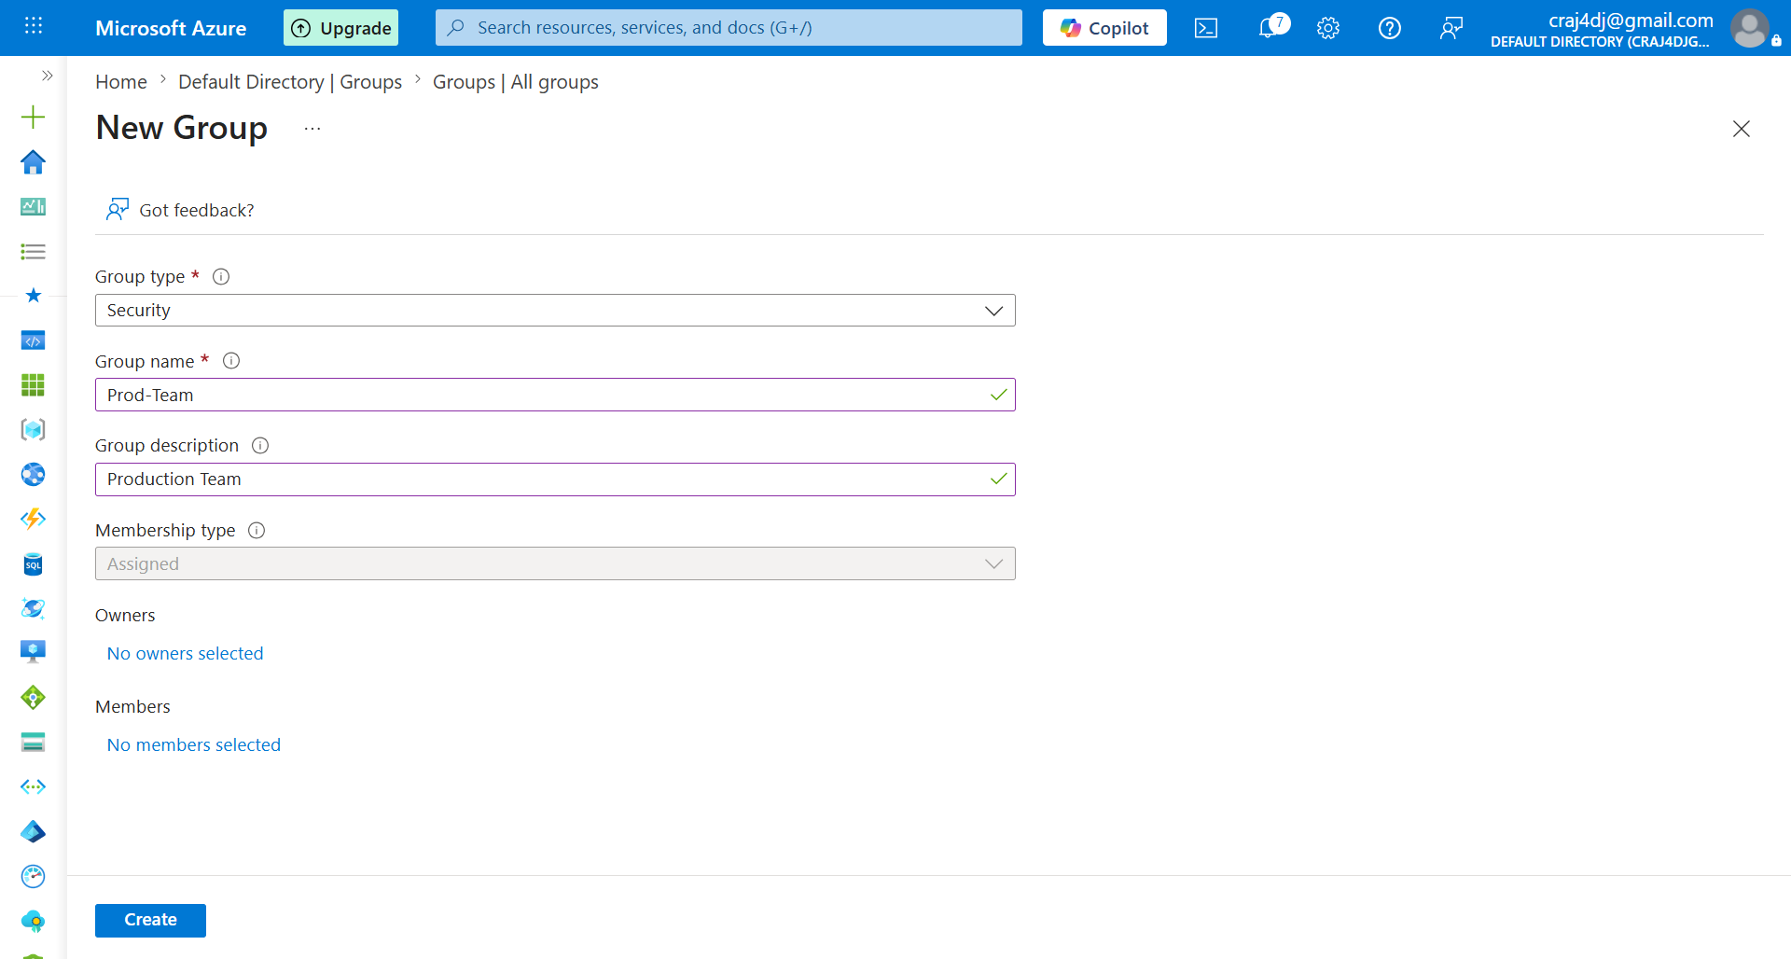

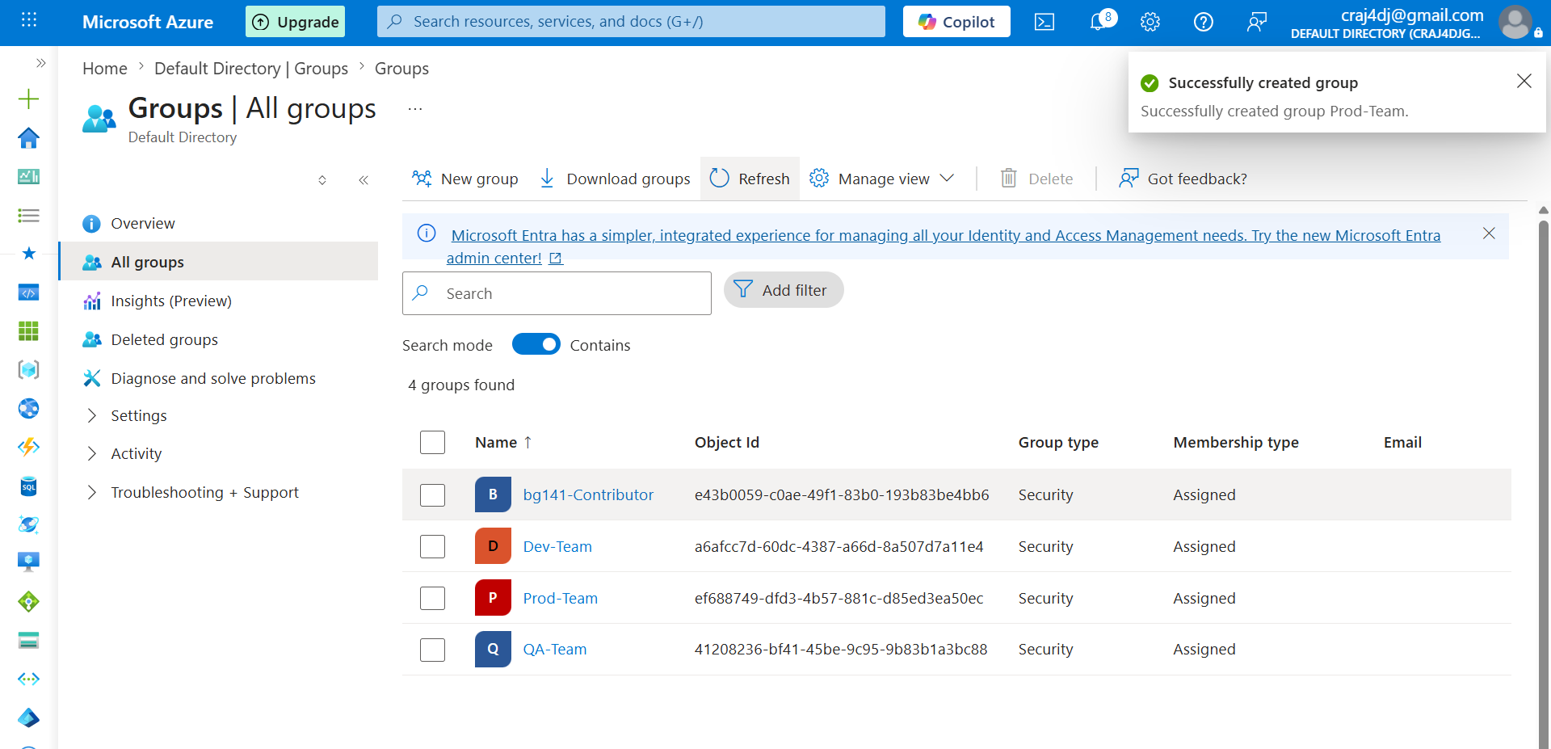

====================================================
AZURE PHASE-2
STEP-12 : GROUPS CREATED
====================================================

Created Security Groups

1. Dev-Team
2. QA-Team
3. Prod-Team

Group Type:
Security

Membership Type:
Assigned

IMPORTANT

Groups have been created successfully.

Current State

Users
-----
devuser
qauser
produser

Groups
------
Dev-Team
QA-Team
Prod-Team

At this stage:

✔ Users Exist
✔ Groups Exist

❌ Users are NOT members of Groups yet
❌ No Roles assigned
❌ No IAM configured

NEXT STEP

Add Users to Groups

Dev-Team
└── devuser

QA-Team
└── qauser

Prod-Team
└── produser

Access Model

User
↓
Group
↓
Role
↓
IAM
↓
Azure Resources
===================================================

Group Membership - (Add users in new Group first)

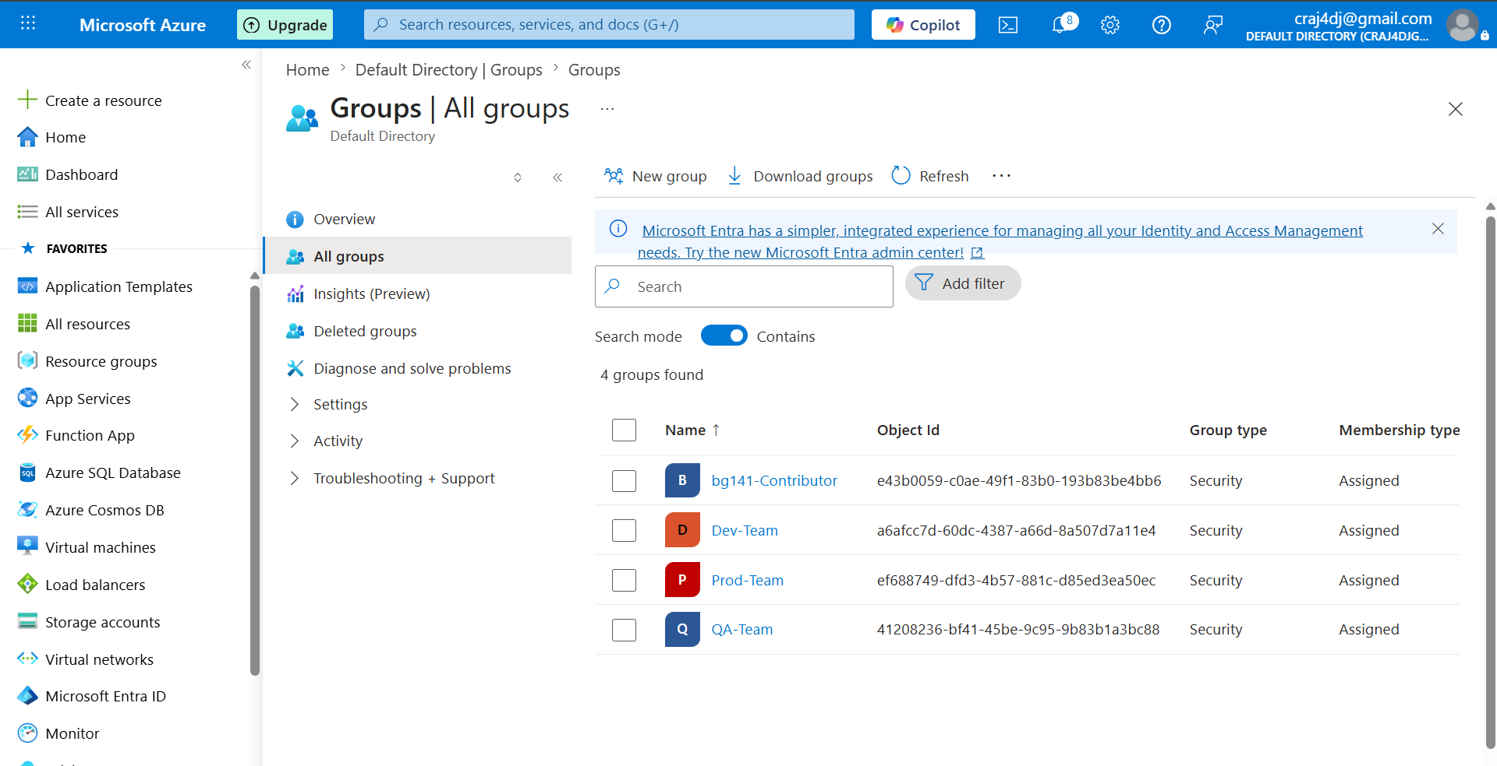

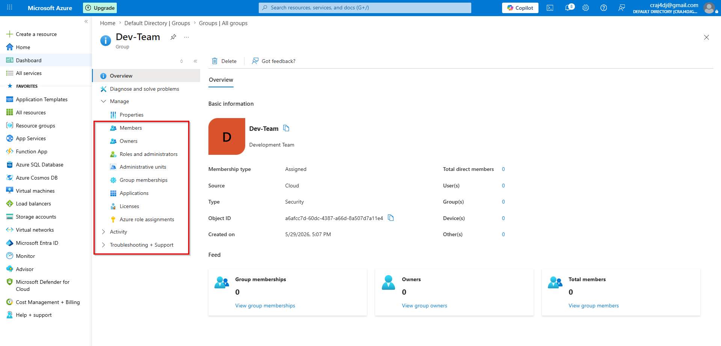

AZURE PHASE-2

DEV-TEAM GROUP STATUS

Group:
Dev-Team

Type:
Security Group

Members:
0

Owners:
0

Current State:

✔ Group Created
❌ No Members
❌ No Owners
❌ No Roles

Important Sections:

Members
- Users added to the Group

Owners
- Users who manage the Group

Roles and administrators
- Special Entra ID administrative roles

Next Step:

Dev-Team
└── Add devuser

Enterprise Flow:

User
↓
Group
↓
Role
↓
IAM
↓
Azure Resources

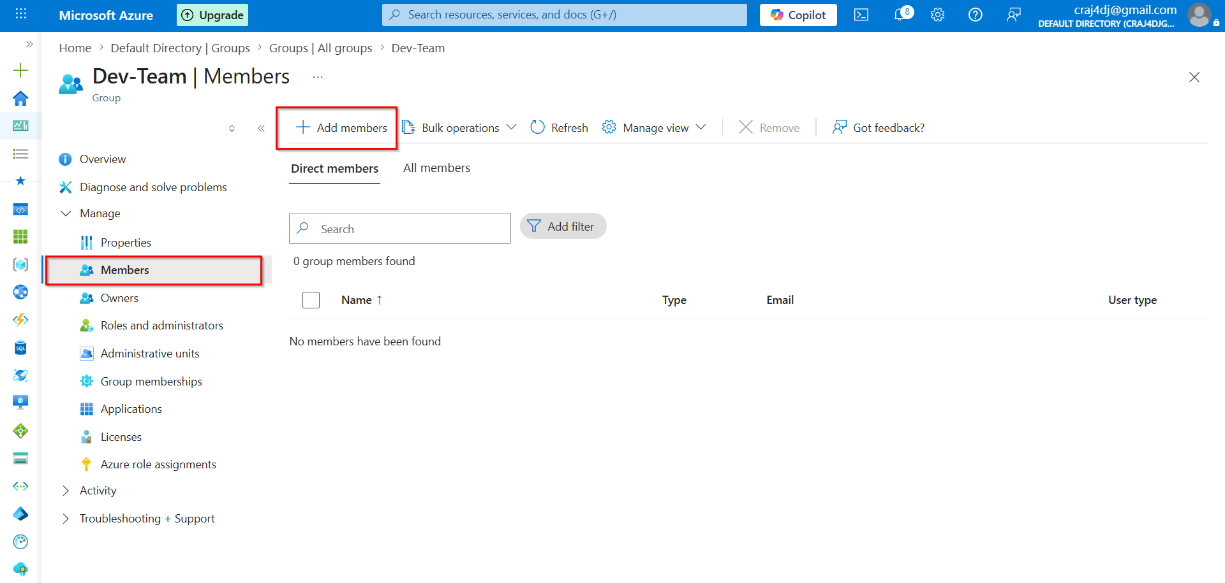

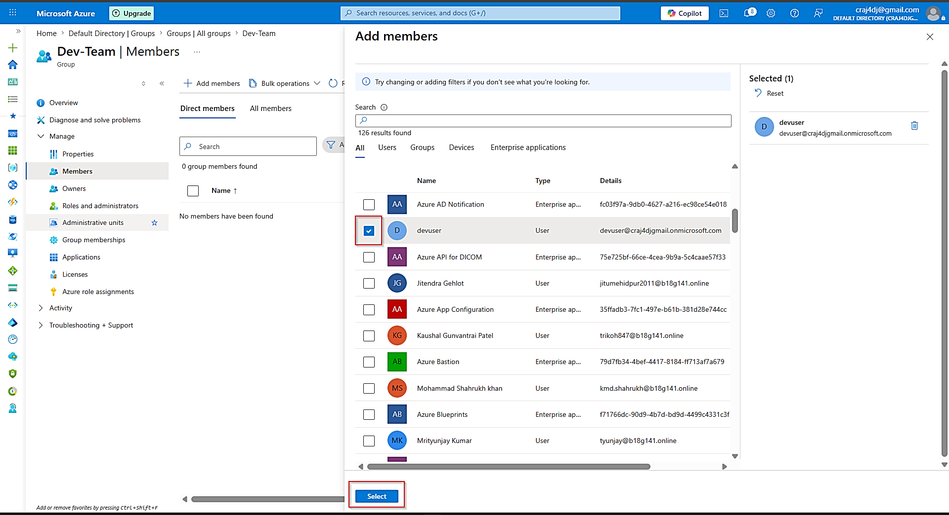

===========================================================================
AZURE PHASE-2

GROUP MEMBERSHIP

Current Group:
Dev-Team

Members:
0

Important Button:

Add Members

Purpose:

Used to add Users into a Group.

Example:

Dev-Team
└── devuser

QA-Team
└── qauser

Prod-Team
└── produser

Key Learning:

User Creation
≠
Group Membership

A user can exist without belonging to any group.

Current Hierarchy:

Tenant
↓
Users
↓
Groups

Next:

Users
↓
Groups
↓
Membership
===========================================================================
AZURE PHASE-2
STEP: USER TO GROUP MAPPING

Selected User:
devuser

Target Group:
Dev-Team

Relationship:

devuser
↓
Dev-Team

IMPORTANT

User and Group are now being connected.
Before:

Users
-----
devuser
qauser
produser

Groups
------
Dev-Team
QA-Team
Prod-Team

After:

Dev-Team
└── devuser

QA-Team
└── qauser

Prod-Team
└── produser

Key Learning:
Users and Groups are separate objects.
Membership creates the relationship between them.
Enterprise Flow:

User
↓
Group
↓
Role
↓
IAM
↓
Azure Resources

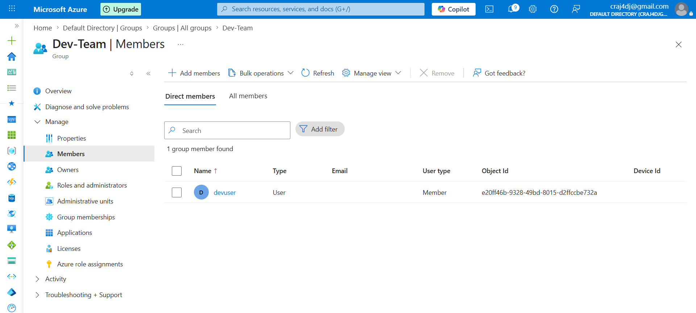

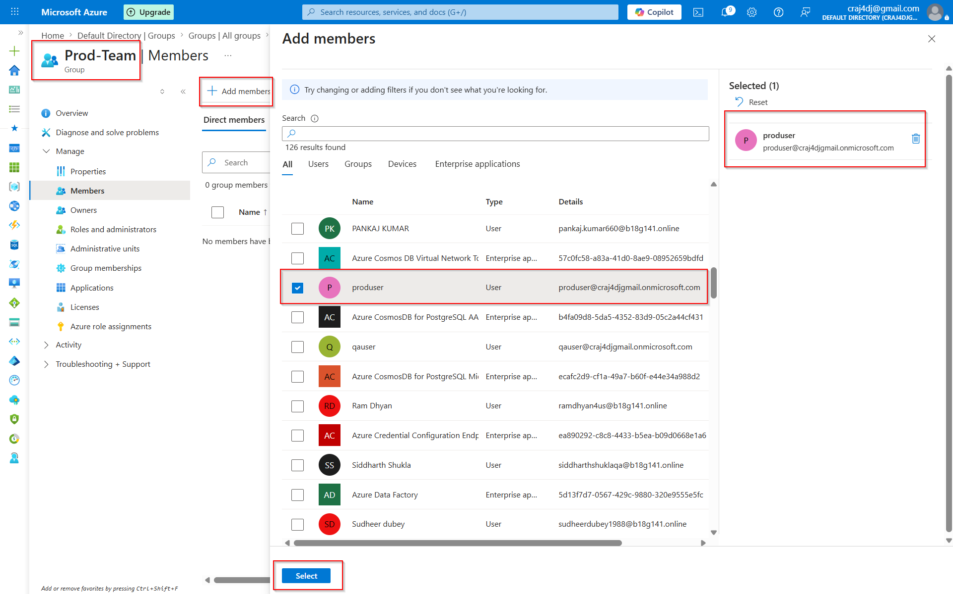

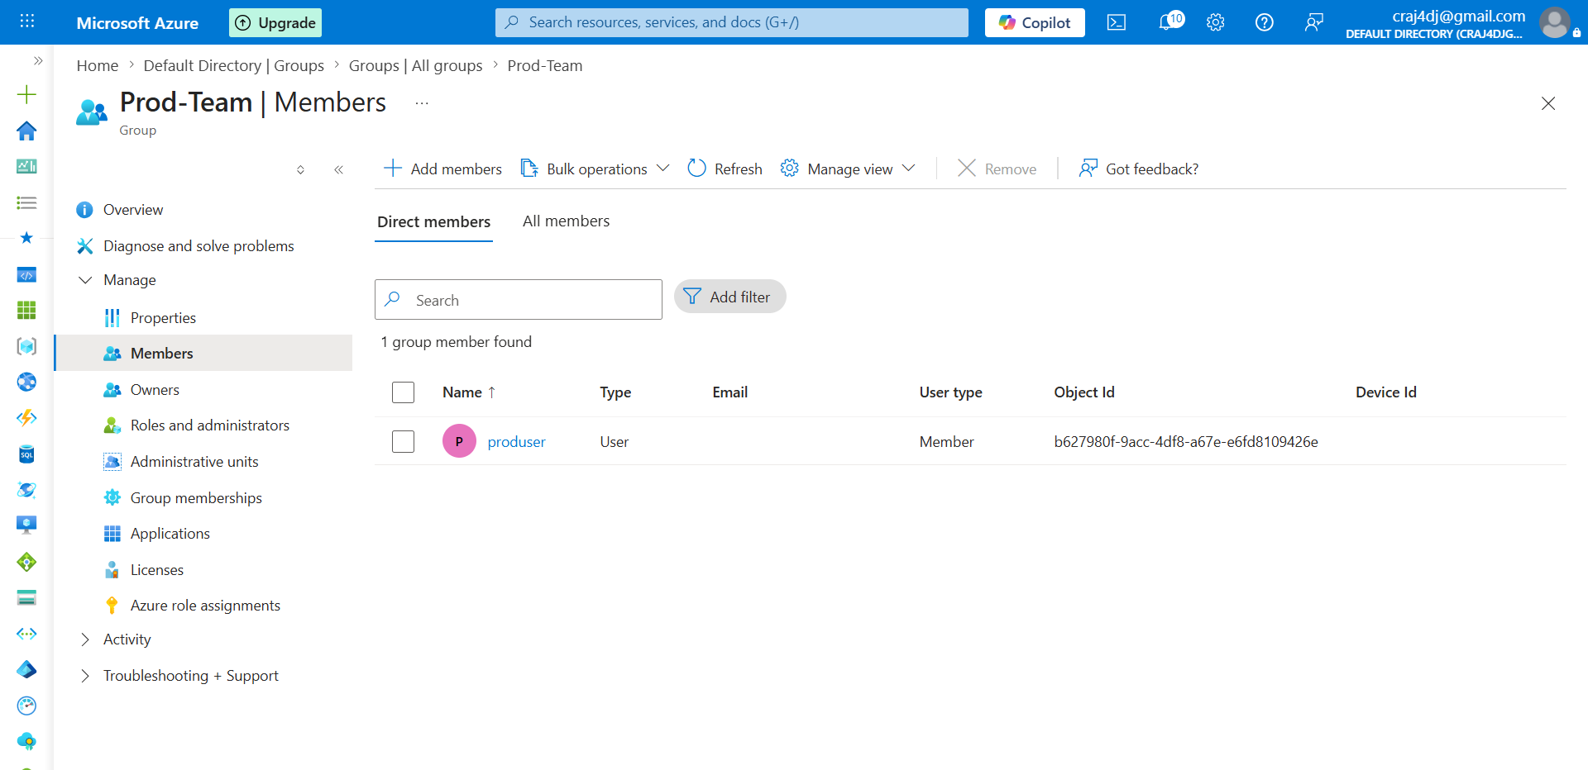

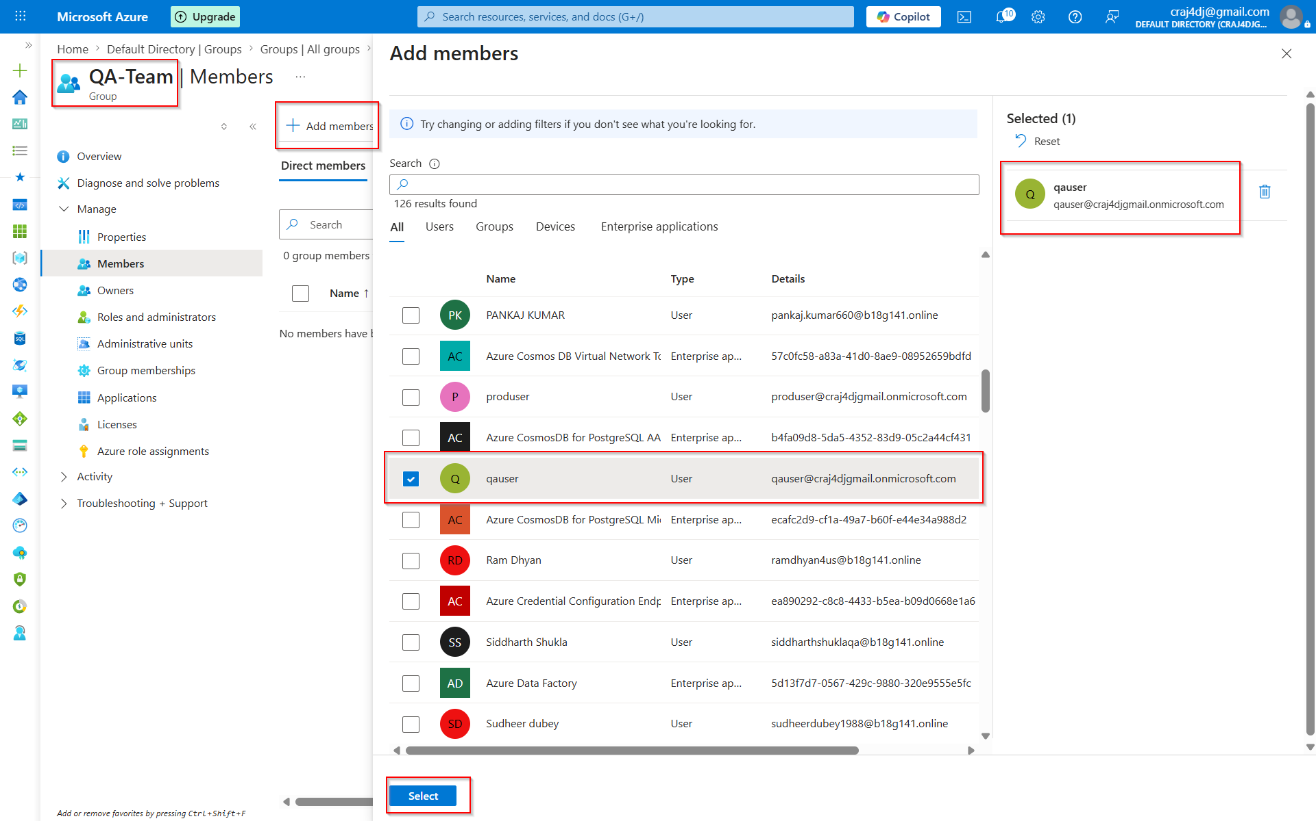

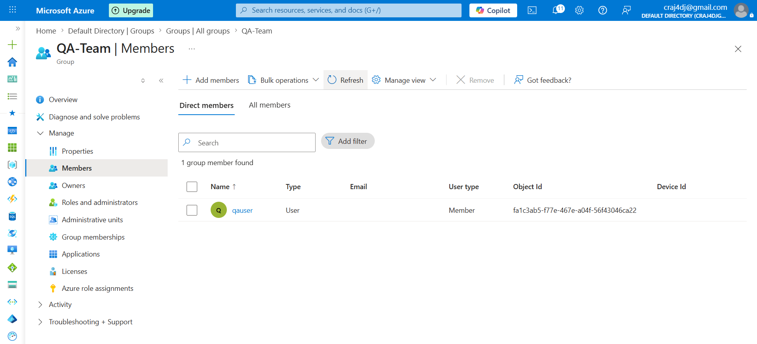

AZURE PHASE 2 PROGRESS

✅ Created Users
- devuser
- qauser
- produser

✅ Created Security Groups
- Dev-Team
- QA-Team
- Prod-Team

✅ Added Group Memberships
- Dev-Team -> devuser
- QA-Team -> qauser
- Prod-Team -> produser

✅ Learned User vs Group Concept

✅ Learned Enterprise Access Model

Current Hierarchy

Tenant
├── Users
│ ├── devuser
│ ├── qauser
│ └── produser
│
└── Groups
├── Dev-Team -> devuser
├── QA-Team -> qauser
└── Prod-Team -> produser

RBAC = Role Based Access Control / IAM – Identity and Access Management

1.4.1 Resource Level IAM (Granular Access)- Small Scope Access
- Resource Group
- VM
- Storage Account
- VNet

1.4.2 Subscription Level IAM (Inherited Access) - Large Scope Access
- Entire Subscription
- All Resource Groups
- All Resources
- Access inherited to all Resource Groups
- Access inherited to all Resources

Resource level IAM - Small Scope Access

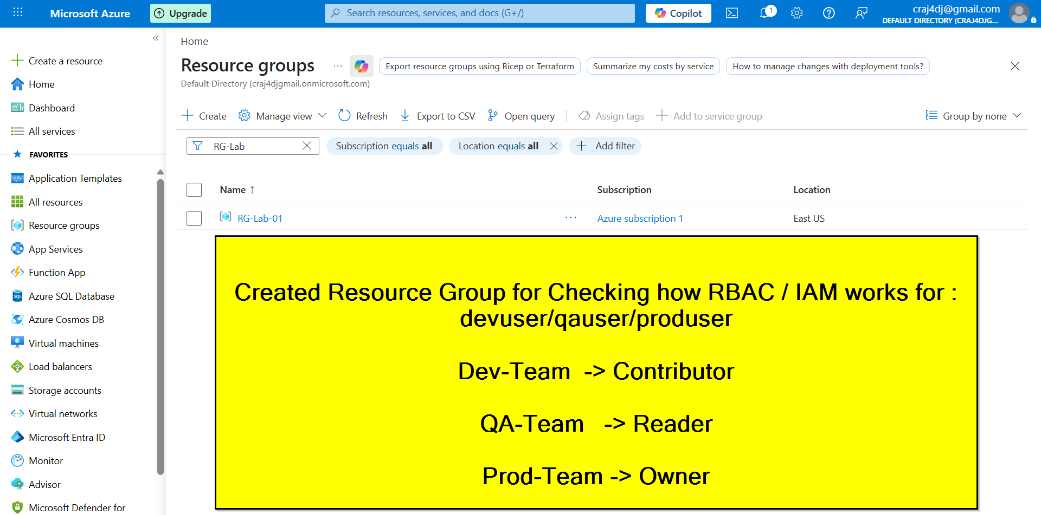

The Real INFRA structure:

Tenant (Entra ID)
│
├── Users
│ ├── devuser
│ ├── qauser
│ └── produser
│
├── Groups
│ ├── Dev-Team
│ ├── QA-Team
│ └── Prod-Team
│
└── Subscription
│
└── RG-Lab-01

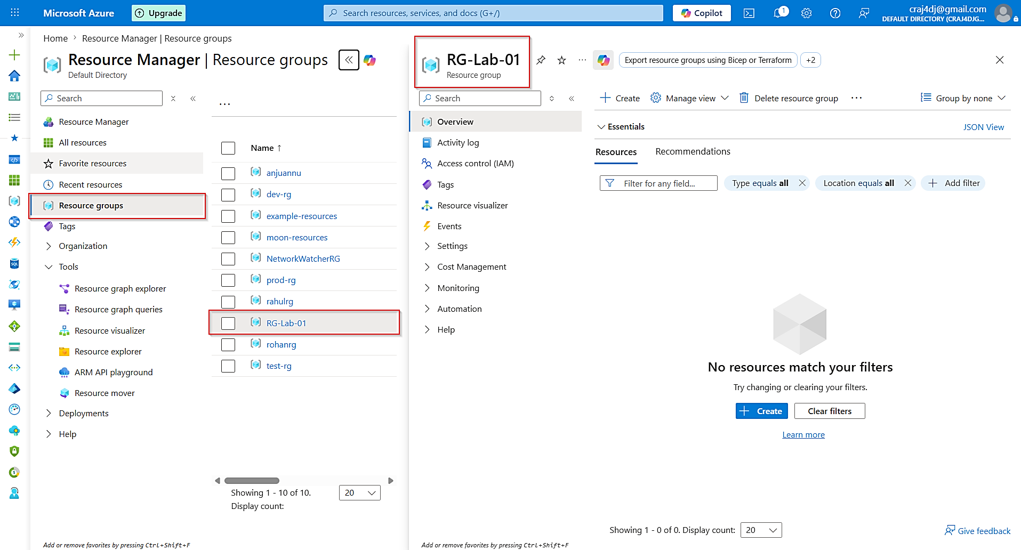

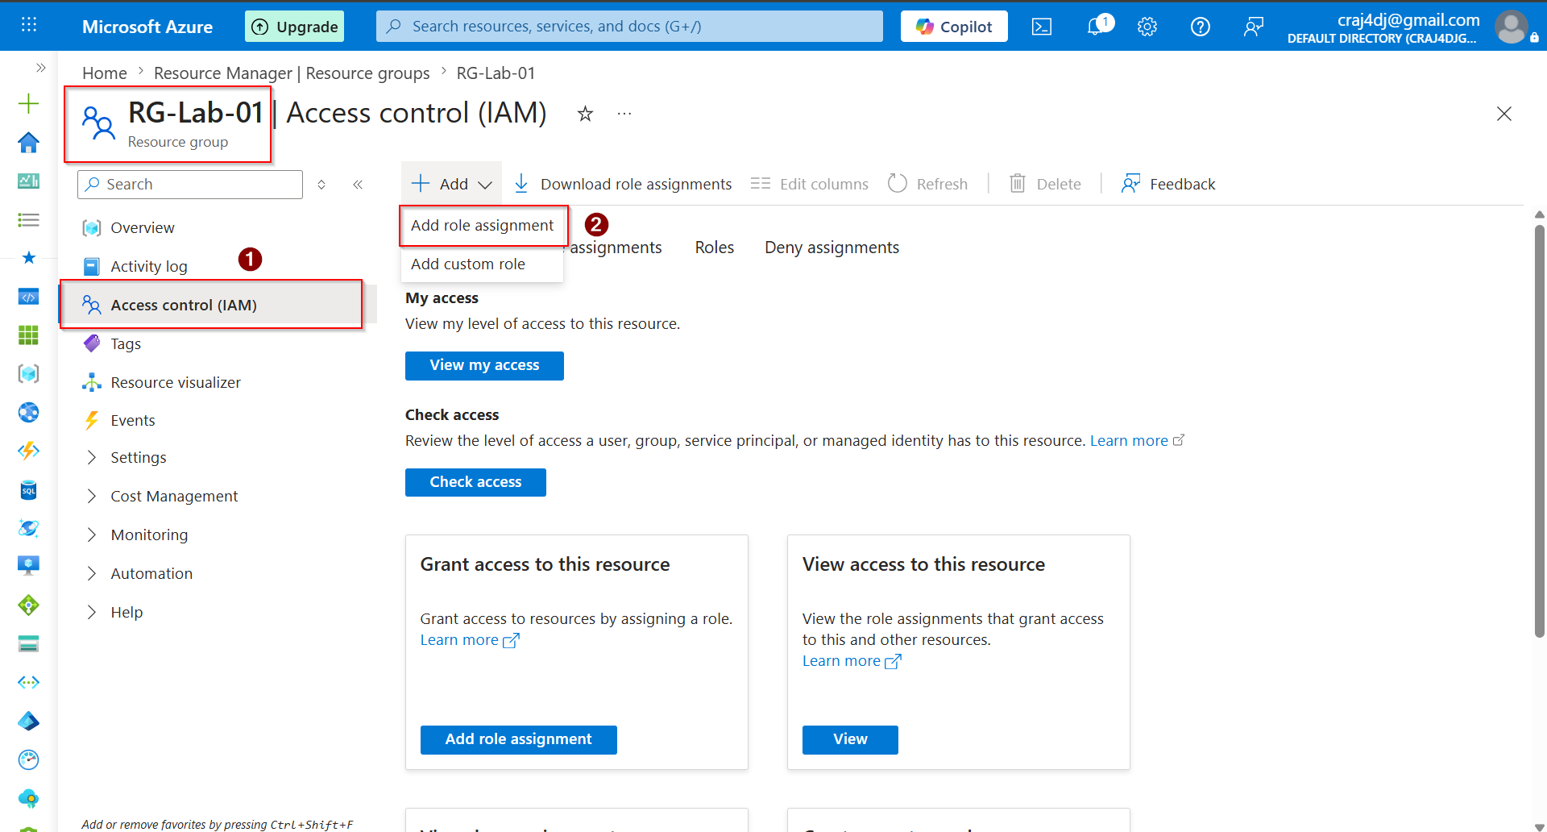

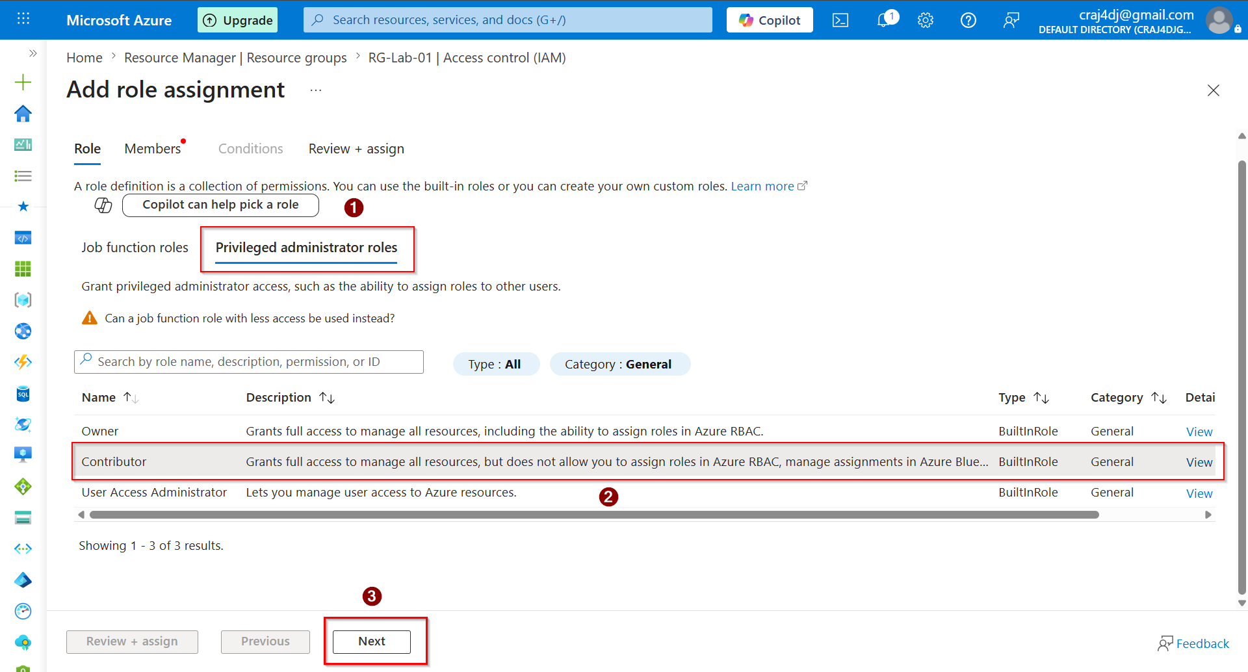

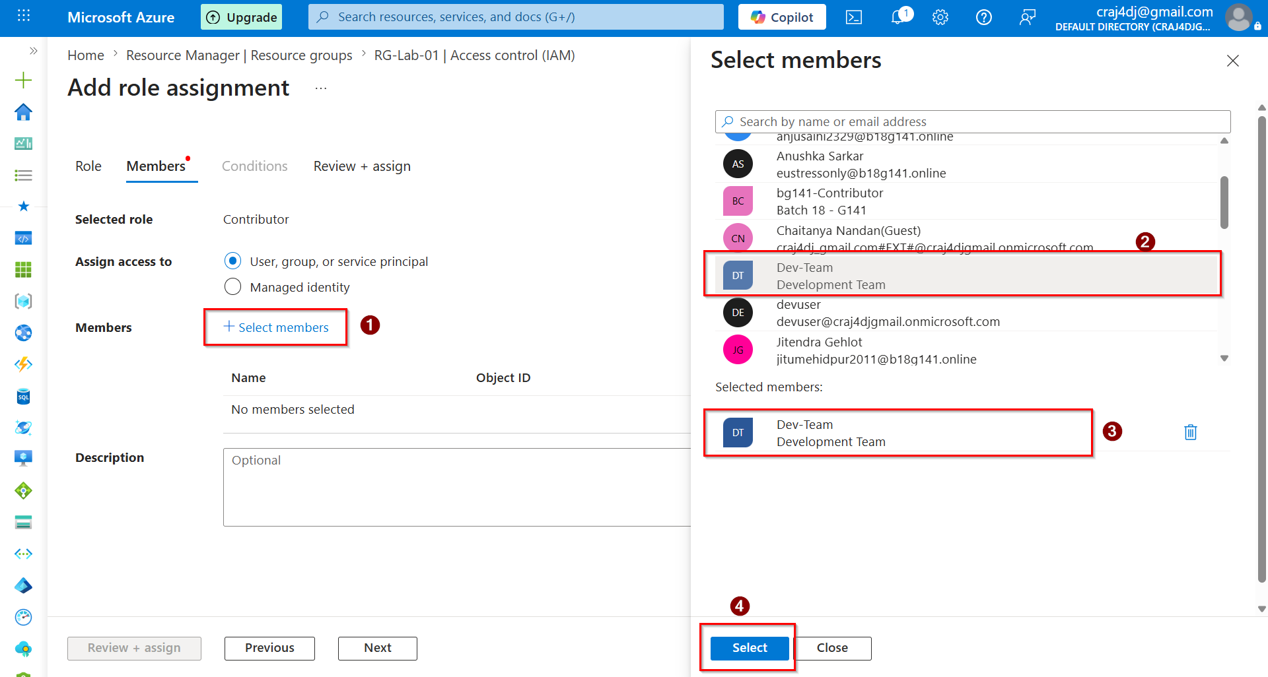

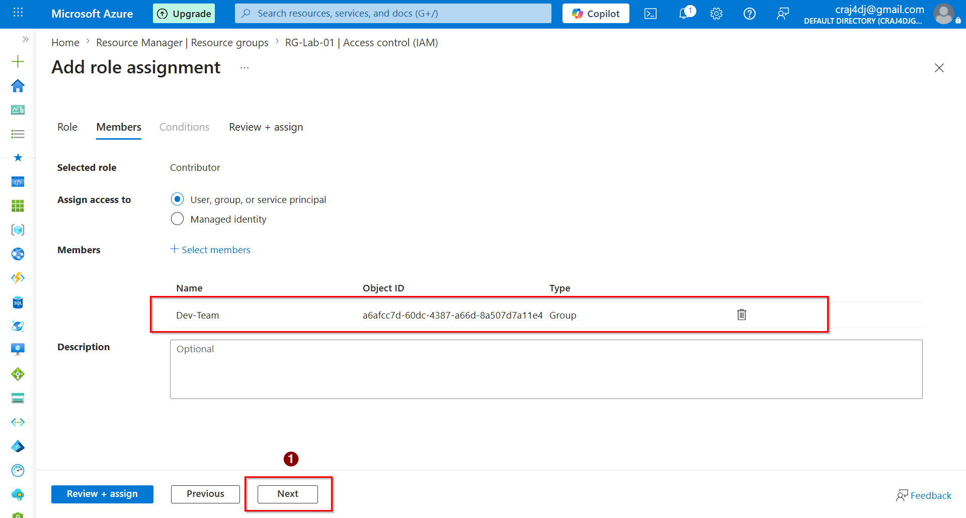

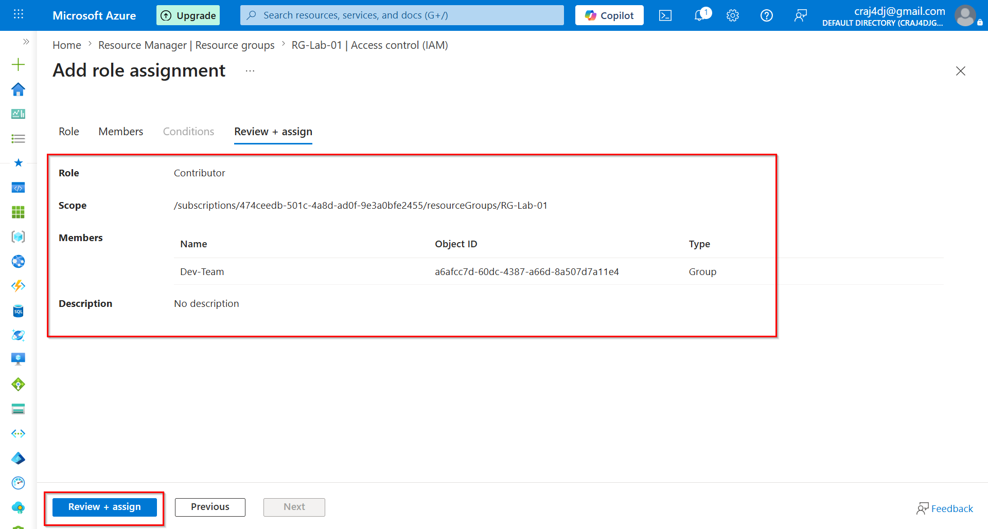

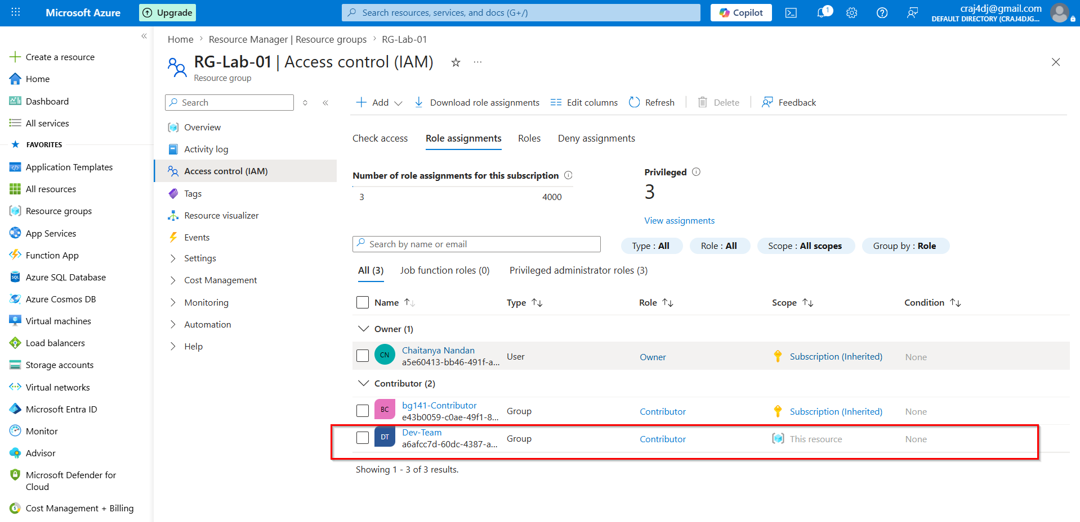

SUBSCRIPTION LEVEL (INHERITED) - Large Scope Access

For DEV TEAM (CONTRIBUTOR)
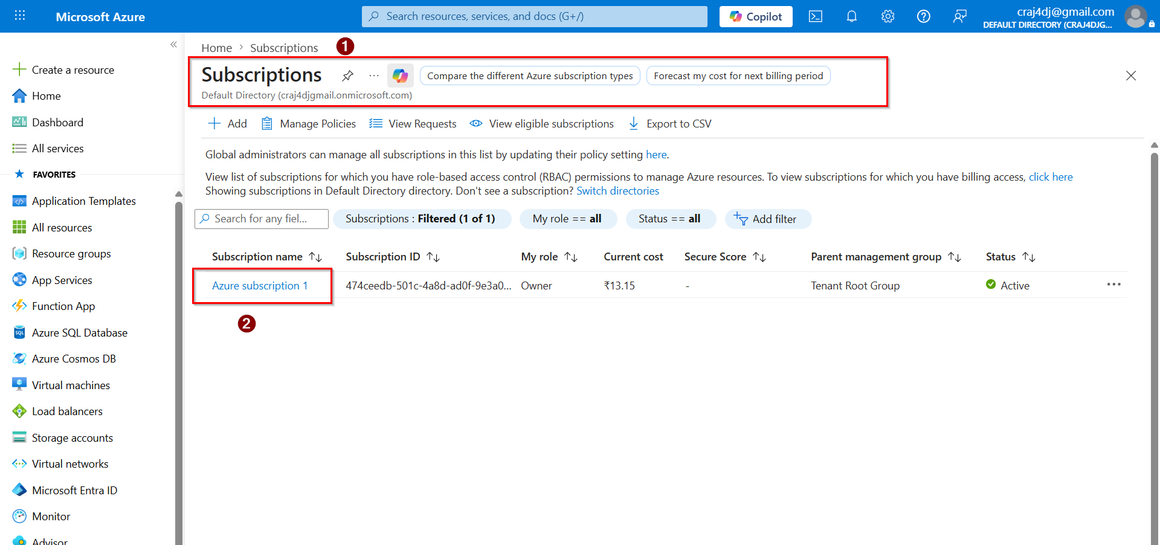

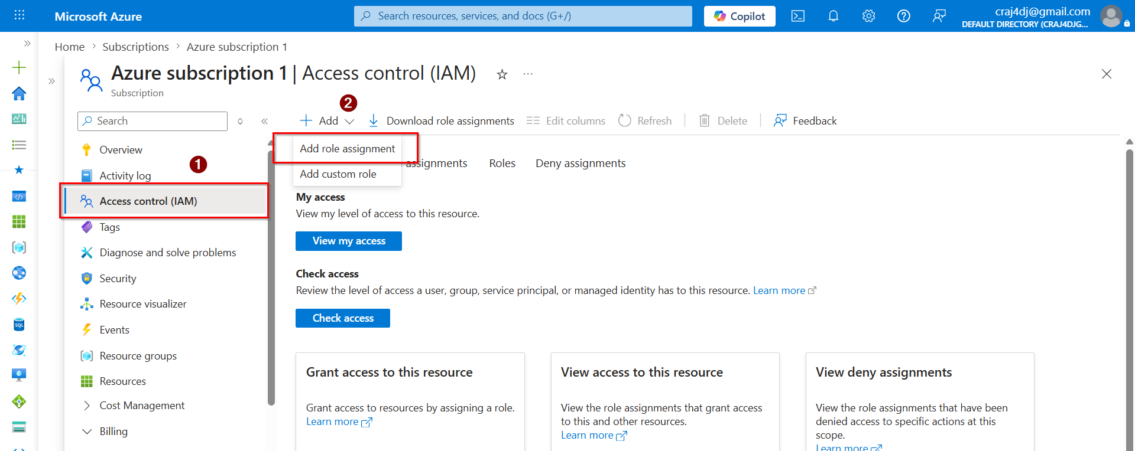

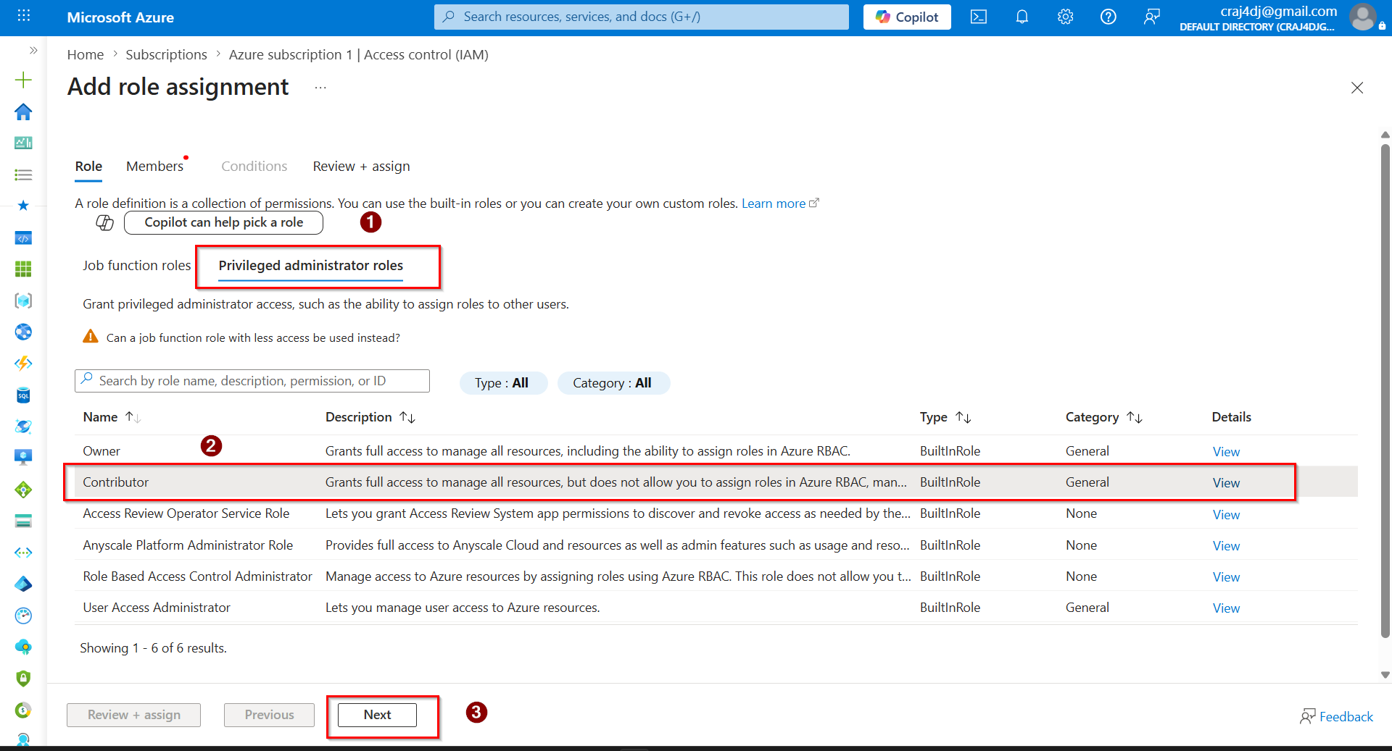

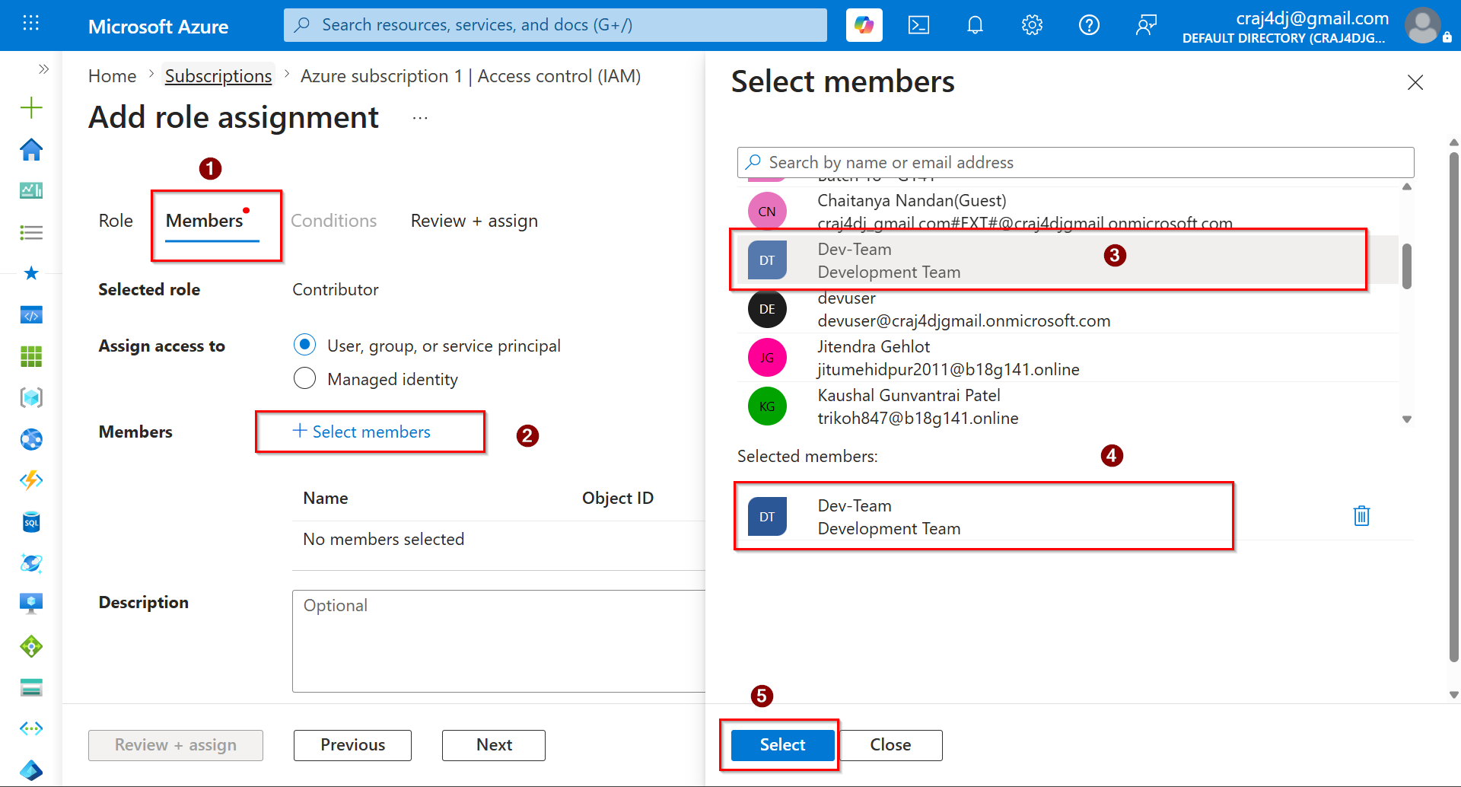

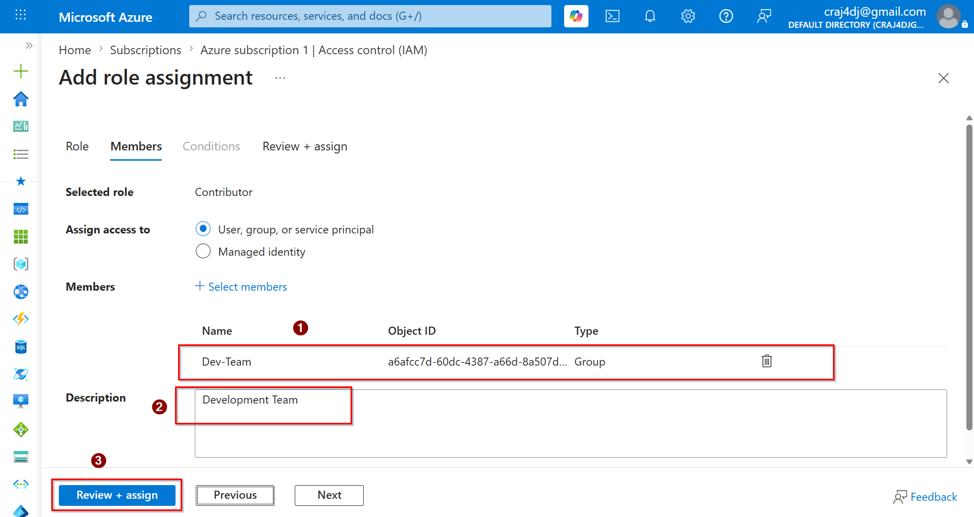

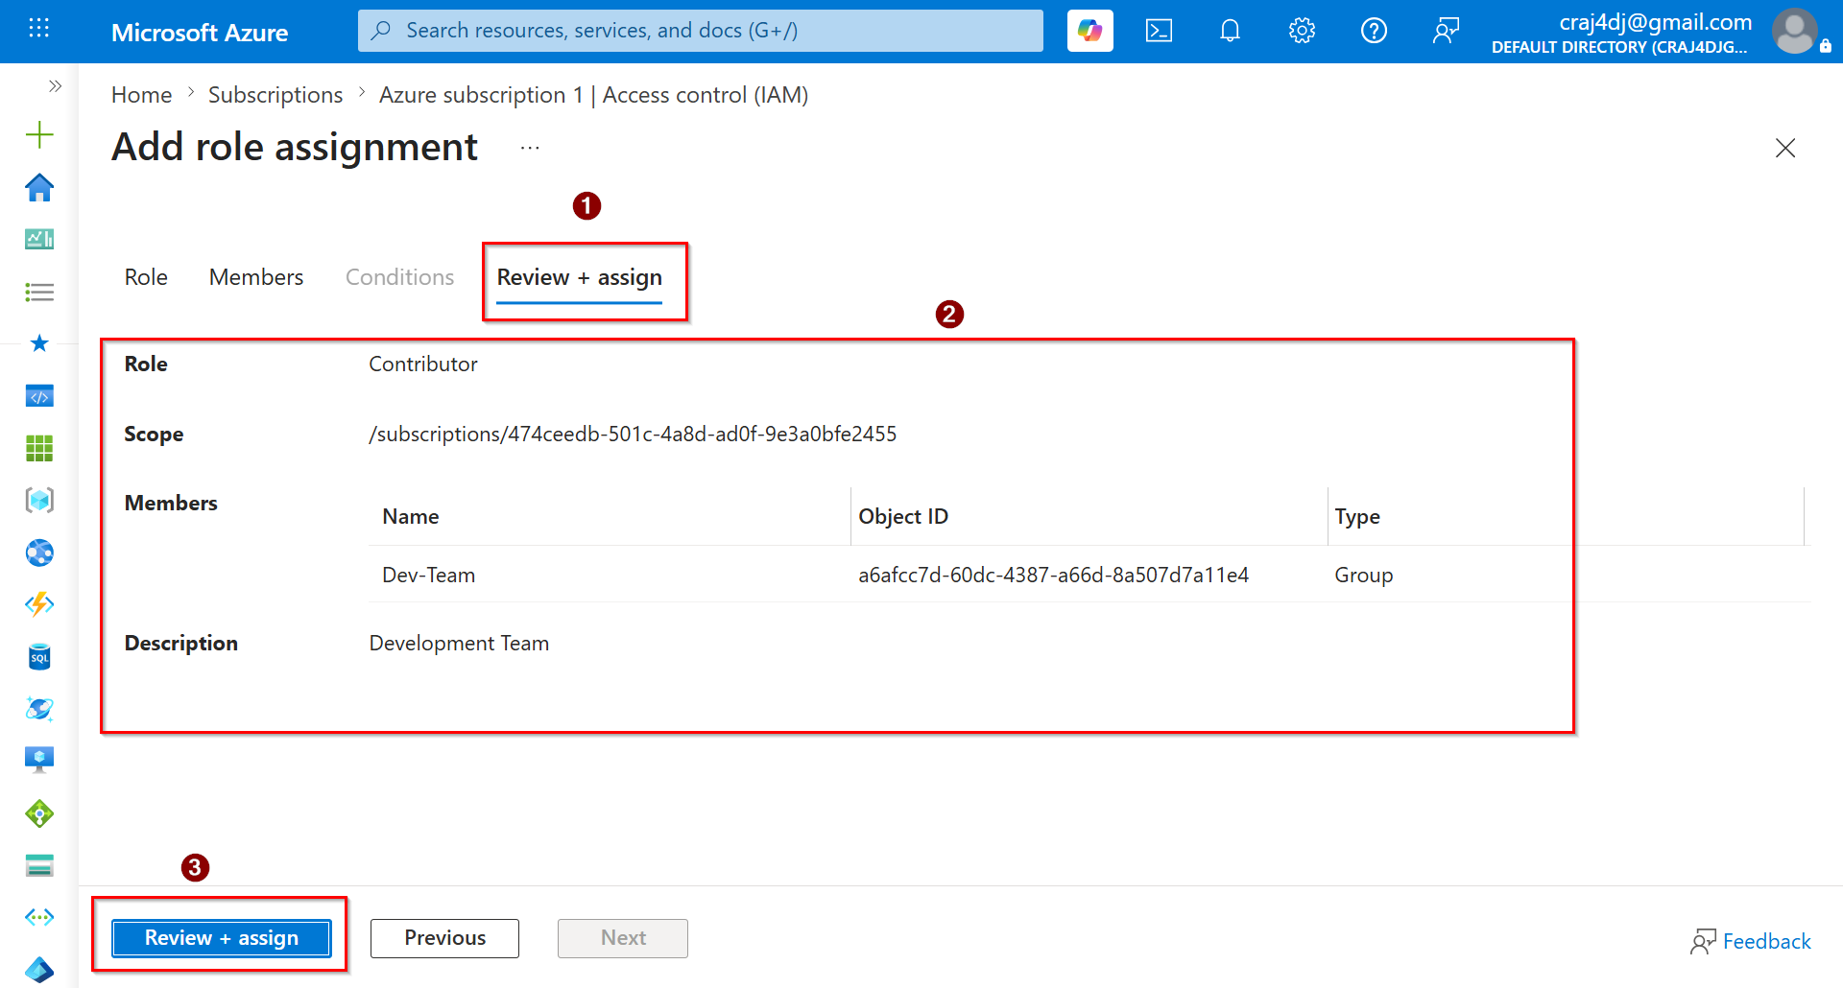

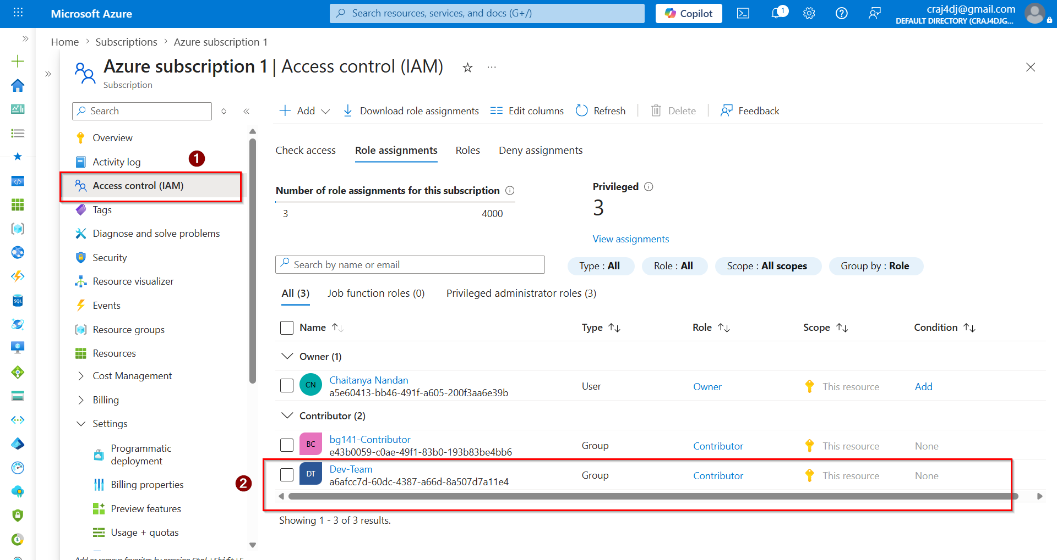

FOR PROD TEAM (OWNER)



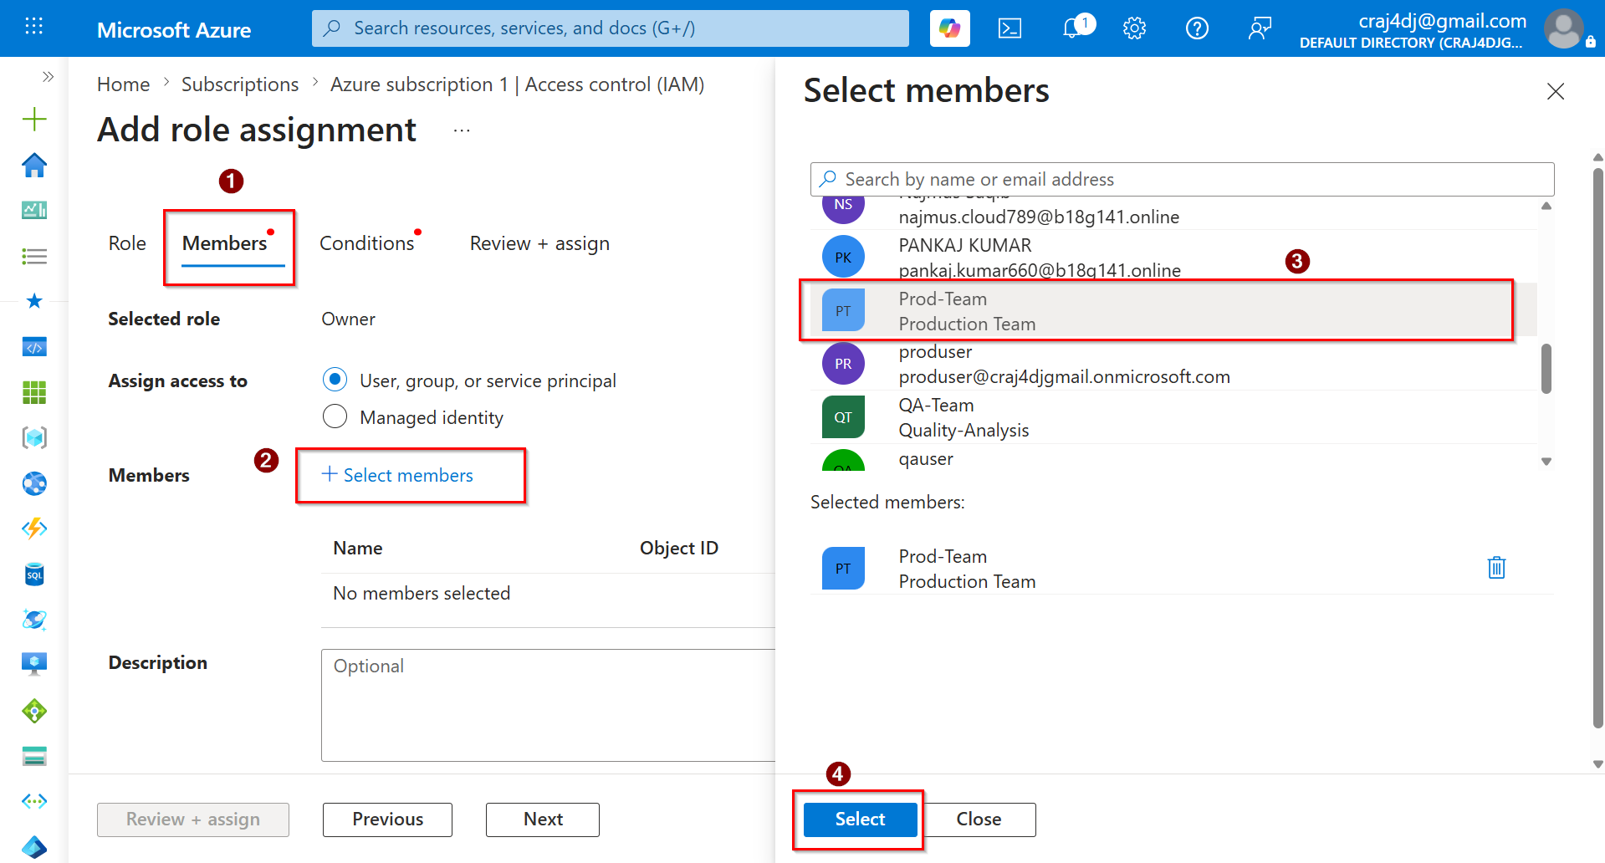
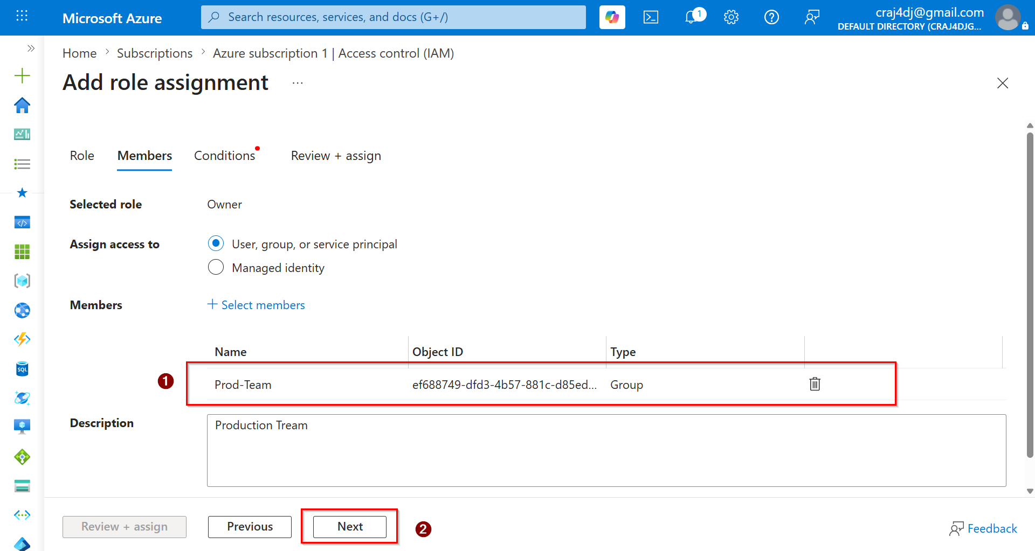

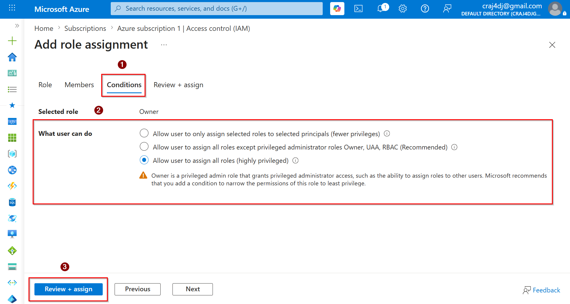

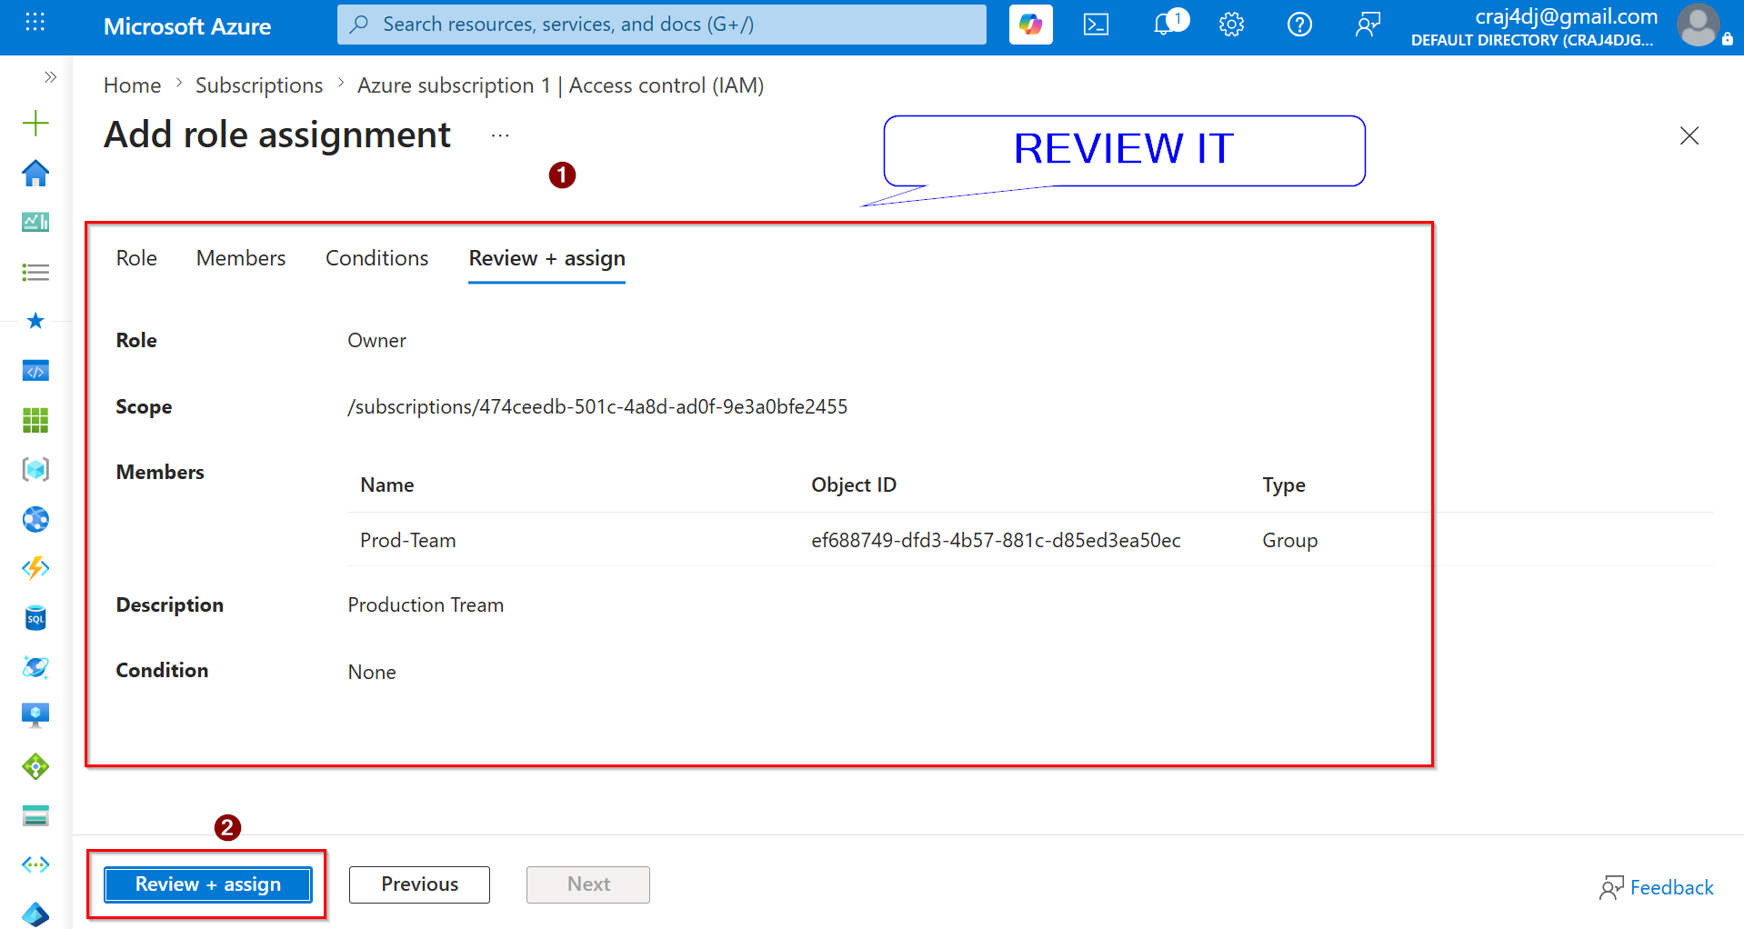

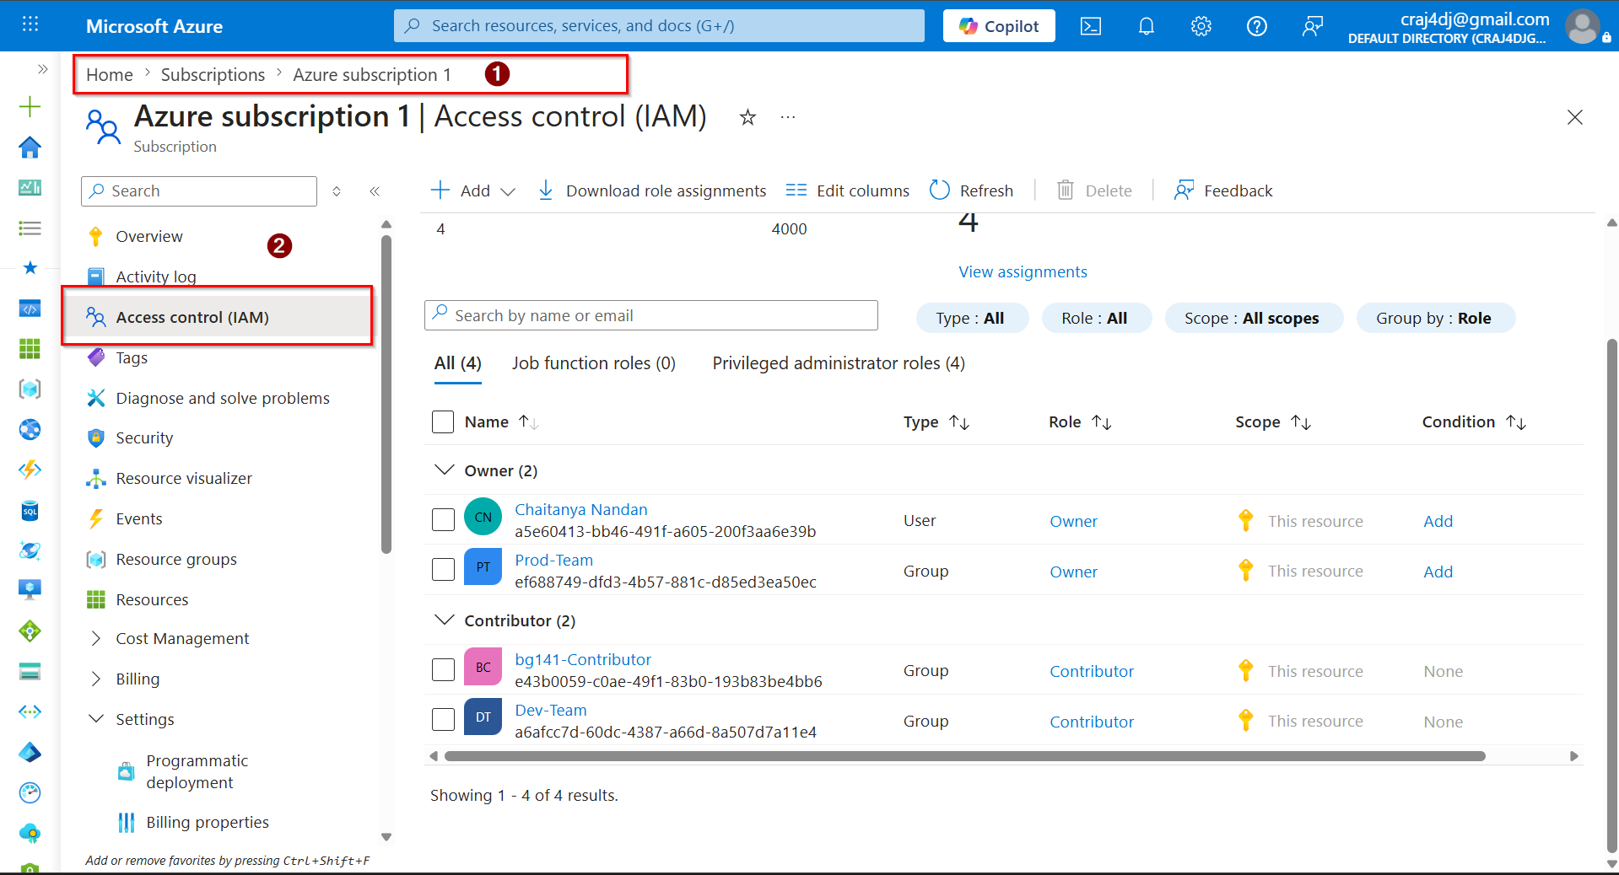

FOR QA TEAM (READER)



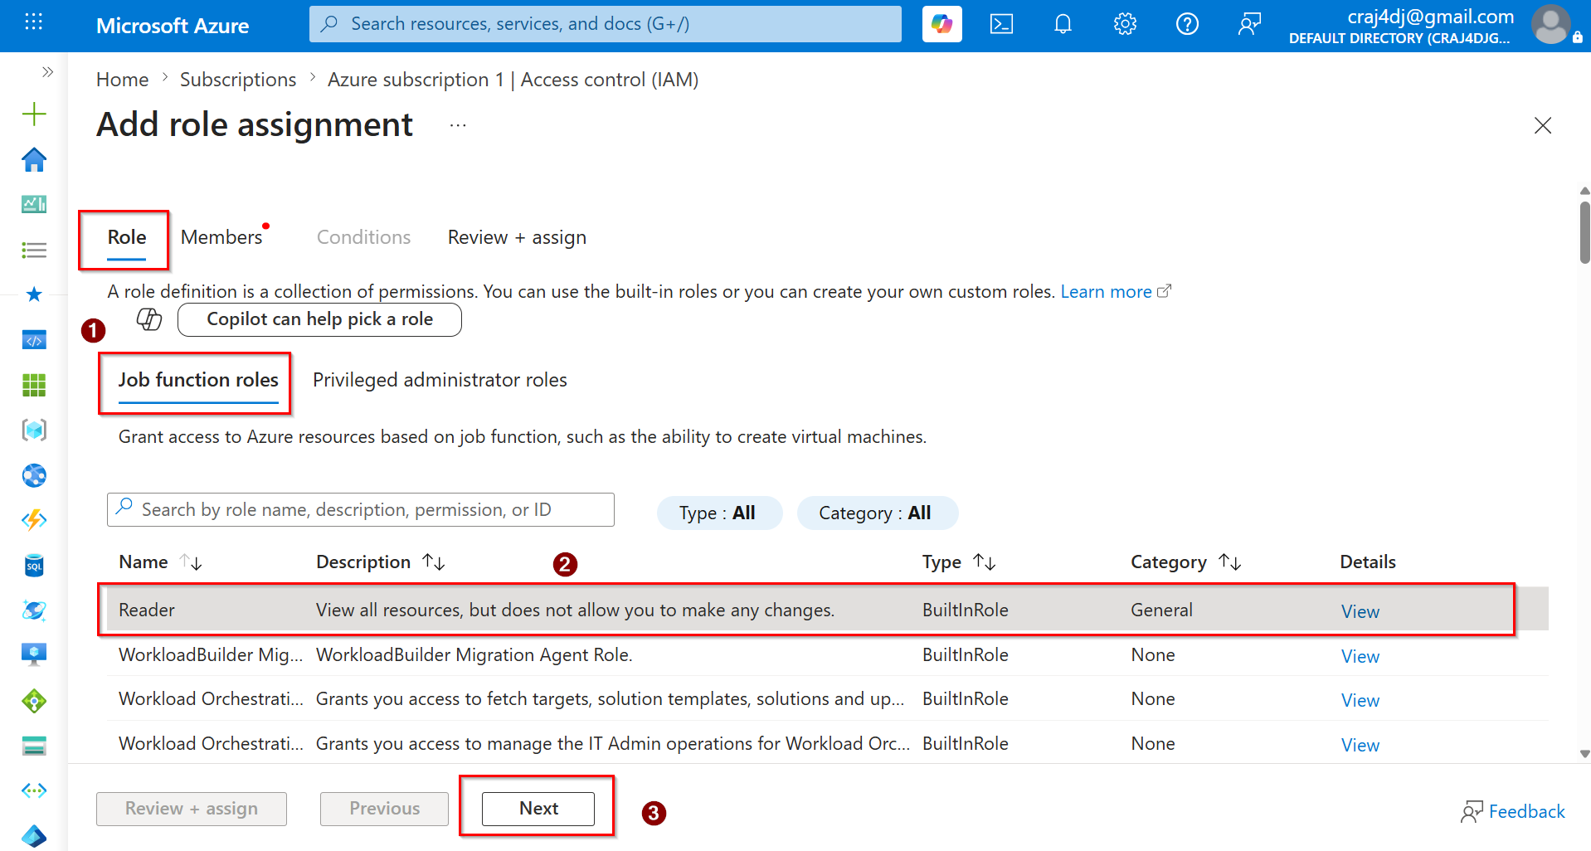

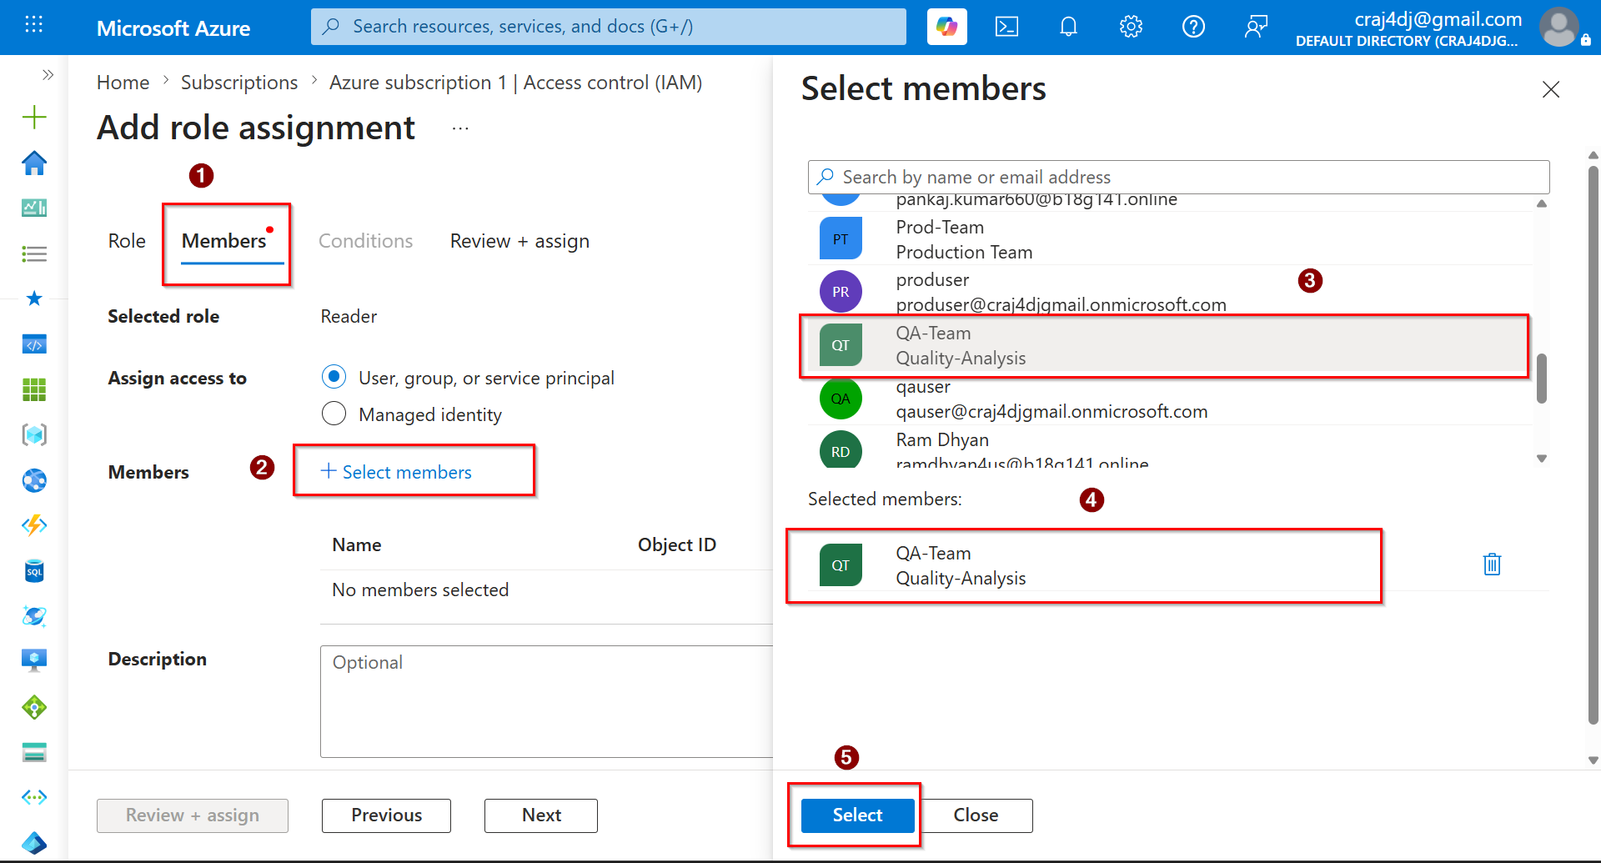

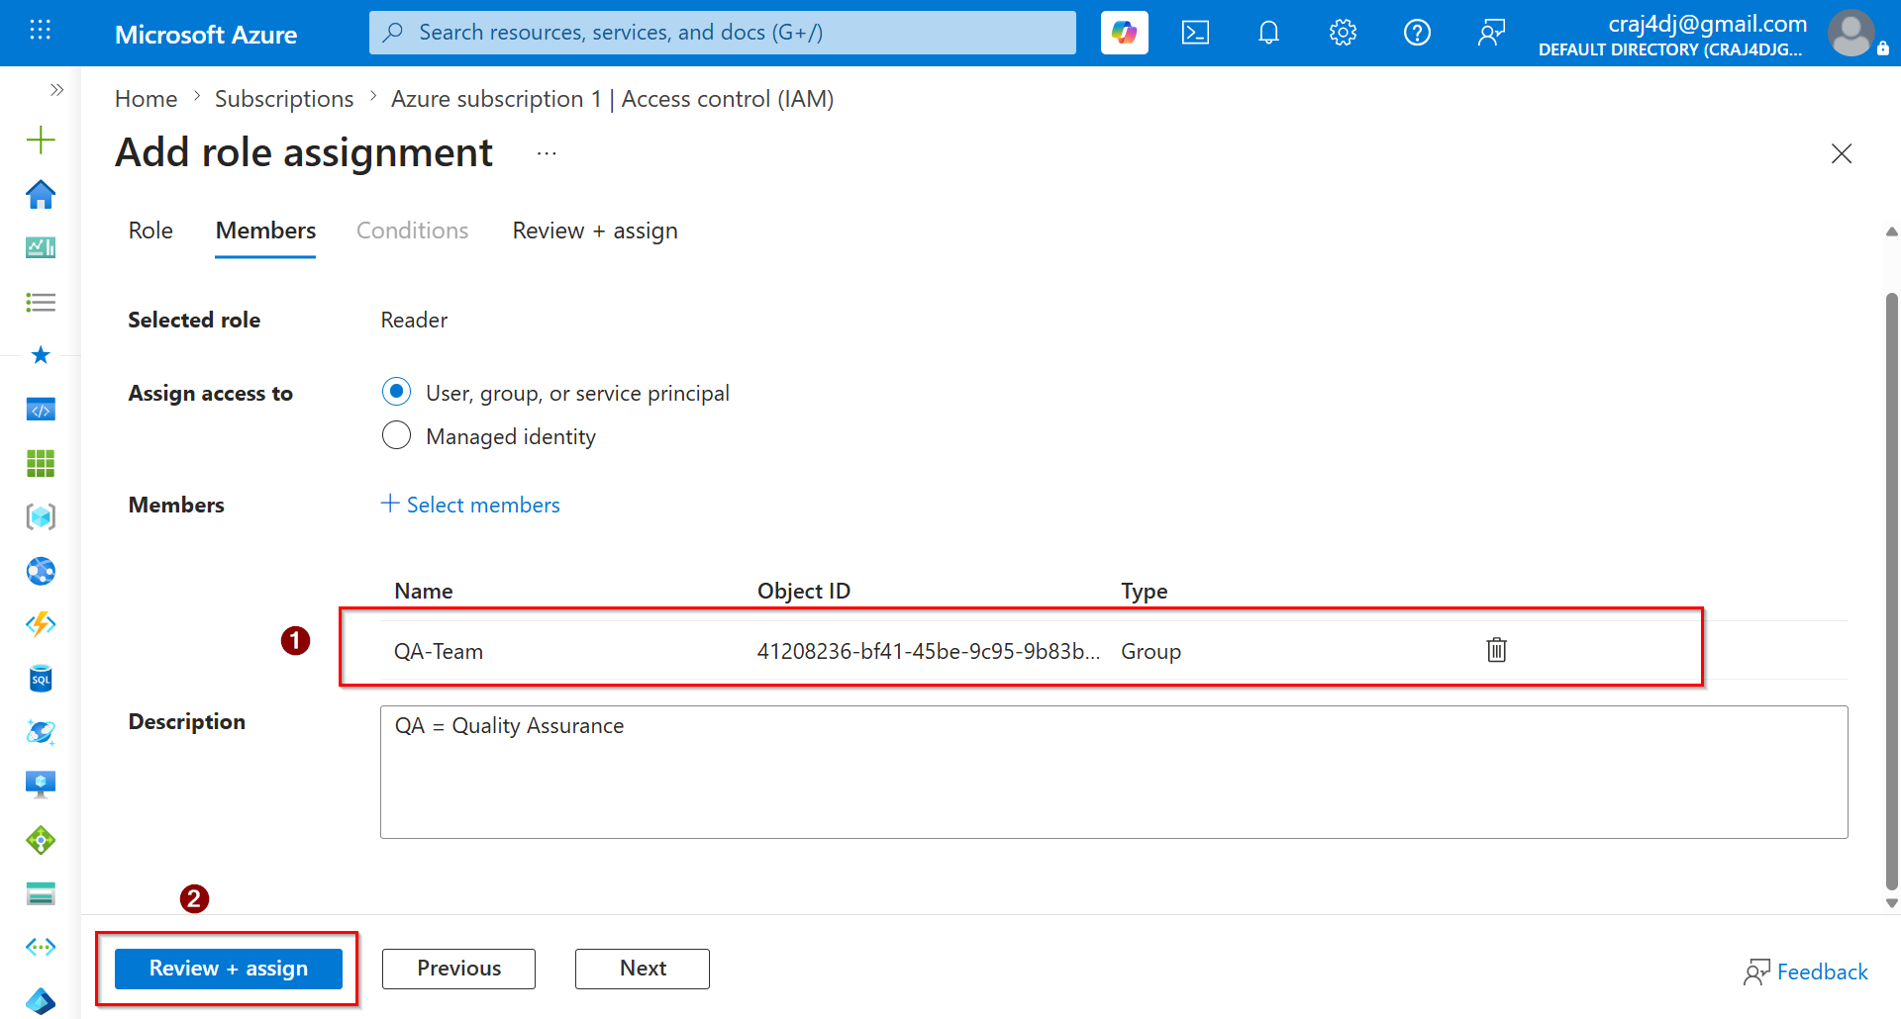

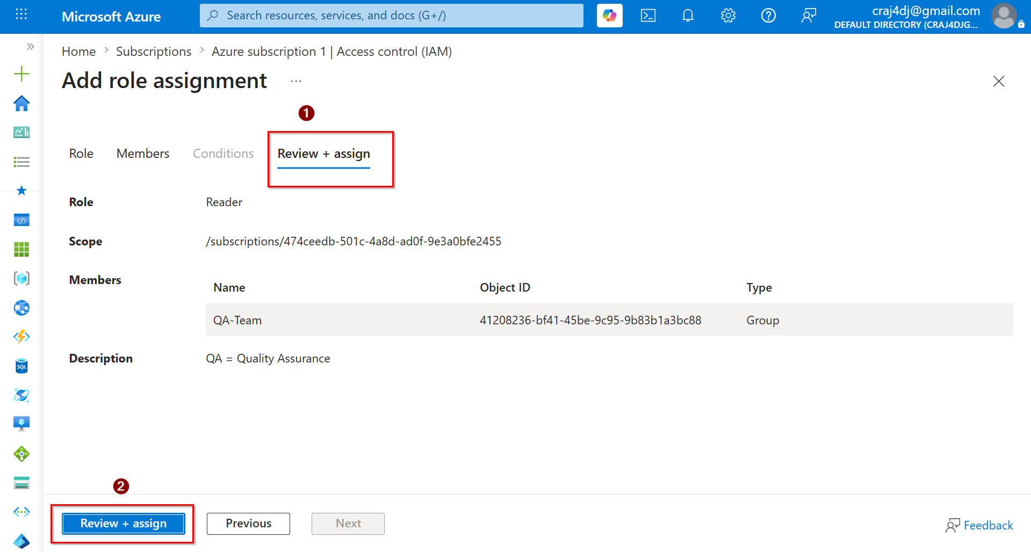

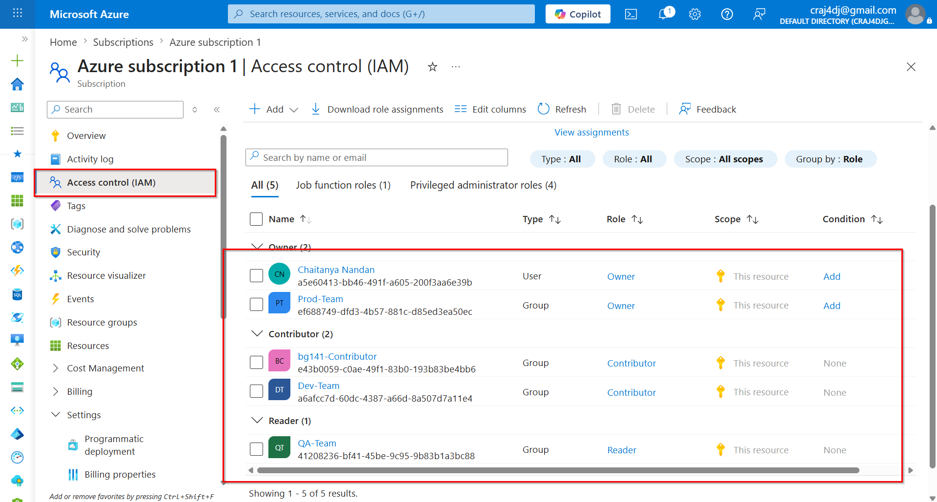

TILL NOW:

✓ User Creation
✓ Group Creation
✓ User Membership
✓ Resource Group Creation
✓ IAM / RBAC
✓ Owner Role
✓ Contributor Role
✓ Reader Role
✓ Group Based Access Control
✓ Principle of Least Privilege

NOTES

══════════════════════════════════════════════════════════════════════════════
AZURE IAM (RBAC) - PHASE 2 SUMMARY 🚀
══════════════════════════════════════════════════════════════════════════════

📌 What is IAM?
IAM = Identity and Access Management
IAM is used to control WHO can access WHAT resources and WHAT actions they can perform.

Identity = User / Group / Service Principal
Access = Permissions
Management= Assigning & Controlling Access

Flow:
Identity → Role → Scope → Permission

══════════════════════════════════════════════════════════════════════════════
1. MICROSOFT ENTRA ID (AZURE AD)
══════════════════════════════════════════════════════════════════════════════

Microsoft Entra ID is Azure's Identity Service.

Responsibilities:
✔ User Management
✔ Group Management
✔ Authentication
✔ Authorization
✔ SSO (Single Sign-On)
✔ RBAC Integration

Think:
Entra ID = Employee Database of Company

Contains:
• Users
• Groups
• Applications
• Service Principals
• Roles

══════════════════════════════════════════════════════════════════════════════
2. USERS
══════════════════════════════════════════════════════════════════════════════

Created Users:

✔ devuser
✔ qauser
✔ produser

Purpose:

devuser = Developer Team
qauser = Quality Assurance Team
produser = Production/Admin Team

Important Properties:

User Principal Name (UPN)
Example:
devuser@company.onmicrosoft.com

Display Name
Mail Nickname
Password
User Type

User Types:
Member = Internal User
Guest = External User

Interview:
Q. What is User Principal Name?
A. Unique login identity of Azure user.

══════════════════════════════════════════════════════════════════════════════
3. GROUPS
══════════════════════════════════════════════════════════════════════════════

Created Groups:

✔ Dev-Team
✔ QA-Team
✔ Prod-Team

Group Type:
Security Group

Membership Type:
Assigned

Why Groups?

Bad Practice ❌

User → Role
User → Role
User → Role
User → Role

Good Practice ✅

User → Group → Role

Benefits:
✔ Easy Management
✔ Centralized Access
✔ Less Administration
✔ Scalable
✔ Enterprise Standard

Interview:
Q. Why assign role to Group instead of User?
A. Easier access management and follows enterprise best practice.

══════════════════════════════════════════════════════════════════════════════
4. GROUP MEMBERSHIP
══════════════════════════════════════════════════════════════════════════════

Assigned Users:

devuser → Dev-Team
qauser → QA-Team
produser → Prod-Team

Result:

Dev-Team
└─ devuser

QA-Team
└─ qauser

Prod-Team
└─ produser

Important Concept:

Role is assigned to Group.
User inherits permissions from Group.

Example:

Dev-Team
↓
Contributor
↓
devuser automatically receives Contributor access.

This is called:
Inherited Access

══════════════════════════════════════════════════════════════════════════════
5. RESOURCE GROUP (RG)
══════════════════════════════════════════════════════════════════════════════

Created:

RG-Lab-01

What is Resource Group?

Logical Container for Azure Resources.

Contains:
• VM
• Storage Account
• VNET
• Database
• Load Balancer
• App Service

Example:

RG-Lab-01
├─ VM01
├─ Storage01
├─ VNET01
└─ SQL01

Benefits:
✔ Resource Organization
✔ Access Control
✔ Monitoring
✔ Cost Tracking
✔ Lifecycle Management

Interview:
Q. Can resources exist without Resource Group?
A. No.

══════════════════════════════════════════════════════════════════════════════
6. RBAC (ROLE BASED ACCESS CONTROL)
══════════════════════════════════════════════════════════════════════════════

RBAC = Role Based Access Control

Used to assign permissions based on Role.

Formula:

Who
+
What Role
+
At Which Scope

Example:

Dev-Team
+
Contributor
+
RG-Lab-01

Azure evaluates:

Identity + Role + Scope

══════════════════════════════════════════════════════════════════════════════
7. IAM (ACCESS CONTROL)
══════════════════════════════════════════════════════════════════════════════

IAM = Interface used to manage RBAC.

Location:

Subscription
Resource Group
Resource

All have:

Access Control (IAM)

Functions:
✔ Add Role Assignment
✔ Remove Role Assignment
✔ Review Access
✔ Audit Permissions

══════════════════════════════════════════════════════════════════════════════
8. ROLE ASSIGNMENTS PERFORMED
══════════════════════════════════════════════════════════════════════════════

Scope:
RG-Lab-01

Assignments:

Dev-Team → Contributor
QA-Team → Reader
Prod-Team → Owner

Architecture:

RG-Lab-01
│
├─ Dev-Team → Contributor
├─ QA-Team → Reader
└─ Prod-Team → Owner

══════════════════════════════════════════════════════════════════════════════
9. OWNER ROLE
══════════════════════════════════════════════════════════════════════════════

Highest commonly used RBAC role.

Permissions:

✔ Create Resources
✔ Modify Resources
✔ Delete Resources
✔ Create Resource Groups
✔ Delete Resource Groups
✔ Assign IAM Roles
✔ Manage Permissions

Special Capability:

Can assign roles to others.

Interview:
Q. What extra permission does Owner have?
A. Owner can assign RBAC roles.

══════════════════════════════════════════════════════════════════════════════
10. CONTRIBUTOR ROLE
══════════════════════════════════════════════════════════════════════════════

Permissions:

✔ Create Resources
✔ Modify Resources
✔ Delete Resources
✔ Manage Resource Group Resources

Restrictions:

✖ Cannot Assign Roles
✖ Cannot Manage RBAC Permissions

Interview:
Q. Difference between Owner and Contributor?

A.
Owner → Can Assign Roles
Contributor→ Cannot Assign Roles

══════════════════════════════════════════════════════════════════════════════
11. READER ROLE
══════════════════════════════════════════════════════════════════════════════

Permissions:

✔ View Resources
✔ View Settings
✔ View Configuration
✔ View Monitoring Data

Restrictions:

✖ Cannot Create
✖ Cannot Modify
✖ Cannot Delete
✖ Cannot Assign Roles

Interview:
Q. Why use Reader role?

A.
For Auditors, QA Teams, Management Teams,
Monitoring Teams who only need visibility.

══════════════════════════════════════════════════════════════════════════════
12. ROLE HIERARCHY
══════════════════════════════════════════════════════════════════════════════

Owner
↑
Contributor
↑
Reader

Permission Level:

Reader = Low
Contributor = Medium
Owner = High

══════════════════════════════════════════════════════════════════════════════
13. ENTERPRISE ACCESS MODEL
══════════════════════════════════════════════════════════════════════════════

Small Lab:

User
↓
Role

Enterprise:

User
↓
Group
↓
Role
↓
IAM

Real Example:

Developer
↓
Dev-Team
↓
Contributor

QA Engineer
↓
QA-Team
↓
Reader

Production Admin
↓
Prod-Team
↓
Owner

══════════════════════════════════════════════════════════════════════════════
14. IMPORTANT INTERVIEW CONCEPTS
══════════════════════════════════════════════════════════════════════════════

Q. What is RBAC?
A. RBAC controls access to Azure resources using roles.

Q. What is IAM?
A. IAM is the Azure interface used to manage RBAC permissions.

Q. Why use Groups?
A. Simplifies access management and follows enterprise standards.

Q. What is least privilege principle?
A. Users should receive only the minimum permissions required.

Example:
Developer → Contributor
QA → Reader
Admin → Owner

Q. How does access inheritance work?
A. User inherits permissions from the group to which the role is assigned.

Q. What is the relationship between IAM and RBAC?
A. IAM is the management interface, RBAC is the permission model.

══════════════════════════════════════════════════════════════════════════════
PHASE 2 FINAL ARCHITECTURE
══════════════════════════════════════════════════════════════════════════════

Microsoft Entra ID
│
├─ Users
│ ├─ devuser
│ ├─ qauser
│ └─ produser
│
├─ Groups
│ ├─ Dev-Team
│ ├─ QA-Team
│ └─ Prod-Team
│
├─ Membership
│ ├─ devuser → Dev-Team
│ ├─ qauser → QA-Team
│ └─ produser → Prod-Team
│
└─ Resource Group
└─ RG-Lab-01
├─ Dev-Team → Contributor
├─ QA-Team → Reader
└─ Prod-Team → Owner

✅ Phase 2 Completed Successfully

