📄 Azure Terraform Remote State (Backend)
===============================
AZURE TERRAFORM BACKEND NOTES
===============================

1. WHAT IS REMOTE STATE?
-----------------------
- Terraform state file (terraform.tfstate) stores current infra state
- By default stored locally
- Remote state = storing this file in Azure Blob Storage

Definition:
Backend is a configuration that defines where and how Terraform state is stored.

--------------------------------

2. WHY REMOTE BACKEND?
----------------------
Problems with local state:
- No team collaboration
- No locking (risk of corruption)
- File can be deleted
- Contains sensitive data

Solution:
- Store state in Azure Storage Account

--------------------------------

3. AZURE COMPONENTS USED
------------------------
- Resource Group
- Storage Account
- Blob Container
- State File (.tfstate)

Structure:
Storage Account
-> Container
-> terraform.tfstate

--------------------------------

4. BACKEND CONFIGURATION
------------------------
terraform {
backend "azurerm" {
resource_group_name = "rg-tfstate"
storage_account_name = "tfstate123"
container_name = "tfstate"
key = "prod.tfstate"
}
}

--------------------------------

5. HOW IT WORKS
----------------

terraform init:
- Connects to Azure Storage
- Checks/creates state file

terraform apply:
1. Acquire lock (blob lease)
2. Read state
3. Compare with code
4. Apply changes
5. Update state
6. Release lock

--------------------------------

6. STATE LOCKING (AZURE)
------------------------
- Uses Blob Lease mechanism
- Only one user/process can modify state
- Prevents parallel execution issues

--------------------------------

7. SECURITY
-----------
State file may contain:
- passwords
- keys
- connection strings

Azure provides:
- Encryption (default)
- RBAC (access control)
- Private endpoints (advanced)

Best Practice:
- Disable public access
- Restrict access via IAM

--------------------------------

8. MULTI-ENVIRONMENT SETUP
--------------------------
Use different keys:

dev.tfstate
qa.tfstate
prod.tfstate

--------------------------------

9. REMOTE STATE SHARING
-----------------------
Used to share outputs:

data "terraform_remote_state" "example" {
backend = "azurerm"
}

--------------------------------

10. COMMON ISSUES
-----------------

1. Auth issue:
- az login missing
- service principal misconfigured

2. Backend already initialized:
terraform init -reconfigure

3. Lock issue:
terraform force-unlock <LOCK_ID>

4. Storage not found:
- wrong name / RG

5. Variables not allowed:
backend does NOT support var.*

--------------------------------

11. CI/CD USAGE
---------------
Use backend-config:

terraform init \
-backend-config="storage_account_name=tfstate123"

--------------------------------

12. BACKEND vs PROVIDER
-----------------------

Backend:
- Stores state
- Example: Azure Blob

Provider:
- Creates resources
- Example: azurerm

--------------------------------

13. INTERVIEW SUMMARY
---------------------
Terraform backend in Azure stores the state file in Azure Blob Storage.
It provides centralized state management, locking via blob lease,
security, and team collaboration. It prevents conflicts and ensures
consistent deployments.

--------------------------------

END OF NOTES
===============================

🖼️ VISUAL 1 — Azure Backend Architecture
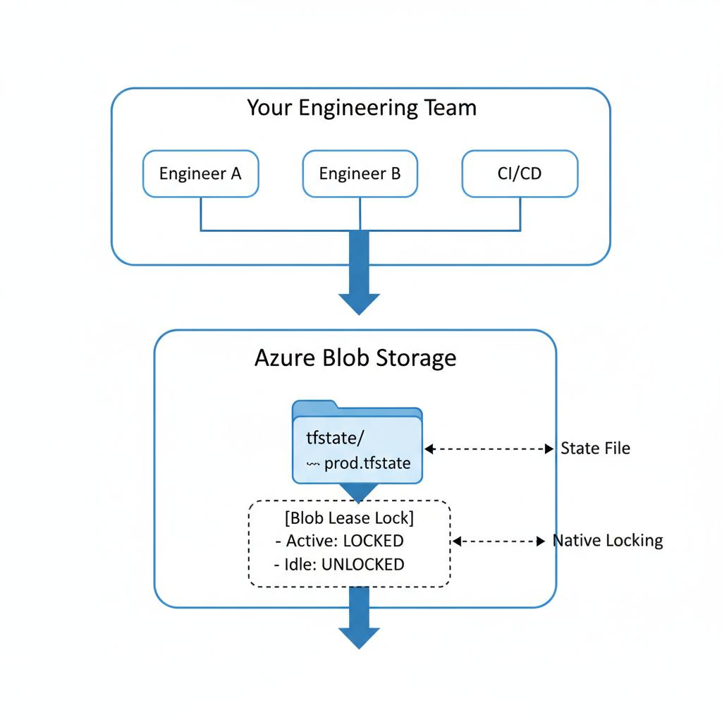
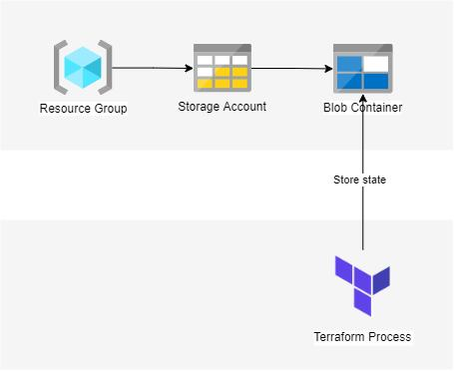
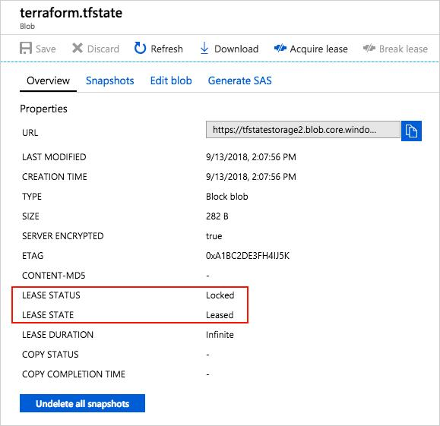
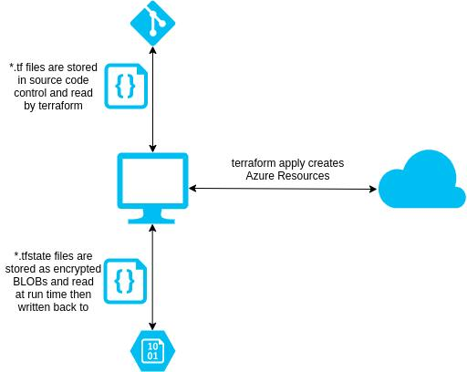
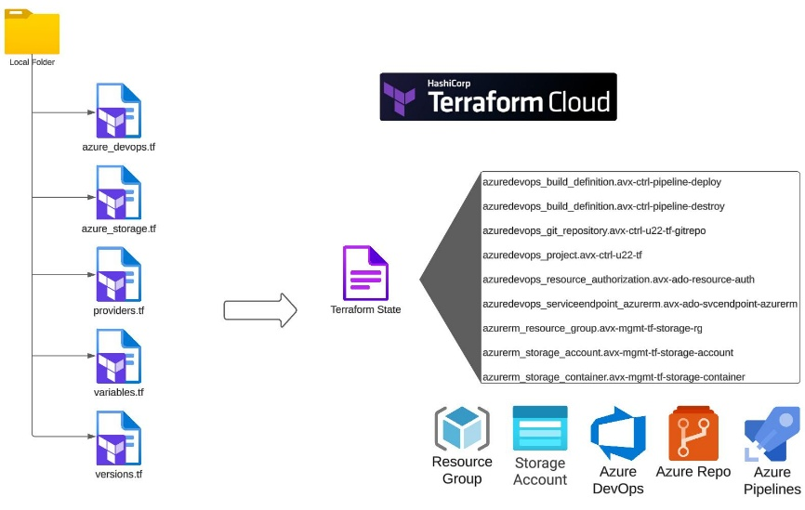
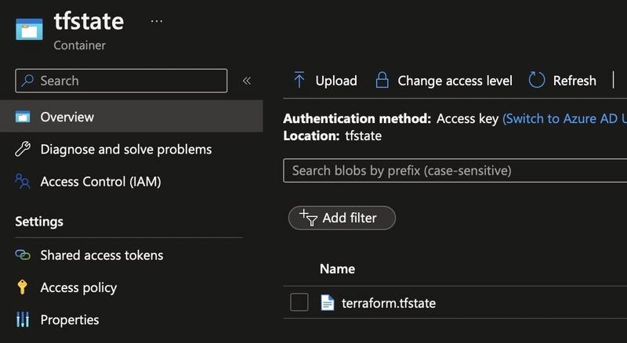
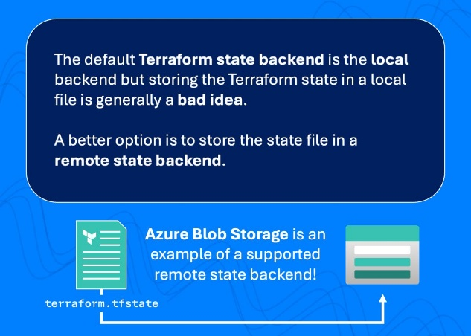

🔄 VISUAL 2 — Terraform Execution Flow (Init → Apply → State)


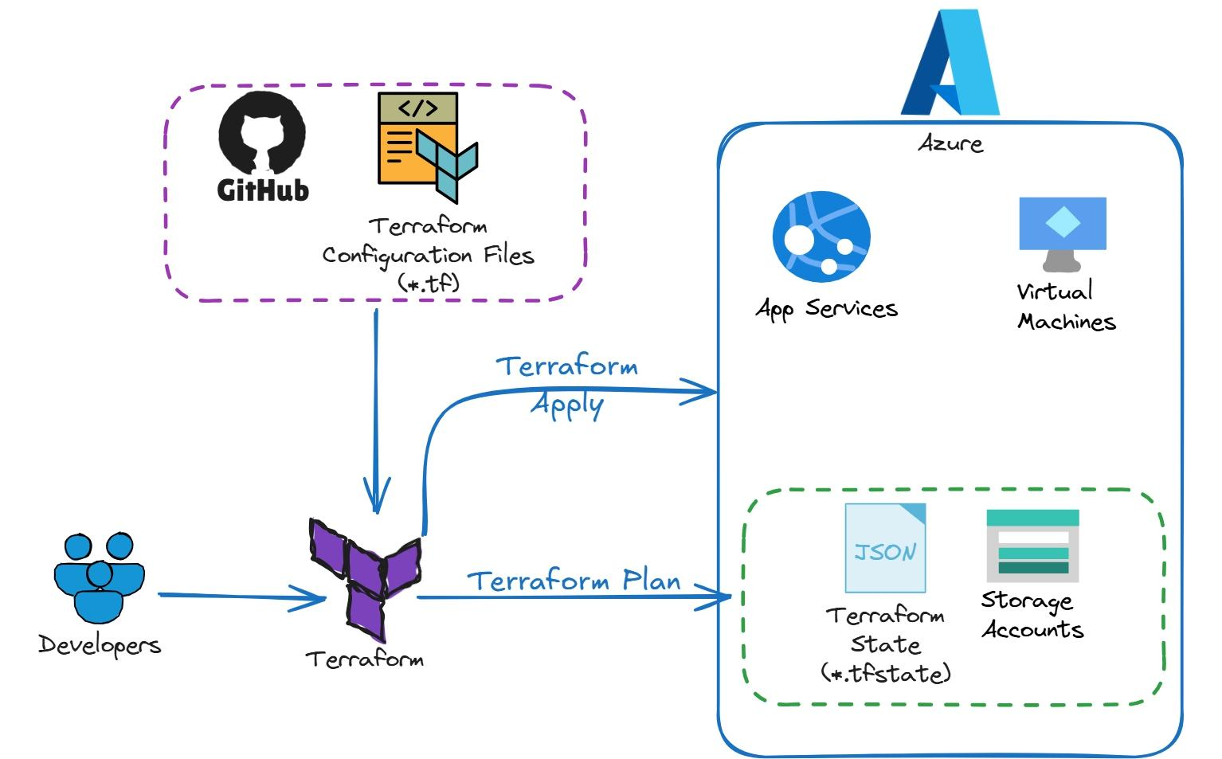
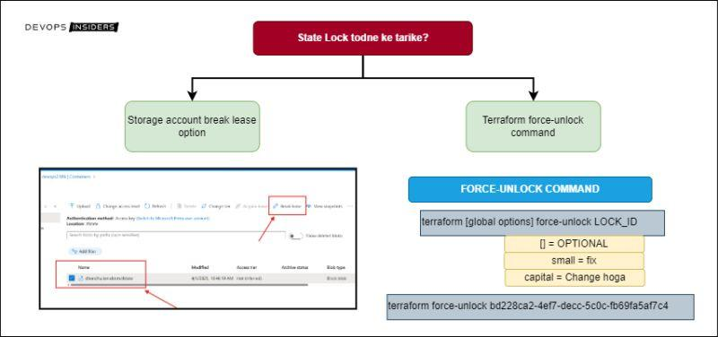
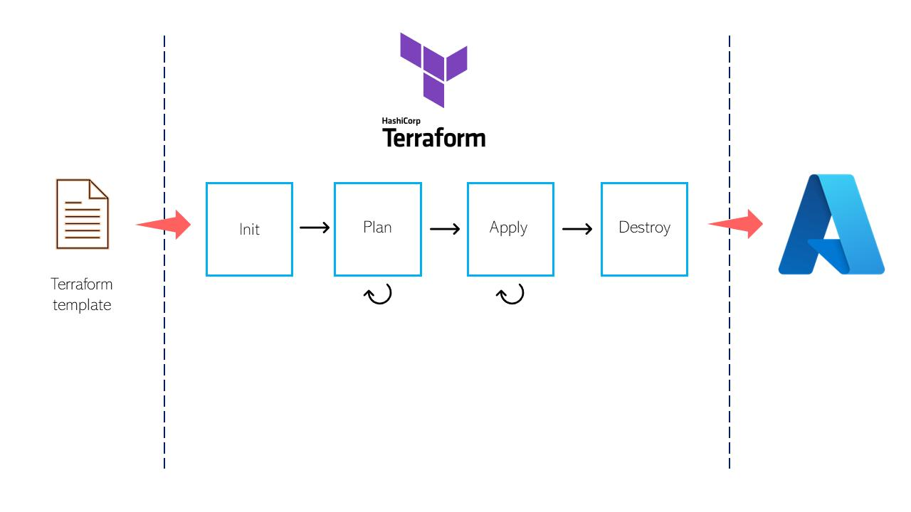
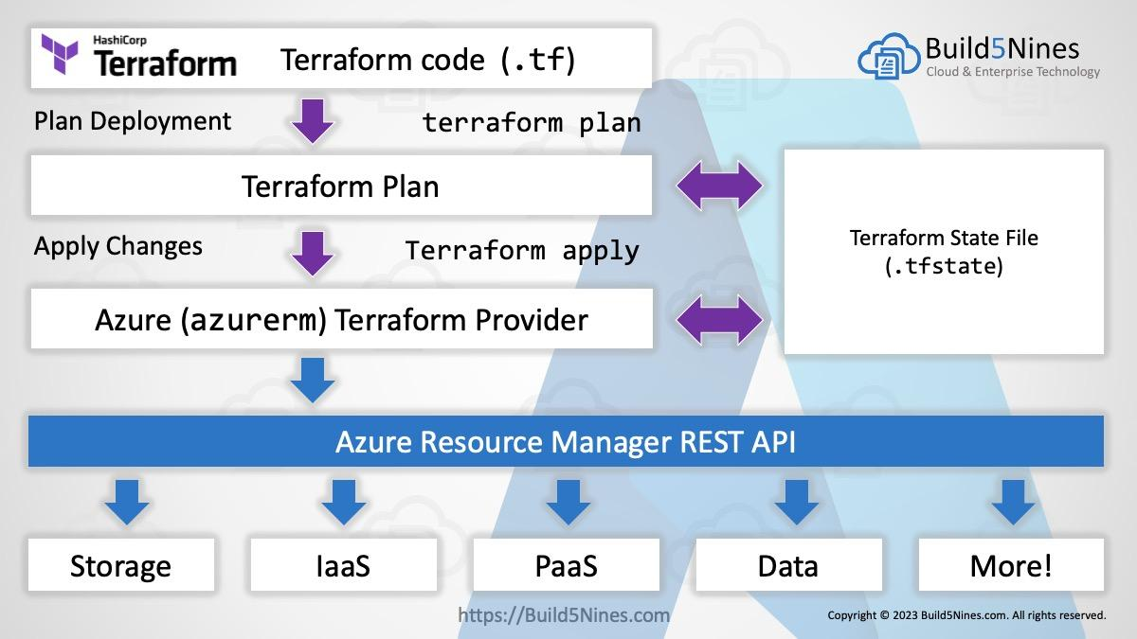

🔒 VISUAL 3 — Blob Lease Locking Concept

