🌍 Terraform Variables — Declaration, Usage & Value Assignment

📌 Variable Declaration
🔹 Creating / Definingb.; Variables

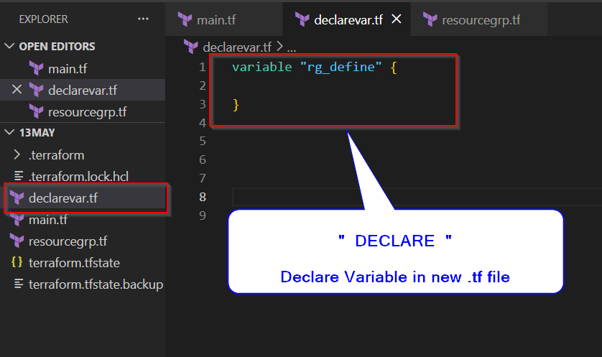

- Variable declaration means informing Terraform that a variable exists in the configuration.
- It acts like a placeholder where values can be supplied later during execution.
- Variables help make Terraform code reusable and environment-independent.
- Without variables, hardcoding values becomes difficult to maintain across Dev, QA, and Prod.
- Variables are mostly declared inside variables.tf file for better project organization.
Syntax:
variable "rg_define" {

}
- A variable can contain:
  - type
  - default
  - description
  - validation
  - sensitive

Example:
variable "rg_define" {
type = string
description = "Resource Group Name"
}
- Terraform does NOT assign value during declaration phase unless default is used.
- Declaration only defines the structure and expectation of the variable.
- Interview Point:
  - Declaration = Variable exists
  - Assignment = Variable gets value
- Common Variable Types:
  - string
  - number
  - bool
  - list
  - map
  - object
- Best Practice:
  - Always use description and type for readability and validation.

📌 Variable Usage
🔹 Accessing Variable Values using: var.<name>

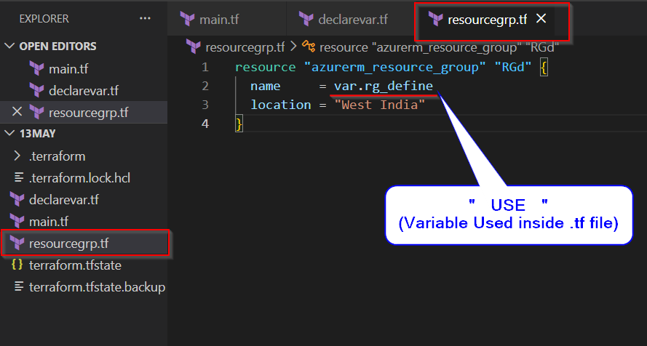

- After declaration, variables are accessed using var.<variable_name> syntax.
  - Syntax:
var.rg_define

- Terraform replaces var.rg_define with the actual assigned value during execution.
- Variables are commonly used inside:
  - Resource blocks
  - Modules
  - Outputs
  - Locals
  - Conditions

Example:
resource "azurerm_resource_group" "rg" {
name = var.rg_define
}
- var is a built-in Terraform keyword used to access input variables.
- If variable is declared but not used, Terraform usually does not fail.
- If variable is used but value is missing, Terraform asks for input unless default exists.
- Interview Point:
  - Declaration creates variable
  - Usage consumes variable value
- Real Life Example:
  - Variable = Empty form field
  - Usage = Using submitted form data somewhere in application
- Best Practice:
  - Use meaningful variable names like:
resource_group_name
location
vm_size

📌 Variable Assign

📌 Variable Value Assignment Methods

🔹 Different Ways to Pass Values to Variables
- Variable assignment means providing actual value to declared variables.
- Terraform supports multiple assignment methods for flexibility and automation.
- Different assignment methods are useful for different project scenarios.
- Example:
  - Manual testing
  - CI/CD pipelines
  - Multi-environment deployments
  - Team collaboration
- Interview Point:
  - Declaration creates variable structure.
  - Assignment provides actual runtime value.

1️⃣ CLI Input

🔹 Interactive User Input
- If no value is assigned and no default exists, Terraform prompts user during execution.
- Command:

terraform apply -> Apply configuration interactively

terraform apply -auto-approve -> Apply configuration without asking for confirmation

terraform destroy -> Remove all resources interactively

terraform destroy -auto-approve -> Remove all resources without asking for confirmation

Terraform asks:
var.rg_define

Prompt while using Terraform apply: Enter a value:

Snaps: terraform apply -auto-approve
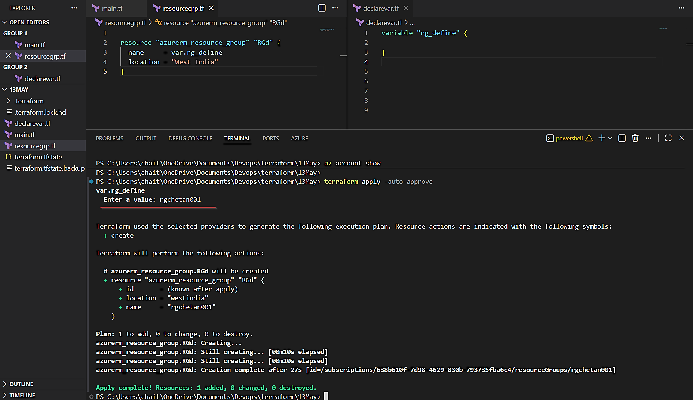

Resource Created on Azure Portal:
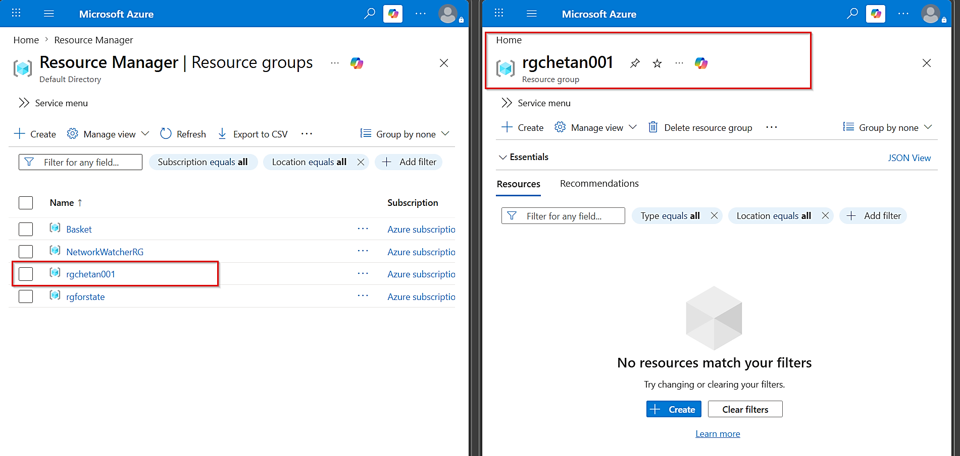

SNAPS: terraform destroy -auto-approve
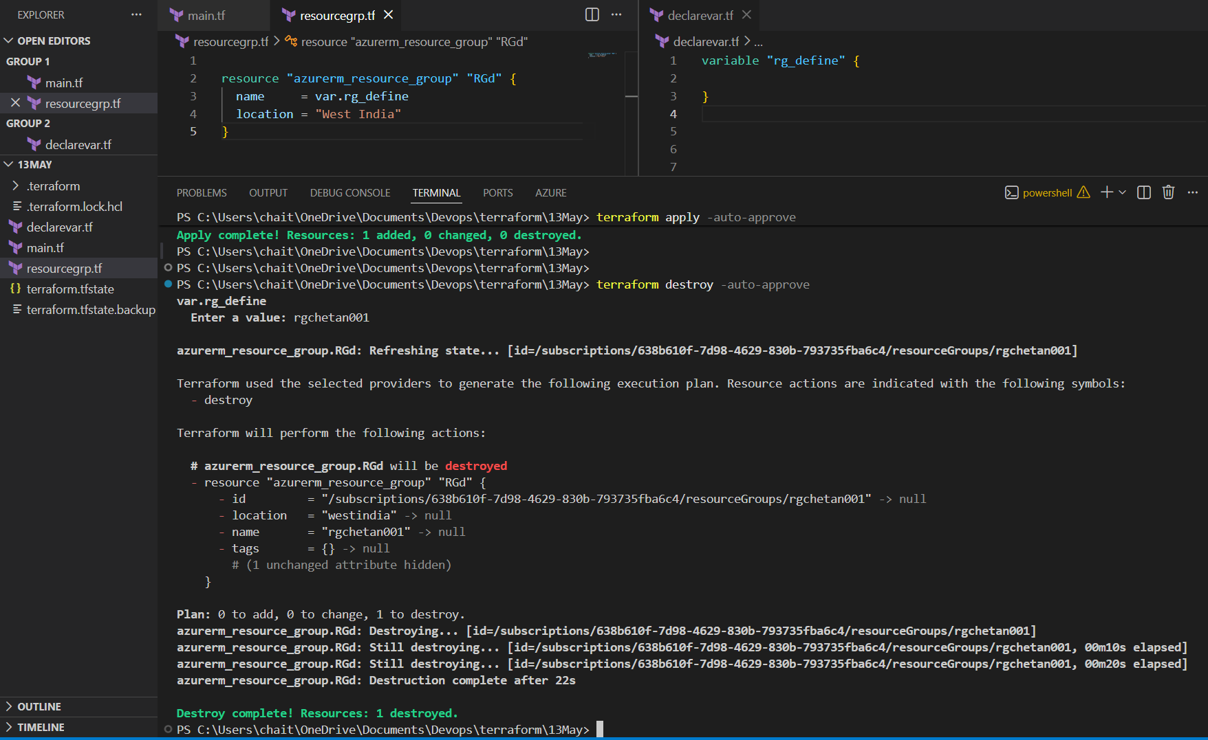

Destroyed Resource: Checking in Azure Portal
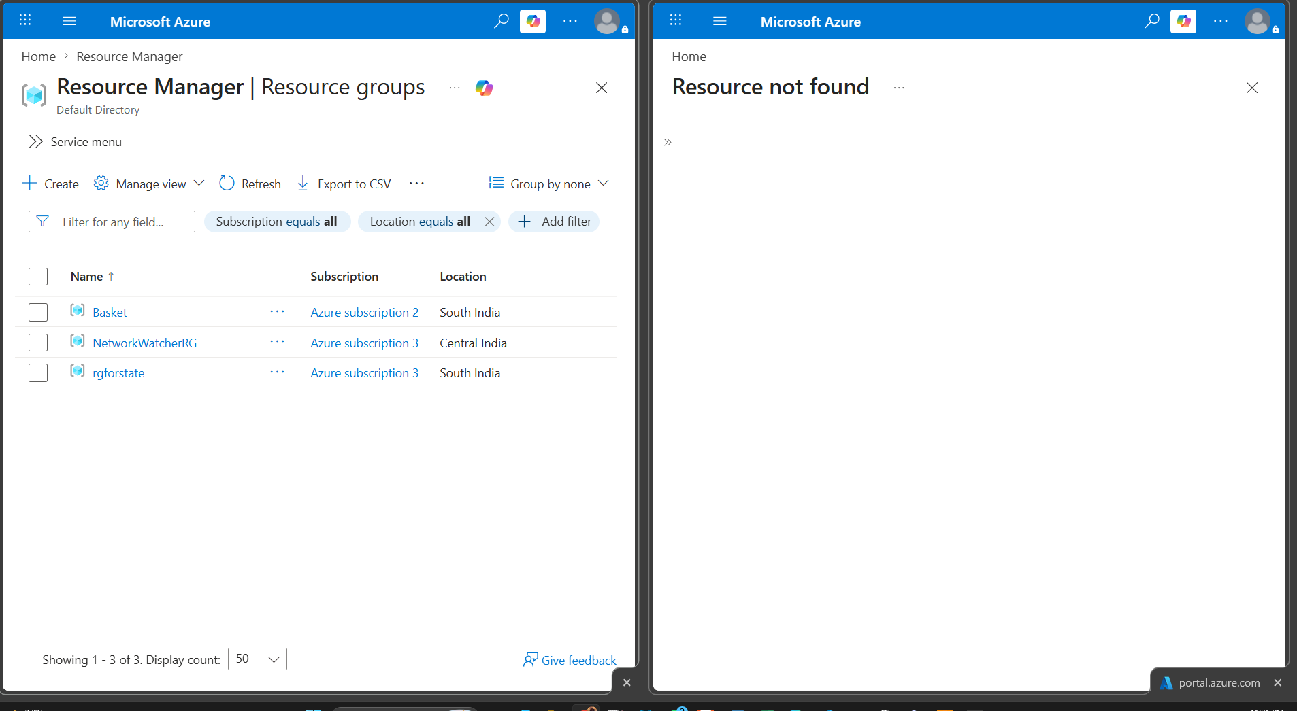

- Useful for beginners and manual testing.
- Not preferred in automation pipelines because execution waits for user input.
- CI/CD pipelines usually disable interactive prompts.
- Interview Point:
  - This is called Interactive Variable Input.

✅ Advantages
- Very easy method for beginners because terraform itself asks user to enter values during execution.
- No need to create extra files or pass long commands, which makes learning simpler initially.
- Useful for quick testing because values can be entered instantly without modifying configuration files.
- Good for temporary infrastructure creation where values change frequently and long-term storage is unnecessary.

❌ Disadvantages / Limitations
- Terraform execution completely stops and waits for user input, which breaks automation workflows.
- Not suitable for CI/CD pipelines because pipelines run automatically without human interaction to provide values.
- Manual typing increases chances of human mistakes such as wrong naming, spelling errors, or incorrect locations.
- Difficult to maintain consistency because every execution depends on what user manually enters each time.
- Cannot be easily reused across team members because values are not stored anywhere permanently.

💼 Usage
- Mostly used during Terraform learning because beginners can manually enter values and understand how variables work internally.
- Helpful in quick testing scenarios where user wants to try different values without creating separate files.
- Commonly used in temporary lab environments where infrastructure is created only for short-term practice.
- Useful during troubleshooting because engineers can manually provide values instantly during execution.

2️⃣ Using -var

🔹 Passing Variables through Command Line
- Variables can be passed directly during execution using -var.
- Command:
terraform apply -var="rg_define=prod-rg"
terraform destroy -var="rg_define=prod-rg"

- Multiple variables can be passed:
terraform apply \
-var="rg_define=prod-rg" \
-var="location=Central India"
- Useful for quick testing and temporary overrides.
- Commonly used in automation scripts and pipelines.
- Not recommended for sensitive values because command history may expose secrets.
- Interview Point:
  - -var provides runtime values directly from command line.

Snap: terraform apply -var="rg_define=prod-rg"

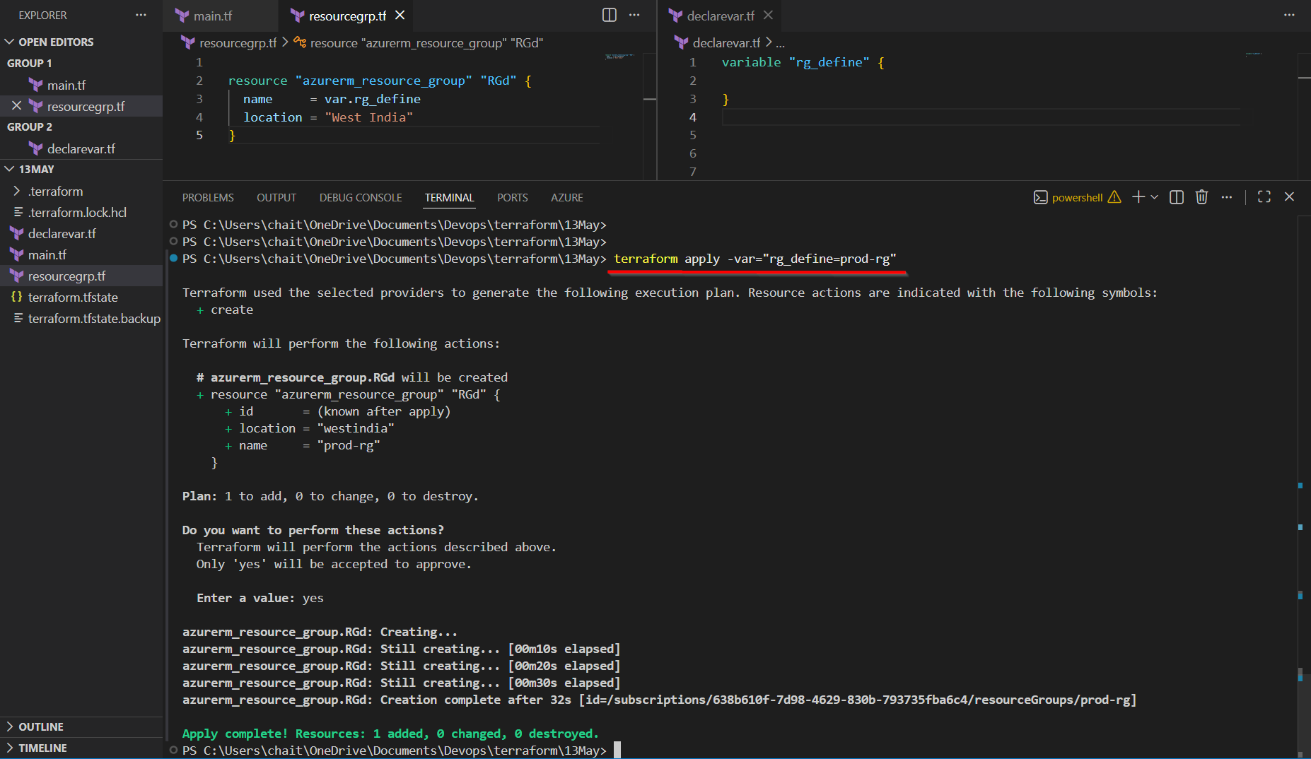

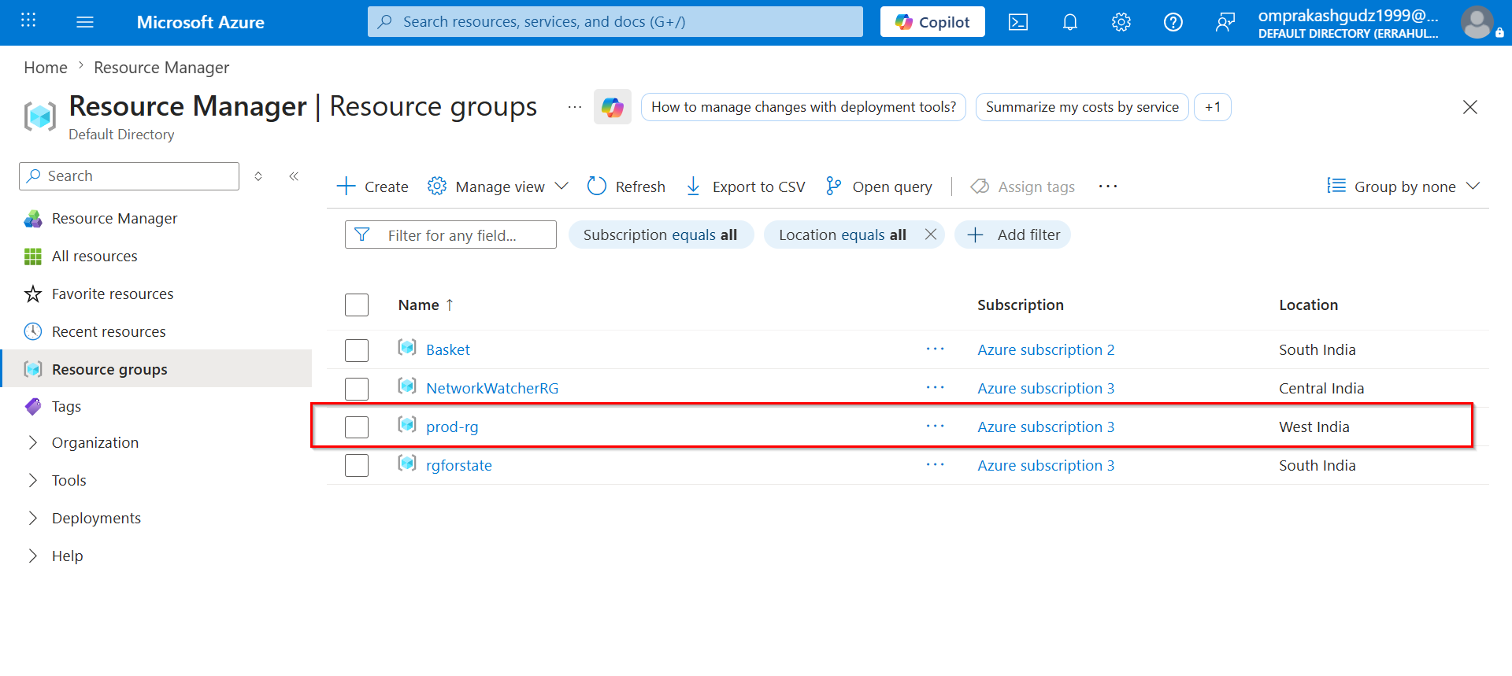

SNAPS: terraform destroy -var="rg_define=prod-rg"

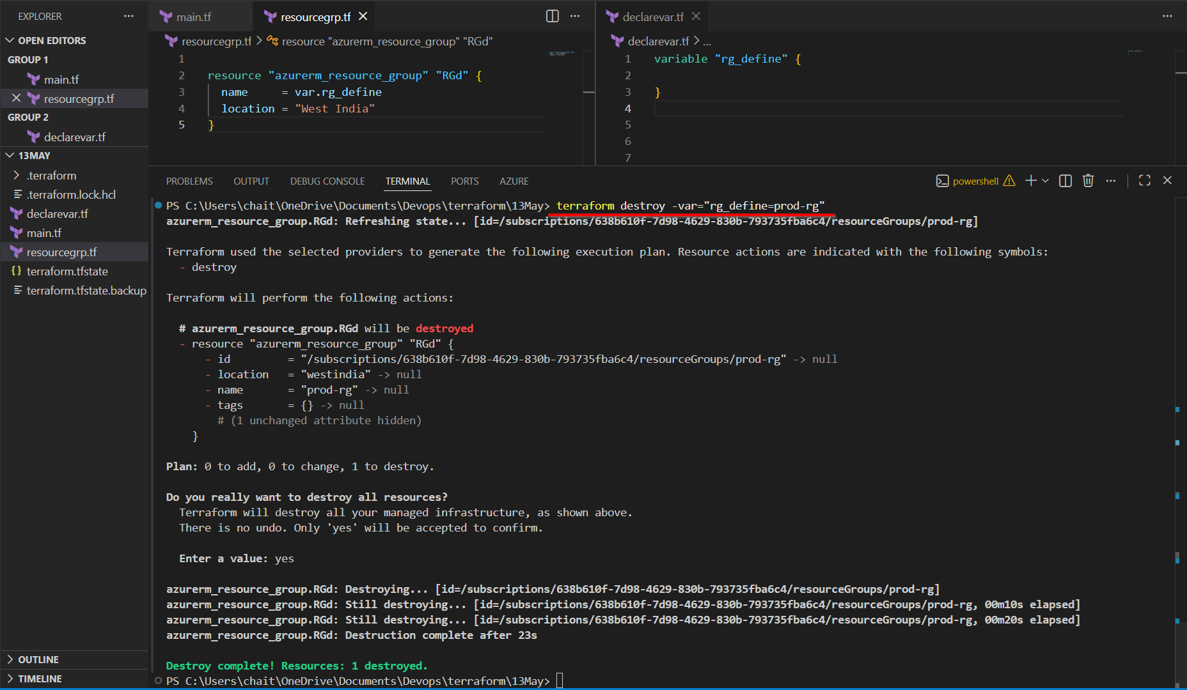

On Azure Portal:
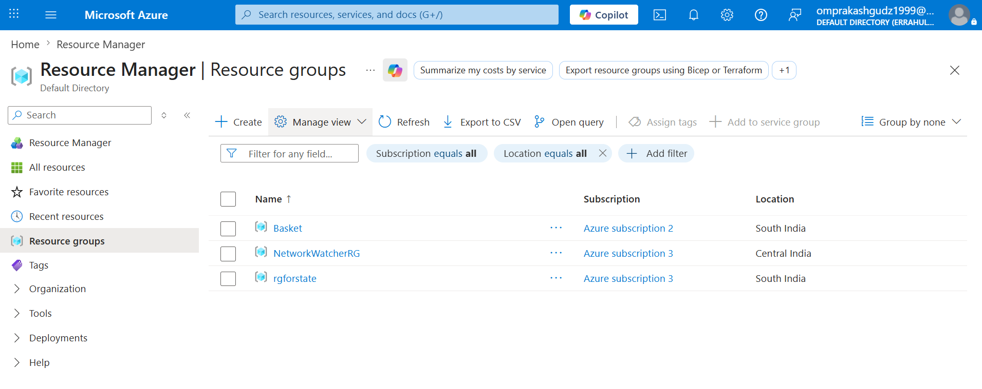

✅ Advantages
- Variables can be passed directly during runtime without modifying Terraform code or variable files.
- Useful for quickly overriding values during testing, debugging, or temporary deployments.
- Works well inside automation scripts where dynamic values need to be injected during execution.
- Flexible approach because different values can be supplied every time command runs.

❌ Disadvantages / Limitations
- Commands become very lengthy and difficult to read when many variables are passed together.
- Sensitive information like passwords may become visible inside terminal history or process logs.
- Managing multiple variables through command line becomes hard in enterprise-scale deployments.
- Team collaboration becomes difficult because values are not centrally stored inside reusable files.
- Reusing same command repeatedly is inconvenient because user must type all variables again.

💼 Usage
- Frequently used in CI/CD pipelines where runtime values like build number, environment name, or image version change dynamically.
- Helpful in automation scripts because shell scripts can pass different values during every execution.
- Useful during testing when engineers want to quickly override one or two values without modifying tfvars files.
- Commonly used for temporary deployments where values are required only for current execution.

3️⃣ Using -var-file

🔹 Passing Variables using External File
- Variables can be stored inside dedicated files and loaded during execution.
- Command:
terraform apply -var-file="dev.tfvars"
terraform destroy -var-file="dev.tfvars"
- Example File:
rg_define = "dev-rg"
location = "Central India"
- Best for environment-specific configurations.
- Common Naming:
dev.tfvars , qa.tfvars , prod.tfvars
- Makes infrastructure cleaner and easier to manage.
- Very common in real-time enterprise projects.
- Interview Point:
  - -var-file is widely used for multi-environment deployments.

SNAP: Terraform APPLY
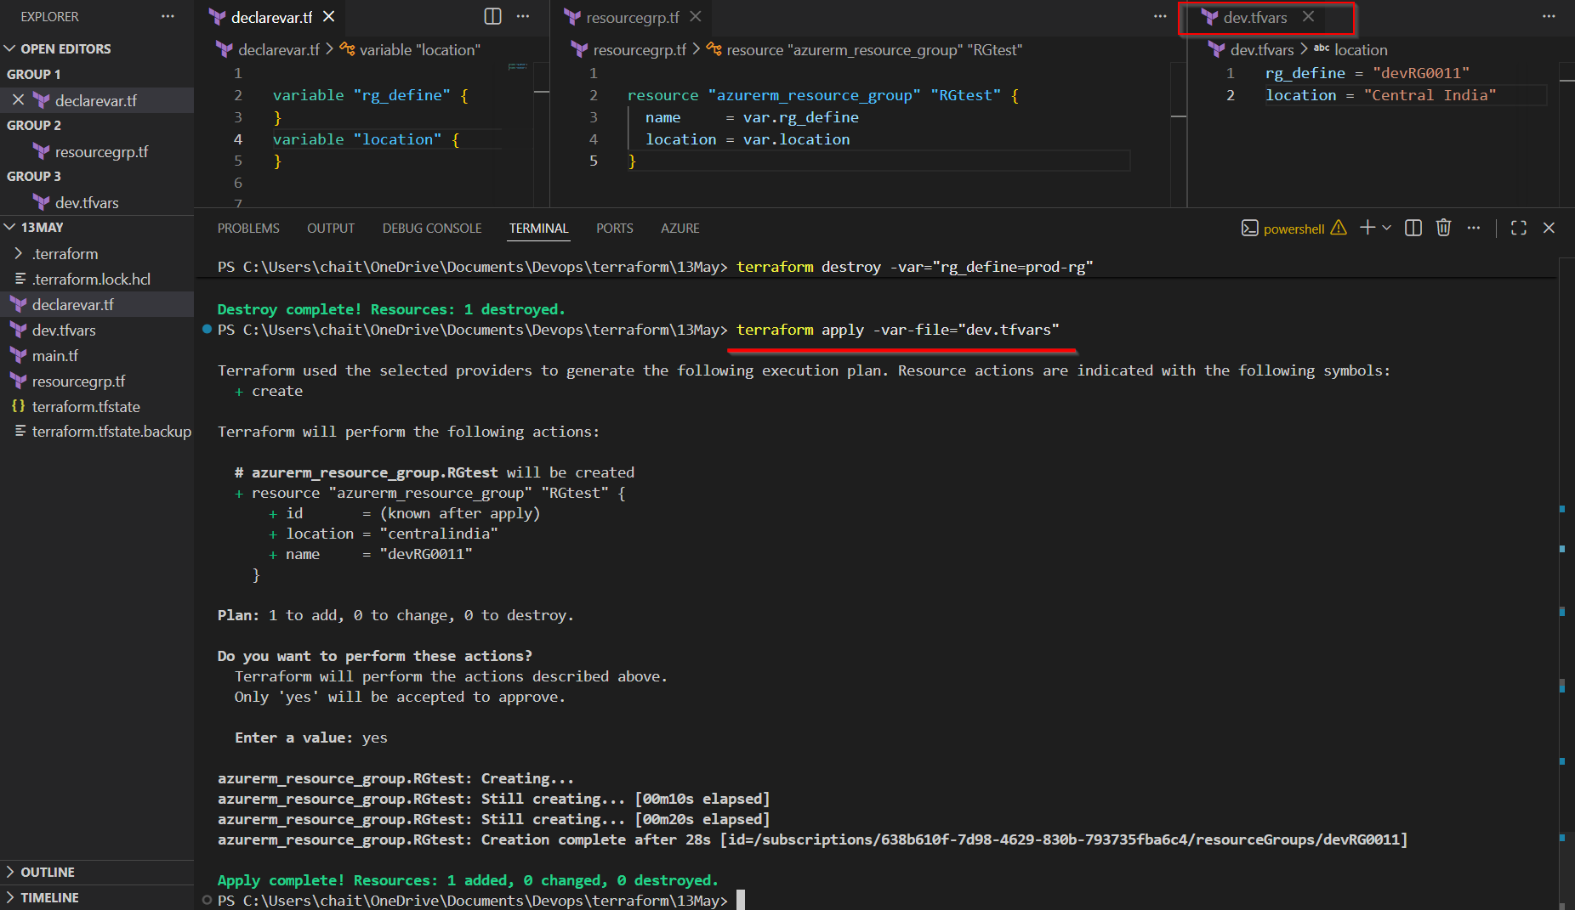
AZURE PORTAL Output:
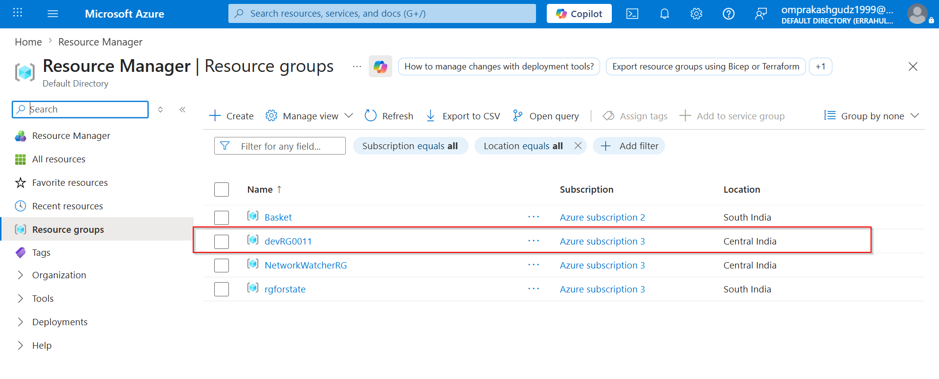

SNAPS: Terraform Destroy
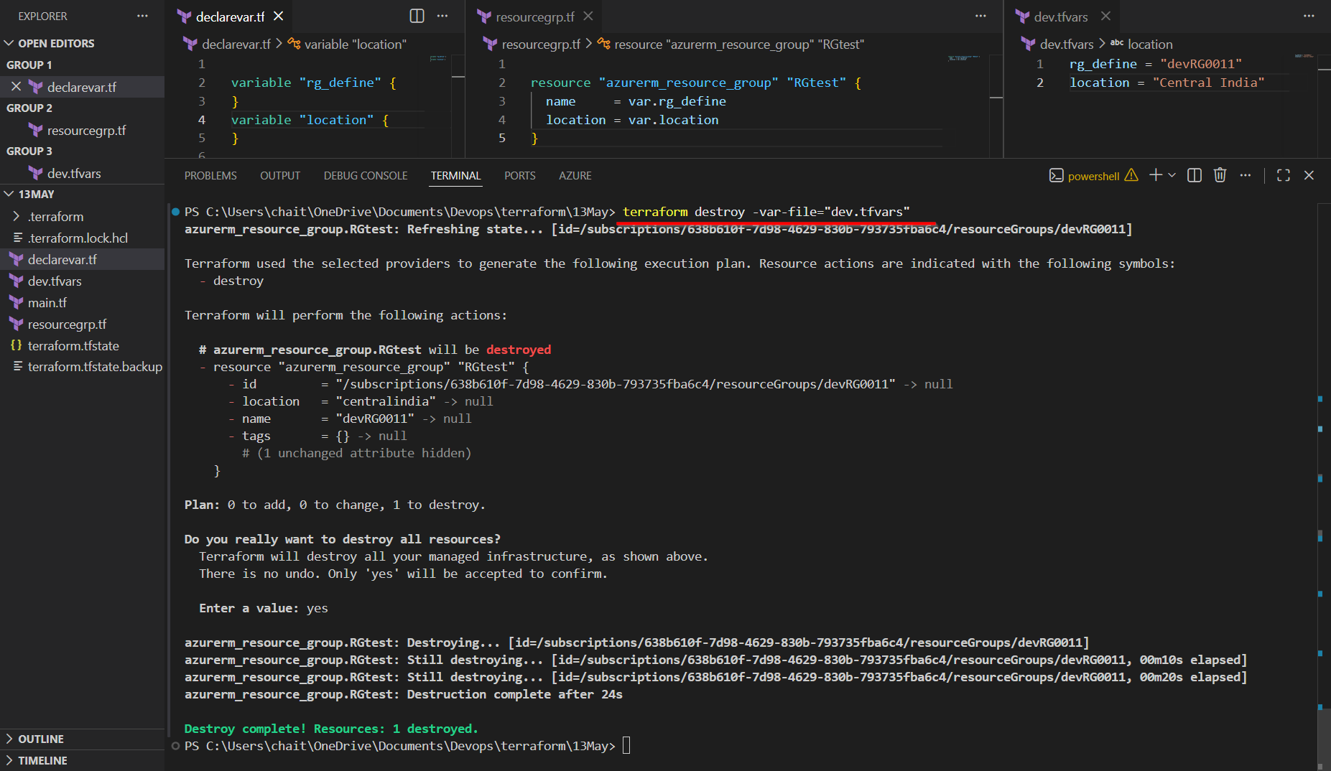

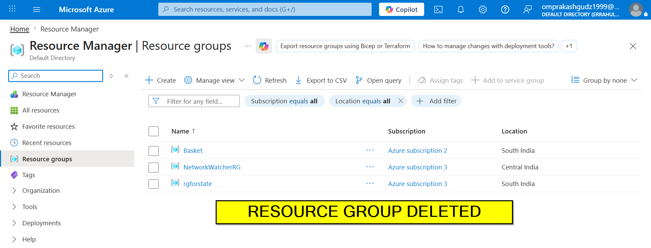

✅ Advantages
- Keeps Terraform configuration cleaner because all variable values are separated into dedicated files.
- Very useful for managing multiple environments like Dev, QA, and Production using different tfvars files.
- Easier team collaboration because everyone can use standardized variable files.
- Improves maintainability because changing environment values does not require modifying Terraform code.
- Widely used in enterprise projects due to better organization and scalability.

❌ Disadvantages / Limitations
- User must manually specify correct tfvars file during every execution.
- Selecting wrong variable file may accidentally deploy resources into incorrect environment.
- Managing too many tfvars files can become confusing in large infrastructures.
- Sensitive values inside tfvars files require proper security protection and access control.
- Additional files increase project complexity slightly for beginners.

💼 Usage
- Widely used in enterprise projects to maintain separate configurations for Dev, QA, UAT, and Production environments.
- Helps infrastructure teams standardize deployments because each environment uses its dedicated tfvars file.
- Useful in team collaboration because developers and DevOps engineers can share common environment files.
- Frequently used in large Terraform projects where managing variables directly in commands becomes difficult.

4️⃣ Using terraform.tfvars

🔹 Automatic Variable Loading File
- Terraform automatically loads terraform.tfvars if file exists.
- No need to specify -var-file.
Example File:
rg_define = "dev-rg"
location = "Central India"
- Helps reduce command complexity.
- Useful for default local environment values.
- Commonly used in small and medium Terraform projects.
- Interview Point:
- Terraform automatically detects and loads this file.
- Best Practice:
- Avoid storing secrets directly inside tfvars files.

SNAPS : terraform apply -auto-approve

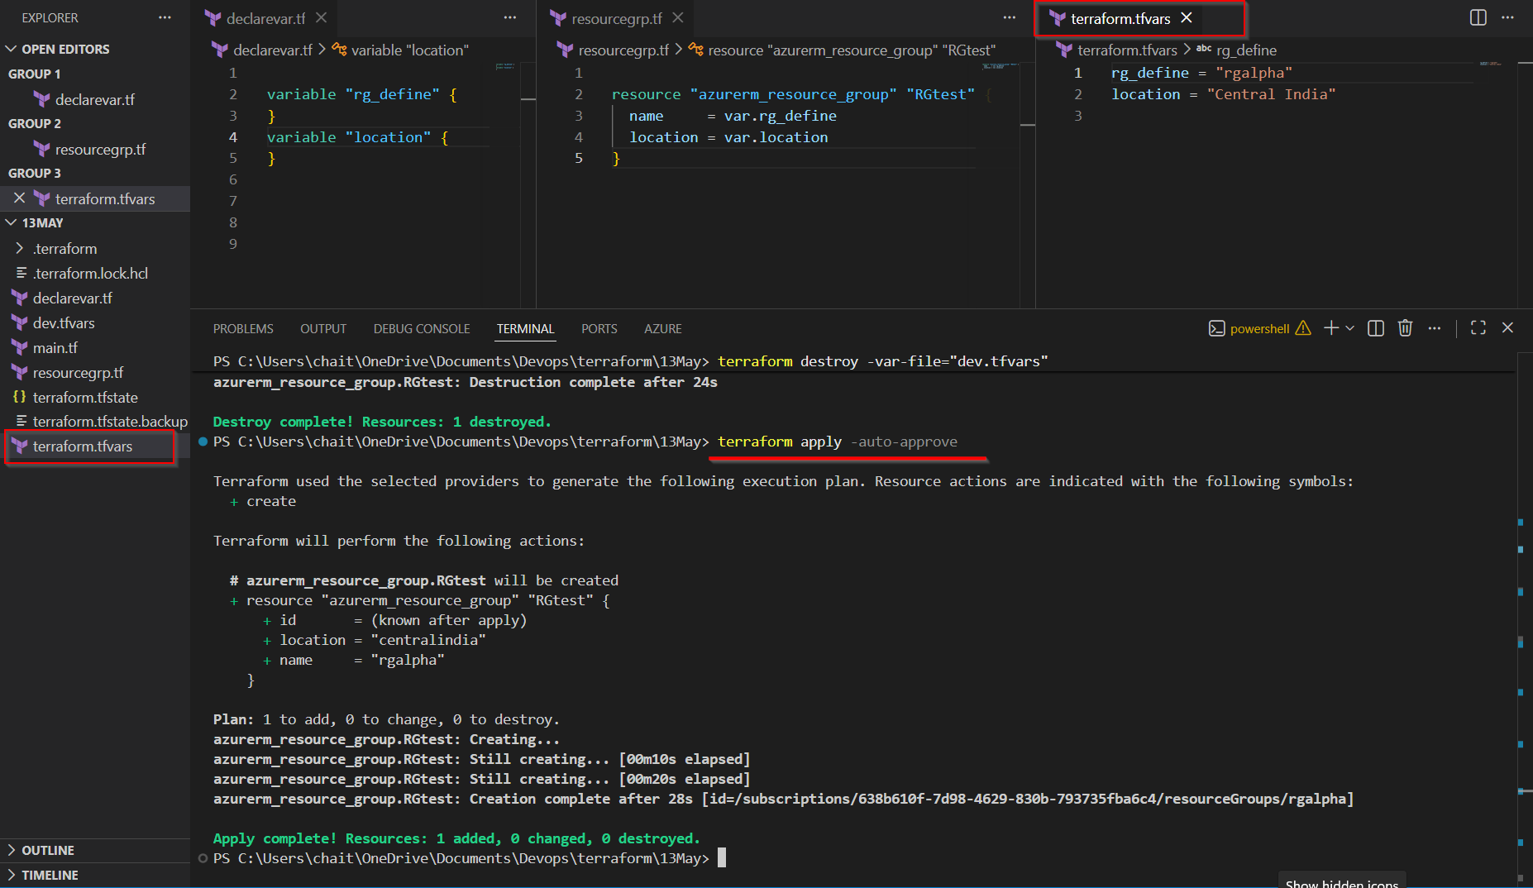

ON AZURE PORTAL:
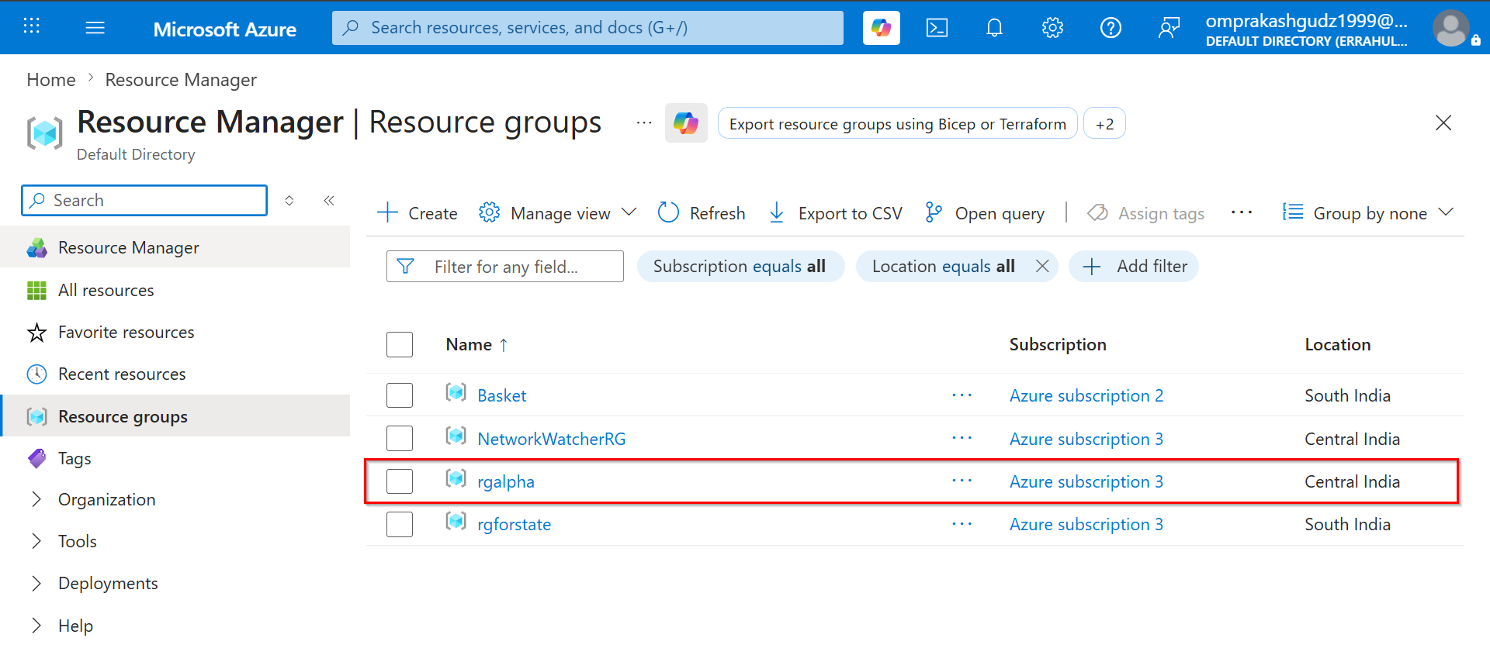

SNAPS: terraform destroy -auto-approve
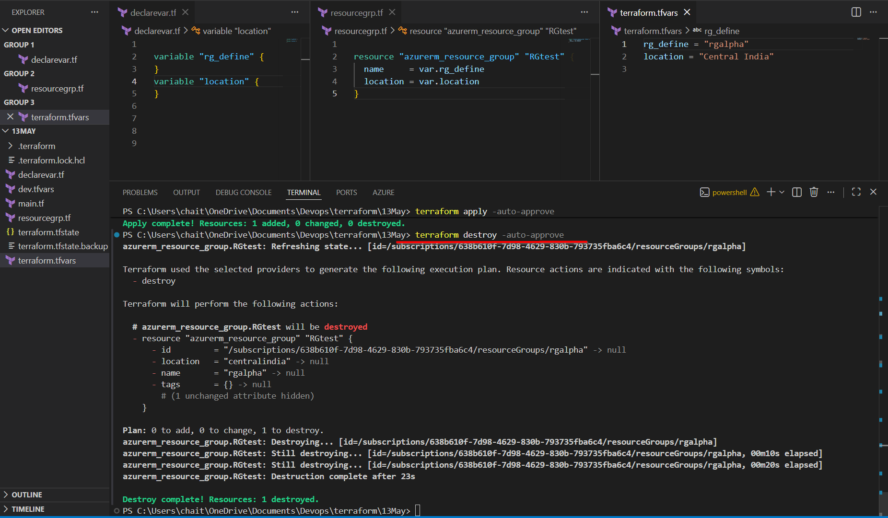

ON AZure Portal
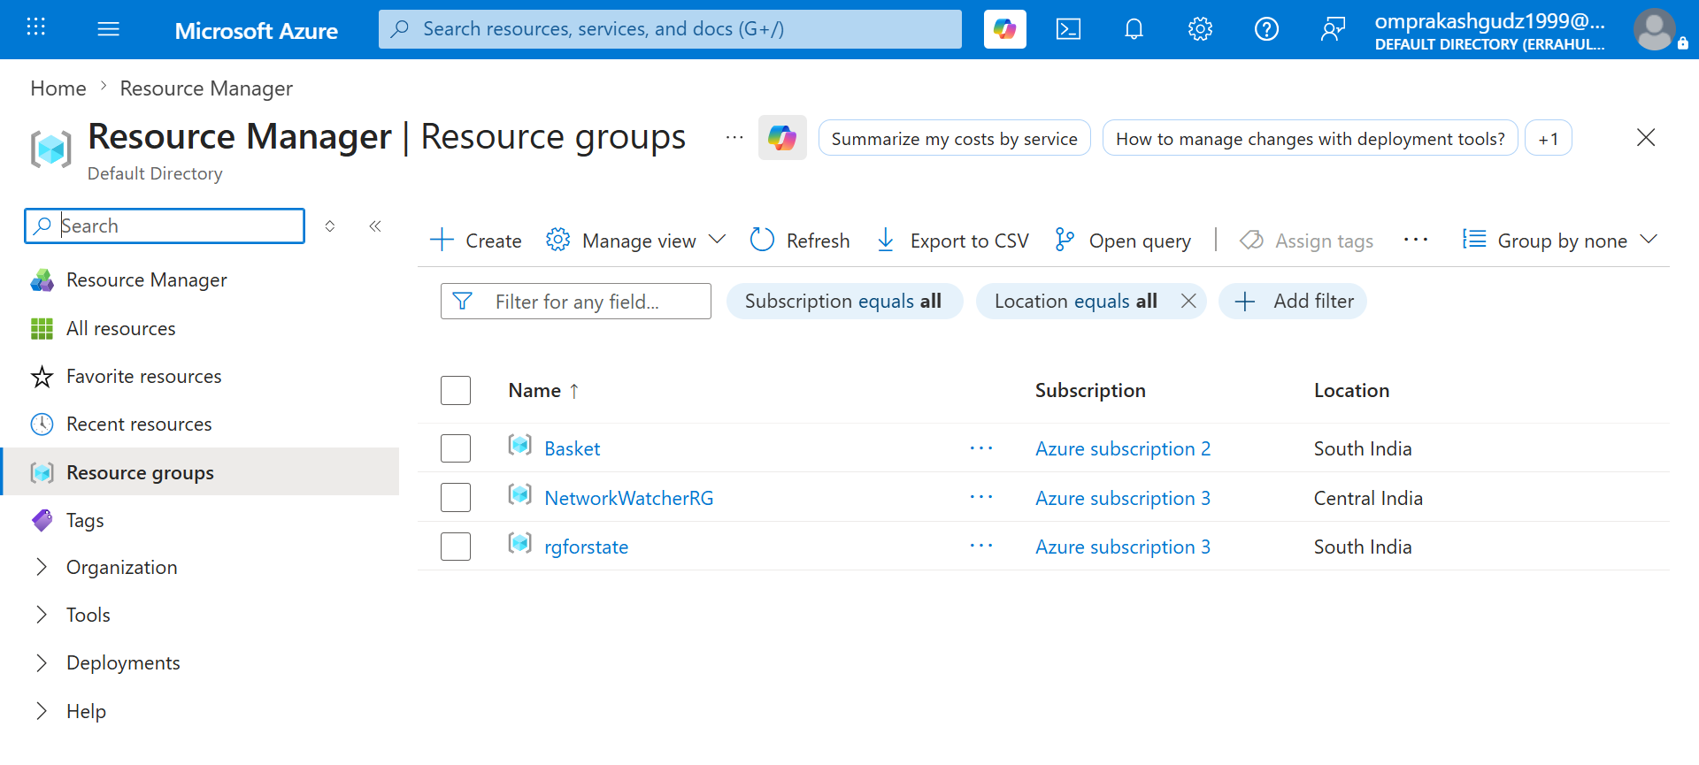

✅ Advantages
- Terraform automatically detects and loads this file, reducing command complexity.
- Simplifies execution because users do not need to repeatedly specify variable files manually.
- Helpful for local developer environments where same values are reused frequently.
- Improves execution speed for repetitive Terraform operations.
- Cleaner command structure improves readability and usability.

❌ Disadvantages / Limitations
- Supports only predefined naming convention which reduces flexibility for multiple environments.
- Team members may unknowingly use outdated or incorrect local tfvars values.
- Sensitive values stored inside local project directories may create security risks.
- Difficult to separate multiple environments cleanly using only one automatic tfvars file.
- Beginners may forget that Terraform automatically loaded values from this file.

💼 Usage
- Commonly used in local developer machines where same variable values are reused frequently.
- Helpful for simplifying Terraform execution because users do not need to repeatedly pass variable files manually.
- Mostly used in small and medium projects where only one primary environment configuration exists.
- Useful during practice and internal development environments for faster execution experience.

5️⃣ Using *.auto.tfvars

🔹 Automatic Variable Loading using Pattern Matching
- Terraform automatically loads files ending with:
<filename>.auto.tfvars
Examples:
dev.auto.tfvars
prod.auto.tfvars
- Useful when multiple variable files must load automatically.
- Helps separate configurations logically.
- Frequently used in advanced Terraform project structures.
- Interview Point:
- Terraform scans directory and auto-loads matching files.
- Important:
- Multiple auto tfvars files can exist in same project.

SNAPS: terraform apply -auto-approve
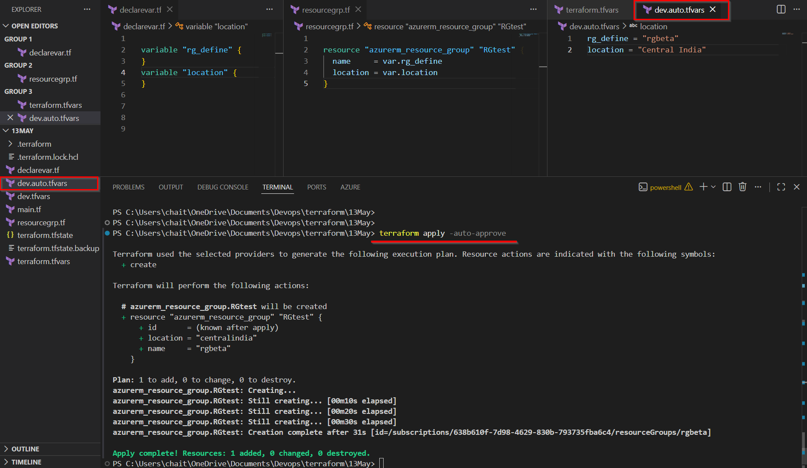

On Azure Portal Output
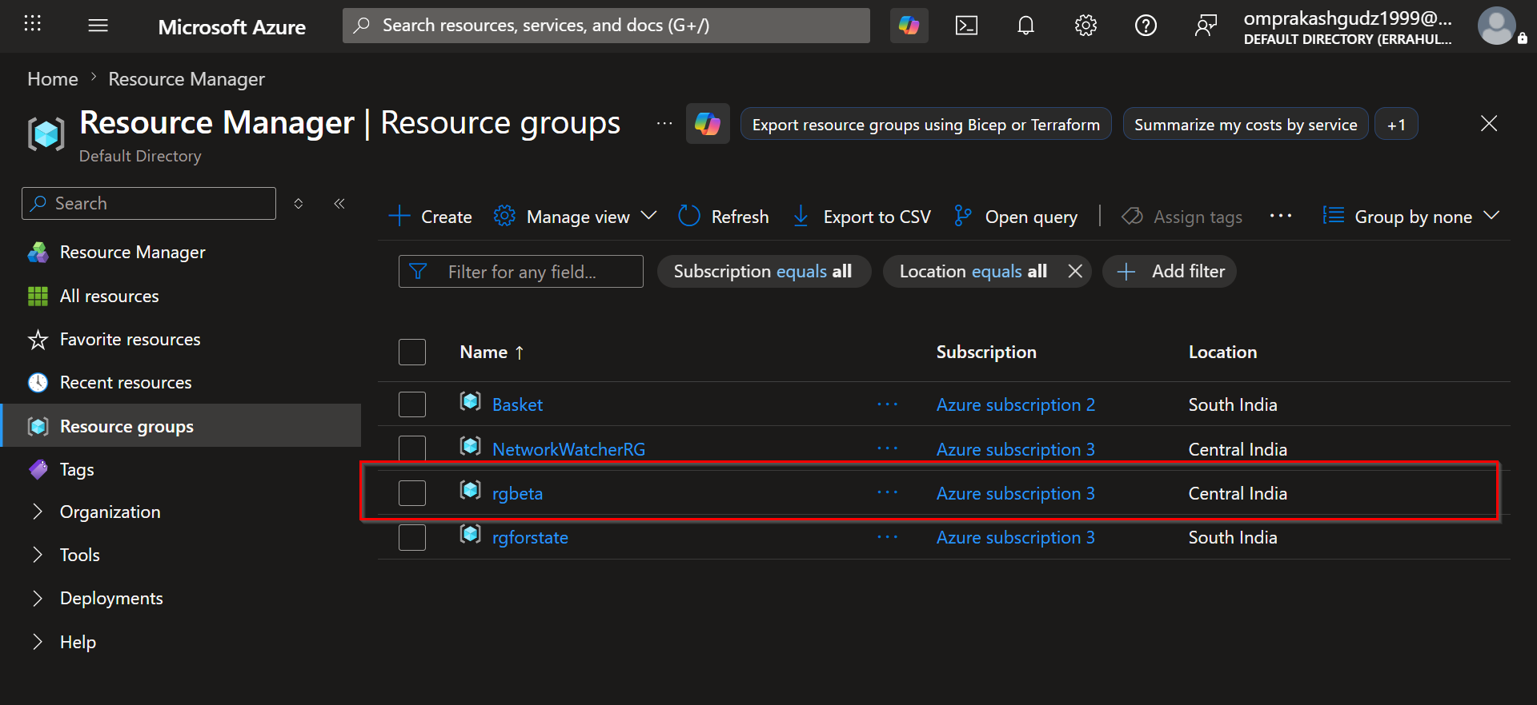

SNAPS : terraform destroy -auto-approve
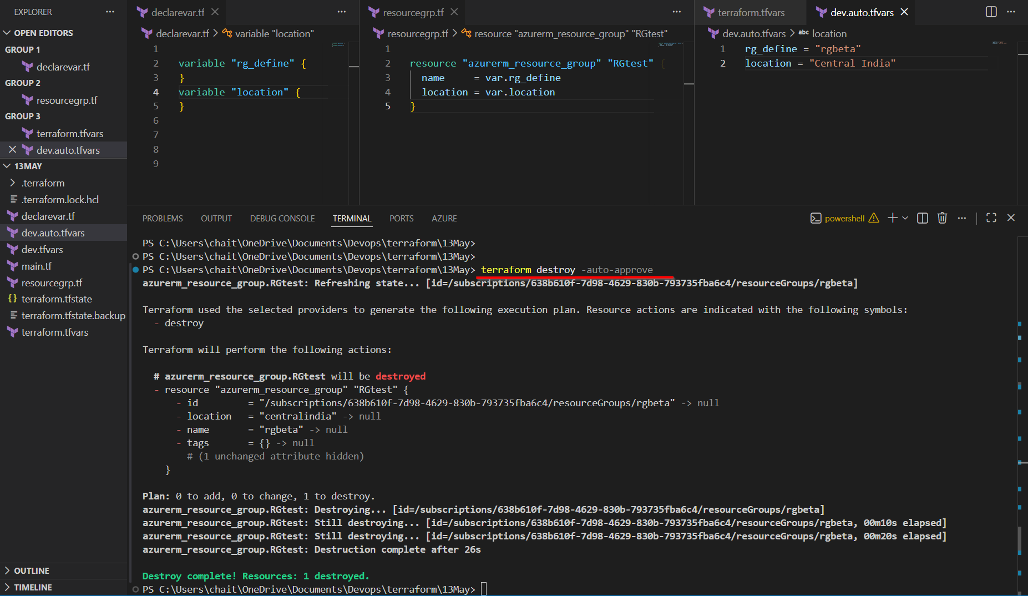

On AZURE PORTAL:
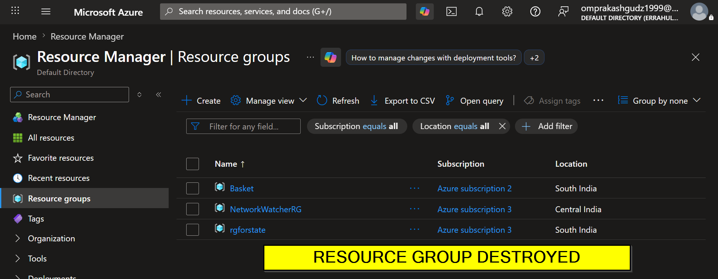

✅ Advantages
- Terraform automatically loads all matching auto tfvars files without manual intervention.
- Helps organize large Terraform projects by separating values logically into multiple files.
- Useful for modular infrastructure where different components require separate configurations.
- Reduces operational effort because no need to repeatedly specify files during execution.
- Supports scalable enterprise project structures very effectively.

❌ Disadvantages / Limitations
- Multiple automatically loaded files may confuse users about which file supplied particular value.
- Debugging becomes difficult because Terraform silently loads matching files in background.
- Incorrect naming conventions may cause files not to load properly.
- Risk of conflicting variable values increases when many auto tfvars files exist together.
- Requires disciplined file management and proper project standards.

💼 Usage
- Frequently used in advanced enterprise Terraform projects where infrastructure is divided into multiple logical components.
- Helpful in modular architectures where separate teams manage different configuration files independently.
- Used in automated deployment systems where Terraform should automatically detect and load required variable files.
- Common in scalable Infrastructure as Code repositories where maintaining single tfvars file becomes difficult.

6️⃣ Using Default Values

🔹 Assigning Values inside Variable Block
- Variables can have built-in default values.
Example:
variable "location" {
default = "Central India"
}
- If user does not provide value, Terraform uses default automatically.
- Makes variables optional instead of mandatory.
- Useful for commonly reused values.
- Reduces repetitive input during execution.
- If another value is supplied manually, Terraform uses that new value.
- Interview Point:
- Default values help simplify Terraform execution.
- Best Practice:
- Use defaults only for safe/common values.
- Avoid default values for secrets or environment-specific settings.

SNAPS: APPLY

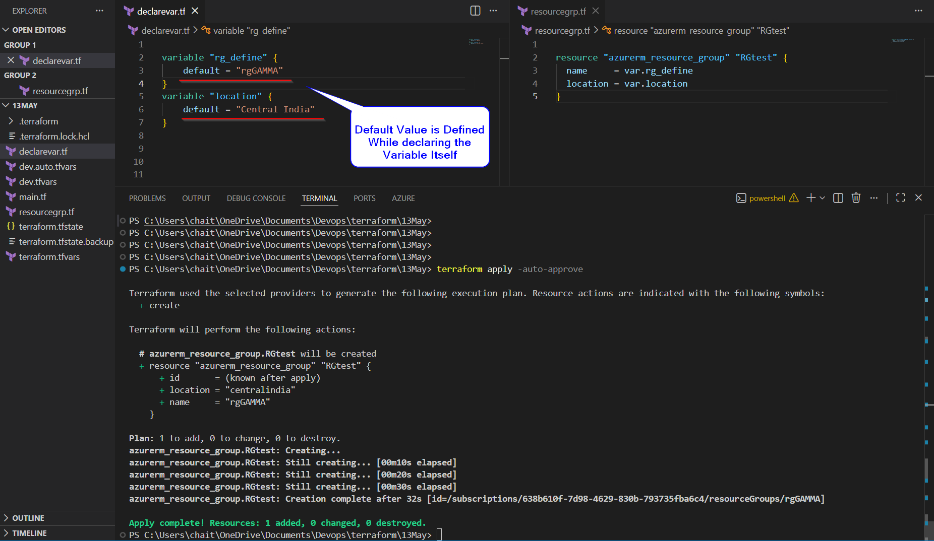

On Azure:
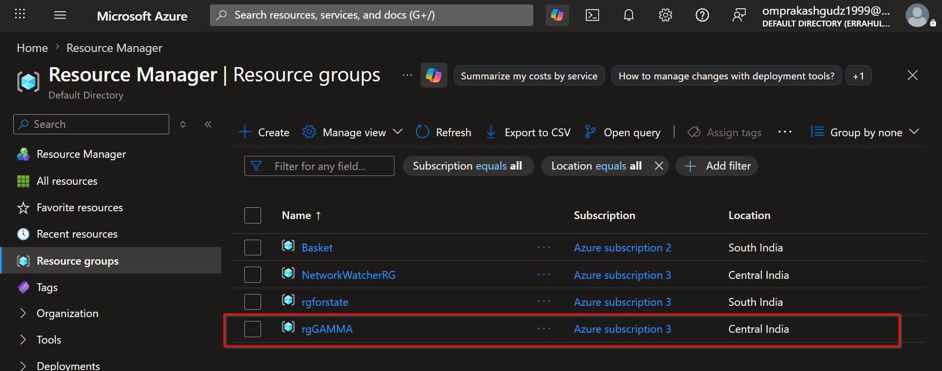

SNAPS: DESTROY
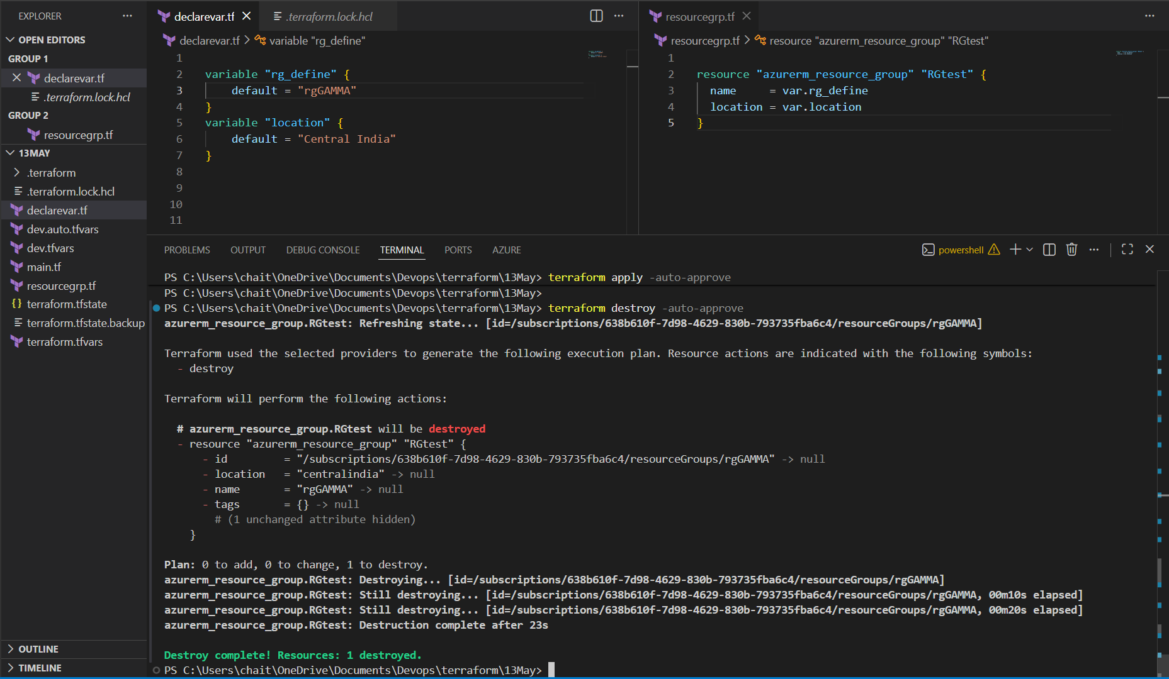

On Azure Portal:

✅ Advantages
- Makes variables optional because Terraform automatically uses default value if user provides nothing.
- Reduces repetitive input for commonly reused values such as locations or VM sizes.
- Simplifies Terraform execution especially for beginners and reusable modules.
- Provides fallback values which help avoid unnecessary prompts during execution.
- Improves user experience by reducing required configuration effort.

❌ Disadvantages / Limitations
- Incorrect default values may unintentionally create resources in wrong region or configuration.
- Users may forget variable was using default value because Terraform execution succeeds silently.
- Not suitable for environment-specific values because same default gets reused everywhere.
- Storing secrets as defaults creates serious security risks because values remain hardcoded in code.
- Excessive use of defaults may reduce configuration visibility and explicitness.

💼 Usage
- Commonly used for standard values that rarely change, such as default Azure region or VM size.
- Helpful in reusable Terraform modules because users are not forced to provide every variable manually.
- Frequently used in learning and testing environments to reduce unnecessary prompts during execution.
- Useful when organization wants fallback values available automatically if user forgets to pass input.

🌍 Terraform Variable Assignment Precedence/ Priority
🔹 Which Variable Assignment Method Gets Highest Priority ?

📌 What is Variable Precedence ?
- Terraform supports multiple ways to assign values to variables.
- Sometimes same variable may receive values from multiple sources at the same time.
- In such situations, Terraform follows a fixed hierarchy called:

Variable Precedence Order
- Higher precedence value overrides lower precedence value.

🖼️ Terraform Variable Precedence Flow
HIGHEST PRIORITY
│
▼
┌──────────────────────┐
│ CLI -var │
└─────────┬────────────┘
│
▼
┌──────────────────────┐
│ CLI -var-file │
└─────────┬────────────┘
│
▼
┌──────────────────────┐
│ *.auto.tfvars │
└─────────┬────────────┘
│
▼
┌──────────────────────┐
│ terraform.tfvars │
└─────────┬────────────┘
│
▼
┌──────────────────────┐
│ Environment Variables│
└─────────┬────────────┘
│
▼
┌──────────────────────┐
│ Default Values │
└──────────────────────┘
▲
│
LOWEST PRIORITY

📌 1️⃣ -var
🔹 Highest Priority

🧠 Explanation
- Variables passed directly through command line have highest precedence.
- Terraform assumes manually supplied runtime values are most important.
- Even if same variable exists inside tfvars files or defaults, -var overrides them.

🧾 Example
terraform apply -var="location=Central India"

🎯 Interview Point
- Direct runtime input always wins because user explicitly provided value during execution.

📌 2️⃣ -var-file
🔹 Second Highest Priority

🧠 Explanation
- Values supplied using -var-file override automatically loaded tfvars files and defaults.
- Terraform gives higher importance to explicitly specified variable files.
- Useful when deploying environment-specific infrastructure.

🧾 Example
terraform apply -var-file="prod.tfvars"

🎯 Interview Point
- Explicitly provided variable files are prioritized over automatic tfvars loading.

📌 3️⃣ *.auto.tfvars
🔹 Third Priority

🧠 Explanation
- Terraform automatically loads files ending with .auto.tfvars.
- These values override terraform.tfvars and default values.
- Useful for modular and enterprise-level projects.

🧾 Example
prod.auto.tfvars

🎯 Interview Point
- Auto tfvars files are automatically detected but still lower priority than manually specified files.

📌 4️⃣ terraform.tfvars
🔹 Fourth Priority

🧠 Explanation
- Terraform automatically loads this file if present in current directory.
- Values inside this file override default variable values.
- Frequently used for local reusable configurations.

🧾 Example
terraform.tfvars

🎯 Interview Point
- Automatically loaded default variable file with lower priority than explicit methods.

📌 5️⃣ Environment Variables
🔹 Fifth Priority

🧠 Explanation
- Terraform can read environment variables using naming format:
TF_VAR_<variable_name>
- Useful in CI/CD systems for passing secret or dynamic values securely.
- Lower priority compared to tfvars files and CLI methods.

🧾 Example
export TF_VAR_location="Central India"

🎯 Interview Point
- Commonly used in pipelines because environment variables integrate well with secret managers.

📌 6️⃣ Default Values
🔹 Lowest Priority

🧠 Explanation
- Default values are used only when no other assignment method provides value.
- Acts as fallback mechanism for optional variables.
- Terraform ignores default if any higher-priority assignment exists.

🧾 Example
variable "location" {

default = "Central India"

}

🎯 Interview Point
- Default values are fallback values, not primary runtime configuration.

📌 Real-Time Example of Precedence

🧾 Variable Declaration
variable "location" {

default = "East US"

}

🧾 terraform.tfvars
location = "West Europe"

🧾 CLI Command
terraform apply -var="location=Central India"

🧠 Final Result
Terraform uses:

Central India

🔍 Why ?
- Because -var has highest precedence among all provided assignment methods.
- Terraform ignores lower-priority values once higher-priority value is available.

🎯 Final Interview Summary
Priority | Method
1 | -var
2 | -var-file
3 | *.auto.tfvars
4 | terraform.tfvars
5 | Environment Variables
6 | Default Values

