INDUSTRY/ INTERNATIONAL HIGHER LEARNING

10215CS173-Large Language Models(LLMs):Fine-Tuning ,Rag, and Agentic AI

VEHICLE BREAKDOWN SYSTEM

final project report submitted in partial fulfillment for the award of the degree of

Bachelor of Technology in Computer Science and Engineering

Submitted By

S SIDDU-VTU29420
V CHAITANYA RAJU-VTU29435

Under the direction of
MURUGAVEL B B.E,M.Tech,MBA(PhD)
Reader in Intelligent Systems
School of Engineering
Chief Projects Officer
ATRIBS GLOBAL TECHNOLOGY
CHENNAI

Department of Computer Science and Engineering
School of Computing
VEL TECH RANGARAJAN DR.SAGUNTHALA R&D INSTITUTE OF SCIENCE
AND TECHNOLOGY
(Deemed to be University Estd.u/s 3 of UGC Act1956)
Accredited by NAAC with A++ Grade, Chennai-600 002
TAMIL NADU, INDIA
SEPTEMBER 2026
TABLE OF CONTENTS
1. Aim and Objectives 3
2. Introduction 3
3. State-of-the-Art Technologies 4
3.1 Hardware 4
3.2 Software 4
3.3 Applications 5
4. Research Gaps 5
5. Research Questions 6
6. Research and Development in AI-Assisted Vehicle Support 6
7. Proposed Innovative Solution 6
7.1 Overview and Architecture 6
7.2 Implementation 7
7.3 Results and Observations 8
7.4 Limitations 9
7.5 Proposed Mobile Application 9
8. Impact Analysis 10
8.1 Technical Impact 10
8.2 Economic Impact 10
8.3 Social Impact 10
8.4 Environmental Impact 10
9. Cost Analysis 10
10. Commercialisation and Exploitation Plan 11
11. Conclusion 12
12. References 12

1. Aim and Objectives

Aim
The aim of this project is to design, implement and compare three approaches for building an AI assistant that helps drivers during a vehicle breakdown: a simple Large Language Model (LLM) chatbot, an LLM chatbot with Retrieval-Augmented Generation (RAG), and a fine-tuned LLM. All three were built with free, open-source models on Google Colab, and the project proposes a combined solution that can later be deployed as an AI-powered mobile application.

Objectives
- To build a baseline conversational chatbot using the open-source Qwen2.5-3B-Instruct model and record its behaviour without any private data.
- To build a RAG chatbot that answers only from a vehicle breakdown knowledge base supplied as a PDF, using ChromaDB as the vector database.
- To fine-tune the small Qwen2.5-0.5B-Instruct model with Low-Rank Adaptation (LoRA) so that it learns the concise instruction style of roadside assistance.
- To combine retrieval with the fine-tuned model so that RAG supplies the facts and fine-tuning shapes the answer.
- To compare the three approaches in terms of knowledge of the domain, grounding, effort required to update data, and cost.
- To outline how the solution can be deployed as a mobile application and commercialised.

2. Introduction
A vehicle breakdown is a stressful and sometimes unsafe event. The driver needs short, correct and calm guidance: stop safely, switch on the hazard lights, check simple causes, and know what details to give when calling for help. Traditionally this guidance comes from a call centre, a printed manual or a web search, all of which are slow or hard to use at the roadside.
Large Language Models (LLMs) are neural networks built on the transformer architecture [1] and trained on very large text collections to predict the next token [2]. Instruction-tuned models can follow questions and hold a conversation [3]. However, an LLM only knows what it saw during training. It has no access to an organisation's private documents and it can produce fluent but incorrect statements, a problem known as hallucination [7]. For safety-related advice such as breakdown support, this is a serious limitation.
Two techniques address this limitation in different ways. Retrieval-Augmented Generation (RAG) [4], [5] leaves the model unchanged but retrieves the relevant part of a knowledge base for every question and places it in the prompt, so the answer is grounded in a known source. Fine-tuning continues the training of the model on domain examples so that its weights change and it learns a style or behaviour. Parameter-efficient methods such as LoRA [6] make this possible on a single low-cost GPU.
In this project, the Vehicle Breakdown System, a short PDF, the Vehicle Breakdown Assistance Knowledge Base, is used as the domain data. It covers five topics: flat tyre, dead battery, engine overheating, vehicle not starting, and the emergency information a driver should give when requesting help. The same domain is used in all three use cases so that the approaches can be compared fairly. The work was done in Google Colab notebooks using the Hugging Face ecosystem [11], [14].

3. State-of-the-Art Technologies

3.1 Hardware
Modern language models are trained and run on parallel accelerators. Data-centre GPUs and TPUs are used for training large models, while cloud notebook services such as Google Colab give students access to GPUs such as the NVIDIA T4 at no cost [14]. This project runs entirely on a Colab GPU, which is sufficient for models with 0.5 to 3 billion parameters.
For deployment, three hardware options are common: a cloud server with a GPU that answers requests from a mobile app; a CPU-only server running a quantised small model; and on-device inference on the smartphone itself, which is becoming practical as small language models and mobile neural processing units improve. Vehicle-side data sources such as OBD-II diagnostic ports and telematics units can supply fault codes and location, and are a natural future input for a breakdown assistant.

3.2 Software
The software stack used in this project is summarised in Table 1.
Table 1: Software and models used
Component | Tool / model | Role in the project
Language models | Qwen2.5-3B-Instruct, 1.5B-Instruct, 0.5B-Instruct [8] | Open-source instruction-tuned models used in the three use cases
Model library | Hugging Face Transformers [11] | Loading models, tokenisation and text generation pipeline
PDF reading | pypdf | Extracting text from the knowledge-base PDF
Embeddings | all-MiniLM-L6-v2 (ChromaDB default) [9], [10] | Converting text chunks and questions into vectors
Vector database | ChromaDB [13] | Storing chunks and retrieving the most similar ones
Fine-tuning | PEFT (LoRA) [6] and TRL SFTTrainer [12] | Supervised fine-tuning with a small trainable adapter
Platform | Google Colab, Python [14] | Free GPU notebook environment

The transformer architecture [1] underlies all modern LLMs. Closed models such as GPT and Claude are used through paid APIs, whereas open-weight families such as Qwen, Llama and Mistral can be downloaded and run locally. The Qwen2.5 family was chosen because it offers several sizes, good instruction following and free availability on Hugging Face.

3.3 Applications
- Customer-support chatbots that answer questions from product manuals and policy documents using RAG.
- Enterprise document search and question answering, where RAG lets a model answer from internal files without retraining.
- Automotive assistants, including in-car voice assistants and digital owner's-manual assistants that explain warning lights and maintenance tasks.
- Roadside-assistance platforms, where a mobile app shares the driver's location and problem type with a service provider.
- Domain-specialised assistants in healthcare, law and education, where fine-tuning is used to fix tone, format and refusal behaviour.

4. Research Gaps
From the technologies and applications reviewed, the following gaps motivated this project:
- General-purpose LLMs do not contain an organisation's private breakdown procedures and may hallucinate, which is risky for safety-related guidance [7].
- Many RAG demonstrations depend on paid commercial APIs. Fewer examples show the complete pipeline running on free, open-source models that a student or small company can reproduce.
- RAG and fine-tuning are often presented as alternatives. Practical comparisons on the same small domain dataset, and how the two can be combined, are less commonly documented.
- Small models (0.5 to 3 billion parameters) are cheap to run but their behaviour with very little fine-tuning data, and on questions outside the knowledge base, needs to be examined.
- A low-cost path from a notebook prototype to a mobile application for roadside assistance is rarely described end to end.

5. Research Questions
- How well does a general open-source LLM answer breakdown questions when it has no access to the domain knowledge base?
- Can RAG with a small PDF knowledge base and a 1.5B-parameter model produce answers that are grounded in that document?
- Can LoRA fine-tuning of a 0.5B-parameter model on a few examples teach a concise, actionable answer style?
- Do RAG and fine-tuning complement each other when used together?
- What are the cost and effort differences between the three approaches, and how could the best combination be deployed in a mobile application?

6. Research and Development in AI-Assisted Vehicle Support
Research and industrial development around intelligent vehicle support has moved from fixed decision trees and call-centre scripts towards data-driven assistants. Current directions include:
- Conversational assistants in vehicles and apps that use LLMs to explain warning lights, manuals and service schedules in natural language.
- Retrieval-augmented systems that ground answers in service manuals and technical bulletins, which reduces hallucination compared with a model answering from memory [4], [5].
- Parameter-efficient fine-tuning such as LoRA, which adapts a model to a domain at a fraction of the memory cost of full training [6].
- Small language models that can run on modest hardware or on the device, reducing cost, latency and dependence on the network.
- Predictive maintenance and diagnostics, where sensor and fault-code data are combined with language models to explain likely causes.
This project sits at the intersection of the first three directions. It uses only open-source components, keeps the knowledge base in a simple editable PDF, and studies how retrieval and fine-tuning can be combined in a small and reproducible setting.

7. Proposed Innovative Solution

7.1 Overview and Architecture
The proposed solution is a hybrid assistant in which RAG controls what the assistant answers from and fine-tuning controls how it answers. Figure 1 and Table 2 describe the flow for each question.
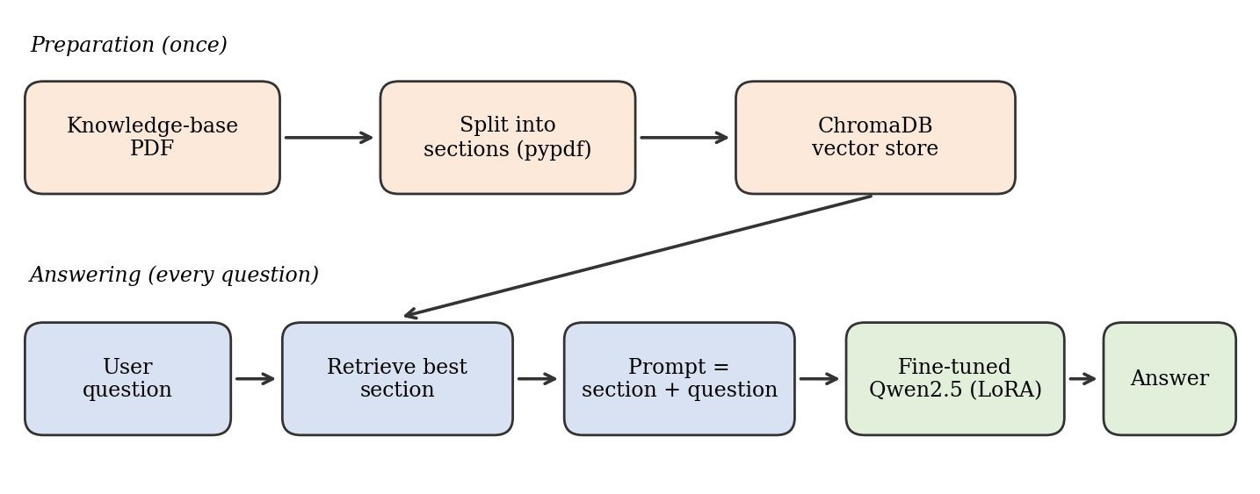
Figure 1: Processing flow of the proposed hybrid assistant (question, retrieval, fine-tuned generation, answer)
Table 2: Stages of the hybrid pipeline
Step | Component | Description
1. Ingest | pypdf + regex | The knowledge-base PDF is read and split into sections by the numbered headings (1., 2., 3. ...).
2. Store | ChromaDB | Each section is embedded automatically and stored in a vector collection.
3. Retrieve | ChromaDB query | The user's question is embedded and the most similar section (top 1 or top 2) is returned.
4. Prompt | Python | The retrieved section and the question are combined into one prompt.
5. Generate | Qwen2.5 (LoRA fine-tuned) | The model writes a short answer using the retrieved information.
6. Respond | Colab / future mobile app | The answer is shown to the user.

7.2 Implementation

7.2.1 Use case 1: Simple LLM chatbot
The baseline chatbot loads Qwen2.5-3B-Instruct through the Hugging Face text-generation pipeline on the Colab GPU. A system prompt ("You are a helpful assistant") is placed at the start of a messages list, every user message and model reply is appended to that list, and the whole history is sent to the model on each turn so that the bot remembers the conversation. Replies are limited to 400 new tokens. No external data is used, so the model answers only from its training knowledge.

7.2.2 Use case 2: LLM with RAG
The RAG chatbot uses Qwen2.5-1.5B-Instruct as the answering model. The user uploads the knowledge-base PDF; pypdf extracts the text, and a regular expression splits it at the numbered headings so that each topic becomes one chunk. The chunks are stored in a ChromaDB collection, which embeds them with its default model, all-MiniLM-L6-v2 [9], [10]. For each question the two most similar chunks are retrieved and inserted into a prompt that instructs the model to answer only from the given information and to say "I don't know" if the answer is not present. Replies are limited to 200 new tokens.

7.2.3 Use case 3: Fine-tuning with LoRA
The third use case fine-tunes Qwen2.5-0.5B-Instruct using supervised fine-tuning (SFT) with the TRL library and LoRA adapters from PEFT [6], [12]. LoRA freezes the original weights and trains only a small set of added low-rank matrices, which is why training fits on a free Colab GPU. Table 3 lists the settings.
Table 3: Fine-tuning configuration
Parameter | Value
Base model | Qwen/Qwen2.5-0.5B-Instruct
Method | Supervised fine-tuning (SFTTrainer) with LoRA
LoRA rank / alpha / dropout | 8 / 16 / 0.05
Target modules | All linear layers
Training data | 5 question-and-answer examples written from the knowledge-base PDF
Epochs / batch size / learning rate | 3 / 2 / 2e-4
Precision | fp16
Answering stage | Top-1 chunk retrieved from ChromaDB and added to the prompt; maximum 80 new tokens

7.3 Results and Observations
Each notebook was tested with a question typed into the chat cell. The inputs and the outputs recorded in the project output document are summarised in Table 4, and the raw notebook outputs are shown in Figures 2 to 4.
Table 4: Test inputs and observed outputs
Use case | Input | Observed output
1. LLM chatbot | what is llm? | A general explanation of LLMs in five points: training, applications, examples, advancements and ethical considerations. The answer is correct but generic and unrelated to vehicles.
2. RAG chatbot | why my car engine is overheating? | Lists low coolant, coolant leakage and a faulty radiator as causes, and advises stopping the vehicle, turning off the engine and letting it cool. This matches the knowledge base.
3. Fine-tuned model + retrieval | my tyre is punctured? | "Stop safely, turn on hazard lights, and replace the tyre or contact roadside assistance." A short, actionable answer that matches the knowledge base.

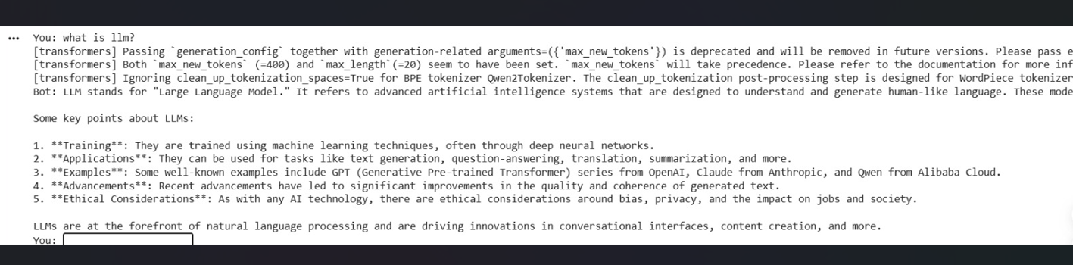
Figure 2: Output of use case 1 (simple LLM chatbot)
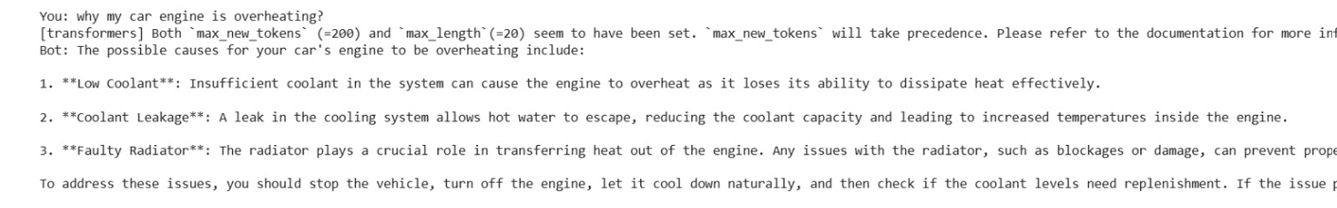
Figure 3: Output of use case 2 (RAG chatbot)
Figure 4: Output of use case 3 (fine-tuned model with retrieval)
The observations support the expected behaviour of each technique. The baseline chatbot is fluent but has no access to the breakdown knowledge base and answers in general terms. The RAG chatbot gives a detailed answer that follows the PDF, and its prompt allows it to decline questions that are not covered. The fine-tuned model gives a compact instruction in the style it was trained on.

7.4 Limitations
- The fine-tuning set contains only five examples, so the fine-tuned model is a proof of concept and not a robust product. Much larger and more varied data would be needed.
- The knowledge base covers five topics only, and no formal accuracy test with a large question set was carried out. The results above are qualitative.
- The fine-tuning examples use a plain "Question/Answer" format while the answering prompt uses a different instruction format, so training and use are not perfectly aligned.
- Small models can still make mistakes, and breakdown advice must not replace professional help in an emergency.
- Colab sessions are temporary, so the models and the vector database must be rebuilt in each new session.

7.5 Proposed Mobile Application
Because the course focuses on AI-powered mobile applications, the notebook prototype is proposed as the back end of a mobile app. The app would let the driver describe the problem by text or voice; send the question to a server running the retrieval and fine-tuned model; and show a short numbered answer. It would also collect the four items listed in the knowledge base (location, vehicle model, problem type and contact number) and offer a one-tap call or message to a roadside-assistance provider when the assistant cannot help. Keeping the knowledge base as a PDF allows a service provider to update advice without retraining the model.

8. Impact Analysis

8.1 Technical Impact
The project shows that a complete RAG and fine-tuning pipeline can be built with open-source models and free tools. It gives a reproducible comparison of three approaches on the same data, and it demonstrates that retrieval and LoRA fine-tuning can be combined so that facts come from the document and style comes from the model. The design is modular: the model, the embedding method and the knowledge base can each be replaced without changing the rest.

8.2 Economic Impact
Using open-source models removes per-query API charges and licence fees during development. For a service provider, an automated first-line assistant could reduce the number of routine calls that a human agent must handle, and updating advice only requires editing the knowledge-base document. Real savings would depend on call volumes and on the hosting approach chosen, and would have to be measured in a pilot.

8.3 Social Impact
Drivers, especially those who are inexperienced or stranded in unfamiliar places, benefit from immediate and clear instructions that put safety first. The assistant is available at any hour and can be offered in multiple languages in future. Because incorrect advice could cause harm, the system is designed to say when it does not know and to direct the driver to a mechanic or roadside assistance.

8.4 Environmental Impact
Small models consume far less energy than very large ones, and LoRA fine-tuning trains only a small fraction of the parameters, which lowers the compute needed for adaptation. Better first-line guidance can also avoid unnecessary tow-truck dispatches when a driver can fix a simple problem, such as checking fuel or battery, themselves. The energy use of hosting the service still has to be considered, and efficient small models or on-device inference help to keep it low.

9. Cost Analysis
Table 5 separates the cost of the prototype built in this project from the costs expected if the solution is deployed. Deployment figures are not quoted because cloud and hosting prices change frequently and must be confirmed with current provider pricing before a budget is prepared.
Table 5: Cost structure
Item | Prototype (this project) | Production deployment
Language models | No cost (open-source models from Hugging Face) | No per-token fee, but licence terms must be checked for each model
Compute | No cost (Google Colab free tier) | Recurring: GPU or CPU server, or on-device inference
Vector database | No cost (ChromaDB, open source) | Low recurring cost for storage and hosting
Knowledge base creation | Team time only | Domain-expert time to write and review content
Mobile application | Not built in this project | One-time development plus store fees
Maintenance and monitoring | Not applicable | Recurring: updating content, retraining, evaluating answers

The prototype therefore has no direct monetary cost, and the main investment is developer time. In production, the largest recurring items are expected to be hosting and the effort needed to keep the knowledge base accurate.

10. Commercialisation and Exploitation Plan

Target users and customers
- Roadside-assistance and towing companies that want an automated first-line assistant.
- Insurance companies that bundle breakdown cover with their policies.
- Car dealerships, service centres and vehicle manufacturers that want a branded driver-support assistant.
- Fleet operators and ride-hailing or delivery companies whose drivers need quick guidance.

Possible business models
- Business-to-business licence or subscription: a white-label assistant with the provider's own knowledge base.
- Usage-based pricing per conversation or per active vehicle.
- Free app for drivers with referral fees from partner garages and roadside-assistance providers.

Plan
- Pilot: expand the knowledge base, collect a larger set of real breakdown questions, and measure answer accuracy with a partner.
- Product: build the mobile app with voice input, location sharing and call-to-help features.
- Scale: add languages, more vehicle types and integration with dispatch systems.

Intellectual property and risks
The solution relies on open-source models and libraries. Licences differ between models and model sizes (for example, not every Qwen2.5 size uses the same licence), so the terms must be checked before commercial use. The main risks are incorrect advice, liability in emergencies, and the need to keep content up to date. These are managed by grounding answers in an approved knowledge base, showing clear disclaimers, and escalating to a human when confidence is low.

11. Conclusion
This project built a vehicle breakdown assistant in three ways using free open-source models on Google Colab. The simple LLM chatbot (Qwen2.5-3B-Instruct) answers fluently but only in general terms. The RAG chatbot (Qwen2.5-1.5B-Instruct with ChromaDB) answers from the supplied PDF and is easy to update by replacing the document. The fine-tuned model (Qwen2.5-0.5B-Instruct with LoRA) learns a short, actionable answer style, and when combined with retrieval it gives concise answers based on the knowledge base.
The main lesson is that the two techniques solve different problems: RAG provides the facts and fine-tuning provides the behaviour, so the best assistant uses both. The results are qualitative and the fine-tuning data is very small, so the work should be seen as a working prototype. Future work includes a larger training set, a formal evaluation with many test questions, a larger knowledge base, multilingual support, and the mobile application described in Section 7.5.

12. References
[1] A. Vaswani et al., "Attention is all you need," in Advances in Neural Information Processing Systems (NeurIPS), vol. 30, 2017.
[2] T. Brown et al., "Language models are few-shot learners," in Advances in Neural Information Processing Systems, vol. 33, 2020.
[3] L. Ouyang et al., "Training language models to follow instructions with human feedback," in Advances in Neural Information Processing Systems, vol. 35, 2022.
[4] P. Lewis et al., "Retrieval-augmented generation for knowledge-intensive NLP tasks," in Advances in Neural Information Processing Systems, vol. 33, 2020.
[5] Y. Gao et al., "Retrieval-augmented generation for large language models: A survey," arXiv:2312.10997, 2023.
[6] E. J. Hu et al., "LoRA: Low-rank adaptation of large language models," in Proc. International Conference on Learning Representations (ICLR), 2022.
[7] Z. Ji et al., "Survey of hallucination in natural language generation," ACM Computing Surveys, vol. 55, no. 12, pp. 1-38, 2023.
[8] A. Yang et al., "Qwen2.5 technical report," arXiv:2412.15115, 2024.
[9] N. Reimers and I. Gurevych, "Sentence-BERT: Sentence embeddings using Siamese BERT-networks," in Proc. EMNLP-IJCNLP, 2019.
[10] W. Wang et al., "MiniLM: Deep self-attention distillation for task-agnostic compression of pre-trained transformers," in Advances in Neural Information Processing Systems, vol. 33, 2020.
[11] T. Wolf et al., "Transformers: State-of-the-art natural language processing," in Proc. EMNLP: System Demonstrations, 2020.
[12] Hugging Face, "PEFT" and "TRL" library documentation. [Online]. Available: https://huggingface.co/docs
[13] Chroma, "Chroma documentation." [Online]. Available: https://docs.trychroma.com
[14] Google, "Google Colaboratory." [Online]. Available: https://colab.research.google.com

