**Automation Using Internet Explorer 11**

While automating any application for windows platform with IE 11 you will encounter withfollowing issue :

OpenQA.Selenium.NoSuchWindowException : Unable to get browser

So how to handle this scenario ..?

To resolve this issue you have to do **two things** :

1. You will need to set a registry entry on the target computer so that the driver can maintain a connection to the instance of Internet Explorer it creates.
2. Change few settings of Internet Explorer browser on that machine (where you desire to run automation).

**Setting Registry Key / Entry :**

* To set registry key or entry, you need to open "Registry Editor".
* To open "Registry Editor" press windows button key + r alphabet key which will open "Run Window" and then type "regedit" and press enter.
* Or Press Windows button key and enter "regedit" at start menu and press enter.
* Now depending upon your OS type whether 32/64 bit follow the corresponding steps.
* Windows 32 bit : go to this location - "HKEY_LOCAL_MACHINE\SOFTWARE\Microsoft\Internet Explorer\Main\FeatureControl" and check for "**FEATURE_BFCACHE**" key.
* Windows 64 bit : go to this location - HKEY_LOCAL_MACHINE\SOFTWARE\Wow6432Node\Microsoft\Internet Explorer\Main\FeatureControl and check for "**FEATURE_BFCACHE**" key.
* **Please note that** the **FEATURE_BFCACHE** subkey may or may not be present, and should be created if it is not present.
* **Important:** Inside this key, create a **DWORD** value named **iexplore.exe** with the value of **0**.

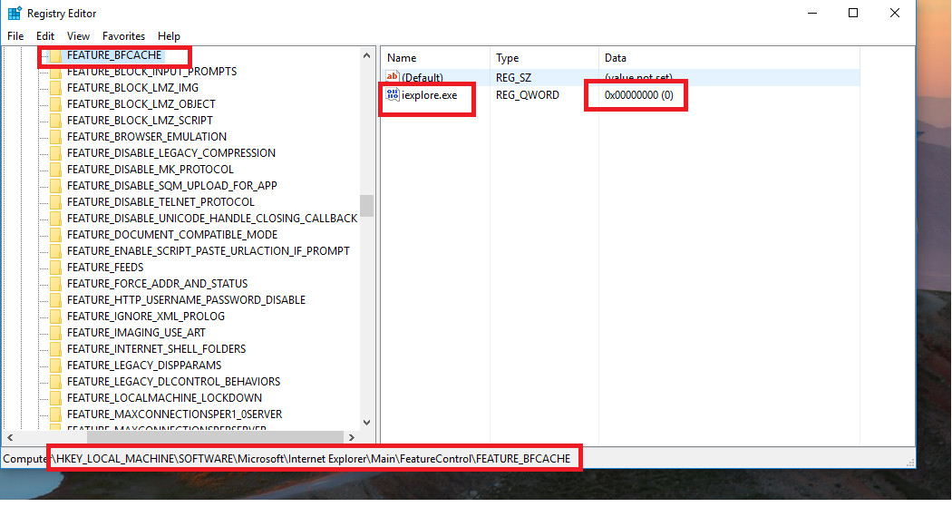

**Change Settings of Internet Explorer Browser :**

* Click on setting button and select "**Internet options**".
* On "**Internet options**" window go to "**Security**" tab
* Now select "**Internet"** option and unchecked the "Enable Protected Mode" check box and change the "Security level" to low.
* Now select "**Local Intranet**" Option and change the "Security level" to low.
* Now select "**Trusted Sites**" Option and change the "Security level" to low.

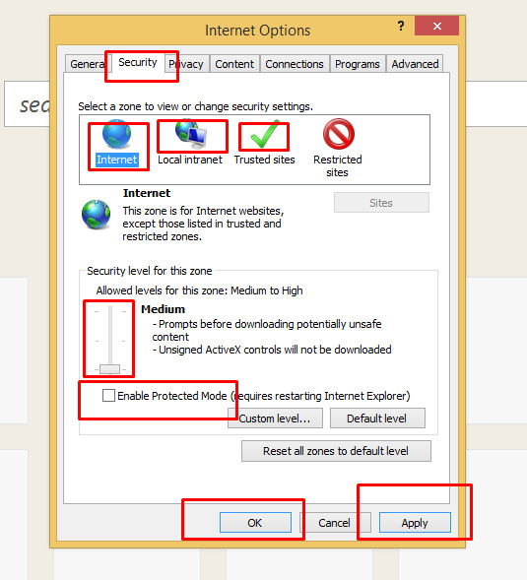

* Now click on "Apply" button , a warning pop up may appear click on "OK" button for warning and then on "OK" button on Internet Options window.

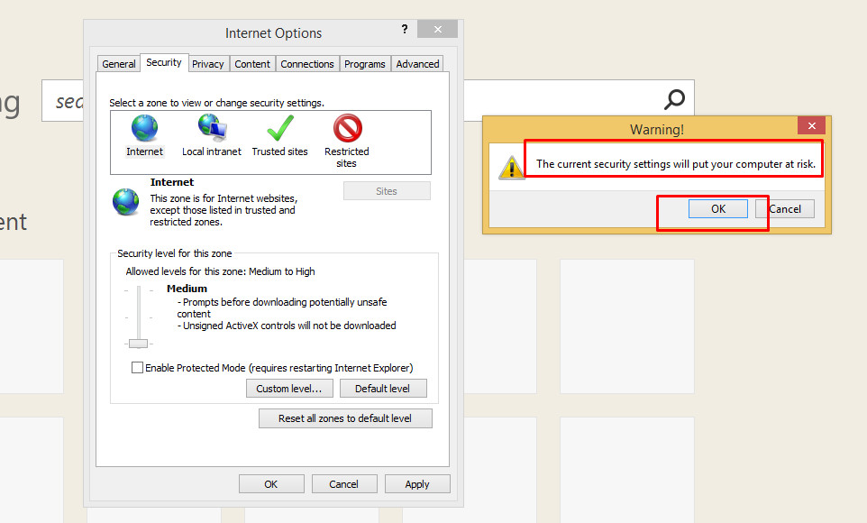

* After this restart the browser.