Using Special Operators in Conditions.

1)Write two different queries that would produce all orders taken on October 3rd or 4th ,1990.

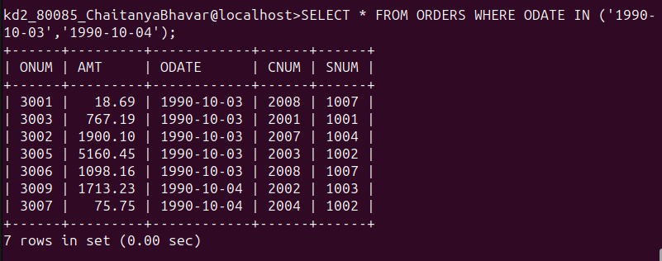

=============================================================
2)Write a query that selects all of the customers serviced by Peel or Motika.(Hint : The snum field relates the two tables to one to another).
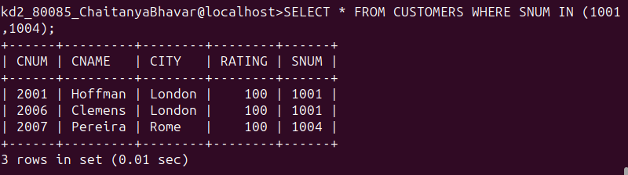

3)Write a query that selects all of the customers whose names begin with a letter ‘A’ to ‘G’.

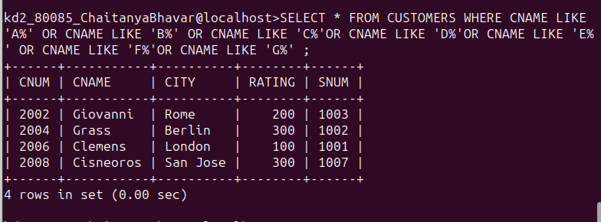

=======================================================================

4)Write a query that selects all customers whose names begin with the letter ‘C’.

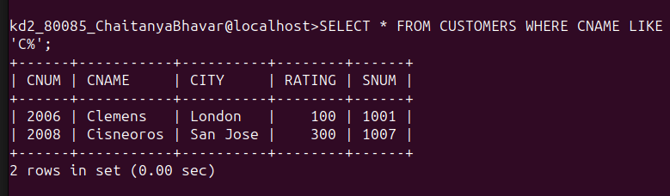

5)Write a query that selects all orders except those with zeroes or nulls in the amt field.

