USING THE OPERATORS IN,ANY AND ALL

1. Write a query that selects all customers whose rating are equal to or greater than any of ‘Serres’.

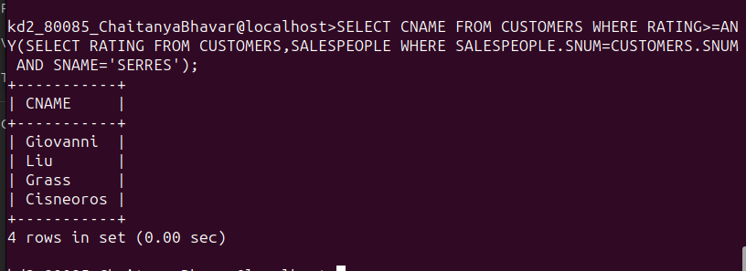

=====================================================

2. Write a query using any or all that will find all salespeople who have no customers located in their city.

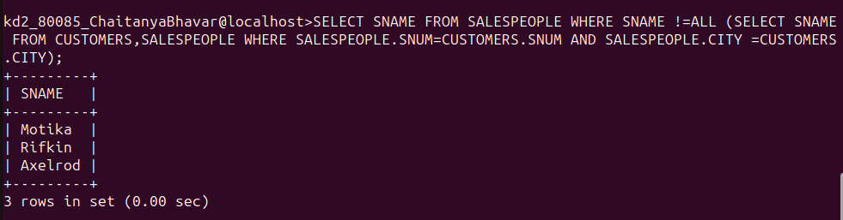

=====================================================

3. Write a query that selects all orders for amount greater than any for the customers in London.

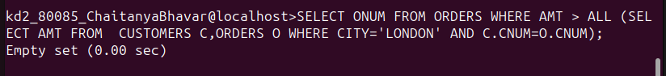

=====================================================

4. Write the above query using min or max.

