Creating sample tables and inserting values.

Create the following tables with the given structures and insert sample data as specified:

A) SALESPEOPLE

Snum int (4)

Sname varchar(10)

City varchar (10)

Comm float (3,2)

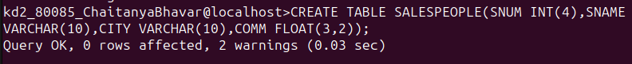
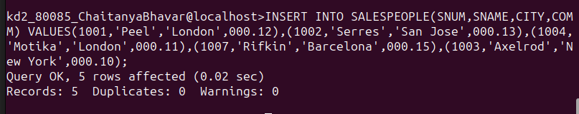
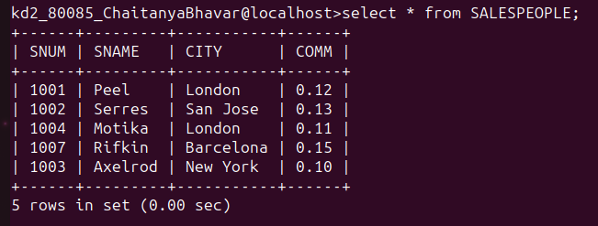

B) CUSTOMERS

Cnum int (4)

Cname varchar (10)

City varchar (10)

Rating int (4)

Snum int (4)

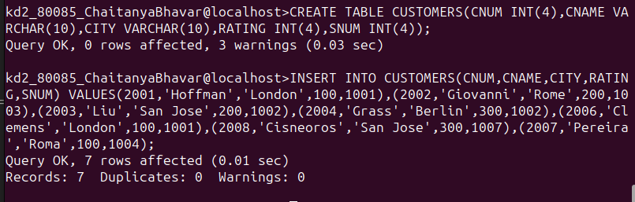

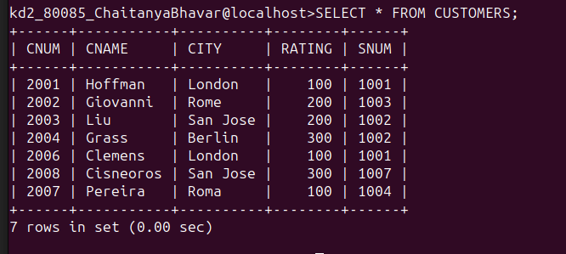

C) ORDERS

num int (4)

Amt float (7,2)

Odate date

Cnum int (4)

Snum int (4)
