- Design responsive website using CSS and Bootstrap.
<!DOCTYPE html>
<html>
<head>
<title>Responsive Website</title>
<meta name="viewport" content="width=device-width, initial-scale=1">

<link href="https://cdn.jsdelivr.net/npm/bootstrap@5.3.3/dist/css/bootstrap.min.css"
rel="stylesheet">

<style>
.box {
padding: 20px;
margin: 10px;
text-align: center;
background: white;
border-radius: 10px;
}
body {
background: lightgray;
}
</style>
</head>

<body>

<nav class="navbar bg-primary navbar-dark">
<div class="container">
<a class="navbar-brand" href="#">My Website</a>
</div>
</nav>

<div class="container text-center mt-4">
<h2>Welcome to My Website</h2>
<p>Responsive website using CSS and Bootstrap</p>

<div class="row">
<div class="col-12 col-md-4">
<div class="box">
<h3>HTML</h3>
<p>Create web pages.</p>
<button class="btn btn-primary">Learn More</button>
</div>
</div>

<div class="col-12 col-md-4">
<div class="box">
<h3>CSS</h3>
<p>Style web pages.</p>
<button class="btn btn-success">Learn More</button>
</div>
</div>

<div class="col-12 col-md-4">
<div class="box">
<h3>Bootstrap</h3>
<p>Create responsive pages.</p>
<button class="btn btn-danger">Learn More</button>
</div>
</div>
</div>
</div>
</body>
</html>
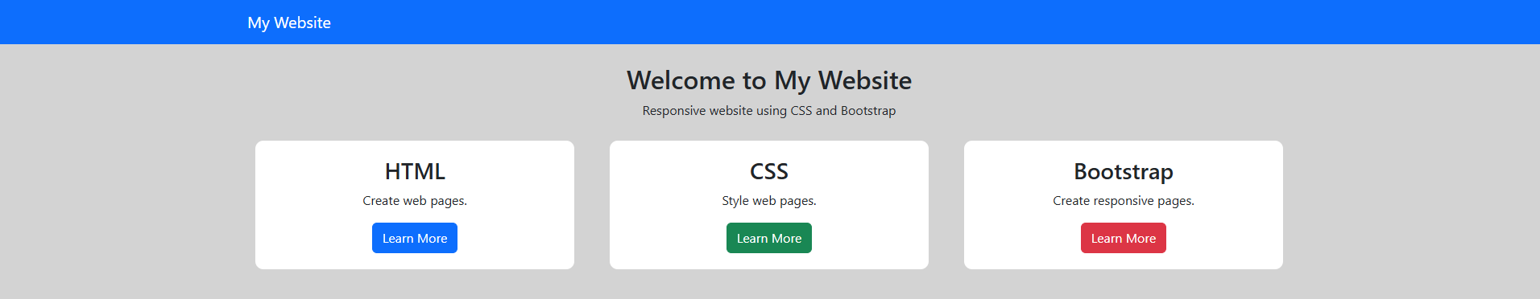

2) Design a webpage using the CSS Box Model, incorporating margins, padding and borders.
<!DOCTYPE html>
<html>
<head>
<title>CSS Box Model</title>
<style>
.box {
width: 300px;
background-color: lightblue;
margin: 30px; /* Outside space */
padding: 20px; /* Inside space */
border: 5px solid blue; /* Border */
}
</style>
</head>
<body>
<h2>CSS Box Model</h2>
<div class="box">
<h3>My Box</h3>
<p>This box demonstrates margin, padding and border.</p>
</div>
</body>
</html>
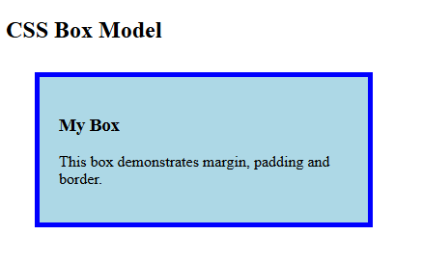

3) Build a responsive web page using Bootstrap, including a navbar, buttons and forms.
<!DOCTYPE html>
<html>
<head>
<title>Bootstrap Website</title>
<meta name="viewport" content="width=device-width, initial-scale=1">

<!-- Bootstrap CSS -->
<link rel="stylesheet"
href="https://cdn.jsdelivr.net/npm/bootstrap@5.3.3/dist/css/bootstrap.min.css">
</head>

<body>
<!-- Navbar -->
<nav class="navbar navbar-dark bg-dark">
<div class="container">
<a class="navbar-brand" href="#">My Website</a>
</div>
</nav>

<!-- Content -->
<div class="container mt-5">
<h2 class="text-center">Welcome</h2>

<!-- Buttons -->
<div class="text-center mb-4">
<button class="btn btn-primary">Home</button>
<button class="btn btn-success">About</button>
<button class="btn btn-danger">Contact</button>
</div>

<!-- Form -->
<form>
<label>Name:</label>
<input type="text" class="form-control mb-3"
placeholder="Enter your name">

<label>Email:</label>
<input type="email" class="form-control mb-3"
placeholder="Enter your email">

<button type="submit" class="btn btn-primary">
Submit
</button>
</form>
</div>

</body>
</html>
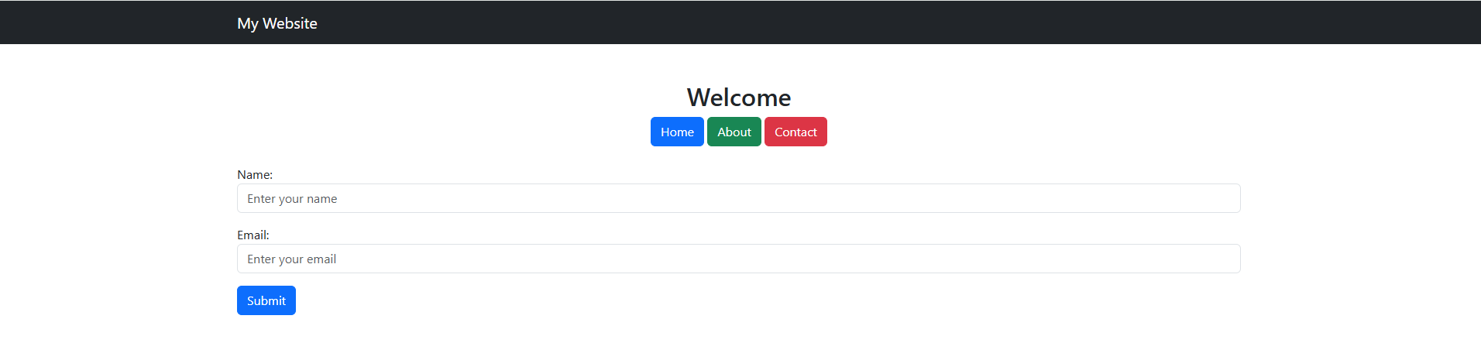

4) a. Write a JavaScript program to take user input and display the result dynamically.
<!DOCTYPE html>
<html>
<head>
<title>User Details</title>
</head>

<body>
<h2>User Registration</h2>

<label>Name:</label>
<input type="text" id="name"><br><br>

<label>Age:</label>
<input type="number" id="age"><br><br>

<label>Course:</label>
<input type="text" id="course"><br><br>

<button onclick="display()">Submit</button>
<h3 id="result"></h3>

<script>
function display() {
let name = document.getElementById("name").value;
let age = document.getElementById("age").value;
let course = document.getElementById("course").value;

document.getElementById("result").innerHTML =
"Name: " + name + "<br>" +
"Age: " + age + "<br>" +
"Course: " + course;
}
</script>

</body>
</html>

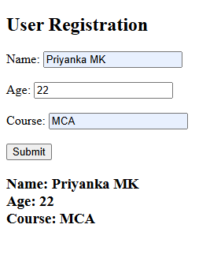

b) Use JavaScript to validate form input, ensuring required fields are not empty.
<!DOCTYPE html>
<html>
<head>
<title>Form Validation</title>
</head>
<body>
<h2>Student Registration Form</h2>
<form onsubmit="return validateForm()">

<label>Name:</label>
<input type="text" id="name"><br><br>

<label>Email:</label>
<input type="text" id="email"><br><br>

<label>Age:</label>
<input type="number" id="age"><br><br>

<label>Course:</label>
<input type="text" id="course"><br><br>

<label>Password:</label>
<input type="password" id="password"><br><br>

<button type="submit">Submit</button>
<button type="reset">Reset</button>
</form>

<p id="message"></p>
<script>
function validateForm() {
let name = document.getElementById("name").value;
let email = document.getElementById("email").value;
let age = document.getElementById("age").value;
let course = document.getElementById("course").value;
let password = document.getElementById("password").value;

if (name == "") {
alert("Please enter your name");
return false;
}

if (email == "") {
alert("Please enter your email");
return false;
}

if (age == "") {
alert("Please enter your age");
return false;
}

if (course == "") {
alert("Please enter your course");
return false;
}

if (password == "") {
alert("Please enter your password");
return false;
}

if (password.length < 6) {
alert("Password must contain at least 6 characters");
return false;
}
document.getElementById("message").innerHTML =
"Form submitted successfully!";
return false;
}
</script>
</body>
</html>
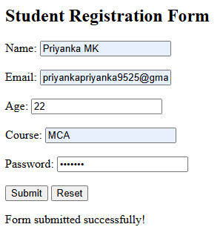

c) Implement JavaScript arrays and objects to store and display values.
<!DOCTYPE html>
<html lang="en">
<head>
<meta charset="UTF-8">
<title>Student Details</title>
</head>
<body>
<h2>Student Details using Array of Objects</h2>
<button onclick="displayStudents()">Show Students</button>

<p id="result"></p>

<script>
let students = [
{ id: 101, name: "Priya", course: "JavaScript" },
{ id: 102, name: "Rahul", course: "Python" },
{ id: 103, name: "Sneha", course: "Java" },
{ id: 104, name: "Arun", course: "C++" },
{ id: 105, name: "Anjali", course: "HTML" }
];
function displayStudents() {
let result = "";
for (let i = 0; i < students.length; i++) {
result += "Student " + (i + 1) + "<br>";
result += "ID: " + students[i].id + "<br>";
result += "Name: " + students[i].name + "<br>";
result += "Course: " + students[i].course + "<br><br>";
}

document.getElementById("result").innerHTML = result;
}
</script>

</body>
</html>
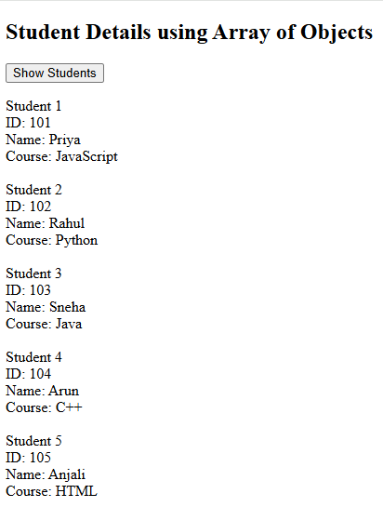

5) Use jQuery to manipulate the DOM, hide/show elements and handle events.
<!DOCTYPE html>
<html>
<head>
<title>jQuery Effects</title>
<script src="https://code.jquery.com/jquery-3.7.1.min.js"></script>
<style>
#circle {
width: 150px;
height: 150px;
background-color: blue;
border-radius: 50%;
margin: 20px;
}
</style>
</head>

<body>
<h2>jQuery Effects</h2>
<p id="text">Welcome to jQuery Effects</p>
<div id="circle"></div>

<button id="hide">Hide</button>
<button id="show">Show</button>
<button id="fadeout">Fade Out</button>
<button id="fadein">Fade In</button>
<button id="slideup">Slide Up</button>
<button id="slidedown">Slide Down</button>
<button id="changetext">Change Text</button>

<script>
$(document).ready(function() {

$("#hide").click(function() {
$("#circle").hide(1000);
});

$("#show").click(function() {
$("#circle").show(1000);
});

$("#fadeout").click(function() {
$("#circle").fadeOut(1000);
});

$("#fadein").click(function() {
$("#circle").fadeIn(1000);
});

$("#slideup").click(function() {
$("#circle").slideUp(1000);
});

$("#slidedown").click(function() {
$("#circle").slideDown(1000);
});

$("#changetext").click(function() {
$("#text").text("Text has been changed using jQuery!");
});

});
</script>

</body>
</html>
