PROJECT REPORT
Visualization Tool for Electric Vehicle Charge and Range Analysis
(EV Charge & Range Analysis using Tableau / SQL & Excel)
Submitted by
Bolla Rathna Bhargavi
College Name
Lakireddy Balireddy College of Engineering (LBRCE)
B.Tech — Computer Science & Engineering, 3rd Year
Internship Program
SmartBridge Internship
Date: July 2026

1. Introduction

What Are Electric Vehicles?
Electric Vehicles (EVs) are automobiles powered wholly or partly by electric motors, using energy stored in rechargeable batteries instead of relying solely on internal combustion engines that burn fossil fuels. EVs include fully battery-powered cars, plug-in hybrids, and increasingly, electric two- and three-wheelers. As global concern over carbon emissions and fuel costs grows, EVs are becoming a central part of the transition toward sustainable transportation.

Why EV Data Analysis Is Useful
Analyzing EV-related data helps manufacturers, policymakers, and consumers make informed decisions. Understanding which brands offer the most models, which vehicles provide the longest driving range, and how charging infrastructure is distributed across regions can guide investment in charging networks, help buyers choose suitable vehicles, and support governments in planning EV-friendly policies. This project uses real-world EV and charging station datasets to uncover these insights through SQL-based analysis and Excel visualizations.

2. Objective
- Analyze electric vehicle and charging station datasets using SQL queries in MySQL Workbench.
- Create clear, meaningful charts in Microsoft Excel to visualize key trends in the data.
- Visualize EV trends such as brand popularity, vehicle range, charging station distribution, and vehicle type adoption in India.

3. Software Used
- MySQL Workbench — for creating the database, writing SQL queries, and analyzing the raw datasets.
- Microsoft Excel — for building charts and visualizations from the query results.
- Windows 11 — the operating system used to carry out the entire project.

4. Datasets Used
- ElectricCarData.csv — contains details of electric car models, including brand, model name, and driving range.
- EVIndia.csv — contains information about electric vehicle adoption and vehicle types within India.
- electric_vehicle_charging_station_list.csv — contains details of charging stations, including their region and charger type.

5. Database Creation
A dedicated MySQL database named ev_project was created to store and organize all datasets used in this project. The three CSV files were imported into MySQL Workbench as separate tables — electric_vehicle, charging_station, and cheapestelectriccars-evdatabase — using the Table Data Import Wizard. Each table's column types were verified (for example, confirming that the Range column was imported as TEXT rather than a numeric type) before running analysis queries, since this affected how sorting and calculations needed to be written.
CREATE DATABASE ev_project;
USE ev_project;
Once the database and tables were set up, all subsequent analysis was performed using SELECT queries with GROUP BY, ORDER BY, and string-to-number conversion functions where required.

6. SQL Queries
The following SQL queries were used to extract and summarize the data needed for each chart in this project.
Query 2 — Brand-wise Electric Cars
SELECT Brand, COUNT(*) AS TotalCars
FROM electric_vehicle
GROUP BY Brand;
Groups all records by the Brand column and counts the number of car models listed for each brand. This result was used to create Chart 1 (Brand-wise Electric Cars).
Query 3 — Top 10 Electric Cars by Range
SELECT Brand, Model, Range_Km
FROM electric_vehicle
ORDER BY Range_Km DESC
LIMIT 10;
Sorts all vehicles in descending order of range and returns the top 10 results. This data was used to build Chart 2 (Top 10 Electric Cars by Range).
Query 4 — Highest Range Cheapest EV
SELECT Name, `Range`
FROM `cheapestelectriccars-evdatabase`
ORDER BY CAST(REPLACE(`Range`, ' km', '') AS UNSIGNED) DESC
LIMIT 10;
The Range column in this table was stored as text (e.g. "970 km"), so a direct sort would order the values alphabetically rather than numerically. This query removes the " km" suffix using REPLACE, converts the remaining text to a number using CAST(...AS UNSIGNED), and then sorts the results in descending order to correctly identify the highest-range vehicles. This result was exported as highest_range_ev.csv and used for Chart 5.
Query 5 — Charging Stations by Region
SELECT region, COUNT(*) AS TotalStations
FROM charging_station
GROUP BY region;
Groups charging station records by region and counts how many stations exist in each region. Used for Chart 6 (Charging Stations by Region).
Query 6 — Charging Station Types
SELECT type, COUNT(*) AS Total
FROM charging_station
GROUP BY type;
Groups charging stations by their type (e.g. AC, DC) and counts the total number of stations of each type. Used for Chart 3 (Charging Station Types).
Query 7 — Vehicle Types in India
SELECT VehicleType, COUNT(*) AS Total
FROM electric_vehicle
GROUP BY VehicleType;
Groups Indian EV records by vehicle type (e.g. two-wheeler, four-wheeler) and counts totals for each category. Used for Chart 4 (Vehicle Types in India).

7. Charts
Six charts were created in Microsoft Excel using the results of the SQL queries above. Each chart is described below, with a placeholder box indicating where the corresponding screenshot should be inserted.

Chart 1 — Brand-wise Electric Cars

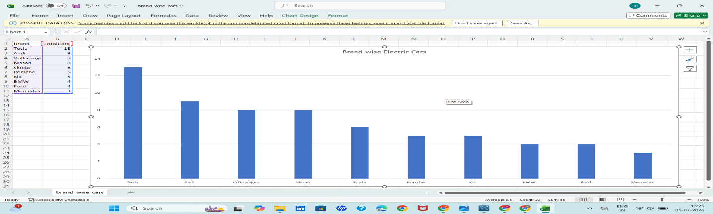

A column chart showing the number of electric car models offered by each brand. This chart highlights which manufacturers have the widest range of EV models available in the dataset, with Tesla having the highest number of listed models.

Chart 2 — Top 10 Electric Cars by Range

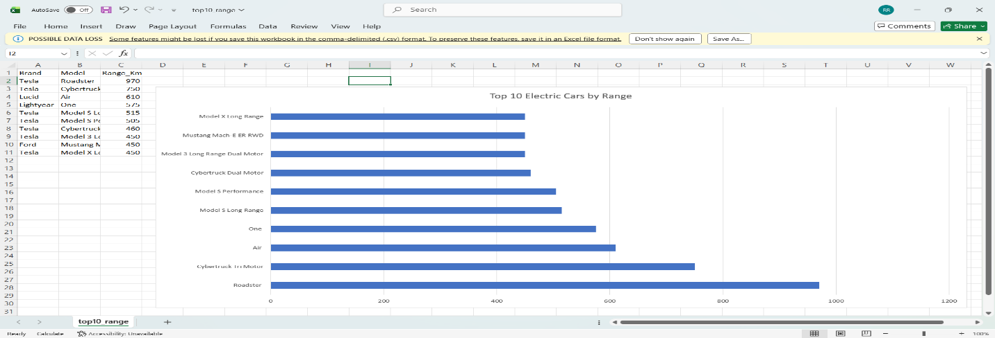

A bar chart comparing the driving range (in km) of the top 10 electric cars. Car names are plotted on the vertical axis since they are long text labels, making a horizontal bar chart easier to read than a column chart.

Chart 3 — Charging Station Types

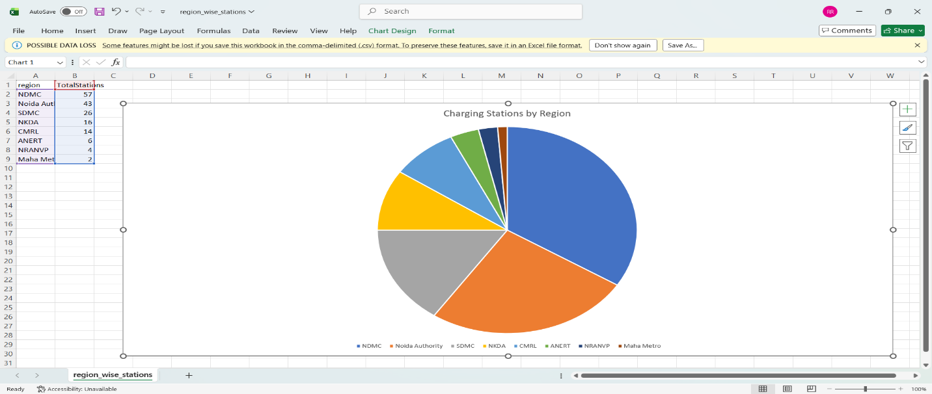

A pie chart showing the proportion of different charging station types (such as AC and DC chargers). It gives a quick visual sense of which charger type is most common across the network.

Chart 4 — Vehicle Types in India

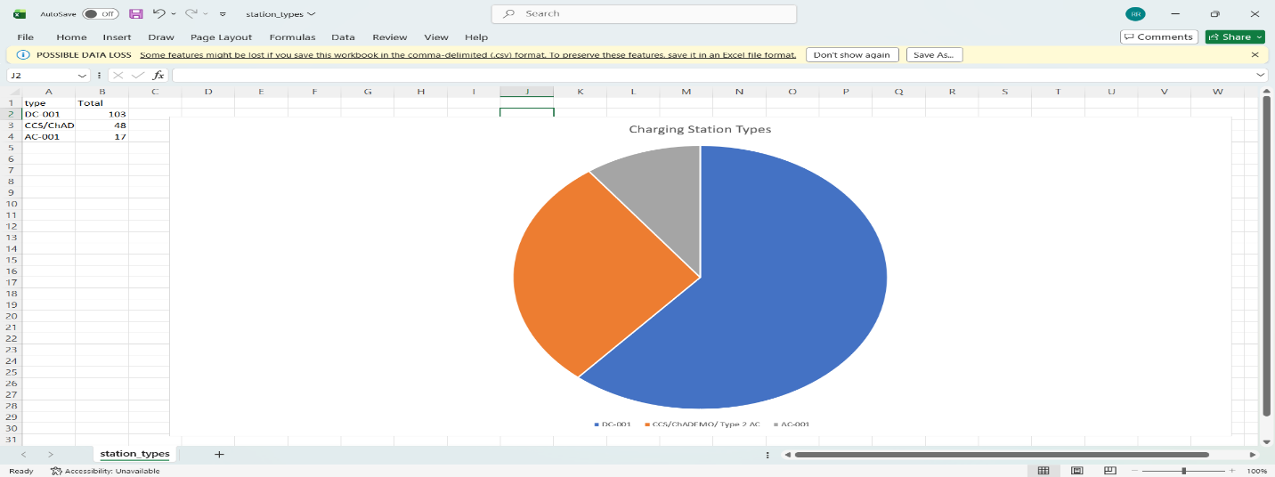

A column chart showing the distribution of electric vehicles in India by category (two-wheeler, three-wheeler, four-wheeler, etc.), illustrating which vehicle segment dominates EV adoption in the Indian market.

Chart 5 — Highest Range Electric Vehicles

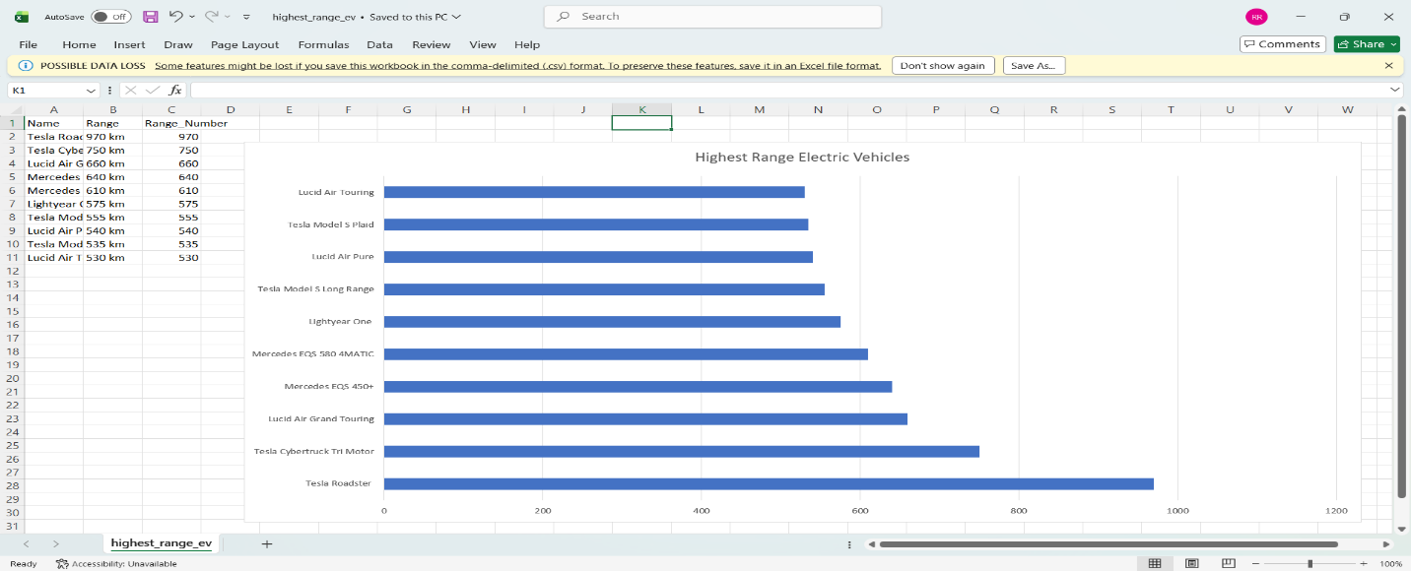

A horizontal bar chart of the top 10 vehicles by range after converting the text-based Range column into numeric values. The Tesla Roadster appears at the top with the highest range among all vehicles analyzed.

Chart 6 — Charging Stations by Region

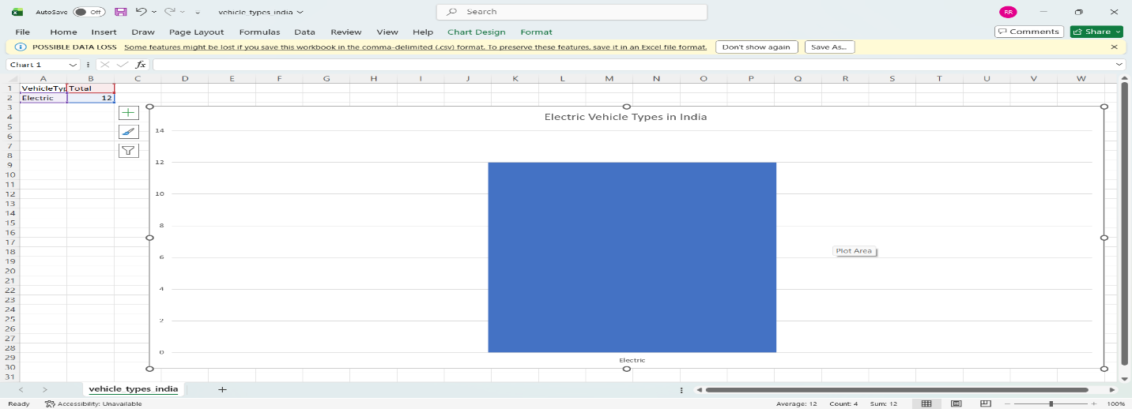

A pie chart illustrating how charging stations are distributed across different regions, helping to identify areas that are well served versus regions that may need additional charging infrastructure.

8. Results
The analysis produced the following key observations:
- Tesla has the most electric car models listed among all brands in the dataset.
- The Tesla Roadster has the highest driving range among all electric vehicles analyzed.
- DC-001 is the most common charging station type across the regions studied.
- Four-wheeler electric vehicles form the largest share of EV types adopted in India, based on the EVIndia.csv dataset.
- Charging stations are unevenly distributed across regions, with certain regions having significantly more stations than others.

9. Conclusion
This project provided hands-on experience in combining SQL-based data analysis with Excel-based data visualization to study electric vehicle trends. Working with real-world datasets required handling practical data-quality issues, such as converting text-formatted range values into numeric form before sorting and charting. The resulting six charts offer a clear, visual summary of brand distribution, vehicle range, vehicle type adoption in India, and charging infrastructure spread across regions. Overall, the project strengthened practical skills in database querying, data cleaning, and dashboard-style visualization — skills directly relevant to data analytics and software engineering roles.

