|  |  |
| --- | --- |
| **Symbol** | **Name** |
| + | Addition |
| - | Subtraction |
| * | Multiplication |
| / | Division |
| ** | Exponentiation |
| % | Modulo |
| // | Integer Division |

Installation :

Run as admin

Add python to path

Click on customise installation

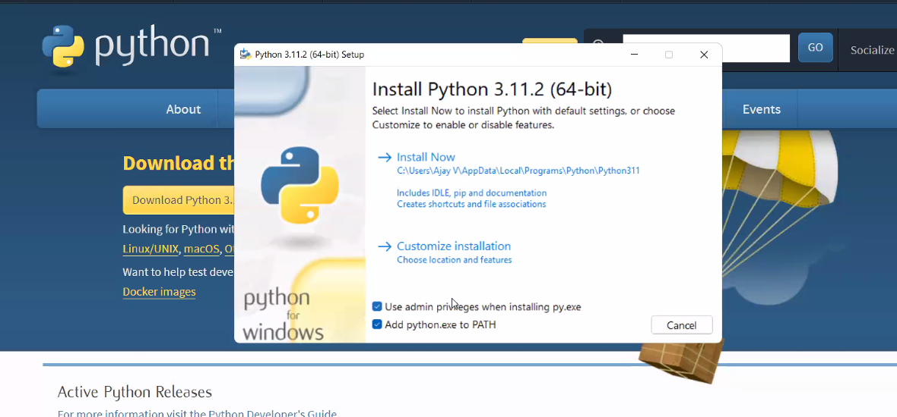

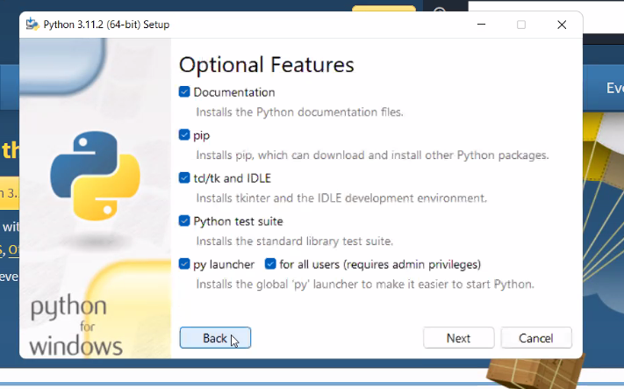

Click on install python for all user

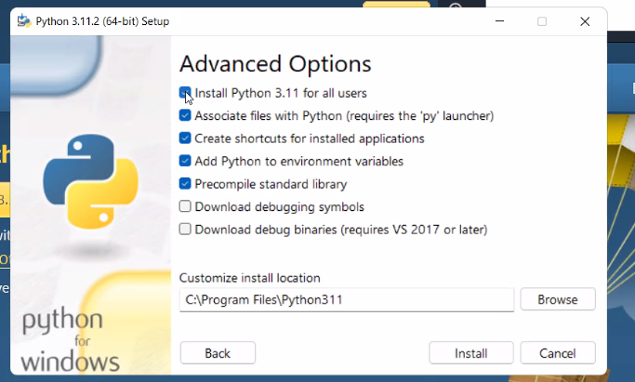

After install :

Disable path limit

