**Ansible**

Ansible is a configuration management and provisioning tool, similar to Chef, Puppet or Salt. It uses SSH to connect to servers and run the configured Tasks.

  It uses a very simple language (YAML, in the form of Ansible Playbooks) that allow you to describe your automation jobs in a way that approaches plain English.

Ansible works by connecting to your nodes and pushing out small programs, called "Ansible modules" to them.  Ansible then executes these modules (over SSH by default), and removes them when finished.

Add your SSH private key to the ssh-agent. If you created your key with a different name, or if you are adding an existing key that has a different name, replace *id_rsa* in the command with the name of your private key file.

ssh-agent bash ;

ssh-add ~/.ssh/id_rsa

**Manage Ansible Static and Dynamic Host Inventory :**

As we know that **Ansible** is the most powerful **automation tool** that can configure the hosts at ease. The main benefit of using Ansible as a automation tools is that we don’t have to install any agent on hosts. Communication between Ansible server and its clients or managed hosts is agentless.

 The system on which we install ansible software  is called as “**Control Node**”.

The server which are managed by ansible server are called as “**Managed Host “.**

Managed Hosts entries are stored in a host inventory file, it is a text file on control node which consists of managed host name or ip addresses

In Ansible  we can manage two type hosts inventory i.e **static** and  **dynamic**.

In this tutorial I will be using followings:

**One Control Node** –   control-node.example.com (192.168.0.10)

**Two Managed Hosts** – servera.example.com (192.168.0.20) and serverb.example.com (192.168.0.30)

### Static Host Inventory :

Each section begins with a host group name enclosed in a square brackets([]) then the host entries are listed for that group.

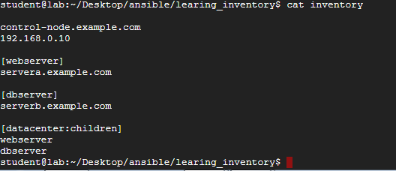

In the inventory file I have created two hosts group with the name webserver and dbserver, apart from this we have created one more group with the name datacenter that include groups of host groups. Anisble host inventories can include groups of host groups, this is accomplished with ‘**:children**‘ suffix example is shown in above created inventory. Also It is not compulsory to place host in a group we can simply place the hosts without mentioning the host group just like “control-node.exmaple.com” entry in the inventory file.

To use ansible command for host management, path of host inventory file must specified with “**-i**” option.

$ ansible {host-pattern}  -i  /<path_of_inventory_file>  –list-hosts

#### **Example:1 List all the manage host :**

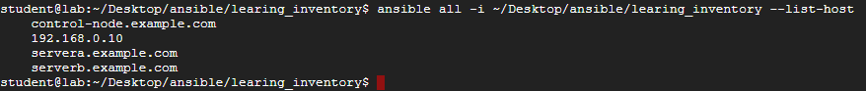

#### **Example:2 List the managed hosts based on host group.**



#### **Example: 3 List managed hosts based on wild card host pattern.**

List all the hosts which are on the domain “*.example.com”



List all the hosts which are on network “192.168.0.0”



#### **Example:4 Advanced host pattern like inclusion and exclusion**

Apart from wildcards, Ansible allows us to create complex host patterns using inclusion and exclusion logic. Inclusion is accomplished with ‘:’ character to separate groups in host pattern to indicate an OR logic.

**Host Inclusion pattern example**



**Host Intersection pattern example**

‘:&’ represents intersection of two groups in the inventory file.

List the entries which are in both the group.



**Host Exclusion pattern example**

Exclusion is accomplished using the ‘:’ character in conjunction with the ‘!’ character.



### Dynamic Host Inventory :

Host inventory in Ansible can be dynamically generated. Sources for dynamic inventory information include public / private cloud providers.

For Cloud providers, authentication and access information should be defined  in files that script can access. A Number of existing scripts are available from Ansible’s GitHub Site at https://github.com/ansible/ansible/tree/devel/contrib/inventory, these scripts support the dynamic generation of an inventory based on host information avai;able from a large number platforms like **Openstack**, **AWS**, **Ovirt**, **Red Hat Satellite** and **OpenShift**.

We can write our own  customize dynamic inventory program in any programming language and must return in JSON format when passed appropriate options.

In order for Ansible to use script to retrieve hosts information from external inventory system, this script has to support the**–list** parameter, returning host group and hosts information similar to the JSON hash/dictionary. Example is shown below :

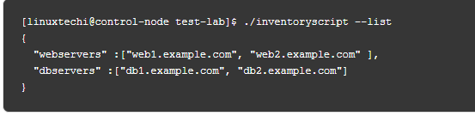

A Script creating a dynamic inventory has to be executable in order for Ansible to use it.

**Note :** <https://www.linuxtechi.com/manage-ansible-static-and-dynamic-host-inventory/>

**YAML Basics:**

All YAML files (regardless of their association with Ansible or not) can optionally begin with ---and end with .... This is part of the YAML format and indicates the start and end of a document.

### A dictionary is represented in a simple key: value form (the colon must be followed by a space):

*# An employee record*

martin:

name: Martin D'vloper

job: Developer

skill: Elite

You can also use abbreviation to represent dictionaries.

Eg : Martin : {name: Martin D'vloper, job: Developer, skill: Elite }

### We can also represent List in YAML. Every element(member) of list should be written in a new line with same indentation starting with “- “ (- and space).

**---**

*# A list of tasty fruits*

fruits:

- Apple

- Orange

- Strawberry

- Mango

**...**

You can also use abbreviation to represent lists.

fruits: [‘Apple’,’Orange’,’Strawberry’,’Mango’]

### List inside Dictionaries :

---

james:

name: james john

rollNo: 34

div: B

sex: male

likes:

- maths

- physics

- english

…

### Ansible doesn’t really use these too much, but you can also specify a boolean value (true/false) in several forms:

create_key: yes

needs_agent: no

knows_oop: True

likes_emacs: TRUE

uses_cvs: false

### YAML uses “|” to include the newline and ”>” to fold newlines to spaces.

include_newlines: |

exactly as you see

will appear these three

lines of poetry

fold_newlines: >

this is really a

single line of text

despite appearances

### Let’s combine what we learned so far in an arbitrary YAML example.

**---**

*# An employee record*

name: Martin D'vloper

job: Developer

skill: Elite

employed: True

foods:

- Apple

- Orange

- Strawberry

- Mango

languages:

perl: Elite

python: Elite

pascal: Lame

education: |

4 GCSEs

3 A-Levels

BSc in the Internet of Things

…

[**https://www.ansible.com/overview/how-ansible-works**](https://www.ansible.com/overview/how-ansible-works)

[**https://willthames.github.io/devops-singapore-2016/04-tools.html#/end-of-the-workshop**](https://willthames.github.io/devops-singapore-2016/04-tools.html#/end-of-the-workshop)