**Educational Institution CRM**

**Alwala Chaithanya**

**2111cs010100@mallareddyuniversity.ac.in**

**1.Project Overview**

In today's competitive educational landscape, effective customer relationship management is crucial for institutions seeking to provide top-notch service to students and stakeholders. This project focuses on developing a customized CRM application using Salesforce to manage and enhance the services offered by educational institutions. Salesforce, as a leading CRM platform, offers powerful tools to streamline service management and improve satisfaction.The CRM will serve as a centralized platform, enabling institutions to track and manage interactions with students, from enrollment inquiries to post-graduation support. It will store essential student information such as contact details, academic history, and preferences. This centralized database ensures staff can deliver personalized and efficient services, ultimately improving the overall student experience.Implementing this CRM will lead to enhanced service management, increased student satisfaction, and operational efficiency. The application will reduce communication gaps and offer data insights to help institutions identify areas for improvement, ensuring better service delivery.

**2.Objectives**

· **Centralized Student Management:**  
 Develop a unified platform to store, access, and manage student information, including contact details, academic records, and preferences.

· **Streamlined Service Delivery:**  
 Ensure efficient management of student interactions, from initial inquiries to post-graduation support, for timely and accurate service delivery.

· **Enhanced Student Satisfaction:**  
 Improve student experiences through personalized services based on their unique preferences and history.

· **Operational Efficiency:**  
 Automate routine tasks, reduce manual efforts, and enhance communication across departments to optimize internal processes.

· **Data-Driven Decision Making:**  
 Utilize CRM analytics to gain insights into student behavior, service trends, and operational challenges, enabling informed decisions.

· **Improved Communication and Collaboration:**  
 Foster better communication among staff and departments through the CRM platform, minimizing miscommunication and ensuring effective collaboration.

· **Optimized Resource Allocation:**  
 Effectively allocate institutional resources, assigning staff and time to meet student needs and service requirements more efficiently.

.

### 3.Key Salesforce Features and Concepts Used in theCRM:

1. **Objects and Fields**: Standard (e.g., Contacts, Cases) and custom objects tailored to the institution, with relationships between them.
2. **Data Model**: Schema Builder to customize the structure, using lookup and master-detail relationships.
3. **Automation Tools**:
   * **Process Builder**: Automates tasks like follow-up emails.
   * **Flow Builder**: Guides users through tasks (e.g., onboarding).
   * **Workflow Rules & Approval Processes**: Automates approvals and updates.
4. **Lightning Experience**: Custom UIs and components via Lightning App Builder.
5. **Security**: Profiles, permission sets, and role hierarchy for secure data access.
6. **Reports and Dashboards**: Track performance metrics and visualize key data.
7. **Email Integration**: Email templates and Salesforce Inbox for logging communications.

**4.Detailed Steps to Solution Design**

**Task-1 Create Objects from Spreadsheet**

Directly Creating Objects from Spreadsheet in Salesforce

**1.1 Create Course object**

* Go to your object manager and and click on create object from spreadsheet
* Click on the link to get the spreadsheet, Course.
* After downloading, upload the file, map the fields and upload to create an object

.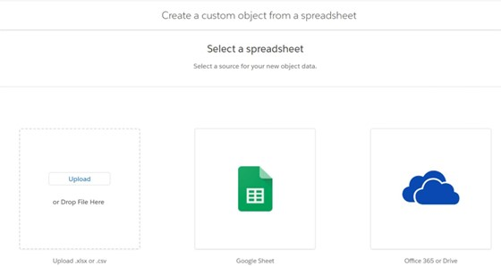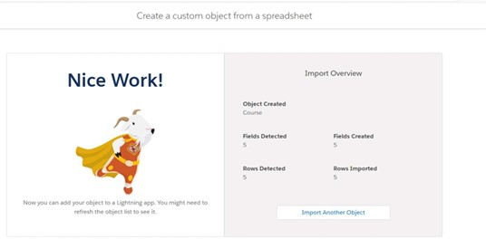

### 1.2 Create Remaining objects

* + - Follow the steps which we have followedfor course object creation.
    - Use the followingsheets for remainingobjects.
    - Consultant
    - Student
    - Appointment

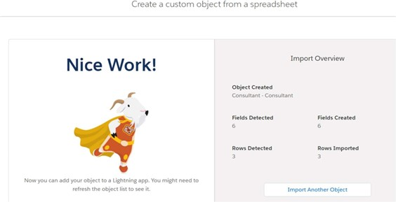

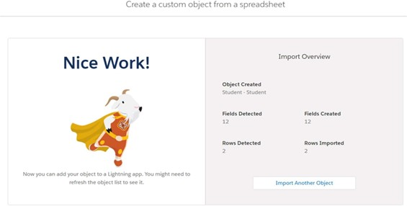

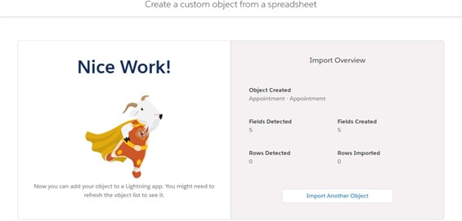

### 1.3Create Relationship among the objects

* + - Create lookup between appointment and student, appointment and consultant.
    - Create an object to store the information student and course details with the name Registration.
    - Also create a lookup between student and case to store the student queries for immigration or visa application.
    - The data model should be similar to the below Data Model with fields & relationships:

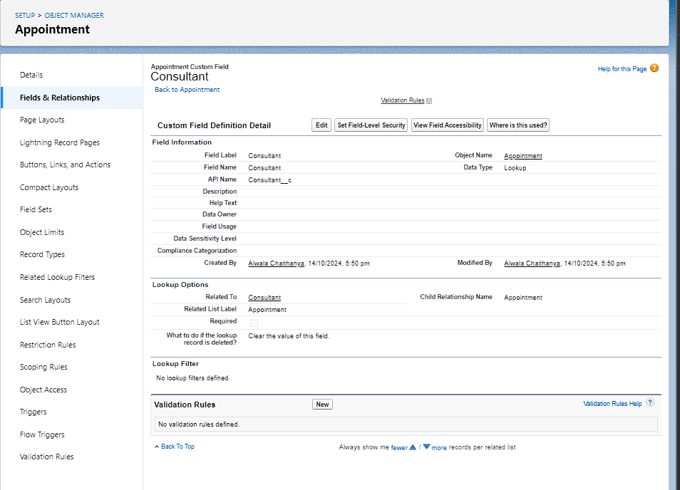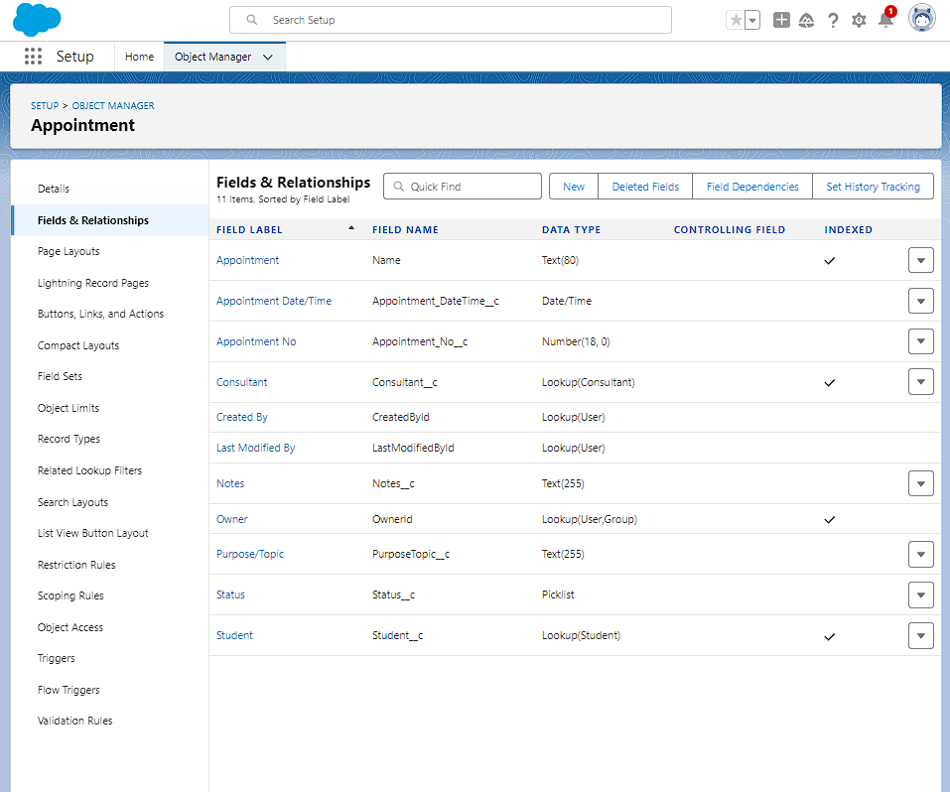

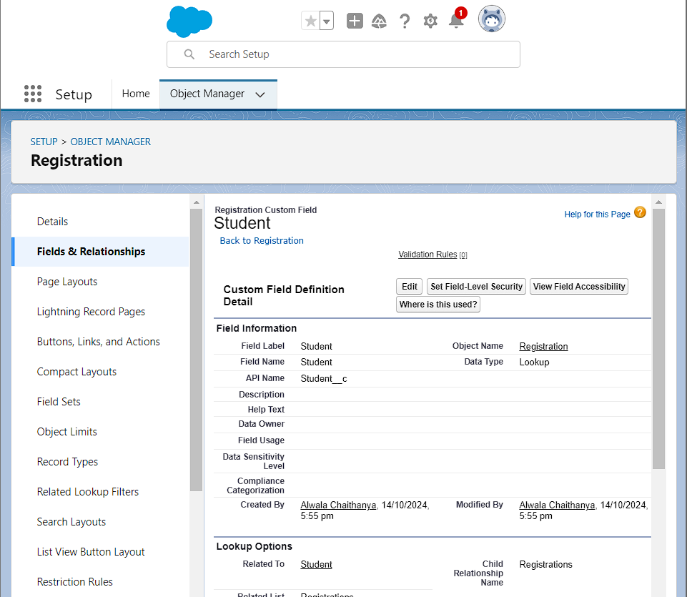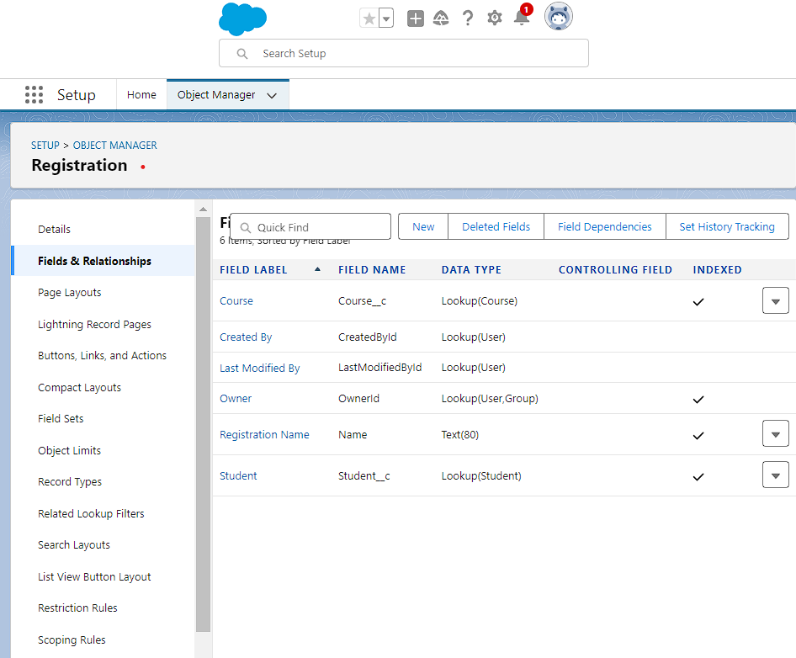

* + - Go to home >quick find type schema builder

|  |  |
| --- | --- |
|  |  |
|  |  |

### 1.4Configure the Case Object

* + - Go to object manager, edit case object.
    - Select the “Type” field and add the values in it.
      * Immigration
      * Visa Application
    - Now Select the “Status” field and add the values in it.
* Open
* In-progress

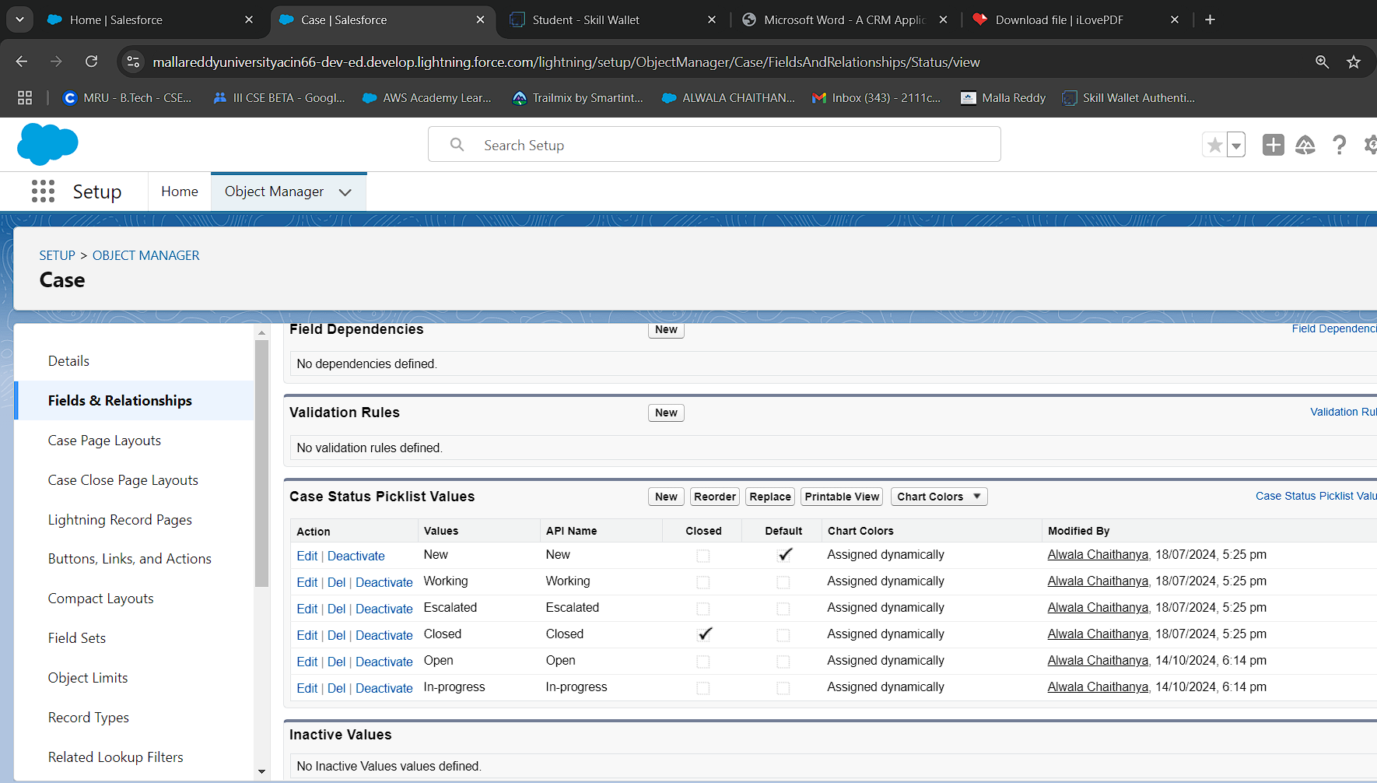

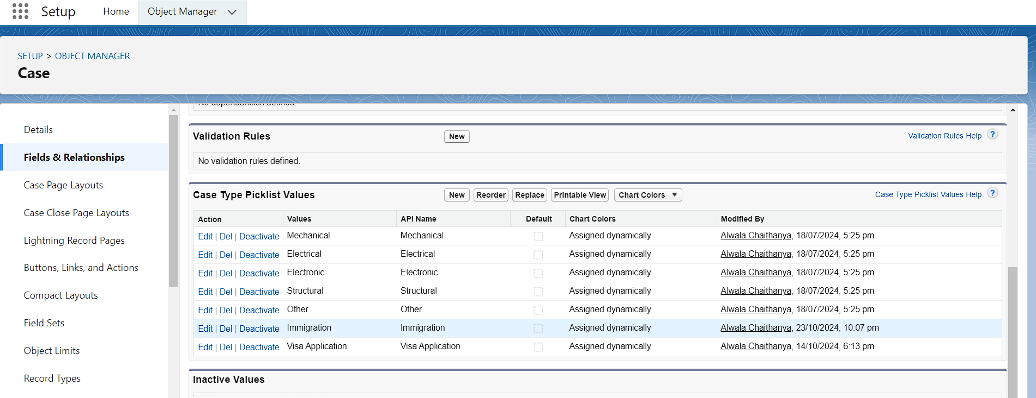

### 1.5 Create a Lightning App

* + 1. Go to Setup, search for the App Manager in quick find
    2. Click on New Lightning App
    3. Give app name as “EduConsultPro”, click Next, Next, Next
    4. Add Home, Students, Courses, Consultants, Appointments, Registrations, and Cases from the Available Items to Selected Items.
    5. Add “System Administrator” profile from Available Profiles to Selected Profiles, click Save & Finish.

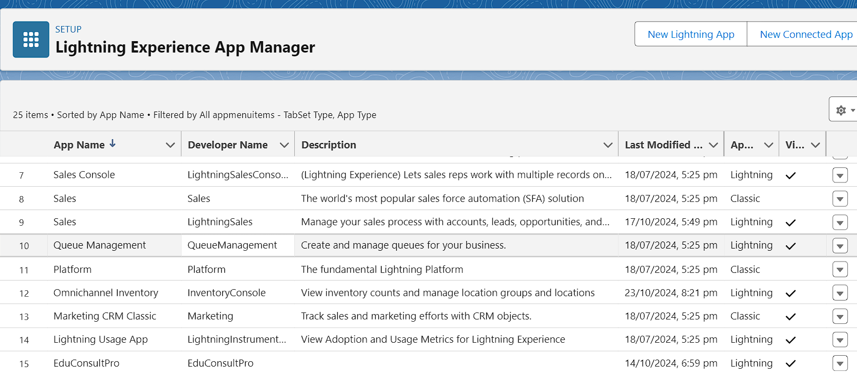

### TASK-2 Create a ScreenFlow for Student Admission Application process

### 2.1Add Screen Element

* + - From Setup, enter Flow Builder in quick find, select new flow --> ScreenFlow.
    - Add a Screen element.
    - In the Screen Properties pane, for Label, enter “StudentInfo”.
    - Click on Fields, click on the record variable input and create a new Resource(StudentRecordRes) to display all the fields which are in the student object. Drag all the fields which are needed to add on the screen inorder to collect the student information.

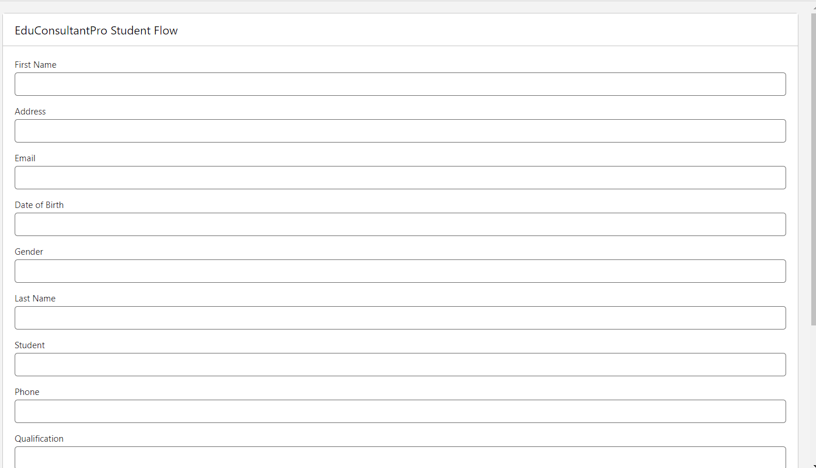

### 2.2 Create Student Record using Create Element

* + - Add a Create element after Student Info Screen Element, Label it as “Create Student Record.”
    - Select “one” under How many records to Create, and select “use all values from a record” under How to Set the record fields.
    - Select the record variable resource(StudentRecordRes) which we have created in the Student Info screen element, under Create a record from these values

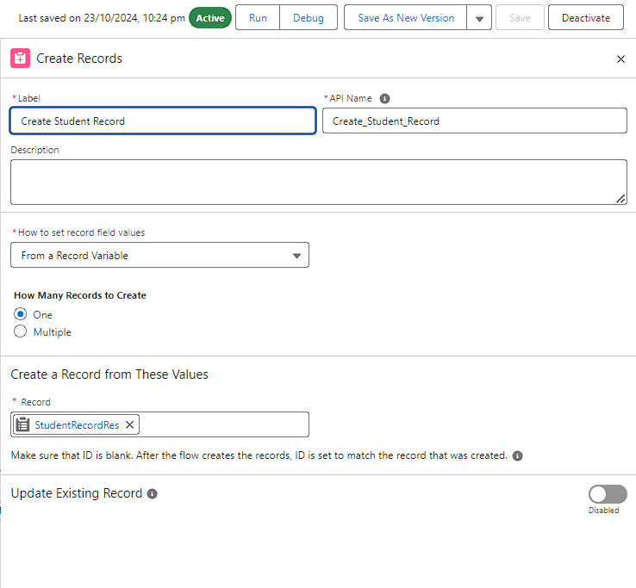

### 2.3 Add Screen Element

* + - Add a Screen Element after Create Student Record Element and label it as Course Screen.
    - Add a picklist component from the left side panel label it as “Select Course”, under choices type “IELTS” and enter. This creates a variable with the name IELTS.
    - Repeat the same for GRE, GMAT, Duolingo, TOEFL.

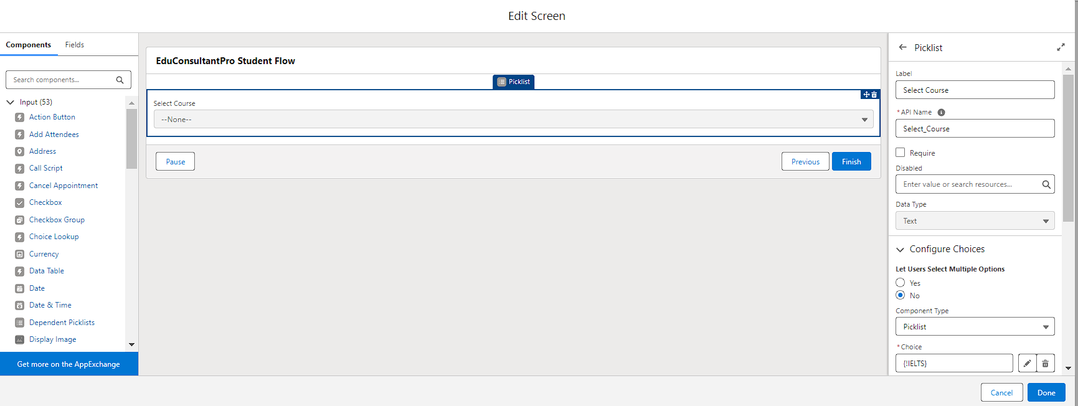

### 2.4Add Decision Element

* Add a Decision Element after Select Course Screen Element, label it as Selecting Course.
* Under outcome label it as “Selected IELTS” and write the condition such as below:
* Resource : Select_Course (Screen Component from Select Course Screen Element)
* Operator : Equals
* Value : IELTS (ChoiceVariable from SelectCourse Screen Element)
* Click on the “+” icon and Repeat step 2 for other options mentioned as below:
* GRE
* GMAT
* DuoLingo
* TOEFL
* Click Done**.**

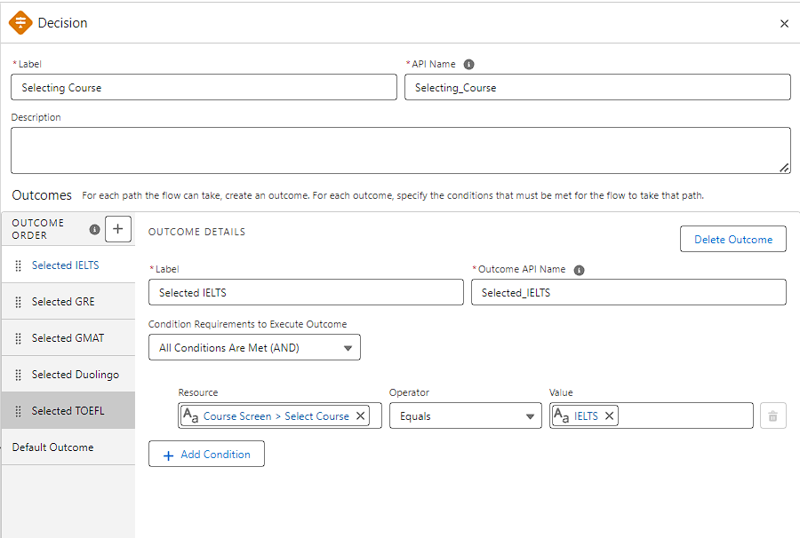

### 2.5Add GET Record Element

* + - Add a GET Record Element after Decision Element, under the IELTS path and label it as “Get IELTS Rec”.

Select Object : Course

Condition Requirement : All Conditions are Met(AND) Field : Course Name

Operator : Equals

Value : {!Select_Course

* + - Repeat the steps 1& 2 for the GRE, GMAT,TOEFL, Duolingo paths.

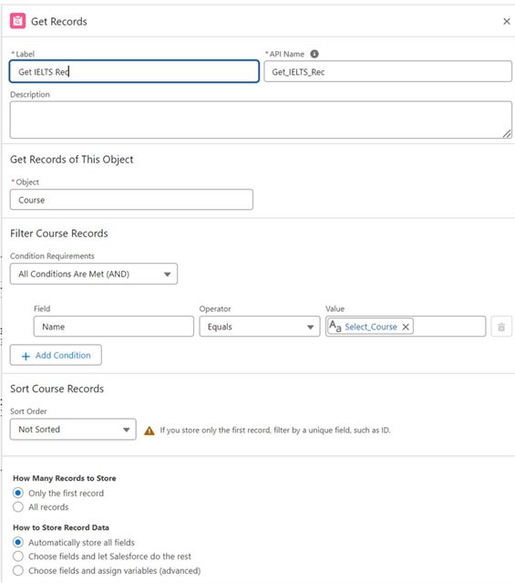

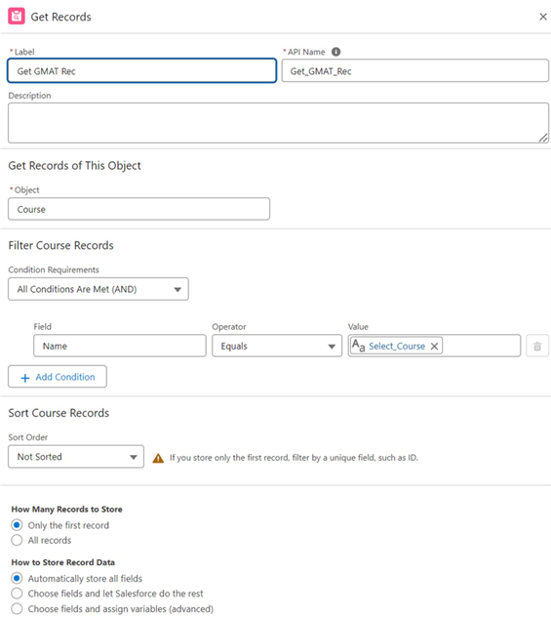

### 2.6Create Email Text Template Variablesfor email body and subject

* + - Click on the toggle toolbox on the left corner, click “New Resource”, then select “Text Template” as Resource Type.
    - Give the API name as “StuRegistrationEmailTextTempBody”, select “view as plain text” and paste the below text in body.

“Dear {!StudentRecordRes.Name}, Congratulations and welcome to EduConsultantPro!

We are delighted to inform you that your registration on our platform has been successfully completed. You are now part of our esteemed community dedicated to empowering students like you to achieve their educational and immigration aspirations.

At EduConsultantPro, we understand the importance of your academic and career goals, and we are committed to providing you with the highest level of support and guidance throughout your journey.

Here are a few key points to help you get started:

Explore Our Resources : Take some time to explore the wide range of resources, tools, and services available on the EduConsultantPro platform. From educational insights to immigration advice, we offer comprehensive support tailored to your needs.

Connect with Our Consultants : Our team of experienced consultants is here to assist you at every stage of your educational and immigration endeavors. Don't hesitate to reach out to us with any questions, concerns, or inquiries you may have. We're here to help!

Stay Updated : Keep an eye on your inbox for important updates, announcements, and exclusive opportunities from EduConsultantPro. We'll ensure that you're informed about the latest developments and relevant information to support your journey.

Engage with the Community : Join our vibrant community of students, professionals, and experts who share your passion for education and global opportunities. Connect with like-minded individuals, participate in discussions, and expand your network.

Once again, congratulations on taking this important step towards realizing your academic and career aspirations. We are thrilled to have you as part of the EduConsultantPro family and look forward to supporting you on your journey to success.

If you have any questions or need assistance, please don't hesitate to contact us.

Thank you.”

* + - Click Done.
    - Repeat steps 1 & 2 to create an email text template for the email subject, label it as “StuRegistrationEmailTextTempSub”, write a text message in the body and save it.

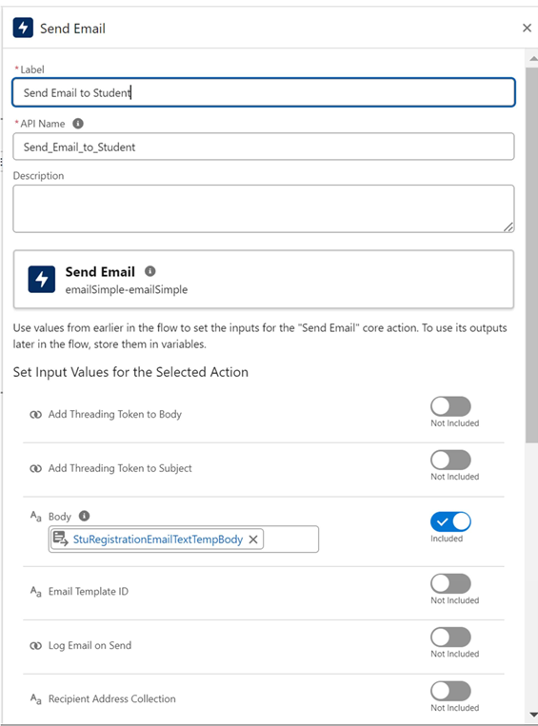

**2.7Add an Action Element**

* + - Add an Action Element after all the Decision paths, label it as “Send Email to Student”.
    - Under “Set input values for selected action”, include body, Recipient Address List and Subject.
    - For input Body : {!StuRegistrationEmailTextTempBody},
    - Recipient Address List : {!StudentRecordRes.Email c},
    - Subject : {!StuRegistrationEmailTextTempSub}.

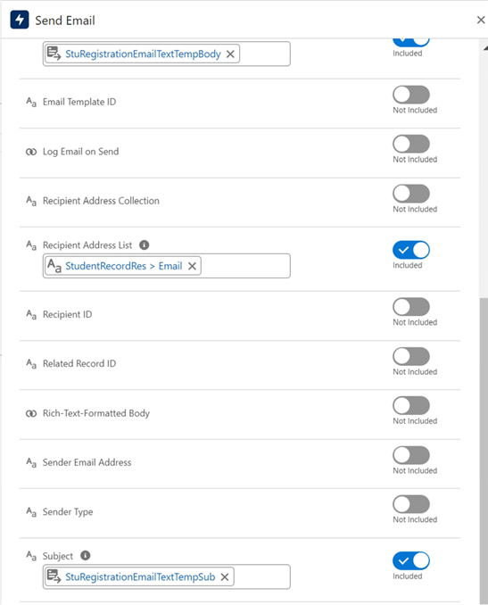

### 2.8Add Screen Element

* + - Add a Screen Element after the Send Email to Student Action Element, label it as Success Screen.
    - From the left side panel search for the Display text component and drag it to the main panel, label it as “SuccessMessage”.
    - Paste the below in the Resource picker box. “Dear {!StudentRecordRes.Name},

Congratulations and welcome to EduConsultantPro!

We are delighted to inform you that your registration on our platform has been successfully completed. You are now part of our esteemed community dedicated to empowering students like you to achieve their educational and immigration aspirations.

Your Registration details have been sent through mail kindly check it once.

Thank you.”

* + - * Click Done.
      * Save the flow and name it as “EduConsultPro Student Flow”. Your flow will look as shown below:

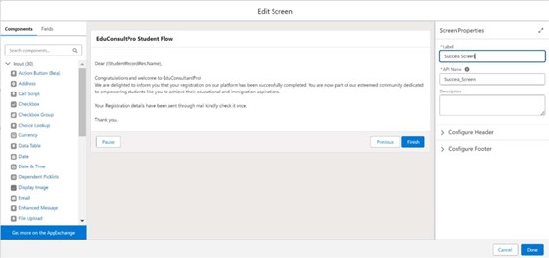

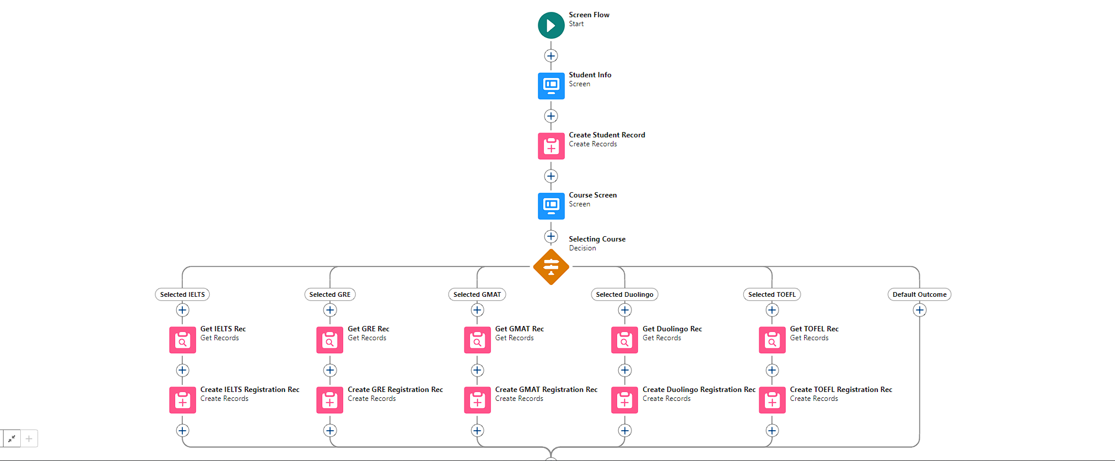

### Task-3 CreateUsers

### 3.1User

* + - Go to Setup --> Administration --> Users --> New User
    - LastName : Consultant
    - License : SalesforcePlatform
    - Profile : StandardPlatform User
    - Fill all the mandatory fields & Save.

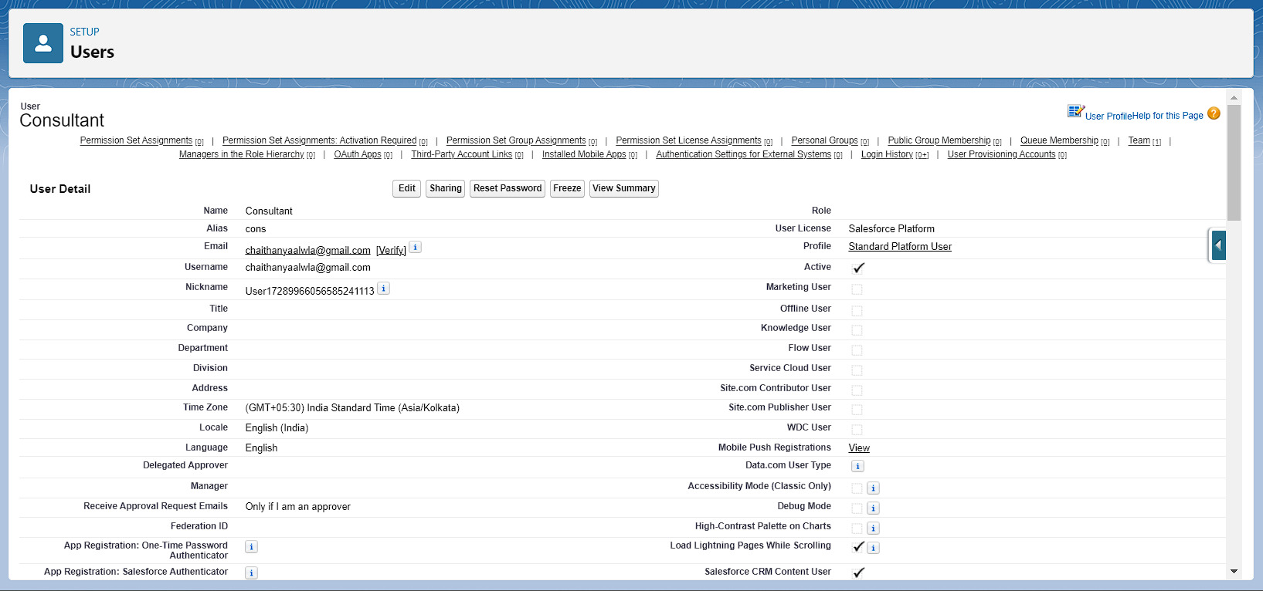

### 3.2Configure the User Settings

* + - Go to Setup --> Administration --> Users --> click Edit next to your name
    - Scroll down to bottom, under Approver Settings, Select “Consultant” the Manager Field.
    - Click Save.

### Task-4. Createan Approval Processfor Property Object

### 4.1Create an Email Template

* + - From Setup, enter Templates in the Quick Find box, and then select Lightning Email Templates, toggle on
    - go to app launcher, search for “Email Templates”, Create a new folder with the desired name.
    - Then create a new email template, select the folder which we have createdin the previous steps, enter the below text in the HTML Value and Save it as "Submission Template".
    - "Dear {{{Appointment c.Student_Name c}}},

I hope this email finds you well. I am writing to confirm the details of our upcoming appointment scheduled

for {{{Appointment c.Appointment_DateTime c}}}regarding

{{{Appointment c.PurposeTopic c}}}.

Appointment Details:

Appointment No : {{{Appointment c.Name}}},

Student Name : {{{Appointment c.Student_Name c}}}, Consultant Name : {{{Appointment c.Consultant c}}},

Date & Time : {{{Appointment c.Appointment_DateTime c}}}, Purpose : {{{Appointment c.PurposeTopic c}}}

I want to assure you that I am lookingforward to our meeting and am fully prepared to address any questionsor concerns you may have regarding

{{{Appointment c.PurposeTopic c}}}. Your success and satisfaction are my top priorities, and I am committed to providing you with the guidance and support you need.

If you have any specific topics or questions you would like to discuss during our appointment, please feel free to share them with me in advance. This will help ensure that our time together is as productive and beneficial as possible.

If for any reason you need to reschedule or cancel our appointment, please notify me at your earliest convenience so that we can make alternative arrangements.

Once again, thank you for choosing to work with me on this matter. I am confident that our collaboration will lead to positive outcomesand progress toward your goals.

If you have any questions or require further information before our scheduled appointment, please don't hesitate to reach out to me.

Looking forward to our meeting. Best regards,

{{{Recipient.Name}}},

EduConsultantPro"

* + - Create two more Email templates for Approval and Rejection of Request similar to the previous one.

### 4.3Create an Approval Process

* + - From Setup, enter Approvalin the Quick Find box, and then select Approval Processes.
    - In Manage ApprovalProcesses For, select Appointment.
    - Click Create New ApprovalProcess --> Use Jump Start Wizard.
    - Configure the approvalprocess.
    - Process Name - Appointment Approval, Under Select Approver, Select Manager for the option : “Automatically assign an approver using a standard or custom hierarchy field.”
    - Click next and “Next Automated Approver Determined By” --> Select Manager.
    - From Record Editability Properties --> Click on Administrators OR the currently assigned approver can edit records during the approval process.
    - Save the approvalprocess.
    - Click View Approval Process Detail Page.
    - Under Initial Submission Actions, click Add New --> Field Update, and configure it with these values.

|  |  |
| --- | --- |
| Field | Value |
| Name | Submitted |
| Field to Update | Appointment: Status |
| A Specific value | Pending |

* + - click Add New --> Email Alert, and configure it with these values. Description:SubmissionEmailAlert

UniqueName : Auto Populates

Email Template : Submission Template Recipient Type : Select your Name

* + - Repeat the Steps 10 - 11 for Final Approval and Final Rejection actions.

**Task 5 Create a Record Triggered Flow**

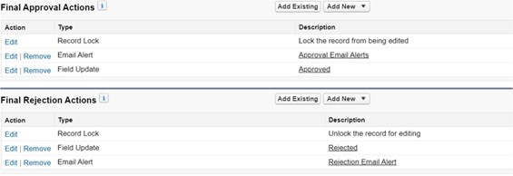

### 5.1Configure the Start Element

* + - From Setup, enter Flows in the Quick Find box, thenselect Flows.
    - Click New Flow.
    - Select Record-Triggered Flow.
    - Click Create. The Configure Start window opens.
    - For Object, select Appointment.
    - For Trigger the Flow When, select A record is created. The flow will look like this**:**

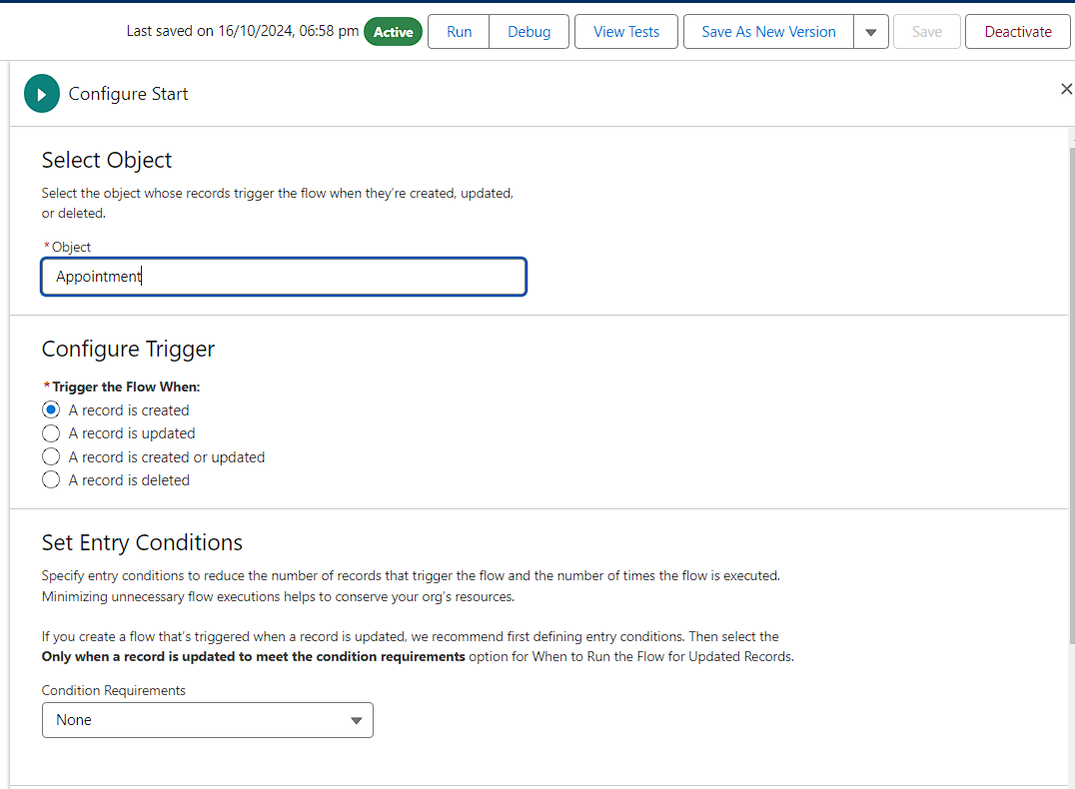

### 5.2Add an Action Element

* + - Add an Action element after the Start Element and Select the Submit for approval action, label it as “Approval SubFlow”.
    - Set the RecordId to “{!$Record.Id}”
    - Save the Flow, label it as "EduConsultPro Approval Flow and Click on Activate.

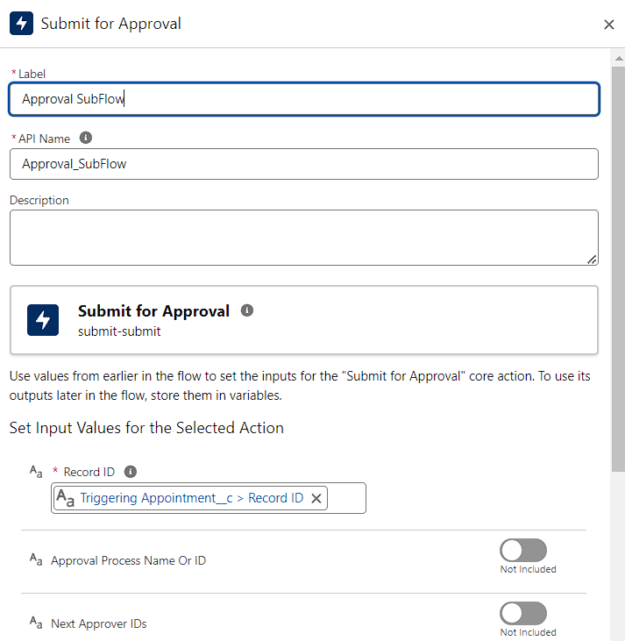

### Task-6 Create a ScreenFlow for Existing Studentto Book an Appointment

### 6.1Add Screen Element

* + - From Setup, enter Flow Builder in quick find, select new flow ? ScreenFlow.
    - Add a Screen element.
    - In the Screen Properties pane, for Label, enter “Get Student Info”.
    - Add two Text components from the left side panel. Give the Label’s as follows:
      * 1st Text Component Label : Enter Student
      * Name 2nd Text Component Label : EnterStudent Email
    - Click on Done.

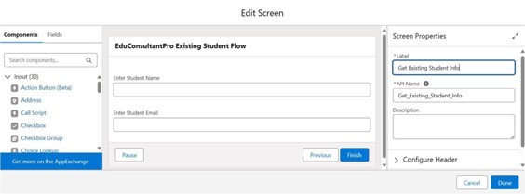

### 6.2Add GET RecordElement

* + - Add a GET Record Element after Decision Element, under the IELTS path and label it as “Get Rec”.
    - Select Object : Student
* Condition Requirement : All Conditionsare Met(AND)

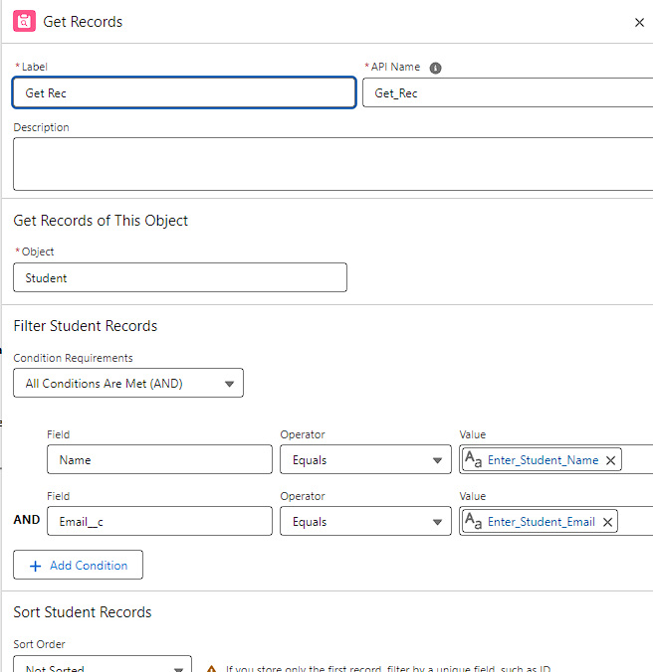

### 6.3Add Decision Element

* Add a Decision Element after Select Display Student Details Element, label it as “Appointment or Case”.
* Under outcome label it as “Appointment” and write the condition such as below:
* Resource : {!How_may_I_Help_you}
* Operator : Equals
* Value : {!Book_an_Appointment}
* Click on the “+” icon and Repeat step 2 for Case options mentioned.

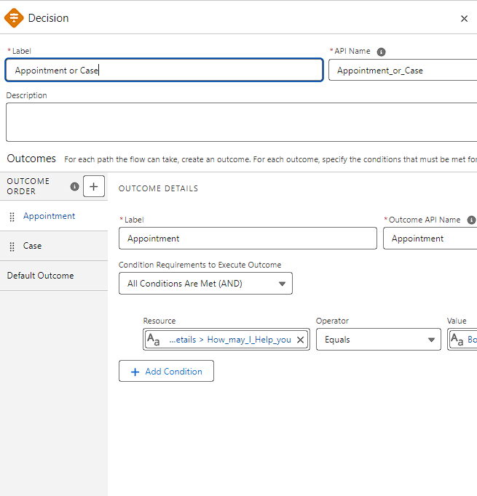

### 6.4 Add Screen Element

* + - Add a Screen elementafter the DecisionElement, on the Appointment path and label it as “Appointment Booking Screen".
    - Click on Fields, click on the record variable input and create a new Resource (AppointmentRecordRes) to display all the fields which are in the Appointment object.
    - Drag all the fields which are needed to add on the screen inorder to collect the student information.
    - Click on Done.
    - 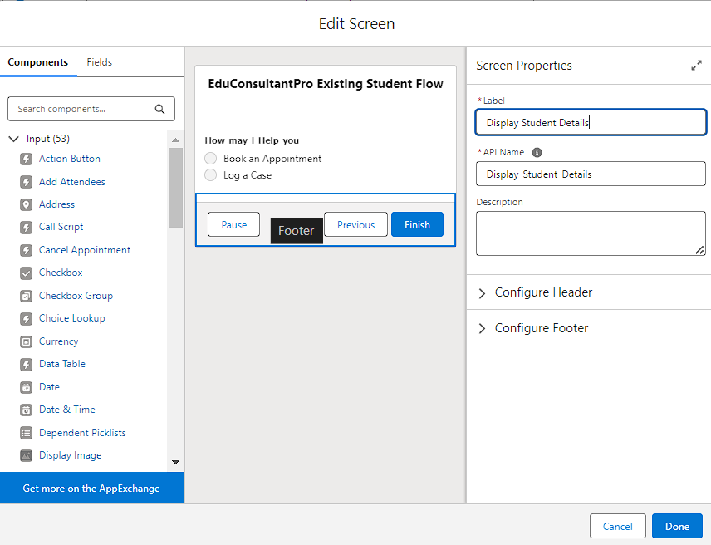

### 6.5Create Appointment Record using Create RecordsElement

* + - Add a Create element after the Get Consultant Rec element and label it as “Create Appointment”.
    - Select “one” under How many records to Create, and select “Use separate resources, and literal values” under How to Set the record fields.
    - Select Object : Appointment
      * Field : Appointment_DateTime c
      * Value : {!AppointmentRecordRes.Appointment_DateTime c}
      * Field : Consultant c
      * Value : {!Get_Consultant_Rec.Id}
      * Field : Notes c
      * Value : {!AppointmentRecordRes.Notes c}
      * Field : PurposeTopic c
      * Value : {!AppointmentRecordRes.PurposeTopic c}
      * Field : Student_Name c Value : {!Get_Rec.Id}

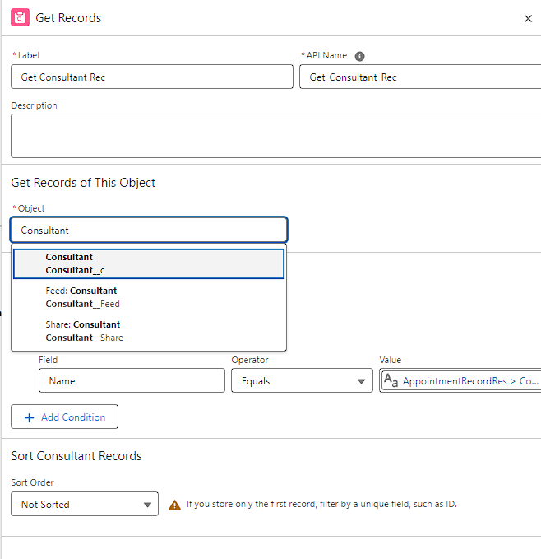

### 6.6Add Screen Element

* Add a Screen Element after the Send Email to Student Action Element, label it as “Confirmation Screen”.
* From the left side panel search for the Display text component and drag it to the main panel, label it as “Appointment_Confirmation”.
* Paste the below in the Resource picker box. Consultant Name : {!Get_Consultant_Rec.Name},
* Date & Time : {!AppointmentRecordRes.Appointment_DateTime c}, Notes : {!AppointmentRecordRes.Notes c},
* Click Done.

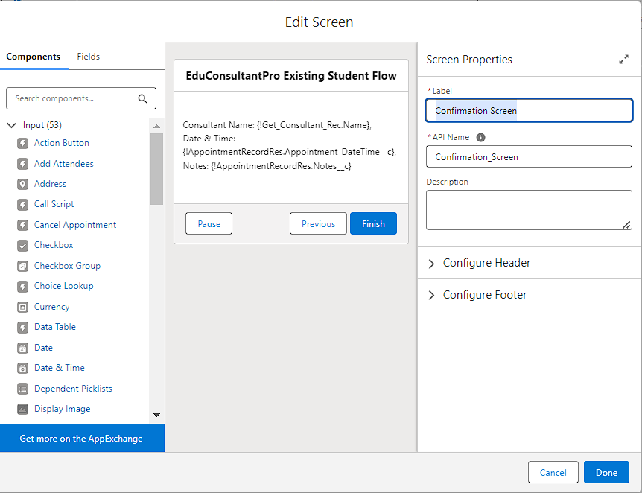

### 6.7Add an SubFlow Element

* + - Add a subflow element after the Decision Element, on the Case path and search and Select for “Create a Case”, label it as “Create Student Case”.
    - Save the flow and label it as “EduConsultantPro Existing Student Flow”, you can use the below image for reference.

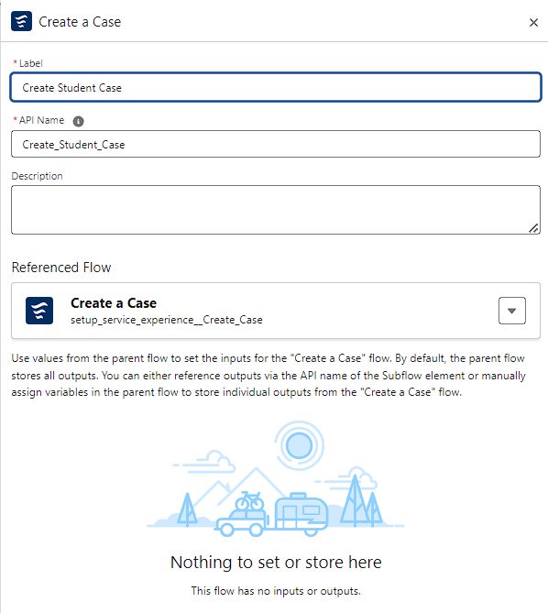

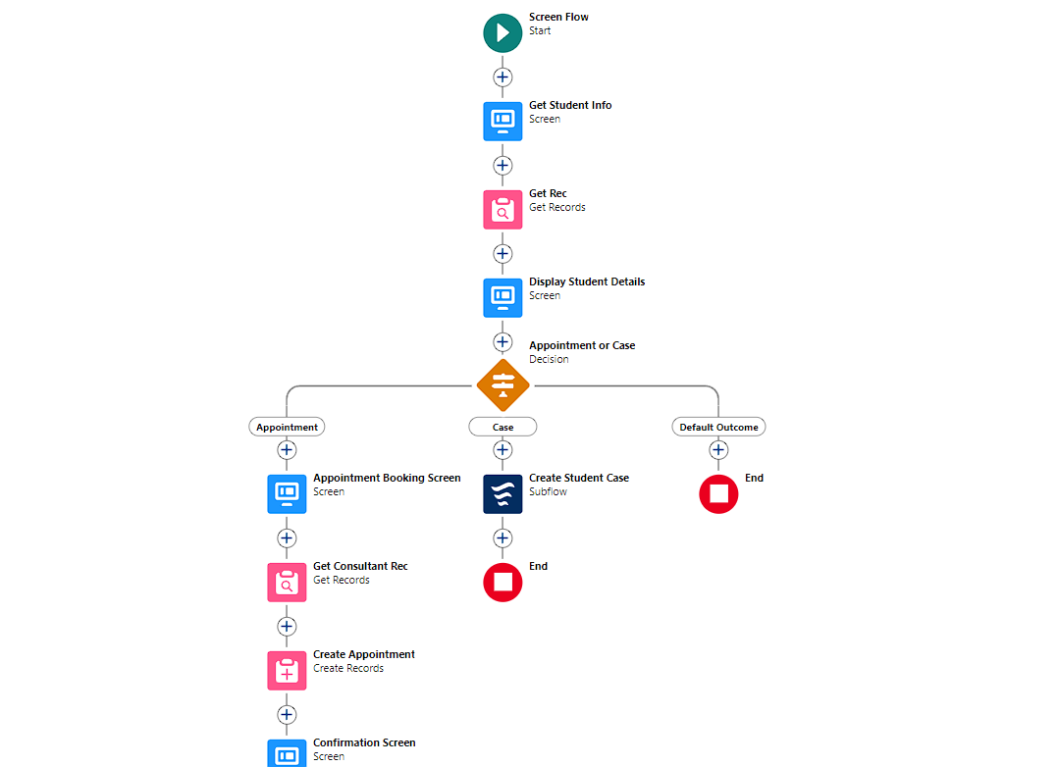

### Task-7 Create a ScreenFlow to Combineall the flows at one place

### 7.1Add Screen Element

* + - Add a Screen Element and label it as WelcomeScreen.
    - From the left side panel search for the Display text component and drag it to the main panel, label it as “SuccessMessage”.
    - Paste the below in the Resource picker box. “Welcome to EduConsultantPro

your premier destination for education and immigration solutions!

At EduConsultantPro, we understand that embarking on educational or immigration journeys can be both exhilarating and daunting. That's why we're here to guide you every step of the way with expertise, dedication, and personalized support.

Whether you're seeking to pursue your academic dreams abroad, navigate the complexities of immigration processes, or enhance your professional skills through international opportunities, EduConsultantPro is your trusted partner.

Our team of seasoned consultants is committed to understanding your unique aspirations and crafting tailored strategies to help you achieve your goals efficiently and effectively. From selecting the right educational institution to navigating visa procedures, our comprehensive services cover all aspects of your journey.

At EduConsultantPro, we believe in fostering inclusive communities and unlocking the full potential of every individual. With our unwavering commitment to excellence and integrity, we strive to make your experience with us seamless and rewarding.

Welcome to EduConsultantPro – where your aspirations meet our expertise, and together, we pave the path tosuccess. Let's embark on this transformative journey together!”

* + - Click Done.

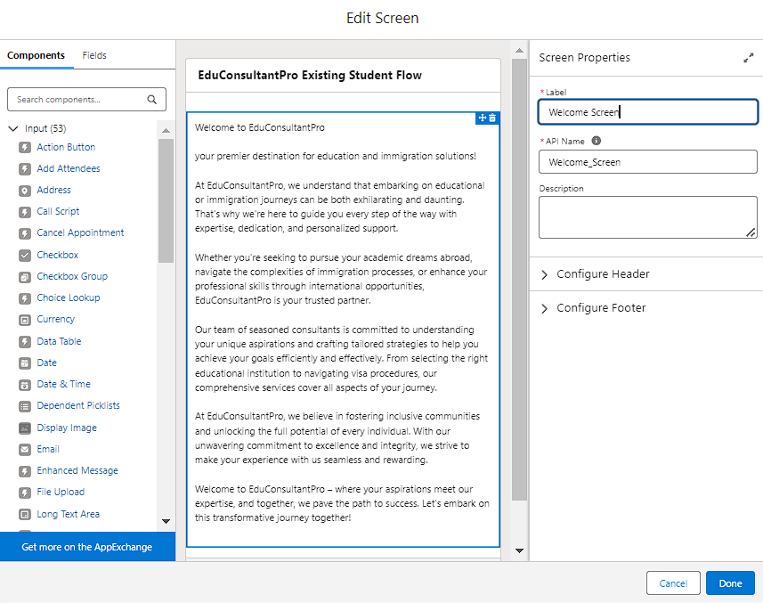

### 7.2Add Screen Element

* + - Add a Screen Element after the Welcome Screen Element, label it as “Existing or New Student Confirmation Screen”.
    - Add a radio button component from the left side panel, label : Are you a Existing Student
    - Click on Add Choice -->type “Yes” in the input field --> click CreateYes choice.
    - Repeat step 6 and create an “No” choice resource
    - Click Done.

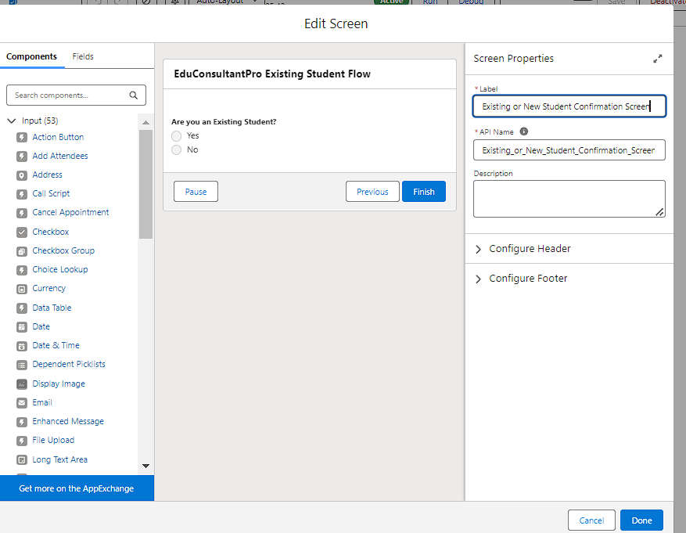

### 7.3Add Decision Element

* Add a Decision Element after Existing or New Student Confirmation Screen Element, label it as “Decision 1”.
* Under outcome label it as “If Existing Student” and write the condition such as below:
  + Resource {!Are_you_a_Existing_Student} Operator : Equals
  + Value : {!Yes}
* Click on the “+” icon and Repeat step 2 for No options mentioned.

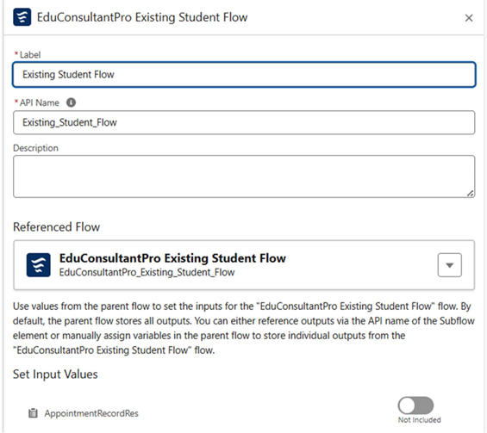

### 7.5Add an SubFlow Element

* + - Add a subflow element after the Decision 1 Element on the if Not an Existing Student path and search and Select for “EduConsultantPro Student Flow '', label it as “New Student Flow”.
    - Save the flow and label it as “EduConsultantPro Existing Student Flow”.
    - Click Done.
    - Save the flow and label it as “EduConsultPro Flow”, you can use the below image for reference.

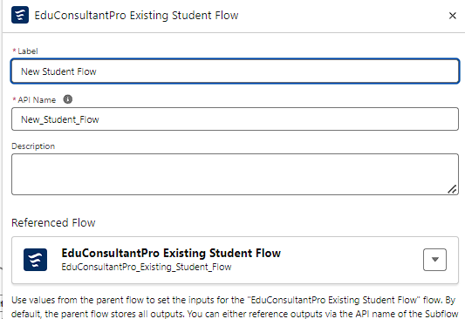

**Task-8 Case Auto-Assignment to Consultants**

**1.Navigate to Setup:**

* + In Salesforce, go to Setup by clicking the gear icon in the upper right-hand corner.

1. **Search for Case Assignment Rules:**
   * In the Quick Find box, search for Case Assignment Rules and select it.
2. **Create a New Assignment Rule:**
   * Click New to create a new Case Assignment Rule.
   * Name it something relevant like EduConsultantPro Case Assignment and ensure it is marked as Active.
   * Save the rule.
3. **Create Assignment Rule Entries:**
   * Inside your newly created rule, click New to add assignment rule entries.
   * Define conditions for how cases should be assigned. For example:
     + Condition 1: Case Type = Education ➔ Assigned to Education Consultant A.
     + Condition 2: Case Type = Immigration ➔ Assigned to Immigration Consultant B.
     + Condition 3: Case Priority = High ➔ Assigned to Senior Consultant.
   * Choose the appropriate criteria for assignment based on fields like Case Type, Priority, or custom fields you’ve added for consultants.
   * Under Assign To, choose the User or Queue that should receive the case.
   * Repeat the process for all necessary case types or priorities.

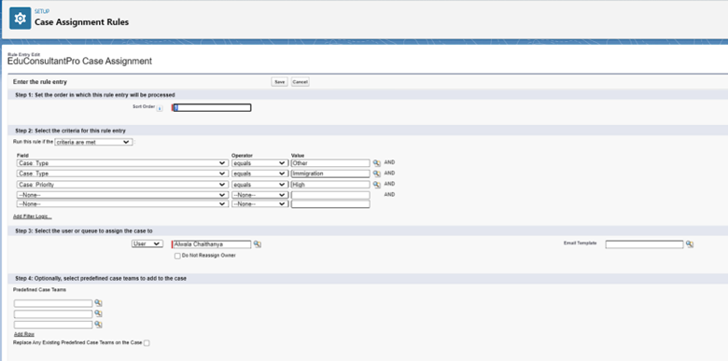

### Task-9Implement Field-Level and Record-Level Security

1. **Field-Level Security**:
   * + - In **Object Manager**, select each sensitive object (e.g., Student, Case).
       - Click on **Fields & Relationships** to set visibility and edit permissions for each sensitive field based on roles.

**2.Record-Level Security**:

* + - * Go to **Sharing Settings** under **Setup**.
      * Set the **Default Internal Access** for each object to **Private** to restrict visibility by default.

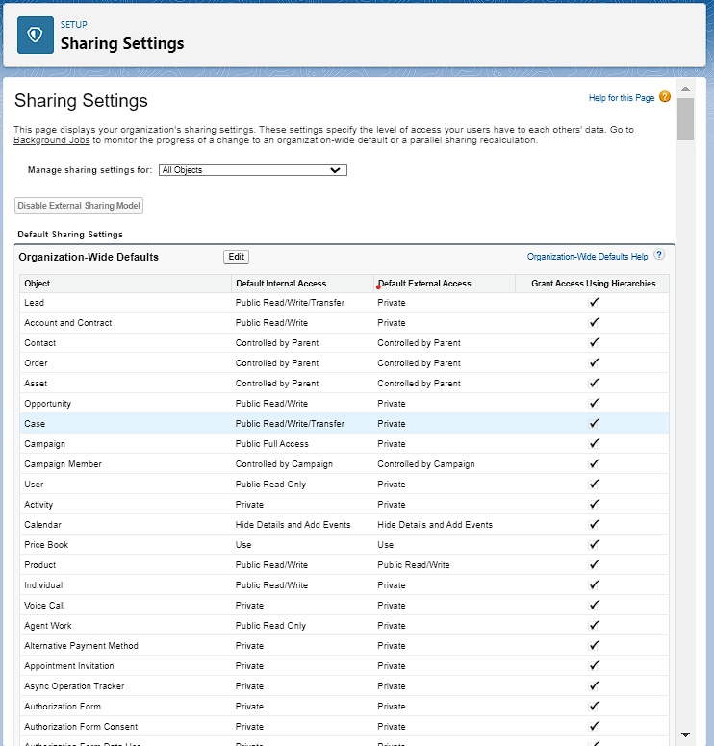

### Task-10 Createa lightning app page

* + - From Setup, enter App Builder in the QuickFind box, then clickLightning App Builder.
    - Click New, select Home Page, then click Next.
    - Step through the wizard and name the page “EduConsultPro Home Page”, select the Standard Home Page template, and then click Done.
    - Drag the Flow component to the top-rightregion.
    - Search for the “EduConsultantPro Flow” and click Save.
    - Click Activate, Click App and Profile,then click Assign to Apps and Profiles.
    - Select the Sales app, then click Next.
    - Scroll down the list of profiles and select System Administrator, then click Next.

Review the assignment, and then click Save**.**

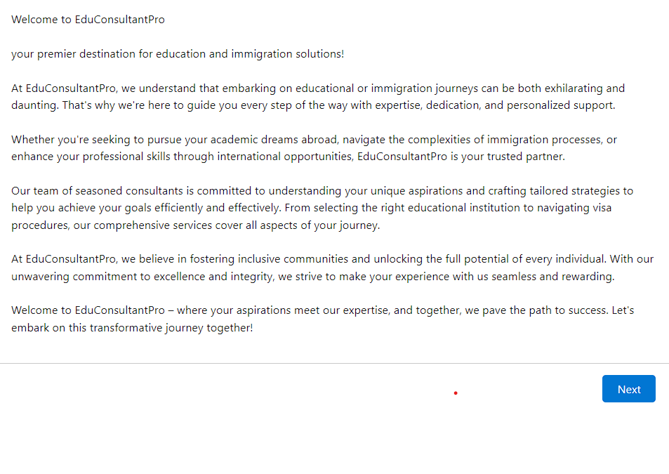

**5. Testing and Validation**

1. Unit Testing:

- Test small parts of the CRM, like forms or buttons, to see if they work properly.

- Example: Make sure the form for adding student details saves the information correctly.

2. System Testing:

- Check if different parts of the CRM work well together.

- Example: Test if creating a student record automatically links to the case system for support.

3. User Acceptance Testing (UAT):

- Let real users try out the CRM to ensure it meets their needs.

- Example: Have the staff try booking appointments to confirm the process is easy to use.

4. Data Validation:

- Make sure all data entered is correct and follows the rules.

- Example: Ensure fields like "Student Name" are required before saving.

5. Security Testing:

- Check if users only have access to the parts of the CRM they should see.

- Example: Confirm that only admins can access sensitive student data.

6. Performance Testing:

- Test if the CRM runs smoothly with many users at once.

- Example: Simulate multiple people using the system to check for slowdowns.

7. Bug Fixing:

- Find and fix any problems before the CRM goes live.

- Example: Fix any form errors that prevent users from saving information.

8. Final Check:

- Do one last test to ensure everything works perfectly before using it fully.

**6. Key Scenarios Addressed by Salesforce in the Implementation Project**

In the implementation of the educational CRM using Salesforce, several key scenarios are addressed to enhance operational efficiency and improve customer satisfaction.

1. **Student Management**: Salesforce enables tracking of student interactions, service history, and preferences, ensuring personalized communication and support.
2. **Appointment Scheduling**: The CRM automates appointment bookings, allowing students to easily schedule consultations and receive reminders, reducing no-shows.
3. **Case Management**: All interactions are logged as cases, ensuring that every inquiry or issue is tracked and resolved promptly.
4. **Reporting and Analytics**: The platform provides insights into student engagement and service effectiveness, enabling data-driven decision-making.
5. **Integration with Communication Channels**: Salesforce facilitates communication through various channels, including email, chat, and social media, enhancing accessibility and responsiveness.
6. **Role-based Access Control**: The CRM ensures that sensitive information is secure by restricting access based on user roles, safeguarding student data.

**7. Conclusion**

In this project, we successfully developed a customized CRM system using Salesforce to enhance service management within an educational institution. The CRM system streamlined student management by centralizing information, enabling personalized communication, and tracking service history. We implemented automated appointment scheduling, reducing administrative tasks and improving student engagement. The inclusion of robust case management ensured that all student inquiries and issues were promptly addressed, leading to improved satisfaction.

The system’s reporting and analytics features provided valuable insights into service performance, facilitating data-driven decisions. Additionally, secure role-based access controls were implemented to protect sensitive student data, ensuring compliance with privacy standards.

Through this implementation, the institution now has a more efficient, user-friendly platform that enhances service delivery, optimizes communication, and improves overall operational efficiency. This project has laid a solid foundation for continued growth and service excellence in the institution.