**Social Media**

Introduction: Our team aim is to create an social media website which is very easy to use. So, we created a front-end part of the website.

Technologies Used:

* Html
* Css
* Javascript
* Bootstrap
* jQuery

Launch:

We can launch this site by login into your account, since it’s only front-end part you can login using any mail address and password. If you don’t have an account you can create an account using bottom link. If you forgot password then you can click on forgot password, using this you can reset your password. After login into your account you can post, chat with friends or go on live all these will be just away from the tap.

Screenshots:

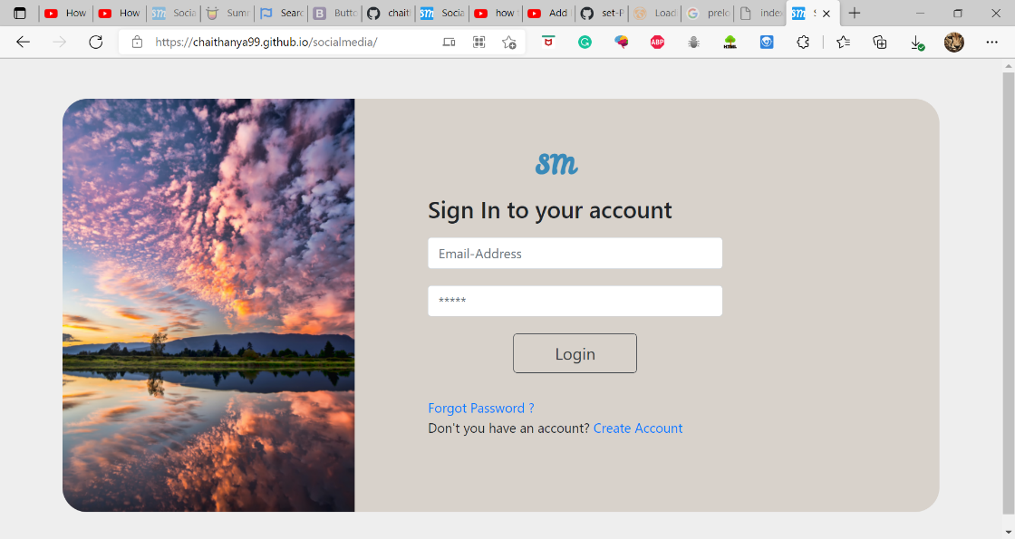

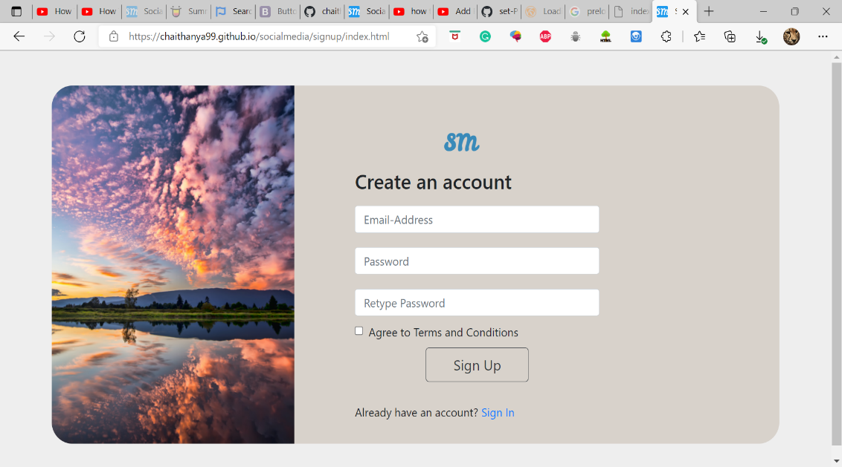

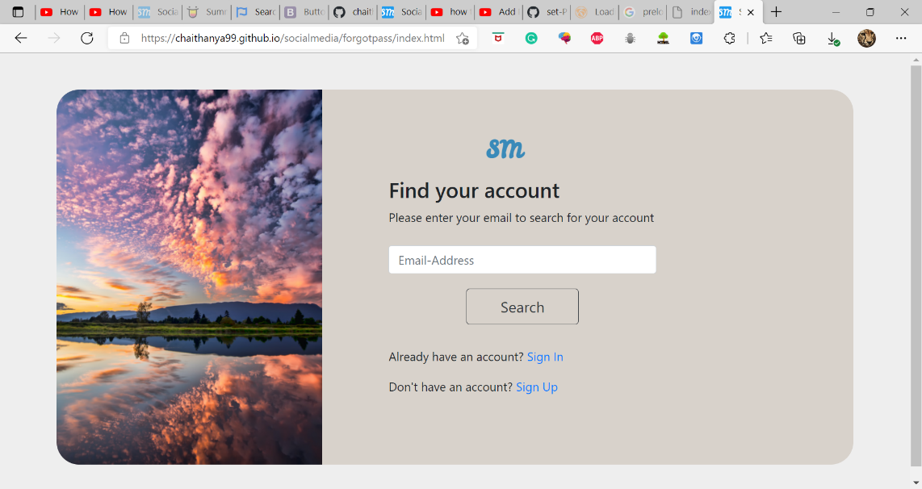

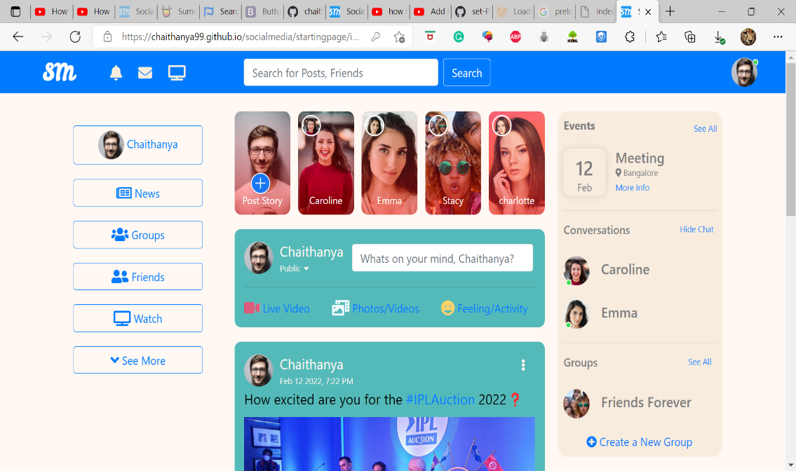

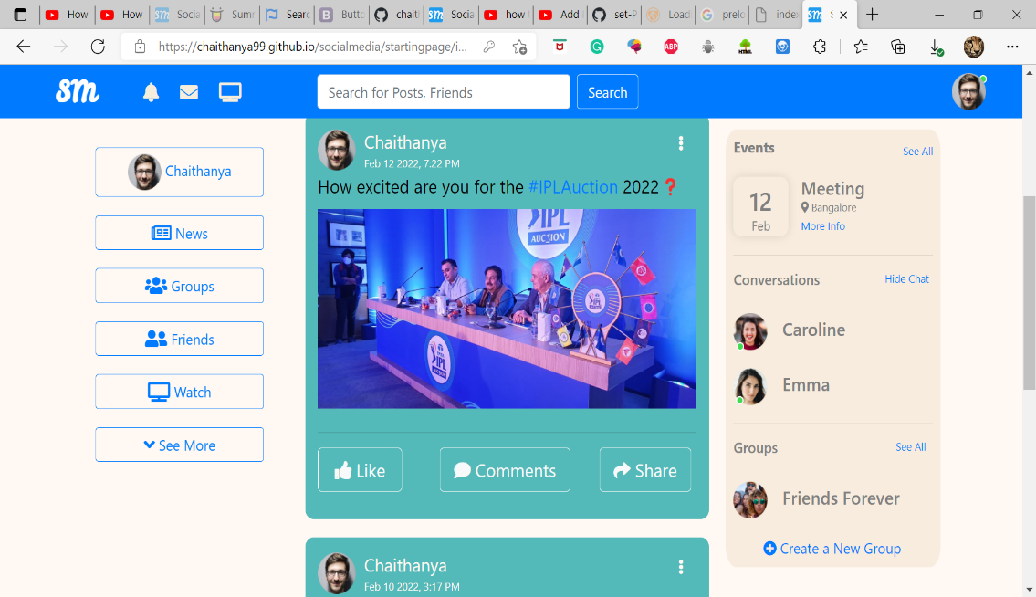

Github Repo-link: [chaithanya99/socialmedia (github.com)](https://github.com/chaithanya99/socialmedia)

Website link: [Social Media (chaithanya99.github.io)](https://chaithanya99.github.io/socialmedia/)