Scala programming

Lab assignment

Name – chaithanya gowda l

Usn – 22btrad010

Write a Scala program to create a map and find the difference between two maps.

ALGORITHM:

1. **Define the FindDifferenceBetweenMapsExample object:**
   * Create an object named **FindDifferenceBetweenMapsExample** to contain the **main** method and the logic to find the difference between maps.
2. **Create the main method:**
   * Define the **main** method to serve as the entry point of the program.
3. **Create two maps:**
   * Create two maps, **map1** and **map2**, with key-value pairs.
4. **Print the original maps:**
   * Print the original contents of **map1** and **map2**.
5. **Find the difference between the maps:**
   * Use the **--** operator to find the difference between **map1** and the keys of **map2**.
6. **Print the difference:**
   * Print the result, which represents the difference between the maps.

INPUT:

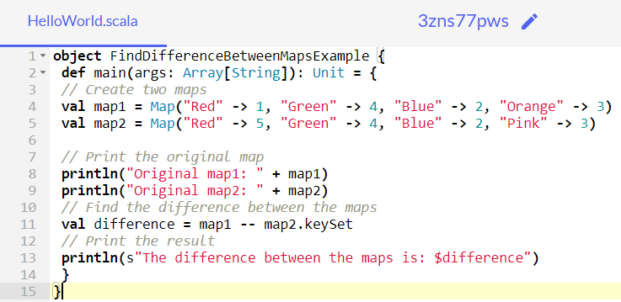

OUTPUT:

