Scala programming

Name – chaithanya gowda l

The "MathUtils" object contains the factorial method. This method calculates the factorial of a given number using recursion. If the number is 0 or 1, it returns 1. Otherwise, it recursively calls itself with n - 1 and multiplies the result by n.

INPUT:

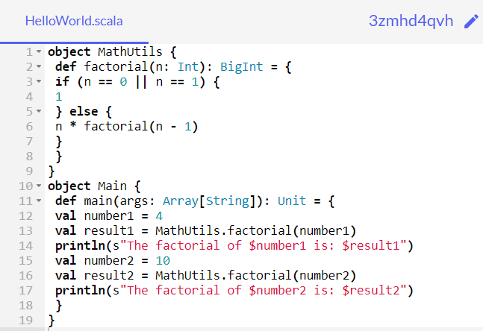

**OUTPUT:**

