**Activity: Filter a SQL query**

**Overview:** As a security analyst, knowing how to make better queries to retrieve specific pieces of data can help you find the security-related information you need more efficiently. In this lab activity, you’ll apply basic filters to SQL queries to retrieve information from a MariaDB database.

**Scenario:** In this scenario, you need to get specific information about employees, their machines, and the departments they’re in. Your team needs this data to perform various tasks, such as running updates, posting a privacy notice in certain departments, and sending an alert to an employee with an issue on a machine.

**First**, you’ll list all organization machines and their operating systems. **Second**, you’ll list all machines with the operating system OS 2. **Third**, you’ll list all the employees in the Finance and Sales departments. **Fourth**, you’ll obtain information about machines.

**Start your lab:** click on “start lab” to start the lab.

**Task 1. List all organization machines**

In this task, you need to get a list of all organization machines and their operating systems.

* Run a SQL query to retrieve only the device_id and operating_system columns from the machines table.

**>SELECT device_id. Operating_system FROM machines;**

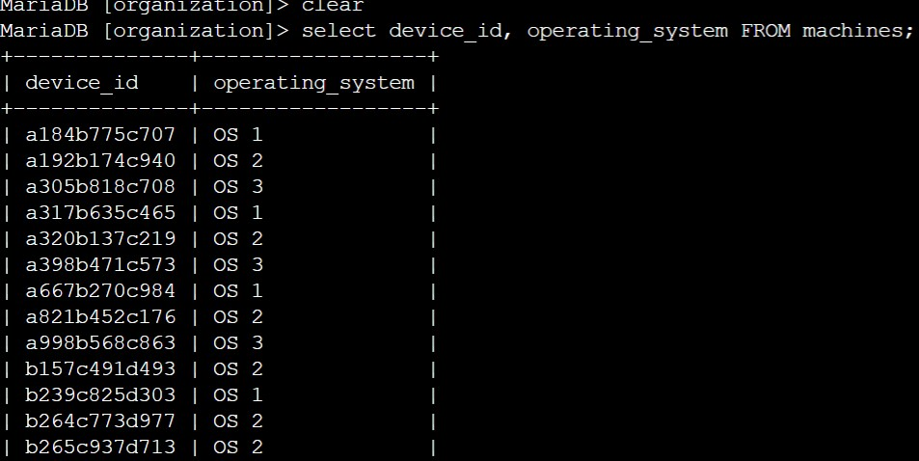

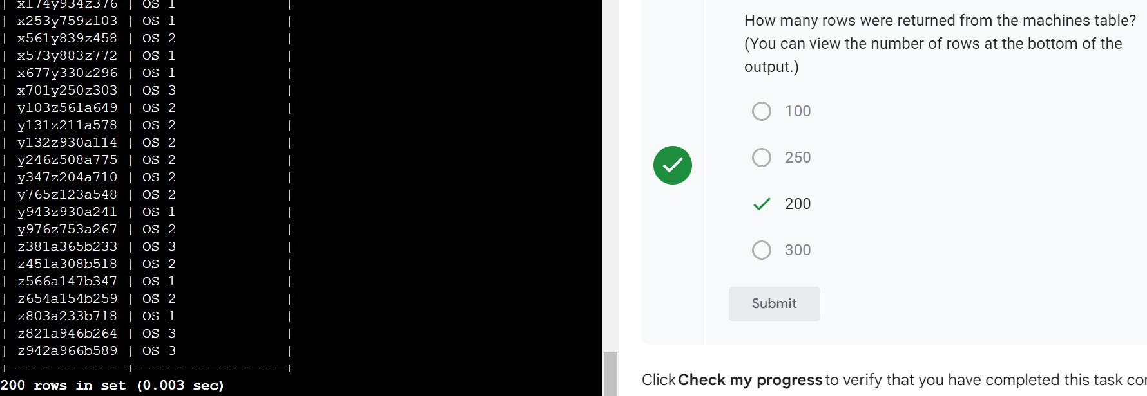

**Task 2. Retrieve a list of the machines with OS 2**

In this task, you need to obtain a list of all machines with the 'OS 2' operating system because these machines need an update.

* Select all the records from the machines table with a value of 'OS 2' in the operating_system column.

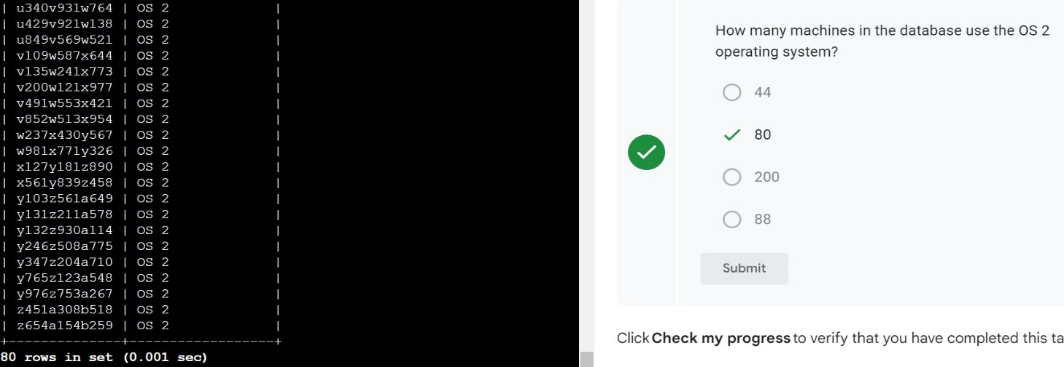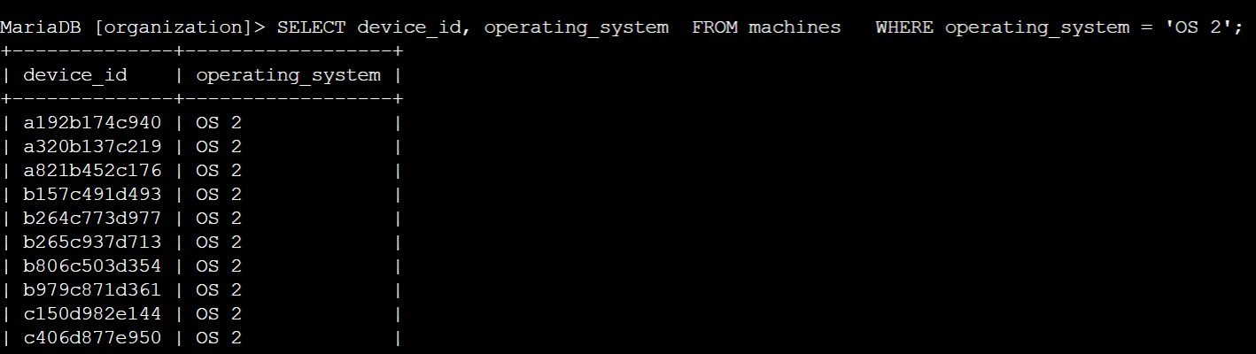**>SELECT device_id, operating_system FROM machines WHERE operating_system= ‘OS 2’ ;**

## **Task 3. List employees in specific departments**

In this task, you need to retrieve a list of all the employees in the Finance and Sales departments to obtain their office numbers. A notice about handling confidential financial information will be posted to these offices.

1. Filter the rows returned from department column in the employees table to include only employees from the 'Finance' department.

**>SELECT * FROM employees WHERE department= ’Finance’ ;**

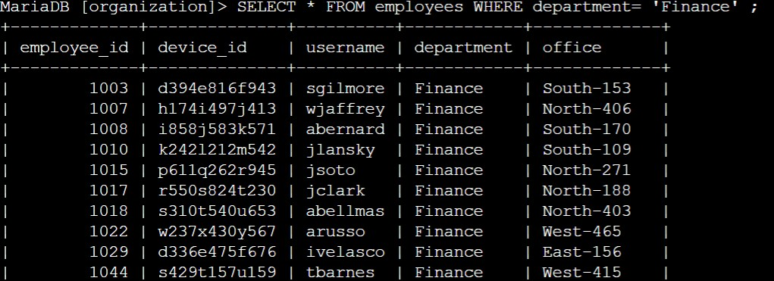

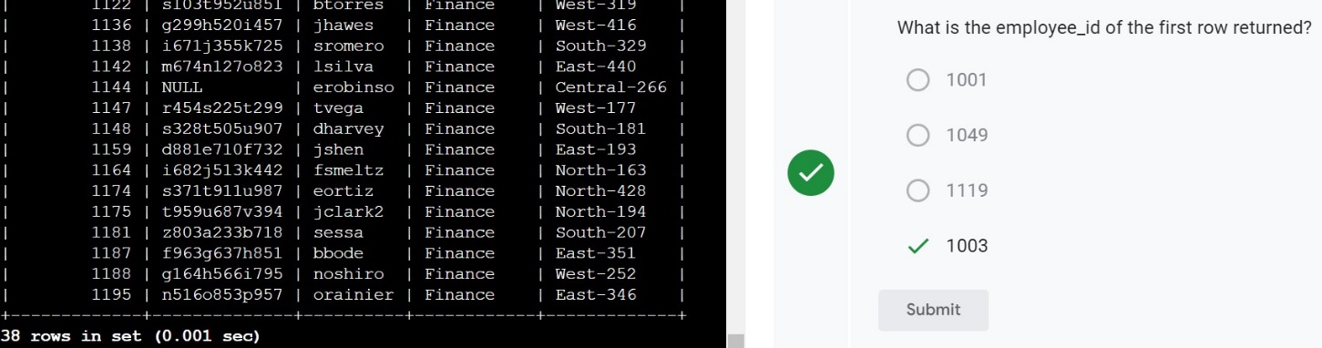

1. Modify the previous query so that it returns employees who are in the 'Sales' department.

**>SELECT * FROM employees WHERE department= ’Sales’ ;**

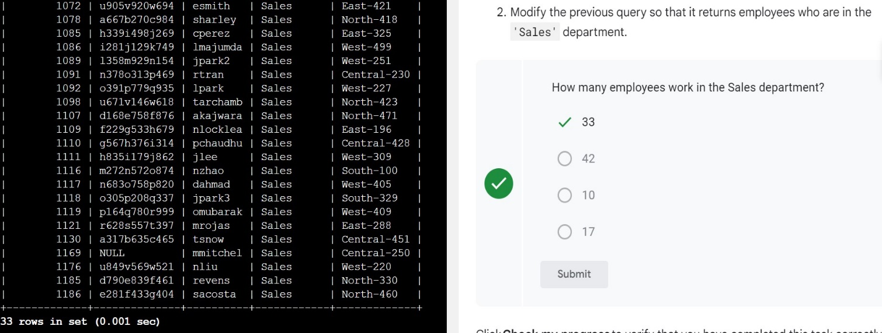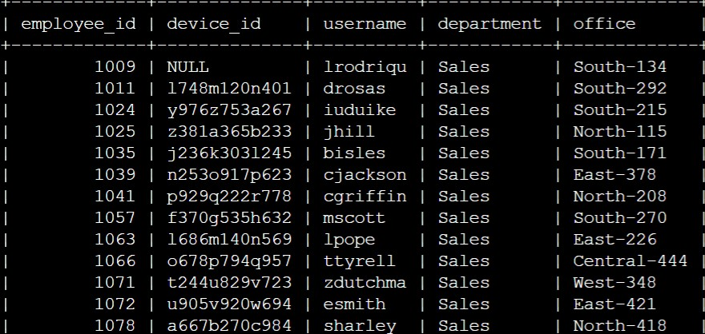

**Task 4. Identify employee machines**

Your team recently discovered that there are issues with machines in the South building. In this task, you need to obtain certain employee and computer information. A machine in 'South-109' has an issue. You need to determine which employee uses that computer so you can send them an alert.

1. Write a query to identify which employee uses the office in 'South-109'.

**>SELECT * FROM employees WHERE office= ‘south-109’ ;**

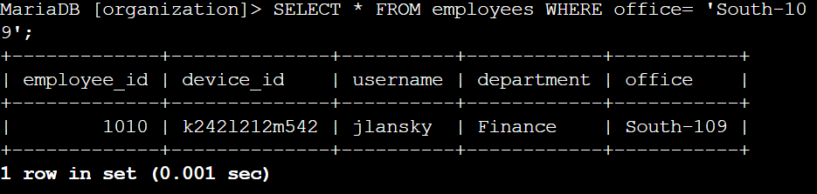

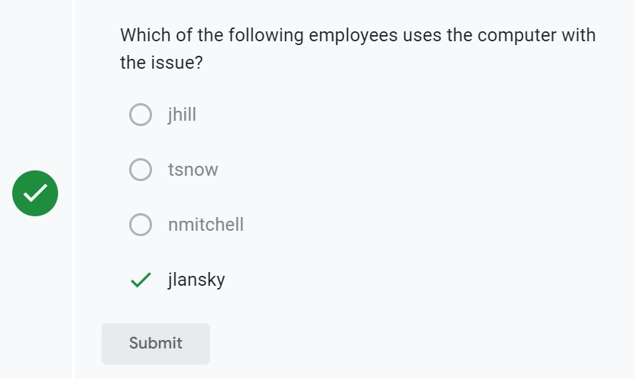

1. Modify the query you used in the previous step so that it returns information on all the employees in the 'South' building. Use the LIKE operator with % in this query.

**>SELECT * FROM employees WHERE office LIKE ‘%South%’ ;**

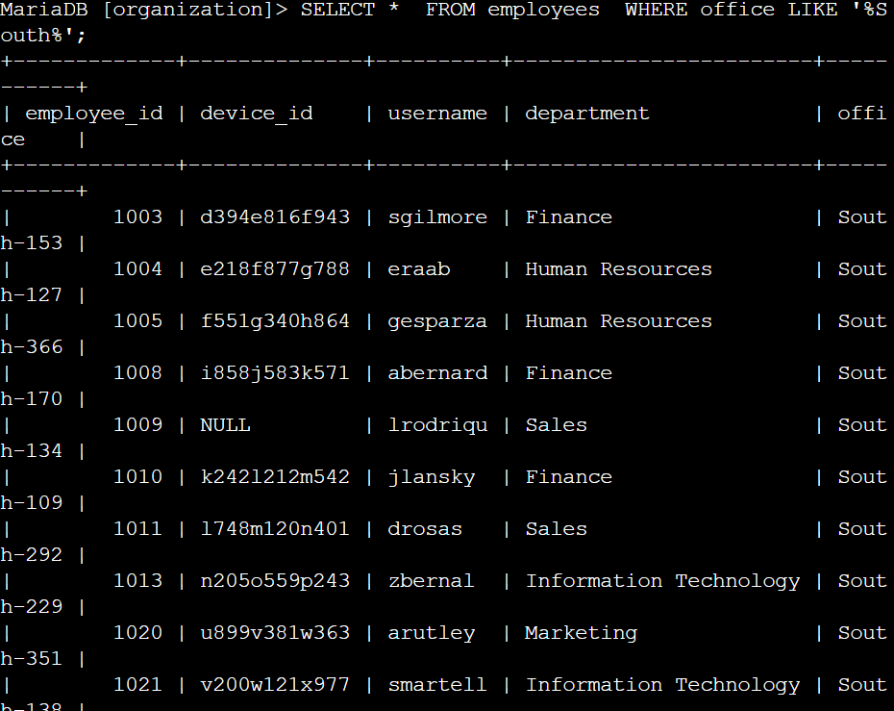

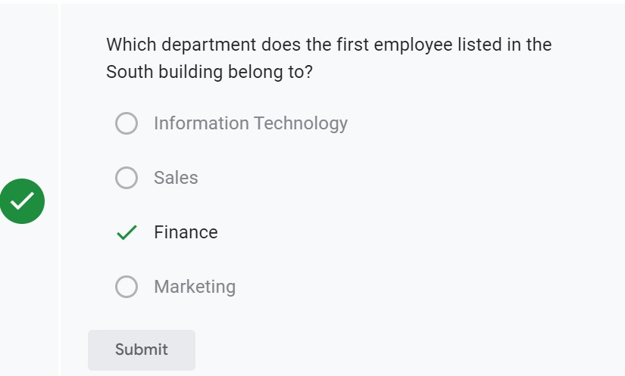

## **Conclusion**

I now have practical experience in using SQL to:

* apply the WHERE clause to filter what a SQL query returns and
* use the LIKE operator to filter for patterns.