**Activity: Find files with Linux commands**

**Overview:** These are essential skills. For example, when investigating unauthorized access, you might navigate to and then read a user access report.

In this lab activity, you’ll navigate a Linux file structure, locate files, and read the contents of files. You’ll also need to answer a few multiple-choice questions based on the information contained in these files.

As a security analyst, it’s key that you know how to navigate, manage, and analyze files remotely via a Linux shell without a graphical user interface.

**Scenario:** **First**, you’ll get the information of the current working directory you’re in and display the contents of the directory. **Second**, you’ll navigate to the reports directory and list the subdirectories it contains. **Third**, you’ll navigate to the users subdirectory and display the contents of the Q1_added_users.txt file. **Finally**, you’ll navigate to the logs directory and display the first 10 lines of a file it contains.

Start your lab : click on start lab to start the lab.

**Task 1. Get the current directory information**

1. Display your working directory.

$pwd

1. Display the names of the files and directories in the current working directory.

$ls

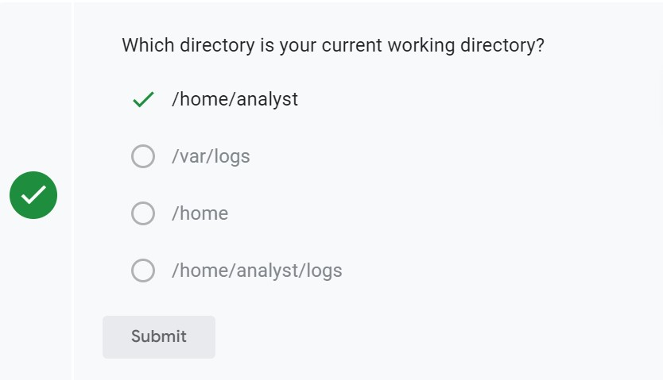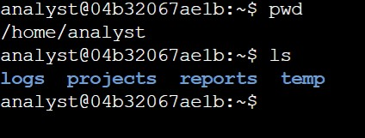

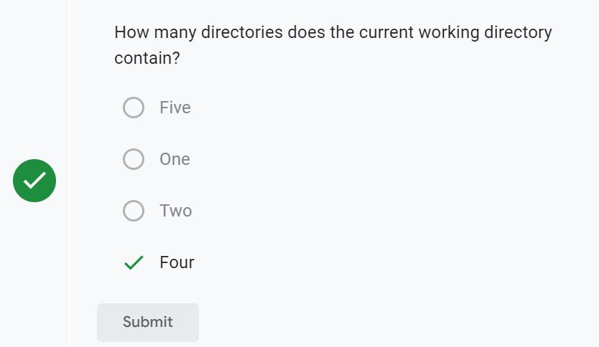

**Task 2. Change directory and list the subdirectories:**

In this task, you must navigate to a new directory and determine the subdirectories it contains.

1. Navigate to the /home/analyst/reports directory.

$ cd /home/analyst/reports

1. Display the files and subdirectories in the /home/analyst/reports directory.

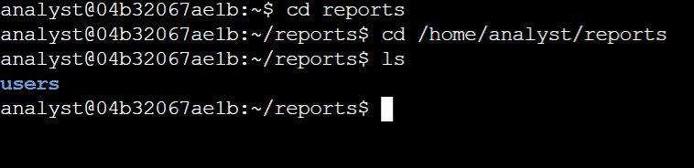$ls

**Task 3. Locate and read the contents of a file**

In this task, you must navigate to a subdirectory and read the contents of a file it contains.

1. Navigate to the /home/analyst/reports/users directory.

$cd /home/analyst/reports/users

1. List the files in the current directory.

$ls

1. Display the contents of the Q1_added_users.txt file.

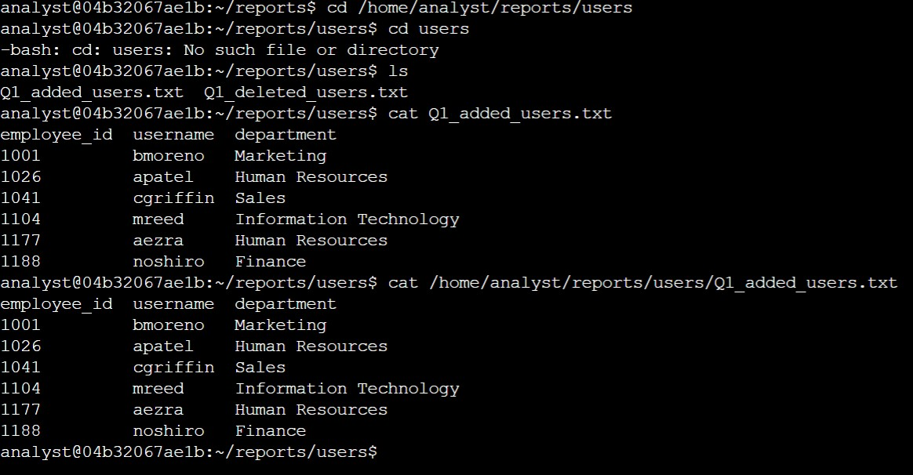$cat Q1_added_users.txt

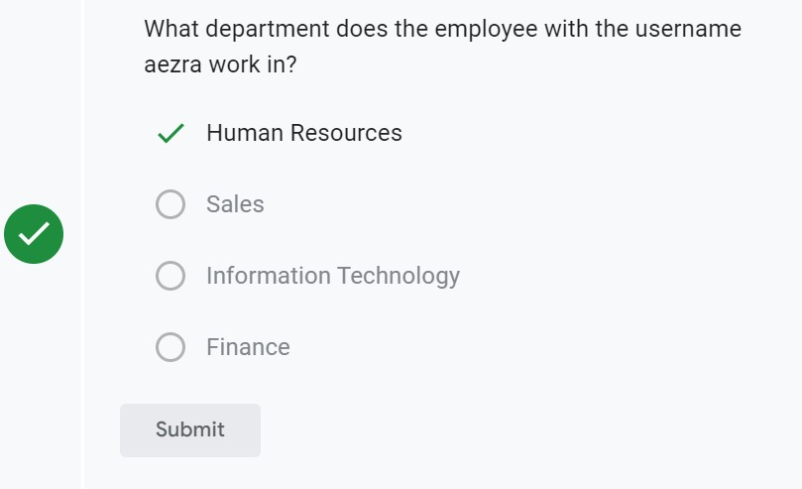

**Task 4. Navigate to a directory and locate a file**

In this task, you must navigate to a new directory, locate a file, and examine the contents of the file.

1. Navigate to the /home/analyst/logs directory.

$cd /home/analyst/logs

1. Display the name of the file it contains.

$ls

1. Display the first **10** lines of this file.

$head server_logs.txt

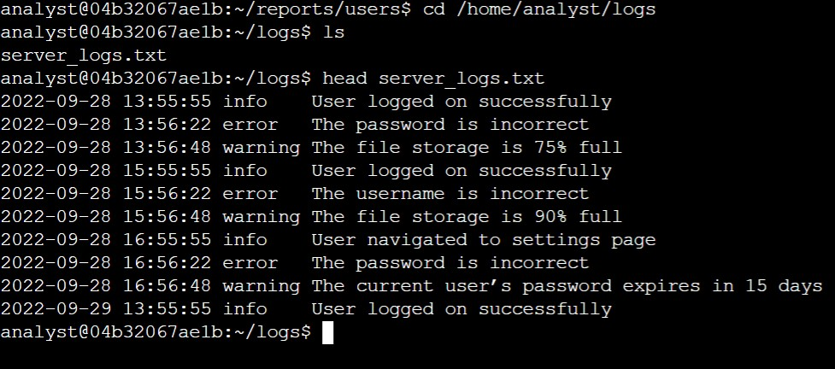

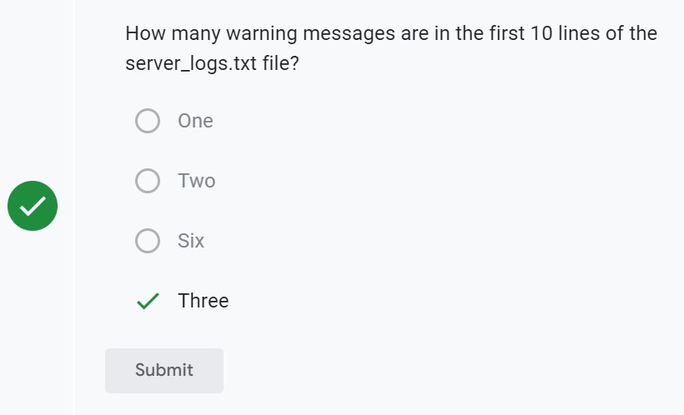

**CONCLUSION:** You now have practical experience in using basic Linux Bash shell commands.

* navigate directory structures with the cd command,
* display the current working directory with the pwd command,
* list the contents of a directory with the ls command, and
* display the contents of files with the cat and head commands.