# Activity: Get help in the command line

# Overview: As a security analyst, you won’t have all the answers all the time, but you can learn where to find them. One of the great things about Linux is that you can get help right through the command line.

# Scenario: **First**, you’ll explore a few commands you can use in the shell to learn more about other commands. **Next**, you’ll find an option you need to add to a command. **Third**, you’ll use a command to get a brief description of commands so you can identify their differences. **Finally**, you’ll identify the command you need to perform a task.

**Start your lab:** click on “start lab” to start the lab.

**Task 1. Learn more about commands**

In this task, you need to explore a few commands you can use in the shell to learn more about the functionality of other commands.

1. Run the whatis command to get a short description of cat.

**$whatis cat**

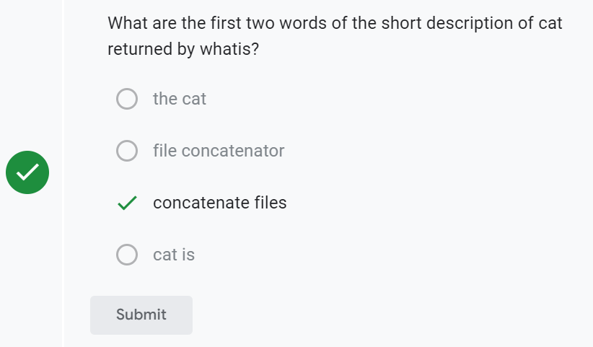

1. Use the man command to get more details about cat.

**$man cat**

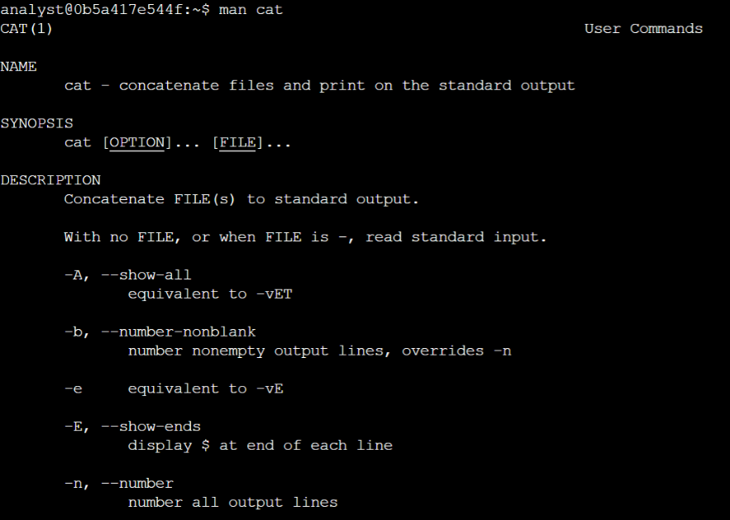

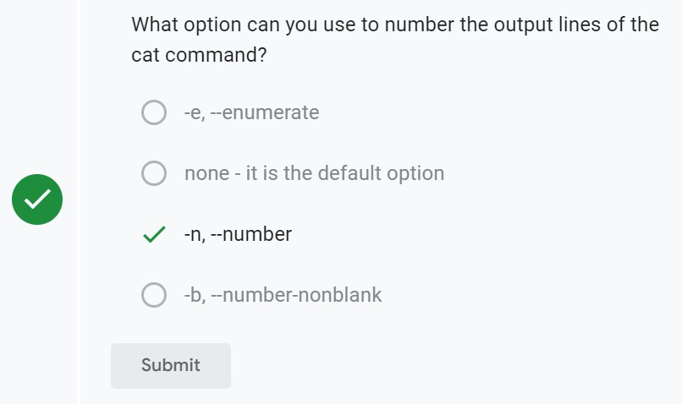

1. Press **Q** to exit this manual page.
2. Use apropos to find a command that returns the first part of a file:

**$ apropos -a first part file**

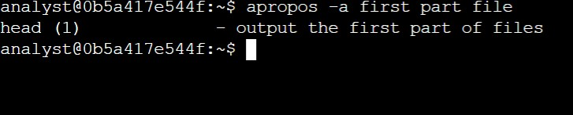

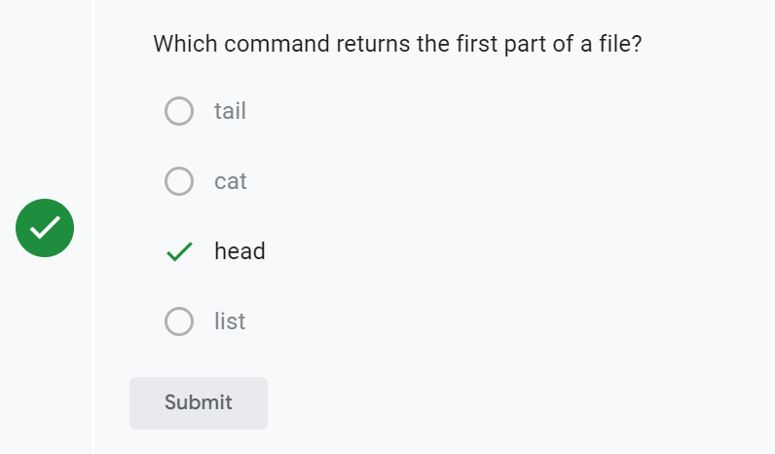

**Task 2: Explore the useradd command**

In this task, imagine that you want to set the expiration date for a temporary user account. You know that you need to use the useradd command for this, but you’re not quite sure how to complete the task. You realize it might involve adding an option to the command.

1. Use the most appropriate Linux command to get help on the useradd command and learn more about all of its options.

**$man useradd**

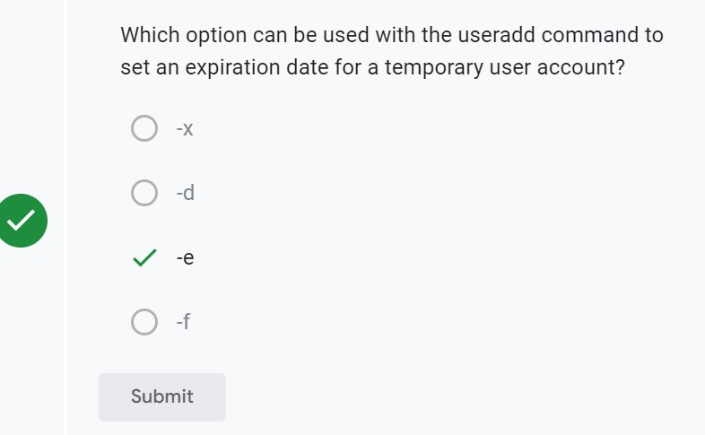

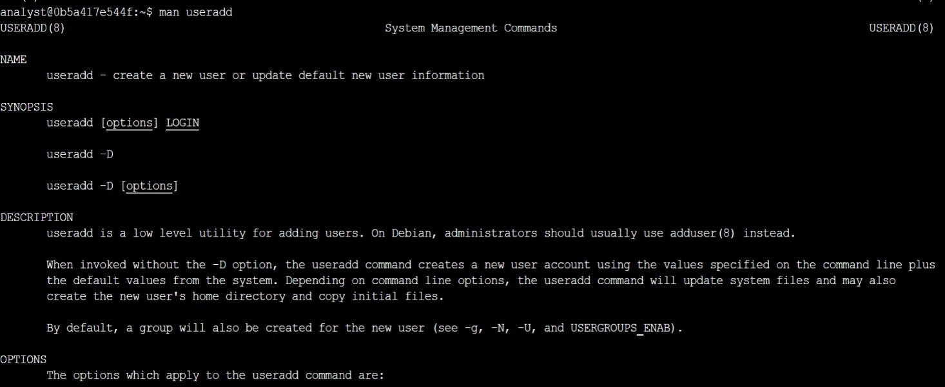

1. Press **Q** to exit this manual page.

**Task 3. Explore the rm and rmdir commands**

In this task, you need to determine the difference between the rm and rmdir commands.

1. Use the most appropriate Linux command to quickly remind yourself what each command does.

**$whatis rm**

**$whatis rmdir**

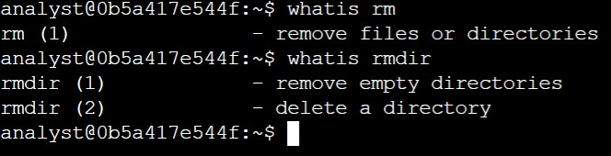

**Task 4: Determine which command to use**

In this task, imagine that you need to create a new group but you can’t remember what command to use. You need to identify a command that will do this by searching for it through keywords. In this case, use the keywords create new group.

1. 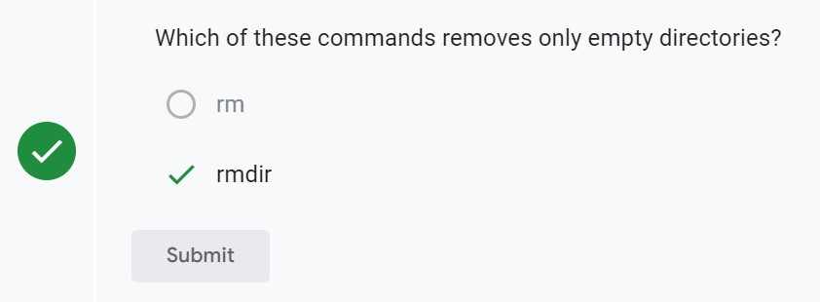Use the most appropriate Linux command with these keywords to identify what command to use.

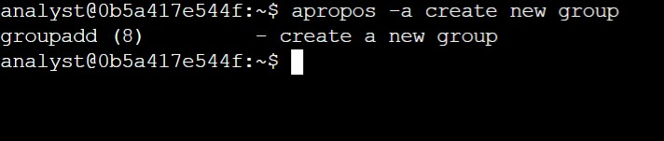**$apropos –a create new group**

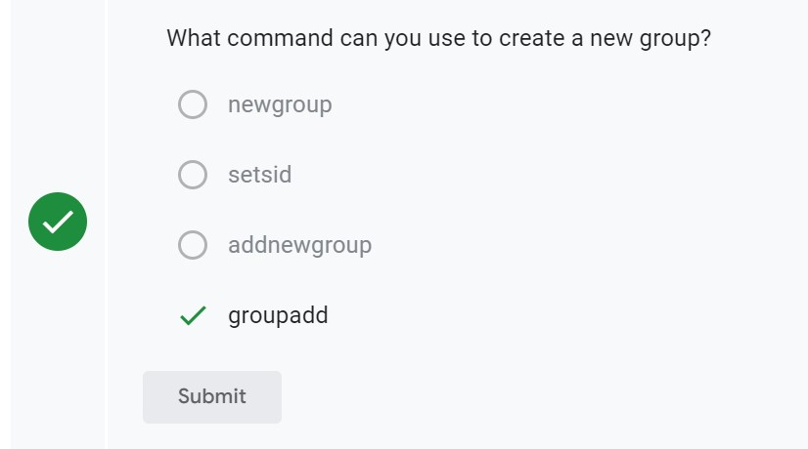

**Conclusion:**

You now have practical experience in using basic Linux Bash shell commands to

* get a short description of a command,
* display the man pages for a command, and
* find commands based on keywords about their function.