**Exemplar: Manage files with Linux commands**

As a security analyst, creating, removing, and editing directories and files are core tasks you’ll need to perform to help you to manage data. When data is well organized, you can more easily detect issues and keep data safe. With that in mind, you’re now ready to practice what you've learned.

**Scenario:** In this scenario, you need to ensure that the /home/analyst directory is properly organized. You have to make a few changes to the /home/analyst directory and the files it contains. You also have to edit a file to record the changes or updates you make to the directory.

When you start, the /home/analyst directory contains the following subdirectories and files:

home

└── analyst

├── notes

│   ├── Q3patches.txt

│   └── tempnotes.txt

├── reports

│   ├── Q1patches.txt

│   └── Q2patches.txt

└── temp

You need to modify the /home/analyst directory to the following directory and file structure:

home

└── analyst

├── logs

├── notes

│   └── tasks.txt

└── reports

   ├── Q1patches.txt

   └── Q2patches.txt

   └── Q3patches.txt

Here’s how you’ll do this: **First**, you’ll create a new subdirectory called logs in the /home/analyst directory. **Next**, you’ll remove the temp subdirectory. **Then**, you’ll move the Q3patches.txt file to the reports subdirectory and delete the tempnotes.txt file. **Finally**, you’ll create a new .txt file called tasks in the notes subdirectory and add a note to the file describing the tasks you've performed.

**Start your lab:** click on “start lab” to start the lab.

**Task 1. Create a new directory**

First, create a dedicated subdirectory called logs, which will be used to store all future log files.

1. Create a new subdirectory called logs in the /home/analyst directory.

$mkdir logs

1. List the contents of the /home/analyst directory to confirm that you’ve successfully created the new logs subdirectory.

$ls

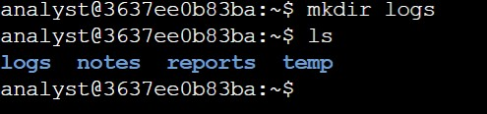

**Task 2. Remove a directory**

I remove the temp directory, as you’ll no longer be placing items in it.

1. Remove the /home/analyst/temp directory.

$rmdir temp

1. List the contents of the /home/analyst directory to confirm that you have removed the temp subdirectory.

$ls

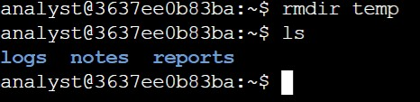

**Task 3. Move a file**

The Q3patches.txt file contains notes taken on third-quarter patches and is now in the correct reporting format. You must move the  Q3patches.txt file from the notes directory to the reports directory.

1. Navigate to the /home/analyst/notes directory.

$cd /home/analyst/notes

$cd notes

1. Move the Q3patches.txt file from the /home/analyst/notes directory to the /home/analyst/reports directory.

$mv Q3patches.txt /home/analyst/reports/

1. List the contents of the /home/analyst/reports directory to confirm that you have moved the file successfully.

$ls /home/analyst/reports

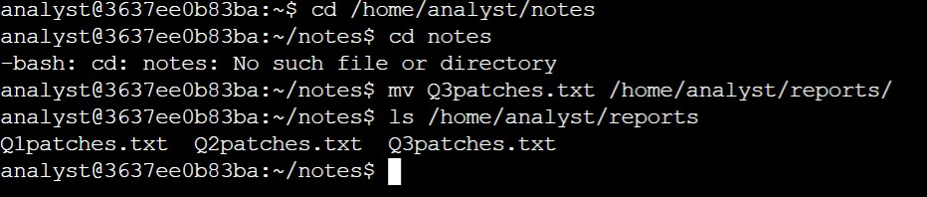

**Task 4. Remove a file**

I deleted an unused file called tempnotes.txt from the /home/analyst/notes directory.

1. Remove the tempnotes.txt file from the /home/analyst/notes directory.

$rm tempnotes.txt

1. List the contents of the /home/analyst/notes directory to confirm that you’ve removed the file successfully.

$ls

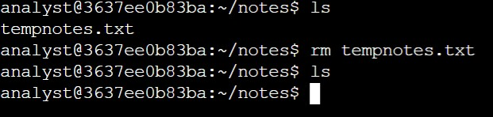

**Task 5. Create a new file**

I  created a file named tasks.txt in the /home/analyst/notes directory that you’ll use to document completed tasks.

1. Use the touch command to create an empty file called tasks.txt in the /home/analyst/notes directory.

$touch tasks.txt

1. List the contents of the /home/analyst/notes directory to confirm that you have created a new file.

$ls

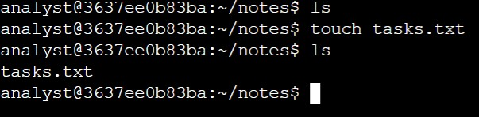

**Task 6. Edit a file**

Finally, I use the nano text editor to edit the tasks.txt file and add a note describing the tasks you’ve completed.

1. Using the nano text editor, open the tasks.txt file that is located in the /home/analyst/notes directory.

$nano tasks.txt

1. Copy and paste the following text into the text input area of the nano editor:

$ Completed tasks

1. Managed file structure in /home/analyst
2. Press **CTRL+X** to exit the nano text editor.
3. Press **Y** to confirm that you want to save the new data to your file.
4. Press **ENTER** to confirm that **File Name to Write** is tasks.txt.
5. Use the clear command to clear the Bash shell window and remove any traces of the nano text input area.

$clear

1. Display the contents of the tasks.txt file to confirm that it contains the updated task details.

$cat tasks.txt

