**Activity: Perform a SQL query**

**Overview:** In this lab activity, you’ll use SELECT and FROM in SQL to return the information you need from a database. You’ll also use the ORDER BY keyword to sequence the information returned by a query based on a specified column.

**Scenario:** In this scenario, you have to determine which employee devices must be updated. You also need to investigate user login activity to explore if any unusual activity has occurred. **First**, you’ll obtain information on the employee devices that must be updated. **Next**, you’ll examine the login attempts for unusual activity. **Finally**, you’ll use the ORDER BY keyword to sort the data returned by your SQL queries.

**Start your lab:** click on “start lab” to start the lab.

**Task 1. Retrieve employee device data**

In this task, you need to obtain information on employee devices because your team needs to update them. The information you need is in the machines table in the organization database.

1. Run the following query to select all device information from the machines table:

**$SELECT * FROM machines;**

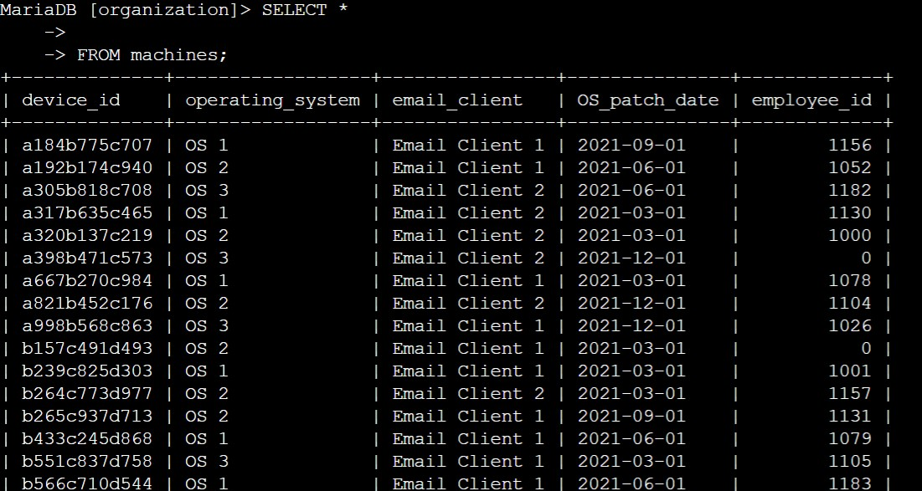

1. Run the following query to select onlythe device_id and email_client columns from the machines table.

**$ SELECT device_id, email_client FROM machines;**

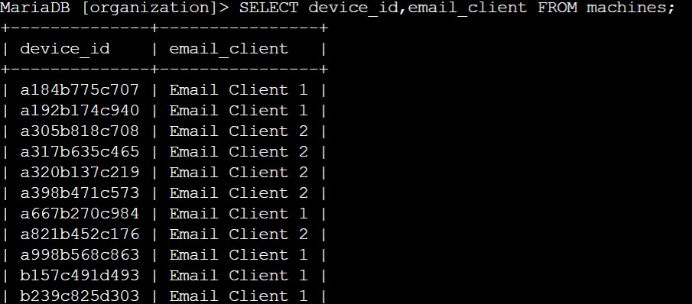

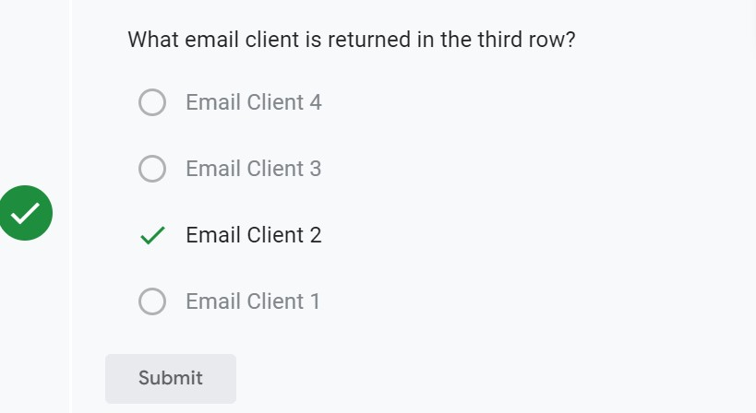

1. Complete the query to return only the device_id, operating_system, and OS_patch_date columns from the machines table.

**$SELECT device_id, operating_system, OS_patch_date FROM machines;**

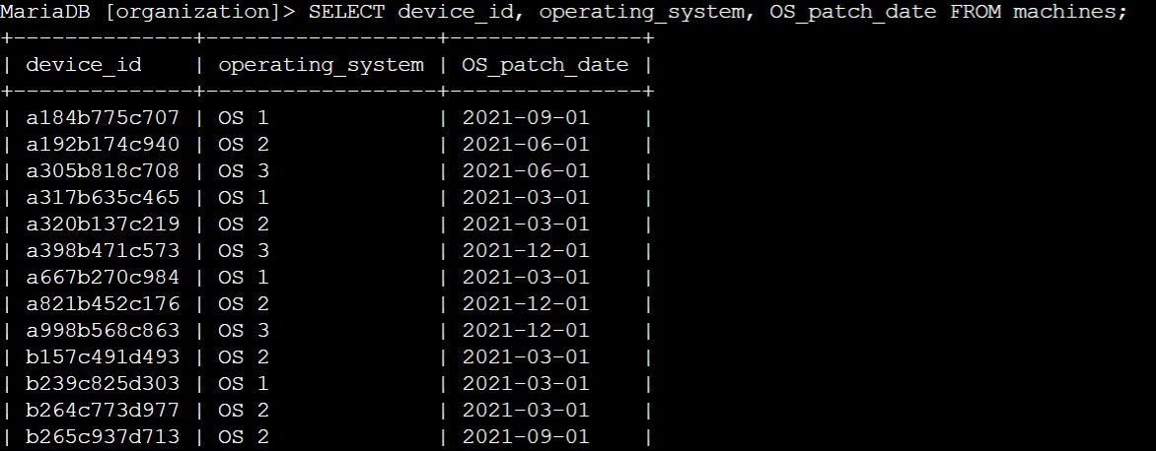

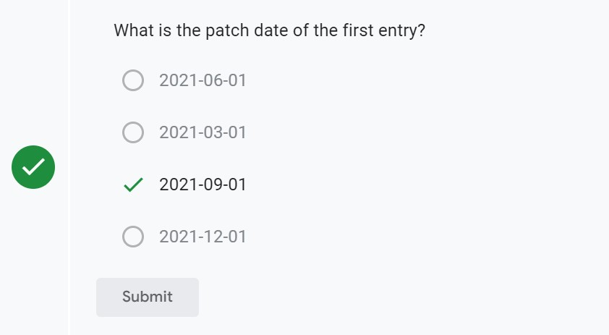

**Task 2. Investigate login activity**

In this task, you need to analyze the information from the log_in_attempts table to determine if any unusual activity has occurred.

1. Write a SQL query to select the event_id and country columns from the log_in_attempts table.

**$SELECT events_id, country FROM log_in_attempts;**

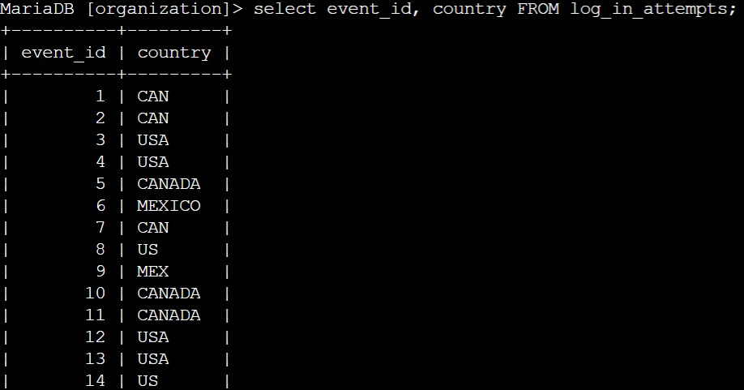

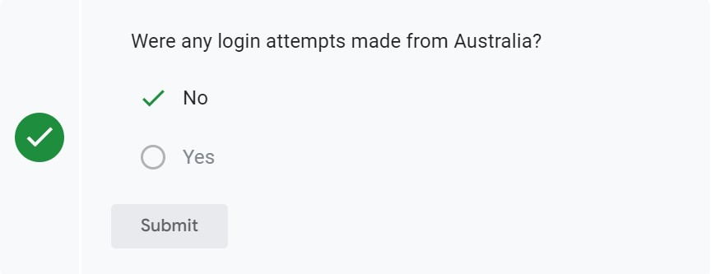

1. Write a SQL query that selects the username, login_date, and login_time columns from the log_in_attempts table.

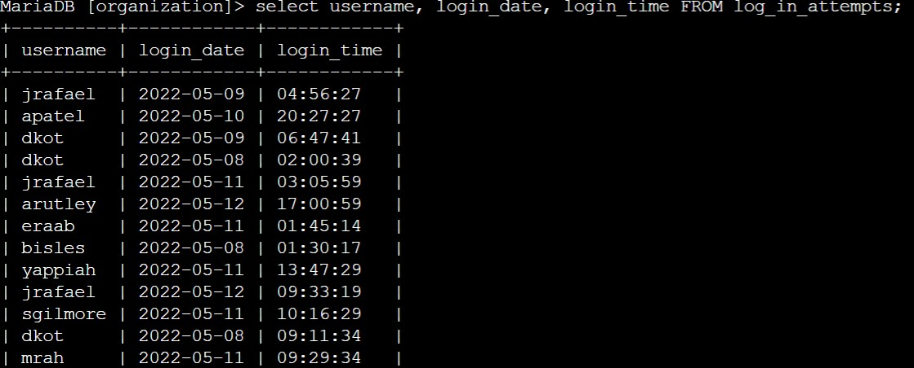**$SELECT username, login_date, login_time** FROM log_in_attempts;

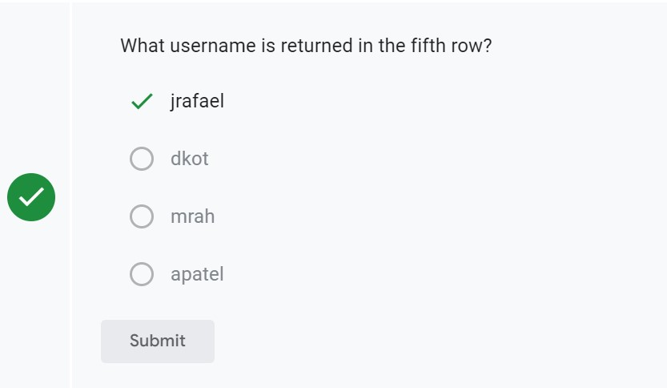

1. Write a SQL query that selects all columns from the log_in_attempts table, using a single symbol after the SELECT keyword.

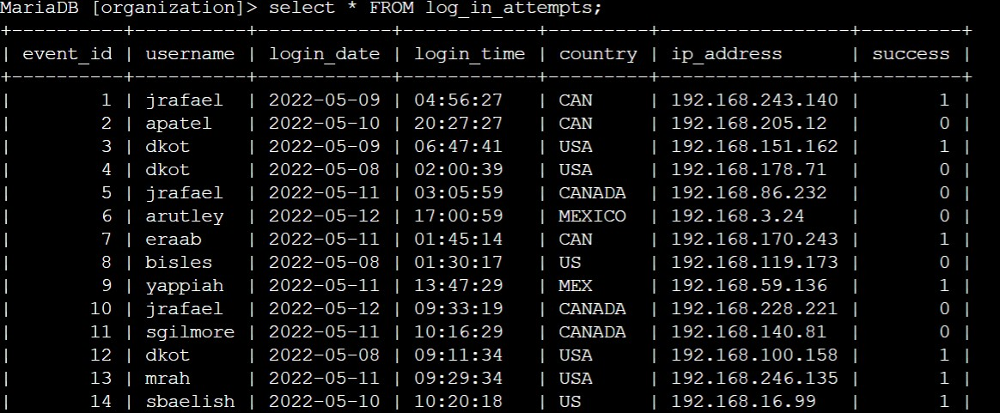**$SELECT * FROM log_in_attempts;**

## **Task 3. Order login attempts data**

In this task, you need to use the ORDER BY keyword. You'll sequence the data that your query returns according to the login date and time.

1. Run the following query, which orders log_in_attempts data by login_date:

**$SELECT * FROM log_in_attempts ORDER BY login_date;**

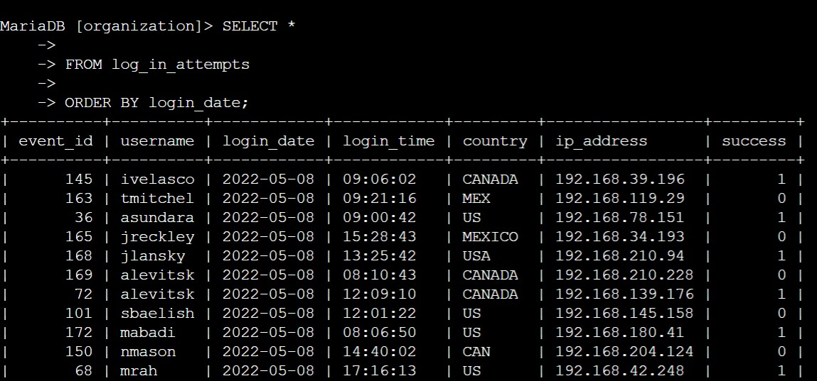

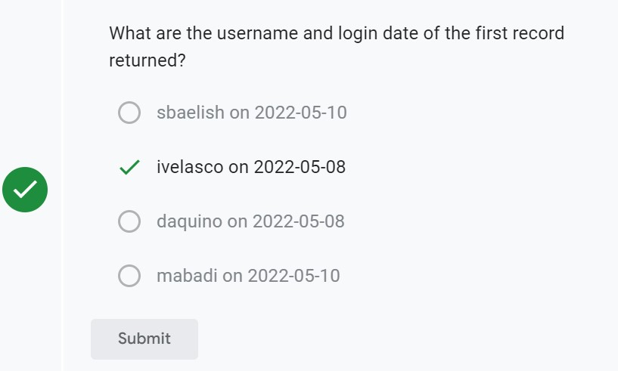

1. Modify the query from the previous step by adding the login time to the ORDER BY clause. You must replace X with the appropriate column name:

**$ SELECT * FROM log_in_attempts ORDER BY login_date, login_time;**

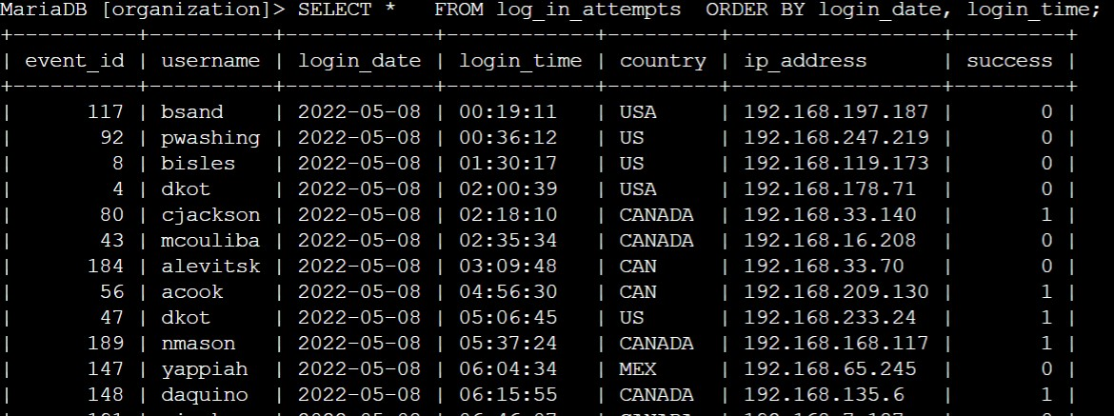

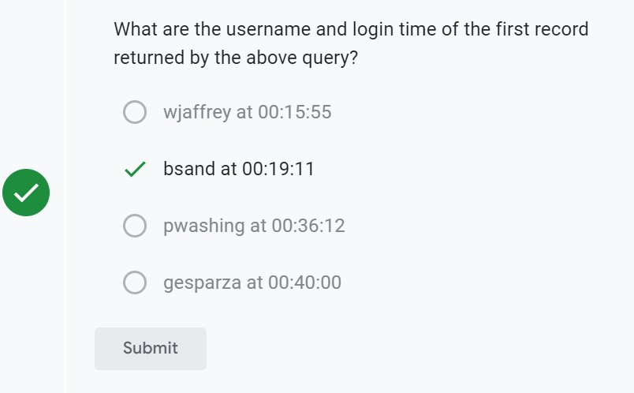

**Conclusion:**

I have completed this activity, and I now have practical experience in running basic SQL queries to

* select specific columns from a table,
* select all columns from a table by using an asterisk (*), and
* sort query results using the ORDER BY keyword.