**Activity: Examine input/output in the Linux shell**

In this lab activity, you’ll use the echo command to examine how input is received and how output is returned in the shell. Next, you’ll use the expr command to further explore input and output while performing some basic calculations in the shell.

**SCENERIO:** Here’s how you’ll do this: **First**, you’ll use the echo command to generate some output in the shell. **Second**, you’ll use the expr command to perform basic mathematical calculations. **Next**, you’ll use the clear command to clear the Bash shell window. **Finally**, you’ll have an opportunity to explore the echo and expr commands further.

**Start your lab:**

click **Start Lab**. This brings up the terminal so that you can begin completing the tasks! When you have completed all the tasks, refer to the **End your Lab** section that follows the tasks for information on how to end your lab.

**Task 1. Generate output with the echo command**

The echo command in the Bash shell outputs a specified string of text. In this task, you’ll use the echo command to generate output in the Bash shell.

1. Type echo hello into the shell and press **ENTER**.

$echo hello

1. Rerun the command, but include quotation marks around the string data.

$echo "hello"

1. Use the echo command to output your name to the shell.

$echo "hacker"

**SCREENSHOTS:**

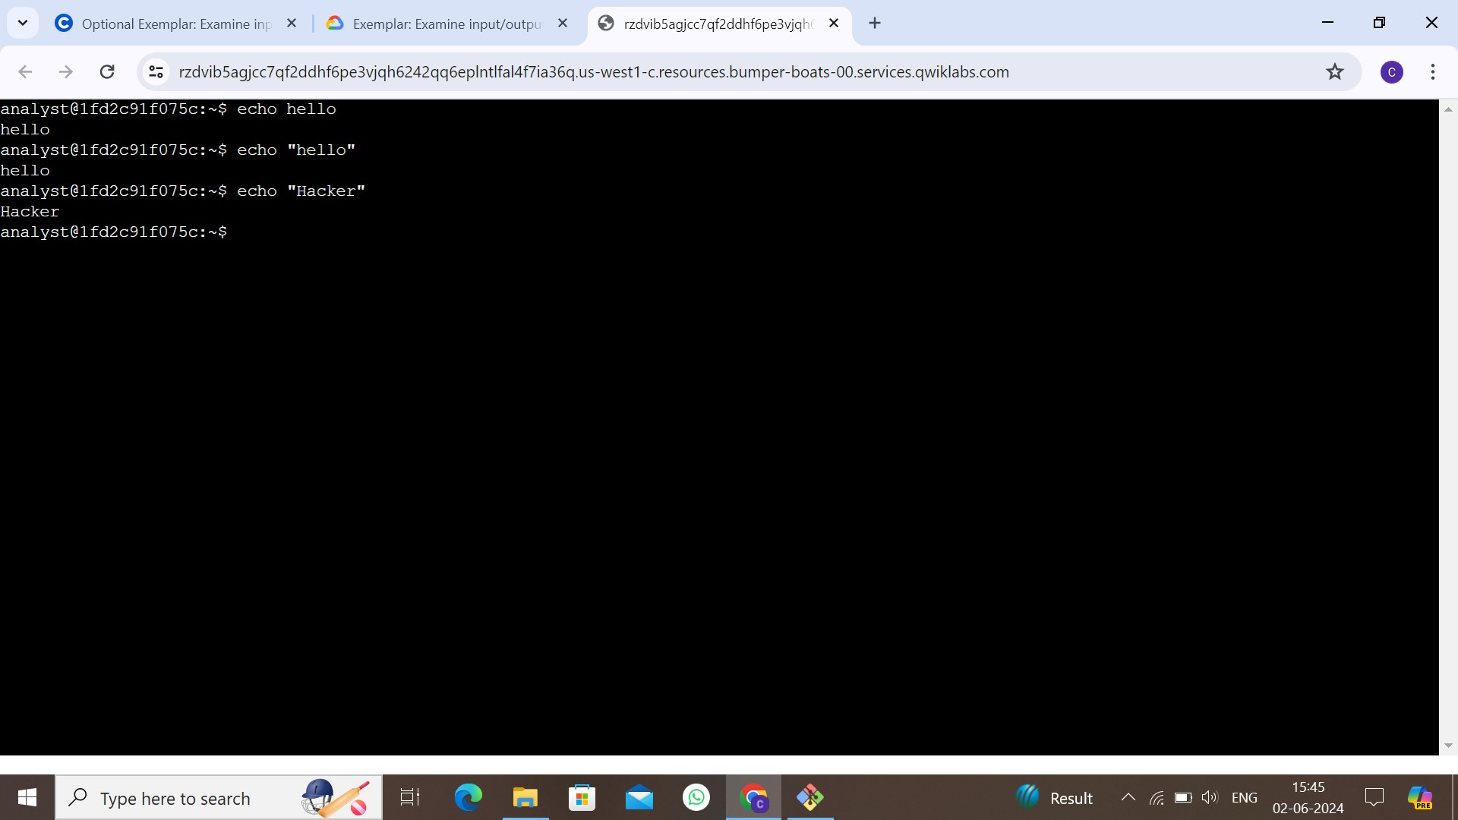

## **Task 2. Generate output with the expr command**

In this task, you’ll use the expr command to generate some additional output in the Bash shell. The expr command performs basic mathematical calculations and can be useful when you need to quickly perform a calculation.

1. Calculate the number of false positives using the expr command.

$expr 32 – 8

NOTE: you need to calculate the average number of login attempts that are expected over the course of a year. From the information you have, you know that an average of 3500 login attempts have been made each month so far this year.

1. Type expr 3500 * 12 into the shell and press **ENTER**.

$expr 3500 * 12

**SCREENSHOTS:**

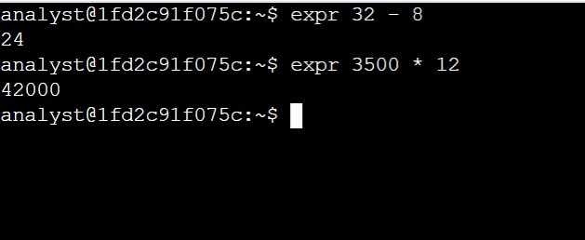

**Task 3. Clear the Bash shell:**

In this task, you’ll use the clear command to clear the Bash shell of all existing output. This allows you to start with the cursor at the top of the Bash shell window.

Type clear into the shell and press **ENTER**.

$clear

**SCREENSHOTS:**

