**Tier 0 – FAWN**

To attack on the target machine, we must be on the same network. So I connected the starting point VPN using OpenVPN. Run the following command to connect to OpenVPN:

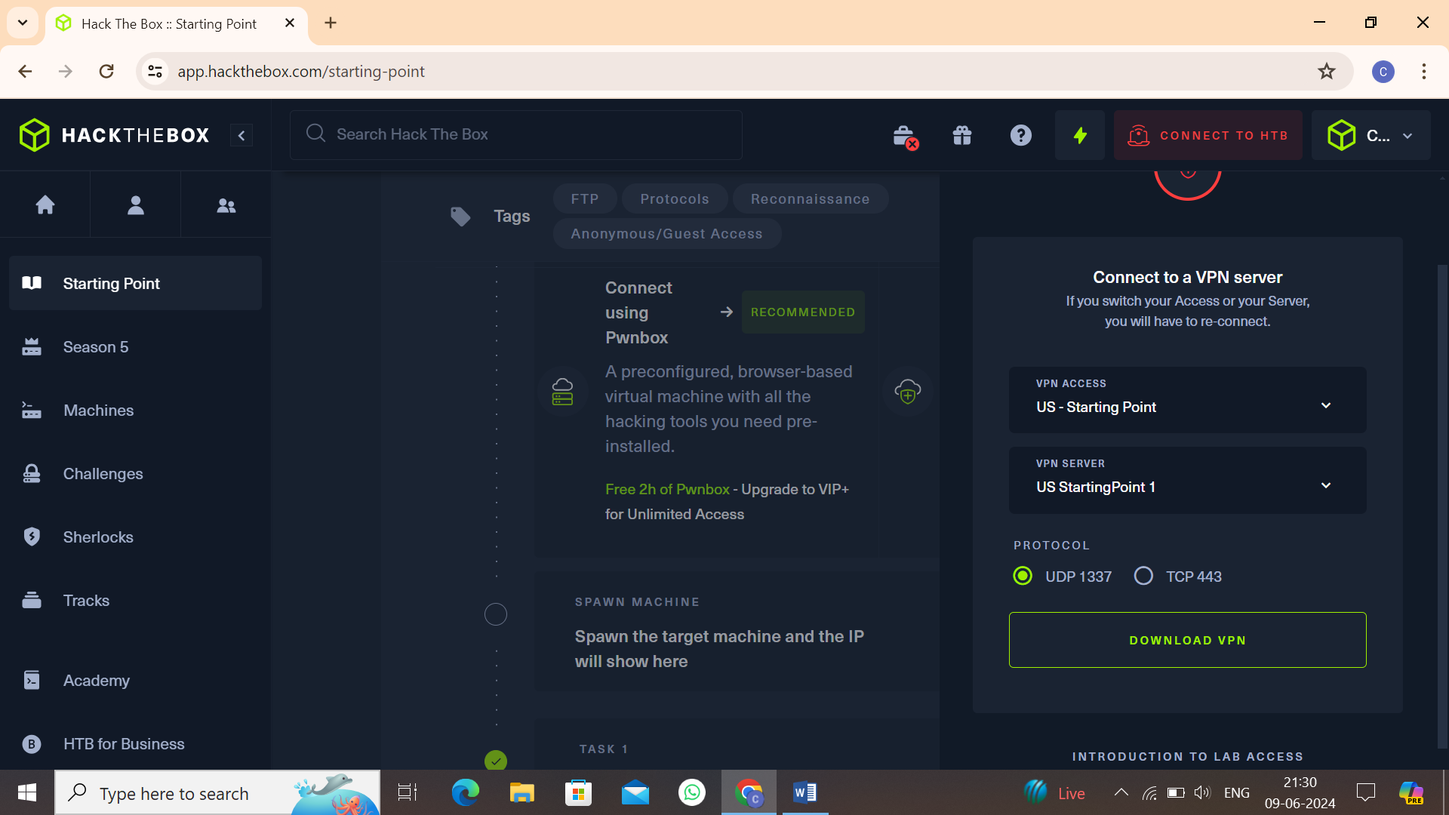

* Click on **“Download VPN”**. Then the file is downloaded into your computer.
* Go to terminal and navigate to the file.

**$cd /home/downloads/**

* Commend:  
  **$openvpn starting_point_ChaithanyaM4**

Here we are successfully connected to target network.

**NOTE:** Don’t close this terminal, use another terminal to pwned the target machines.

Click on **“spawn machine”**, it will display the IP address of target machine.

Check whether the target machine is up or not. Run the following command to check target machine :

**$ping 10.129.22.178**

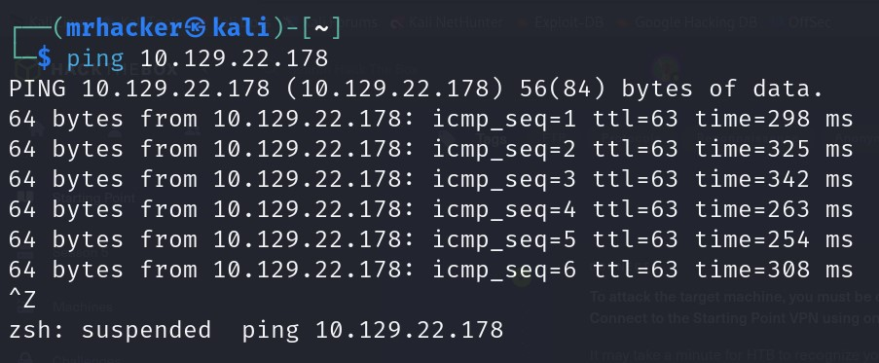

**Completing the tasks:**

* **Task 1:** What does the 3-letter acronym FTP stand for?

File Transfer Protocol

* **Task 2:** Which port does the FTP service listen on?

21

* **Task 3:** What acronym is used for the secure version of FTP?

SFTP

* **Task 4:** What is the command we can use to send an icmp echo request to test our connection to the target?

Ping

* **Task 5:** From your scans, what version is FTP running on the target?

Vsftpd 3.0.3

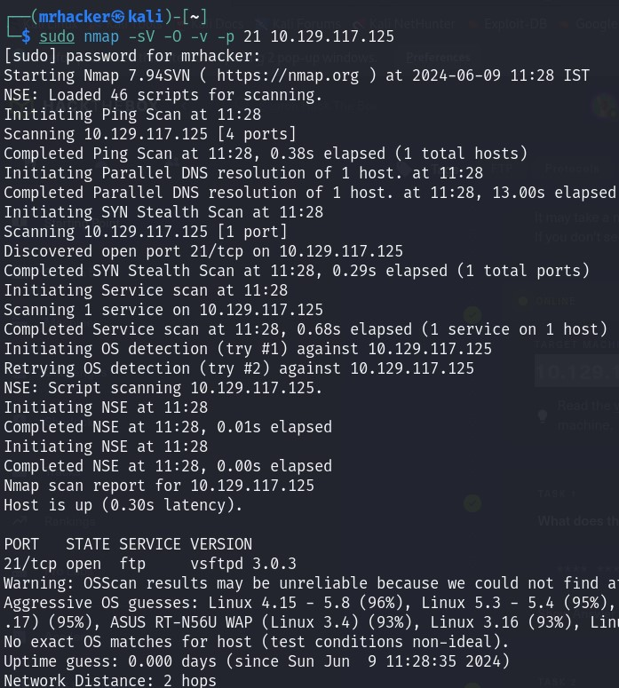We do an nmap scan to find more information about the open port in target machine:

* **Task 6:** From your scan what type of OS running on the target?

Unix

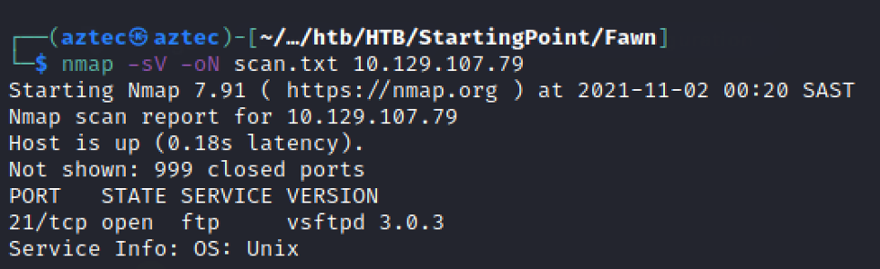

* **Task 7:** What is the command we need to run in order to display the ‘ftp’ client help menu?

ftp –h

* **Task 8:** What is the username that is used over FTP when you want to login without having an accout?

Anonymous

We use following command and given enter for the passwor:

**$ ftp anonymous@10.129.22.178**

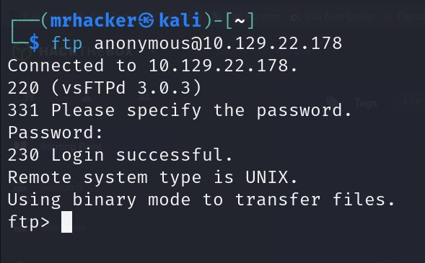

* **Task 9:** What is the response code we got for the FTP message “Login successful”?

230

* **Task 10:** There are couples of commands we use to list the files and directories available on FTP server. One is dir. What is other that is a common way to list the files on linux command?

ls

* **Task 11:** What is the command used to download the file we found on the ftp server?

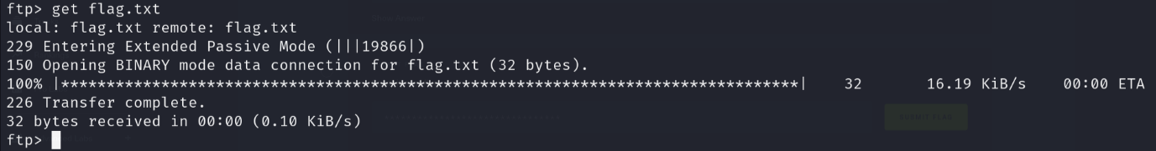Get

The flag.txt file was downloaded into our working directory.

**Submit the flag:**

Run the following command to display flag.txt file downloaded into current working directory. Display the flag present in flag.txt file.

**$ls**

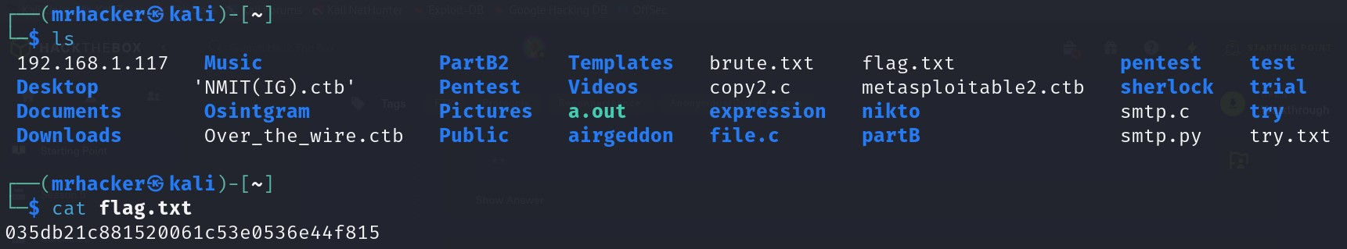**$cat flag.txt**

After submitting flag, the machine was pwned!!.