**Tier 0 – REDEEMER**



To attack on the target machine, we must be on the same network. So I connected the starting point VPN using OpenVPN. Run the following command to connect to OpenVPN:

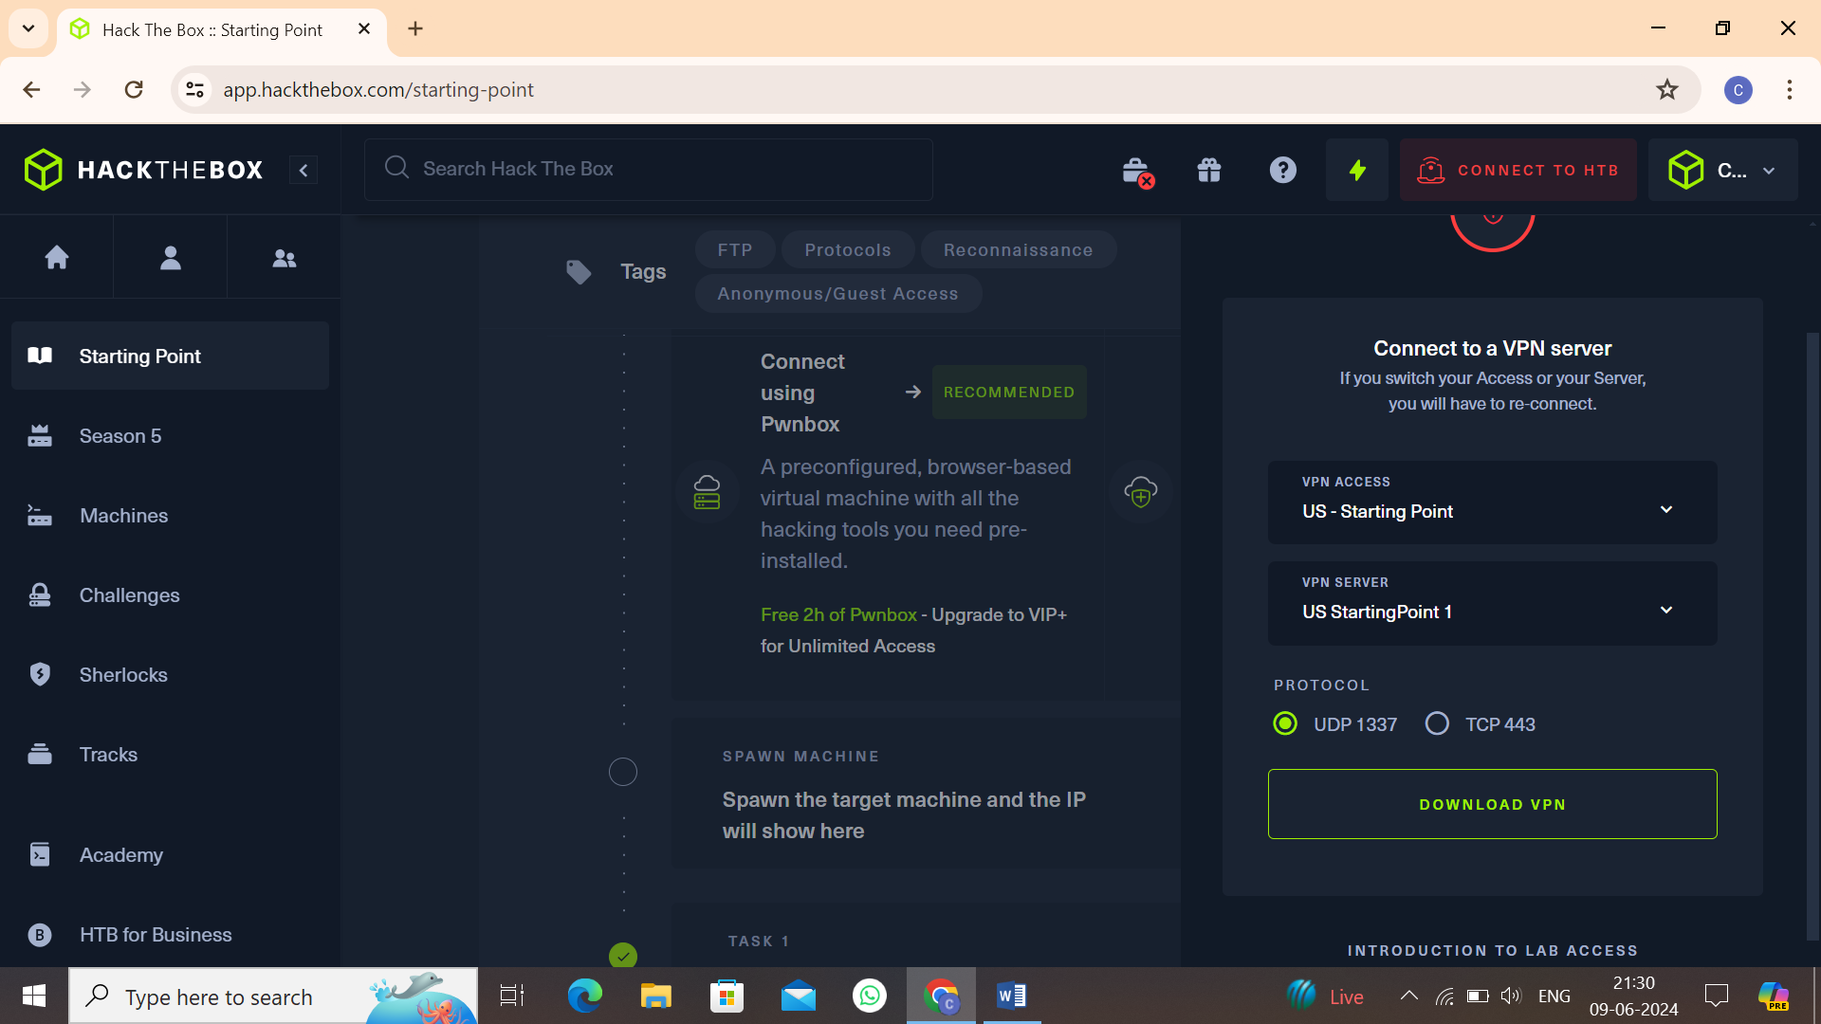

* Click on **“Download VPN”**. Then the file is downloaded into your computer.
* Go to terminal and navigate to the file.

**$cd /home/downloads/**

* Commend:  
  **$openvpn starting_point_ChaithanyaM4**
* Here we are successfully connected to target network

**NOTE:** Don’t close this terminal, use another terminal to pwned the target machines.

Click on **“spawn machine”**, it will display the IP address of target machine.

Check whether the target machine is up or not. Run the following command to check target machine :

**$ping 10.129.147.73**

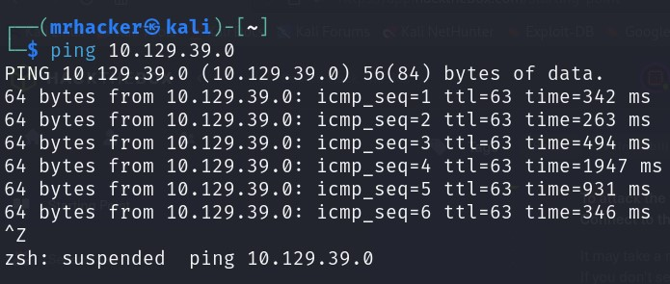

* **Task 1:** Which TCP port is open on the machine?

6379

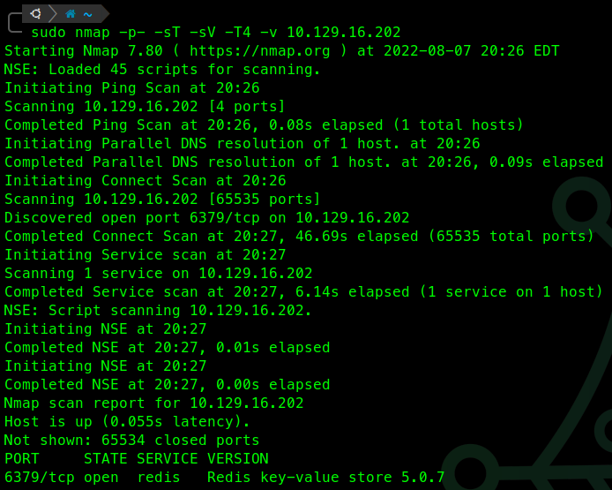

#### **Task 2:** Which service is running on the port that is open on the machine?

Redis

#### **Task 3:** What type of database is Redis? Choose from the following options: (i) In-memory Database, (ii) Traditional Database

in-memory Database

#### **Task 4:** Which command-line utility is used to interact with the Redis server? Enter the program name you would enter into the terminal without any arguments.

redis-cli

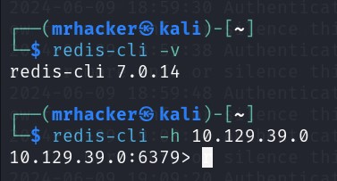

Firstly we check for the whether radis is installed or not. If installed, we run the following command to check its version:

**$redis-cli –v**

Run the following command to connect to the target machine through radis:

**$redis-cli –h 10.129.39.0**

#### **Task 6:** Which flag is used with the Redis command-line utility to specify the hostname?

*-*h

#### **Task 7:** Once connected to a Redis server, which command is used to obtain the information and statistics about the Redis server?

info

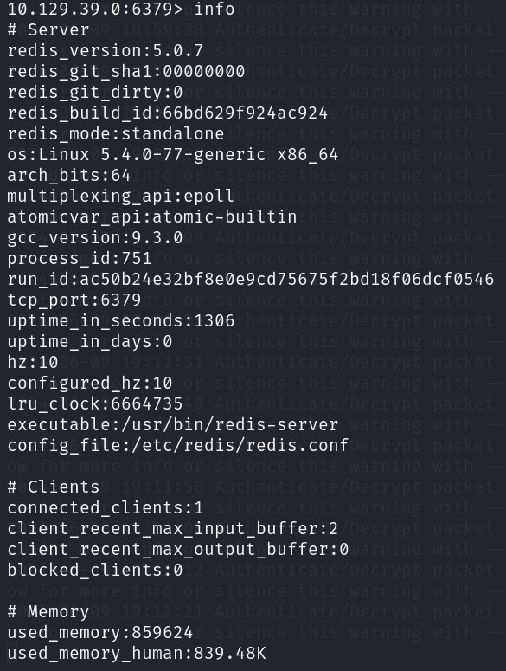

#### **Task 7:** What is the version of the Redis server being used on the target machine?

5.0.7

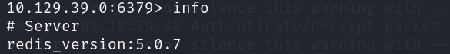

#### **Task 8:** Which command is used to select the desired database in Redis?

select

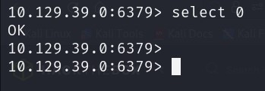

#### **Task 9:** How many keys are present inside the database with index 0?

4

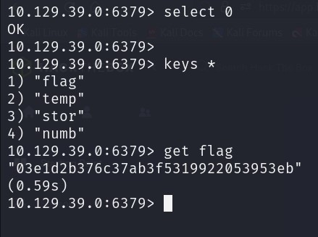

#### **Task 10:** Which command is used to obtain all the keys in a database?

keys *

#### **Submit root flag**

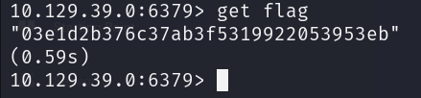

Use “get” command to print the flag.

**Finally the radeemer is pwned!!**

