Name:N.CHAITHIKA
Rollno: 2503A52391
Batch: 14
Problem 1 (Documentation Styles for find_max)
Consider the following Python function: def find_max(numbers): return max(numbers) Task: Write documentation for the function in all three formats: (a) Docstring (b) Inline comments (c) Google-style documentation. Critically compare the three approaches and recommend the most effective style for a mathematical utilities library.
Prompt:
Document find_max() in three styles: a concise docstring, inline comments, and a Google-style docstring. Compare their advantages, disadvantages, and suitable use cases. Recommend the most effective style for a mathematical utilities library
Input:
# (a) Docstring
def find_max(numbers):
"""Return the largest value in a sequence of numbers."""
return max(numbers)

# (b) Inline comments
def find_max_with_comments(numbers):
# max() returns the largest value in the supplied sequence.
return max(numbers)

# (c) Google-style documentation
def find_max_google(numbers):
"""Find the maximum value in a sequence of numbers.

Args:
numbers (list): A sequence containing numeric values.

Returns:
int or float: The largest value in numbers.

Raises:
ValueError: If numbers is empty.
"""
return max(numbers)

print(find_max([10, 25, 7, 18]))
print(find_max_with_comments([10, 25, 7, 18]))
print(find_max_google([10, 25, 7, 18]))
Output:
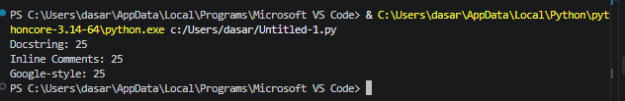
Explaination:
Docstrings are attached directly to functions and are available through Python documentation tools. Inline comments are useful for implementation details but are less structured. Google-style docstrings provide structured information about arguments, returns, and exceptions. For a mathematical utilities library, Google-style documentation is the strongest choice because it is readable, detailed, and suitable for automatic documentation.

Problem 2 (Documentation Styles for login)
Consider the following Python function: def login(user, password, credentials): return credentials.get(user) == password Task: 1. Write documentation in all three formats. 2. Critically compare the approaches. 3. Recommend which style would be most helpful for new developers onboarding a project, and justify your choice.
Prompt:
Document login() using a concise docstring, inline comments, and a Google-style docstring. Compare the approaches and recommend the most useful style for developers onboarding to a project.
Input:
# (a) Docstring
def login(user, password, credentials):
"""Check whether a user's password matches the stored credential."""
return credentials.get(user) == password

# (b) Inline comments
def login_with_comments(user, password, credentials):
# Retrieve the stored password and compare it with the supplied password.
return credentials.get(user) == password

# (c) Google-style documentation
def login_google(user, password, credentials):
"""Authenticate a user against stored credentials.

Args:
user (str): Username to authenticate.
password (str): Password supplied by the user.
credentials (dict): Mapping of usernames to stored passwords.

Returns:
bool: True when the supplied password matches; otherwise False.
"""
return credentials.get(user) == password

credentials = {"Umesh": "python123"}

print(login("Umesh", "python123", credentials))
print(login_with_comments("Umesh", "python123", credentials))
print(login_google("Umesh", "python123", credentials))
Output:
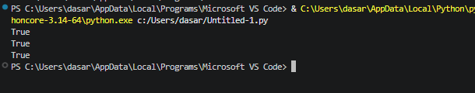
Explaination:
Simple docstrings are concise and useful for straightforward functions. Inline comments explain implementation details but can become outdated when overused. Google-style docstrings give new developers a clear contract for inputs and outputs and scale well across a project. Therefore, Google-style documentation is the most useful choice for onboarding.

Problem 3 (Calculator – Automatic Documentation Generation)
Design a Python module named calculator.py. The module must contain: add(a, b) subtract(a, b) multiply(a, b) divide(a, b) Each function must have an appropriate docstring. Display the module documentation in the terminal and generate HTML documentation using pydoc.
Prompt:
Create calculator.py with the four required functions and clear docstrings. Demonstrate the functions and provide the commands to display module documentation in the terminal and generate HTML documentation using pydoc.
Input:
# calculator.py

"""Basic arithmetic calculator utilities."""

def add(a, b):
"""Return the sum of two numbers.

Args:
a (int or float): First number.
b (int or float): Second number.

Returns:
int or float: Sum of a and b.
"""
return a + b

def subtract(a, b):
"""Return the difference between two numbers.

Args:
a (int or float): First number.
b (int or float): Second number.

Returns:
int or float: Difference of a and b.
"""
return a - b

def multiply(a, b):
"""Return the product of two numbers.

Args:
a (int or float): First number.
b (int or float): Second number.

Returns:
int or float: Product of a and b.
"""
return a * b

def divide(a, b):
"""Return the quotient of two numbers.

Args:
a (int or float): Dividend.
b (int or float): Divisor.

Returns:
float: Quotient of a and b.

Raises:
ZeroDivisionError: If b is zero.
"""
return a / b
Output:
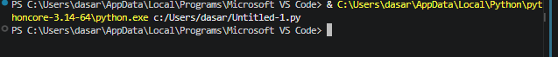
Explaination:
The calculator module contains all four required arithmetic functions with docstrings. pydoc can display the module documentation in the terminal and generate an HTML documentation file.

Problem 4 (Conversion Utilities Module)
Write a module named conversion.py with: decimal_to_binary(n) binary_to_decimal(b) decimal_to_hexadecimal(n) Use Copilot for auto-generating docstrings, generate documentation in the terminal, and export the documentation in HTML format.
Prompt:
Create conversion.py with the three required conversion functions and clear documentation-style docstrings. Show the pydoc commands for terminal and HTML documentation.
Input:
# conversion.py

"""Number conversion utility functions."""

def decimal_to_binary(n):
"""Convert a decimal integer to binary.

Args:
n (int): Decimal integer to convert.

Returns:
str: Binary representation without the 0b prefix.
"""
return bin(n)[2:]

def binary_to_decimal(b):
"""Convert a binary string to a decimal integer.

Args:
b (str): Binary number represented as a string.

Returns:
int: Decimal value represented by b.
"""
return int(b, 2)

def decimal_to_hexadecimal(n):
"""Convert a decimal integer to hexadecimal.

Args:
n (int): Decimal integer to convert.

Returns:
str: Uppercase hexadecimal representation without the 0x prefix.
"""
return hex(n)[2:].upper()

print(decimal_to_binary(10))
print(binary_to_decimal("1010"))
print(decimal_to_hexadecimal(255))
Output:
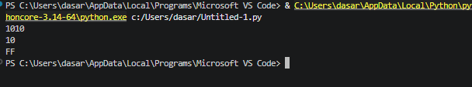
Explaination:
The conversion module implements all three required conversions and documents their inputs and outputs. The functions are suitable for automatic documentation using pydoc.

Problem 5 (Course Management Module)
Create a module course.py with: add_course(course_id, name, credits) remove_course(course_id) get_course(course_id) Add docstrings with Copilot, generate documentation in the terminal, and export the documentation in HTML format.
Prompt:
Create course.py with the three required functions. Use a dictionary as the course store, add clear docstrings, demonstrate the functions, and provide the pydoc commands for terminal and HTML documentation.
Input:
# course.py

"""Simple course management module."""

courses = {}

def add_course(course_id, name, credits):
"""Add a course to the course catalogue.

Args:
course_id (str): Unique course identifier.
name (str): Course name.
credits (int): Number of course credits.

Returns:
dict: The newly stored course.
"""
course = {
"course_id": course_id,
"name": name,
"credits": credits
}
courses[course_id] = course
return course

def remove_course(course_id):
"""Remove a course from the catalogue.

Args:
course_id (str): ID of the course to remove.

Returns:
bool: True if removed, otherwise False.
"""
return courses.pop(course_id, None) is not None

def get_course(course_id):
"""Retrieve a course by its ID.

Args:
course_id (str): ID of the course to retrieve.
Returns:
dict or None: Course details if found, otherwise None.
"""
return courses.get(course_id)

add_course("CS101", "Python Programming", 4)
add_course("AI102", "Artificial Intelligence", 3)

print(get_course("CS101"))
print(remove_course("AI102"))
print(get_course("AI102"))
Output:
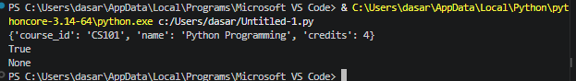
Explaination:
The course module uses a dictionary indexed by course ID and implements all three required functions. Structured docstrings make the module suitable for automatic terminal and HTML documentation through pydoc.

