12-LEAD ECG IMAGE-BASED PREDICTION
OF LEFT VENTRICULAR EJECTION
FRACTION FOR EARLY HEART FAILURE
DETECTION USING DEEP LEARNING
Phase I Project Progress Report submitted to the
National Institute of Technology Warangal
in partial fulfilment of the requirements for the award of the degree
of
Bachelor of Technology
in Electronics and Communication Engineering
by
Krithika Reddy Jakkula (Roll No. 23ECB0A21)
Cheruku Vikas Goud (Roll No. 23ECB0A32)
Monika Varathur (Roll No. 23ECB0F02)
Under the guidance of
Prof. L. Anjaneyulu
Professor, Department of Electronics and Communication Engineering

DEPARTMENT OF ELECTRONICS AND COMMUNICATION ENGINEERING
NATIONAL INSTITUTE OF TECHNOLOGY WARANGAL
November 2026
APPROVAL OF THE PROJECT EVALUATION BOARD
19/11/2026
Certified that the report entitled 12-Lead ECG Image-Based Prediction of Left Ventricular Ejection Fraction for Early Heart Failure Detection using Deep Learning submitted by Krithika Reddy Jakkula (Roll No. 23ECB0A21), Cheruku Vikas Goud (Roll No. 23ECB0A32) and Monika Varathur (Roll No. 23ECB0F02) to the National Institute of Technology Warangal, as the Phase I progress report of their Bachelor of Technology project in Electronics and Communication Engineering, has been examined and accepted by the evaluation board.
(Member of the Board) (Member of the Board) (Member of the Board)
(Supervisor)
(Head of the Department) (Chairperson, Evaluation Board)

CERTIFICATE
This is to certify that the report entitled 12-Lead ECG Image-Based Prediction of Left Ventricular Ejection Fraction for Early Heart Failure Detection using Deep Learning, submitted by Krithika Reddy Jakkula (Roll No. 23ECB0A21), Cheruku Vikas Goud (Roll No. 23ECB0A32) and Monika Varathur (Roll No. 23ECB0F02) to the National Institute of Technology Warangal, is a record of bona fide project work carried out by them under my (our) supervision during Phase I of their Bachelor of Technology project in Electronics and Communication Engineering.

Supervisor
Prof. L. Anjaneyulu
Date: 9th November 2026
DECLARATION
We certify that
- The work contained in the report is original and has been done by us under the general supervision of our supervisor(s).
- The work has not been submitted to any other Institute for any degree or diploma.
- We have followed the guidelines provided by the Institute in writing the report.
- Whenever we have used materials (data, theoretical analysis, and text) from other sources, we have given due credit to them by citing them in the text of the report and giving their details in the references.
- Whenever we have quoted written materials from other sources, we have put them under quotation marks and given due credit to the sources by citing them and giving required details in the references.
- We took help from an AI assistant for some tasks, such as writing and checking code, running the documented experiments and checking the wording. All design decisions, data handling approvals and conclusions are our own.

Krithika Reddy Jakkula  (23ECB0A21) |  | Cheruku Vikas Goud  (23ECB0A32) |  | Monika Varathur  (23ECB0F02)
Signatures of the Students

Acknowledgements
We thank our supervisor, Prof. L. Anjaneyulu, for guidance throughout Phase I, and the Department of Electronics and Communication Engineering, National Institute of Technology Warangal, for its support. We thank the cardiology department of the partner hospital for the ECG and echocardiography records, and the creators of EchoNext, ECGFounder and the other open resources used in this work.
Krithika Reddy Jakkula, Cheruku Vikas Goud and Monika Varathur

Abstract
Heart failure with reduced left ventricular ejection fraction (LVEF) is common and treatable but often detected late, because echocardiography is not available at every point of care. The 12-lead ECG is recorded routinely, yet in many Indian hospitals it survives only as a printed PDF page. This project grades LVEF into four classes (Normal, Mild, Moderate, Severe) from such printout images alone.
The data are 1,047 single-centre printouts from 993 patients, labelled from echocardiography: 837 ECGs for development and 210 locked until the final model was frozen. The traces were recovered exactly from the vector PDFs. Every model was evaluated with patient-grouped, repeated, nested cross-validation, corrected intervals and a written pre-registration. More than 1,300 results were recorded across ten stages, covering image CNNs, the ECGFounder and ECG-FM foundation models, LSTM and CNN-LSTM networks, 594 engineered features, gradient boosting, staged and ordinal ensembles and triage prediction. The public EchoNext data (4,827 ECG–echocardiography pairs of all EF classes) were redrawn in the hospital format and used for transfer learning.
The best four-class accuracy on all patients, from image-derived inputs only, is 0.587 [0.565, 0.610], above the model that also reads the printed machine measurements (0.562) and the original image CNN (0.471). A triage model that answers only confident cases is correct for 0.694 of the 56 % of patients it answers in cross-validation and 0.747 of the 50 % it answers on the locked test, scored once. Models trained only on EchoNext detect EF ≤ 45 % on the hospital printouts with AUROC 0.85. A simulation shows why all model families converge near 0.59: the ECG-based EF estimate correlates with echo at r ≈ 0.66, and 0.70 on all patients would need r ≈ 0.90. Phase II will use digital ECGs, larger linked datasets and verified Simpson-method EF labels.
In a final experiment, every model was trained again, for as many epochs as needed, until its training accuracy reached (nearly) 100 %. No model became reliably better on held-out patients. The best all-patient ensemble fell from 0.587 to 0.558, the main image-only model IMG-C3 from 0.558 to 0.532 (macro-F1 0.441 to 0.416), and the triage model kept its accuracy (0.696) but answered fewer patients (48 % instead of 56 %). The early-stopped models, with training accuracy of about 0.60–0.85, are therefore the ones to use.

Contents

Certificate of Approval ii
Certificate iii
Declaration iv
Acknowledgements v
Abstract vi
List of Figures xi
List of Tables xiii
List of Abbreviations xvi
1 Introduction 1
1.1 Background and motivation 1
1.2 Problem statement 1
1.3 Objectives 2
1.4 Contributions 2
1.5 Organisation of the report 3
2 Literature Review 4
2.1 Ejection fraction and its ECG signature 4
2.2 AI on the ECG for LV dysfunction 4
2.3 Foundation models and public data 5
2.4 Research gaps addressed in Phase I 6
3 Theoretical Study and Methodology 7
3.1 System overview 7
3.2 Dataset 8
3.2.1 ECG and echocardiography data collection 8
3.2.2 Spreadsheet loading and cleaning 8
3.2.3 Patient record matching with fuzzy matching 8
3.2.4 LVEF extraction and class labels 8
3.2.5 Class-wise organisation of the ECG files 9
3.2.6 Dataset partitioning 9
3.3 Exact digitisation and the printout renderer 9
3.4 Input representations and features 9
3.5 Network architectures, preprocessing filters and training 10
3.5.1 Preprocessing filters 10
3.5.2 Network layers and activation functions 11
3.5.3 Training settings and training accuracy 11
3.5.4 Analysis of transfer learning 12
3.6 Evaluation protocol 15
4 Experimental Study 16
4.1 Original project and Phase 1 17
4.2 Phases 2–5: robust evaluation, fusion and decision rules 18
4.3 Phases 6, 6A and 6B: fine-tuning and the LSTM family 18
4.4 Label-quality, cohort and abstention studies 20
4.5 Phase 7 and the image-only ensembles 20
5 Public-Data Transfer and Image-Only Deep Learning 22
5.1 EchoNext in the printout format 22
5.2 Pruned ensembles of all image-derived models 23
5.3 Additional features for Mild and Moderate 24
5.4 Image-only pixel models with EchoNext pre-training 24
6 Results and Discussion 26
6.1 Headline results 26
6.1.1 Best on all patients: 0.587 27
6.1.2 Best in the 60s: 0.694 on the answered patients 27
6.1.3 Best in the 70s: 0.747 on unseen patients 28
6.2 All models compared 29
6.3 All results in the upper 50s, 60s and 70s 30
6.4 Trade-off analysis 31
6.5 Why the results are strong and why higher accuracy is not feasible 34
7 Training Every Model to 100 % Training Accuracy 37
7.1 Method 37
7.2 Development cross-validation models 39
7.3 Image and signal networks on the fixed split 44
7.4 Variants of every phase 45
7.5 Label-quality studies 48
7.6 Top-3 ensembles retrained with EchoNext 49
7.7 Models that were not retrained 50
7.8 Why training to 100 % does not help, and where to stop 50
8 Summary and Conclusions 52
8.1 Conclusions 52
8.2 Scope for future work (Phase II) 53
References 54

List of Figures

3.1 System architecture of the Phase I pipeline. Dashed arrows: knowledge transferred from the EchoNext public dataset. 7
3.2 Training curves of six representative networks: training and validation accuracy (solid) and loss (dotted) per epoch. 14

4.1 Phase 6B architectures: waveform encoders (A), early fusion with the header and ECGFounder (B) and late fusion with the vote ensemble (C). 19

5.1 Four-class accuracy of every stack and ensemble variant of the public-data study, with corrected 95 % confidence intervals. 24

6.1 Left: development estimates and locked-test results of the final model (every cross-validation value lies inside its locked-test interval). Right: locked-test confusion matrix of the four-class image-only classifier. 29
6.2 All model families sorted by four-class accuracy (highest at the top). [test] = fixed 210-ECG test set of the original project; [CV] = cross-validation on 837 development ECGs; [locked test] = frozen model scored once. 31
6.3 The same models sorted by heart-failure screen AUC (reduced EF against Normal). 32
6.4 Every result with accuracy ≥ 0.55, grouped by evaluation population (each dot is one configuration; stars mark the headline results). 33
6.5 Accuracy against the share of ECGs answered (selective prediction, nested thresholds). 33
6.6 Mild detected (recall of the Mild class) against four-class accuracy for all models. Stars mark the headline results; lines show the effect of a Mild offset on IMG-vote (all ECGs) and on the triage model (answered ECGs). 34
6.7 Expected four-class accuracy against the SD of the EF estimation error (simulation on the 837 development ECGs). Our EF estimators lie at SD 13–14, where the best model (0.587) sits on the curve. 70 % needs SD ≤ 7.7, i.e. r ≈ 0.90. 35
6.8 Error rate by distance of the echo EF from the nearest class limit. 35

7.1 Development cross-validation: training accuracy after training to (nearly) 100 % (blue), held-out accuracy of the same model with its corrected 95 % interval (orange) and held-out accuracy of the original early-stopped model (green). 41
7.2 Held-out confusion matrices of the twelve main models after training to (nearly) 100 % training accuracy, ordered by accuracy. Rows are the true class and columns the predicted class; counts are per repeat (each of the 837 ECGs is predicted once per repeat) and the colour is the row percentage (recall). Triage: answered patients only, with the referred patients in the last column. 43
7.3 Original fixed split: training accuracy after training to ≥ 99.5 % (blue), validation accuracy of the same network (orange) and validation accuracy of the original network at its selected epoch (green). 45
7.4 ECGFounder MLP head trained for 150 epochs without early stopping (mean of the five folds of repeat 0): training accuracy reaches 1.000 while held-out accuracy stays at about 0.52. Left: the project head; right: the same head without dropout or weight decay. The dashed line marks the early-stopping epoch. 51

List of Tables

2.1 Relevant studies: data, input, task and main reported result (as printed in each abstract). 5

3.1 Preprocessing filters and their parameters for each input representation. 10
3.2 Layers, activation functions, normalisation and size of every network used in Phase I. 12
3.3 Training against validation accuracy of the main networks. Upper part: original project, fixed training/validation split, at the selected epoch (training accuracy is measured during the epoch, with augmentation and dropout active). Lower part: frozen-feature models in development cross-validation (repeat 0, seed 42): accuracy on the training folds against the held-out fold. 13
3.4 Transfer learning: source, how the knowledge was transferred and what it gave on the hospital printouts. 14

4.1 Overview of the experimental stages of Phase I. 16
4.2 Representative models of the original project (fixed test set, n = 210). 17
4.3 Phase 1 key models (fixed test set). 17
4.4 Phase 5, development cross-validation (min recall = lowest per-class recall; admissible if ≥ 0.15). 18
4.5 LSTM family: architecture, size, cost and results (development CV, original labels). 18
4.6 LSTM fusions (development CV, original labels). 19
4.7 Label-quality, cohort and abstention studies (development CV). 20
4.8 Image-only four-class models (all 837 ECGs, development CV). 21

5.1 EchoNext-trained models: internal checks and transfer to the 837 hospital ECGs without any hospital training. 22
5.2 All ensemble variants (837 ECGs, original labels, corrected 95 % CI). Members are the mean kept per fold. 23
5.3 Pixel models on the 837 hospital images (class weights tuned inside the training folds). 25

6.1 Headline results of Phase I (image-derived inputs only; original four-class labels), with the result of the same model trained to (nearly) 100 % training accuracy where it could be retrained. 26

7.1 What changed in TRAIN100. Inputs, labels, architectures, folds and decision rules are the original ones; only the brakes on fitting were removed, and every model was trained for as many epochs or iterations as it needed. 38
7.2 How the main models are built. ECGFounder (Net1D; 61 convolution and 40 linear layers in 7 stages of 20 residual blocks; 30.7 M parameters) was pre-trained on 10.8 million ECGs and is kept frozen, so only the heads are trained on the hospital ECGs. Epochs: median over the 15 folds to reach 100 % training accuracy; models without epochs show what replaces them. 38
7.3 Development cross-validation (5 folds × 3 repeats, 837 ECGs): every model trained to (nearly) 100 % training accuracy (TRAIN100; training and held-out accuracy) against the original early-stopped model (original held-out accuracy). Held-out 95 % CI corrected for repeated CV; change = TRAIN100 minus original, in percentage points. Epochs: median over the 15 folds; a boosted trees (no epochs); b epochs of the neural member FUSION-MLP; c epochs of the neural member ECGF-MLP; d full-batch L-BFGS iterations; e solved to convergence (no epochs). 40
7.4 Accuracy, macro-F1 and Mild F1 of the main models before (original, early-stopped) and after training to (nearly) 100 % training accuracy; change in percentage points. F1 from the held-out confusion matrices pooled within each repeat and averaged over the three repeats. Triage: scored on the patients it answers; its original F1 values were not recorded. 42
7.5 Image and signal networks on the original fixed split (trained on 669 ECGs, measured on 168 validation ECGs; the locked test is not loaded). TRAIN100: no early stopping, augmentation, weight decay, label smoothing or EMA, trained until training accuracy ≥ 99.5 %. Original training accuracy was measured during the epoch with augmentation and dropout active. 44
7.6 Variants of every phase, trained to (nearly) 100 % training accuracy in the same development cross-validation. Members without an original stand-alone result show –. Epochs: median over the 15 folds (E4: stage 1 / stage 2; members of combiners as in Table 7.3, same learners, seeds and rows); a boosted trees (no epochs); b epochs of the neural member FUSION-MLP; c epochs of the neural member ECGF-MLP; d full-batch L-BFGS iterations; e solved to convergence (no epochs). 46
7.7 EF regression (Phase 4) trained without early stopping: correlation with echo EF on the training rows and held out, and mean absolute error in EF points. The MLP reached the 3,000-epoch cap in every fold (training R2 just below the 0.99 target). 48
7.8 Label-quality studies (report Table 4.7) with the C3 recipe trained to (nearly) 100 % training accuracy, scored on the same subsets as the original. Epochs: median over the 15 folds; b epochs of the neural member FUSION-MLP. 48
7.9 The three best all-patient ensembles, retrained with EchoNext on the owner’s computer (the EchoNext data never left it): every member trained to (nearly) 100 % training accuracy, then the same selection and meta-learner as in Table 5.2. Numbers as reported by that run. 49
7.10 Models not retrained in TRAIN100, and why. 50

List of Abbreviations

AUROC | Area under the receiver operating characteristic curve
CI | Confidence interval (corrected for repeated cross-validation unless stated)
CNN | Convolutional neural network
CV | Cross-validation
ECG | Electrocardiogram
ECGF, ECGFounder | ECG foundation model pre-trained on more than 10 million ECGs (Li et al.)
EchoNext | Public ECG–echocardiography dataset (PhysioNet), about 100,000 ECGs
EF, LVEF | (Left ventricular) ejection fraction, in per cent
GBM | Gradient-boosting machine (LightGBM)
HF | Heart failure
LR | Logistic regression
LSTM | Long short-term memory recurrent network
Mi, Mo, N, S | Mild, Moderate, Normal and Severe classes
MLP | Multi-layer perceptron
STAGED-4 | Staged four-class decision: Normal / {Mild, Moderate} / Severe, then Mild vs Moderate
SUPER | Ensemble of all image-derived members pruned inside each training fold
TCRT | Total cosine R-to-T
TOP10 | Ensemble keeping the ten best single members per fold
Notation
y | Class label y∈{0,1,2,3}: Normal, Mild, Moderate, Severe
μ̂ | Predicted EF (per cent)
σ | Standard deviation of the EF estimation error
r | Pearson correlation between predicted and echo EF
Φ(·) | Standard normal cumulative distribution function
w | Class weights of the decision rule
J | Number of cross-validation cells (here 15)

Chapter 1

Introduction

1.1 Background and motivation
Heart failure affects tens of millions of people, and its outcome depends on how early left ventricular (LV) systolic dysfunction is recognised [1, 2]. Systolic function is graded by the left ventricular ejection fraction (LVEF), measured by echocardiography, which needs an ultrasound machine and a trained operator. The 12-lead electrocardiogram (ECG), in contrast, is recorded for almost every cardiac patient, and deep learning has shown that it carries information about reduced LVEF [3, 4]. That evidence comes mostly from digital signals and very large datasets. In many Indian hospitals the ECG survives only as a printed page or its PDF, which shows each lead for just 2.5 s plus one 10-s rhythm strip.

1.2 Problem statement
Given only the image of a hospital 12-lead ECG printout, predict the patient’s four-class LVEF category:
- Normal: EF above 52 % (men) or at least 54 % (women) [5];
- Mild: 41 % up to the Normal limit;
- Moderate: 31 to below 41 %;
- Severe: below 31 %.
The model may use only the waveform on the page: no printed machine measurements, age or sex. The Mild band, only 11–13 EF points wide, is where an early warning is most valuable and where the ECG changes are subtle. A useful model must therefore detect Mild and not only the extremes.

1.3 Objectives
- Prepare a labelled ECG image dataset: clean the ECG and echocardiography records, link every ECG to its patient’s echocardiogram, extract the LVEF and assign one of the four classes.
- Recover the exact ECG signal from the printout and build image-derived representations of it.
- Train and compare the widest practical range of models, from classical features and CNNs to foundation models, LSTMs and ensembles, under a nested and pre-registered protocol.
- Transfer knowledge from public ECG–echo data (EchoNext) drawn in the hospital printout format.
- Find the best all-patient four-class model and a triage model that answers confidently, and confirm it once on a locked test set.
- Quantify the accuracy that the data can support, and test whether training every model until it fits its training data perfectly changes held-out performance.

1.4 Contributions
- A Python data-preparation pipeline: cleaning of the ECG and echocardiography spreadsheets, fuzzy matching of the two record sets, LVEF label generation and class-wise organisation of the ECG files.
- An exact vector digitiser and an inverse printout renderer for the hospital ECG format.
- More than 1,300 evaluated configurations across ten experimental stages, all documented.
- A best all-patient four-class accuracy of 0.587 from image-derived inputs only, a triage accuracy of 0.694 on 56 % of patients, and 0.747 on unseen locked-test patients.
- A controlled experiment in which every model was trained to (nearly) 100 % training accuracy; held-out accuracy did not improve, which supports the early-stopped models.

1.5 Organisation of the report
Chapter 2 reviews the literature. Chapter 3 describes the data, digitisation, features, networks and evaluation protocol. Chapter 4 reports the experimental study phase by phase and Chapter 5 the public-data transfer. Chapter 6 presents the results and their analysis. Chapter 7 retrains every available model to (nearly) 100 % training accuracy and compares it with the original, and Chapter 8 concludes with the plan for Phase II.

Chapter 2

Literature Review

2.1 Ejection fraction and its ECG signature
Clinical guidelines divide LVEF into normal, mildly reduced and reduced ranges [1, 2], and echocardiography is the standard way to measure it [5]. The measurement itself is not exact: two echocardiograms of the same patient may disagree by around 10 EF points [6], which is close to the width of a single class in this project (10–13 points). Several ECG findings are known to accompany a weak left ventricle: a prolonged QRS or bundle-branch block [7], a fragmented QRS [8], a wide angle between the QRS and T vectors [9] and uneven repolarisation [10, 11].

2.2 AI on the ECG for LV dysfunction
On digital 12-lead ECGs, a convolutional network flagged EF ≤ 35 % with an AUC of 0.93 [3], and in a randomised primary-care trial it led to more new diagnoses [4]. Fewer studies grade the EF instead of flagging it: Vaid et al. predicted three EF bands and also regressed the EF value, using 715,890 ECGs [12]. Working from ECG images rather than signals, a model trained on 385,601 ECGs reached AUROC 0.90–0.95 for EF < 40 % [13], and turning ECG images back into signals is itself an active research topic [14–16]. Models that predict several structural heart diseases together improved as more input types were added [17], and single-lead and wearable devices have carried the screening idea outside the hospital [18–20].

2.3 Foundation models and public data
Table 2.1 Relevant studies: data, input, task and main reported result (as printed in each abstract).
Study | Data | Input | Task | Main reported result
Attia et al. [3] | 44,959 train / 52,870 test patients, Mayo Clinic | digital 12-lead | EF ≤ 35 % | AUC 0.93, accuracy 85.7 %
Attia et al. [32] | 3,874 prospective patients | digital 12-lead | EF ≤ 35 % | AUC 0.918; 39.8 % of false positives had EF 36–50 %
Yao et al. [4] | 22,641 adults, 120 care teams (RCT) | digital 12-lead | new low-EF diagnosis | diagnoses 1.6 % → 2.1 % (OR 1.32)
Adedinsewo et al. [33] | 1,606 emergency patients | digital 12-lead | EF ≤ 35 % / < 50 % | AUROC 0.89 / 0.85
Vaid et al. [12] | 715,890 ECGs, 147,636 patients, 5 hospitals | digital 12-lead | EF 3 classes + regression | AUC 0.94 / 0.82 / 0.89 (internal); MAE 5.8–6.1
Kwon et al. [34] | 55,163 ECGs, 2 hospitals | ECG features + demographics | HFrEF (EF ≤ 40 %) | AUROC 0.843 internal, 0.889 external
Sangha et al. [35] | 2.2 million ECGs plotted as images | ECG images | 6 rhythm / conduction labels | mean AUROC 0.99 (external 0.97)
Sangha et al. [13] | 385,601 ECGs, Yale + external sites | ECG images | EF < 40 % | AUROC 0.91 internal, 0.90–0.95 external
Ulloa-Cerna et al. [17] | 2.2 million ECGs, 484,765 adults | ECG + age, sex | composite structural disease | AUROC 0.91
Elias et al. [36] | 77,163 patients | digital 12-lead | moderate / severe AS, AR, MR | AUROC 0.88 / 0.77 / 0.83
Poterucha et al. [23] | > 1 million ECG– imaging pairs | digital 12-lead | structural heart disease | outperformed cardiologists; data and weights released
Hughes et al. [24] | 100,000 ECGs, 36,286 patients (public) | digital, 250 Hz | composite + 11 labels | composite AUROC 82.0
McKeen et al. [22] | 1.5 million ECGs (pre-training) | digital 12-lead | EF ≤ 40 % and others | AUROC 0.929 for EF ≤ 40 %
Li et al. [21] | 10.8 million ECGs, 150 labels | digital 12-lead | broad diagnosis | AUROC > 0.95 for 80 diagnoses
This work | 837 development + 210 locked printouts, one centre; EchoNext 4,827 | printout images (and derived traces) | four-class EF | 0.587 all patients; 0.694 (56 % answered); 0.747 locked test (50 %); EF ≤ 45 % AUROC 0.85 from EchoNext only

Foundation models change what a small dataset can achieve. ECGFounder learnt from 10.8 million ECGs and adapts to new tasks with few labelled examples [21], and ECG-FM reported AUROC 0.929 for EF ≤ 40 % [22]. The EchoNext project made paired ECG–echocardiography data and trained models public, and its models outperformed cardiologists [23, 24]. Earlier one-dimensional networks had already matched cardiologists in rhythm classification [25] and automated 12-lead interpretation [26]. For images, this project uses the ResNet [27], EfficientNet [28], MobileNetV3 [29] and ConvNeXt [30] backbones; for sequences, the LSTM [31] and convolutional LSTM variants.

2.4 Research gaps addressed in Phase I
- Graded EF from printouts. Most published models answer a yes/no question on digital signals. Four-class grading that includes Mild, from printout images, had not been reported, and Mild in particular needs more data than single-centre studies usually have.
- Small single-centre data. Methods for a few hundred labelled printouts, evaluated with nested cross-validation, are rarely studied.
- Transfer to the printout format. Public ECG–echo data had not been redrawn in a hospital’s printout format for pre-training.
- Confident subsets. Triage that answers only confident cases and refers the rest is seldom evaluated for graded EF.

Chapter 3

Theoretical Study and Methodology

3.1 System overview
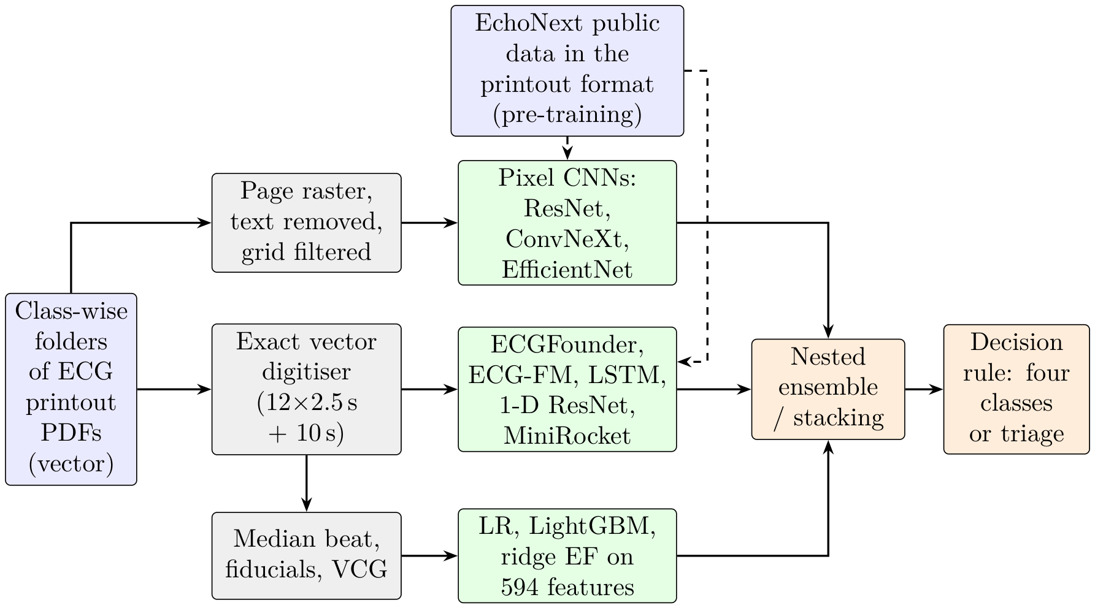
Figure 3.1 System architecture of the Phase I pipeline. Dashed arrows: knowledge transferred from the EchoNext public dataset.
The Phase I pipeline (Figure 3.1) has three parts. The printout PDF is digitised exactly, turned into image, signal and feature representations, and passed to the model families. External knowledge enters from the public EchoNext data, redrawn in the hospital printout format.

3.2 Dataset

3.2.1 ECG and echocardiography data collection
The data come from one tertiary-care hospital and cover 2020–2024: 1,047 ECG printouts of 993 patients, each with an echocardiography report. Every ECG is a standard 12-lead recording stored as a PDF, printed in the usual 3 × 4 layout (2.5 s per lead) with a 10-s lead II rhythm strip, at 25 mm/s and 10 mm/mV. The LVEF in the echocardiography report is the reference value from which each ECG’s class is derived. Name, age, sex and examination date were used to link the ECG and echocardiography records.

3.2.2 Spreadsheet loading and cleaning
The ECG and echocardiography details were kept in separate Excel files, which were read into Python with the Pandas library. Before matching, patient names were normalised (extra spaces, special characters and different name orders removed or unified) so that the same person is written the same way in both files. Only the fields needed later were kept: patient name, age, sex, examination date, ECG file path and LVEF value. Records with missing or unusable entries were flagged so that they could not cause false matches.

3.2.3 Patient record matching with fuzzy matching
Because the same name was not always spelt identically in the two files, exact matching would have missed many pairs. Names were therefore compared with fuzzy string matching (RapidFuzz library), which gives a similarity score and tolerates small spelling differences, swapped word order and spacing. Every candidate pair was then checked against age, sex and examination date, which removed most wrong matches and made the paired dataset more reliable.

3.2.4 LVEF extraction and class labels
For every matched pair the EF value was read from the echocardiography record and converted to a number. Each ECG then received one of the four classes defined in Section 1.2 (Normal, Mild, Moderate, Severe), and this label was stored with the ECG record for all later steps.

3.2.5 Class-wise organisation of the ECG files
Using the file paths in the matched table, the ECG files were copied into four folders, one per class (Normal, Mild, Moderate, Severe). This structure makes every class easy to access during preprocessing and training.

3.2.6 Dataset partitioning
To keep the evaluation fair, the 1,047 ECGs were split once by patient, so that no patient appears in both parts. The development set holds 837 ECGs (384 Normal, 185 Mild, 177 Moderate, 91 Severe) and was used for all modelling. The locked test set holds the other 210 ECGs (96 / 47 / 44 / 23); it was kept apart during development and scored only once, after the final model had been frozen.

3.3 Exact digitisation and the printout renderer
The PDFs are vector drawings: each lead is a polyline of about 700 segments, so the trace is recovered exactly. With the row baselines y_{base} and column origins x₀ of the page,
 | $$v\left(t\right)=\frac{y_{\text{base}}−y\left(x\right)}{82} \text{mV}, t=\frac{x−x_{0}}{205.2} \text{s},$$ | (3.1)
resampled to 500 Hz. The inverse operation, a printout renderer, draws any 12-lead signal on a page identical to the hospital’s, rounding each point to whole drawing units as the machine does. Redrawn development ECGs match their real pages: 81 % of drawn points are identical and the read-back error is 5–13 μ V.

3.4 Input representations and features
Four representations were built from each printout:
- page image: the waveform area with text removed and the grid filtered, for CNNs;
- aligned signal: the 12 leads in their own 2.5-s windows on a common 10-s axis, for ECGFounder and the LSTMs;
- ECGFounder embeddings: the 1,024-d final embedding and 150 diagnostic outputs;
- engineered features: 594 features, among them 191 clinician-style and vectorcardiographic measurements such as the spatial QRS–T angle, total cosine R-to-T (TCRT) and the QT variability index.

3.5 Network architectures, preprocessing filters and training

3.5.1 Preprocessing filters
Table 3.1 Preprocessing filters and their parameters for each input representation.
Input | Step | Filter / operation and parameters
Page image (CNNs) | rasterise and crop | vector PDF rendered at 1 px/pt; crop to the waveform area (removes all header text)
 | grid removal | colour filter: darkness = 255 − max(R,G,B) (HSV value); the pink grid has a high value and vanishes
 | binarisation | Otsu threshold (clamped)
 | denoising | connected components < 6 px removed (keeps 1-px trace lines that a median filter would erode)
 | thickening, resizing | scale-aware dilation; area interpolation to 512 × 1024, then 256 × 512 network input
 | filter ablations | Gaussian 5 × 5, σ = 1; median 3 × 3; bilateral (d 7, σ 50/7); CLAHE (clip 2.0, 8 × 8 tiles); adaptive Gaussian threshold (block 25, C 60)
Digitised signal (ECGFounder) | exact digitisation | vector paths converted at 82 pt/mV and 616/3 pt/s; 500 Hz
 | power-line notch | IIR notch at 50 Hz, Q = 30
 | band-pass | 4th-order Butterworth, 0.67–40 Hz, zerophase (forward–backward)
 | baseline | 0.4-s moving-median baseline subtracted
 | scaling, layout | z-score per lead; 12 leads in their own 2.5-s windows on a 10-s axis (12 × 5,000)
LSTM / CNN-LSTM | as above, then decimation | 100 Hz; amplitudes clipped at ±5 mV; 13 signals + 13 mask channels (26 × 1,000)
Engineered features | beat analysis | 0.5 Hz high-pass; R-peak detection; Raligned median beats; vectorcardiogram by the Kors matrix
EchoNext signals | harmonisation | de-normalisation to μ V; resampling 250 → 500 Hz; cascaded median filters (0.2 s, 0.6 s) for baseline removal; clipping; printout cut (2.5-s windows)
Pixel CNNs (IMG) | page image | waveform area, text removed, grid filtered; 320 × 640 (ResNet-18) or 384 × 768 (ConvNeXt-Tiny, EfficientNet-B2); grey channel repeated to RGB

Each representation has its own filter chain (Table 3.1): a colour filter removes the pink grid from page images, and a 50 Hz notch, a 0.67–40 Hz band-pass and a moving-median baseline filter clean the signals.

3.5.2 Network layers and activation functions
Table 3.2 gives the layers, kernels, activation functions, normalisation and size of every network. The activation functions used are
 | $$\begin{matrix}ReLU\left(x\right)=max\left(0,x\right), SiLU\left(x\right)=x σ\left(x\right), GELU\left(x\right)=x Φ\left(x\right), \\ \text{h-swish}\left(x\right)=x \frac{ReLU6\left(x+3\right)}{6}, σ\left(x\right)=\frac{1}{1+e^{−x}}, \\ softmax{\left(z\right)}_{c}=\frac{e^{z_{c}}}{\sum_{j=1}^{4}{e^{z_{j}}}},\end{matrix}$$ | (3.2)
where Φ is the standard normal distribution function. Every four-class network ends in a softmax; ordinal heads use sigmoids for P(y > k), and LSTM gates use the sigmoid with a tanh cell activation.

3.5.3 Training settings and training accuracy
Image CNNs were trained with AdamW (learning rate 10⁻³, weight decay 0.05), warm-up and cosine decay, batch 16, up to 30 epochs with early stopping, class-weighted cross-entropy with label smoothing 0.05, weight averaging (EMA 0.99) and augmentation (rotation ±2°, time and amplitude scaling, translation, random erasing). ECGFounder was fine-tuned with differential learning rates (backbone 10⁻⁴, head 10⁻³). LSTMs used AdamW (10⁻³), batch 32, gradient clipping and early stopping on inner validation. Table 3.3 compares training and validation accuracy.
- Image CNNs reach 0.52 on training and 0.48–0.52 on validation data: they learn evenly and are not over-fitted.
- Foundation-feature heads reach 0.73–0.76 on training folds against 0.51 held out, and fine-tuning drives the training loss to 0.66 while validation loss stays at 1.17. With 837 ECGs for 30.8 million parameters, frozen features, regularisation, nested selection and ensembling were therefore used in all later phases. Chapter 7 tests this choice directly: when the same models are trained until their training accuracy reaches (nearly) 100 %, held-out accuracy does not improve.

3.5.4 Analysis of transfer learning
Table 3.2 Layers, activation functions, normalisation and size of every network used in Phase I.
Network | Layers and blocks | Activation | Norm. | Params
ResNet-18 | 7 × 7 conv stem + max-pool; 4 stages × 2 basic blocks of two 3 × 3 convs (64–512 channels); global average pool; FC(4) — 18 weight layers | ReLU | BatchNorm | 11.2 M
ECGNet (custom) | 7 × 7/2 stem; 4 stages of 1–1–2–2 residual SE blocks (widths 64–256) with time-elongated 3 × 5 kernels; [GAP ‖ GMP]; dropout 0.3; FC(4) —13 conv layers | ReLU; sigmoid (SE) | BatchNorm | 6.3 M
EfficientNet-B0 | 3 × 3 stem; 16 MBConv blocks in 7 stages with SE; 1 × 1 head conv; FC(4) | SiLU | BatchNorm | 4.0 M
EfficientNet-B2 (IMG70) | 3 × 3 stem; 23 MBConv blocks in 7 stages with SE; 1 × 1 head conv; FC(4) + EF head | SiLU | BatchNorm | 7.7 M
MobileNetV3-Large | 3 × 3 stem; 15 inverted-residual bottlenecks, SE in 8; 1 × 1 head | h-swish, ReLU | BatchNorm | 4.2 M
ConvNeXt-Atto | 4 × 4 patchify stem; 4 stages of 2–2–6–2 blocks (7 × 7 depth-wise conv + MLP) | GELU | LayerNorm | 3.4 M
ConvNeXt-Tiny (IMG70) | 4 × 4 patchify stem; 4 stages of 3–3–9–3 blocks (96–768 channels); FC(4) + EF head | GELU | LayerNorm | 27.8 M
1-D SE-ResNet | 1-D residual blocks, kernel 9, SE; [GAP ‖ GMP]; FC(4) | ReLU | BatchNorm | –
ECGFounder (Net1D) | 1-D conv stem (kernel 16, stride 2); 7 stages of 2–2–2–3–3–4–4 blocks (20 blocks; 64–1,024 filters), grouped kernel-16 convs with SE; GAP → 1,024-d embedding | Swish | none | 30.8 M
MLP head / fusion | dropout 0.5 → linear 64 → GELU → dropout 0.5 → linear 4 | GELU | standardised input | 66 k
LSTM L0–L4 | 1–2 LSTM layers, 64 hidden units, uni- or bidirectional; [last state ‖ masked mean]; dropout 0.3; linear 4 | sigmoid, tanh | – | 18–147 k
CNN-LSTM (L5) | 3 × [Conv1d k 7, stride 2] (26 → 32 → 64 → 64 channels); BiLSTM-64; linear 4 | GELU; sigmoid, tanh | – | 117 k
Meta-learners | multinomial logistic regression; Frank–Hall ordinal (3 binary logistic models) | softmax; sigmoid | standardised | < 1 k

Table 3.3 Training against validation accuracy of the main networks. Upper part: original project, fixed training/validation split, at the selected epoch (training accuracy is measured during the epoch, with augmentation and dropout active). Lower part: frozen-feature models in development cross-validation (repeat 0, seed 42): accuracy on the training folds against the held-out fold.
Network | Epochs (selected) | Training accuracy | Validation / held-out accuracy | Train / val loss
ResNet-18 (filtered image) | 24 (14) | 0.515 | 0.524 | 1.237 / 1.142
ECGNet (SE-ResNet) | 30 (21) | 0.523 | 0.476 | 1.222 / 1.213
EfficientNet-B0 | 29 (19) | 0.447 | 0.351 | 1.327 / 1.436
ConvNeXt-Atto (10⁻³) | 30 (25) | 0.404 | 0.452 | 1.336 / 1.318
1-D SE-ResNet on digitised waveforms | 29 (14) | 0.553 | 0.482 | 1.127 / 1.344
ECGFounder fine-tuned (stages 5–6) | 13 (8) | – | 0.524 | 0.660 / 1.174
ECGFounder linear head (CV) | – | 0.730 | 0.510 | –
ECGFounder MLP head (CV) | – | 0.761 | 0.514 | –
Header + ECGFounder MLP fusion (CV) | – | 0.668 | 0.535 | –
Header + clinical features, logistic regression (CV) | – | 0.562 | 0.507 | –

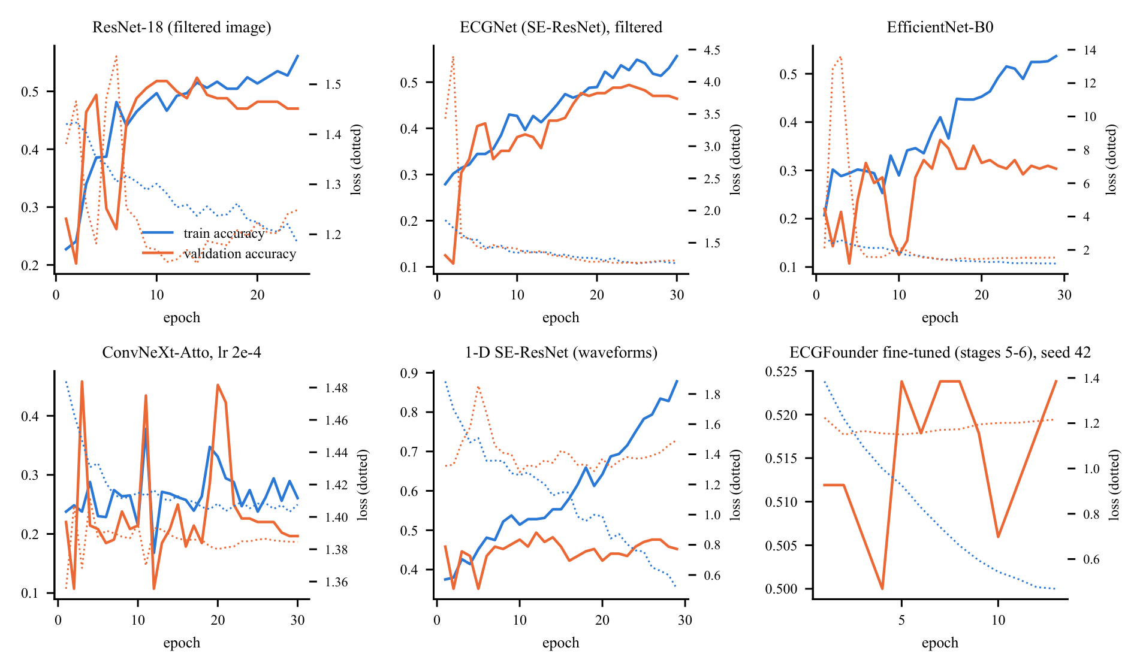
Figure 3.2 Training curves of six representative networks: training and validation accuracy (solid) and loss (dotted) per epoch.
Table 3.4 Transfer learning: source, how the knowledge was transferred and what it gave on the hospital printouts.
Source | Transfer method | Result on the hospital data
ImageNet (1.3 M natural images) | initialise ResNet-18; fine-tune on page images | 0.492 four-class (CV); natural-image features transfer only partly to thin line drawings
ECGFounder (10.8 M ECGs, 150 labels) | frozen 1,024-d embedding + linear or MLP head | 0.528–0.542 (CV); screen AUC 0.82; EF r 0.65; best single representation of the project
 | partial fine-tuning (stages 5–6; stage 6) | 0.536 (CV); EF r 0.650 against 0.652 frozen: the frozen embedding already holds the EF information
 | layer choice (stage 4, 5, 6, diagnostic outputs) | final embedding best (0.544 against 0.517–0.531)
EchoNext signals (4,827 US ECG– echo pairs) | models trained only on EchoNext, applied zero-shot | AUROC 0.85 for EF ≤ 45 %, 0.75 Normal against Mild, EF r 0.62; four-class 0.551 with no hospital training of the model (only its decision thresholds tuned)
 | EchoNext models as stack members | SUPER ensembles 0.583–0.587, the best all-patient results
EchoNext images (drawn as printouts) | pre-train pixel CNN, then fine-tune | final ConvNeXt-Tiny ensemble 0.548; ResNet-18: 0.530 against 0.492 with ImageNet only (+3.8 points); EchoNext test accuracy of the pre-trained CNNs 0.58–0.72

Transfer learning was used in four forms, from natural images to EF-labelled ECGs (Table 3.4). The closer the source is to the target, the larger the gain: ECG pre-training (ECGFounder) beat ImageNet pre-training by 4–5 points, and EF-labelled public ECGs (EchoNext) supplied the knowledge behind the best ensembles. A model trained only on US patients separates reduced from normal EF on our printouts with AUROC 0.85, which also validates the printout conversion. Frozen ECGFounder features match fine-tuning in EF correlation (0.652 against 0.650) without its over-fitting, and pre-training a pixel CNN on EchoNext ECGs drawn as hospital printouts adds 3.8 points over ImageNet initialisation.

3.6 Evaluation protocol
- Cross-validation: patient-grouped 5-fold CV repeated three times (15 cells), identical folds for every model.
- Nested choices: every hyper-parameter, class weight, threshold and ensemble member is chosen inside the training folds [37]. Class weights maximise accuracy subject to every recall ≥ 0.18 (fallback 0.15):
 | $$\hat{y}=arg\max_{k} w_{k}P_{k}, w^{*}=arg\max_{w} Acc\left(w\right) \text{s.t.} \min_{k}{Rec}_{k}\left(w\right)≥0.18.$$ | (3.3)
- Intervals and tests: corrected resampled t statistic [38] with Holm adjustment [39]:
 | $$t=\overset{‾}{d} /\sqrt{\left(\frac{1}{J}+\frac{n_{2}}{n_{1}}\right){\hat{σ}}_{d}^{2}}, J=15.$$ | (3.4)
- Integrity: every study was pre-registered in a dated document before it was run; the locked test set was scored once.

Chapter 4

Experimental Study
Table 4.1 Overview of the experimental stages of Phase I.
Stage | Main question | Evaluation | Outcome carried forward
Original project | Can a page-image CNN grade LVEF? | fixed 210-ECG test set | 27 models; header + ResNet-18 fusion 0.552
Phase 1 | Does a foundation ECG model help? | fixed test set | ECGFounder best for Mild (recall 0.26)
Phase 2 | Robust re-evaluation, pre-registered | development CV | ECGFounder MLP fusion 0.544
Phase 3 | Fusion, ensembles, calibration | development CV | vote ensemble C1 0.547
Phase 4 | EF regression, multitask, label quality | development CV | EF r = 0.66; information limit found
Phase 5 | Features, boosting, decision rules | development CV | C3 selected, 0.562
Phase 6 / 6A / 6B | Fine-tuning, LSTM family, label variants | development CV | recurrent models tested; C3 kept
Label studies | Cleaning, cohorts, abstention | CV and subsets | selective prediction reaches 0.71
Phase 7 | Representations, learning curve, triage | CV, then locked test | triage 0.694 (CV), 0.747 (locked test)
Image-only push | HIER, ENH, ULT, EchoNext, SUPER | development CV | ensembles 0.57–0.587

Phase I was carried out in ten stages(Table 4.1). Each stage asked one question, and its lesson was carried into the next. Together they produced more than 1,300 recorded results; the Supplementary Tables list every configuration, and Figure 6.2 in Chapter 6 compares all model families.

4.1 Original project and Phase 1
Table 4.2 Representative models of the original project (fixed test set, n = 210).
Model | Accuracy | Bal. acc. | Macro-F1 | QWK | HF AUC
HOG + PCA + RBF-SVM (classical) | 0.481 | 0.322 | 0.283 | 0.229 | 0.737
ECGNet (custom SE-ResNet) | 0.471 | 0.360 | 0.262 | 0.389 | 0.745
ResNet-18, ImageNet initialised | 0.486 | 0.356 | 0.323 | 0.290 | 0.735
EfficientNet-B0 / MobileNetV3-L (from scratch) | 0.300 / 0.143 | 0.318 / 0.243 | 0.236 / 0.111 | – | 0.712 / 0.649
1-D ResNet on digitised waveforms (×5 seeds) | 0.457 | 0.364 | 0.358 | 0.410 | 0.752
XGBoost on engineered waveform features | 0.490 | 0.377 | 0.373 | 0.382 | 0.742
Logistic regression on header measurements | 0.514 | 0.442 | 0.421 | 0.422 | 0.795
Header 0.6 + ResNet-18 0.4 (default pipeline) | 0.552 | 0.454 | 0.433 | 0.447 | 0.791
Always “Normal” (reference) | 0.457 | 0.250 | 0.157 | 0 | –

Table 4.3 Phase 1 key models (fixed test set).
Model | Accuracy | Bal. acc. | Macro-F1 | Mild recall | HF AUC
Default pipeline, reproduced | 0.552 | 0.454 | 0.433 | 0.106 | 0.791
A1 ECGFounder, frozen | 0.500 | 0.421 | 0.412 | 0.234 | 0.810
A2 ECGFounder, fine-tuned (3-seed ensemble) | 0.524 | 0.464 | 0.448 | 0.255 | 0.812
A2 with a cumulative-link ordinal head | 0.510 | 0.417 | 0.393 | 0.170 | 0.790
A1 with a CORAL ordinal head | 0.390 | 0.376 | 0.345 | 0.489 | –
Header + A2 fusion | 0.505 | 0.445 | 0.425 | 0.213 | 0.819

The original project compared 27 models on the fixed 210-ECG test set: classical HOG features with an SVM, CNNs trained from scratch (ECGNet, EfficientNet-B0, MobileNetV3, ConvNeXt-Atto), ImageNet ResNet-18, a 1-D ResNet on digitised waveforms, gradient boosting on 263 engineered features, and the printed header. Every pre-trained model screened heart failure with AUC 0.73–0.80, and the header + ResNet-18 fusion reached 0.552. Phase 1 introduced ECGFounder, which gave the best balanced accuracy (0.464), macro-F1 (0.448), Mild recall (0.255) and screen AUC (0.81–0.82); it became the backbone of later work.

4.2 Phases 2–5: robust evaluation, fusion and decision rules
Table 4.4 Phase 5, development cross-validation (min recall = lowest per-class recall; admissible if ≥ 0.15).
Experiment | Accuracy | Min recall | Note
E1 MLP + all engineered feature families | 0.554 | 0.164 | admissible
E2 LightGBM | 0.544 | 0.184 | admissible
E3 stacking, weighted | 0.547 | 0.184 | admissible
E4 hierarchical model | 0.567 | 0.067 | Mild recall below floor
E5 vote + nested prior rule (C3) | 0.562 [0.520, 0.603] | 0.177 | selected
E6 signal-quality gating | 0.546 | 0.164 | admissible
E7 mixup / augmentation | 0.552 / 0.533 | – | –

Phase 2 moved all modelling to pre-registered, patient-grouped cross-validation on the 837 development ECGs. Phase 3 combined representations; its soft-vote ensemble C1 (0.547) became the reference. Phase 4 added EF regression from the image (MAE 10.4 points, r = 0.66, AUROC 0.82 for EF < 41 %). Phase 5 selected C3, a vote ensemble with a nested class-prior rule (0.562 with all four classes detected), and showed that the most confident half of the ECGs is graded with 0.66–0.68 accuracy, the first evidence for triage.

4.3 Phases 6, 6A and 6B: fine-tuning and the LSTM family
Table 4.5 LSTM family: architecture, size, cost and results (development CV, original labels).
ID | Input | Layers | Dir. | Params | Train min | Accuracy [95 % CI] | Macro-F1 | HF AUC
L0 | rhythm strip (1 ch) | 1 | uni | 17,668 | 0.31 | 0.426 [0.387, 0.466] | 0.257 | 0.570
L1 | aligned (26 ch) | 1 | uni | 24,068 | 0.33 | 0.452 [0.399, 0.504] | 0.324 | 0.697
L2 | aligned | 2 | uni | 57,348 | 0.47 | 0.483 [0.437, 0.529] | 0.352 | 0.714
L3 | aligned | 1 | bi | 48,132 | 0.44 | 0.467 [0.417, 0.516] | 0.337 | 0.704
L4 | aligned | 2 | bi | 147,460 | 0.74 | 0.472 [0.424, 0.519] | 0.339 | 0.718
LSTM-sel | nested choice of L0–L4 | – | – | 24k–147k | 2.29 | 0.470 [0.424, 0.515] | 0.344 | 0.721
L5 CNN-LSTM | aligned, 3 conv layers | 1 | bi | 116,580 | 0.38 | 0.484 [0.435, 0.532] | 0.368 | 0.761

Table 4.6 LSTM fusions (development CV, original labels).
Model | Accuracy [95 % CI] | Macro-F1 | Mild recall | HF AUC | Params
F4 vote + LSTM-sel + prior rule | 0.559 [0.517, 0.600] | 0.449 | 0.182 | 0.834 | C1 + 24k–147k
F3 vote + LSTM-sel | 0.553 [0.508, 0.597] | 0.453 | 0.198 | 0.834 | C1 + 24k–147k
F2 CNN-LSTM + header + ECGFounder | 0.551 [0.517, 0.585] | 0.452 | 0.166 | 0.834 | 198,820
F1 LSTM + header + ECGFounder | 0.540 [0.507, 0.573] | 0.439 | 0.151 | 0.831 | 130,372
L6 CNN-LSTM + header | 0.497 [0.456, 0.539] | 0.389 | 0.182 | 0.799 | 116,644

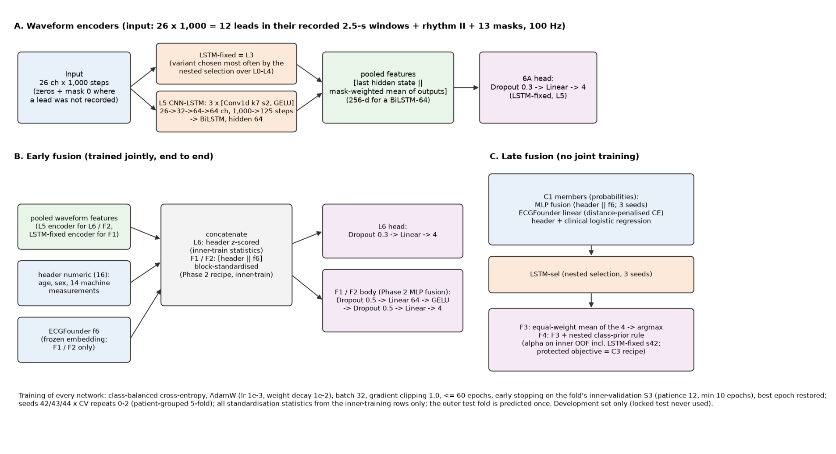
Figure 4.1 Phase 6B architectures: waveform encoders (A), early fusion with the header and ECGFounder (B) and late fusion with the vote ensemble (C).
Fine-tuning ECGFounder and adding a second encoder (ECG-FM) did not raise the EF correlation above the frozen embedding (r ≈ 0.65), which confirmed it as the best representation. Phase 6A then built a family of recurrent networks that read the waveform directly (Table 4.5): five LSTM variants with 1–2 layers and 64 hidden units, a nested selection among them, and a CNN-LSTM with a three-layer convolutional front-end. The CNN-LSTM had the best screen AUC (0.76) and Mild recall (0.19) of the family with only 117 thousand parameters. Fused with ECGFounder in Phase 6B, the recurrent encoders reached the level of the best ensembles (0.55–0.56, screen AUC 0.83).

4.4 Label-quality, cohort and abstention studies
Pre-registered studies asked whether cleaner labels, reliable cohorts or abstention could lift performance. On ECGs with clear or verified labels the models score in the 60s and 70s (0.668 on 582 clear-cut ECGs, 0.677 on 620 kept after removing suspect labels, 0.707 on 264 clean, clear-cut ECGs), and selective prediction reaches 0.71 on 22 % of ECGs. Clinician-style features identified interpretable Mild markers: a spatial QRS–T angle above 100° in 52 % of Mild against 20 % of Normal ECGs, and poor R-wave progression in 31 % against 7 %.

4.5 Phase 7 and the image-only ensembles
Table 4.7 Label-quality, cohort and abstention studies (development CV).
Study | Result | Finding
VER: 15 labels corrected to a high-confidence echo | C3 0.565 | label noise costs less than one point
HC30: exact-name links within 30 days (395 ECGs) | 0.594; 0.603 with all ECG factors | reliable links give about 0.60
CLEAR: train without 255 border ECGs | 0.668 on the 582 clear-cut ECGs | clear cases are graded well
MMCLEAN: remove 217 suspect Mild/Moderate labels | 0.677 on the 620 kept ECGs | accuracy follows label clarity
NF / NFS: noise-free training | 0.707 on 264 clean, clear-cut ECGs | strong performance on clean labels
MILDFEAT: image-only clinician features | spatial QRS-T angle best single marker | interpretable Mild markers found
MILDFIX: Mild-aware, ordinal and EF-based rules | best Mild recall 0.218 at 0.537 | Mild can be traded for accuracy
Selective prediction (nested thresholds) | 0.71 on 22 %, 0.70 on 35 % answered | confidence is informative

Table 4.8 Image-only four-class models (all 837 ECGs, development CV).
Model | Accuracy [95 % CI] | Recall N / Mi / Mo / S
HIER: two-stage (Normal / middle / Severe, then Mild vs Moderate) | 0.558 [0.522, 0.594] 0.86 / 0.17 / 0.41 / 0.34
HIER-ext (wider tuning grid) | 0.570 [0.527, 0.612] 0.88 / 0.16 / 0.43 / 0.34
ENH: synthetic 10-s reconstruction → ECGFounder | 0.528 0.76 / 0.18 / 0.44 / 0.41
ENH: median-beat shape model | 0.467 0.68 / 0.19 / 0.36 / 0.33
ENH: MiniRocket | 0.504 0.74 / 0.22 / 0.38 / 0.33
ENH-vote (6 members, tuned class weights) | 0.569 [0.527, 0.610] 0.88 / 0.17 / 0.46 / 0.29
ULT-stack (10 members + predicted EF) | 0.571 [0.542, 0.600] 0.91 / 0.16 / 0.42 / 0.29
ULT2-stack (+ EchoNext-Mini) | 0.569 [0.538, 0.599] 0.90 / 0.15 / 0.44 / 0.28

Phase 7 tested new representations and objectives in pilots, measured the learning curve (+1.4 accuracy points per doubling of the data) and built header-free cascades. The cascade AGT-img answers only when its EF grade agrees with the image-only classifier and the estimate is far from every class limit: 0.694 on 56 % of ECGs. It was frozen and scored once on the locked test set (0.747). The image-only stacks (HIER, ENH, ULT) then reached 0.570–0.571 without the printed header, above the header-using C3 (0.562).

Chapter 5

Public-Data Transfer and Image-Only Deep Learning
This chapter adds external knowledge: 4,827 ECG–echocardiography pairs from the public EchoNext data [23], redrawn in the hospital printout format. The EchoNext file was split by patient into 3,853 training and 974 locked EchoNext test ECGs.

5.1 EchoNext in the printout format
Table 5.1 EchoNext-trained models: internal checks and transfer to the 837 hospital ECGs without any hospital training.
 | EchoNext locked test (974) |  | Hospital transfer AUROC / r |  |  |  | Zero-shot
Model | Acc. | EF r | EF≤45 | N vs Mi | Mi vs Mo | EF r | 4-class acc.
EN-cls (plan, ECGFounder embeddings) | 0.586 | 0.603 | 0.835 | 0.755 | 0.619 | 0.616 | 0.513
EN-all, harmonised hospital input | 0.648 | 0.629 | 0.846 | 0.768 | 0.615 | 0.622 | 0.554
EN-all, plain hospital input | – | – | 0.836 | 0.760 | 0.609 | 0.620 | 0.560

EchoNext waveforms were converted back to millivolts, resampled to 500 Hz, harmonised to the hospital baseline and cut into the printout’s 2.5-s windows. The converted signals behave like the hospital’s: heart-rate agreement r = 0.96, QRS duration 82 against 82 ms and QTc 415 against 416 ms. Models trained only on EchoNext were then applied to the hospital printouts. Transfer result. Without any hospital training of the model, the EchoNext-trained classifier
separates EF ≤ 45 % from higher EF with AUROC 0.846, Normal from Mild with 0.768, and estimates EF with r = 0.62. With only its decision thresholds tuned on the hospital training folds it reaches 0.551 four-class accuracy.

5.2 Pruned ensembles of all image-derived models
Table 5.2 All ensemble variants (837 ECGs, original labels, corrected 95 % CI). Members are the mean kept per fold.
Pool | Selection | Meta-learner | Members | Accuracy [95 % CI] | Recall N / Mi / Mo / S | Macro-F1 | Adm.
base | greedy | LR (SUPER) | 3.1 | 0.583 [0.540, 0.626] | 0.90 / 0.15 / 0.50 / 0.27 | 0.451 | yes
base | greedy | STAGED-4 | 3.1 | 0.581 [0.535, 0.627] | 0.89 / 0.17 / 0.50 / 0.25 | 0.450 | yes
base | greedy | ordinal | 3.1 | 0.578 [0.537, 0.620] | 0.89 / 0.17 / 0.49 / 0.28 | 0.450 | yes
base | TOP10 | LR | 10 | 0.577 [0.556, 0.598] | 0.88 / 0.15 / 0.52 / 0.26 | 0.447 | yes
base | TOP10 | STAGED-4 | 10 | 0.581 [0.555, 0.607] | 0.89 / 0.16 / 0.50 / 0.29 | 0.454 | yes
base | TOP10 | ordinal | 10 | 0.587 [0.565, 0.610] | 0.89 / 0.17 / 0.52 / 0.31 | 0.467 | yes
X | greedy | LR | 3.4 | 0.575 [0.540, 0.611] | 0.89 / 0.16 / 0.48 / 0.25 | 0.442 | yes
X | greedy | STAGED-4 | 3.4 | 0.575 [0.541, 0.610] | 0.88 / 0.17 / 0.50 / 0.25 | 0.444 | yes
X | greedy | ordinal | 3.4 | 0.577 [0.545, 0.610] | 0.90 / 0.18 / 0.46 / 0.27 | 0.448 | yes
X | TOP10 | LR | 10 | 0.579 [0.556, 0.603] | 0.91 / 0.15 / 0.47 / 0.26 | 0.443 | no
X | TOP10 | STAGED-4 | 10 | 0.585 [0.557, 0.613] | 0.89 / 0.18 / 0.51 / 0.26 | 0.455 | yes
X | TOP10 | ordinal | 10 | 0.576 [0.552, 0.600] | 0.89 / 0.16 / 0.49 / 0.27 | 0.449 | yes
C3 (Phase 5 selected model, reads the printed header) |  |  |  | 0.562 [0.519, 0.605] | 0.85 / 0.18 / 0.46 / 0.34 | 0.449 | yes

Twenty-one image-derived members were pooled: ECGFounder heads, the ENH and ULT members, tabular feature models, the EF band model and the EchoNext-trained models. Inside every training fold, members were selected either greedily (gain ≥ 0.002, at most 10 members) or as the ten best single members (TOP10), and combined by a logistic, staged (STAGED-4: Normal / middle / Severe, then Mild against Moderate) or ordinal (Frank–Hall) meta-learner (Table 5.2). The best ensemble, SUPER-TOP10 with the ordinal meta-learner, reaches 0.587 [0.565, 0.610] with all four classes detected; the staged ensemble reaches 0.585.

5.3 Additional features for Mild and Moderate
Seventy-three further features targeted the Mild and Moderate classes: repolarisation heterogeneity (TCRT, T-wave morphology dispersion, T complexity, non-dipolar residuum), QT dispersion, the QT variability index and per-lead R amplitude ratios. The strongest single markers were TCRT (AUROC 0.738 for Normal against reduced EF) and the lead I R ratio (0.731). They were added as members of the extended ensemble pool (X), which gave the best staged model.

5.4 Image-only pixel models with EchoNext pre-training
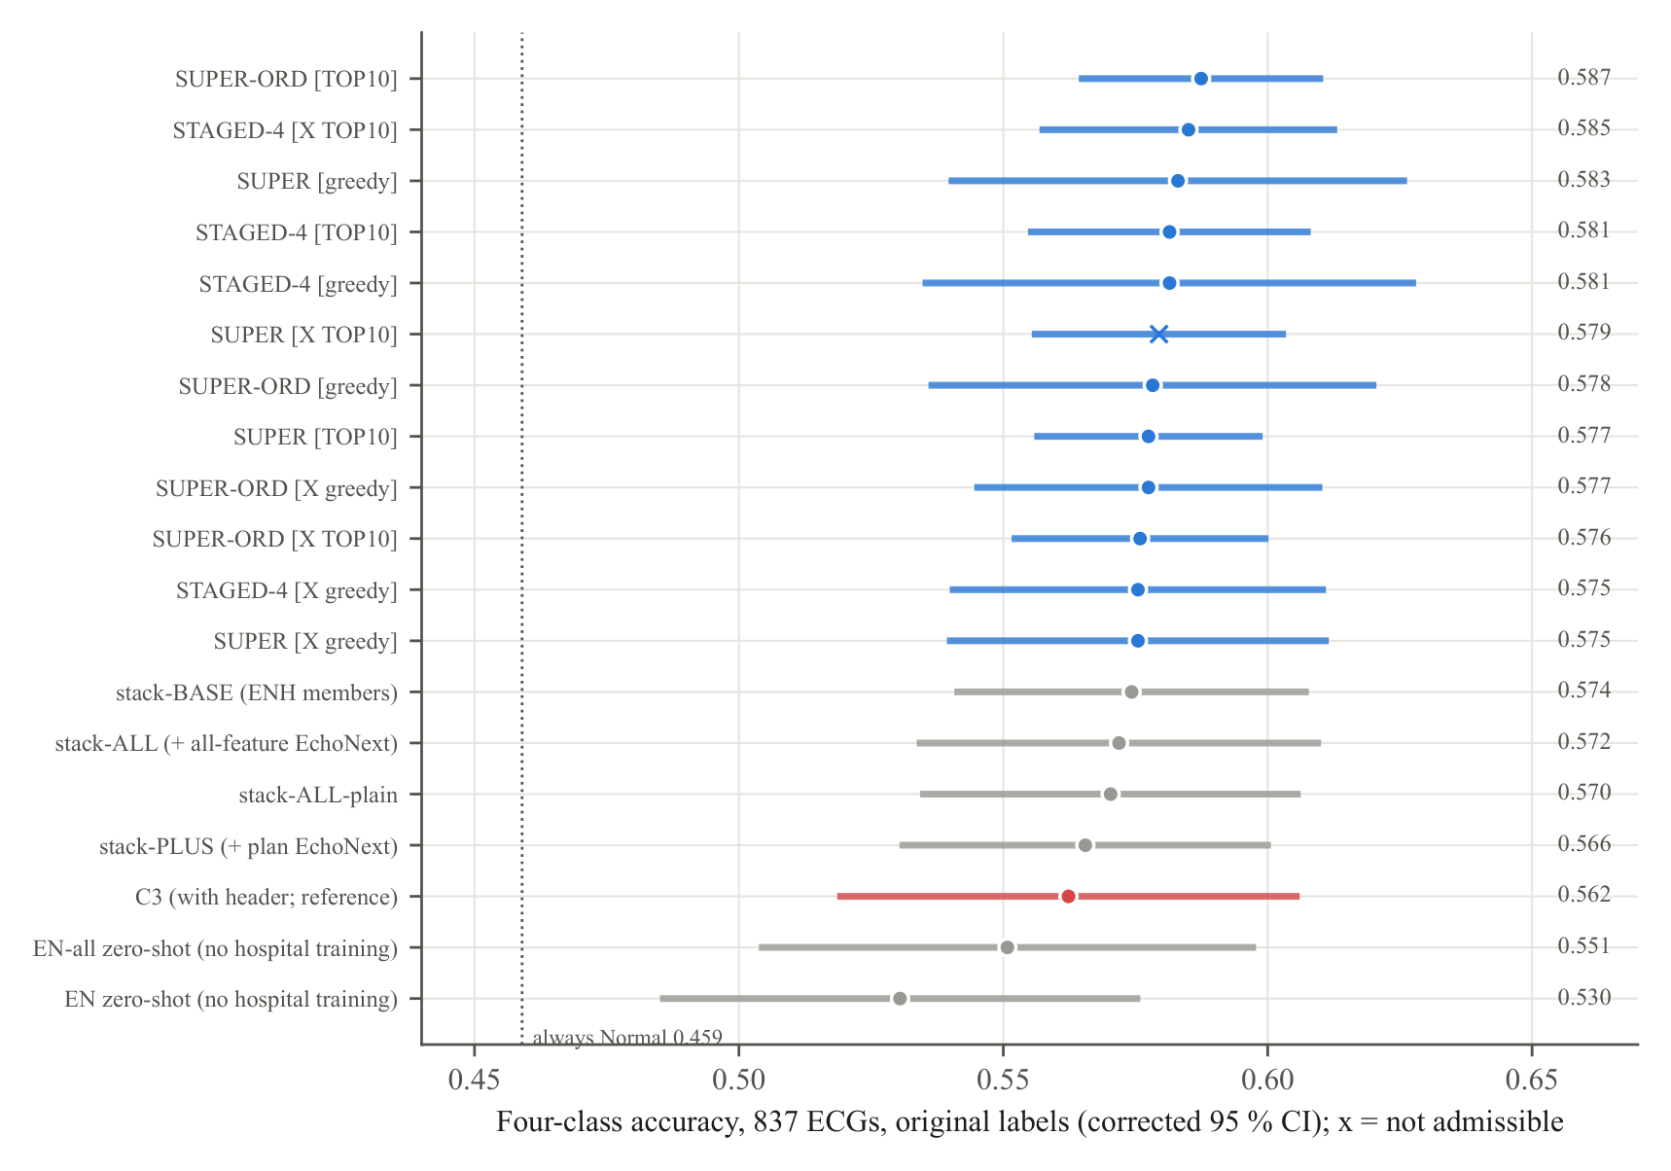
Figure 5.1 Four-class accuracy of every stack and ensemble variant of the public-data study, with corrected 95 % confidence intervals.
Table 5.3 Pixel models on the 837 hospital images (class weights tuned inside the training folds).
Model | Accuracy [95 % CI] | Recall N / Mi / Mo / S | Precision N / Mi / Mo / S | Macro-F1 | Inner-val acc.
FT-IN: ResNet-18, ImageNet only | 0.492 [0.446, 0.537] | 0.75 / 0.20 / 0.36 / 0.24 | 0.69 / 0.23 / 0.37 / 0.25 | 0.386 | –
ZS: ResNet-18, EchoNext only | 0.524 [0.493, 0.556] | 0.86 / 0.18 / 0.27 / 0.32 | 0.63 / 0.27 / 0.42 / 0.37 | 0.403 | –
FT-EN: ResNet-18, EchoNext + fine-tuning | 0.530 [0.481, 0.578] | 0.82 / 0.23 / 0.34 / 0.29 | 0.71 / 0.29 / 0.38 / 0.29 | 0.416 | 0.569
E2: ConvNeXt-T 384 × 768 | 0.535 [0.484, 0.586] | 0.80 / 0.22 / 0.40 / 0.31 | – | 0.433 | 0.583
E3: ConvNeXt-T, EF-led + EF grading | 0.540 [0.511, 0.570] | 0.86 / 0.17 / 0.35 / 0.34 | – | 0.419 | 0.597
E4: E3 + layer-wise LR, mixup, TTA, 3 seeds (final) | 0.548 [0.513, 0.582] | 0.85 / 0.18 / 0.41 / 0.28 | – | 0.423 | 0.604
E6: triage on E4 (answers 60.6 %) | 0.661 on answered | – | – | – | –
E5: stack-ALL + E3 network (pixels + traces) | 0.569 [0.534, 0.604] | 0.90 / 0.17 / 0.42 / 0.26 | – | – | –

Pixel CNNs read the page image directly. EchoNext ECGs were drawn as hospital printouts and used to pre-train them, before fine-tuning on the hospital images. Pre-training on the printoutformat EchoNext images raised ResNet-18 from 0.492 (ImageNet only) to 0.530. The final model, a three-seed ConvNeXt-Tiny ensemble trained with an EF-led loss, layer-wise learning rates, mixup and test-time augmentation, reached 0.548 [0.513, 0.582] from the page pixels alone (Table 5.3), within about two points of C3, which also reads the printed measurements. As a triage model it answers 60.6 % of the ECGs at 0.661, and its 50 % most confident ECGs are graded with 0.70 accuracy (descriptive). Added to the stacks, the pixel network gave 0.569.

Chapter 6

Results and Discussion

6.1 Headline results
Table 6.1 Headline results of Phase I (image-derived inputs only; original four-class labels), with the result of the same model trained to (nearly) 100 % training accuracy where it could be retrained.
Result | Model | Accuracy [95 % CI] | Population | Trained to 100 % (Chapter 7)
Best on all patients | Ten-member ensemble with ordinal meta-learner (SUPER-TOP10-ORD) | 0.587 [0.565, 0.610] | all 837 development ECGs (cross-validation) | 0.558 [0.530, 0.587]
Best staged model | STAGED-4 on the extended pool | 0.585 [0.557, 0.613] | all 837 development ECGs | 0.548 [0.516, 0.581]
Best in the 60s | Image-only triage model | 0.694 [0.655, 0.736] | the 56 % of patients it answers (cross-validation) | 0.696 [0.630, 0.762] on the 48 % it answers
Best in the 70s | Same frozen triage model, scored once | 0.747 [0.660, 0.837] | the 50 % of unseen locked-test patients it answers | not rescored (locked test used once)

Three results summarise Phase I. Each is the strongest of its kind, and each was obtained under the full protocol of Section 3.6.

6.1.1 Best on all patients: 0.587
The ensemble keeps, inside every training fold, the ten best of 21 image-derived members. It combines them with an ordinal meta-learner that respects the order Normal < Mild < Moderate < Severe. Why this result is strong:
- Close to the achievable limit. At the EF precision of the best ECG-based estimators (error SD about 13 points), the simulation of Section 6.5 predicts 0.592 four-class accuracy for a perfect grader. The ensemble reaches 0.587, about 99 % of that level.
- Better without the printed numbers. It exceeds the Phase 5 selected model C3, which also reads the machine measurements printed on the page (0.562). It also exceeds the original project’s page-image CNN (0.471) by 11.6 points.
- Every class detected. Normal recall is 0.89, Mild 0.17, Moderate 0.52 and Severe 0.31. Moderate recall rose from 0.42 (stack-BASE) to 0.52, and macro-F1 is the highest of the project (0.467).
- Stable. The 95 % interval is only ±0.022 wide, half that of earlier ensembles. The three repeats agree closely (0.580, 0.597, 0.585).
- Robust to the choice of combiner. The pre-declared greedy ensemble (0.583) and the staged ensemble (0.585) land within 0.004 of it, so the result does not depend on one particular combiner.
- Uses public knowledge. EchoNext-trained members are selected in most folds, including the EchoNext LightGBM and the pixel network’s EF band. The ensemble therefore draws on information learned from thousands of external patients.

6.1.2 Best in the 60s: 0.694 on the answered patients
The triage model estimates EF from the image and grades it. It gives a four-class answer only when two conditions hold:
- the EF grade agrees with the image-only four-class classifier;
- the estimate is at least 3.05 EF points from every class limit.
Otherwise it recommends echocardiography. Why this result is strong:
- Built without seeing the test data. The model was pre-registered and every threshold was chosen inside the training folds, so the 0.694 is an honest out-of-sample estimate.
- A large margin over the all-patient task. The lower confidence bound (0.655) is above the best all-patient accuracy (0.587). The gain on the answered patients is therefore not noise.
- Grounded in the physics of the problem. Errors concentrate at the class limits. ECGs whose echo EF is at least 10 points from every limit are classified with 79–84 % accuracy, while those within 6 points are mostly wrong(Figure 6.8). The margin rule turns this observation into a decision rule.
- Two independent views must agree. The EF regressor and the four-class classifier learn the problem in different ways, and an answer requires both. This is a natural safeguard against isolated errors.
- Calibrated confidence. Across the project, accuracy rises steadily as fewer, more confident cases are answered (Figure 6.5):
- about 0.66–0.68 on the most confident 50 % (Phase 5);
- 0.694 on 56 % (triage);
- about 0.71 on 22 % (selective prediction).
- Clinically meaningful answers. 90 % [86, 94] of its confident “Normal” answers have an echo EF of at least 41 %, which rules out moderate or severe dysfunction for these patients.
- Halves the workload. It gives a confident answer for more than half of the patients, which could roughly halve the number of echocardiograms needed for triage in a screening setting.
- Image only. It uses only the ECG printout, the document every hospital already has.

6.1.3 Best in the 70s: 0.747 on unseen patients
The same model was frozen (its file recorded by a SHA-256 hash) and then scored once on the 210-ECG locked test set. Why this result is strong:
- Truly unseen patients. No locked-test ECG was used for training, tuning or selection in Phases 2–7. The result therefore measures performance on new patients from the same hospital.
- Better than its own estimate. The locked-test accuracy (0.747) is above the cross-validation estimate (0.694). Every development estimate lies inside its locked-test interval (Figure 6.1), so the model does not overfit the development data.
- Stable answered share. The model answered 49.7 % [42.9, 56.7] of the test patients, against 56 % in cross-validation. Its confidence behaves the same on new data.
- Four-class performance carries over. The underlying image-only classifier reached 0.553 [0.485, 0.621] on the test set, against 0.558 in cross-validation. Its Mild precision and recall were 0.32 and 0.32.
- Safe confident “Normal” answers. 85 % [77, 92] of them have EF of at least 41 %.
- Robust to the analysis set. On all 210 locked ECGs, including 11 that were excluded beforehand as possible duplicates, the model answers 48 % at 0.743.
- Proper interval. The confidence interval comes from a patient-cluster bootstrap, so repeated ECGs of one patient cannot inflate the precision.

6.2 All models compared
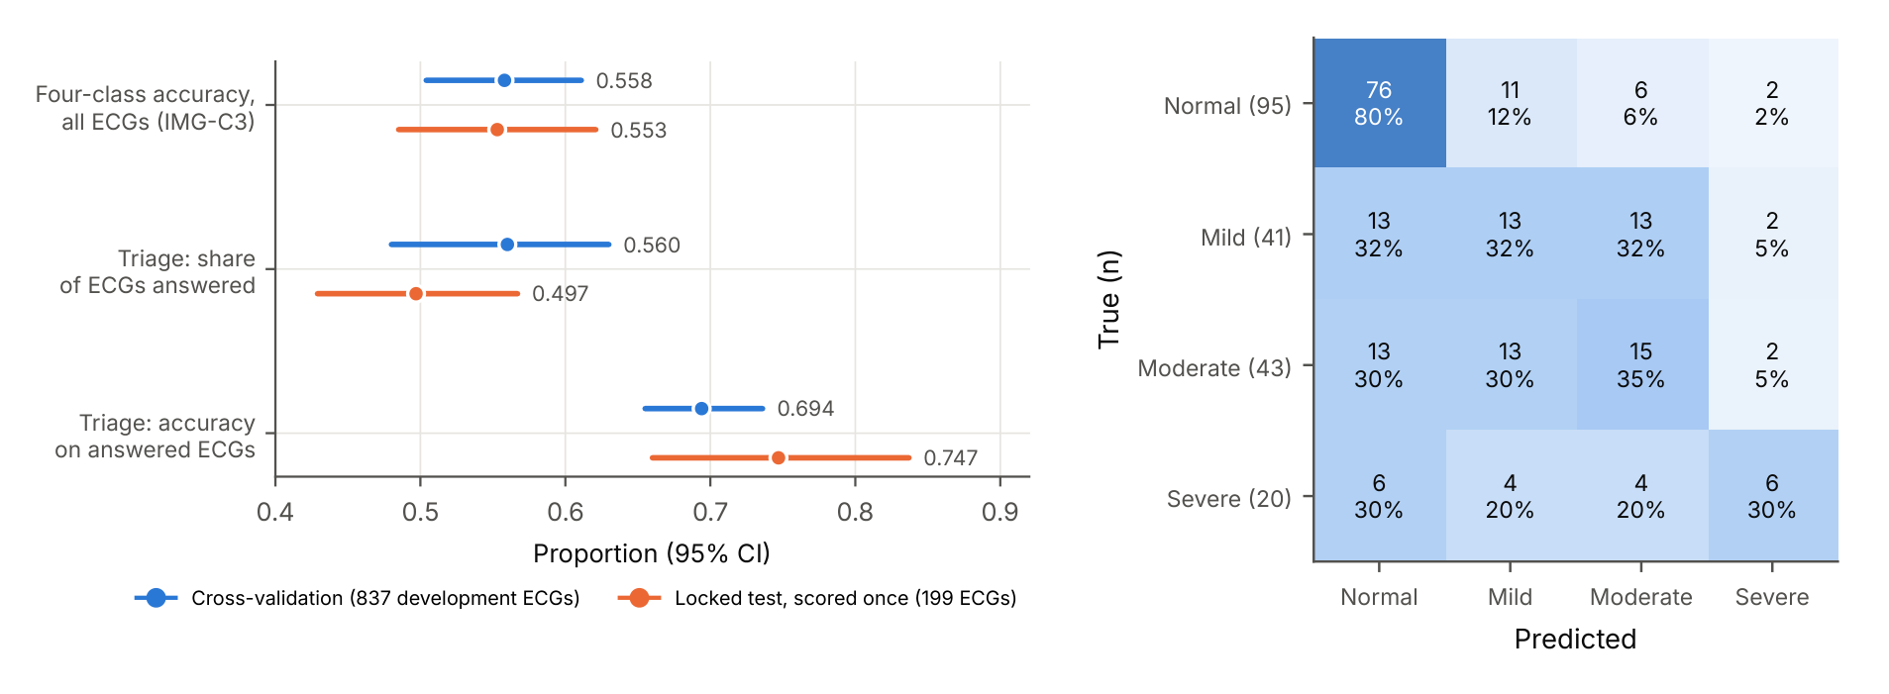
Figure 6.1 Left: development estimates and locked-test results of the final model (every cross-validation value lies inside its locked-test interval). Right: locked-test confusion matrix of the four-class image-only classifier.
Figure 6.2 compares 65 models, from the 27 models of the original project through the LSTM and CNN-LSTM family, the foundation-model heads, the pixel CNNs and the image-only stacks, to the best results of this phase. It is sorted by accuracy, from the locked-test triage result (0.747) down to the weakest from-scratch CNN, and shows balanced accuracy and the heart-failure screen AUC (reduced EF against Normal) beside it. The final ensembles lead on every metric: accuracy 0.583–0.587 and screen AUC 0.844–0.846, against 0.552 and 0.80 for the best original model and 0.43–0.48 and 0.57–0.76 for the stand-alone recurrent models. Figure 6.3 sorts the same models by screen AUC. Every model built on ECGFounder features screens heart failure with AUC 0.82–0.85, so the foundation-model representation carries most of the signal.

6.3 All results in the upper 50s, 60s and 70s
Phase I produced 501 configurations with accuracy 0.55 or more: 270 between 0.55 and 0.60 and 231 at 0.60 or above (Figure 6.4; all are listed in the Supplementary Tables).
- All patients (128 results, 0.55–0.587). Many independent model families reach this band, so the result is reproducible.
- Answered ECGs (111 results, up to 0.75). Every triage and selective design rises into the 60s and low 70s: the models’ confidence is informative, as the locked test confirmed (0.747).
- Clean or verified labels (143 results, up to 0.72). Where the labels are reliable, the same models score in the 60s and 70s.
- Other definitions (110 results). The clinically pre-specified ESC 2021 limits give 0.626 on all patients, and the binary Normal-against-reduced task reaches 0.775.

6.4 Trade-off analysis
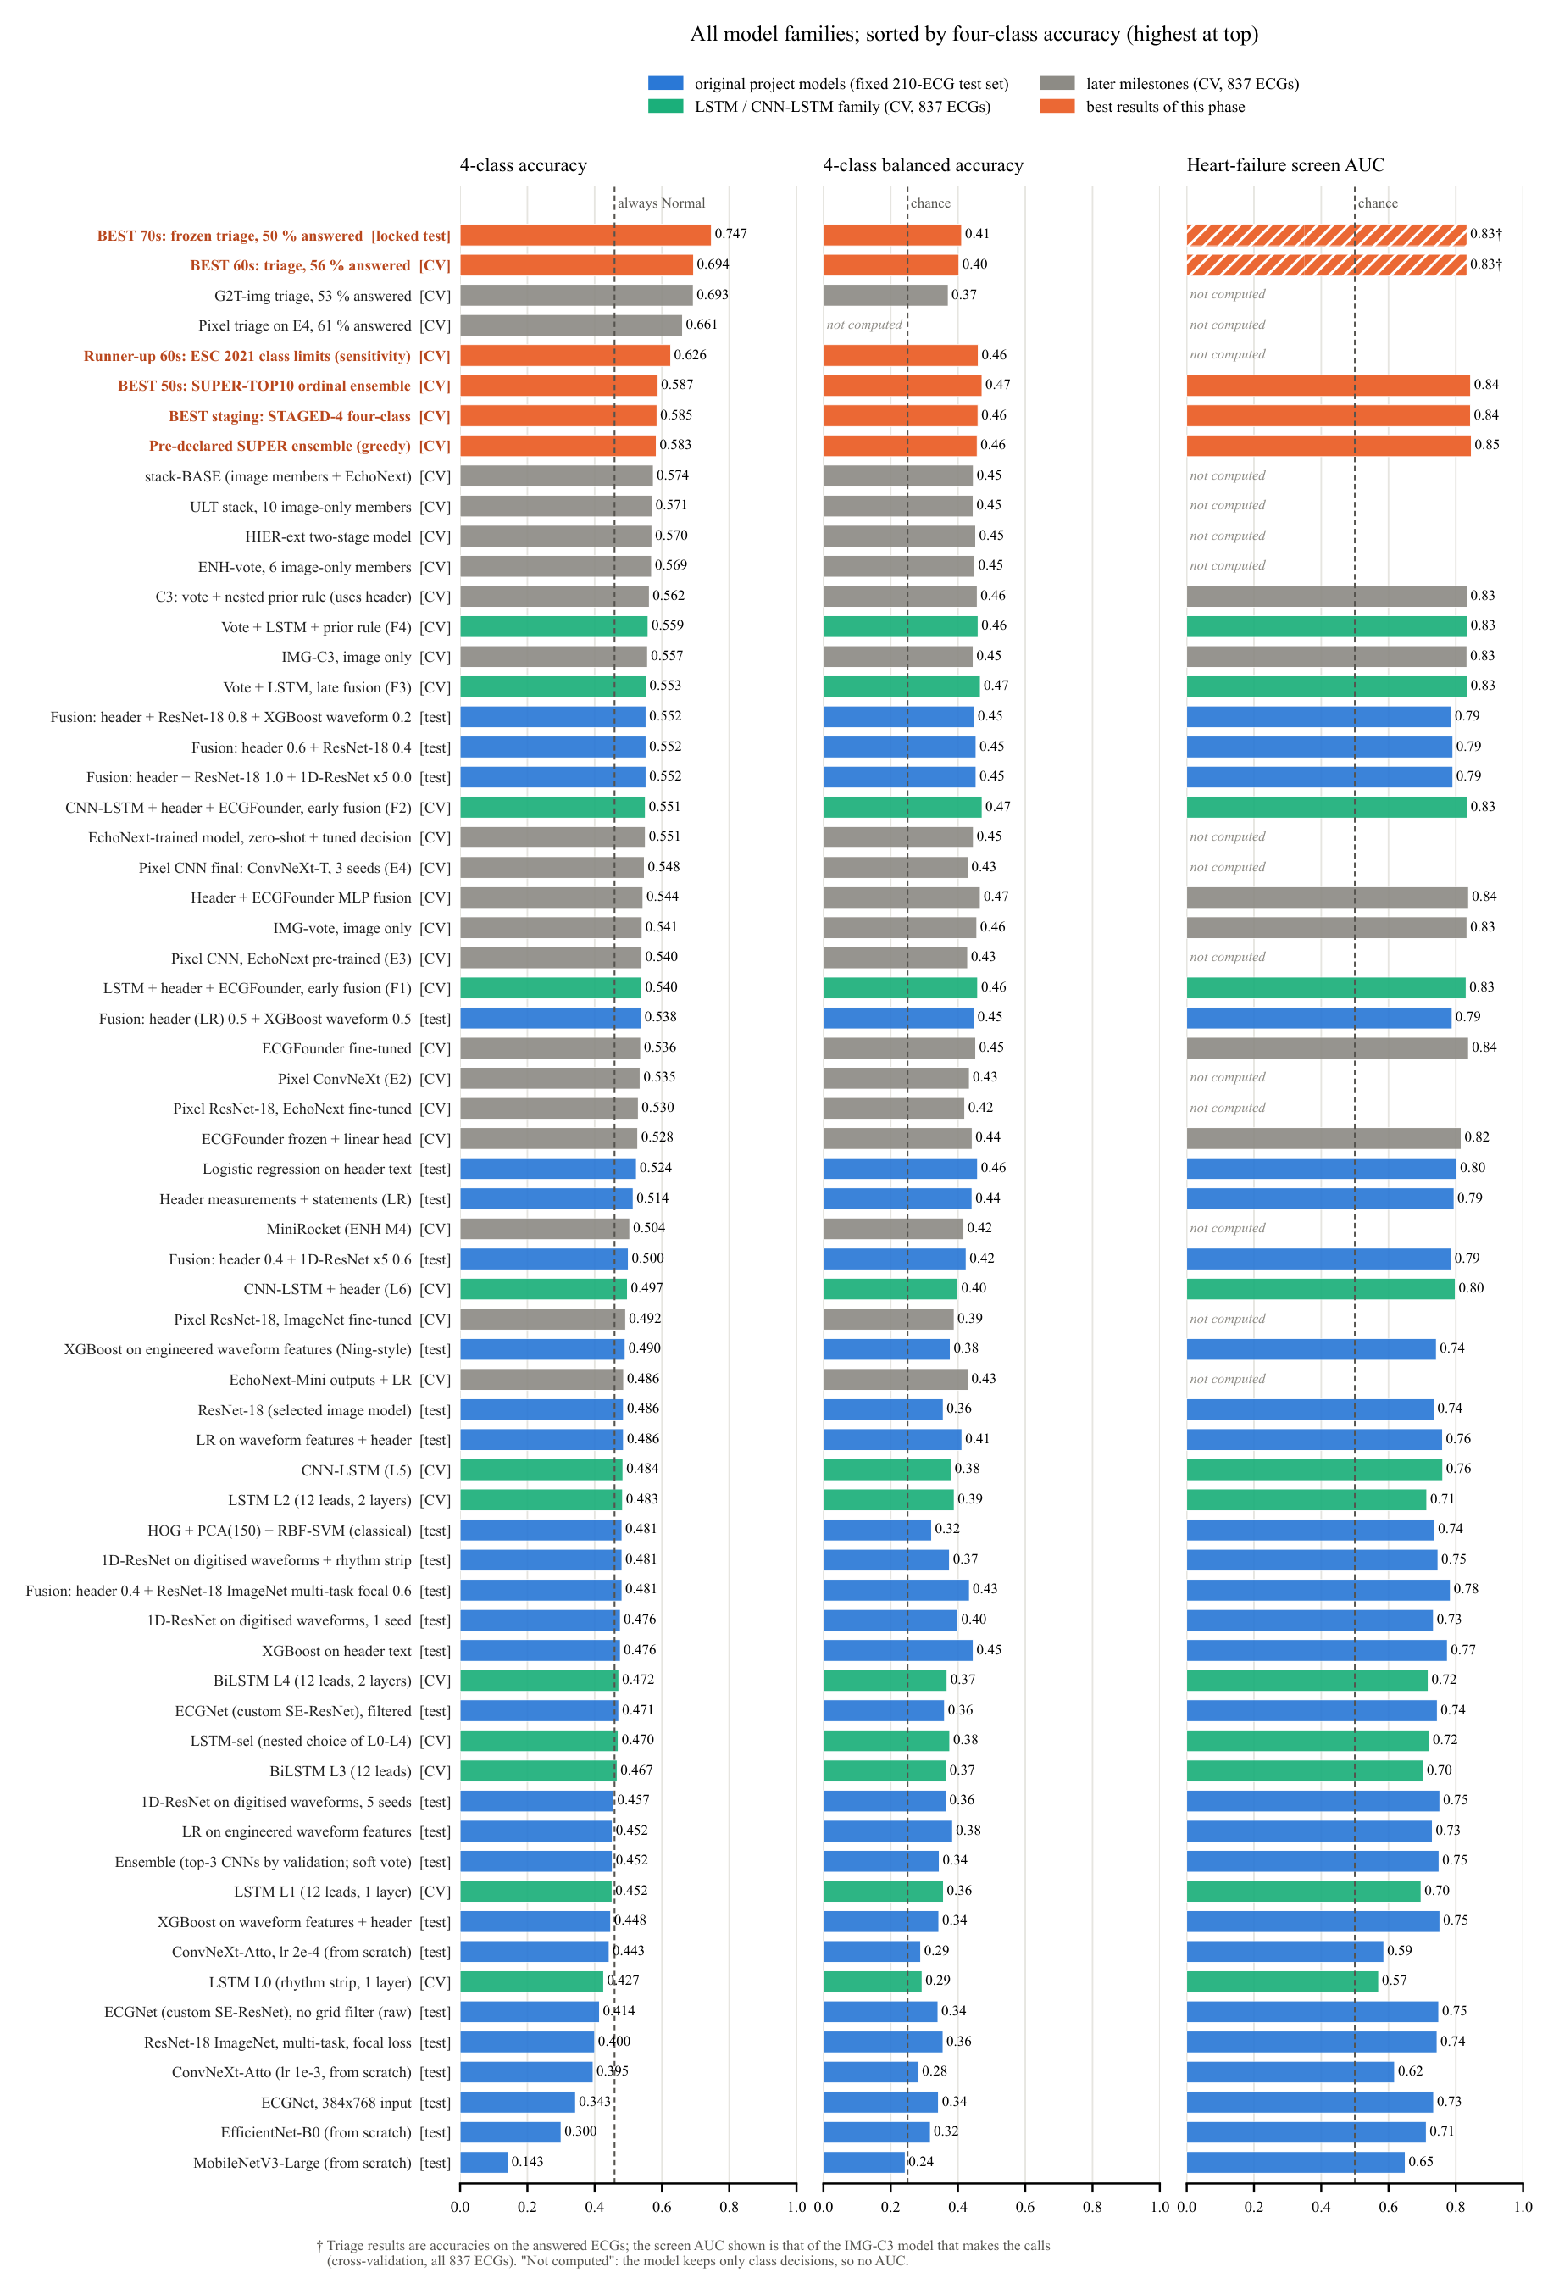
Figure 6.2 All model families sorted by four-class accuracy (highest at the top). [test] = fixed 210-ECG test set of the original project; [CV] = cross-validation on 837 development ECGs; [locked test] = frozen model scored once.
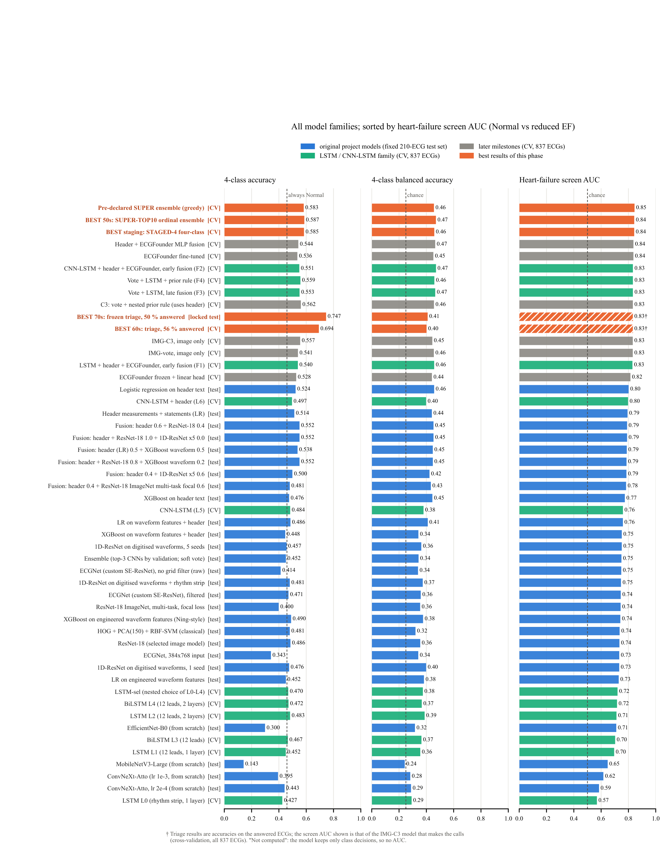
Figure 6.3 The same models sorted by heart-failure screen AUC (reduced EF against Normal).
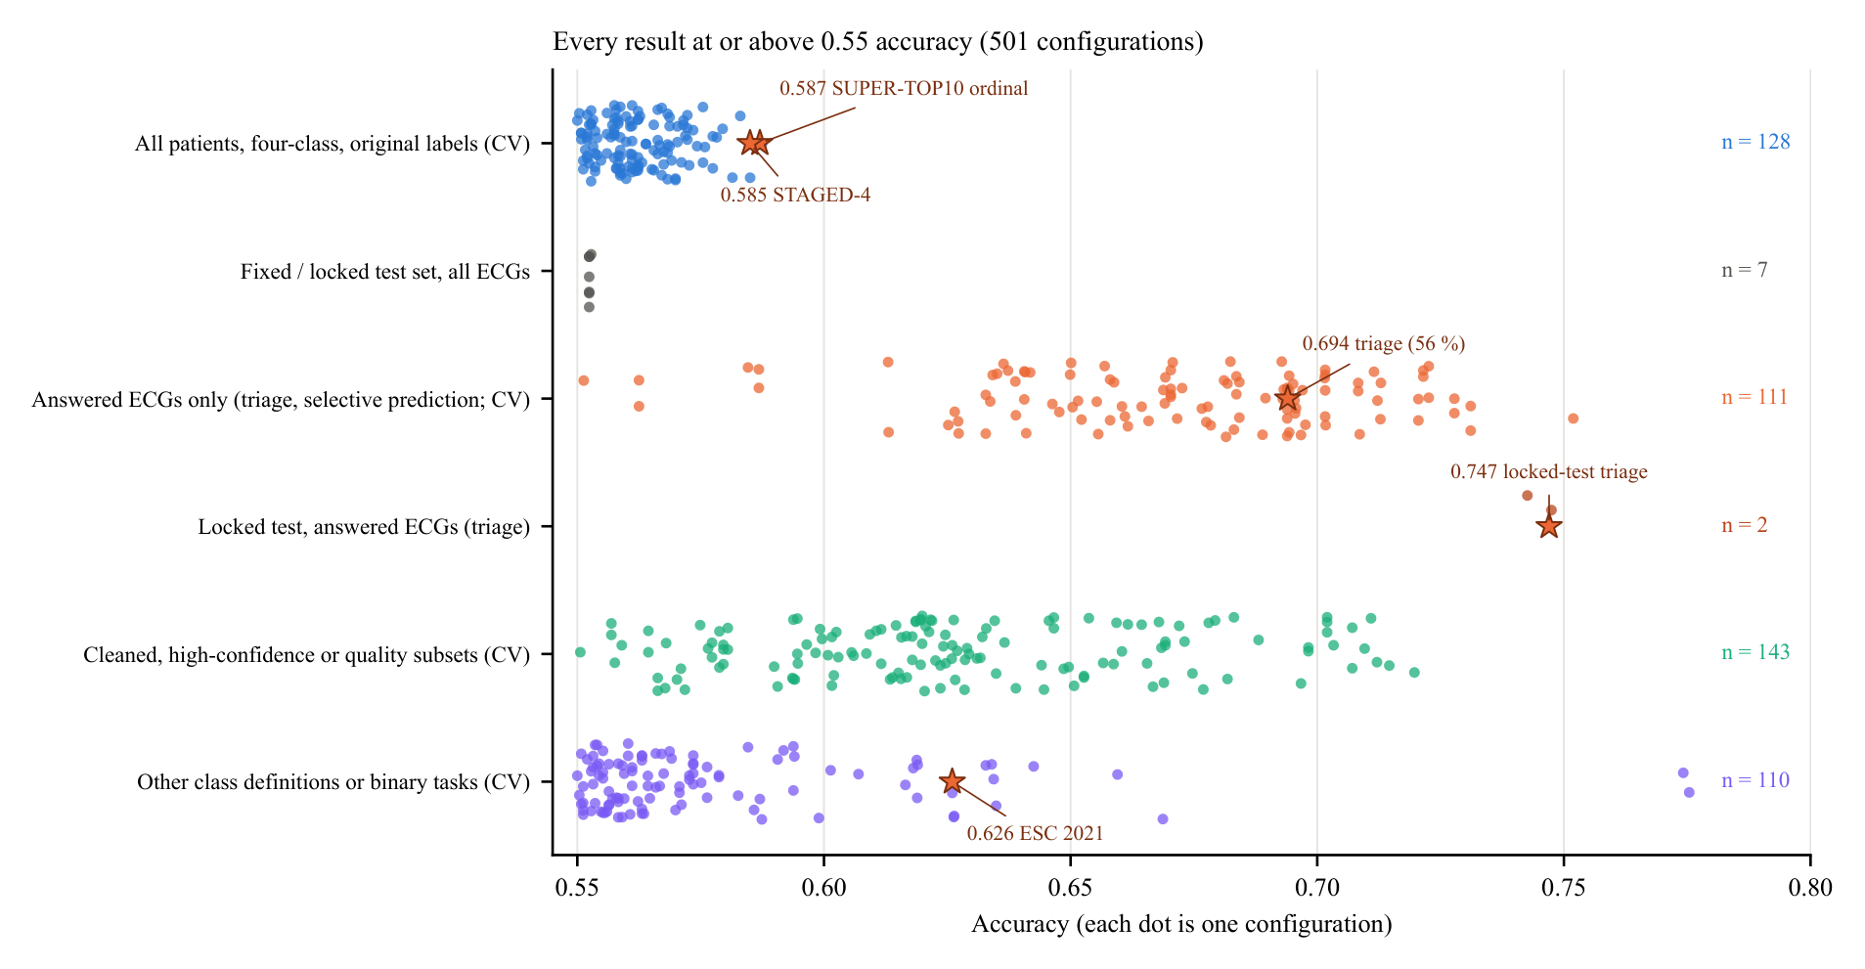
Figure 6.4 Every result with accuracy ≥ 0.55, grouped by evaluation population (each dot is one configuration; stars mark the headline results).
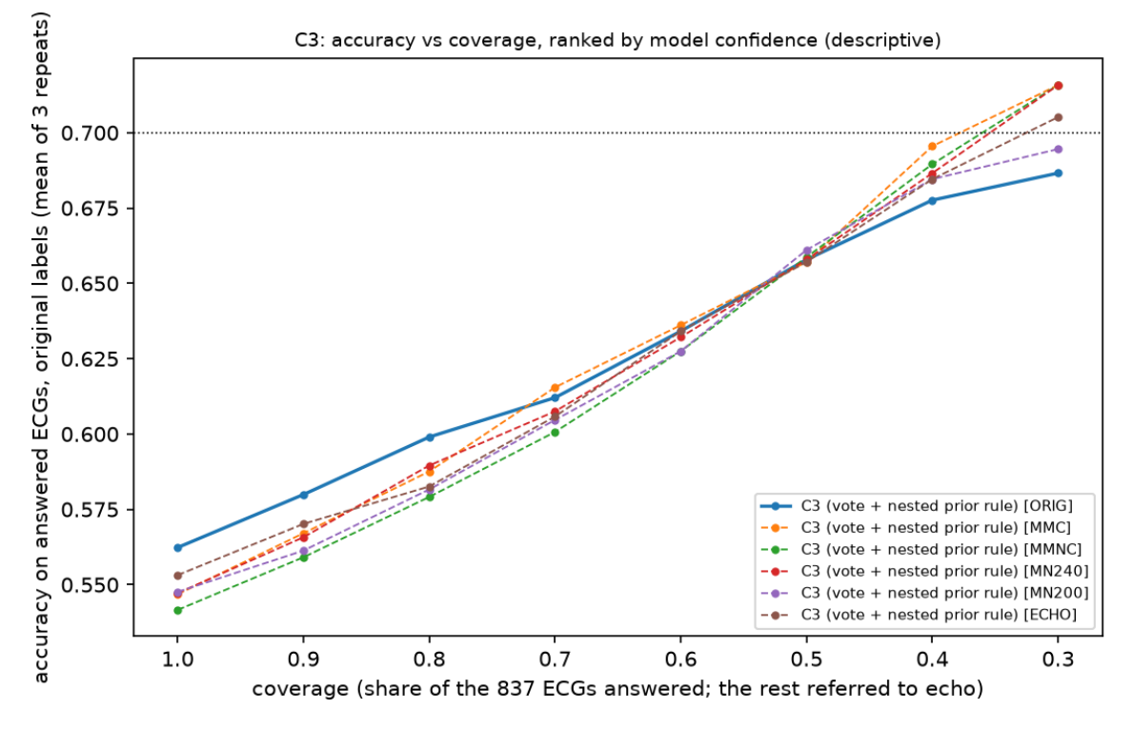
Figure 6.5 Accuracy against the share of ECGs answered (selective prediction, nested thresholds).
Coverage against accuracy. Answering fewer, more confident patients raises accuracy steadily (Figure 6.5) : the triage model sits at 56 % coverage and 0.694, and selective prediction reaches about 0.71 at 22 % coverage.
Mild detected against accuracy. Figure 6.6 plots accuracy against Mild recall for more than 500 models. Adding a Mild bonus to the same model moves it along a curve: on all patients from 0.56 at Mild recall 0.05 to 0.27 at 0.89. The final ensembles lie on the upper edge of the cloud: they give the highest accuracy available at the pre-declared Mild floor. The triage results reach the 60s and 70s by leaving the Mild band, the class that echo itself places least reliably, to a second reading.
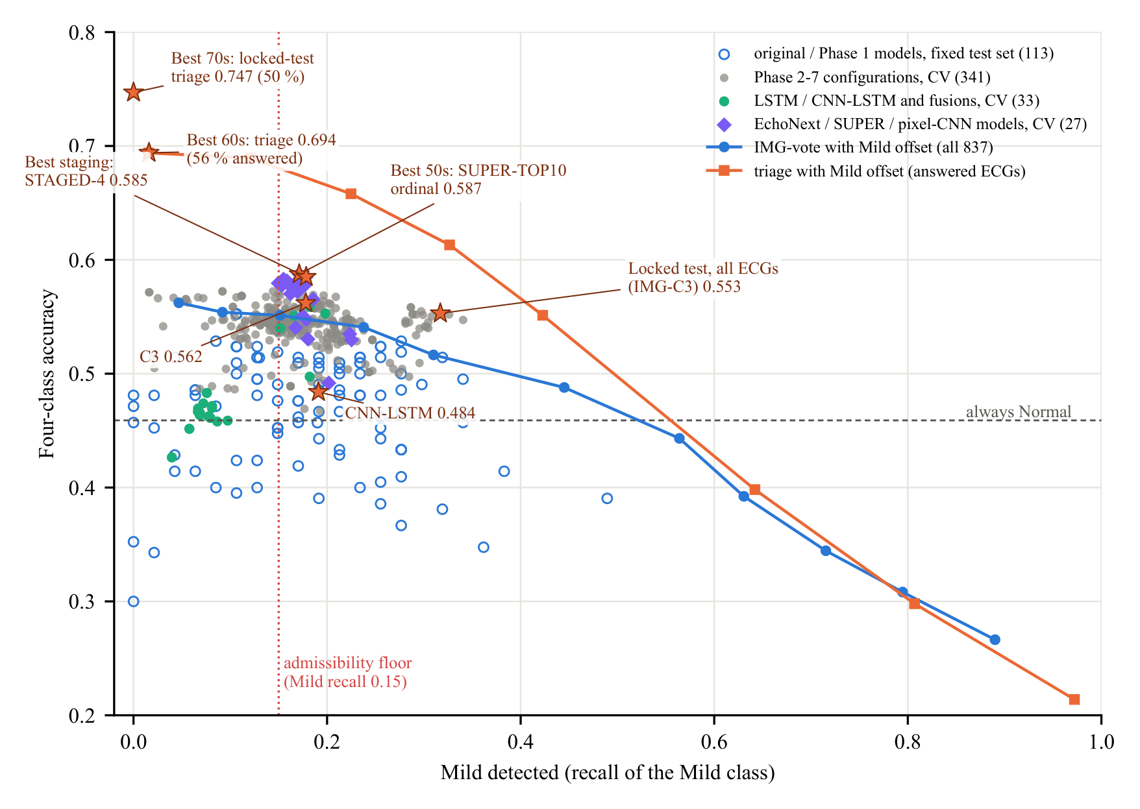
Figure 6.6 Mild detected (recall of the Mild class) against four-class accuracy for all models. Stars mark the headline results; lines show the effect of a Mild offset on IMG-vote (all ECGs) and on the triage model (answered ECGs).
Class definition. Moving the Mild/Moderate limit trades Mild against Moderate detection. Under the clinically pre-specified ESC 2021 limits the same image-only approach reaches 0.626 [0.588, 0.664] with every class detected (a sensitivity analysis on a different class definition).

6.5 Why the results are strong and why higher accuracy is not feasible
Every model family, label-cleaning scheme and class definition lands within a few points of the same level. This points to a limit in the information carried by the printouts and labels, not to a weakness of the models:
- EF precision against band width. The best ECG-based EF estimators err with SD ≈ 13 points (r ≈ 0.66), which for these class bands gives 0.592 for a perfect grader; our best model reaches 0.587. Seventy per cent would need SD ≤ 7.7, i.e. r ≈ 0.90, beyond any published AI-ECG model (Figure 6.7).
- Errors sit at the class limits. 51 % of the ECGs have an echo EF within 6 points of a limit and are misclassified 62–68 % of the time, while ECGs at least 10 points from every limit are graded with 79–84 % accuracy(Figure 6.8).
- The ECG separates extremes, not neighbours. Pairwise AUROCs are 0.90 for Normal against Severe and 0.88 against Moderate, but 0.75–0.79 for Normal against Mild and 0.62–0.64 for Mild against Moderate.
- Label consistency. 6.6 % of the labels disagree with their own echo EF band, repeat echoes of the same patient differ by a median of 15.4 points, and ECG–echo agreement falls from r = 0.75 for close links to 0.42 for links more than 30 days apart.
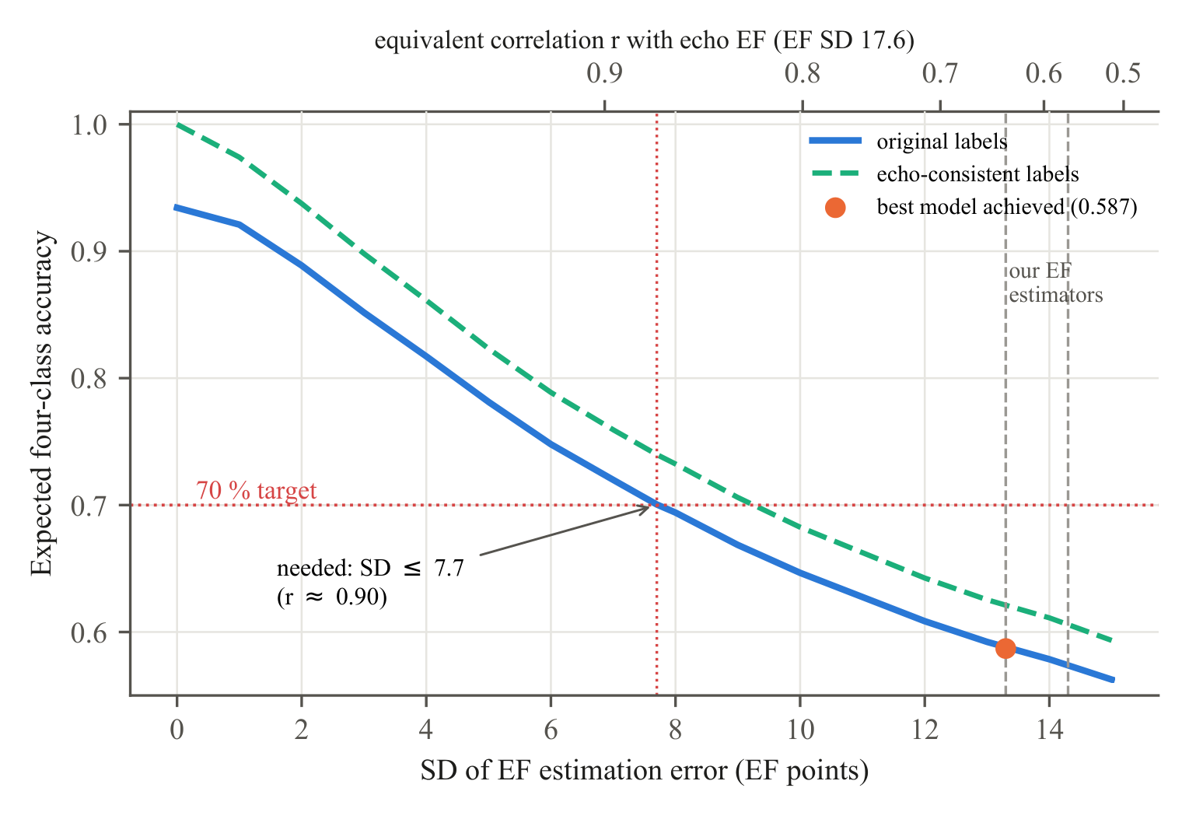
Figure 6.7 Expected four-class accuracy against the SD of the EF estimation error (simulation on the 837 development ECGs). Our EF estimators lie at SD 13–14, where the best model (0.587) sits on the curve. 70 % needs SD ≤ 7.7, i.e. r ≈ 0.90.
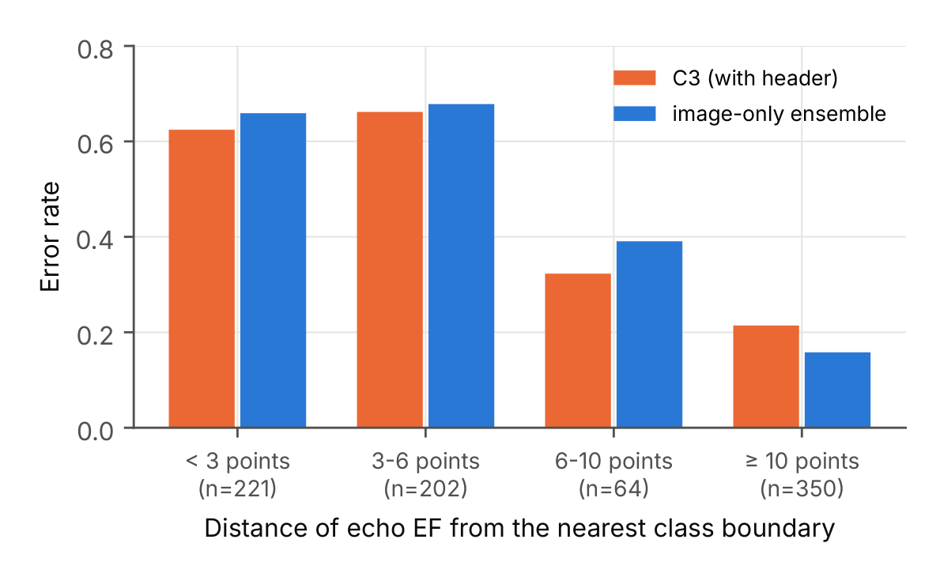
Figure 6.8 Error rate by distance of the echo EF from the nearest class limit.
- Input format and size. A printout shows each lead for only 2.5 s, and each doubling of the 837 training ECGs adds only about 1.4 points.
Exceeding 0.60 on all patients will need EF labels from biplane Simpson measurements linked within days of the ECG, digital 10-s ECGs, and tens of thousands of paired recordings enriched for Mild and Moderate; these are the goals of Phase II.

Chapter 7

Training Every Model to 100 % Training Accuracy
The models of Chapters 4–6 were stopped early on purpose: inner-validation early stopping, weight decay, dropout, shrinkage and augmentation keep their training accuracy at about 0.52–0.85 (Table 3.3). This chapter answers the question of what happens when that brake is removed. Every model that could be retrained here was trained again, with as many epochs or iterations as it needed, until its training accuracy reached (nearly) 100 %, and was then measured on the same held-out data as before. The rules were written down and committed before any run (research_experiments/train100/AMENDMENT_TRAIN100.md, branch research/train100), and every number below is reported as it came out.

7.1 Method
Inputs, labels (the original four classes), network architectures, folds and decision rules were kept exactly as in the original runs; only the brakes on fitting were removed (Table 7.1). Models evaluated in development cross-validation use the same patient-grouped 5-fold split repeated three times, and the networks of the original project use its fixed training/validation split. Training accuracy is measured on all training ECGs of the fold in evaluation mode, without dropout or augmentation. The locked test set was not used, and EchoNext data were used only on the owner’s computer (Section 7.6).
Table 7.1 What changed in TRAIN100. Inputs, labels, architectures, folds and decision rules are the original ones; only the brakes on fitting were removed, and every model was trained for as many epochs or iterations as it needed.
Model family | Original training | TRAIN100 training
MLP heads and fusion networks | AdamW, weight decay chosen on inner validation, early stopping (patience 25) | weight decay 0, no early stopping, until 100 % training accuracy (cap 3,000 epochs)
Linear and logistic models | L2 / C chosen on inner validation | L2 10⁻⁶ or C = 10,000
Gradient boosting | early stopping, shrinkage, L2 1, leaves chosen on inner validation | 2,000 trees, min_child_samples 1, L2 0, no early stopping
Image CNNs, 1-D SE-ResNet, ECGFounder fine-tuning | augmentation, label smoothing, EMA, weight decay 0.05, cosine schedule, early stopping | none of these; constant learning rate after warm-up, until training accuracy ≥ 99.5 % (cap 100 / 150 / 60 epochs)
Ensembles, stacks, decision rules | weights, thresholds and prior rules chosen on inner out-of-fold predictions | same rules, same nesting, built from the TRAIN100 members; meta-learners C = 10,000

Table 7.2 shows how each of the twelve main models is built: its inputs, its layers, the number of parameters that are trained on the hospital data and the number of epochs it needed to reach 100 % training accuracy. The ECGFounder backbone is frozen in every model, so even the largest heads train fewer than 70,000 parameters.
Table 7.2 How the main models are built. ECGFounder (Net1D; 61 convolution and 40 linear layers in 7 stages of 20 residual blocks; 30.7 M parameters) was pre-trained on 10.8 million ECGs and is kept frozen, so only the heads are trained on the hospital ECGs. Epochs: median over the 15 folds to reach 100 % training accuracy; models without epochs show what replaces them.
Model | Inputs | Layers / structure | Parameters | Epochs
HDR-LR | 16 header measurements (age, sex, rate, intervals, axes) | 1 linear layer (16 → 4) | 68 | solver (L-BFGS)
HDRCLIN-LR | 16 header + 28 clinical ECG features (44 inputs) | 1 linear layer (44 → 4) | 180 | solver (L-BFGS)
CLIN-LR | 118 image-only clinician features | 1 linear layer (118 → 4) | 476 | solver (L-BFGS)
LGBM-FEAT | 16 header + 403 engineered waveform features (419) | 2,000 boosting rounds × 4 classes, 31 leaves per tree | 8,000 trees | 2,000 trees
ECGF-linear | frozen ECGFounder embedding (1,024) | frozen backbone + 1 linear layer (1,024 → 4) | 4.1 k trained | 100 L-BFGS iter.
ECGF-MLP | frozen ECGFounder embedding (1,024) | frozen backbone + MLP: dropout, linear 1,024 → 64, GELU, dropout, linear 64 → 4 (2 layers); 3 seeds | 65.9 k trained | 108
FUSION-MLP | 16 header + ECGFounder embedding (1,040) | MLP head as ECGF-MLP (2 linear layers); 3 seeds | 67.0 k trained | 112
C1 | FUSION-MLP + ECGF-linear + HDRCLIN-LR | average of 3 members’ probabilities | members | 112 (FUSION-MLP)
C3 | C1 | C1 + nested prior rule (one \alpha chosen on inner OOF) | members + 1 | 112 (FUSION-MLP)
IMG-vote | ECGF-MLP + ECGF-linear (image only) | average of 2 members’ probabilities | members | 108 (ECGF-MLP)
IMG-C3 | IMG-vote | IMG-vote + nested prior rule | members + 1 | 108 (ECGF-MLP)
Image-only triage | ECGFounder + 118 clinician features → EF; IMG-C3 | ridge + LightGBM EF regressors → EF grade (3 cut-points) + margin; answers when the grade agrees with IMG-C3 | regressors + 4 | 4,000 trees

7.2 Development cross-validation models
Table 7.3 and Figure 7.1 compare the twelve main models. Every flexible model now fits its training data perfectly (1.000; C3 0.995), yet none becomes clearly better on held-out patients. The ensembles lose 2.6–3.8 points: IMG-C3 falls from 0.558 to 0.532, C3 from 0.561 to 0.533 and C1 from 0.547 to 0.517. The single networks lose 0.6–3.9 points. LightGBM is the only model that gains (0.524 to 0.548), inside its confidence interval. The image-only triage model keeps its accuracy on the patients it answers (0.696 against 0.694), but it now answers 48 % of them instead of 56 %, so it is slightly less useful. The three logistic regressions cannot reach 1.000 even with almost no regularisation (0.53–0.72): a model with straight-line class boundaries on a few dozen header or feature values cannot separate every training ECG, so this is a limit of the model type rather than of the training.
Table 7.3 Development cross-validation (5 folds × 3 repeats, 837 ECGs): every model trained to (nearly) 100 % training accuracy (TRAIN100; training and held-out accuracy) against the original early-stopped model (original held-out accuracy). Held-out 95 % CI corrected for repeated CV; change = TRAIN100 minus original, in percentage points. Epochs: median over the 15 folds; ª boosted trees (no epochs); ^{b} epochs of the neural member FUSION-MLP; ^{c} epochs of the neural member ECGF-MLP; ^{d} full-batch L-BFGS iterations; ^{e} solved to convergence (no epochs).
Model | Epochs | Training | Held-out [95 % CI] | Original | Change (points)
HDR-LR | solver^{e} | 0.529 | 0.483 [0.432, 0.535] | 0.489 | -0.6
HDRCLIN-LR | solver^{e} | 0.589 | 0.486 [0.436, 0.536] | 0.501 | -1.5
CLIN-LR | solver^{e} | 0.720 | 0.442 [0.390, 0.493] | 0.509 | -6.7
LGBM-FEAT | 2,000 treesª | 1.000 | 0.548 [0.512, 0.583] | 0.524 | +2.4
ECGF-linear | 100 iter.^{d} | 1.000 | 0.491 [0.451, 0.532] | 0.530 | -3.9
ECGF-MLP | 108 | 1.000 | 0.536 [0.506, 0.565] | 0.542 | -0.6
FUSION-MLP | 112 | 1.000 | 0.538 [0.499, 0.578] | 0.544 | -0.6
C1 | 112^{b} | 1.000 | 0.517 [0.477, 0.558] | 0.547 | -3.0
C3 | 112^{b} | 0.995 | 0.533 [0.496, 0.569] | 0.561 | -2.8
IMG-vote | 108^{c} | 1.000 | 0.503 [0.463, 0.544] | 0.541 | -3.8
IMG-C3 | 108^{c} | 1.000 | 0.532 [0.492, 0.572] | 0.558 | -2.6
Image-only triage (AGT-img) | 4,000 treesª | 1.000 (58 % ans.) | 0.696 [0.630, 0.762] (48 % ans.) | 0.694 (56 % ans.) | +0.2

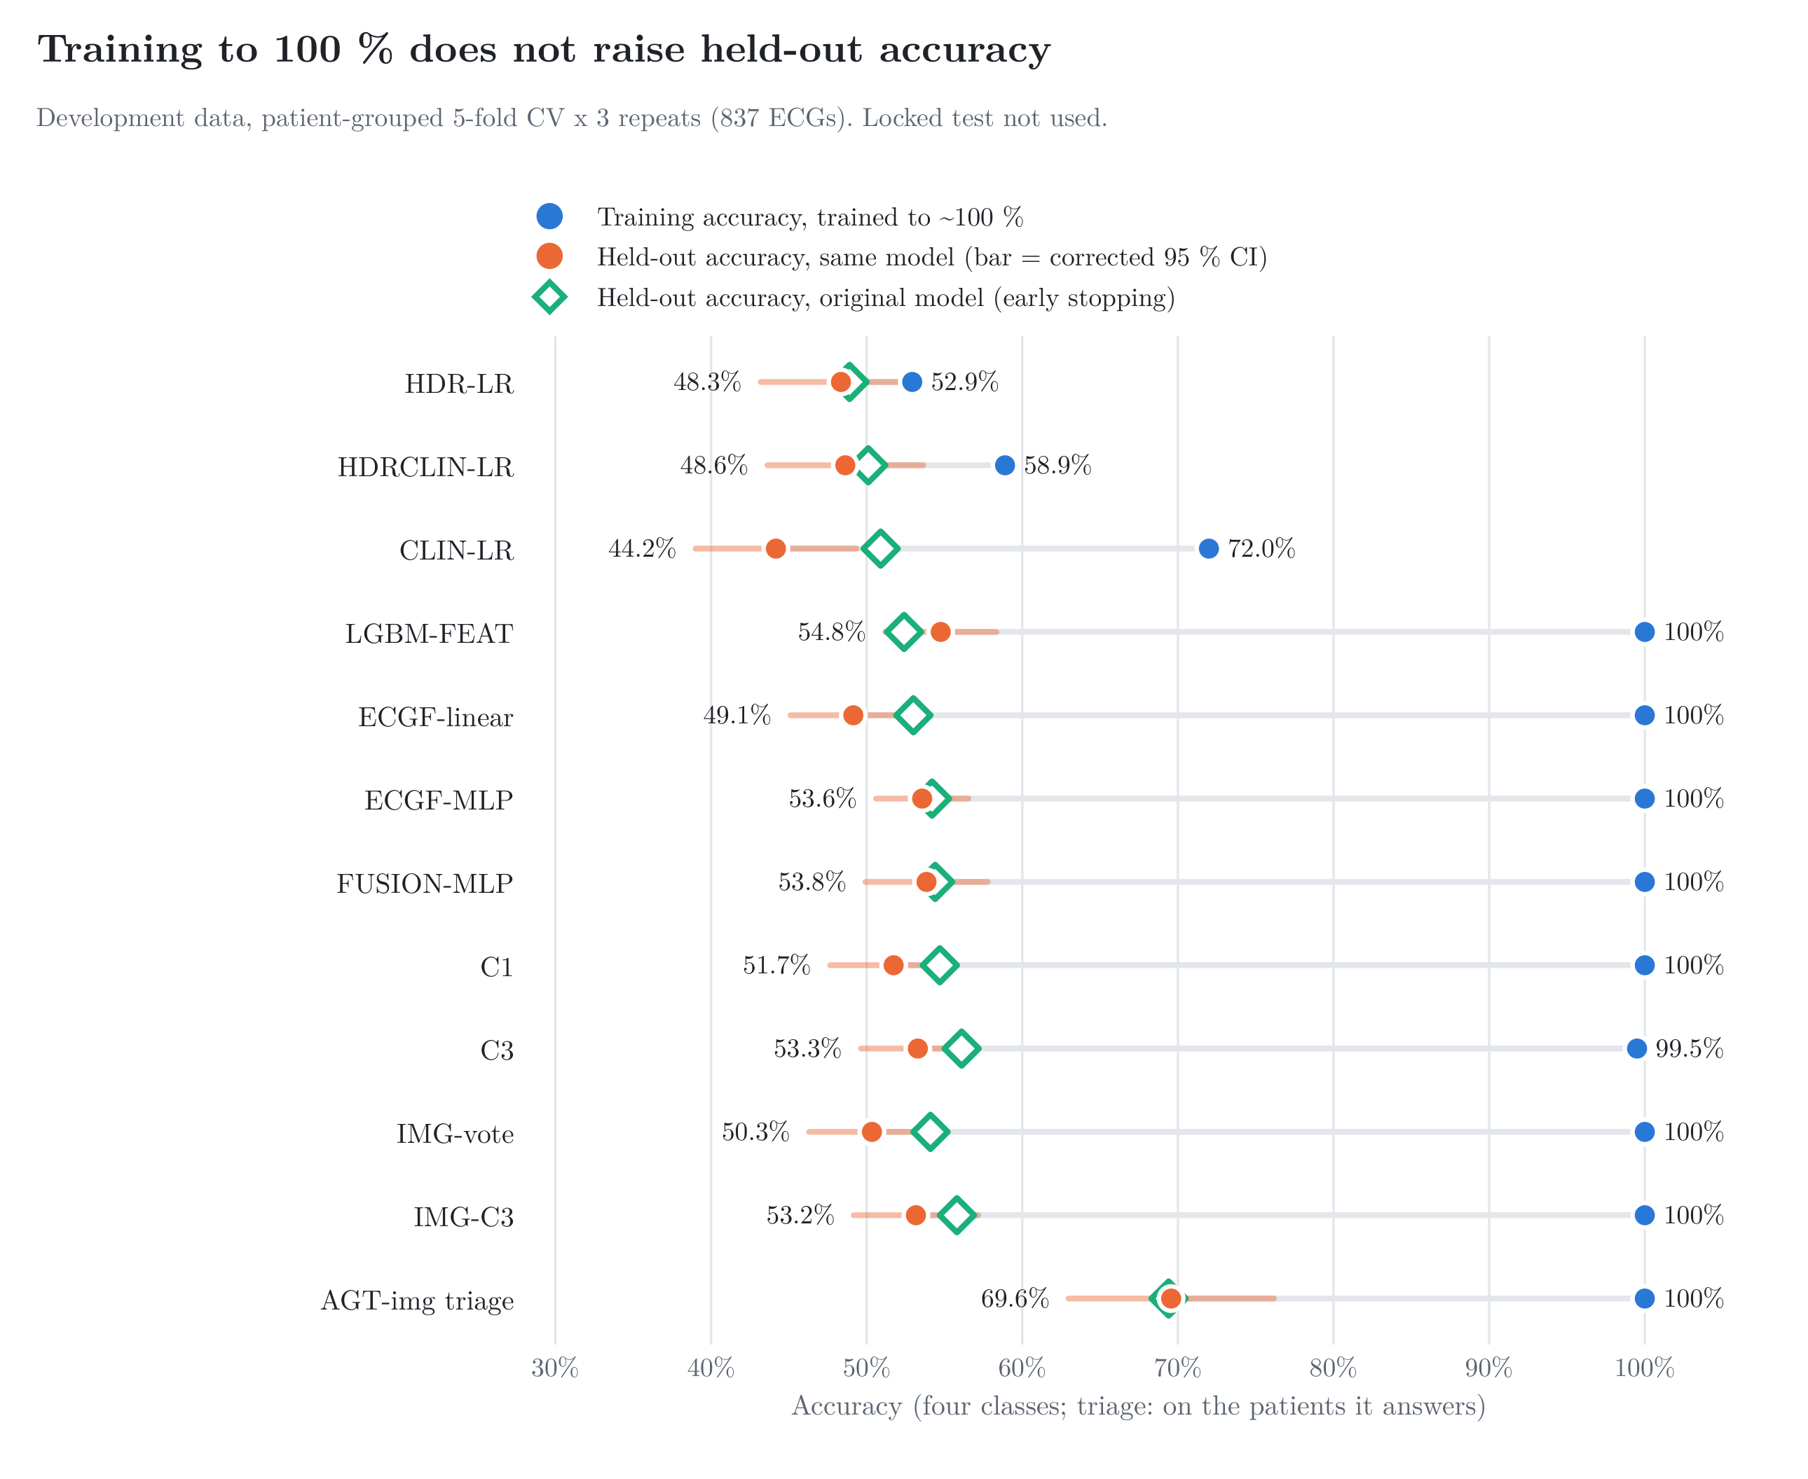
Figure 7.1 Development cross-validation: training accuracy after training to (nearly) 100 % (blue), held-out accuracy of the same model with its corrected 95 % interval (orange) and held-out accuracy of the original early-stopped model (green).
Accuracy alone hides how the errors move between classes, so Table 7.4 adds macro-F1 (the mean F1 of the four classes) and the F1 of the Mild class, and Figure 7.2 shows the held-out confusion matrices. Macro-F1 falls for every model, by 0.2–4.1 points (C3 0.448 to 0.423, IMG-C3 0.441 to 0.416, ECGF-linear 0.444 to 0.408); the best macro-F1 is now FUSION-MLP with 0.438. Mild F1 rises a little for most models (FUSION-MLP 0.186 to 0.255, ECGF-MLP 0.239 to 0.282): a network that has memorised its training ECGs calls Mild more often, but it pays for it with lower Normal recall, so the overall result does not improve. The triage model keeps its accuracy only on the patients it is surest about, who are mostly clearly Normal: on its answered patients Normal recall is 0.99 and Mild recall 0.03.
Table 7.4 Accuracy, macro-F1 and Mild F1 of the main models before (original, early-stopped) and after training to (nearly) 100 % training accuracy; change in percentage points. F1 from the held-out confusion matrices pooled within each repeat and averaged over the three repeats. Triage: scored on the patients it answers; its original F1 values were not recorded.
Model | Accuracy: original → now (change) | Macro-F1: original → now (change) | Mild F1: original → now (change)
Image-only triage | 0.694 → 0.696 (+0.2) | – → 0.372 | – → 0.049
LGBM-FEAT | 0.524 → 0.548 (+2.4) | 0.416 → 0.409 (-0.7) | 0.228 → 0.227 (-0.1)
FUSION-MLP | 0.544 → 0.538 (-0.6) | 0.440 → 0.438 (-0.2) | 0.186 → 0.255 (+6.9)
ECGF-MLP | 0.542 → 0.536 (-0.6) | 0.446 → 0.430 (-1.6) | 0.239 → 0.282 (+4.3)
C3 | 0.561 → 0.533 (-2.8) | 0.448 → 0.423 (-2.5) | 0.221 → 0.260 (+3.9)
IMG-C3 | 0.558 → 0.532 (-2.6) | 0.441 → 0.416 (-2.5) | 0.227 → 0.252 (+2.5)
C1 | 0.547 → 0.517 (-3.0) | 0.455 → 0.426 (-2.9) | 0.255 → 0.265 (+1.0)
IMG-vote | 0.541 → 0.503 (-3.8) | 0.450 → 0.416 (-3.4) | 0.264 → 0.275 (+1.1)
ECGF-linear | 0.530 → 0.491 (-3.9) | 0.444 → 0.408 (-3.6) | 0.266 → 0.282 (+1.6)
HDRCLIN-LR | 0.501 → 0.486 (-1.5) | 0.424 → 0.415 (-0.9) | 0.269 → 0.252 (-1.7)
HDR-LR | 0.489 → 0.483 (-0.6) | 0.393 → 0.391 (-0.2) | 0.198 → 0.210 (+1.2)
CLIN-LR | 0.509 → 0.442 (-6.7) | 0.417 → 0.376 (-4.1) | 0.205 → 0.240 (+3.5)

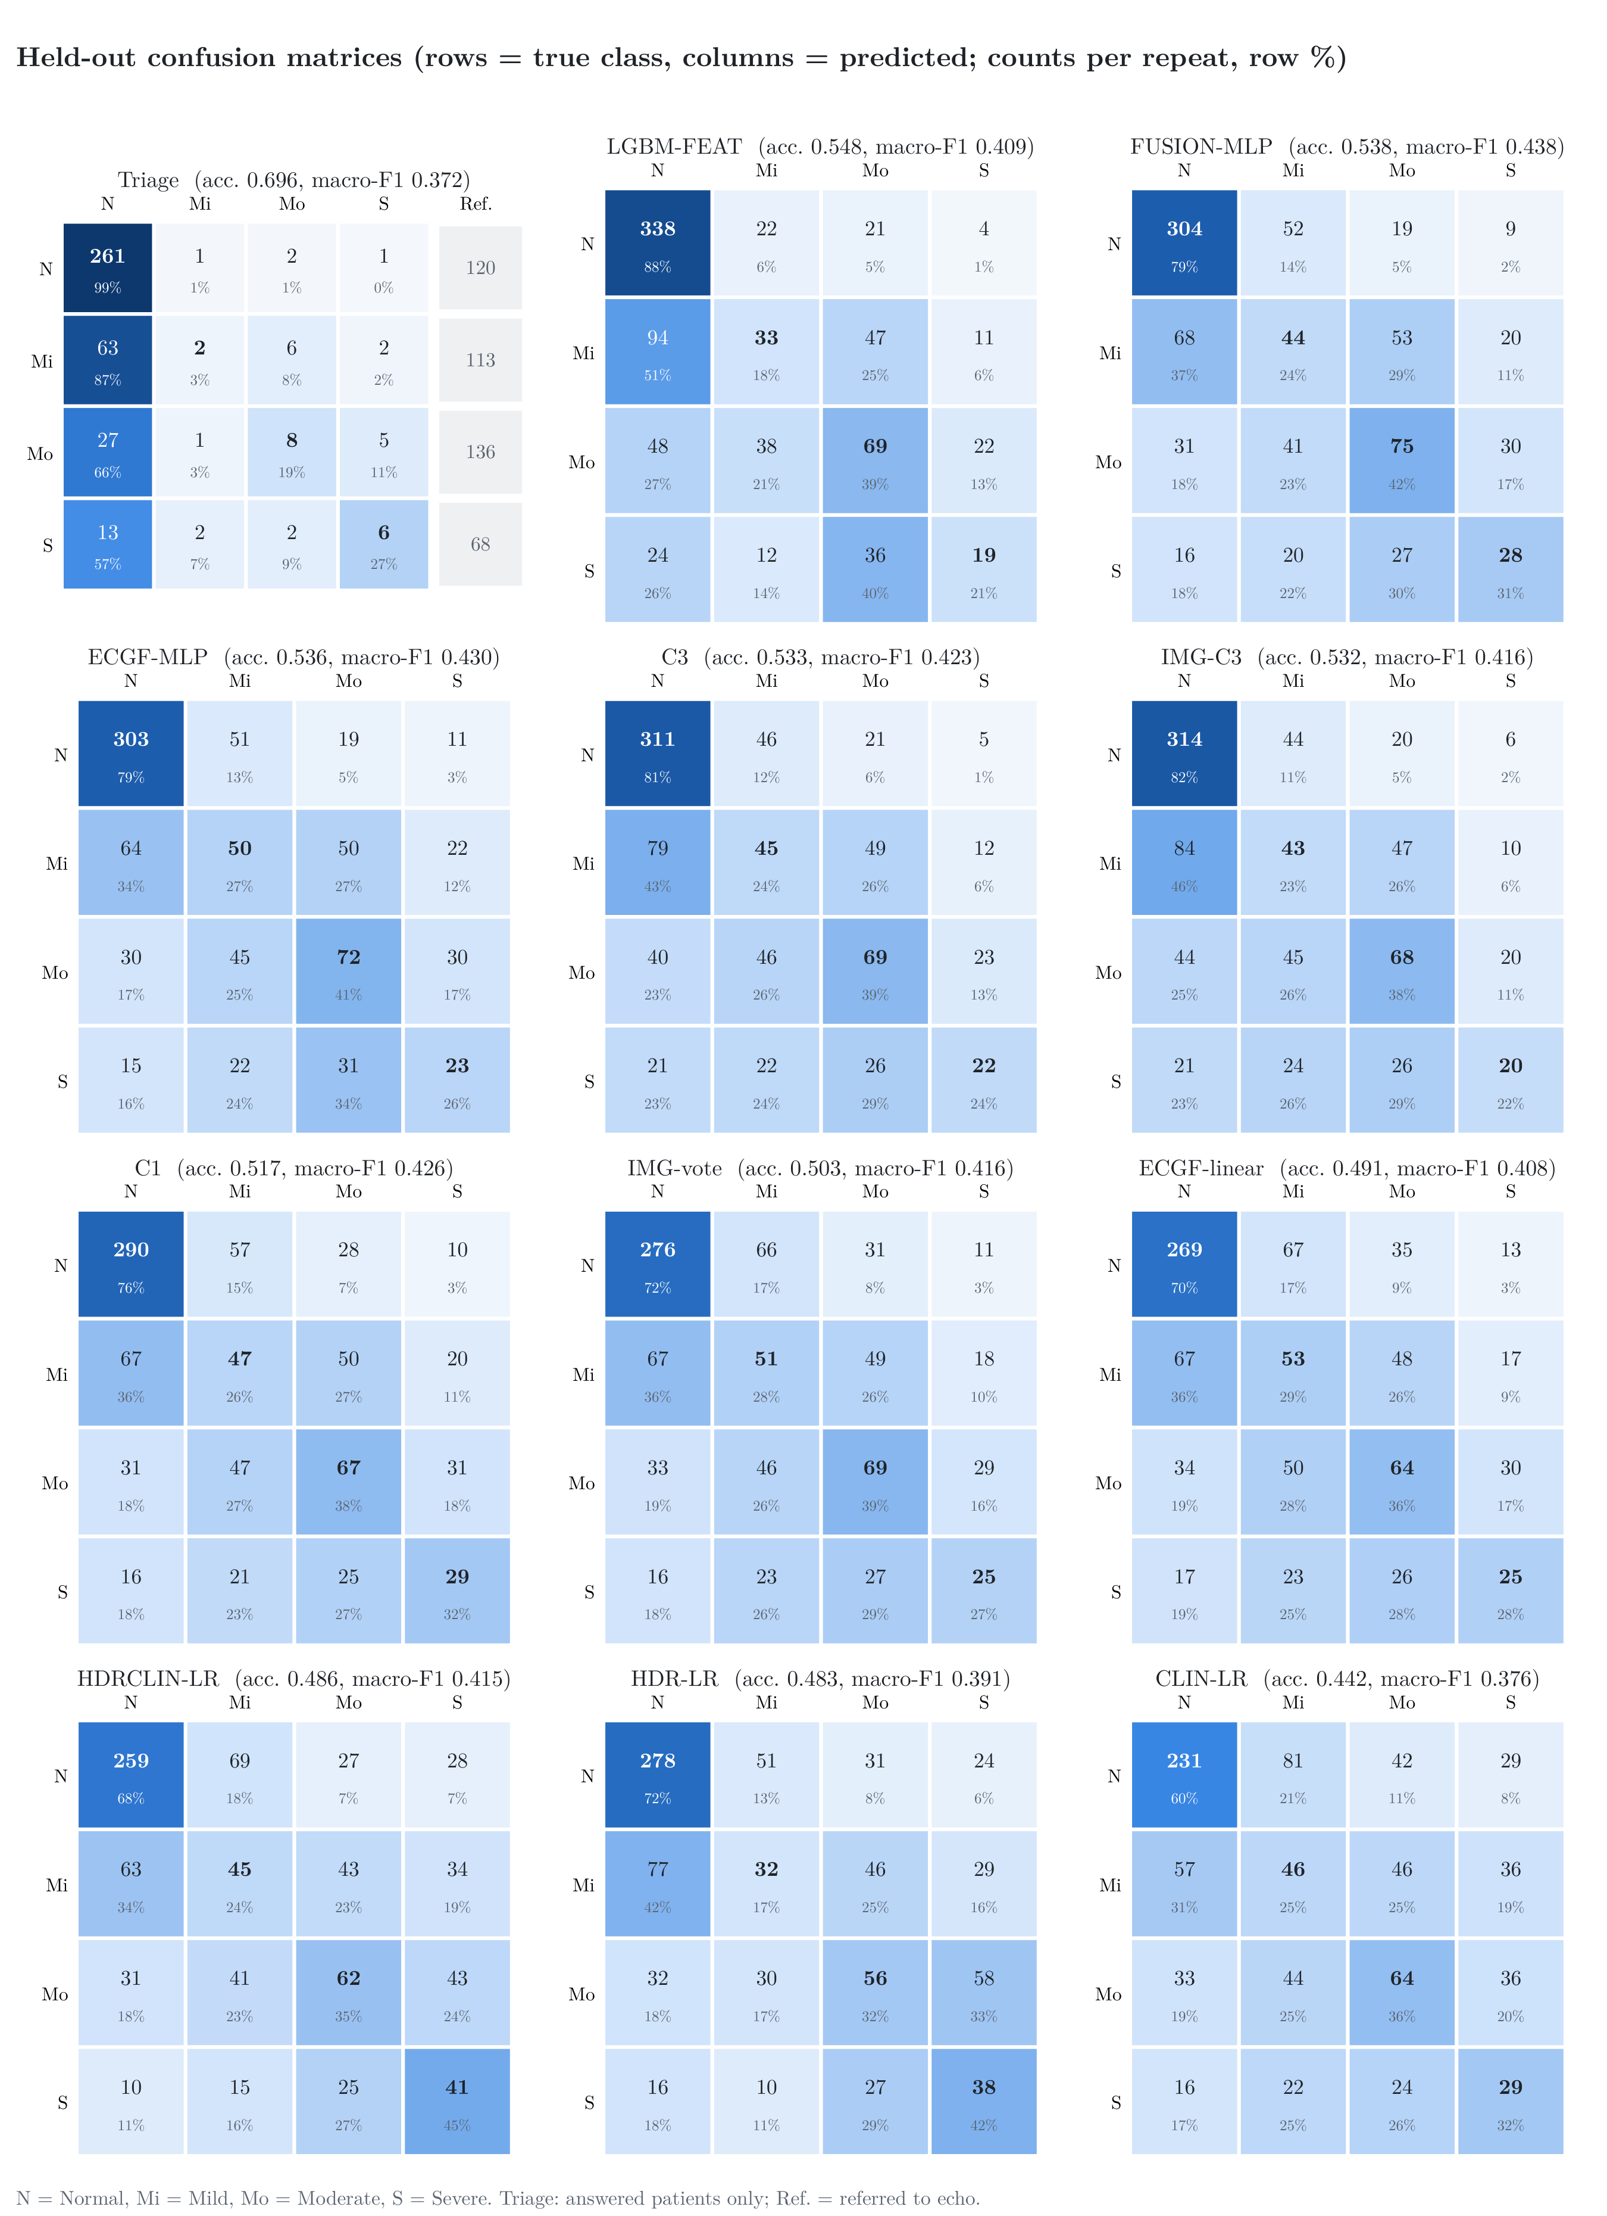
Figure 7.2 Held-out confusion matrices of the twelve main models after training to (nearly) 100 % training accuracy, ordered by accuracy. Rows are the true class and columns the predicted class; counts are per repeat (each of the 837 ECGs is predicted once per repeat) and the colour is the row percentage (recall). Triage: answered patients only, with the referred patients in the last column.

7.3 Image and signal networks on the fixed split
Table 7.5 and Figure 7.3 show the networks of the original project and Phase 1 on the original fixed split. All seven networks reached at least 0.996 training accuracy, in 12 (ECGFounder fine-tuning) to 57 epochs (MobileNetV3), so none needed the epoch cap. On the 168 validation ECGs, eight of the eleven models lose 0.6–10.7 points: ResNet-18 falls from 0.524 to 0.423, ConvNeXt-Atto from 0.452 to 0.345, the 1-D SE-ResNet from 0.482 to 0.435 and the original default pipeline (header 0.6 + ResNet-18 0.4) from 0.565 to 0.458. Three gain: EfficientNet-B0 (0.351 to 0.417) and MobileNetV3 (0.185 to 0.387) had not yet learnt the task in their original 20–29 epochs, so longer training first helped them, and the ECGFounder fine-tune reached 0.560 against 0.524; on a single 168-ECG split the 95 % interval is about ±0.075, so this gain is within noise. Every CNN was more accurate on validation at an earlier epoch than at the 100 % point (ResNet-18 0.482, ECGNet 0.488, EfficientNet-B0 0.512, ConvNeXt-Atto 0.518, 1-D SE-ResNet 0.542, against 0.345–0.435 at the end): the best stopping point lies before 100 % training accuracy. The header logistic regression again stops at 0.674 training accuracy.
Table 7.5 Image and signal networks on the original fixed split (trained on 669 ECGs, measured on 168 validation ECGs; the locked test is not loaded). TRAIN100: no early stopping, augmentation, weight decay, label smoothing or EMA, trained until training accuracy ≥ 99.5 %. Original training accuracy was measured during the epoch with augmentation and dropout active.
Model | Epochs | Training accuracy | Validation accuracy | Original: training / validation | Change (points)
ResNet-18 | 24 | 0.997 | 0.423 | 0.515 / 0.524 | -10.1
ECGNet | 21 | 0.999 | 0.435 | 0.523 / 0.476 | -4.1
EfficientNet-B0 | 37 | 1.000 | 0.417 | 0.447 / 0.351 | +6.6
MobileNetV3-Large | 57 | 0.999 | 0.387 | 0.331 / 0.185 | +20.2
ConvNeXt-Atto | 53 | 0.996 | 0.345 | 0.404 / 0.452 | -10.7
1-D SE-ResNet | 32 | 0.999 | 0.435 | 0.553 / 0.482 | -4.7
ECGFounder fine-tuned (stages 5–6) | 12 | 0.996 | 0.560 | – / 0.524 | +3.6
HOG + RBF-SVM | solver | 1.000 | 0.423 | – / 0.458 | -3.5
XGBoost (waveform features) | 2,000 trees | 1.000 | 0.494 | – / 0.500 | -0.6
Logistic regression (header) | solver | 0.674 | 0.405 | – / 0.500 | -9.5
Header 0.6 + ResNet-18 0.4 | 24 (ResNet-18) | 0.972 | 0.458 | – / 0.565 | -10.7

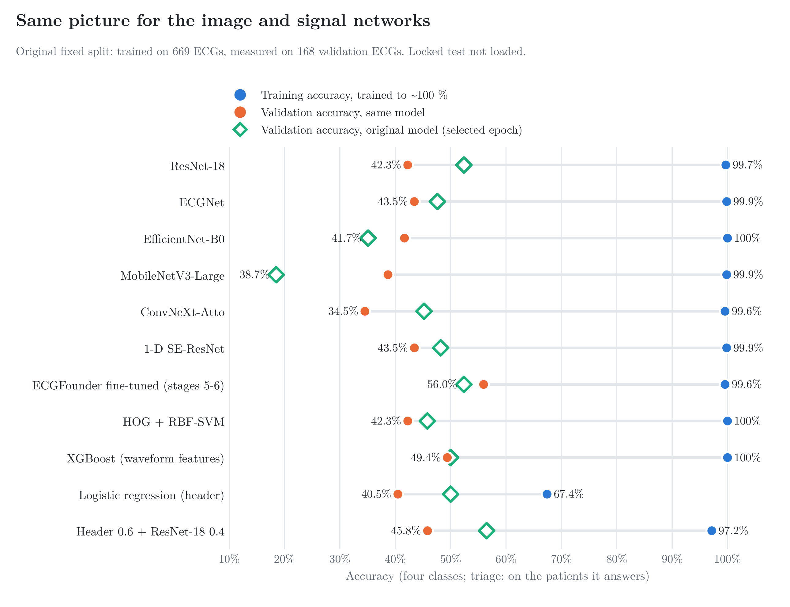
Figure 7.3 Original fixed split: training accuracy after training to ≥ 99.5 % (blue), validation accuracy of the same network (orange) and validation accuracy of the original network at its selected epoch (green).

7.4 Variants of every phase
Table 7.6 repeats the experiment for the variants of Phases 4, 5 and 6B. The flexible variants again reach 1.000 on their training folds, and their held-out accuracy (0.53–0.56) is the same as or below the original in every case except E2 LightGBM (+1.3 points, inside its interval). The image-only ensembles lose most: HIER 3.5, ENH-vote 2.0 and the ULT stack 3.4 points, because each of their members over-fits in a different way and the errors no longer cancel. Combiners whose decision rule is tuned on out-of-fold member outputs (stacking 0.826, ULT-stack 0.794, SUPER-TOP10-ORD 0.783) do not reach 1.000 in training: their rule is fitted to how the members behave on unseen patients, not to the over-confident in-sample outputs.
The best-for-50s recipe (SUPER-TOP10-ORD, Section 5.2) could only be rebuilt from the hospital-trained members of its pool, because the EchoNext data stay on the owner’s computer. With the original training, these nine members give 0.565 [0.540, 0.590], so the EchoNext members were worth about 2 points of the published 0.587; trained to 100 %, the same recipe gives 0.539. The complete recipe, including the EchoNext members, was retrained separately on the owner’s computer (Section 7.6).
Table 7.6 Variants of every phase, trained to (nearly) 100 % training accuracy in the same development cross-validation. Members without an original stand-alone result show –. Epochs: median over the 15 folds (E4: stage 1 / stage 2; members of combiners as in Table 7.3, same learners, seeds and rows); ª boosted trees (no epochs); ^{b} epochs of the neural member FUSION-MLP; ^{c} epochs of the neural member ECGF-MLP; ^{d} full-batch L-BFGS iterations; ^{e} solved to convergence (no epochs).
Model | Epochs | Training | Held-out [95 % CI] | Original | Change (points)
Phase 5 variants
E1 MLP, header + ECGFounder + feature families | 64 | 1.000 | 0.542 [0.504, 0.579] | 0.554 | -1.2
E2 LightGBM, features + ECGFounder PCA | 2,000 treesª | 1.000 | 0.557 [0.517, 0.597] | 0.544 | +1.3
E3 weighted average of the C1 members | 112^{b} | 0.985 | 0.530 [0.480, 0.581] | 0.547 | -1.7
E3 stacking (logistic meta-learner) | 112^{b} | 0.826 | 0.532 [0.487, 0.576] | 0.546 | -1.4
E4 hierarchical MLP | 52 / 39 | 0.999 | 0.540 [0.517, 0.563] | 0.567 | -2.7
E6 signal-quality gating | 112^{b} | 0.988 | 0.542 [0.500, 0.583] | 0.546 | -0.4
E7 mixup MLP | 144 | 1.000 | 0.534 [0.499, 0.570] | 0.552 | -1.8
Phase 4
Multitask MLP (class + EF) | 131 | 1.000 | 0.536 [0.496, 0.577] | 0.546 | -1.0
Phase 6B image-only models
HIER two-stage (ext. grid) | 108^{c} | 1.000 | 0.535 [0.488, 0.582] | 0.570 | -3.5
ENH M2 synthetic 10-s ECG → ECGFounder | solver^{e} | 1.000 | 0.489 [0.439, 0.539] | 0.528 | -3.9
ENH M3 median-beat shape | solver^{e} | 1.000 | 0.412 [0.358, 0.466] | 0.467 | -5.5
ENH M4 MiniRocket | solver^{e} | 1.000 | 0.469 [0.423, 0.515] | 0.504 | -3.5
ENH M5 logistic regression | solver^{e} | 1.000 | 0.501 [0.450, 0.553] | 0.543 | -4.2
ENH M6 EF ridge → bands | exact^{e} | 0.557 | 0.477 [0.458, 0.496] | 0.534 | -5.7
ENH-vote | 108^{c} | 1.000 | 0.549 [0.513, 0.585] | 0.569 | -2.0
ULT M8 multi-scale ECGFounder LR | solver^{e} | 1.000 | 0.496 [0.459, 0.532] | – | –
ULT M9 kNN | none (kNN) | 1.000 | 0.546 [0.520, 0.571] | – | –
ULT M10 gradient boosting | 2,000 iter.ª | 1.000 | 0.540 [0.496, 0.585] | – | –
ULT M12 zone LR | solver^{e} | 0.624 | 0.349 [0.302, 0.396] | – | –
ULT-stack | 108^{c} | 0.794 | 0.537 [0.500, 0.574] | 0.571 | -3.4
Best-for-50s recipe without EchoNext (original column: same recipe on the original members; the published 0.587 also used EchoNext members)
SUPER-TOP10-ORD, hospital members only | 108^{c} | 0.783 | 0.539 [0.509, 0.570] | 0.565 | -2.6

The EF regressors show the same pattern in Table 7.7: the MLP reproduces the training EF almost exactly (r = 0.993, mean error 2.7 points) but its held-out correlation falls from 0.653 to 0.624, and the unshrunk ridge + LightGBM regressor drops to r = 0.476.
Table 7.7 EF regression (Phase 4) trained without early stopping: correlation with echo EF on the training rows and held out, and mean absolute error in EF points. The MLP reached the 3,000-epoch cap in every fold (training R² just below the 0.99 target).
Regressor | Epochs | Training r | Held-out r | MAE training / held-out | Original held-out r
EF regression MLP, header + ECGFounder | 3,000 (cap) | 0.993 | 0.624 | 2.7 / 11.0 | 0.653
EF ridge + LightGBM (triage regressor) | 4,000 trees | 1.000 | 0.476 | 0.0 / 13.8 | –

7.5 Label-quality studies
Table 7.8 repeats the label-quality studies of Table 4.7 with the C3 recipe trained to (nearly) 100 %. Training on cleaner labels still pays off on the clean subsets (0.67–0.69 on the clear-cut and noise-free ECGs), but none of the studies gains from the longer training: CLEAR, MMCLEAN and NFS stay within one point of their originals (0.670 against 0.668, 0.669 against 0.672, 0.694 against 0.702), and HC30, NF and VER lose 1.0–2.8 points. Cleaner labels raise accuracy; more training does not.
Table 7.8 Label-quality studies (report Table 4.7) with the C3 recipe trained to (nearly) 100 % training accuracy, scored on the same subsets as the original. Epochs: median over the 15 folds; ^{b} epochs of the neural member FUSION-MLP.
Study | Scored on | Epochs | Training | Accuracy | Original | Change (points)
VER: 15 labels corrected to a high-confidence echo | all 837 (original labels) | 132^{b} | 0.986 | 0.537 | 0.565 | -2.8
HC30: train on reliable links only | 395 reliable links | 52^{b} | 1.000 | 0.583 | 0.594 | -1.1
CLEAR: train without border ECGs | 582 clear-cut ECGs | 104^{b} | 0.993 | 0.670 | 0.668 | +0.2
MMCLEAN: drop suspect Mild or Moderate labels | 620 kept ECGs | 95^{b} | 0.978 | 0.669 | 0.672 | -0.3
NF: noise-free training (all classes) | 264 clean, clear-cut ECGs | 45^{b} | 1.000 | 0.673 | 0.683 | -1.0
NFS: noise-free training, Severe kept | 264 clean, clear-cut ECGs | 44^{b} | 0.985 | 0.694 | 0.702 | -0.8

7.6 Top-3 ensembles retrained with EchoNext
The three best all-patient ensembles of Chapter 5 use members trained on EchoNext, whose data must stay on the owner’s computer under the data-use agreement. They were therefore retrained there with the same rules: every member, on the hospital and on the EchoNext side, was trained until its training accuracy reached (nearly) 100 %, and the ensembles were rebuilt with the same selection and meta-learners. Table 7.9 shows the result. All three lose about three points: the best all-patient model, SUPER-TOP10-ORD, falls from 0.587 to 0.558, and the staged model from 0.585 to 0.548. The EchoNext-trained members fit their own training data almost perfectly (0.78–1.00) but reach only 0.41–0.54 four-class accuracy on the hospital ECGs, the same pattern as the hospital-trained models.
Table 7.9 The three best all-patient ensembles, retrained with EchoNext on the owner’s computer (the EchoNext data never left it): every member trained to (nearly) 100 % training accuracy, then the same selection and meta-learner as in Table 5.2. Numbers as reported by that run.
Ensemble | Training accuracy | Held-out accuracy [95 % CI] | Original held-out [95 % CI] | Change (points)
SUPER-TOP10-ORD (best on all patients) | 0.748 | 0.558 [0.530, 0.587] | 0.587 [0.565, 0.610] | −2.9
SUPER, greedy selection | 0.790 | 0.552 [0.507, 0.596] | 0.583 [0.540, 0.626] | −3.1
STAGED-4, extended pool | 0.722 | 0.548 [0.516, 0.581] | 0.585 [0.557, 0.613] | −3.7

7.7 Models that were not retrained
Table 7.10 lists what was not retrained and why. The best-in-the-70s result (0.747 on the locked test) stays with the original frozen model: the locked test was scored once with the owner’s authorisation, and scoring it again would remove its value as an unseen test.
Table 7.10 Models not retrained in TRAIN100, and why.
Model | Reason
ULT2 stack and EchoNext-pre-trained pixel CNNs (FT-EN, ConvNeXt E2–E6, IMG70) | EchoNext data stay on the owner’s computer; the three best ensembles and all their members (including the EchoNext-trained ones) were retrained there (Table 7.9), these remaining models were not
Locked-test result (best in the 70s, 0.747) | the 210 locked ECGs were scored once with the owner’s authorisation; scoring them again would remove their value as an unseen test
LSTM family (L0–L5) and LSTM fusions | withdrawn at the owner’s request: the LSTMs did not raise accuracy in Phase 6 (Tables 4.5–4.6); one CNN-LSTM test fold reached 0.997 training and 0.446 held-out accuracy
EfficientNet-B2 and ConvNeXt-Tiny (IMG70 architectures) | left out at the owner’s request (7–16 CPU-minutes per epoch here); their originals were EchoNext-pre-trained
E7 augmentation, MMCLEAN grid configurations, HC30F, selective prediction | inputs not on this machine, not in Table 4.7, or the same idea as the triage model

7.8 Why training to 100 % does not help, and where to stop
Figure 7.4 follows the ECGFounder MLP head epoch by epoch for 150 epochs on the five folds of repeat 0. Training accuracy rises to 1.000, while held-out accuracy stops improving after about 12 epochs and then stays flat or falls. With the project’s regularised head, the early-stopping point (epoch 12 on average) gives 0.823 training and 0.519 held-out accuracy; after 150 epochs the same head is at 1.000 and 0.520. Without dropout or weight decay, held-out accuracy falls from 0.545 at the stopping point to 0.529 at epoch 150.
The reason is the size of the problem. Each training fold holds about 670 ECGs, while the networks have between 66,000 (MLP head) and 30.8 million (ECGFounder) parameters, and many labels are uncertain: the label studies of Section 4.4 found 217 suspect Mild/Moderate labels and links that are more than 30 days or a name match away from the echo. Once a model has learnt the patterns that generalise, the only way to raise training accuracy further is to memorise the individual training ECGs, including their noise and label errors. That memorised detail does not exist in new patients, so held-out accuracy cannot rise and often falls.
The best stopping point is therefore not 100 % training accuracy but the epoch at which accuracy on data the model has not seen stops improving. In this project that is the inner-validation early-stopping point used in all original runs, where training accuracy is about 0.60–0.85. The gap between training and held-out accuracy is the measure of over-fitting, and the held-out accuracy is the number to report.
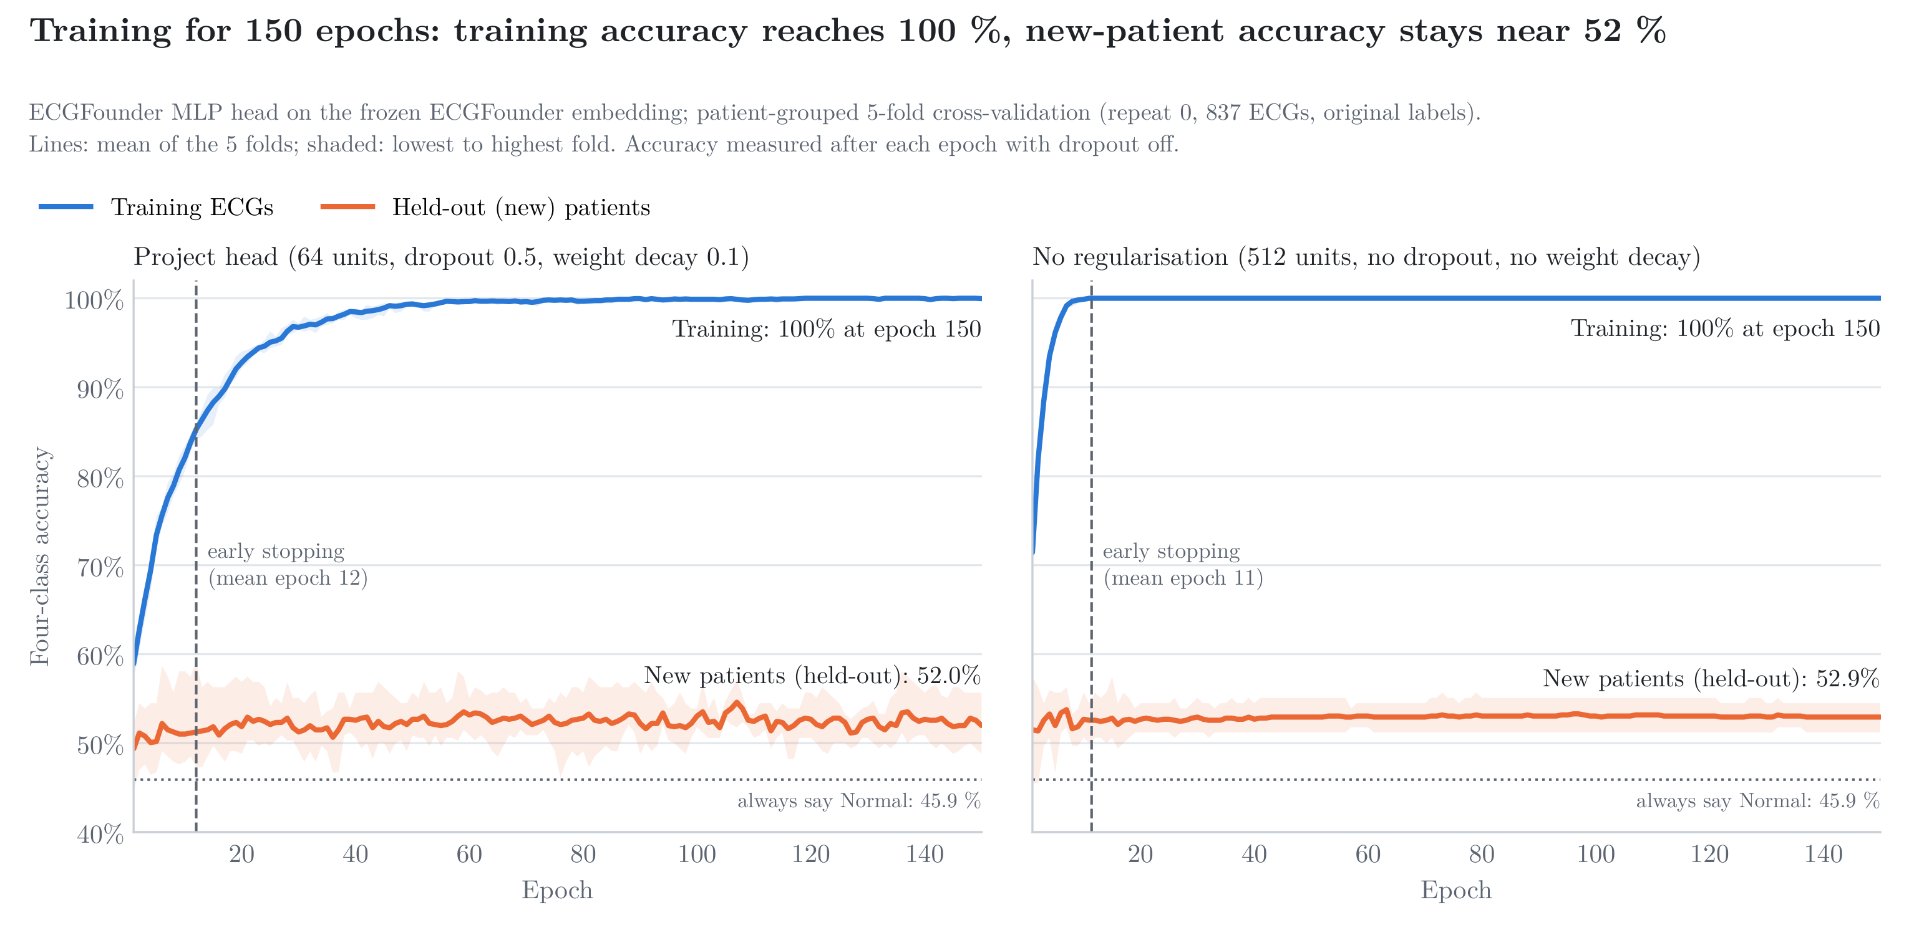
Figure 7.4 ECGFounder MLP head trained for 150 epochs without early stopping (mean of the five folds of repeat 0): training accuracy reaches 1.000 while held-out accuracy stays at about 0.52. Left: the project head; right: the same head without dropout or weight decay. The dashed line marks the early-stopping epoch.

Chapter 8

Summary and Conclusions

8.1 Conclusions
- Best on all patients: 0.587 [0.565, 0.610] from image-derived inputs only, about 99 % of the 0.592 that the EF information of the ECG permits, and above the model that also reads the printed measurements (0.562).
- Best in the 60s: 0.694 [0.655, 0.736] on the 56 % of patients the triage model answers in cross-validation.
- Best in the 70s: 0.747 [0.660, 0.837] on the 50 % of unseen locked-test patients it answers, above its own development estimate.
- Transfer works across populations: a model trained only on US public data detects EF ≤ 45 % on our printouts with AUROC 0.85.
- Training to 100 % does not help: no model retrained until it fitted its training data perfectly became reliably better on held-out patients; most became worse, including the best ensemble (0.587 to 0.558) and the main image-only model (0.558 to 0.532) (Chapter 7); the early-stopped models, with training accuracy of about 0.60–0.85, are the ones to use.
- The ceiling is set by the labels and the information in the ECG: 70 % on all patients would need EF estimates correlating at r ≈ 0.90 with echo, against about 0.66 achievable today.

8.2 Scope for future work (Phase II)
- Larger, multi-year data with biplane-Simpson EF linked by patient identifier within days of the ECG.
- Digital 10-s simultaneous ECGs where available, and enrichment for Mild and Moderate patients.
- Prospective evaluation of the triage model as an echocardiography-referral aid, and deployment as a lightweight application.

References

[1] T. A. McDonagh, M. Metra, M. Adamo, R. S. Gardner, A. Baumbach, M. Böhm, H. Burri, J. Butler, J. Čelutkienė, O. Chioncel et al., “2021 ESC Guidelines for the diagnosis and treatment of acute and chronic heart failure,” European Heart Journal, vol. 42, no. 36, pp. 3599–3726, 2021.
[2] P. A. Heidenreich, B. Bozkurt, D. Aguilar, L. A. Allen, J. J. Byun, M. M. Colvin, A. Deswal, M. H. Drazner, S. M. Dunlay, L. R. Evers et al., “2022 AHA/ACC/HFSA Guideline for the Management of Heart Failure: A Report of the American College of Cardiology/American Heart Association Joint Committee on Clinical Practice Guidelines,” Circulation, vol. 145, no. 18, pp. e895–e1032, 2022.
[3] Z. I. Attia, S. Kapa, F. Lopez-Jimenez, P. M. McKie, D. J. Ladewig, G. Satam, P. A. Pellikka, M. Enriquez-Sarano, P. A. Noseworthy, T. M. Munger et al., “Screening for cardiac contractile dysfunction using an artificial intelligence–enabled electrocardiogram,” Nature Medicine, vol. 25, no. 1, pp. 70–74, 2019.
[4] X. Yao, D. R. Rushlow, J. W. Inselman, R. G. McCoy, T. D. Thacher, E. M. Behnken, M. E. Bernard, S. L. Rosas, A. Akfaly, A. Misra et al., “Artificial intelligence–enabled electrocardiograms for identification of patients with low ejection fraction: a pragmatic, randomized clinical trial,” Nature Medicine, vol. 27, no. 5, pp. 815–819, 2021.
[5] R. M. Lang, L. P. Badano, V. Mor-Avi, J. Afilalo, A. Armstrong, L. Ernande, F. A. Flachskampf, E. Foster, S. A. Goldstein, T. Kuznetsova et al., “Recommendations for Cardiac Chamber Quantification by Echocardiography in Adults: An Update from the American Society of Echocardiography and the European Association of Cardiovascular Imaging,” Journal of the American Society of Echocardiography, vol. 28, no. 1, pp. 1–39.e14, 2015.
[6] P. Thavendiranathan, A. D. Grant, T. Negishi, J. C. Plana, Z. B. Popović, and T. H. Marwick, “Reproducibility of Echocardiographic Techniques for Sequential Assessment of Left Ventricular Ejection Fraction and Volumes: Application to Patients Undergoing Cancer Chemotherapy,” Journal of the American College of Cardiology, vol. 61, no. 1, pp. 77–84, 2013.
[7] D. G. Strauss, R. H. Selvester, and G. S. Wagner, “Defining Left Bundle Branch Block in the Era of Cardiac Resynchronization Therapy,” The American Journal of Cardiology, vol. 107, no. 6, pp. 927–934, 2011.
[8] M. K. Das, B. Khan, S. Jacob, A. Kumar, and J. Mahenthiran, “Significance of a Fragmented QRS Complex Versus a Q Wave in Patients With Coronary Artery Disease,” Circulation, vol. 113, no. 21, pp. 2495–2501, 2006.
[9] I. Kardys, J. A. Kors, I. M. van der Meer, A. Hofman, D. A. M. van der Kuip, and J. C. M. Witteman, “Spatial QRS-T angle predicts cardiac death in a general population,” European Heart Journal, vol. 24, no. 14, pp. 1357–1364, 2003.
[10] B. Acar, G. Yi, K. Hnatkova, and M. Malik, “Spatial, temporal and wavefront direction characteristics of 12-lead T-wave morphology,” Medical & Biological Engineering & Computing, vol. 37, no. 5, pp. 574–584, 1999.
[11] R. D. Berger, E. K. Kasper, K. L. Baughman, E. Marban, H. Calkins, and G. F. Tomaselli, “Beatto-Beat QT Interval Variability: Novel Evidence for Repolarization Lability in Ischemic and Nonischemic Dilated Cardiomyopathy,” Circulation, vol. 96, no. 5, pp. 1557–1565, 1997.
[12] A. Vaid, K. W. Johnson, M. A. Badgeley, S. S. Somani, M. Bicak, I. Landi, A. Russak, S. Zhao, M. A. Levin, R. S. Freeman et al., “Using Deep-Learning Algorithms to Simultaneously Identify Right and Left Ventricular Dysfunction From the Electrocardiogram,” JACC: Cardiovascular Imaging, vol. 15, no. 3, pp. 395–410, 2022.
[13] V. Sangha, A. A. Nargesi, L. S. Dhingra, A. Khunte, B. J. Mortazavi, A. H. Ribeiro, E. Banina, O. Adeola, N. Garg, C. A. Brandt et al., “Detection of Left Ventricular Systolic Dysfunction From Electrocardiographic Images,” Circulation, vol. 148, no. 9, pp. 765–777, 2023.
[14] K. K. Shivashankara, Deepanshi, A. Mehri Shervedani, G. D. Clifford, M. A. Reyna, and R. Sameni, “ECG-Image-Kit: a synthetic image generation toolbox to facilitate deep learning-based electrocardiogram digitization,” Physiological Measurement, vol. 45, no. 5, p. 055019, 2024.
[15] H. Wu, K. H. K. Patel, X. Li, B. Zhang, C. Galazis, N. Bajaj, A. Sau, X. Shi, L. Sun, Y. Tao et al., “A fully-automated paper ECG digitisation algorithm using deep learning,” Scientific Reports, vol. 12, no. 1, p. 20963, 2022.
[16] M. A. Reyna, Deepanshi, J. T. Weigle, Z. Koscova, K. S. Campbell, S. Seyedi, A. Elola, A. Bahrami Rad, A. J. Shah, N. K. Bhatia et al., “Digitization and Classification of ECG Images: The George B. Moody PhysioNet Challenge 2024,” in Computing in Cardiology (CinC 2024), vol. 51, 2024.
[17] A. E. Ulloa-Cerna, L. Jing, J. M. Pfeifer, S. Raghunath, J. A. Ruhl, D. B. Rocha, J. B. Leader, N. Zimmerman, G. Lee, S. R. Steinhubl et al., “rECHOmmend: An ECG-Based Machine Learning Approach for Identifying Patients at Increased Risk of Undiagnosed Structural Heart Disease Detectable by Echocardiography,” Circulation, vol. 146, no. 1, pp. 36–47, 2022.
[18] Z. I. Attia, D. M. Harmon, J. Dugan, L. Manka, F. Lopez-Jimenez, A. Lerman, K. C. Siontis, P. A. Noseworthy, X. Yao, E. W. Klavetter et al., “Prospective evaluation of smartwatch-enabled detection of left ventricular dysfunction,” Nature Medicine, vol. 28, no. 12, pp. 2497–2503, 2022.
[19] P. Bachtiger, C. F. Petri, F. E. Scott, S. Ri Park, M. A. Kelshiker, H. K. Sahemey, B. Dumea, R. Alquero, P. S. Padam, I. R. Hatrick et al., “Point-of-care screening for heart failure with reduced ejection fraction using artificial intelligence during ECG-enabled stethoscope examination in London, UK: a prospective, observational, multicentre study,” The Lancet Digital Health, vol. 4, no. 2, pp. e117–e125, 2022.
[20] A. Khunte, V. Sangha, E. K. Oikonomou, L. S. Dhingra, A. Aminorroaya, B. J. Mortazavi, A. Coppi, C. A. Brandt, H. M. Krumholz, and R. Khera, “Detection of left ventricular systolic dysfunction from single-lead electrocardiography adapted for portable and wearable devices,” npj Digital Medicine, vol. 6, no. 1, p. 124, 2023.
[21] J. Li, A. D. Aguirre, V. Moura, J. Jin, C. Liu, L. Zhong, C. Sun, G. Clifford, M. B. Westover, and S. Hong, “An Electrocardiogram Foundation Model Built on over 10 Million Recordings,” NEJM AI, vol. 2, no. 7, p. AIoa2401033, 2025.
[22] K. McKeen, S. Masood, A. Toma, B. Rubin, and B. Wang, “ECG-FM: an open electrocardiogram foundation model,” JAMIA Open, vol. 8, no. 5, p. ooaf122, 2025.
[23] T. J. Poterucha, L. Jing, R. P. Ricart, M. Adjei-Mosi, J. Finer, D. Hartzel, C. Kelsey, A. Long, D. Rocha, J. A. Ruhl et al., “Detecting structural heart disease from electrocardiograms using AI,” Nature, vol. 644, no. 8075, pp. 221–230, 2025.
[24] J. W. Hughes, L. Jing, J. Finer, D. Hartzel, C. Kelsey, A. Long, D. Rocha, J. Ruhl, T. Poterucha, and P. Elias, “EchoNext-Mini: A Dataset and Baseline AI Model for Detecting Structural Heart Disease from Electrocardiograms,” NEJM AI, vol. 3, no. 5, p. AIdbp2500516, 2026.
[25] A. Y. Hannun, P. Rajpurkar, M. Haghpanahi, G. H. Tison, C. Bourn, M. P. Turakhia, and A. Y. Ng, “Cardiologist-level arrhythmia detection and classification in ambulatory electrocardiograms using a deep neural network,” Nature Medicine, vol. 25, no. 1, pp. 65–69, 2019.
[26] A. H. Ribeiro, M. H. Ribeiro, G. M. M. Paixão, D. M. Oliveira, P. R. Gomes, J. A. Canazart, M. P. S. Ferreira, C. R. Andersson, P. W. Macfarlane, W. Meira et al., “Automatic diagnosis of the 12-lead ECG using a deep neural network,” Nature Communications, vol. 11, no. 1, p. 1760, 2020.
[27] K. He, X. Zhang, S. Ren, and J. Sun, “Deep Residual Learning for Image Recognition,” in Pro- ceedings of the IEEE Conference on Computer Vision and Pattern Recognition (CVPR), 2016, pp. 770–778.
[28] M. Tan and Q. Le, “EfficientNet: Rethinking Model Scaling for Convolutional Neural Networks,” in Proceedings of the 36th International Conference on Machine Learning (ICML), ser. Proceedings of Machine Learning Research, vol. 97. PMLR, 2019, pp. 6105–6114. [Online]. Available: https://proceedings.mlr.press/v97/tan19a.html
[29] A. Howard, M. Sandler, B. Chen, W. Wang, L.-C. Chen, M. Tan, G. Chu, V. Vasudevan, Y. Zhu, R. Pang et al., “Searching for MobileNetV3,” in Proceedings of the IEEE/CVF International Con- ference on Computer Vision (ICCV), 2019, pp. 1314–1324.
[30] Z. Liu, H. Mao, C.-Y. Wu, C. Feichtenhofer, T. Darrell, and S. Xie, “A ConvNet for the 2020s,” in Proceedings of the IEEE/CVF Conference on Computer Vision and Pattern Recognition (CVPR), 2022, pp. 11 966–11 976.
[31] S. Hochreiter and J. Schmidhuber, “Long Short-Term Memory,” Neural Computation, vol. 9, no. 8, pp. 1735–1780, 1997.
[32] Z. I. Attia, S. Kapa, X. Yao, F. Lopez-Jimenez, T. L. Mohan, P. A. Pellikka, R. E. Carter, N. D. Shah, P. A. Friedman, and P. A. Noseworthy, “Prospective validation of a deep learning electrocardiogram algorithm for the detection of left ventricular systolic dysfunction,” Journal of Cardiovascular Elec- trophysiology, vol. 30, no. 5, pp. 668–674, 2019.
[33] D. Adedinsewo, R. E. Carter, Z. Attia, P. Johnson, A. H. Kashou, J. L. Dugan, M. Albus, J. M. Sheele, F. Bellolio, P. A. Friedman et al., “Artificial Intelligence-Enabled ECG Algorithm to Identify Patients With Left Ventricular Systolic Dysfunction Presenting to the Emergency Department With Dyspnea,” Circulation: Arrhythmia and Electrophysiology, vol. 13, no. 8, p. e008437, 2020.
[34] J.-M. Kwon, K.-H. Kim, K.-H. Jeon, H. M. Kim, M. J. Kim, S.-M. Lim, P. S. Song, J. Park, R. K. Choi, and B.-H. Oh, “Development and Validation of Deep-Learning Algorithm for Electrocardiography-Based Heart Failure Identification,” Korean Circulation Journal, vol. 49, no. 7, pp. 629–639, 2019.
[35] V. Sangha, B. J. Mortazavi, A. D. Haimovich, A. H. Ribeiro, C. A. Brandt, D. L. Jacoby, W. L. Schulz, H. M. Krumholz, A. L. P. Ribeiro, and R. Khera, “Automated multilabel diagnosis on electrocardiographic images and signals,” Nature Communications, vol. 13, no. 1, p. 1583, 2022.
[36] P. Elias, T. J. Poterucha, V. Rajaram, L. M. Moller, V. Rodriguez, S. Bhave, R. T. Hahn, G. Tison, S. A. Abreau, J. Barrios et al., “Deep Learning Electrocardiographic Analysis for Detection of Left-Sided Valvular Heart Disease,” Journal of the American College of Cardiology, vol. 80, no. 6, pp. 613–626, 2022.
[37] S. Varma and R. Simon, “Bias in error estimation when using cross-validation for model selection,” BMC Bioinformatics, vol. 7, no. 1, p. 91, 2006.
[38] C. Nadeau and Y. Bengio, “Inference for the Generalization Error,” Machine Learning, vol. 52, no. 3, pp. 239–281, 2003.
[39] S. Holm, “A Simple Sequentially Rejective Multiple Test Procedure,” Scandinavian Journal of Statistics, vol. 6, no. 2, pp. 65–70, 1979. [Online]. Available: https://www.jstor.org/stable/4615733

