JENKINS CI/CD

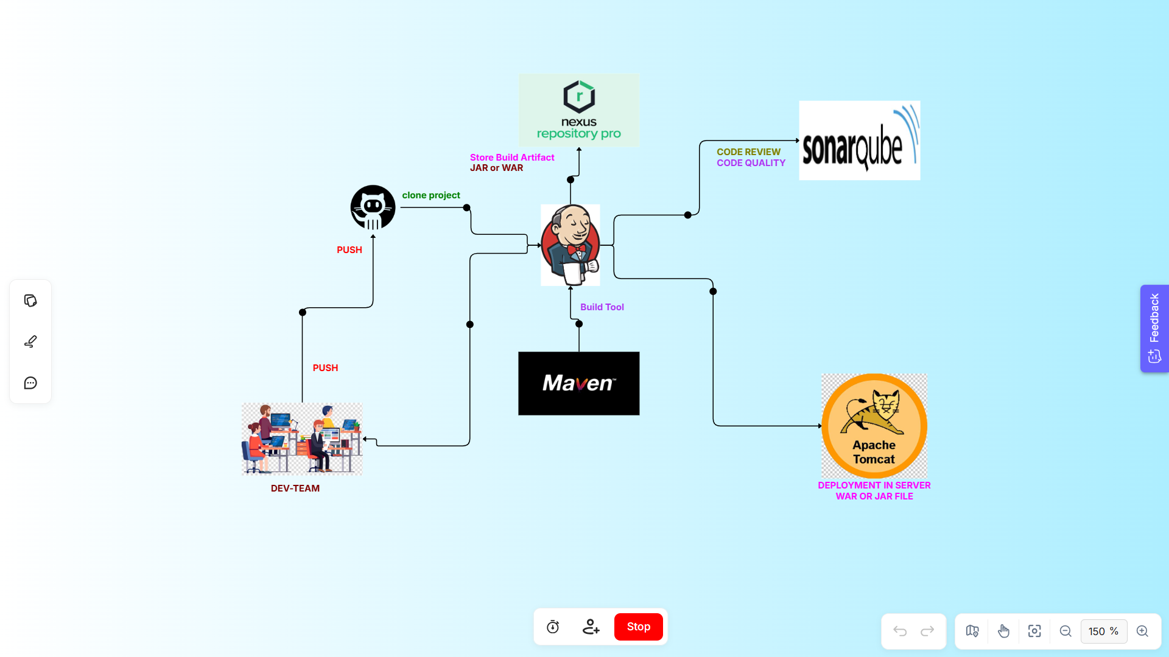

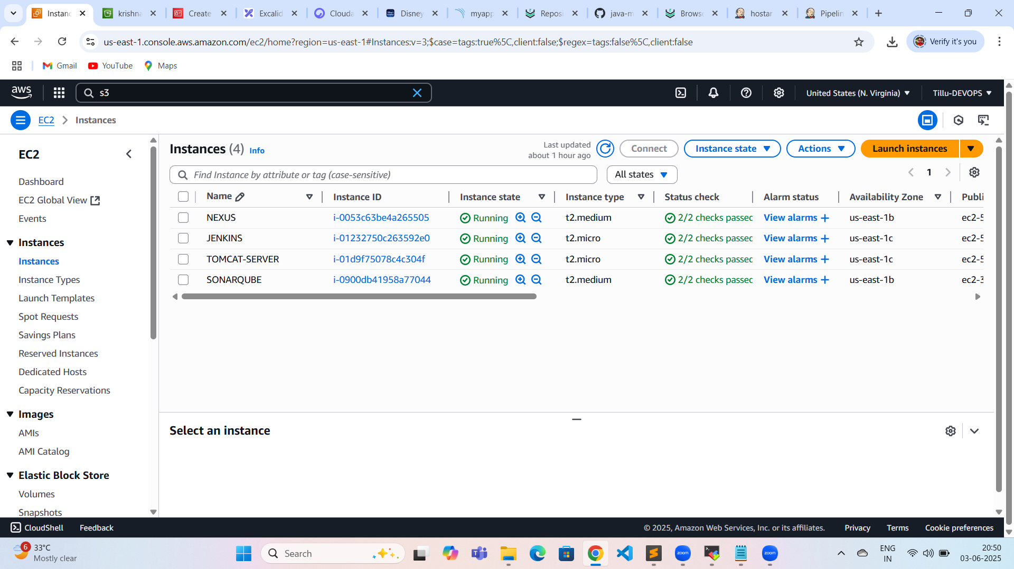

Jenkins installation

-------------------------

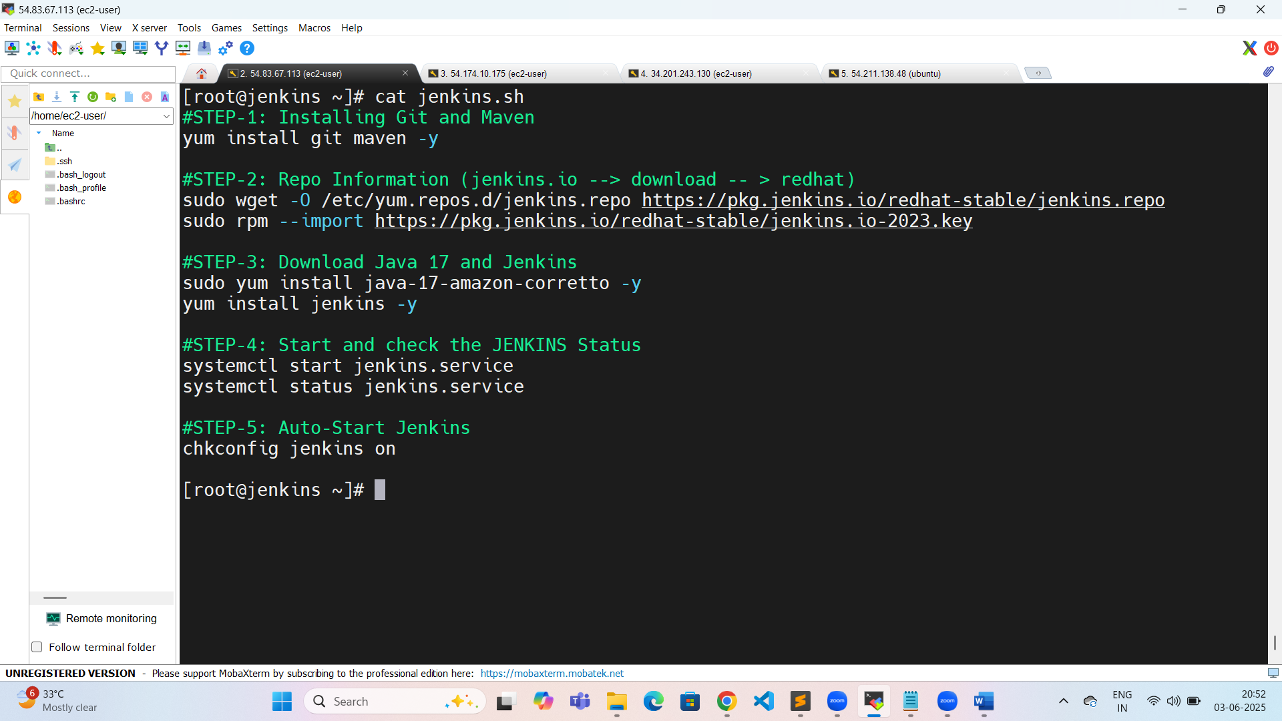

[root@jenkins ~]# cat jenkins.sh

#STEP-1: Installing Git and Maven

yum install git maven -y

#STEP-2: Repo Information (jenkins.io --> download -- > redhat)

sudo wget -O /etc/yum.repos.d/jenkins.repo https://pkg.jenkins.io/redhat-stable/jenkins.repo

sudo rpm --import https://pkg.jenkins.io/redhat-stable/jenkins.io-2023.key

#STEP-3: Download Java 17 and Jenkins

sudo yum install java-17-amazon-corretto -y

yum install jenkins -y

#STEP-4: Start and check the JENKINS Status

systemctl start jenkins.service

systemctl status jenkins.service

#STEP-5: Auto-Start Jenkins

chkconfig jenkins on

[root@jenkins ~]#

Sonar installation:

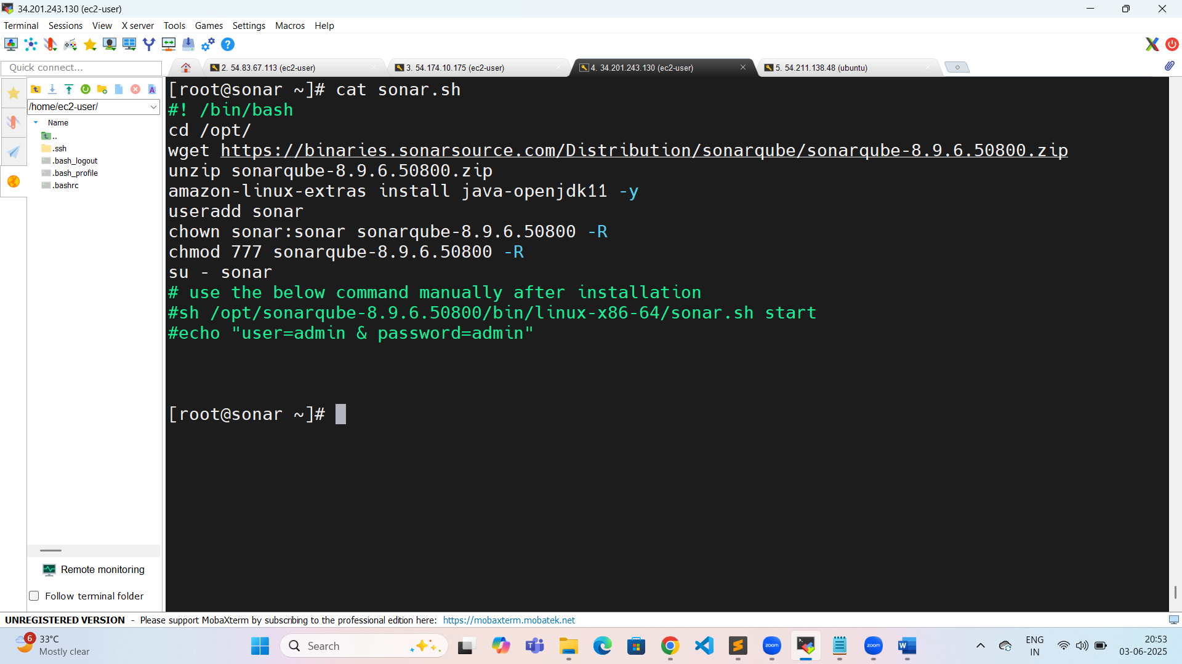

[root@sonar ~]# cat sonar.sh

#! /bin/bash

cd /opt/

wget https://binaries.sonarsource.com/Distribution/sonarqube/sonarqube-8.9.6.50800.zip

unzip sonarqube-8.9.6.50800.zip

amazon-linux-extras install java-openjdk11 -y

useradd sonar

chown sonar:sonar sonarqube-8.9.6.50800 -R

chmod 777 sonarqube-8.9.6.50800 -R

su - sonar

# use the below command manually after installation

#sh /opt/sonarqube-8.9.6.50800/bin/linux-x86-64/sonar.sh start

#echo "user=admin & password=admin"

[root@sonar ~]#

Tomcat installation:

[root@tomcat ~]# history

1 sudo yum install java-17-amazon-corretto -y

2 wget https://dlcdn.apache.org/tomcat/tomcat-9/v9.0.105/bin/apache-tomcat-9.0.105.tar.gz

3 ll

4 tar -zxvf apache-tomcat-9.0.105.tar.gz

5 cd apache-tomcat-9.0.105/

6 ll

7 cd webapps/

8 ls

9 cd manager/

10 ls

11 cd META-INF/

12 ls

13 vim context.xml

14 cd ../../..

15 ls

16 cd conf/

17 ls

18 vim tomcat-users.xml

19 cd ..

20 cd bin/

21 ls

22 ./startup.sh

23 cd

24 history

[root@tomcat ~]#

Nexus installation:

ubuntu@ip-172-31-87-227:/opt/nexus$ history

1 sudo apt update

2 sudo apt install openjdk-17-jdk openjdk-17-jre -y

3 cd /opt/

4 wget https://download.sonatype.com/nexus/3/nexus-3.76.1-01-unix.tar.gz

5 sudo wget https://download.sonatype.com/nexus/3/nexus-3.76.1-01-unix.tar.gz

6 sudo tar -zxvf nexus-3.76.1-01-unix.tar.gz

7 ll

8 sudo mv /opt/nexus-3.76.1-01 /opt/nexus

9 ll

10 sudo adduser nexus

11 sudo visudo

12 sudo chown -R nexus:nexus /opt/nexus

13 ll

14 sudo chown -R nexus:nexus /opt/sonatype-work/

15 ll

16 cd nexus/

17 sudo vim /opt/nexus/bin/nexus.rc

18 sudo ln -s /opt/nexus/bin/nexus /etc/init.d/nexus

19 su - nexus

20 ll

21 history

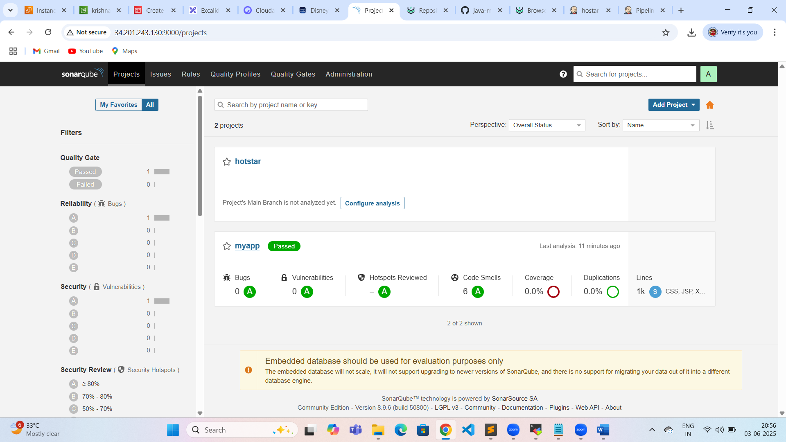

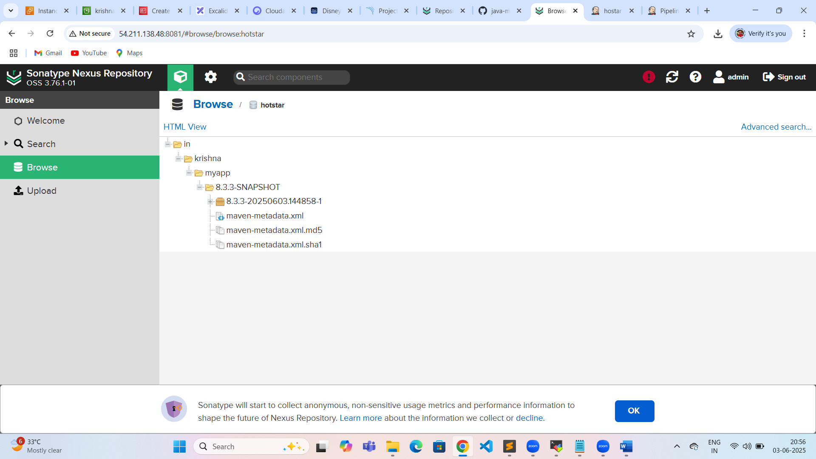

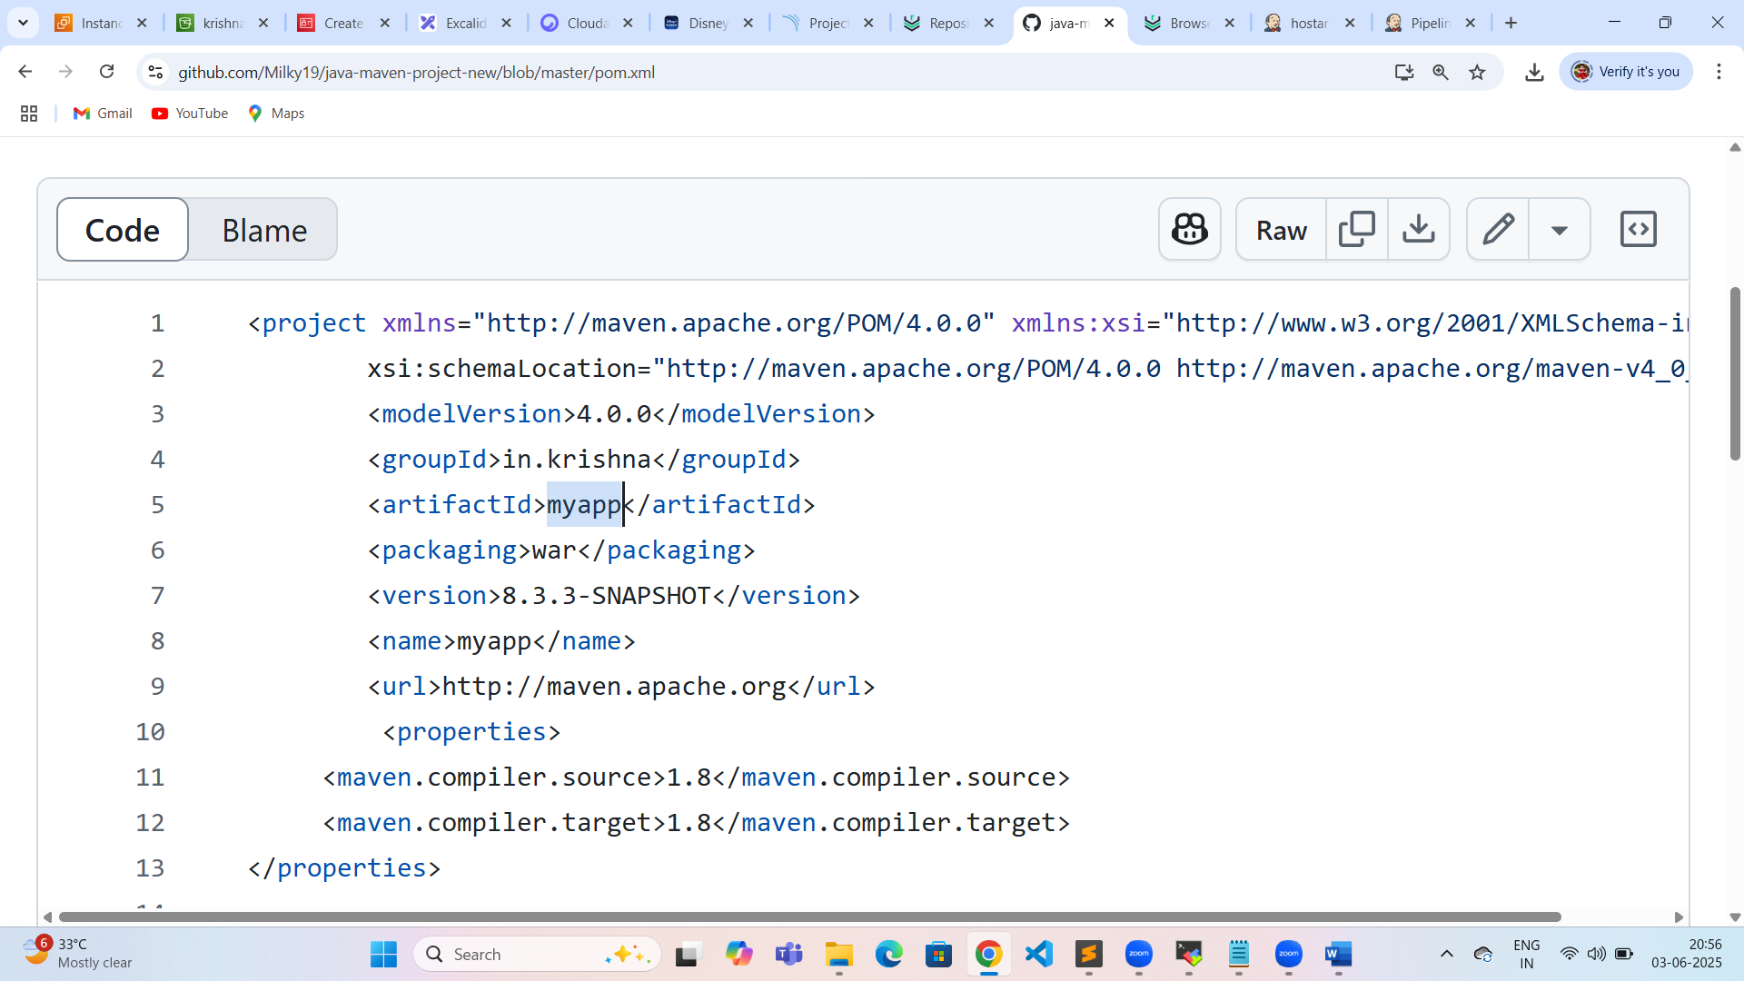

Pipeline code:

pipeline {

agent any

stages{

stage('checkout'){

steps{

git 'https://github.com/Milky19/java-maven-project-new.git'

}

}

stage("Compile-Project"){

steps{

sh 'mvn compile'

}

}

stage("Test-project"){

steps{

sh 'mvn test'

}

}

stage('sonarqube-scanning'){

steps{

withSonarQubeEnv('SonarQube') {

sh 'mvn org.sonarsource.scanner.maven:sonar-maven-plugin:3.7.0.1746:sonar'

}

}

}

stage("Generate Artifact"){

steps{

sh 'mvn clean package'

}

}

stage("Uploading-artifactory"){

steps{

nexusArtifactUploader artifacts: [[artifactId: 'myapp', classifier: '', file: 'target/myapp.war', type: '.war']], credentialsId: 'nexus', groupId: 'in.krishna', nexusUrl: '54.211.138.48:8081', nexusVersion: 'nexus3', protocol: 'http', repository: 'hotstar', version: '8.3.3-SNAPSHOT'

}

}

stage('deploying artifact'){

steps{

deploy adapters: [tomcat9(alternativeDeploymentContext: '', credentialsId: 'mytomcat', path: '', url: 'http://54.174.10.175:8080')], contextPath: 'myapp', war: '**/*.war'

}

}

}

}

Plugins:

1. Deploy to container
2. Nexus artifact uploader
3. Sonarqube scanner
4. Sonarqube server
5. Pipeline stage view

