

**Custom Messaging Application**

High Level Design Version Draft v0.4

**Document Control:**

|  |  |  |  |  |  |  |
| --- | --- | --- | --- | --- | --- | --- |
| **Project Revision History** | | | | | | |
|  |  |  | |  |  |  |
| **Date** | **Version** | **Author** | **Brief Description of Changes** | | | |
|  |  |  |  | | | |
|  |  |  |  | | | |
|  |  |  |  | | | |
|  |  |  |  | | | |

|  |
| --- |
| **Team Members** |

|  |  |
| --- | --- |
| **Employee ID:** | **Name** |
| 46290140 | Sasumalli Durga Bhavani |
| 46290142 | Harshitha Manduri |
| 46287669 | Chaithra J Shetty |
| 46291225 | Satrasala Supraja |
| 46290062 | Shireesha Vennapusa |

|  |
| --- |
| **Table of Contents** |

1. **High Level Design**

|  |  |  |
| --- | --- | --- |
| 1. Introduction | | 5 |
| 1.1 | Purpose | 5 |
| 1.2 | Scope | 5 |
| 1.3 | Overview | 5 |
| 2. General Description | | 5 |
| 2.1 | Product Perspective | 5 |
| 2.2 | Tools used | 6 |
| 2.3 | General Constraints | 6 |
| 2.4 | Assumptions | 6 |
| 2.5 | Special Design aspects | 6 |
| 3. Design Details | | 6 |
| 3.1 | Main Design Features | 6 |
| 3.2 | Application Architecture | 7 |
| 3.3 | Standards | 7 |
| 3.4 | Data Flow Level-0 | 7 |
| 3.5 | Data Flow Level-1 | 8 |
| 3.6 | User Interface | 8 |
| 3.7 | Error Handling | 8 |
| 3.8 | Help | 8 |
| 3.9 | Performance | 8 |
| 3.10 | Reliability | 8 |
| 3.11 | Maintainability | 9 |
| 3.12 | Portability | 9 |
| 3.13 | Reusability | 10 |
| 3.14 | Application compatibility | 10 |

|  |
| --- |
| **High Level Design** |

**1. Introduction**

* 1. **Purpose**

The Custom Messaging Application is a project that helps us in understanding the concept functions, data structure and system programming architecture. It can create a record of the data of the users that have successfully registered into the system. Their data can be efficiently used to validate them when they will try to login again in the future.

**1.2 Scope**

The project aims to create and develop a server to client messaging application. While registration it asks for the username and password from the user along with other valuable information like name etc. It stores all this data into the server for validation part later. The messages can very efficiently be transferred among the users into this system. This function also provides the function of searching a chat done earlier. Chat backup is done on the server and user can very easily search the chat done by them.

**1.3** **Overview**

This HLD Document is arranged in the following format:

-Section1: Introduction

A brief explanation about the purpose, aim, scope, and design format of the proposed project.

- Section 2: General Description

This section is all about the general constraints, assumptions, and design aspects associated with the proposed project. The product perspective will give an overall description of the simulator.

- Section 3: Design Details

This section documents the detailed design of all modules associated with the development of the proposed simulator.

1. **General Description**

**2.1 Product Perspective**

The Custom Messaging Application is a system in which the user can register and afterwards login into the system using the valid username and password. After successful login attempt, the user will be able to view rest of the users that are also logged in at that time. Once the user is registered, their data i.e., username and password are stored on the server in a structured format.

**2.2** **Tools used**

1. valgrind

2. make

* 1. **General Constraints**

1. Maximum of 3 users can login to the application

2. Server should be established before running the client side files.

3. Passwords should be at least of 8 characters with 1 special character.

**2.4 Assumptions**

**2.5 Special Design aspects**

One of the design aspects is that the system will work with a single user at a time.

**3. Design Details**

**3.1 Main Design Features**

The main design features include four major parts: User login, New User Registration, Active Users, Group Chat and Private Chat. In order to make these designs easier to understand, the design has been illustrated in attached diagrams (Use Case, Data flow diagrams).

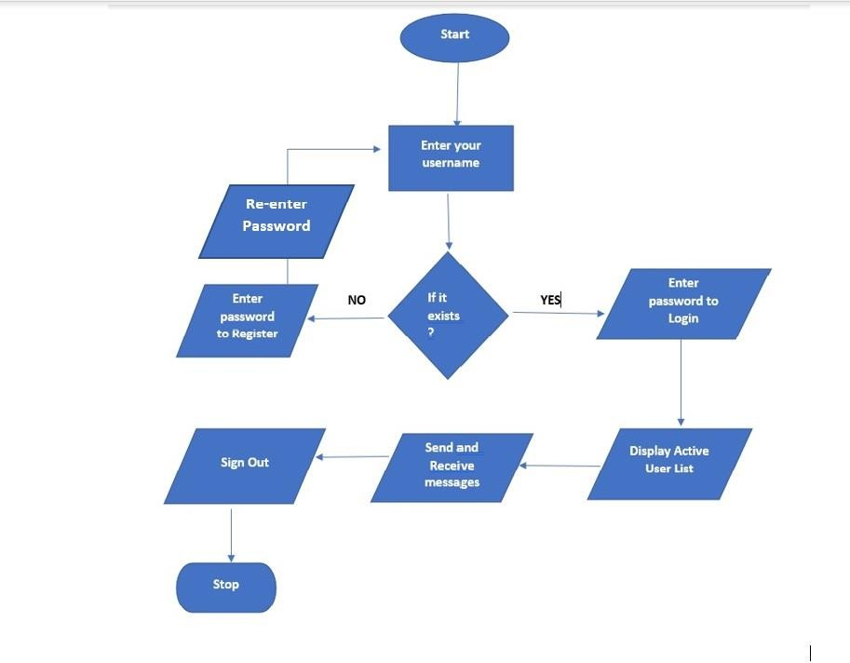**3.2 Application Architecture**

**3.3 Standards**

* Security –NA
* Quality – by keeping the interface simple and direct, quality should be kept at a maximum.

**3.4 Data Flow Diagram (Level - 0)**

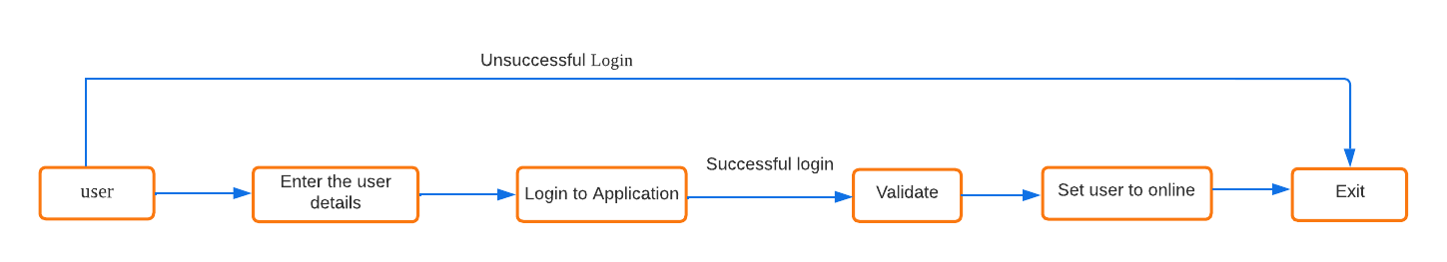

**3.5 Data Flow Diagram (Level - 1)**

**3.6 User Interface**

Command Line interface.

**3.7 Error Handling**

Should errors be encountered, an explanation will be displayed as to what went wrong.

An error will be defined as anything that falls outside the normal and intended usage.

**3.8 Help**

Help will come in the form of all the documentation created prior to coding, which explains the intended users. Detailed instructions will be written on how to create and implement the system with the intention of publishing as an Open-Source solution.

**3.9** **Performance**

Performance is going to be very important for this project. For everything to run smoothly for this project, The Custom Messaging Application will work on the user terminal, performance depends upon the hardware component of the user and Scheduling efficiency is dependent on the algorithm selected by the user.

**3.10 Reliability**

The simulation can schedule custom messaging flawlessly .

**3.11 Maintainability**

NA

**3.12 Portability**

This system should have the ability that, once it is together, the entire system should be able to be physically moved to any location. Code and program portability should be possible between kernel-recompiled Linux distributions. For everything to work properly, all programs should be in one folder.

**3.13 Reusability**

The code can be reused with no problems. Everything will be completely reusable to anyone.

**3.14 Application compatibility**

This was designed as an independent system. As it is not connected to any other components or interfaces, application compatibility is not a concern.