Cyclone Intensity Estimation: A Comprehensive Approach with Transfer Learning and Computer Vision

Vankayalapati Bhargav

*Department of Computer Science and Engineering*

*VIT-AP University*

Amaravati, India

vankayalapatibhargav2@gmail.com

Dr. S Kalyani

*Department of Computer Science and Engineering*

*VIT-AP University*

Amaravati, India

kalyani.s@vitap.ac.in

Polisetty Venkata Pardhasaradhi Naidu

*Department of Computer Science and Engineering*

*VIT-AP University*

Amaravati, India

[pardhasaradhi.polisetty@outlook.com](mailto:pardhasaradhi.polisetty@outlook.com)

Konathala Venkata Siva Apparao

*Department of Computer Science and Engineering*

*VIT-AP University*

Amaravati, India

venkatasiva.konathala@gmail.com

Badugu Mohan Kishore

*Department of Computer Science and Engineering*

*VIT-AP University*

Amaravati, India

[mohankishore.badugu@gmail.com](mailto:mohankishore.badugu@gmail.com)

***Abstract — Accurately forecasting tropical cyclone intensity is crucial for mitigating the devastating impacts of these natural events. Traditional methods of cyclone intensity estimation, particularly in the early stages of formation, often fall short due to the challenge of precisely identifying the cyclone’s center. In this work, we propose a novel approach for estimating cyclone intensity using a transfer learning technique combined with a Graph Neural Network (GNN) model, which directly processes infra-red (IR) satellite images from the INSAT-3D satellite. By focusing solely on intensity estimation rather than center localization, the model leverages transfer learning to capture complex patterns from pre-trained networks and GNNs to exploit spatial relationships within the image data. This enables accurate intensity predictions even during the early development stages of cyclones. The model is trained on a dataset of tropical cyclone images, with data augmentation techniques employed to enhance generalization. Experimental results demonstrate the model's competitive performance in intensity estimation, contributing to more timely and reliable forecasts. This approach can significantly improve early warnings and disaster preparedness, potentially saving lives and minimizing damage, while future enhancements with larger datasets and more advanced models will further refine these predictions.***

INTRODUCTION

Tropical cyclones are among the most destructive natural hazards, causing widespread devastation to both lives and infrastructure in vulnerable regions. Effective disaster management, including timely evacuation and resource allocation, depends heavily on accurate predictions of cyclone intensity. Traditional methods of intensity estimation rely on identifying the storm's center; however, during the early stages of cyclone development, the structure is often poorly defined, leading to inaccuracies and delays that weaken early warning systems.

This research focuses on applying deep learning techniques to estimate the intensity of tropical cyclones using infrared satellite images without the need to detect the cyclone’s center. By utilizing deep learning models, complex features are extracted directly from the imagery, offering a more reliable alternative to traditional methods that rely on center localization. The dataset used in this study is sourced from the INSAT-3D satellite, which provides half-hourly IR images, making it suitable for continuous monitoring.

The proposed approach leverages this data to improve intensity estimation, particularly during the cyclone's formative stages. The primary objectives of this work include developing an effective deep learning model for cyclone intensity prediction and evaluating its performance against traditional methods. Additionally, the study examines the role of data augmentation techniques in enhancing model generalization, addressing the challenge of a limited dataset. This research contributes to disaster management by providing a more accurate and timelier tool for predicting cyclone intensity, ultimately helping to save lives and minimize damage.

LITERATURE SURVEY

In recent years, several models and techniques have been developed to enhance tropical cyclone intensity estimation using deep learning approaches.

Tian et al. (2020) proposed a hybrid CNN-based model to improve tropical cyclone intensity (TCI) estimation. The model outperformed traditional methods and provided a significant enhancement by utilizing a hybrid CNN for regression and classification tasks, particularly focusing on improving predictions using a single infrared band.

Archana et al. (2024) introduced an approach that leverages Graph Convolutional Recurrent Networks (GCRNs) and INSAT 3D imagery. Their model integrated both spatial and temporal data to improve cyclone intensity estimation. This approach utilized advanced machine learning and deep learning techniques, such as CNNs, RNNs, and GNNs, to predict cyclone intensity.

Tian et al. (2023) developed a lightweight multitask learning model with adaptive loss balance for simultaneously estimating the intensity and size of tropical cyclones. This approach allowed for more accurate and reliable predictions by balancing the learning objectives of multiple tasks, significantly improving the efficiency of the estimation process.

Ma et al. (2024) proposed a Multiscale and Multilayer Feature Extraction Network with Dual Attention (MLFED) to improve feature extraction from satellite images. Their model incorporated convolution block attention modules (CBAM) and demonstrated higher accuracy in tropical cyclone classification and intensity estimation by focusing on multiscale feature extraction.

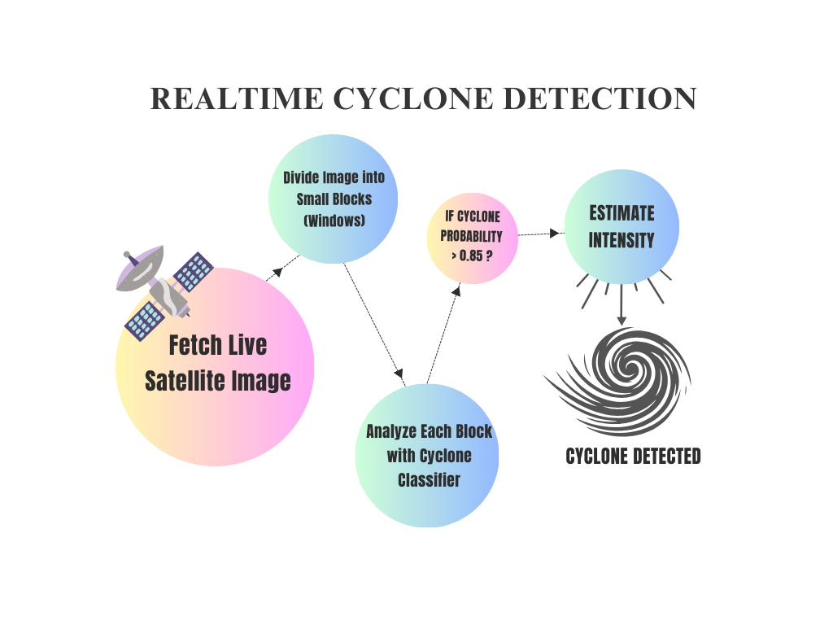Chen et al. (2021) introduced a novel tensor network model for cyclone intensity estimation, specifically addressing challenges like low-quality and distorted single-channel infrared images. Their model used tensor network analysis, which significantly improved accuracy by combining various techniques, such as CNNs and TCI-net.

Chen et al. (2021) also presented a semi supervised deep learning framework for tropical cyclone intensity estimation. This framework employed CNNs to enhance feature extraction and relied on a dropout and stochastic gradient approach to iteratively refine the predictions. The model effectively utilized both labeled and unlabeled data, leading to improved estimation accuracy.

Niranjana et al. (2020) explored the use of infrared satellite imagery for cyclone intensity estimation. Their method incorporated the Dvorak technique, enhancing predictions by focusing on variations in satellite images, such as noise and operational latency.

Maskey et al. (2020) introduced the Deepti deep-learning-based system for tropical cyclone intensity estimation, utilizing advanced Dvorak techniques and symmetry analysis. The system primarily used passive microwave imagery and aimed to overcome the limitations of conventional observation methods.

Gujral et al. (2023) proposed TCI-Net, a deep learning approach using a combination of CNNs and hybrid models. Their model outperformed previous models in predicting cyclone intensity by leveraging datasets from multiple channels, providing a more robust and scalable solution.

PROPOSED METHODOLOGY

Dataset:

Our experimentation is conducted using a dataset of tropical cyclone images provided by the INSAT-3D satellite. This dataset consists of IR satellite images of various cyclones, each paired with corresponding intensity values. These intensity measurements, derived from meteorological data, serve as the ground truth for evaluating the accuracy of our cyclone intensity estimation model. The dataset's diversity in capturing different stages and formations of cyclones makes it well-suited for assessing the performance of our deep learning approach in predicting cyclone intensity.

CYCLONE DETECTION:

In our research, we propose a methodology for real-time cyclone detection using live satellite imagery. The process begins by fetching real-time satellite images of the targeted geographical area. These images are then divided into smaller blocks, resembling windows, to facilitate detailed analysis. Each block is subsequently analyzed using a cyclone classifier, which identifies potential cyclone features. The classifier evaluates the intensity of detected cyclone features within each block. If the intensity surpasses a threshold value of 25, the intensity will be estimated and in the final outcome the cyclone will be detected. This systematic approach ensures efficient and accurate identification of cyclones, leveraging advanced image processing and machine learning techniques.

This project tackles cyclone classification, detection, and intensity estimation from satellite images. Classification identifies the presence of a cyclone, while detection locates its exact position. Intensity estimation measures the strength of the cyclone, aiding in early warnings and disaster response.

A. CYCLONE CLASSIFICATION:

Our research begins with assembling a robust dataset composed of labeled images, divided into two distinct categories: cyclone and no-cyclone. This dataset is the cornerstone of our machine learning model, providing the raw visual data necessary for training and validation. Each image undergoes a systematic resizing to a uniform resolution of 64x64 pixels. This standardization is crucial as it ensures consistency across the dataset, facilitating efficient processing and accurate feature extraction.

The preprocessing phase further refines the dataset. Initially, each image is converted to grayscale. This transformation simplifies the image data by reducing the complexity from three color channels to one intensity channel, without losing vital information. Grayscale conversion helps in focusing on the intensity variations within the image, which are pivotal for distinguishing cyclone features from non-cyclone backgrounds.

SOME MAJOR AND KEY STEPS IN EXTRACTION:

Grayscale Conversion: The first step is converting the color image to grayscale. This process highlights intensity variations, which are essential for identifying cyclone patterns. The grayscale image simplifies the data, making it easier to extract meaningful features

.

White Pixel Ratio Calculation: Next, the grayscale image is thresholded to create a binary image, where pixels are classified as either white or black. By calculating the ratio of white pixels, we can infer the presence and extent of cyclone features. This ratio serves as a preliminary indicator of cyclone activity within the image.

Segmentation: To further dissect the image, we apply Felzenszwalb's segmentation algorithm. This algorithm segments the image into regions based on color and texture similarities, effectively isolating different parts of the image. Each segment represents a distinct region, which can be analyzed separately for more granular feature extraction.

Region Feature Analysis: For each segmented region, we extract a set of detailed features:

Mean Color: The average color values of the region, providing insights into the overall color characteristics.

Area and Perimeter: These metrics measure the region's size and the length of its boundary. The area quantifies the total number of pixels within the region, while the perimeter accounts for the length of the outer edge.

Circularity: This feature indicates how circular the region is, with higher values suggesting a more circular shape.

Colorfulness: This measure assesses the diversity of colors within the region, offering additional texture information.

Local Binary Pattern (LBP) Histograms: LBP is a texture descriptor that captures the local texture information. Histograms of LBP values within each region provide a detailed texture profile.

Centroid: The coordinates of the centroid are normalized to ensure consistency across images of different sizes. The centroid feature provides spatial context about the location of significant regions within the image, which is crucial for identifying cyclone patterns.

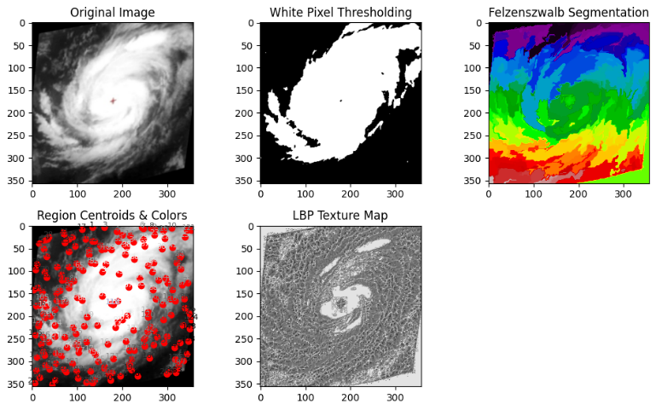

Cyclone Classification Results:

In our approach to cyclone classification, we combined several key features—texture, color, and shape—into a single, comprehensive feature vector for each image. This vector effectively represents the essential characteristics needed for distinguishing cyclone images from non-cyclone ones. By using advanced computer vision techniques, we achieved outstanding results.

It is important to note that we utilized a custom dataset by subdividing the non-cyclone satellite images. While this introduced certain limitations that slightly reduced the standards of robustness, our results still showed a significant positive progression, demonstrating the potential of our approach.

The effectiveness of our classifier can be seen through the following performance metrics:

Validation Accuracy: 100%

Precision, Recall, and F1-Score for Cyclone and No-Cyclone Classes:

* No-Cyclone (Class 0):

Precision: 1.00, Recall: 1.00, F 1-Score: 1.00

Number of Images: 680

* Cyclone (Class 1):

Precision: 1.00, Recall: 1.00, F1-Score: 1.00

Number of Images: 125

Overall Accuracy: 100% across 805 images

Macro and Weighted Averages: Precision: 1.00, Recall: 1.00, F1-Score: 1.00, ROC AUC Score: 1.

B. CYCLONE DETECTION:

In this project, we developed a comprehensive system for cyclone classification and intensity prediction using advanced machine learning models and image processing techniques. Our goal was to analyse satellite images to predict the presence and intensity of cyclones accurately. The project involved several key processes, including model loading, image preprocessing, segmentation, feature extraction, and prediction.

Model Loading: The first step in our project was to load a pre-trained classification model. We utilized the joblib library to load our model from a specified path. We implemented error handling to ensure that if the model failed to load, an appropriate error message would be generated. This robustness is crucial for the reliability of our system.

Image Preprocessing: To prepare the images for analysis, we developed a preprocessing function. This function converts input images to RGB format, resizes them to a target size of 128x128 pixels, normalizes the pixel values, and adds a batch dimension. These steps ensure that the images are in the correct format for our model to process.

Image Segmentation: We implemented a sliding window technique to segment the input images. This technique divides the images into a grid and extracts overlapping sub-images, allowing for detailed local feature analysis. The segmentation is critical for isolating specific regions of interest within the images, which enhances the accuracy of our feature extraction process.

Image Loading and Feature Extraction: We developed functions to load and resize images, making them suitable for further analysis. For feature extraction, we used various image processing techniques. This included segmentation using the Felzenszwalb algorithm and Local Binary Pattern (LBP) analysis. We also calculated the ratio of white pixels in grayscale images, which helps in distinguishing different features within the images.

Prediction: Our prediction process involved two main functions. The first function, predict_image, uses the pre-trained model to predict the intensity of the cyclone. The second function, predict_class, classifies the image as either 'Cyclone' or 'Non-Cyclone'. These predictions are based on the features extracted during preprocessing and segmentation.

Web Application Endpoint: To make our system user-friendly, we developed a Flask web application endpoint. This endpoint allows users to upload images and receive predictions in real-time. The uploaded images are processed, segmented, and classified to determine the presence and intensity of cyclones. If a cyclone is detected, the intensity is predicted and returned to the user.

Through this project, we successfully built a robust system for cyclone classification and intensity prediction. By leveraging advanced image processing techniques and machine learning models, we achieved accurate predictions that can be utilized for early warning systems and disaster management. This project highlights the importance of combining different computational techniques to address real-world problems effectively.

C. INTENSITY ESTIMATION:

DenseNet:

Among all the models tested, DenseNet achieved the best performance in terms of accuracy for cyclone intensity prediction. With a Root Mean Squared Error (RMSE) of 0.82304 and a Mean Squared Error (MSE) of 0.6774, DenseNet outperformed the other models, demonstrating its exceptional ability to capture the nuances of cyclone intensity. The DenseNet architecture, with its dense connectivity between layers, facilitated superior feature reuse and efficient gradient flow, enabling the model to make more precise predictions. These results highlight DenseNet as the most reliable model in our study for cyclone intensity estimation.

Xception:

Xception was another model we trained separately for intensity prediction. Its architecture, built on depthwise separable convolutions, allowed us to extract detailed features with high accuracy, especially in cases where cyclone structure and intensity were more difficult to discern from the images.

MobileNetV3:

MobileNetV3, with its emphasis on efficiency through depthwise separable convolutions, was employed separately for intensity estimation as well. This model was chosen for its balance between computational speed and accuracy, making it a good candidate for faster predictions while still extracting meaningful features from the images.

ResNet and Inception-ResNet:

Both ResNet and Inception-ResNet models were trained independently for intensity estimation. ResNet’s residual connections helped prevent vanishing gradients in deep networks, allowing the model to capture a wide range of features. Inception-ResNet, with its mixed inception modules, helped capture multi-scale features, which proved useful for understanding complex cyclone structures.

EfficientNet Family:

In our approach, we trained models from the EfficientNet family separately for cyclone intensity estimation. Each variant EfficientNet, EfficientNet-B3, and EfficientNet-B7 was used to process infrared satellite images, leveraging their compound scaling strategy to efficiently extract image features. The use of different versions allowed us to explore how model complexity affects performance, providing a range of options from more lightweight models (EfficientNet-B3) to deeper, more powerful ones (EfficientNet-B7).

RESULT

The RMSE for different models built in this research work include the following.

|  |  |  |
| --- | --- | --- |
| Model Name | RMSE | MSE |
| DenseNet | 0.82304 | 0.6774 |
| Xception | 1.13243 | 1.2824 |
| Inception ResNet | 1.63801 | 2.6811 |
| MobileNet V3 | 19.52505 | 381.2906 |
| ResNet | 20.68629 | 428.0157 |
| EfficientNet | 21.96343 | 482.4145 |
| GNN | 23.68405 | 560.9342 |

DenseNet: 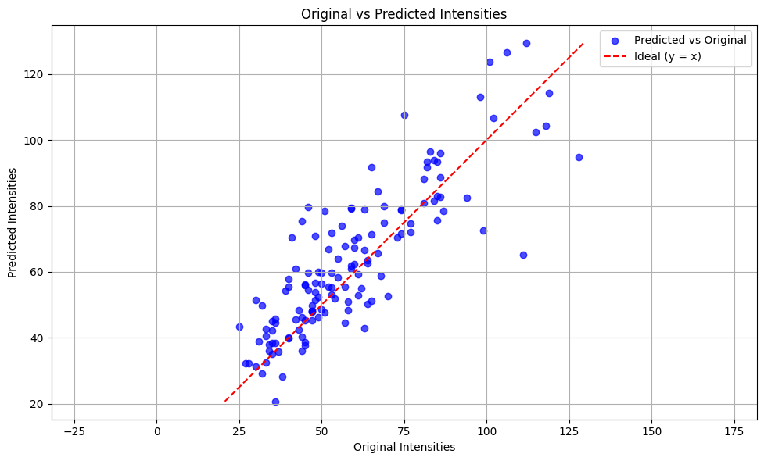

Xception:

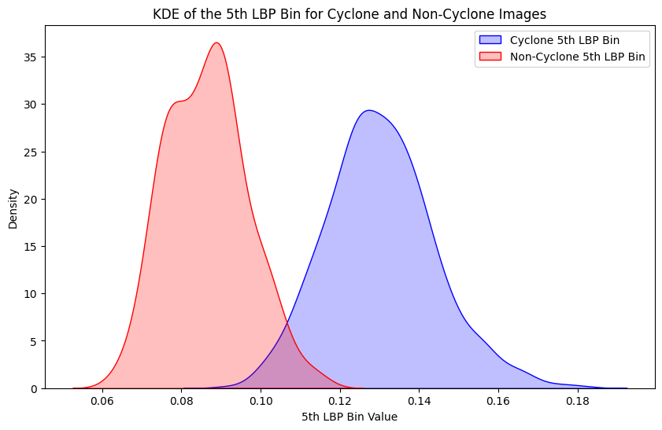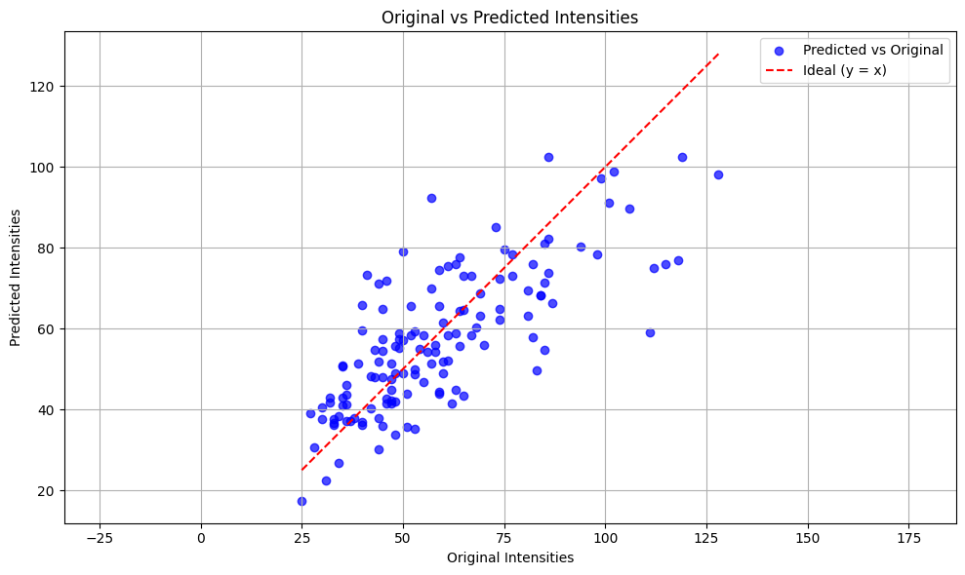

Inception ResNet:

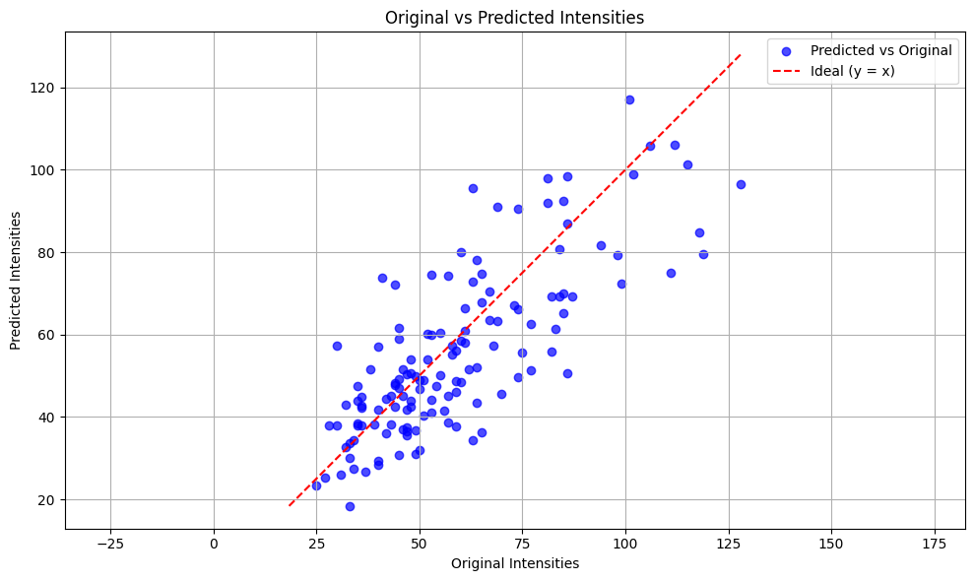

LBP 5th Bin: A Crucial Feature for Cyclone Classification:

In our work, the 5th Local Binary Pattern (LBP) bin turned out to be a key feature in classifying cyclone and non-cyclone images. While we achieved a perfect accuracy of 100%, it’s important to note that the model’s robustness couldn't be fully assessed due to the limited annotated data available. Despite this, the LBP 5th bin played a major role in the decision tree, contributing significantly to the model's ability to distinguish between cyclone and non-cyclone images.

We’ve visualized the impact of this feature through two plots:

Violin Plot: The violin plot shows the distribution of the 5th LBP bin for both cyclone and non-cyclone images. It clearly demonstrates how the values of this feature are well-separated between the two categories, highlighting its effectiveness in classification.

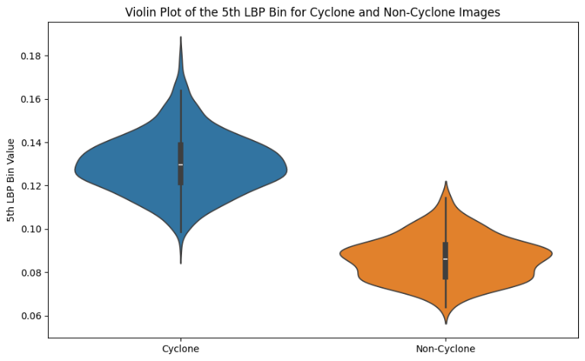

Kernel Density Estimate (KDE): The KDE plots give a more detailed look at the distribution of LBP 5th bin values. They show the density of these values for both cyclone and non-cyclone images, making it clear how distinct the two groups are based on this feature.

These findings suggest that the LBP 5th bin is a highly effective feature for cyclone classification, and its contribution to the decision tree underscores its importance in accurately identifying cyclones.

CONCLUSION

Among all the models, DenseNet proves to be the most effective for cyclone intensity prediction, followed by Xception and Inception ResNet. Models like EfficientNet, MobileNet V3, and ResNet show significantly higher errors, indicating that they are less suited for this particular task. Therefore, DenseNet could be considered the best model for further deployment or improvement.

CYCLONE CLASSIFICATION PERFORMANCE:

In our project, we aimed to create a robust system for cyclone intensity estimation by harnessing the power of machine learning and advanced image processing techniques. Our approach focused on extracting a wide array of features from images, including texture, color, and shape, to build a detailed feature vector for each image. This comprehensive approach ensured that our classifier could accurately distinguish between cyclone and non-cyclone images.

The results were outstanding. Our model demonstrated exceptional performance, achieving a flawless validation accuracy of 100%.

These results demonstrate that our Random Forest classifier is not only accurate but also consistent across different performance metrics. The model, trained with a random state of 42, has proven to be reliable and highly effective for this task. Moreover, we've ensured that this valuable model is saved for future use, making it accessible for real-time cyclone monitoring and decision-making. This means that organizations can leverage our model to enhance their preparedness and response strategies against cyclones.

In summary, our machine learning-based method for cyclone intensity estimation is a significant leap forward. It combines meticulous feature extraction with robust classification to meet the high demands for accuracy and efficiency in real-time applications. This advancement holds great promise for improving how we monitor and respond to cyclones, potentially saving lives and reducing damage.

REFERENCES

[1] Tian, W., Huang, W., Yi, L., Wu, L., & Wang, C. (2020). A CNN-Based Hybrid Model for Tropical Cyclone Intensity Estimation in Meteorological Industry.

[2] Archana, A., Mary, M.J., Devi, R.S., & Yogeshkannah, K. (2024). Cyclone Intensity Estimation Leveraging Graph Convolution Recurrent Networks and INSAT 3D Imagery.

[3] Tian, W., Zhou, X., Niu, X., Lai, L., Zhang, Y., & Kam Sian, K.T.C. (2023). A Lightweight Multitask Learning Model with Adaptive Loss Balance for Tropical Cyclone Intensity and Size Estimation.

[4] Ma, Z., Yan, Y., Lin, J., & Ma, D. (2024). A Multiscale and Multilayer Feature Extraction Network with Dual Attention for Tropical Cyclone Intensity Estimation.

[5] Chen, Z., & Yu, X. (2021). A Novel Tensor Network for Tropical Cyclone Intensity Estimation.

[6] Chen, G., Chen, Z., Zhou, F., Yu, X., Zhang, H., & Zhu, L. (2021). A Semi supervised Deep Learning Framework for Tropical Cyclone Intensity Estimation.

[7] Niranjana, G., & Rakesh, J. (2020). Cyclone Intensity Estimation Using Infrared Satellite Imagery.

[8] Maskey, M., Ramachandran, R., Ramasubramanian, M., Gurung, I., Freitag, B., Kaulfus, A., Bollinger, D., Cecil, D.J., & Miller, J. (2020). Deepti: Deep-Learning-Based Tropical Cyclone Intensity Estimation System.

[9] Gujral, S., Rao, D., Khanvilkar, A., Shah, U., & Maktum, T. (2023). TCI-Net: A Deep Learning Approach for Tropical Cyclone Intensity Prediction.

FUTURE ENHANCEMENTS

1. Multisource Data Integration: Combine satellite imagery with radar and buoy data for better accuracy.
2. Temporal Dynamics: Use RNNs or LSTMs to capture cyclone intensity changes over time.