Sales Trend and Time-Based Performance Analysis
Afficionado Coffee Roasters
NAME: CHAITRA B HURALIKUPPI
PROGRAM: DATA ANALYST INTERN
ORGANIZATION: UNIFIED MENTOR PRIVATE LIMITED
DATE:
ABSTRACT
This project focuses on analysing sales trends and time-based performance for Afficionado Coffee Roasters using transaction-level data from the year 2025. The main objective is to understand when sales occur and identify peak and low-demand periods.
The analysis includes daily and weekly sales trends, day-of-week performance, hourly demand patterns, and comparisons across store locations. The results show that sales are concentrated during specific hours of the day, particularly in the morning and evening. Variations across different store locations were also observed.
These insights can help improve staffing decisions, optimize store operations, and enhance overall efficiency through data-driven planning.

INTRODUCTION:
In specialty coffee retail, understanding when customers make purchases is just as important as understanding what they buy. However, many operational decisions are still based on assumptions rather than actual data.
At Afficionado Coffee Roasters, there is currently no structured analysis of time-based sales patterns. This lack of visibility can lead to overstaffing during slow hours, understaffing during peak periods, and inefficient operational planning.
Therefore, this project aims to analyse transaction-level data to identify clear patterns in customer behaviour and support better decision-making.

Problem Statement:
Despite having access to detailed transaction data, the business currently lacks:
- A clear view of sales trends over time
- Identification of peak and off-peak days
- Insights into hourly demand patterns
- Comparison of performance across store locations
OBJECTIVES
Primary Objectives
- To analyse overall sales trends across 2025
- To identify the busiest and slowest days of the week
- To determine peak transaction hours
Secondary Objectives
- To compare demand patterns across store locations
- To support staff scheduling and operational planning
- To provide explanations for observed sales patterns

DATA DESCRIPTION
Source: Afficionado Coffee Roasters Sales Dataset link
Number of Transactions: 149,116
Features Include:
- Transaction ID
- Transaction Time
- Quantity Purchased
- Unit Price
- Store Location
- Product Category and Type
The dataset contains detailed transaction-level records across multiple store locations. With over 149,000 transactions, it provides a strong foundation for analysing sales trends and customer behaviour over time.
ANALYTICAL METHODOLOGY
Data Cleaning
- Converted transaction time into proper datetime format to enable time-based analysis
- Checked for missing values across all columns and handled them appropriately
- Removed duplicate transaction records to maintain data accuracy
- Verified logical consistency by ensuring all transaction quantities and unit prices were positive

Feature Engineering

New features were created to support time-based analysis:
- Revenue per transaction calculated as:
Transaction Quantity × Unit Price
- Extracted:
  - Hour of the day (0–23)
  - Day of the week
- Created time-based segments:
  - Morning (6–11)
  - Afternoon (12–16)
  - Evening (17–21)
  - Late Night (22–5)

These features enabled deeper analysis of customer purchasing behaviour across different time periods.

Sales Trend Analysis
- Daily and hourly revenue trends were analysed to understand how sales vary over time
- The analysis shows fluctuations in revenue, indicating that customer demand is not constant throughout the day
- Certain hours consistently generate higher sales, highlighting clear peak periods
- Time-based patterns suggest that customer activity is concentrated during specific intervals rather than being evenly distributed

Day-of-Week Performance Analysis
- Average revenue and transaction volume were analysed across each day of the week
- Some days consistently perform better than others, indicating variation in customer activity
- Weekends generally show higher sales compared to weekdays, suggesting increased customer visits during leisure time
- This pattern reflects behavioural differences between working days and non-working days

Time-of-Day Demand Analysis
- Hourly transaction volume and revenue distribution were analysed
- Morning hours show strong demand, indicating peak coffee consumption during early hours
- A secondary peak is observed during evening hours, while midday remains relatively stable
- Late-night hours show lower activity, indicating reduced customer engagement

This analysis clearly highlights peak and off-peak periods throughout the day.

Cross-Location Sales Analysis
- Sales performance was compared across different store locations
- Certain locations consistently generate higher revenue and transaction volumes
- Variations across stores indicate differences in customer behaviour and demand patterns
- These insights suggest that location plays a significant role in influencing sales performance

Hourly Sales Heatmap Analysis
- A heatmap was used to visualize transaction volume across both hours and days
- Peak activity is concentrated during morning hours across most days
- Some variation is observed during evening periods depending on the day
- The heatmap provides a clear visual representation of demand intensity across time

Product Performance Analysis
- Top-performing products were identified based on revenue contribution
- A small number of products contribute significantly to overall sales
- This indicates that revenue is concentrated among key high-performing items
- Understanding these products helps in inventory management and sales strategy
Dashboard Implementation
An interactive Streamlit dashboard was developed to visualize sales trends and time-based performance.
The dashboard includes:
- KPI Metrics
- Sales Trend Charts
- Day-of-Week Analysis
- Store Comparison
- Product Analysis
- Heatmap
- Filters: Store selection, metric selection, and hour range
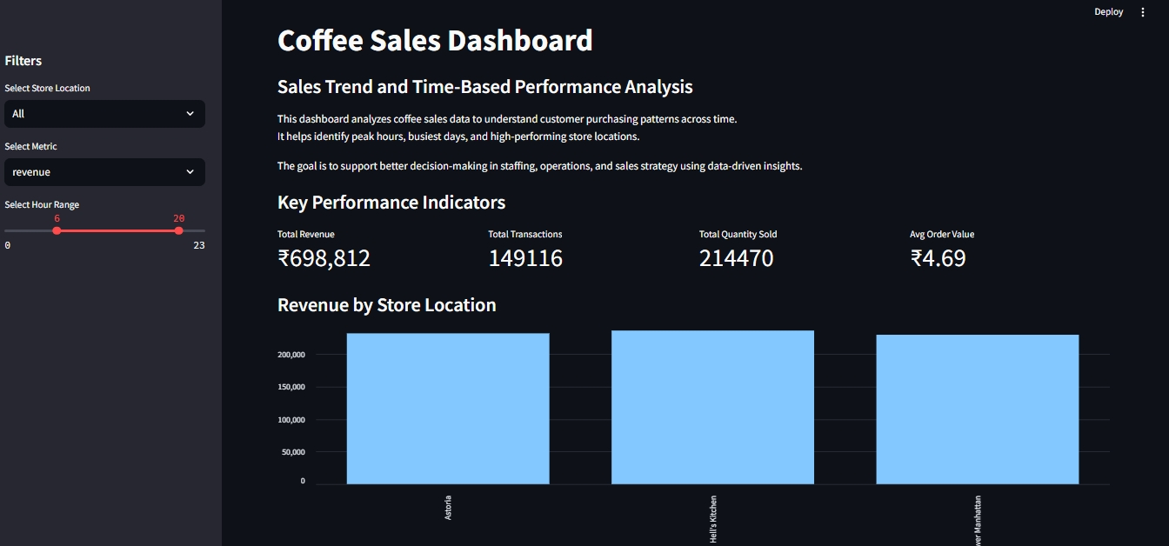

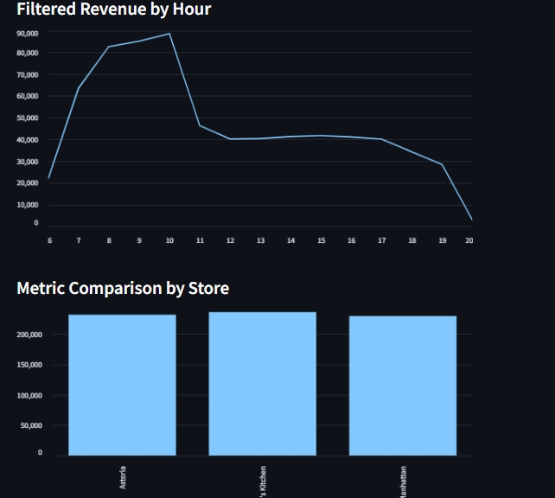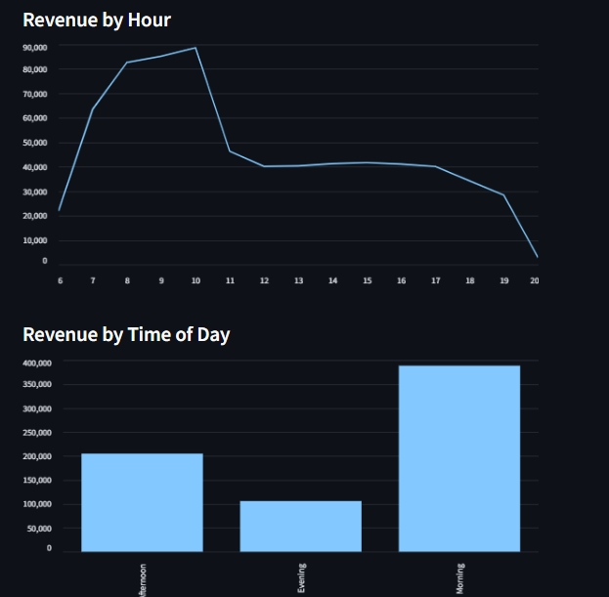
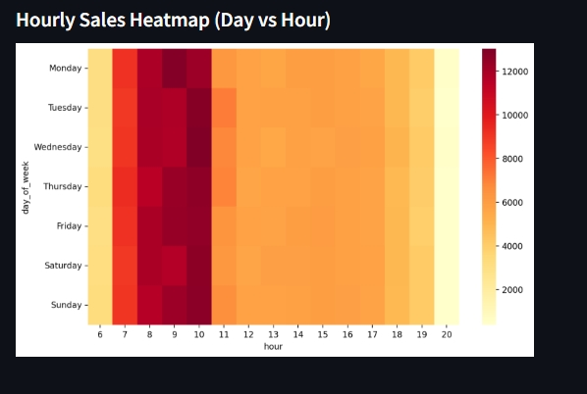

Key Business Insights
- Sales are concentrated during specific hours, particularly in the morning and evening
- Customer activity varies across different days of the week
- Certain store locations consistently outperform others
- Revenue is driven by a small number of high-performing products
- Sales patterns clearly indicate time-based customer behaviour
Recommendations
- Increase staffing during peak hours to improve service efficiency
- Optimize staff allocation during low-demand periods to reduce costs
- Focus on high-performing store locations for expansion opportunities
- Introduce promotional offers during slow hours to boost sales
- Prioritize top-performing products for inventory and marketing strategies

Conclusion
This project demonstrates the importance of time-based sales analysis in retail businesses. By identifying when customers are most active, businesses can optimize operations and improve overall efficiency.
The insights derived from this analysis support data-driven decision-making and provide a strong foundation for improving customer experience and business performance.

Github repo - https://github.com/chaitra336/coffee-sales-performance-analysis
Streamlit app - https://coffee-sales-performance-analysis-mp9kd2mnxyjjdnc7bh6kvb.streamlit.app/#coffee-sales-dashboard

