**Siddaganga Institute of Technology,Tumakuru**

(AnAutonomousInstitutionaffiliatedtoVisvesvarayaTechnologicalUniversity,Approved by AICTE and Program Accredited by NBA, New Delhi, NAAC with ‘A++’ Grade & ISO 9001-2015 Certified Institute)

**Report on Website Creation**

**for**

**N5EI03-ComputerNetwork**

**BY**

Student Name: Chaitra H D

USN: 1SI22EI401

**Departmen of Electronics &Instrumentation Engineering**

**SIDDAGANGA INSTITUTE OF TECHNOLOGY**

**TUMAKURU-572103**

**2023-24**

**CONTENTS**

**Chapter Title Pageno**

**1. INTRODUCTION 1**

**1.1**

**2. SCREENSHOTS OF THE WEBSITE 2-5**

**2.1**

**3. WEBSITE PROGRAM 5-14**

**3.1**

**Introduction**

This website , including an About me, detailed resume, projects and activities, and accessible contact information and programming language can be used for creating website is Html css and javascript.

About Me :

In the About Me section, we have to introduce myself, sharing background, interests.

Resume:

The resume section it including details about skills,qualifications, projects .

.Activities

Activities section which includes participation in extracurricular activities, volunteer work.

Contact :

contact section which includes name email address and phone number used for communication..

**1.HOME**

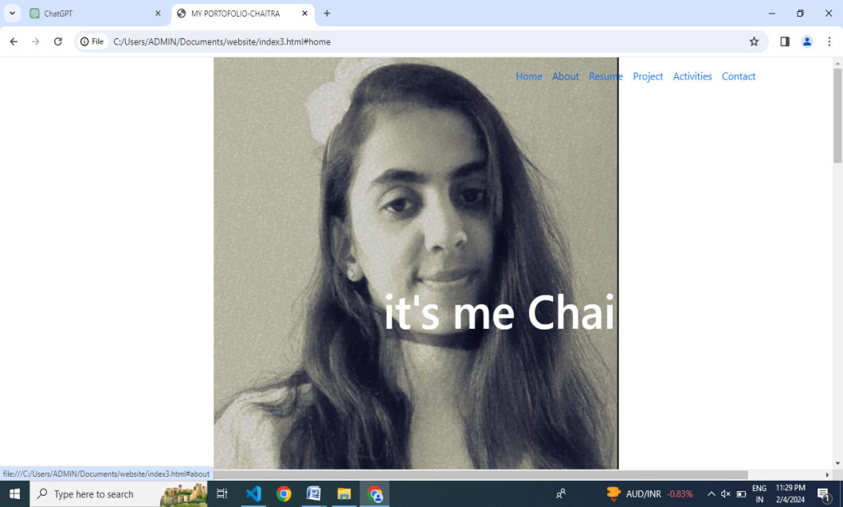

2.ABOUT

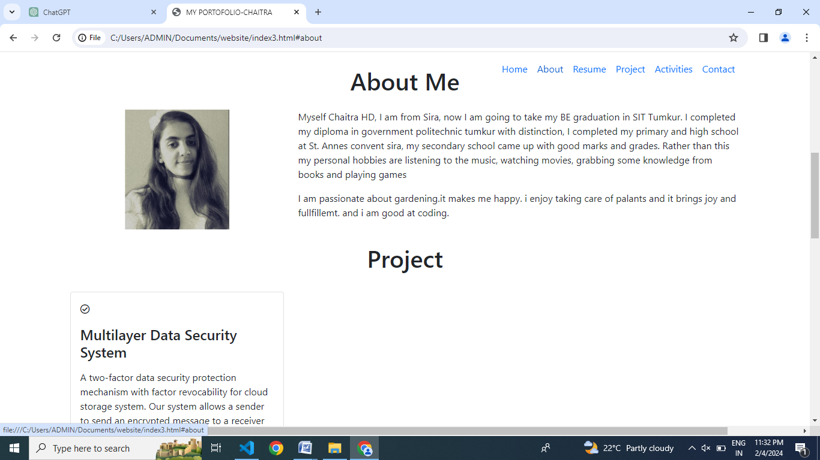

3.RESUME

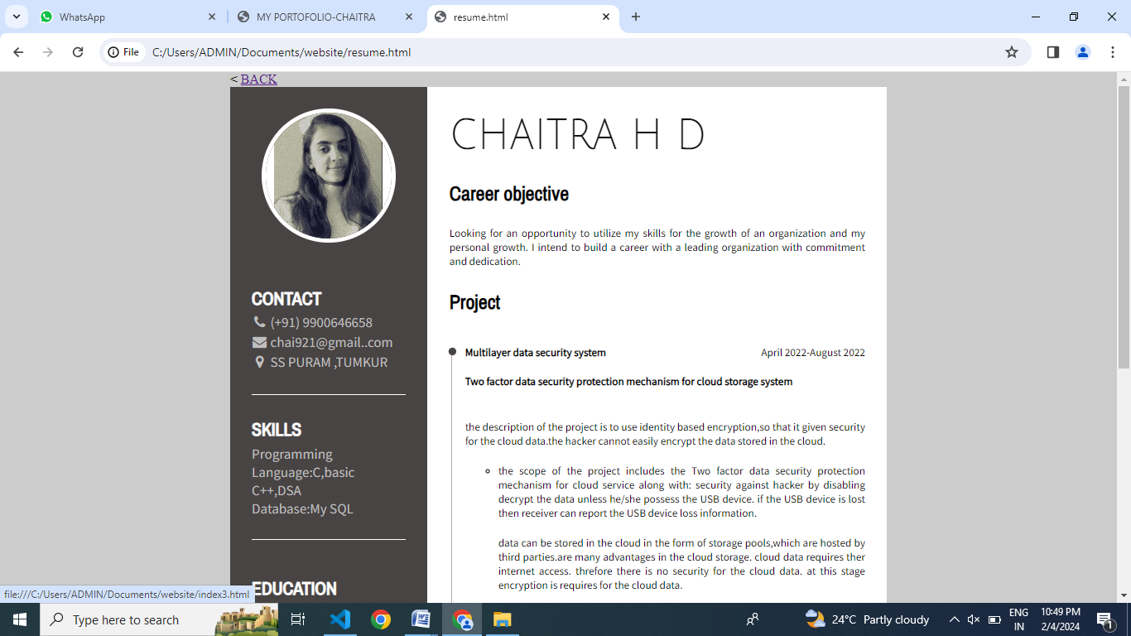

4.PROJECT

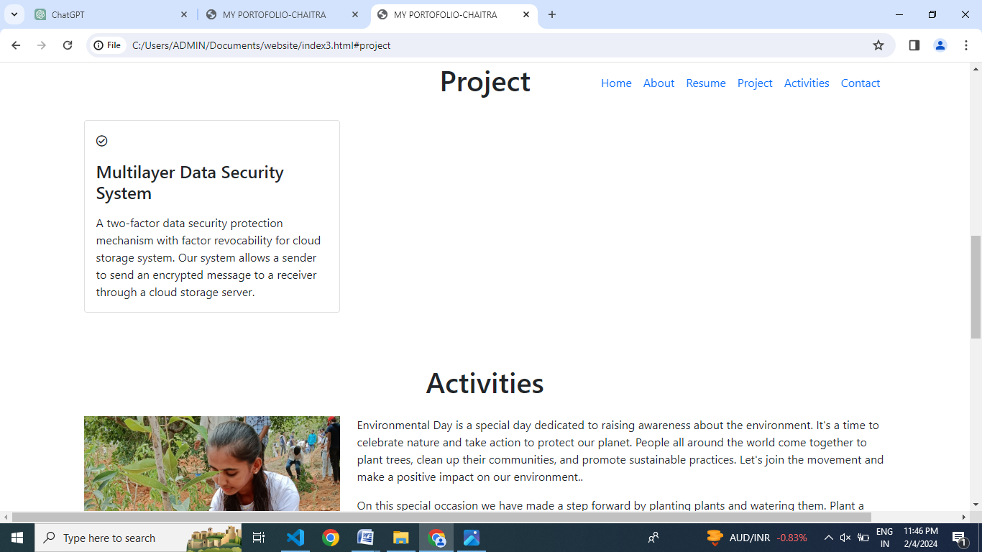

5.ACTIVITIES

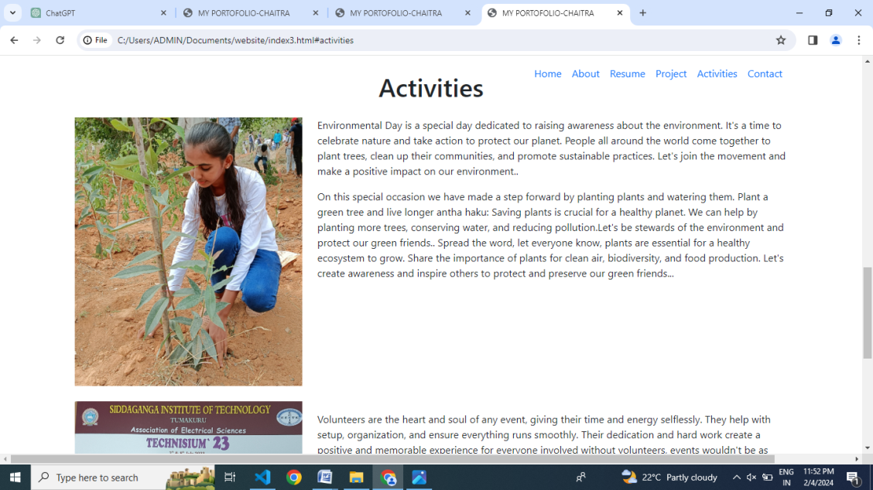

6.CONTACT

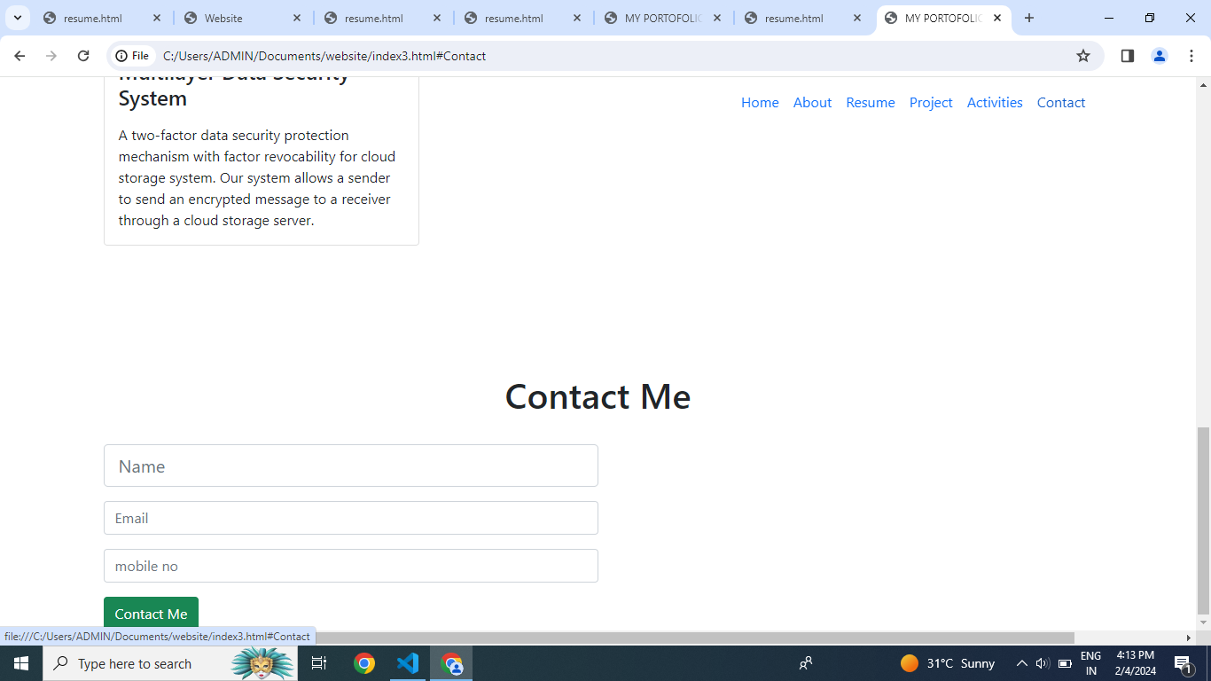

* HTML file

<!DOCTYPE html>

<html lang="en">

<head>

<title>WEBSITE </title>

<meta charset=-8">

<meta name="viewport" content="width=device-width,initial-scale1">

<link rel= "stylesheet"href="style3.css">

<linkhref="https://cdn.jsdelivr.net/npm/bootstrap@5.1.3/dist/css/bootstrap.min.css" rel="stylesheet”>

<scriptsrc="https://cdn.jsdelivr.net/npm/bootstrap@5.1.3/dist/css/bootstrap.bundle.min.js">

</script>

<scriptsrc="https://kit.fontawesome.com/31149d48b0.js"crossorigin="anonyms></script>

</head>

<body>

<nav class="navbar navbar-expand-lg fixed-top navbarScroll">

<div class="container">

<buttonclass="navbar-toggler"type="button"data-bs-toggle="collapse"data-bs-target="#navbarSupportedContent"ariacontrols="#navbarSupportedContent"aria-expanded="false"aria-label="Toggle navigation">

<span class="navbar-toggler-icon"></span>

</button>

<div class="collapse navbar-collapse id="navbarSupportedContent">

<ul class="navbar-nav ms-auto">

<li class="nav-item-active">

<a class="nav-link"href="#home">Home</a>

</li>

<li class="nav-item">

<a class="nav-link"href="#about">About</a>

</li>

<li class="nav-item">

<a class="nav-link"href="resume.html">Resume</a>

</li>

<li class="nav-item">

<a class="nav-link"href="#project">Project</a>

</li>

<li class="nav-item">

<a class="nav-link"href="#activities">Activities</a>

</li>

<li class="nav-item">

<a class="nav-link"href="#Contact">Contact</a>

</li>

</ul>

</div>

</div>

</nav>

/* main page*/

<section class="bgimage" id="home">

<div class="container-fluid">

<div class="row">

<div class="col-lg-12 col-md-12 col-sm-12 col-xs-12 text">

<h2 class="title">it's me Chai</h2>

</div>

</div>

</div>

</section>

/* about section */

<section id="about">

<div class="container mt-4 pt-4">

<h1 class="text-center">About Me</h1>

<div class="row mt-4">

<div class="col-lg-4">

<img src="chai.jpg" class="imageAboutPage"alt="">

</div>

<div class="col-lg-8">

<p>

Myself Chaitra HD, I am from Sira, now I am going to take my BE graduation in SIT Tumkur. I completed my diploma in government polytechnic tumkur with distinction, I completed my primary and high school at St. Annes convent sira, my secondary school came up with good marks and grades. Rather than this my personal hobbies are listening to the music, watching movies, grabbing some knowledge from books and playing games.

</p>

<div class="row mt-3">

<p>

I am passionate about gardening.it makes me happy. i enjoy taking care of palants and it brings joy and fullfillemt.and i am good at coding.

</p>

</div>

</div>

</div>

</div>

</section>

/*project section*/

<br>

<section id="project">

<div class="container">

<h1 class="text-center">Project</h1>

<div class="row">

<div class="col-lg-4 mt-4">

<div class="card servicesText">

<div class="card-body">

<i class='far servicesIcon fa-check-circle'></i>

<h4 class="card-title mt-3">Multilayer Data Security System</h4>

<p class="card-text mt-3">A two-factor data security protection mechanism with factor revocability for cloud storage system.

Our system allows a sender to send an encrypted message to a receiver through a cloud storage server. </p>

</div>

</div>

</div>

</div>

</div>

</section>

</br>

/*Activities*/

<section id="activities">

<div class="container mt-4 pt-4">

<h1 class="text-center">Activities</h1>

<div class="row mt-4">

<div class="col-lg-4">

<img src="ac3.jpg" class="imageAboutPage"alt="">

</div>

<div class="col-lg-8">

<p>

Environmental Day is a special day dedicated to raising awareness about the environment. It's a time to celebrate nature and take action to protect our planet. People all around the world come together to plant trees, clean up their communities, and promote sustainable practices. Let's join the movement and make a positive impact on our environment..

</p>

<div class="row mt-3">

<p>

On this special occasion we have made a step forward by planting plants and watering them.

Plant a green tree and live longer antha haku: Saving plants is crucial for a healthy planet.

We can help by planting more trees, conserving water, and reducing pollution.Let's be stewards of the environment and protect our green friends..

Spread the word, let everyone know, plants are essential for a healthy ecosystem to grow. Share the importance of plants for clean air, biodiversity, and food production. Let's create awareness and inspire others to protect and preserve our green friends...

</p>

</div>

</div>

</div>

<div class="row mt-4">

<div class="col-lg-4">

<img src="act1.jpg" class="imageAboutPage"alt="">

</div>

<div class="col-lg-8">

<div class="row mt-3">

<p>

Volunteers are the heart and soul of any event, giving their time and energy selflessly. They help with setup, organization, and ensure everything runs smoothly. Their dedication and hard work create a positive and memorable experience for everyone involved without volunteers, events wouldn't be as successful or enjoyable

</p>

</div>

</div>

</div>

</div>

</section>

/*Contact section*/

<section id="Contact">

<div class=" container mt-3 contactContent">

<h1 class="text-center">Contact </h1>

<br>

<div class="col-lg-6" >

<form>

<input type="text" class="form-control form-control-lg" placeholder="Name">

<input type="email" class="form-control mt-3" placeholder="Email">

<input type="text" class="form-control mt-3" placeholder="mobile no">

</form>

<button type="button"class="btn btn-success mt-3">Contact Me</button>

</br>

</div>

</div>

</section>

<script src="script.js"></script>

</body>

</html>

CSS file

.navbarScroll.navbarDark {

background-color: black;

}

/* hero background image */

.bgimage {

height:100vh;

background: url('chai.jpg');

background-size:cover;

position:relative;

}

/* text css above hero image*/

.title {

font-size: 4.5rem;

}

.desc {

font-size: 2rem;

}

.text {

text-align: center;

position: absolute;

top: 60%;

left: 60%;

transform: translate(-50%, -50%);

color:white;

}

.imageAboutPage

{

width:100%;

}

#About,#Resume,#Project,#Activities,#Contact{

margin-top: 4rem;

padding-top: 4rem;

}

#contact{

padding-bottom: 4rem;

}

JAVASCRIPT file

const header=document.querySelector('.navbar');

window.onscroll=function(){

var top=window.srollY;

if(top>=100){

header.classList.add('nabbarDark');

}

else{

header.classList.remove('nabbarDark');

}

}