1: Identify the lifecycle to be followed for the execution of your project and justify why you have chosen the model. (Use Degree of certainty)

(Shubhangi – PES2UG20CS424)

We are choosing agile model for execution of our project

Justification:

* Agile helps teams and individuals effectively prioritize work and features.
* Even late changes in requirements are welcomed.
* Regular adaptation to changing circumstances.
* Fast delivery of product.
* Continuous interaction between developer, customer and product owner (PO). Customers’ opinions are valued more than the process.
* Focus on simplicity in both product and process.
* Teams can make quick-course corrections based on stakeholder feedback

2: Identify the tools which you want to use throughout the lifecycle like planning tool, design tool, version control, development tool, bug tracking, testing tool.

GitHub: version control, development tool

Jira: planning tool, bug tracking,

Draw-io: design tool

3. Determine all the deliverables and categorise them as reuse/build components and justify the same.

4: Create a WBS for the entire functionalities in detail. (Chaitra BN -PES2UG2U20CS424)

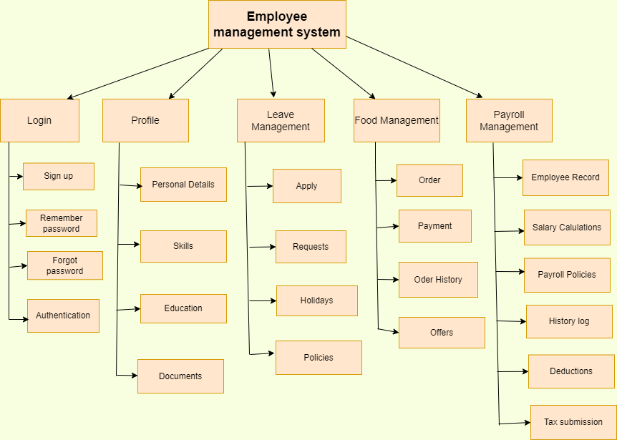

5: Do a rough estimate of effort required to accomplish each task in terms of person months. (Use BASIC COCOMO)

6: Create the Gantt Chart for scheduling using any tool.

