Task 1:

Check whether /user/acadgild directory exists or not in the HDFS.

If it doesn't exist, then create this.

Create a directory /user/acadgild/hadoop.

**Solution :** to check if/user/acadgild/hadoop directory exist

hdfs dfs –ls /user/acadgild/hadoop

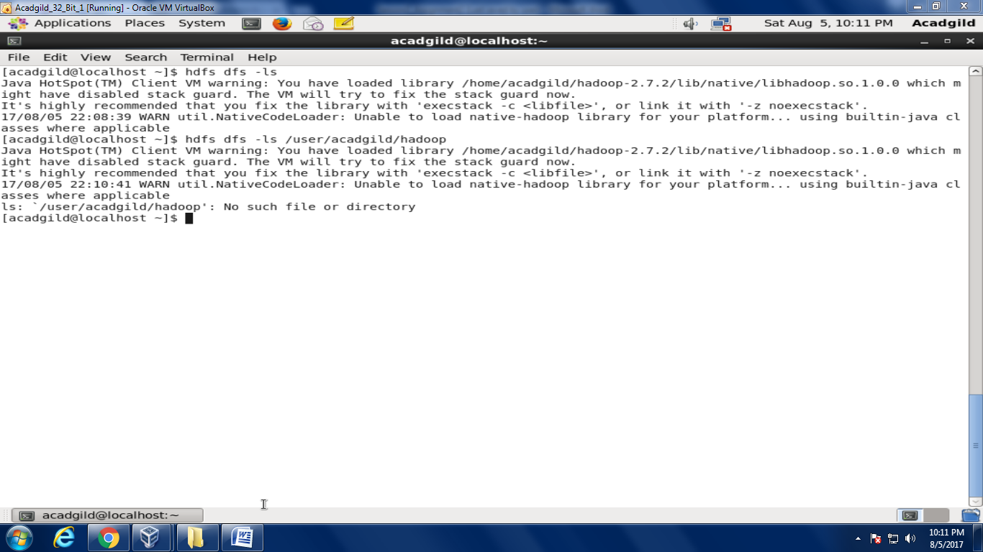

To create directory hdfs dfs –mkdir /user/acadgild/hadoop

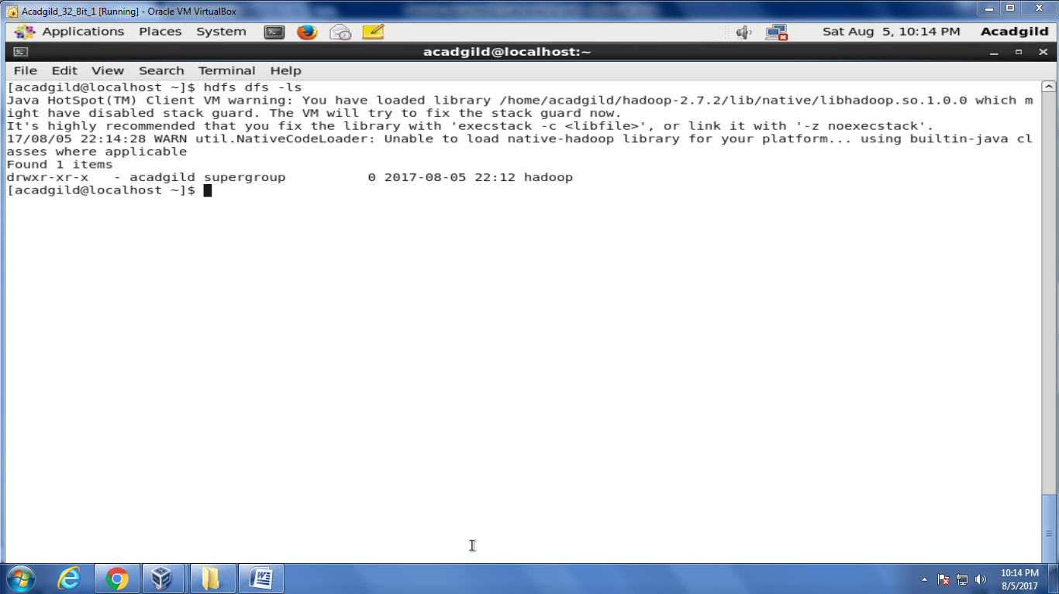

Task 2:

Create a file in HDFS under directory /user/acadgild/hadoop, with name word-count.txt.

Whatever we type on screen should get appended to the file.

Try to type (on screen) few lines from any online article or textbook.

**Solution:**  hdfs dfs –touchz /user/acadgild/hadoop/word-count.txt

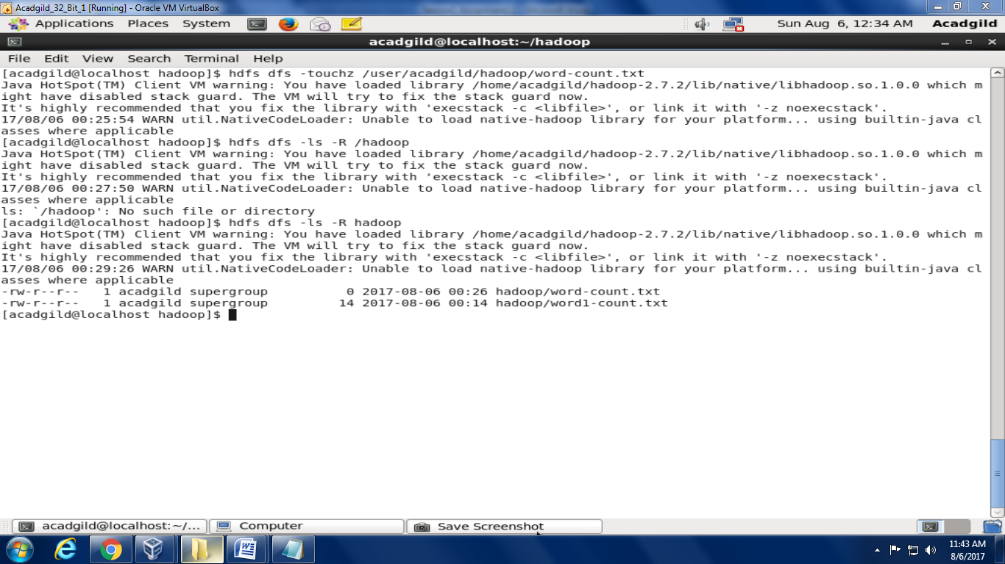

To appened via command line :

hdfs dfs –appendToFile - /user/acadgild/hadoop/word-count.txt

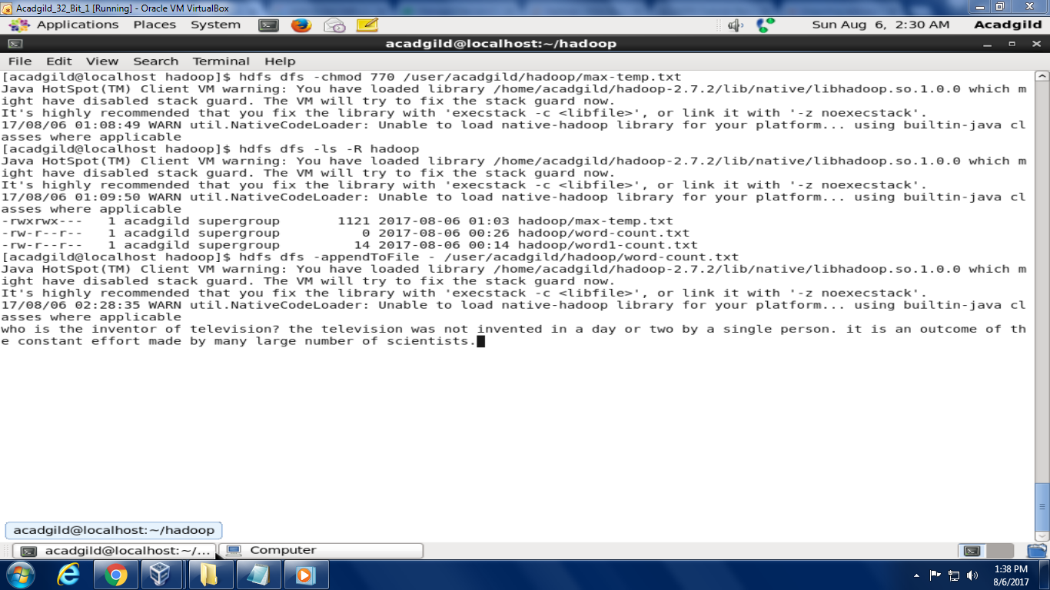

To view the file we appended:

Hdfs dfs –cat /user/acadgild/hadoop/word-count.txt

