**Session1: Assignment 2**

1. pwd : Present working directory.

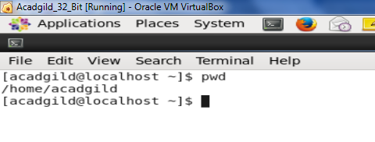

2. vi : Vi editor is used for creating a new file, opening an existing file (used to operate on file)

Example : vi chaitra.txt

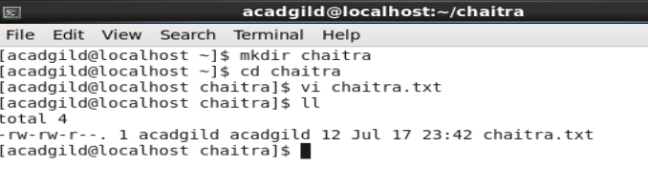

3. touch : Also used to create a new empty file.

Example : touch acadgild.txt

It can also create multiple files

Example : touch 1.txt 2.txt 3.txt

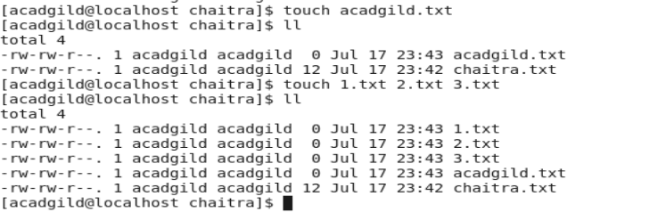

4. mkdir : It is used to make a directory .

Example : mkdir chaitra

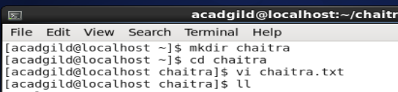

5. rm : it is used to remove the directory

Example : rm chaitra.txt

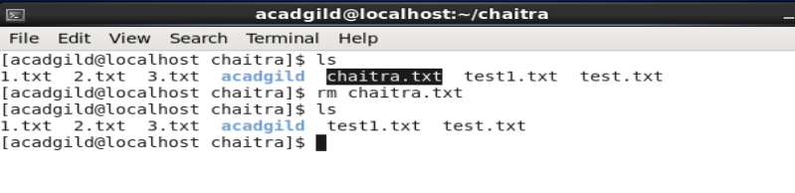

6. ls : it is used to list all the files and folders inside a directory

Example : ls

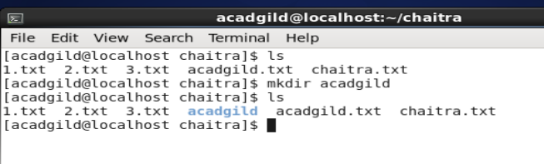

7. echo : it is used to write the aruguments into the standdard output.

Example : echo hello wold

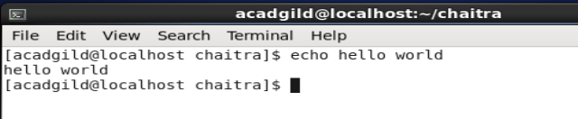

8. cat : stands for concatenate. It is used to create single or multiple files ,view contain a file, concatenate file and redirect output to the terminal or file.

Example : cat chaitra.txt 1.txt

Where file chaitra.txt contains the text “Hi Acadgild” and 1.txt contains “How are you doing”

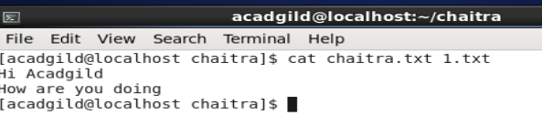

The cat >test1.txt will create a file and let us enter the value to the line via the command line.

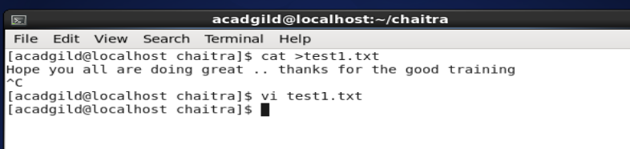

9. who : It is used to display the list of users who are currently logged into the computer.

Example : who

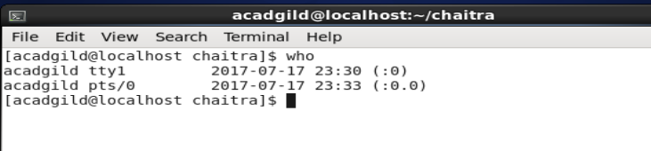

10.cd: change directory is used to change the present working directory to another.

Example : cd chaitra

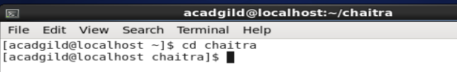

11.date: it is used to give the current system date,time and also the timezone.

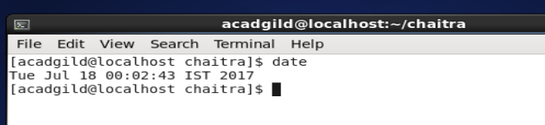

12.cal : it is a command line utlity for displaying the calendar in the terminal.

By default it would give the current date of the month.

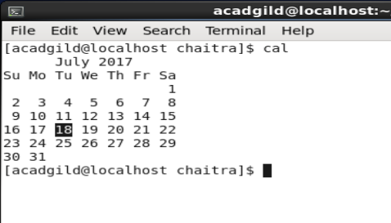

13.mv: it is used to move file/directory from one location to another. Example : mv <source> <destination>

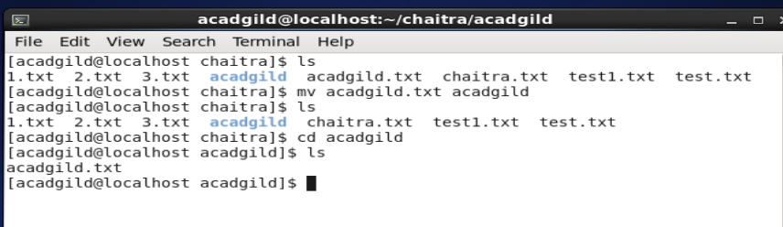

14.cp: it is used to copy file/directory from one location to another. The move command would move the file from pne path to another, wheras the copy command will copy the file/directory from one path to another.

Example : cp <from> <to>

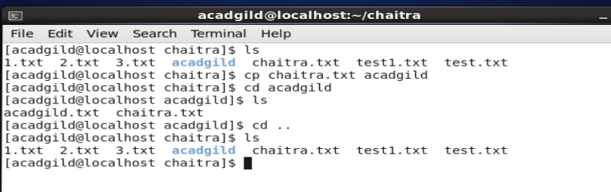

15.which: it is used to identify the location of the executables.

