1. Write a java code with the class named ‘acad’ and a method ‘main’. Hard Code the program with two integers and print the sum of those two.

package com.haddop.bigdata;

public class Acad1 {

public static void main(String[] args) {

// TODO Auto-generated method stub

int value1=30;

int value2=20;

int sum=value1+value2;

System.out.println("Sum of "+value1+ " and " +value2+ " is : "+sum);

}

}

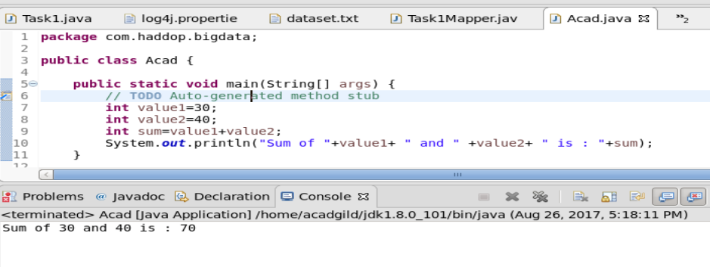

1. Rewrite the above code, where, inputs are provided by the user at runtime and the output is printed.

package com.haddop.bigdata;

import java.util.Scanner;

public class Acad {

public static void main(String[] args) {

// TODO Auto-generated method stub

Scanner sc = new Scanner(System.in);

System.out.println("Enter the value1");

int value1=sc.nextInt();

System.out.println("Enter the value2");

int value2=sc.nextInt();

int sum=value1+value2;

System.out.println("Sum of "+value1+ " and " +value2+ " is : "+sum);

}

}

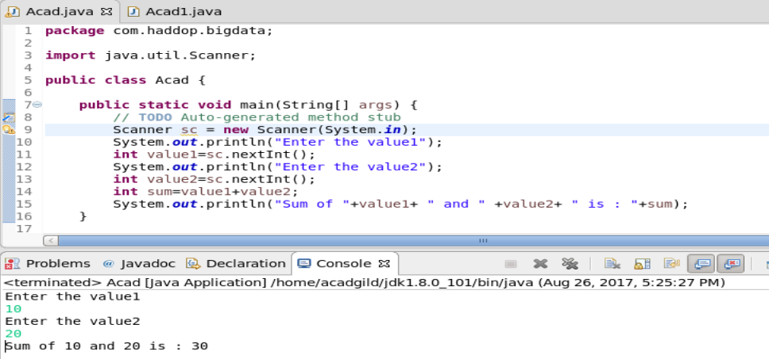

1. Write a program with method name sum() that accepts two parameters from user and print the sum of two numbers.

Output format should be as:

First number is:

Second number is:

Sum is:

package com.haddop.bigdata;

import java.util.Scanner;

public class Sum {

public void sum(int i,int j)

{

int sum = i+j;

System.out.println("First number is : "+i);

System.out.println("Second number is : "+j);

System.out.println("Sum is : "+sum);

}

public static void main(String[] args) {

// TODO Auto-generated method stub

Sum sum = new Sum();

Scanner sc = new Scanner(System.in);

System.out.println("Enter the value1");

int value1=sc.nextInt();

System.out.println("Enter the value2");

int value2=sc.nextInt();

sum.sum(value1, value2);

}

}

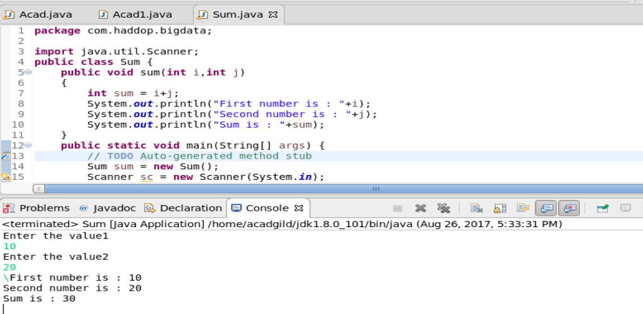

1. Write a program to accepts two numbers from stdin and find all the odd as well as even numbers present in between them.

package com.haddop.bigdata;

import java.util.Scanner;

public class OddOrEven {

public static void main(String[] args) {

// TODO Auto-generated method stub

Scanner sc = new Scanner(System.in);

System.out.println("Enter the value1");

int value1=sc.nextInt();

System.out.println("Enter the value2");

int value2=sc.nextInt();

for (int i = value1;i<=value2;i++)

{

if(i%2==0)

{

System.out.println("The number "+i+" is even");

}

else

{

System.out.println("The number "+i+" is odd");

}

}

}

}

1. Joe is scared to go to school. When her dad asked the reason, joe said she is unable to complete the task given by her teacher. The task was to find the “first 10 multiples” of the number entered from stdin . Eg: Input: 3 O/p: 3 x 1 = 3 3 x 2 = 6 ……… ……… ……. …. 3 x 10 = 30 Help Joe in completing the task!

package com.haddop.bigdata;

import java.util.Scanner;

public class FirstTenMultiples {

public static void main(String[] args) {

// TODO Auto-generated method stub

Scanner sc = new Scanner(System.in);

System.out.println("Enter the number");

int value1=sc.nextInt();

for(int i=1;i<=10;i++)

{

System.out.println("3X"+i+"="+value1\*i);

}

}

}

1. Write a program consisting method sum() and demonstrate the concept of method overloading using this method.

If two methods in a class has the same name but with different types and number of arguments then this concept is called method overloading.

In the below example the method sum has two differnet set of arguments.

package com.haddop.bigdata;

class Parent

{

void sum(int i,int j)

{

System.out.println("Inside method 1 pf parent class");

System.out.println("SUm is :" +(i+j));

}

void sum(int i,int j,int k )

{

System.out.println("Inside method2 of parent class");

System.out.println("SUM is :" +(i+j+k));

}

}

public class MethodOverloading {

public static void main(String[] args) {

// TODO Auto-generated method stub

Parent p = new Parent();

p.sum(10, 20);

p.sum(10, 20,30);

}

}

1. Can you overload a method with same return type.? Explain your answer with proper logic.

Yes, overloading means having same name and same signature except that the arguments that is being passed would be different.

8) Write a program in java using Arrays, that sorts the element in descending order