VISVESVARAYA TECHNOLOGICAL UNIVERSITY
“JnanaSangama”, Belgaum -590014, Karnataka.


LAB REPORT

On

ANALYSIS AND DESIGN OF ALGORITHMS (23CS4PCADA)

Submitted by

CHAITRA M (1BM24CS078)

in partial fulfillment for the award of the degree of
BACHELOR OF ENGINEERING
in
COMPUTER SCIENCE AND ENGINEERING



B.M.S. COLLEGE OF ENGINEERING
(Autonomous Institution under VTU)
BENGALURU-560019
February to June 2026
CERTIFICATE

B. M. S. College of Engineering,
Bull Temple Road, Bangalore 560019
(Affiliated To Visvesvaraya Technological University, Belgaum)
Department of Computer Science and Engineering



This is to certify that the Lab work entitled “ANALYSIS AND DESIGN OF ALGORITHMS” carried out by CHAITRA M (1BM24CS078), who is bonafide student of B. M. S. College of Engineering. It is in partial fulfillment for the award of Bachelor of Engineering in Computer Science and Engineering of the Visvesvaraya Technological University, Belgaum during the year 2025-26. The Lab report has been approved as it satisfies the academic requirements in respect of Analysis and Design of Algorithms Lab - (23CS4PCADA) work prescribed for the said degree.

Pallavi C V Dr. Kavitha Sooda
Assistant Professor Professor and Head
Department of CSE Department of CSE
BMSCE, Bengaluru BMSCE, Bengaluru

Index Sheet
Sl.  No. | Experiment Title | Page No.
1 | Write program to obtain the Topological ordering of vertices in a given digraph. | 4-8
2 | Implement Johnson Trotter algorithm to generate permutations. | 9-11
3 | Sort a given set of N integer elements using Merge Sort technique and compute its time taken. Run the program for different values of N and record the time taken to sort. | 12-15
4 | Sort a given set of N integer elements using Quick Sort technique and compute its time taken. | 16-18
5 | Sort a given set of N integer elements using Heap Sort technique and compute its time taken. | 19-21
6 | Implement 0/1 Knapsack problem using dynamic programming. (5 Marks) | 22-24
7 | Implement All Pair Shortest paths problem using Floyd’s algorithm. | 25-27
8 | - Find Minimum Cost Spanning Tree of a given undirected graph using Prim’s algorithm.  - Find Minimum Cost Spanning Tree of a given undirected graph using Kruskal’s algorithm. | 28-33
9 | Implement Fractional Knapsack using Greedy technique. | 34-36
10 | From a given vertex in a weighted connected graph, find shortest paths to other vertices using Dijkstra’s algorithm. | 37-39
11 | Implement “N-Queens Problem” using Backtracking. | 40-43

Course outcomes:
CO1 | Analyze time complexity of algorithms using asymptotic notations.
CO2 | Apply various algorithm design techniques for the given problem.
CO3 | Evaluate the appropriate algorithm/design technique for solving a given problem.
CO4 | Conduct practical experiments by applying appropriate algorithm design technique to solve problems.

Lab program 1:
Write program to obtain the Topological ordering of vertices in a given digraph.
#include <stdio.h>
#define MAX 10
int graph[MAX][MAX], visited[MAX], stack[MAX];
int n, top = -1;
void dfs(int v) {
visited[v] = 1;
for (int i = 0; i < n; i++) {
if (graph[v][i] && !visited[i]) {
dfs(i);
}
}
stack[++top] = v;
}
void topologicalSort() {
for (int i = 0; i < n; i++)
if (!visited[i])
dfs(i);
printf("Topological Ordering: ");
while (top != -1)
printf("%d ", stack[top--]);
}
int main() {
printf("Enter number of vertices: ");
scanf("%d", &n);
printf("Enter adjacency matrix row by row:\n");
for (int i = 0; i < n; i++) {
for (int j = 0; j < n; j++) {
printf("graph[%d][%d]: ", i, j);
scanf("%d", &graph[i][j]);
}
visited[i] = 0;
}
topologicalSort();
}

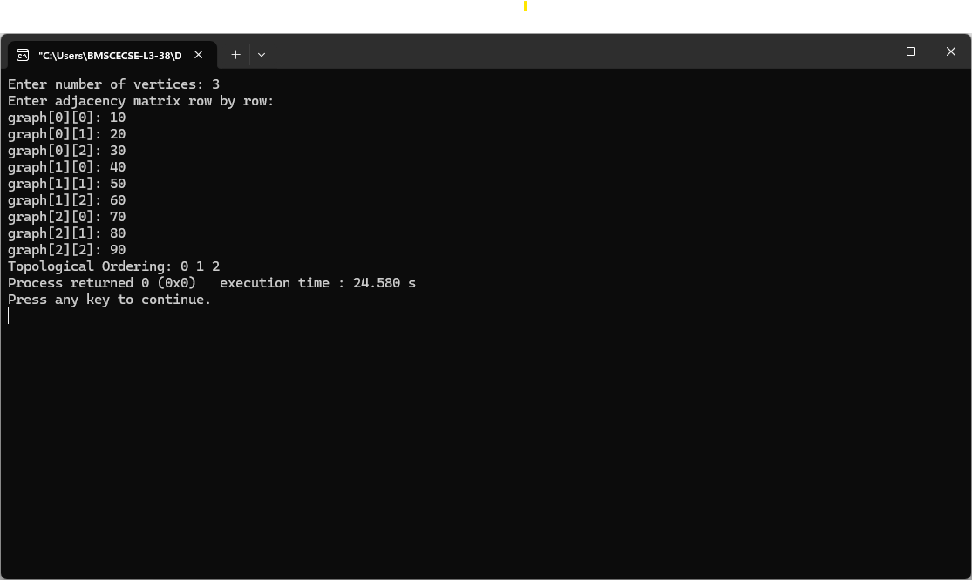
OUTPUT:

Graph :

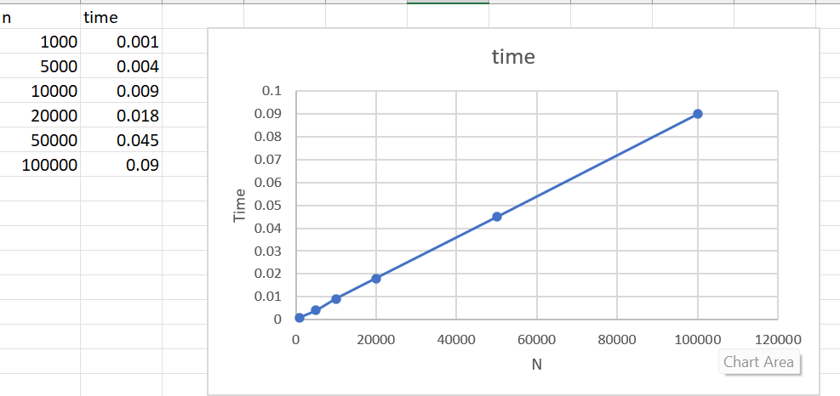

LeetCode on Topological Sorting

#include <stdbool.h>
#include <stdlib.h>

bool canFinish(int numCourses, int** prerequisites, int prerequisitesSize, int* prerequisitesColSize) {

int indegree[numCourses];

for (int i = 0; i < numCourses; i++) {
indegree[i] = 0;
}

for (int i = 0; i < prerequisitesSize; i++) {
int course = prerequisites[i][0];
indegree[course]++;
}

int queue[numCourses];
int front = 0, rear = 0;

for (int i = 0; i < numCourses; i++) {
if (indegree[i] == 0) {
queue[rear++] = i;
}
}

int count = 0;

while (front < rear) {

int current = queue[front++];
count++;

for (int i = 0; i < prerequisitesSize; i++) {

int course = prerequisites[i][0];
int prereq = prerequisites[i][1];

if (prereq == current) {

indegree[course]--;

if (indegree[course] == 0) {
queue[rear++] = course;
}
}
}
}

return (count == numCourses);
}


OUTPUT:

Lab program 2
Implement Johnson Trotter algorithm to generate permutations.
#include <stdio.h>
#define LEFT -1
#define RIGHT 1
int getMobile(int a[], int dir[], int n)
{
int mobile = 0, mobileIndex = -1;
for(int i = 0; i < n; i++)
{
if(dir[a[i]-1] == LEFT && i != 0)
{
if(a[i] > a[i-1] && a[i] > mobile)
{
mobile = a[i];
mobileIndex = i;
}
}
if(dir[a[i]-1] == RIGHT && i != n-1)
{
if(a[i] > a[i+1] && a[i] > mobile)
{
mobile = a[i];
mobileIndex = i;
}
}
}

return mobileIndex;
}
void printPermutation(int a[], int n)
{
for(int i = 0; i < n; i++)
printf("%d ", a[i]);
printf("\n");
}
int main()
{
int n;
printf("Enter number of elements: ");
scanf("%d",&n);
int a[n], dir[n];
for(int i = 0; i < n; i++)
{
a[i] = i + 1;
dir[i] = LEFT;
}
printPermutation(a,n);
while(1)
{
int mobileIndex = getMobile(a,dir,n);
if(mobileIndex == -1)
break;
int mobile = a[mobileIndex];
if(dir[mobile-1] == LEFT)
{
int temp = a[mobileIndex];
a[mobileIndex] = a[mobileIndex-1];
a[mobileIndex-1] = temp;
mobileIndex--;
}
else
{
int temp = a[mobileIndex];
a[mobileIndex] = a[mobileIndex+1];
a[mobileIndex+1] = temp;
mobileIndex++;
}
for(int i = 0; i < n; i++)
{
if(a[i] > mobile)
dir[a[i]-1] = -dir[a[i]-1];
}
printPermutation(a,n);
}
return 0; }

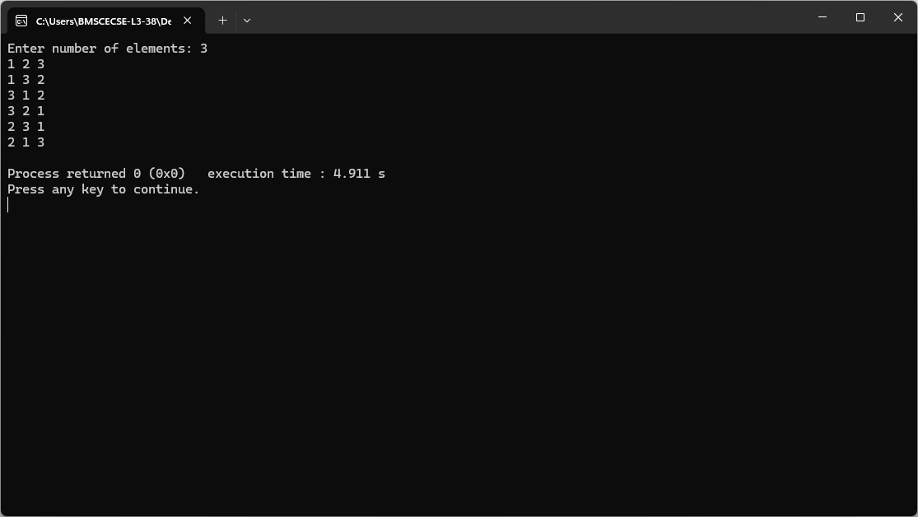
OUTPUT:
Lab Program 3
Sort a given set of N integer elements using Merge Sort technique and compute its time taken. Run the program for different values of N and record the time taken to sort
#include <stdio.h>
#include <stdlib.h>
#include <time.h>
void merge(int arr[], int l, int m, int r) {
int i, j, k;
int n1 = m - l + 1;
int n2 = r - m;
int L[n1], R[n2];
for(i = 0; i < n1; i++)
L[i] = arr[l + i];
for(j = 0; j < n2; j++)
R[j] = arr[m + 1 + j];
i = 0;
j = 0;
k = l;
while(i < n1 && j < n2) {
if(L[i] <= R[j]) {
arr[k] = L[i];
i++;
}
else {
arr[k] = R[j];
j++;
}
k++;
}

while(i < n1) {
arr[k] = L[i];
i++;
k++;
}
while(j < n2) {
arr[k] = R[j];
j++;
k++;
}
}

void mergeSort(int arr[], int l, int r) {
if(l < r) {
int m = l + (r - l) / 2;
mergeSort(arr, l, m);
mergeSort(arr, m + 1, r);

merge(arr, l, m, r);
}
}
int main() {
int n, i;
clock_t start, end;
double cpu_time;

printf("Enter number of elements: ");
scanf("%d", &n);
int arr[n];
printf("Enter elements:\n");
for(i = 0; i < n; i++)
scanf("%d", &arr[i]);
start = clock();
mergeSort(arr, 0, n - 1);
end = clock();
cpu_time = ((double)(end - start)) / CLOCKS_PER_SEC *1000;
printf("\nSorted elements:\n");
for(i = 0; i < n; i++)
printf("%d ", arr[i]);
printf("\nTime taken: %f seconds\n", cpu_time);
return 0;
}

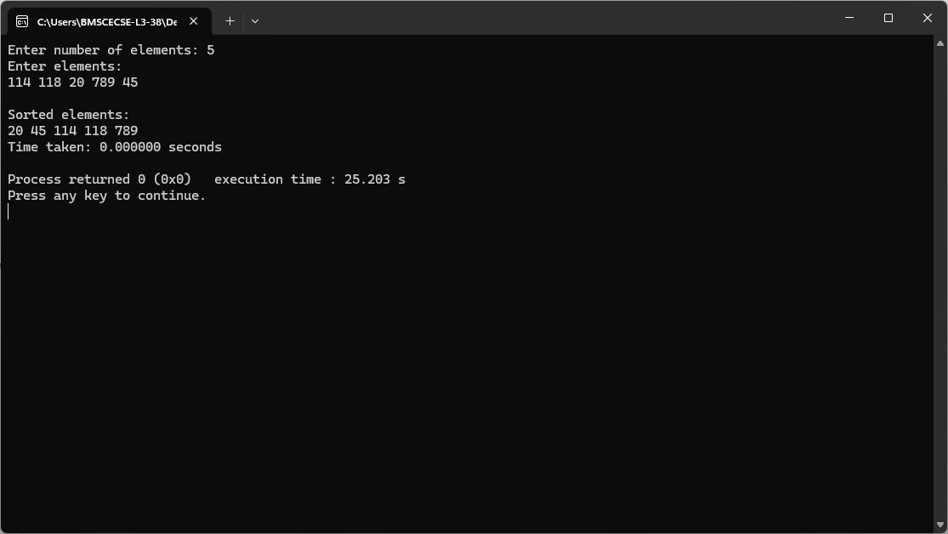
Output:

Graph:

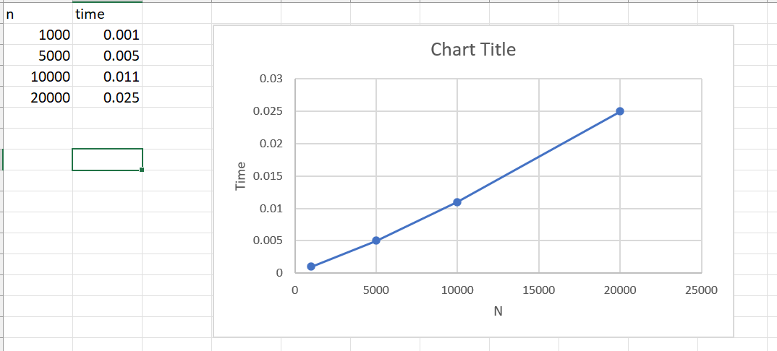

Lab Program 4
Sort a given set of N integer elements using Quick Sort technique and compute its time taken.
#include <stdio.h>
#include <time.h>
int partition(int arr[], int low, int high) {
int pivot = arr[low];
int i = low + 1;
int j = high;
int temp;
while (i <= j) {
while (i <= high && arr[i] <= pivot)
i++;
while (arr[j] > pivot)
j--;
if (i < j) {
temp = arr[i];
arr[i] = arr[j];
arr[j] = temp;
}
}
temp = arr[low];
arr[low] = arr[j];
arr[j] = temp;
return j;
}
void quickSort(int arr[], int low, int high) {
if (low < high) {
int pos = partition(arr, low, high);
quickSort(arr, low, pos - 1);
quickSort(arr, pos + 1, high);
}
}
int main() {
int n, i;
printf("Enter number of elements: ");
scanf("%d", &n);
int arr[n];
printf("Enter elements:\n");
for (i = 0; i < n; i++)
scanf("%d", &arr[i]);
clock_t start, end;
start = clock();
quickSort(arr, 0, n - 1);
end = clock();
printf("\nSorted array:\n");
for (i = 0; i < n; i++)
printf("%d ", arr[i]);
double time_taken = (double)(end - start) / CLOCKS_PER_SEC;
printf("\nTime taken: %f seconds\n", time_taken);
return 0;
}

Output:
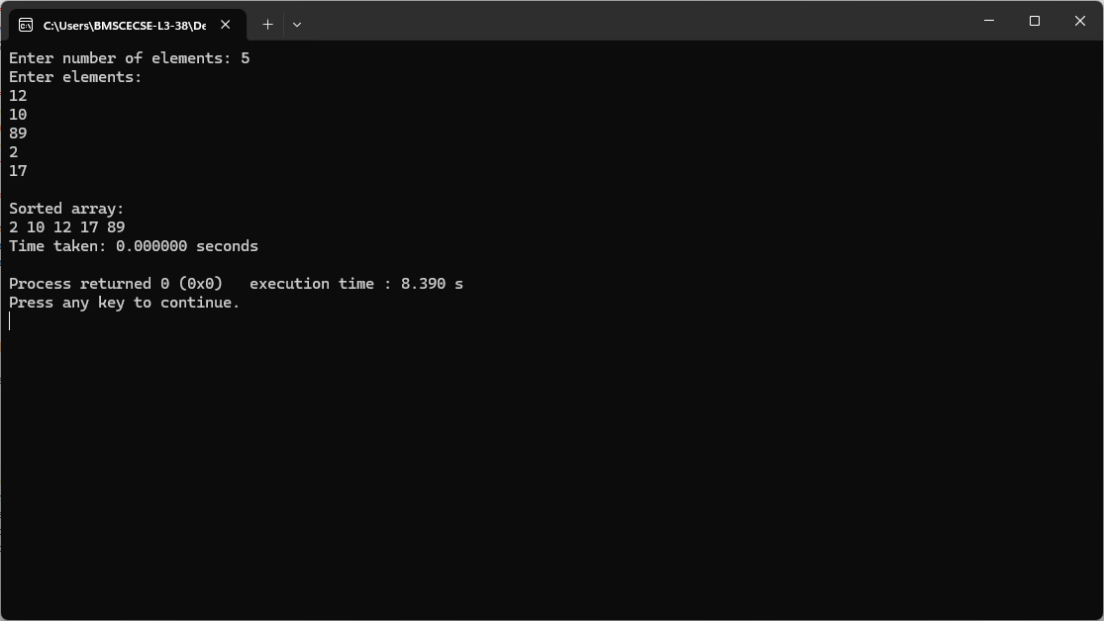

Graph:

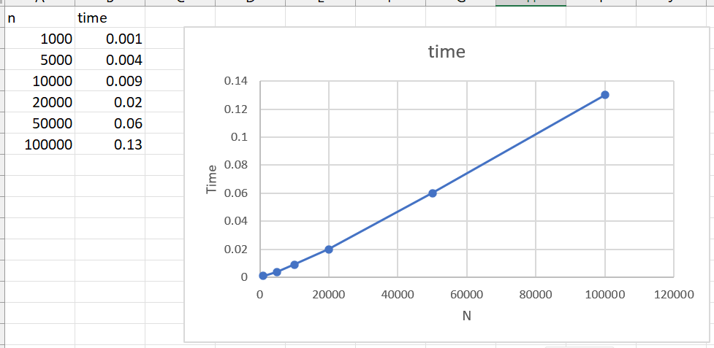

Lab Program 5
Sort a given set of N integer elements using Heap Sort technique and compute its time taken.
#include <stdio.h>
#include <time.h>
void heapify(int arr[], int n, int i) {
int largest = i;
int left = 2*i + 1;
int right = 2*i + 2;
if (left < n && arr[left] > arr[largest])
largest = left;
if (right < n && arr[right] > arr[largest])
largest = right;
if (largest != i) {
int temp = arr[i];
arr[i] = arr[largest];
arr[largest] = temp;
heapify(arr, n, largest);
}
}
void heapSort(int arr[], int n) {
for (int i = n/2 - 1; i >= 0; i--)
heapify(arr, n, i);
for (int i = n-1; i > 0; i--) {
int temp = arr[0];
arr[0] = arr[i];
arr[i] = temp;
heapify(arr, i, 0);
}
}
void printArray(int arr[], int n) {
for (int i = 0; i < n; i++)
printf("%d ", arr[i]);
printf("\n");
}
int main() {
int n;
printf("Enter number of elements: ");
scanf("%d", &n);
int arr[n];
printf("Enter elements:\n");
for (int i = 0; i < n; i++)
scanf("%d", &arr[i]);
clock_t start, end;
start = clock();
heapSort(arr, n);
end = clock();
printf("Sorted array:\n");
printArray(arr, n);
double time_taken = ((double)(end - start)) / CLOCKS_PER_SEC;
printf("Time taken: %f seconds\n", time_taken);
return 0;
}

Output:
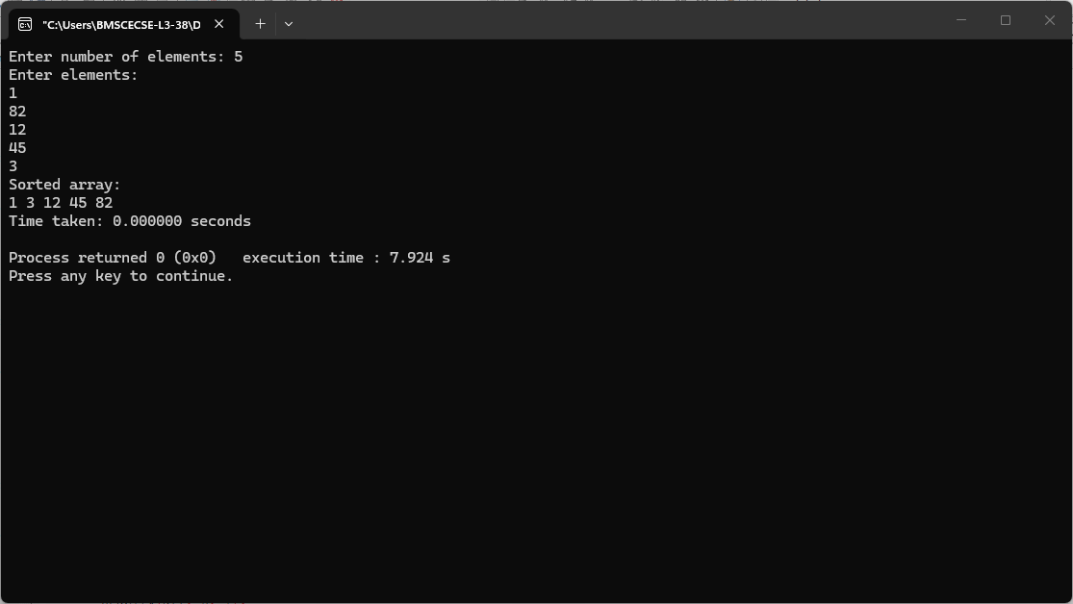

Graph:

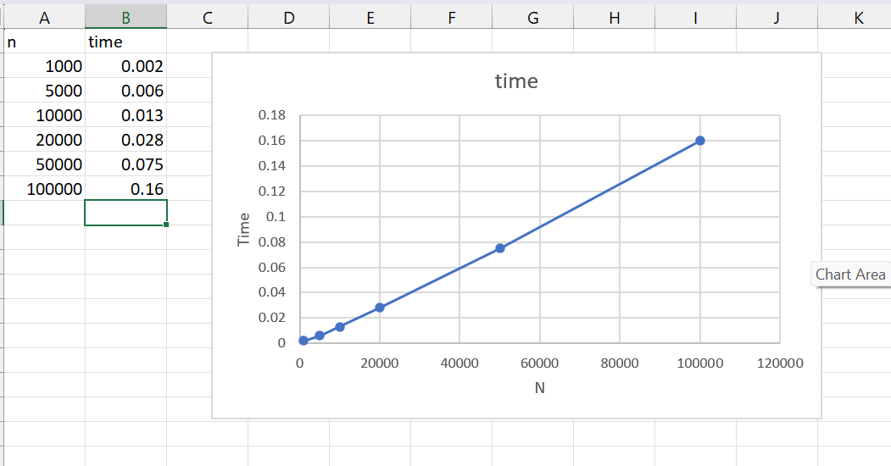

Lab Program 6
Implement 0/1 Knapsack problem using dynamic programming
#include <stdio.h>
int max(int a, int b) {
return (a > b) ? a : b;
}
int KnapsackDP(int n, int M, int W[], int P[]) {
int Table[n + 1][M + 1];
for (int i = 0; i <= n; i++) {
Table[i][0] = 0;
}
for (int j = 0; j <= M; j++) {
Table[0][j] = 0;
}
for (int i = 1; i <= n; i++) {
for (int j = 1; j <= M; j++) {
if (j < W[i - 1]) {
Table[i][j] = Table[i - 1][j];
} else {
Table[i][j] = max(
Table[i - 1][j],
P[i - 1] + Table[i - 1][j - W[i - 1]]
);
}
}
}
return Table[n][M];
}

int main() {
int n, M;
printf("Enter number of items: ");
scanf("%d", &n);
printf("Enter capacity of knapsack: ");
scanf("%d", &M);
int W[n], P[n];
printf("Enter weights of items:\n");
for (int i = 0; i < n; i++) {
scanf("%d", &W[i]);
}
printf("Enter profits of items:\n");
for (int i = 0; i < n; i++) {
scanf("%d", &P[i]);
}
int result = KnapsackDP(n, M, W, P);
printf("Maximum Profit = %d\n", result);
return 0;
}
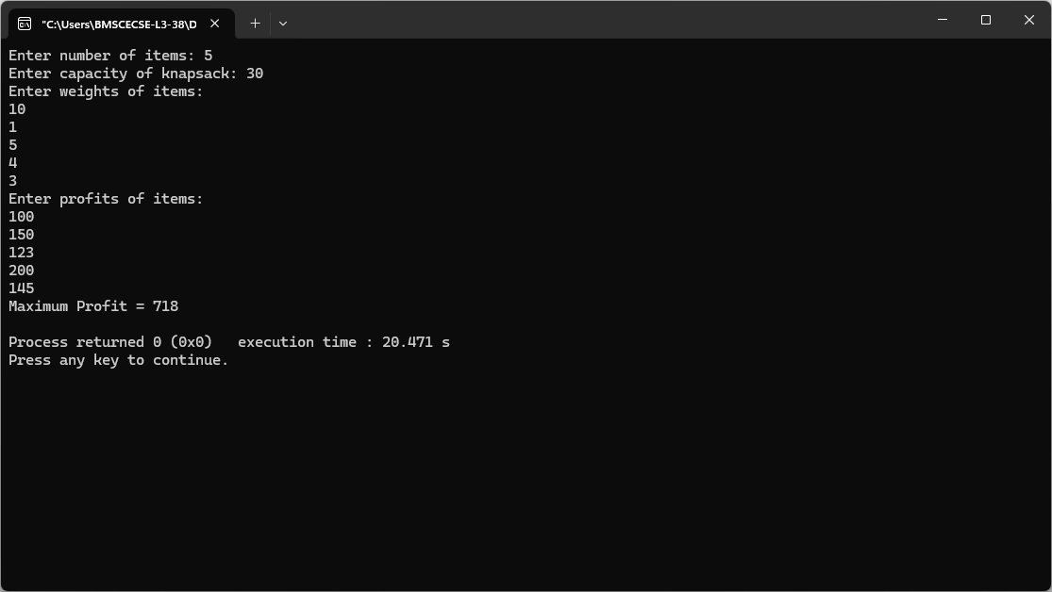
Output:

Leetcode on 0\1 Knapsack Problem
#include <limits.h>

int minSwap(int* nums1, int nums1Size, int* nums2, int nums2Size) {
int keep = 0;
int swap = 1;

for (int i = 1; i < nums1Size; i++) {
int newKeep = INT_MAX;
int newSwap = INT_MAX;

if (nums1[i] > nums1[i-1] && nums2[i] > nums2[i-1]) {
newKeep = keep;
newSwap = swap + 1;
}

if (nums1[i] > nums2[i-1] && nums2[i] > nums1[i-1]) {
if (swap < newKeep)
newKeep = swap;
if (keep + 1 < newSwap)
newSwap = keep + 1;
}

keep = newKeep;
swap = newSwap;
}

return (keep < swap) ? keep : swap;
}

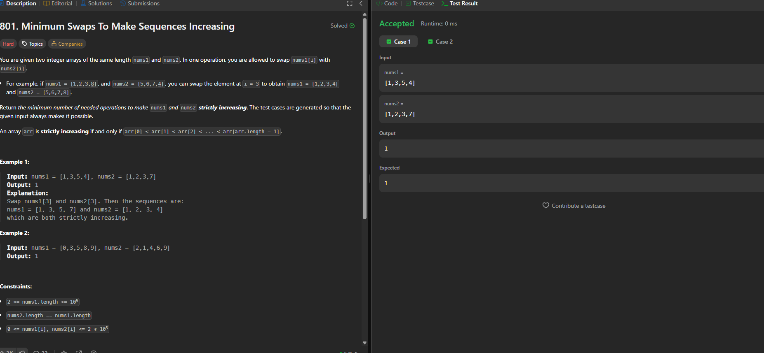
Output:
Lab Program 7
Implement All Pair Shortest paths problem using Floyd’s algorithm.
#include <stdio.h>
#define INF 99999
int main() {
int n, i, j, k;
printf("Enter number of vertices: ");
scanf("%d", &n);
int graph[n][n];
printf("Enter adjacency matrix:\n");
printf("Use %d for INF (no direct edge)\n", INF);
for(i = 0; i < n; i++) {
for(j = 0; j < n; j++) {
scanf("%d", &graph[i][j]);
}
}
for(k = 0; k < n; k++) {
for(i = 0; i < n; i++) {
for(j = 0; j < n; j++) {
if(graph[i][k] + graph[k][j] < graph[i][j]) {
graph[i][j] = graph[i][k] + graph[k][j];
}
}
}
}
printf("\nShortest Distance Matrix:\n");
for(i = 0; i < n; i++) {
for(j = 0; j < n; j++) {

if(graph[i][j] == INF)
printf("INF ");
else
printf("%3d ", graph[i][j]);
}
printf("\n");
}
return 0;
}

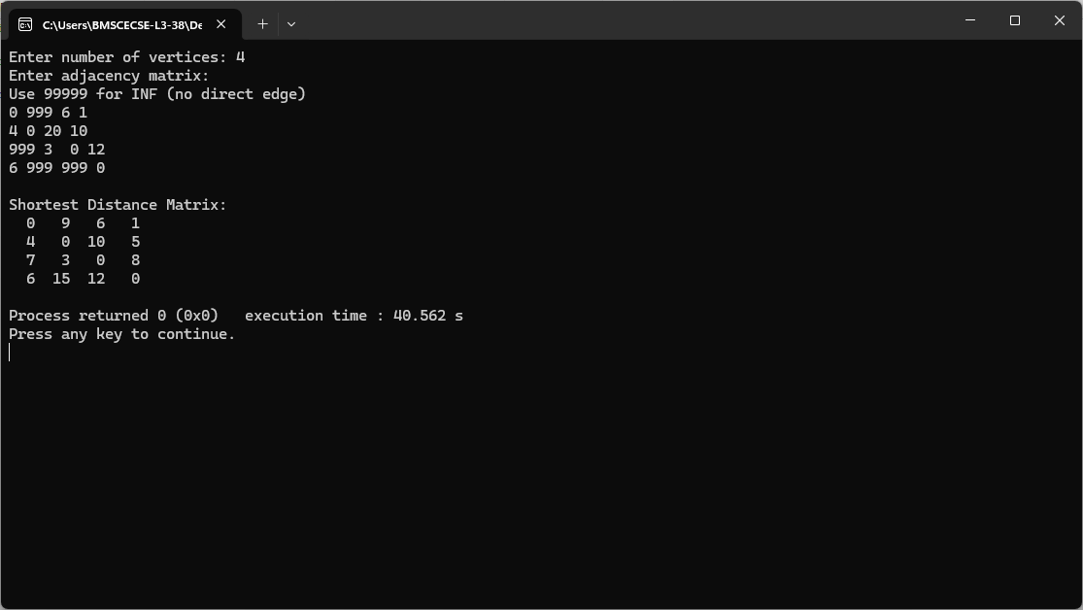
Output:

Leetcode on Floyd’s Algorithm
int findDuplicate(int* nums, int numsSize) {

int slow = nums[0];
int fast = nums[0];

do {
slow = nums[slow];
fast = nums[nums[fast]];
} while (slow != fast);

slow = nums[0];

while (slow != fast) {
slow = nums[slow];
fast = nums[fast];
}

return slow;
}

Output:
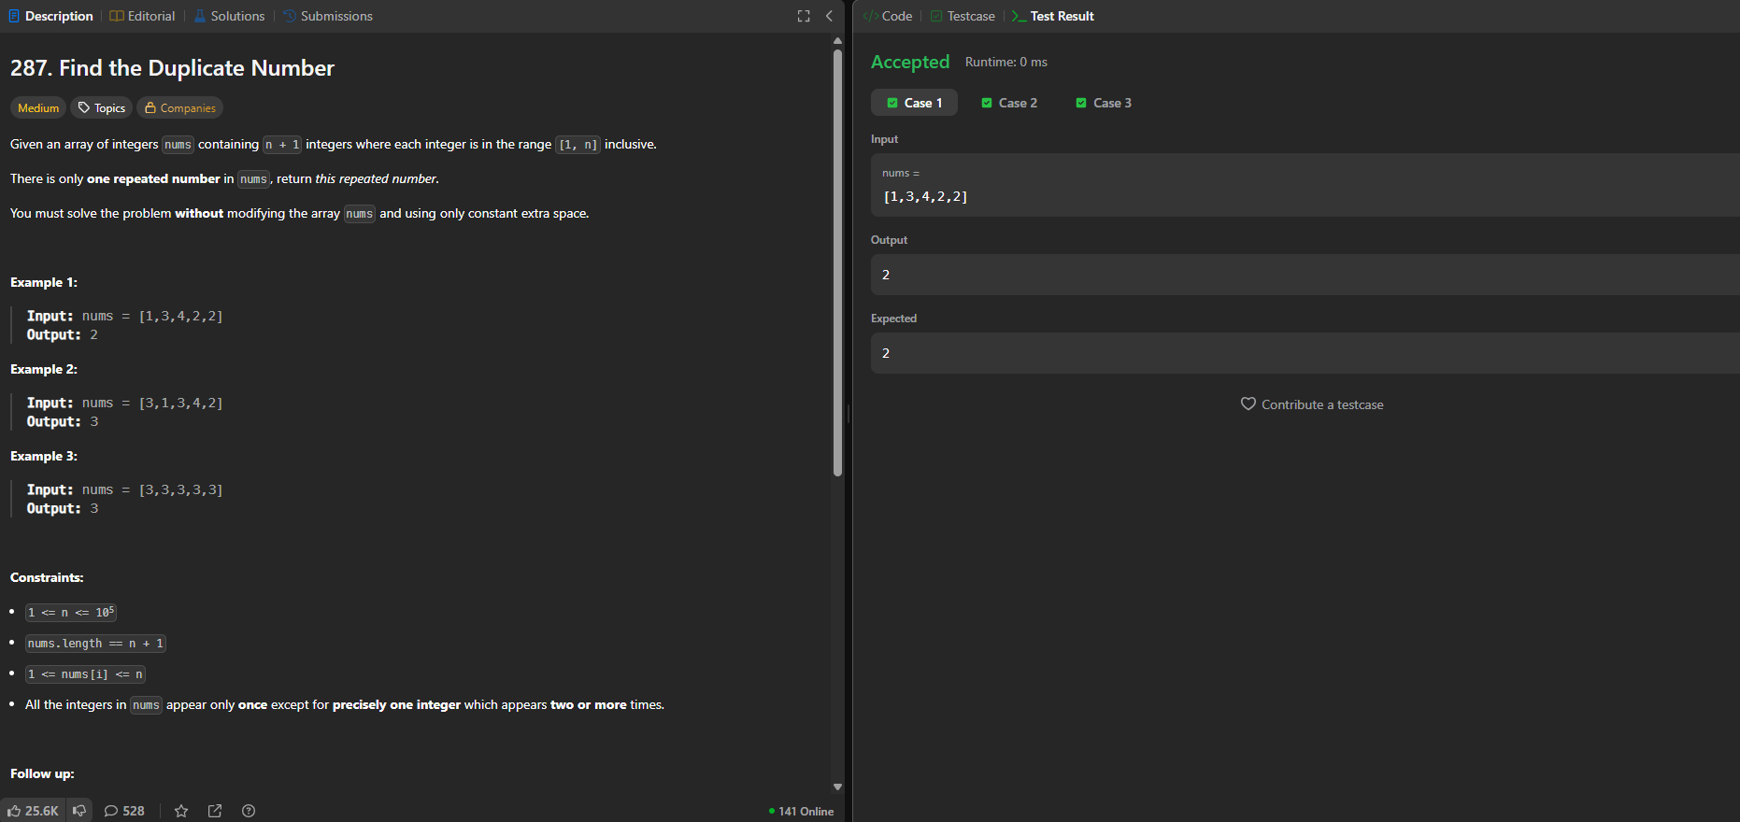

Lab program 8
(a) Find Minimum Cost Spanning Tree of a given undirected graph using Prim’s algorithm.
(b) Find Minimum Cost Spanning Tree of a given undirected graph using Kruskal’s algorithm

(a) Prim’s Algorithm:
#include <stdio.h>
#define MAX 100
#define INF 9999
int minKey(int key[], int visited[], int n) {
int min = INF, min_index;
for (int i = 0; i < n; i++) {
if (!visited[i] && key[i] < min) {
min = key[i];
min_index = i;
}
}
return min_index;
}
void primMST(int graph[MAX][MAX], int n) {
int parent[MAX];
int key[MAX];
int visited[MAX];
for (int i = 0; i < n; i++) {
key[i] = INF;
visited[i] = 0;
}
key[0] = 0;
parent[0] = -1;
for (int count = 0; count < n - 1; count++) {
int u = minKey(key, visited, n);
visited[u] = 1;
for (int v = 0; v < n; v++) {
if (graph[u][v] && !visited[v] && graph[u][v] < key[v]) {
parent[v] = u;
key[v] = graph[u][v];
}
}
}
int cost = 0;
printf("\nEdge \tWeight\n");
for (int i = 1; i < n; i++) {
printf("%d - %d \t%d\n", parent[i], i, graph[i][parent[i]]);
cost += graph[i][parent[i]];
}
printf("Minimum Cost = %d\n", cost);
}
int main() {
int n, graph[MAX][MAX];
printf("Enter number of vertices: ");
scanf("%d", &n);
printf("Enter adjacency matrix:\n");
for (int i = 0; i < n; i++) {
for (int j = 0; j < n; j++) {
scanf("%d", &graph[i][j]);
}
}
primMST(graph, n);
return 0;
}

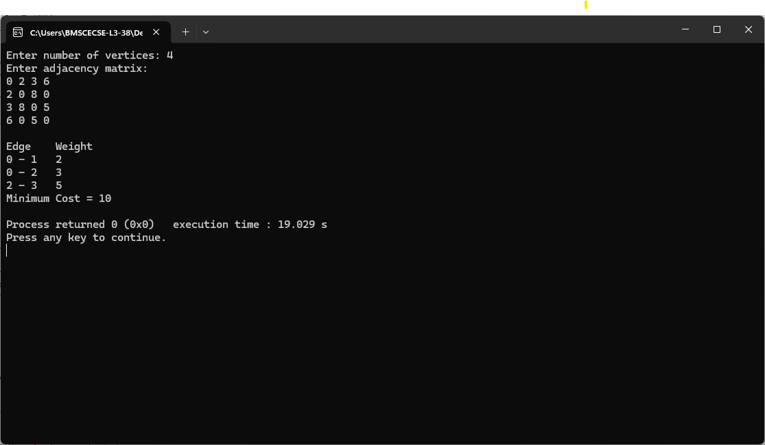
Output:

(b) Kruskal Algorithm

#include <stdio.h>
#define MAX 20
#define INF 9999
int parent[MAX];
int find(int i) {
while (parent[i] != i)
i = parent[i];
return i;
}
void unionSet(int i, int j) {
parent[i] = j;
}
int main() {
int n, cost[MAX][MAX];
int i, j, u, v, min, mincost = 0;
int edges = 0;
printf("Enter number of vertices: ");
scanf("%d", &n);
printf("Enter cost adjacency matrix:\n");
for (i = 0; i < n; i++) {
for (j = 0; j < n; j++) {
scanf("%d", &cost[i][j]);
if (cost[i][j] == 0)
cost[i][j] = INF;
}
}
for (i = 0; i < n; i++)
parent[i] = i;
printf("\nEdges in MST:\n");
while (edges < n - 1) {
min = INF;
for (i = 0; i < n; i++) {
for (j = 0; j < n; j++) {
if (cost[i][j] < min) {
min = cost[i][j];
u = i;
v = j;
}
}
}
int set_u = find(u);
int set_v = find(v)
if (set_u != set_v) {
printf("%d - %d : %d\n", u, v, min);
mincost += min;
unionSet(set_u, set_v);
edges++;
}
cost[u][v] = cost[v][u] = INF;
}
printf("Minimum Cost = %d\n", mincost);
return 0;
}

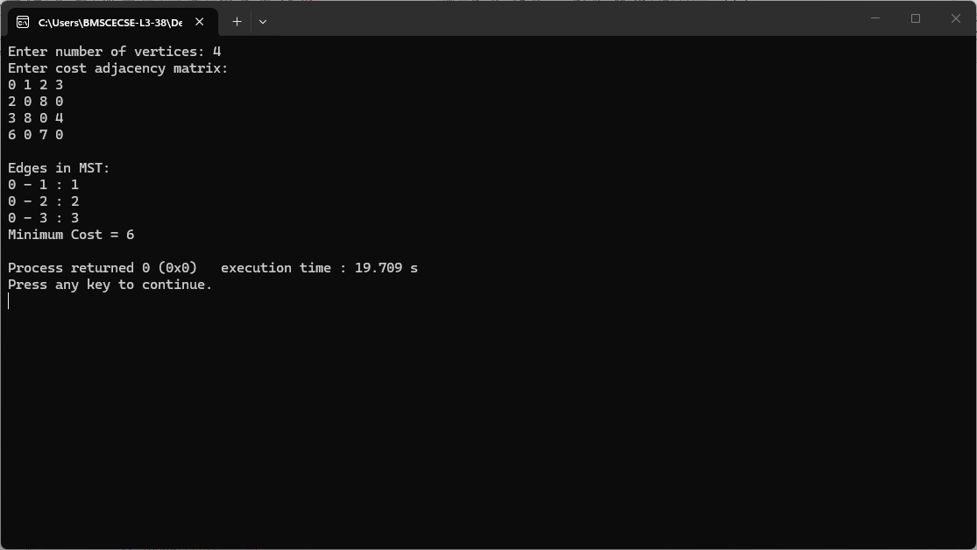
Output:

Lab program 9
Implement Fractional Knapsack using Greedy technique
#include <stdio.h>
struct Item {
float weight;
float profit;
float ratio;
};
void sortItems(struct Item items[], int n) {
int i, j;
struct Item temp;
for (i = 0; i < n - 1; i++) {
for (j = 0; j < n - i - 1; j++) {
if (items[j].ratio < items[j + 1].ratio) {
temp = items[j];
items[j] = items[j + 1];
items[j + 1] = temp;
}
}
}
}
float fractionalKnapsack(struct Item items[], int n, float capacity) {
float totalProfit = 0.0;
int i;
sortItems(items, n);
for (i = 0; i < n; i++) {
if (capacity >= items[i].weight)
totalProfit += items[i].profit;
capacity -= items[i].weight;
} else {
totalProfit += items[i].profit *
(capacity / items[i].weight);
break;
}
}
return totalProfit;
}
int main() {
int n, i;
float capacity;
printf("Enter number of items: ");
scanf("%d", &n);
struct Item items[n];
for (i = 0; i < n; i++) {
printf("\nItem %d\n", i + 1);
printf("Enter Profit: ");
scanf("%f", &items[i].profit);
printf("Enter Weight: ");
scanf("%f", &items[i].weight);
items[i].ratio = items[i].profit / items[i].weight;
}
printf("\nEnter Knapsack Capacity: ");
scanf("%f", &capacity);

float maxProfit = fractionalKnapsack(items, n, capacity);
printf("\nMaximum Profit = %.2f\n", maxProfit);
return 0;
}
Output :
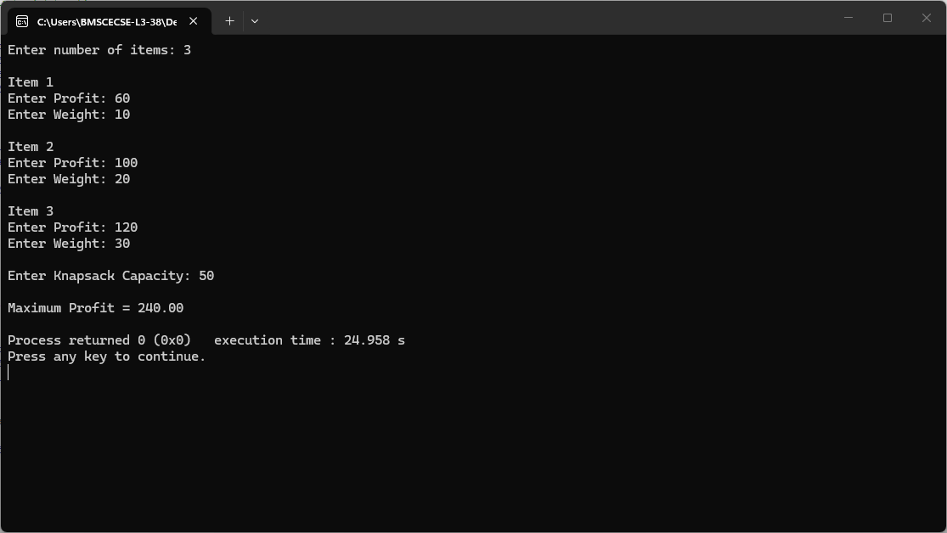

Lab program 10
From a given vertex in a weighted connected graph, find shortest paths to other vertices using Dijkstra’s algorithm
#include <stdio.h>
#include <limits.h>
int minDistance(int dist[], int visited[], int V) {
int min = INT_MAX, min_index = -1;
for (int v = 0; v < V; v++) {
if (!visited[v] && dist[v] <= min) {
min = dist[v];
min_index = v;
}
}
return min_index;
}
void dijkstra(int V, int graph[V][V], int src) {
int dist[V];
int visited[V];
for (int i = 0; i < V; i++) {
dist[i] = INT_MAX;
visited[i] = 0;
}
dist[src] = 0;
for (int count = 0; count < V - 1; count++) {
int u = minDistance(dist, visited, V);
visited[u] = 1;
for (int v = 0; v < V; v++) {
if (!visited[v] &&
graph[u][v] != 0 &&
dist[u] != INT_MAX &&
dist[u] + graph[u][v] < dist[v]) {
dist[v] = dist[u] + graph[u][v];
}
}
}
printf("\nVertex \t Distance from Source\n");

for (int i = 0; i < V; i++) {
printf("%d \t %d\n", i, dist[i]);
}
}
int main() {
int V, source;
printf("Enter number of vertices: ");
scanf("%d", &V);
int graph[V][V];
printf("Enter the adjacency matrix (%d x %d):\n", V, V);

for (int i = 0; i < V; i++) {
for (int j = 0; j < V; j++) {
scanf("%d", &graph[i][j]);
}
}
printf("Enter source vertex (0 to %d): ", V - 1);
scanf("%d", &source);
dijkstra(V, graph, source);

return 0;
}
Output :
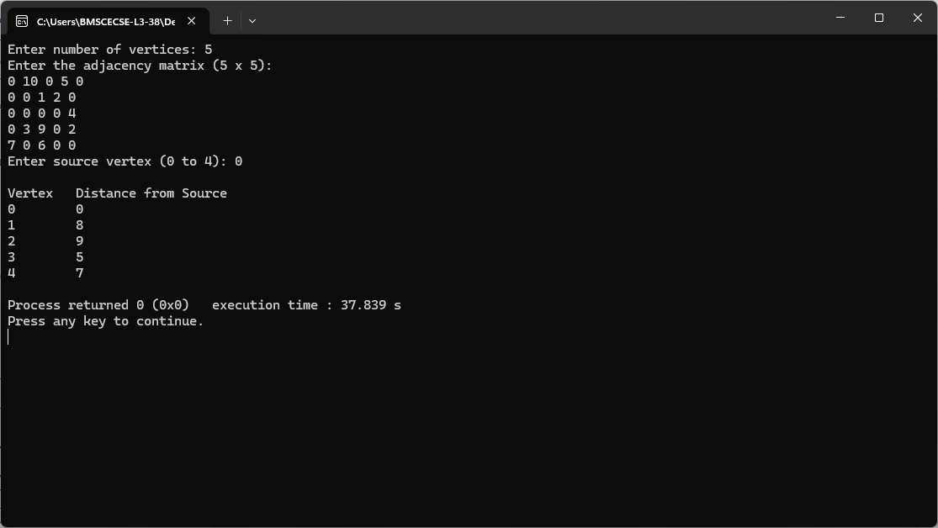

Lab Program 11
Implement “N-Queens Problem” using Backtracking
#include <stdio.h>
#define MAX 20
int board[MAX][MAX];
int N;
int isSafe(int row, int col)
{
int i, j;
for(i = 0; i < col; i++)
{
if(board[row][i] == 1)
return 0;
}
for(i = row, j = col; i >= 0 && j >= 0; i--, j--)
{
if(board[i][j] == 1)
return 0;
}
for(i = row, j = col; i < N && j >= 0; i++, j--)
{
if(board[i][j] == 1)
return 0;
}
return 1;
}
int solveNQueens(int col)
{
int i;
if(col >= N)
return 1;
for(i = 0; i < N; i++)
{
if(isSafe(i, col))
{
board[i][col] = 1;
if(solveNQueens(col + 1))
return 1;
board[i][col] = 0;
}
}
return 0;
}
void printBoard()
{
int i, j;
printf("\nSolution Exists:\n\n");
for(i = 0; i < N; i++)
{
for(j = 0; j < N; j++)
{
if(board[i][j] == 1)
printf("Q ");
else
printf(". ");
}
printf("\n");
}
}
int main()
{
int i, j;
printf("Enter value of N: ");
scanf("%d", &N);
for(i = 0; i < N; i++)
{
for(j = 0; j < N; j++)
{
board[i][j] = 0;
}
}
if(solveNQueens(0))
{
printBoard();
}
else
{
printf("No Solution Exists\n");
}
return 0;
}

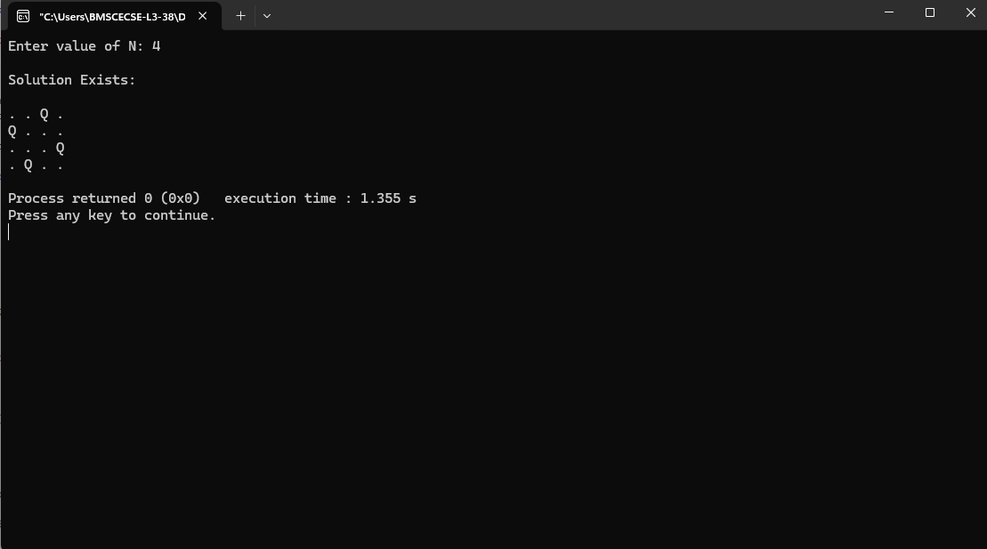
Output:

