|  |  |  |  |
| --- | --- | --- | --- |
| HIGH LEVEL DESIGN DOCUMENT  SMART PARKING SYSTEM  UE18CS390A – Capstone Project Phase – 1  ***Submitted by:***   |  |  | | --- | --- | | **R S CHAITRA SREE**  **PALLAVI A N**  **YUKTHI G L**  **ABHISHEK D** | **PES1201801628**  **PES1201801979**  **PES1201802033**  **PES1201802109** |   Under the guidance of   |  | | --- | | **Prof. SUNITHA R**  Professor  PES University |   **January - May 2021**  **DEPARTMENT OF COMPUTER SCIENCE AND ENGINEERING**  FACULTY OF ENGINEERING  **PES UNIVERSITY**  (Established under Karnataka Act No. 16 of 2013)  100ft Ring Road, Bengaluru – 560 085, Karnataka, India |

TABLE OF CONTENTS

|  |  |
| --- | --- |
| 1. Introduction | 4 |
| 1. Current System | 4 |
| 1. Design Considerations | 4 |
| 3.1 Design Goals | 4 |
| 3.2 Architecture Choices | 4 |
| 3.3Constraints, Assumptions and Dependencies | 4 |
| 1. High Level System Design | 5 |
| 1. Design Description | 5 |
| * 1. Master Class Diagram | 6 |
|  |  |
| 1. ER Diagram / Swimlane Diagram / State Diagram | 6 |
| 1. User Interface Diagrams | 6 |
| 1. Report Layouts | 6 |
| 1. External Interfaces | 7 |
| 1. Packaging and Deployment Diagram | 7 |
| 1. Help | 7 |
| Appendix A: Definitions, Acronyms and Abbreviations | 8 |
| Appendix B: References | 8 |
| Appendix C: Record of Change History | 8 |
| Appendix D: Traceability Matrix | 8 |

# Note:

|  |  |
| --- | --- |
| **Section – 1 & Section 2** | **Common for Product Based and Research Projects** |
| **Section 3 to Section 11** | **High-Level Design for Product Based Projects.** |
| **Section 12** | **High-Level Design for Research Projects.** |
| **Appendix** | **Provide details appropriately** |

# Introduction

A Smart Parking is a parking management system where users can find their parking slots in a more efficient manner. As we all know about the parking problems we face in our day-to-day life , with increasing population and increasing vehicles it has almost been impossible to find parking slots.

According to study people spend most of their time on road by looking for a parking space, this increases emission of gases resulting to global warming. Therefore implementing a Smart Parking system would be useful to environment and also could save a lot of time.

This document would contain information about product features, product implementation , product functionality, product requirements.

# Current System

There are few malls namely mantrisquare ,orion mall etc which have smart parking system implemented . But still users would find a huge line of vehicles waiting for their parking payment or searching for best place to park. We will be trying to overcome all this problems in our smart parking system.

1. **Design Considerations** 
   1. **Design Goals**

* Reducing the amount of time spent in looking for parking.
* Lesser traffic
* Low emission of harmful gases
* User-friendly design
  1. **Architecture Choices**

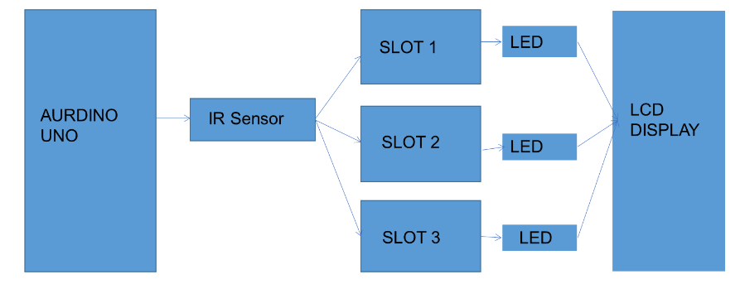

# Constraints,Assumptions and Dependencies

* The system in which the model is developed should have Arduino IDE installed.
* We assume there would continuous power supply.
* The system won’t work if there is no power supply.

# High Level System Design

[Provide high-level design view of the system]

[This section should not go into the detail about that the deliverable. Rather, this section should identify the logical user groups, application components, data components, and interfacing systems. Illustrate the collaboration and interaction between the major components. Identify any relevant design patterns or reuse relevant to the design.]

[The diagram should include the following,

* Logical Dataflow.
* Servers, Storage, Networks, Database Architecture.]

[Provide technical specifications with enough detail to develop the system.]

Identify the system elements in from different perspectives.

1. Conceptual or logical – This elaborates the logical functional elements of the system. [UML – component or package diagram]
2. Process - Runtime view of the system. [UML – Interaction diagram].
3. Physical – Brief the view of the distributed system. [UML – Deployment diagram].
4. Module – Describe the project management and code organization.
5. Security – Describe the security features of the system.

**[Note: It is not mandatory to describe all these perspectives, document only theones which will help you design and implement the system.]**

# Design Description

* 1. **Master Class Diagram**

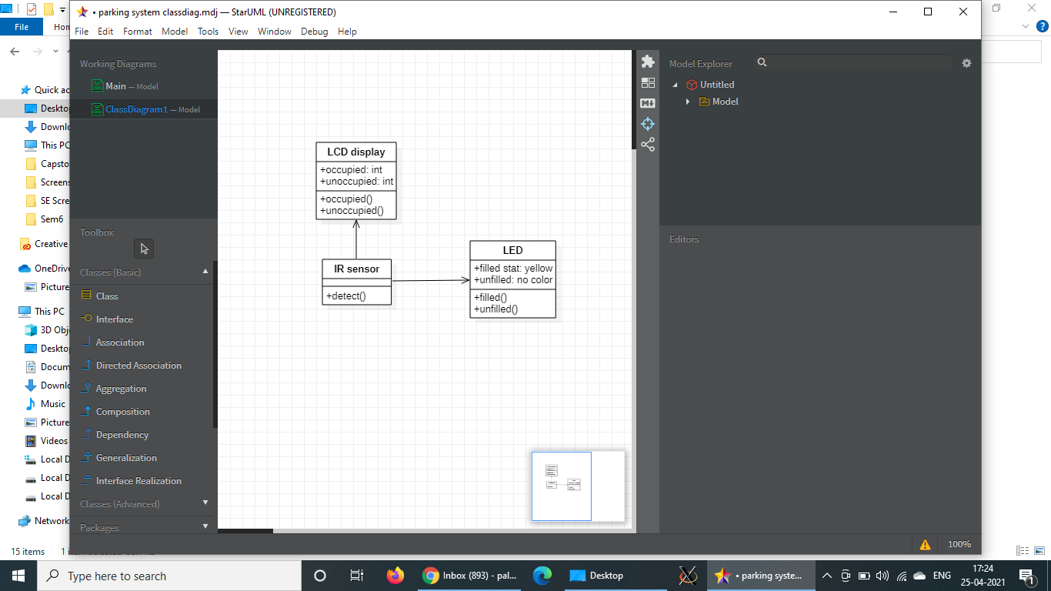

1. **ER Diagram**

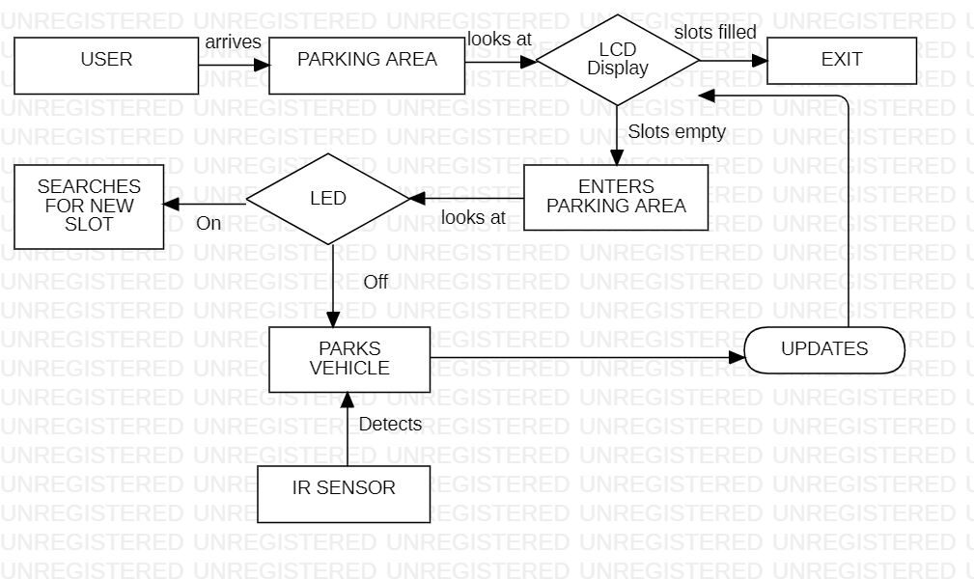

1. **User Interface Diagrams**

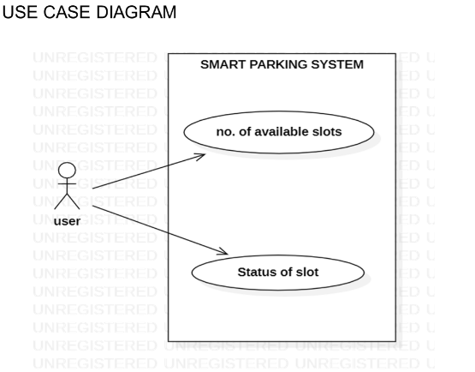

1. **External Interfaces**

[Give an overall diagram as to how the system with known interfaces will work. However, the description of the interface may or may not be covered in this document, depending on whether it is within the scope of the offshore development.]

1. **Packaging and Deployment Diagram**

[The packaging and deployment for the system implementation shall be presented here.]

# Help

Install ArduinoIDE for coding purpose and just click on compile so that the compiling is completed without any error and then upload code for your product.

**Appendix A: Definitions, Acronyms and Abbreviations**

[Provide definition of all terms, acronyms and abbreviations required for interpreting this High Level Design document.]

# Appendix B: References

[This section describes the complete list of documents referred to prepare the High Level Design. This section shall describe the title, version number, dates, authors and publishers of the referenced documents whenever applicable.

If industry standard methodology is used for design, it will be clearly mentioned here. If however, other methodologies are used, the deviation from a standard methodology will be clearly described.]

# Appendix C: Record of Change History

[This section describes the details of changes that have resulted in the current High-Level Design document.]

|  |  |  |  |  |
| --- | --- | --- | --- | --- |
| **#** | **Date** | **Document Version No.** | **Change Description** | **Reason for Change** |
|  |  |  |  |  |
|  |  |  |  |  |
|  |  |  |  |  |

# Appendix D: Traceability Matrix

[Demonstrate the forward and backward traceability of the system to the functional and non-functional requirements documented in the Requirements Document.]

|  |  |
| --- | --- |
| **Project Requirement Specification Reference Section No.and Name.** | **DESIGN / HLD Reference Section No. and Name.** |
|  |  |
|  |  |
|  |  |