**Word Embeddings:**

1. Tf-Idf (term frequency-inverse document frequency): Used to transform that text into numbers, also known as text vectorization, measures how relevant a word is to a document in a collection of documents

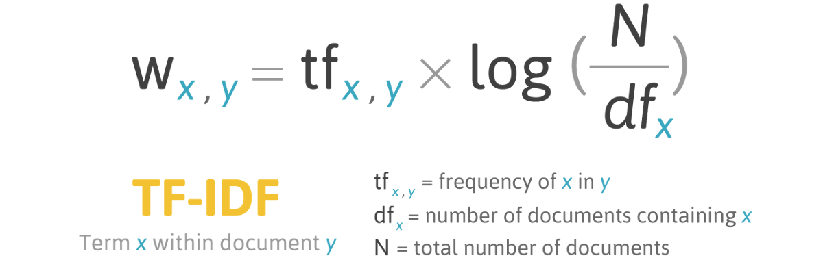

1. Word2vec - The word2vec algorithm uses a neural network model to learn word associations from a large corpus of text. It finds similar and dissimilar words and synonyms have similar representation of vectors vs antonyms have different vectors that are far apart in vector space

**Classifiers:**

1. SVM (Support Vector Mechanism): It is a supervised learning method useful for high dimensional data. Different Kernel functions can be specified for the decision function. Samples on boundaries are support vectors. Hyperplane W*x – b = 0 in linear kernel separates classes.

1. Neural Network Models (MLP – Multi-layer perceptron): MLP has number of neurons in each hidden layer having specific activation functions(non-linear functions). This supervised algorithm learns using technique called backpropagation. Weights from each node to another node is learned automatically

