**Administrative-portal-for-Learner-s-Academy**

**Project' Details**

This project aims to design and develop a backend administrative portal for the Learner’s Academy using Java EE technologies. I developed it as a project of phase 2 for the Become a back-end expert course. The goal of this project is to apply servlet, jsp and JDBC concepts.

**Product Backlog:**

1. Create database and tables.
2. Connect the database to the project.
3. Create models classes.
4. Create a database utility class to retrieve data.
5. Create login page.
6. Create JSP files for all pages of the project.
7. Create a servlet to get requests and send responses to the JSP files.
8. Add cookies.
9. Create a CSS file to format the contents.
10. Debug and Test the project.

**Technologies and tools Used**

• Servlet: to do the business logic and works a controller for the project.

• JSP: to handle the presentation view.

• SQL: to create and manage the database.

• JDBC: to make operations on the database for the project.

• Eclipse: to write and run the code.

• Tomcat: to run and deploy servlet application.

**Flowcharts of The Application**

[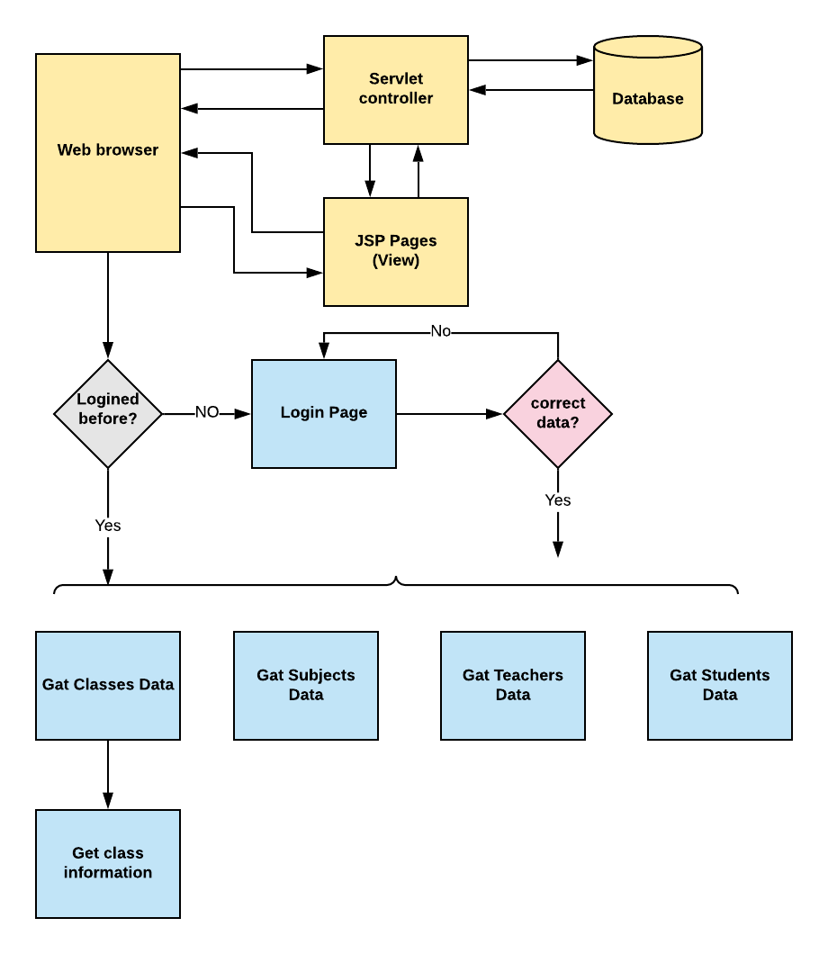](https://user-images.githubusercontent.com/64940728/120771636-182e8e00-c528-11eb-92bb-f5856138c93f.png)

Git link: https://github.com/chaitu-123/phase2_finalProj.git