prerequisites

Before installing the Nagios, the system needs to meet the requirements for installing Nagios. So install the Web Server (httpd), PHP, compilers and development libraries.

Install all packages in a single command.

yum -y install httpd php gcc glibc glibc-common wget perl gd gd-devel unzip zip

Create a nagios user and nagcmd group for allowing the external commands to be executed through the web interface, add the nagios and apache user to be a part of the nagcmd group.

useradd nagios

groupadd nagcmd

usermod -a -G nagcmd nagios

usermod -a -G nagcmd apache

Download latest Nagios Core.

cd /tmp/

wget https://assets.nagios.com/downloads/nagioscore/releases/nagios-4.4.2.tar.gz

tar -zxvf /tmp/nagios-4.*.tar.gz

cd /tmp/nagios-4.*

Compile and Install Nagios.

./configure --with-nagios-group=nagios --with-command-group=nagcmd

make all

make install

make install-init

make install-config

make install-commandmode

Install & Configure Nagios Web Interface

Install the Nagios web configuration using the following command.

make install-webconf

Run the following command to install a Nagios**exfoliation** theme

make install-exfoliation

Create a user account (**nagiosadmin**) for logging into the Nagios web interface. Remember the password that you assign to this user – you’ll need it later.

htpasswd -c /usr/local/nagios/etc/htpasswd.users nagiosadmin

Restart Apache web server to make the new settings take effect.

### CentOS 7 / RHEL 7 ###

systemctl restart httpd

systemctl enable httpd

### CentOS 6 / RHEL 6 ###

service httpd start

chkconfig httpd on

Configure Nagios

Sample configuration files have now been installed in the **/usr/local/nagios/etc** directory. These sample files should work fine for getting started with Nagios. You’ll need to make just one change before you proceed…

Edit the **/usr/local/nagios/etc/objects/contacts.cfg** config file with your favorite editor and change the email address associated with the nagiosadmin contact definition to the address you’d like to use for receiving alerts.

vi /usr/local/nagios/etc/objects/contacts.cfg

Change the Email address field to receive the notification.

define contact{

contact_name nagiosadmin ; Short name of user

use generic-contact ; Inherit default values from generic-contact template (defined above)

alias Nagios Admin ; Full name of user

email [chandanabbupur@gmail.com](mailto:chandanabbupur@gmail.com) ; <<***** CHANGE THIS TO YOUR EMAIL ADDRESS ******

}

Download and Install Nagios Plugins

Download Nagios Plugins to /tmp directory.

cd /tmp

wget https://nagios-plugins.org/download/nagios-plugins-2.2.1.tar.gz

tar -zxvf /tmp/nagios-plugins-*.tar.gz

cd /tmp/nagios-plugins-*/

Compile and install the Nagios plugins.

./configure --with-nagios-user=nagios --with-nagios-group=nagios

make

make install

Start Nagios Server

Verify the sample Nagios configuration files.

/usr/local/nagios/bin/nagios -v /usr/local/nagios/etc/nagios.cfg

**Output:**

Nagios Core 4.4.2

Copyright (c) 2009-present Nagios Core Development Team and Community Contributors

Copyright (c) 1999-2009 Ethan Galstad

Last Modified: 2018-08-16

License: GPL

Website: https://www.nagios.org

Reading configuration data...

Read main config file okay...

Read object config files okay...

Running pre-flight check on configuration data...

Checking objects...

Checked 8 services.

Checked 1 hosts.

Checked 1 host groups.

Checked 0 service groups.

Checked 1 contacts.

Checked 1 contact groups.

Checked 24 commands.

Checked 5 time periods.

Checked 0 host escalations.

Checked 0 service escalations.

Checking for circular paths...

Checked 1 hosts

Checked 0 service dependencies

Checked 0 host dependencies

Checked 5 timeperiods

Checking global event handlers...

Checking obsessive compulsive processor commands...

Checking misc settings...

Total Warnings: 0

Total Errors: 0

Things look okay - No serious problems were detected during the pre-flight check

If there are no errors, then start the Nagios service.

service nagios start

Start Nagios on system startup.

chkconfig nagios on

SELinux

See if SELinux is in Enforcing mode.

getenforce

Put **SELinux** in **Permissive mode or Disable it**.

setenforce 0

To make this change permanent, you’ll have to [**modify the settings in /etc/selinux/config and reboot**](https://www.itzgeek.com/how-tos/linux/centos-how-tos/disable-selinux-on-centos-6-disable-selinux-on-rhel-6.html).

Firewall

Make sure to allow web server access through the firewall.

### FirwallD ###

firewall-cmd --permanent --add-service=http

firewall-cmd --reload

### IP Tables ###

iptables -I INPUT -m state --state NEW -m tcp -p tcp --dport 80 -j ACCEPT

service iptables save

Access Web Interface

Now access the Nagios web interface using the following URL. You’ll be prompted for the username (**nagiosadmin**) and password you specified earlier.

http://your-ip-add-ress/nagios/

[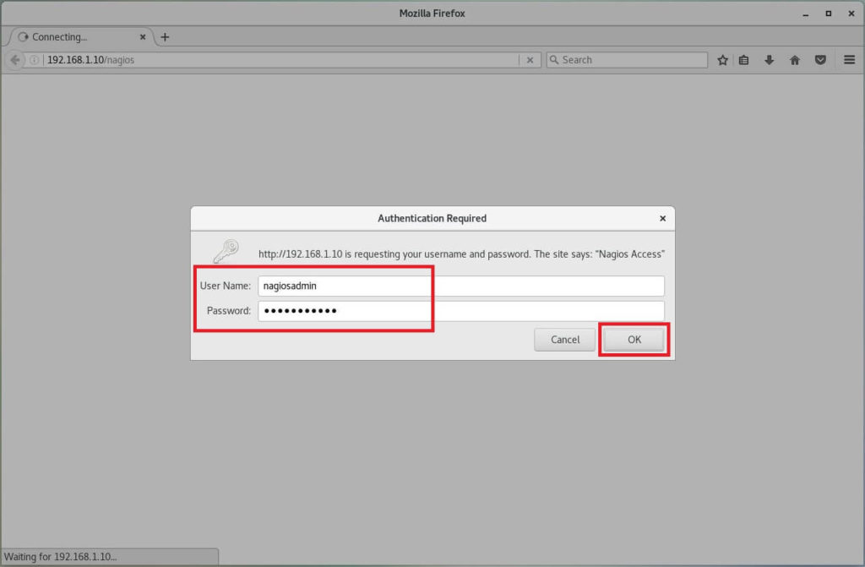](https://www.itzgeek.com/wp-content/uploads/2014/07/Install-Nagios-4.4.2-on-CentOS-7-%E2%80%93-Nagios-Login-Screen.jpg)Install Nagios 4.4.2 on CentOS 7 – Nagios Login Screen

Nagios console will look like below.

[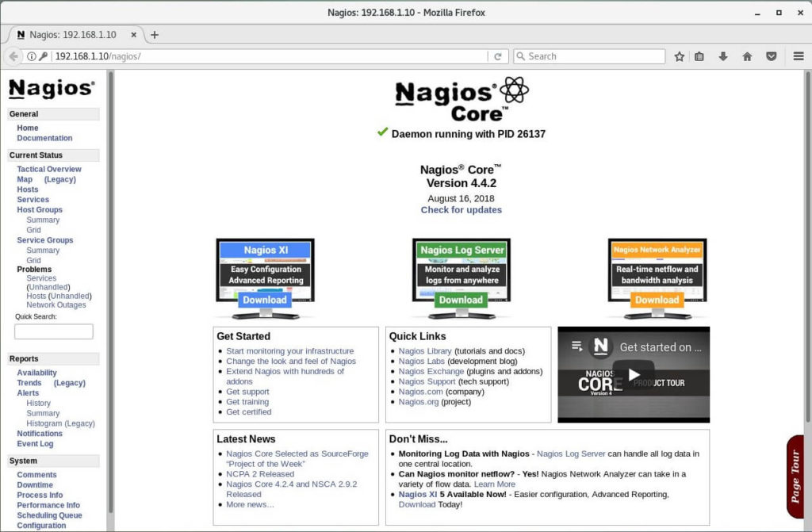](https://www.itzgeek.com/wp-content/uploads/2014/07/Install-Nagios-4.4.2-on-CentOS-7-%E2%80%93-Nagios-Core-Home-Page.jpg)Install Nagios 4.4.2 on CentOS 7 – Nagios Core Home Page

Click on **Hosts** in the left pane to get a list of systems being monitored by Nagios. We have not added any host to Nagios, So it simply monitors the localhost itself**.**

**To monitor a remote Linux system,**

**READ**: [**Monitor Remote Linux System with Nagios Server**](https://www.itzgeek.com/how-tos/linux/centos-how-tos/monitor-remote-linux-system-with-nagios-3.html)

[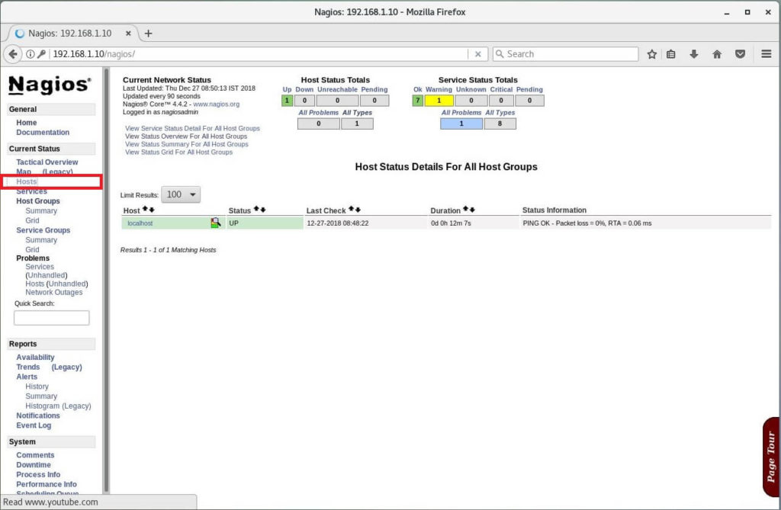](https://www.itzgeek.com/wp-content/uploads/2014/07/Install-Nagios-4.4.2-on-CentOS-7-%E2%80%93-Nagios-Hosts-List.jpg)Install Nagios 4.4.2 on CentOS 7 – Nagios Hosts List

Click on **Service**in the left pane to get the status of any services that are being monitored with Nagios.

[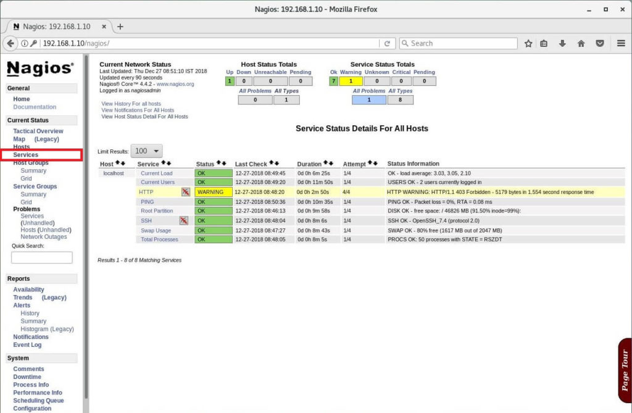](https://www.itzgeek.com/wp-content/uploads/2014/07/Install-Nagios-4.4.2-on-CentOS-7-%E2%80%93-Monitoring-Services-with-Nagios.jpg)